**JAVA DAY 3 ASSIGNMENT 3 DT:21.07.2022**

**Q:1)Complete the code by running main in different class?**

**class CPU {**

**double price;**

**// nested class**

**class Processor{**

**// members of nested class**

**double cores;**

**String manufacturer;**

**double getCache(){**

**return 4.3;**

**}**

**}**

**// nested protected class**

**protected class RAM{**

**// members of protected nested class**

**double memory;**

**String manufacturer;**

**double getClockSpeed(){**

**return 5.5;**

**}**

**}**

**}**

**Ans:1)** 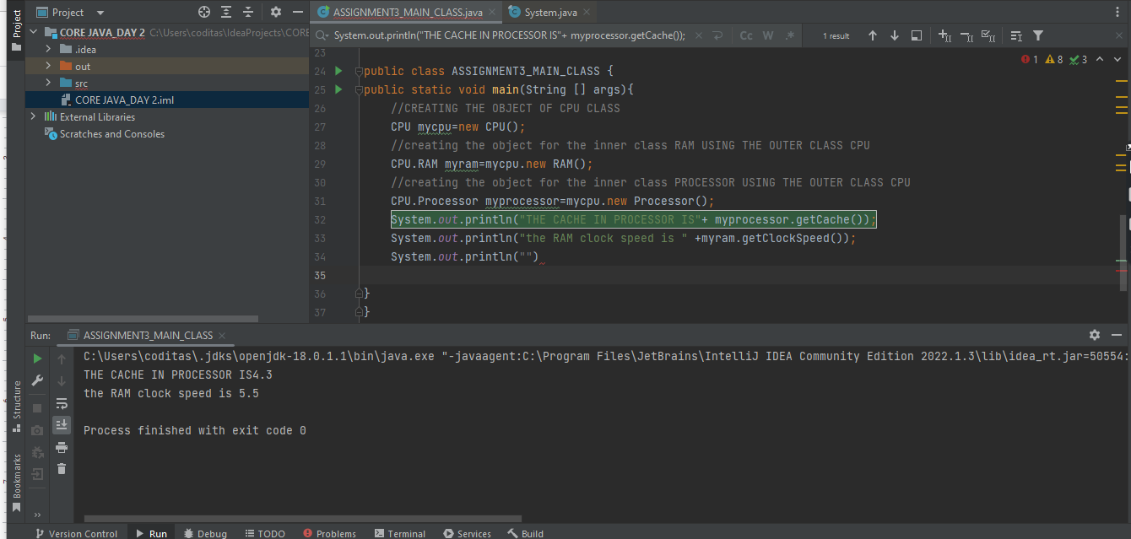

**Q:2)Write a program on local,instance and static variables?**

**Ans:1)Static variable:**

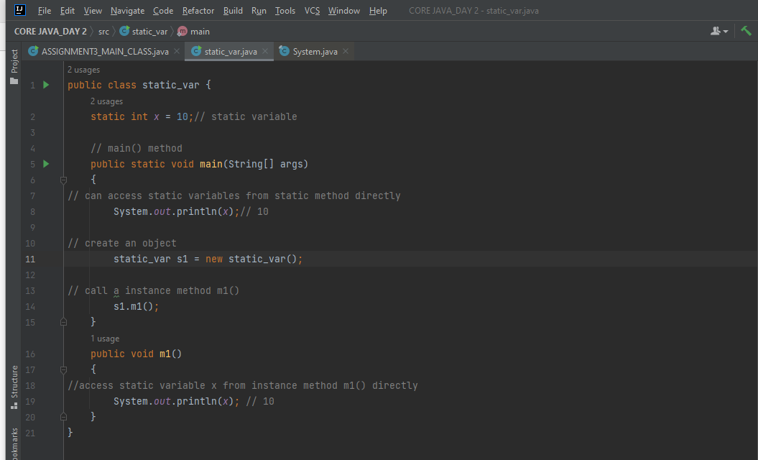



**Local variables:-**

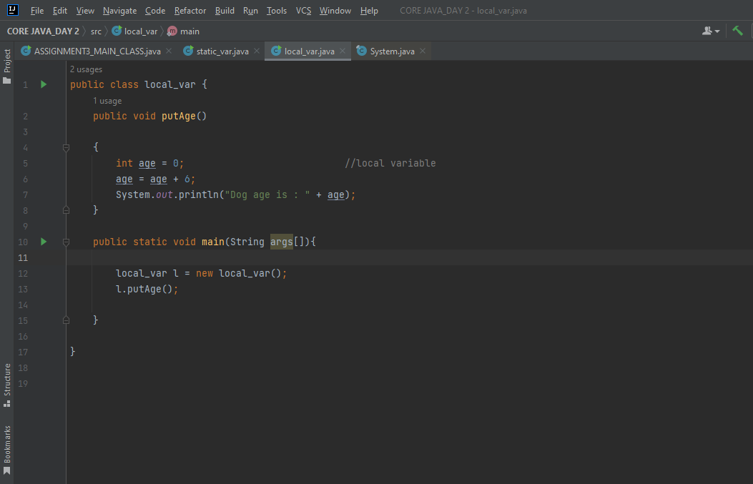

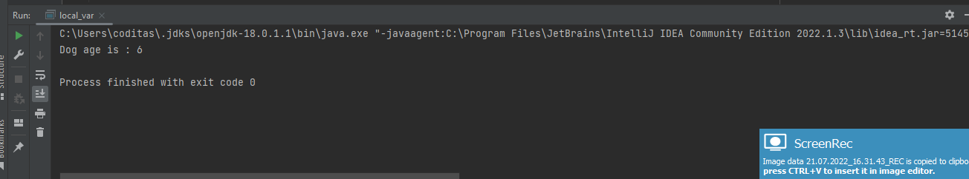

**Instance variables:**

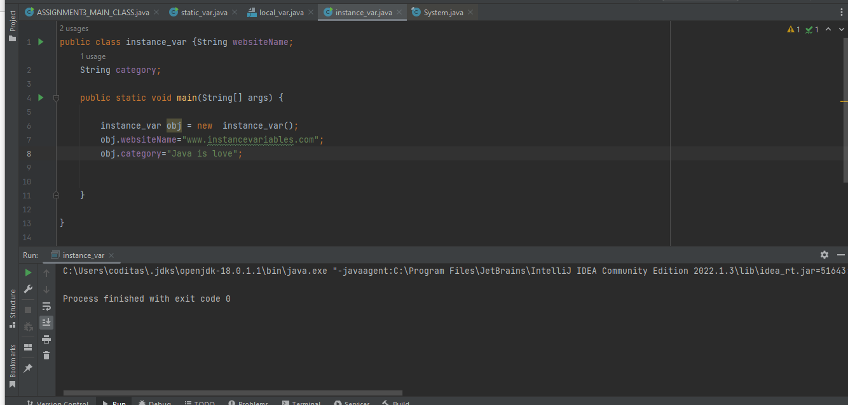

**Q:4)Addition of two same data type variables into the same third data type variables?**

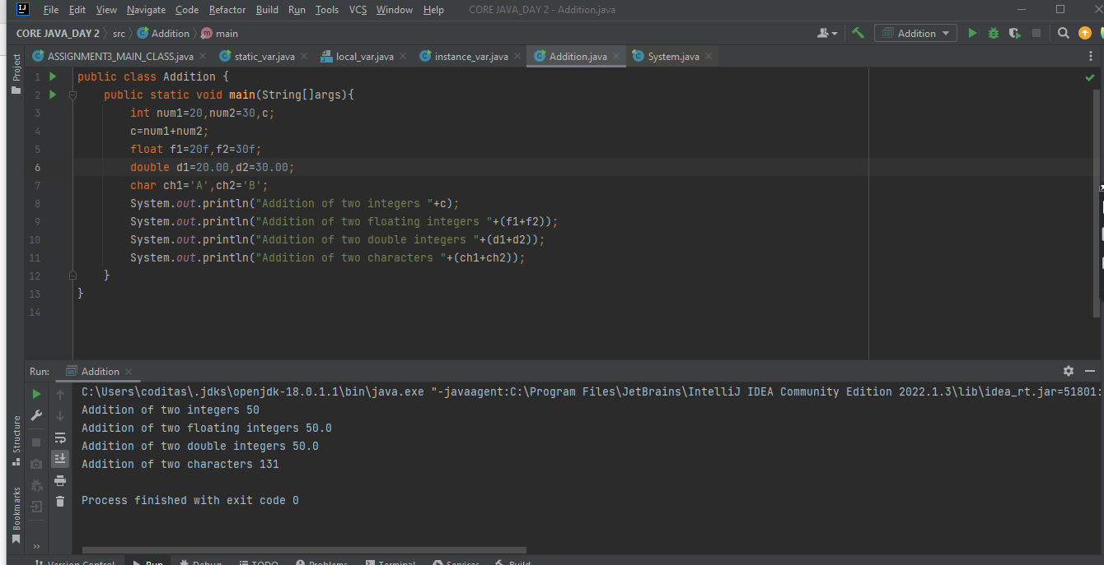

**Q:3)Write a program on operators and explore the concept of Operators and state the differences between logical and bitwise operators?**

**Ans:1)Arithmetic operators:**

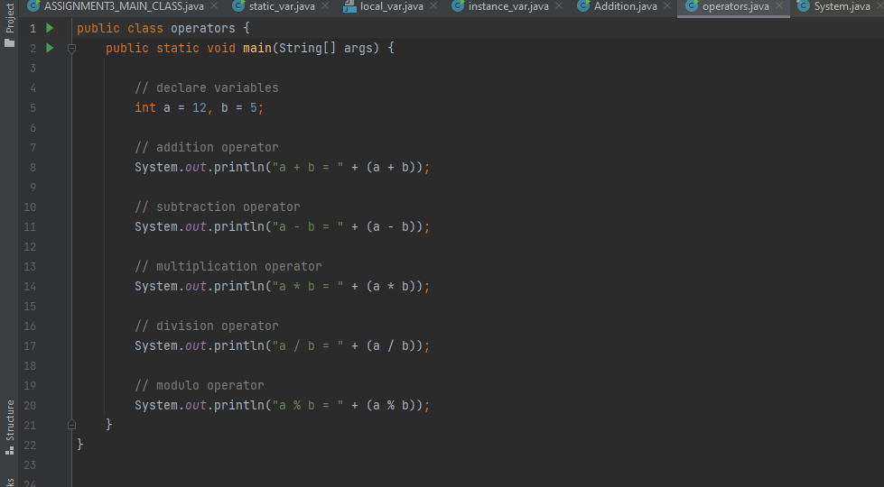

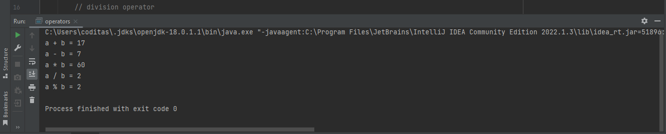

**ASSIGNMENT OPERATORS:**

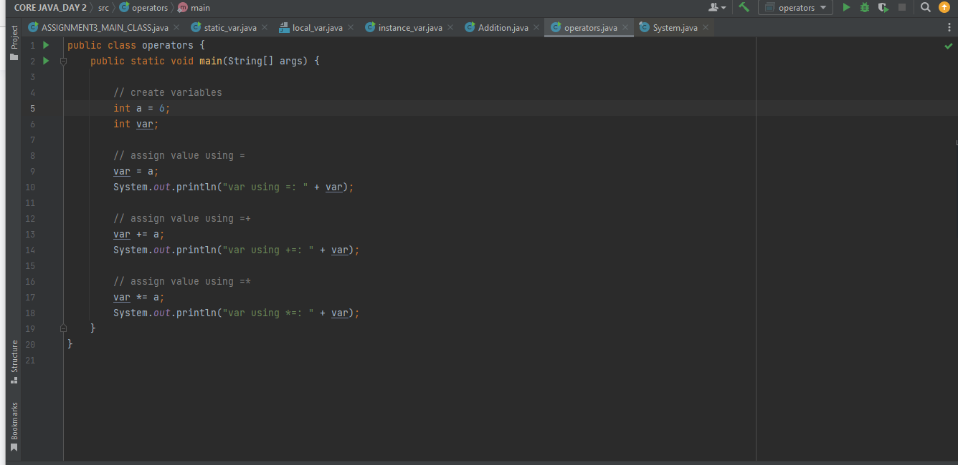

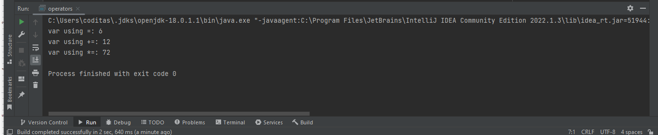

**RELATIONAL OPERATORS:**

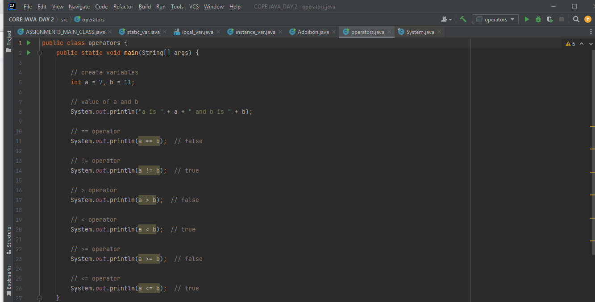

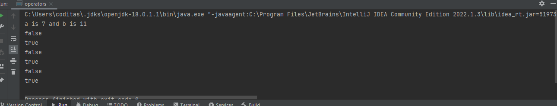

**LOGICAL OPERATORS:**

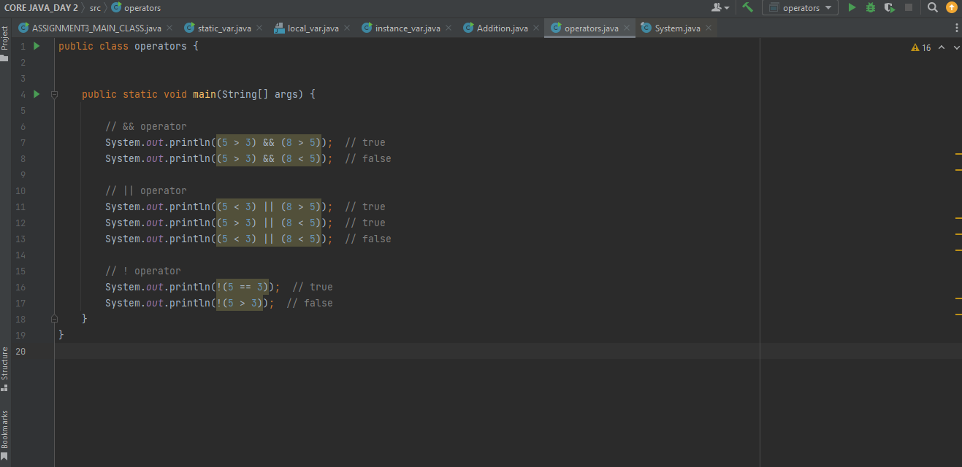

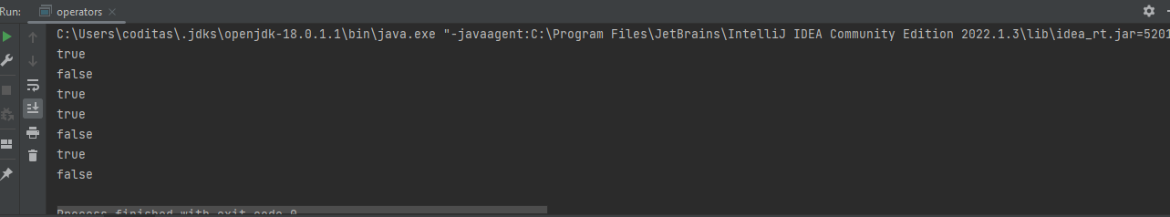

**INCREMENT AND DECREMENT OPERATORS:**

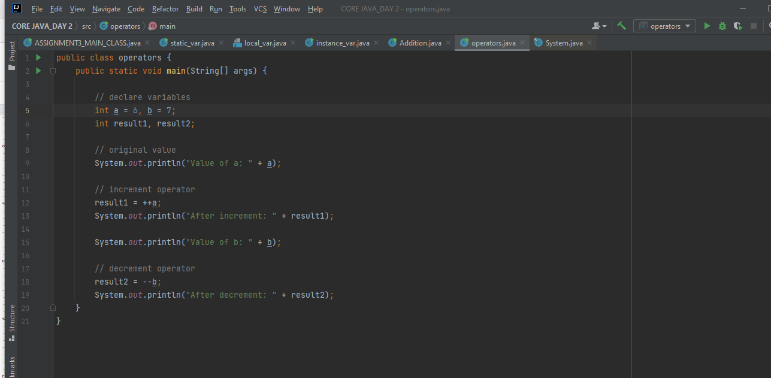

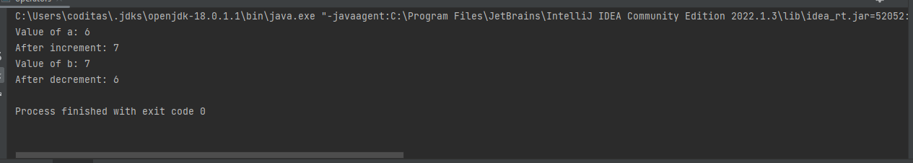

**Q:5)Create .jar file of your project?**

**Ans:5)**