**JAVA ASSIGNMENT DAY 6: DT:26/07/2022**

**Q:1)Check for the package related to array where array related in built methods are present .**

**=>create Simple code using those package in-built functionality**

**=>follow naming conventions and indentation while coding**

**ANS :1)**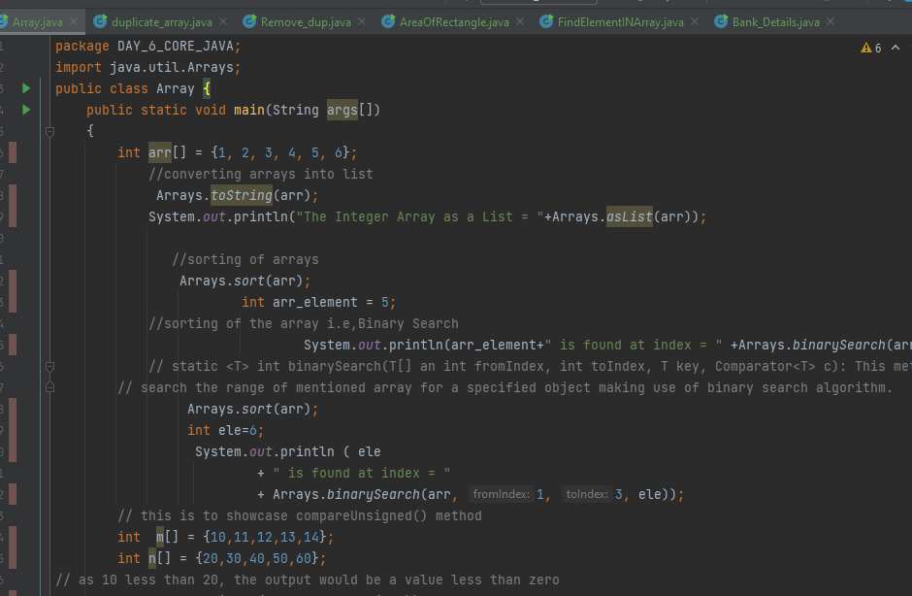

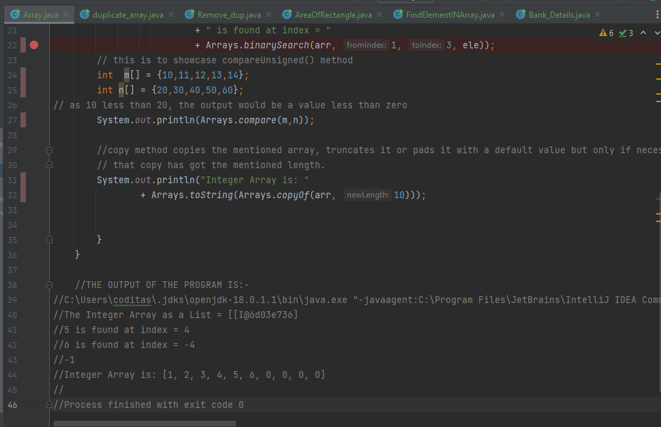

**Q:2)Print array in ascending and descending order?**

**ANS:2)**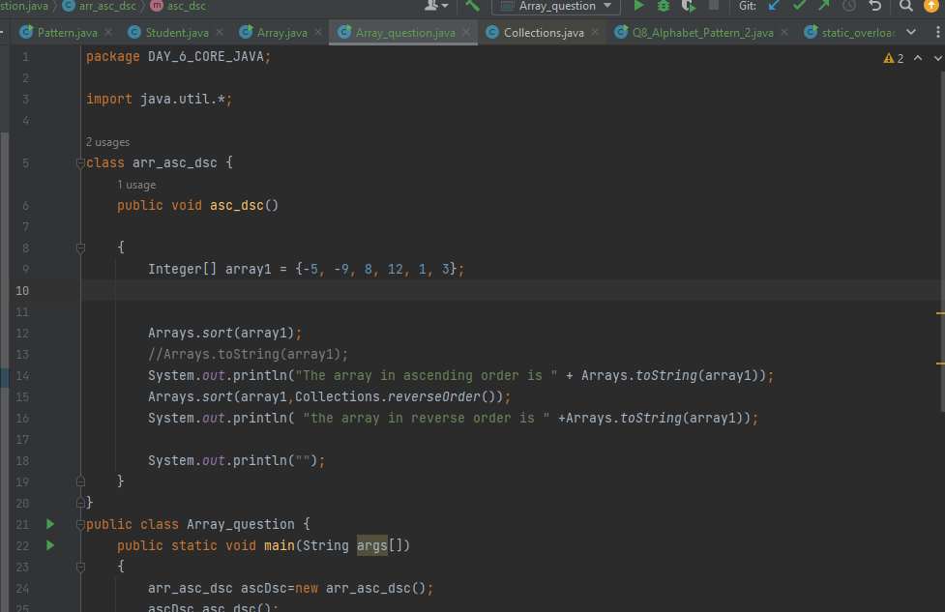

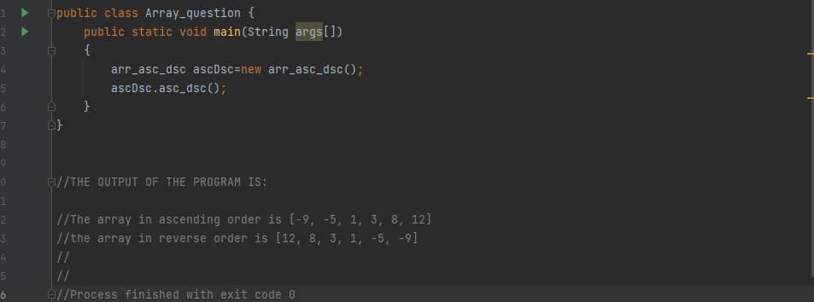

**Q:3}Copy one array into another array using inbuilt functions?**

**ANS:3)**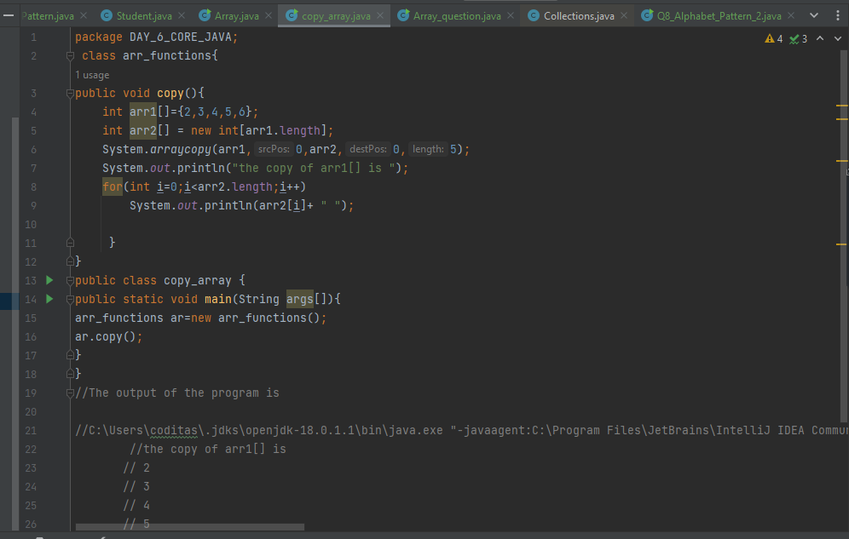

**Q:4)Using the equals method find the duplicate elements of the array print the duplicate element**

**=>try to remove the second occurrence of Duplicate element,again print the array without duplicate elements.**

**ANS:4)**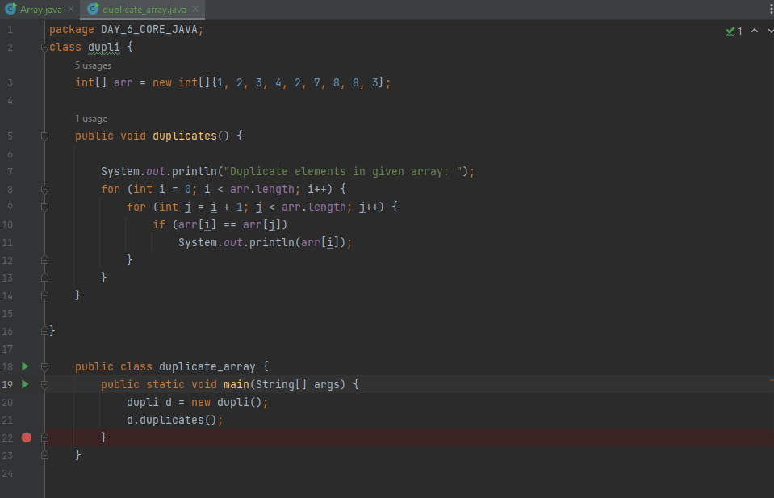

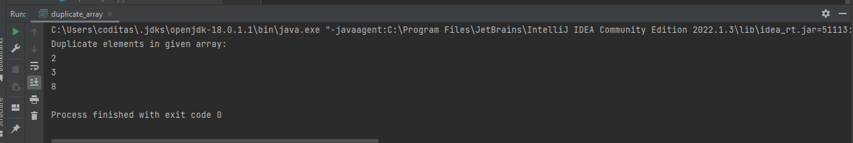

**REMOVE DUPLICATE ELEMENTS:**

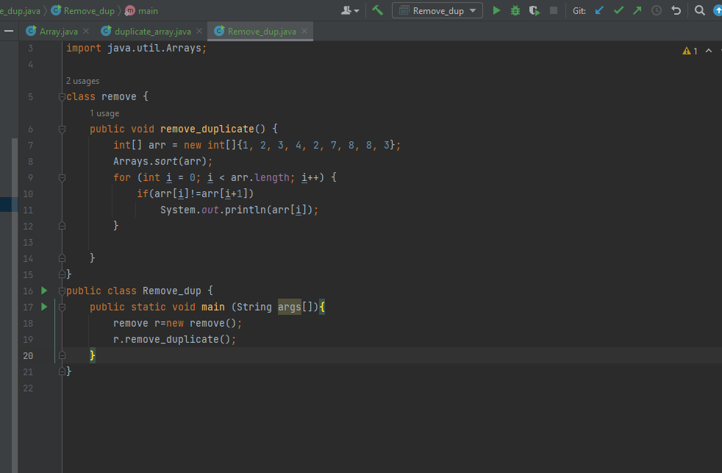

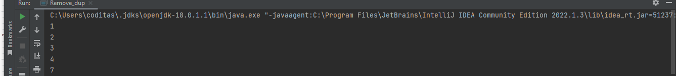

**Q:6)Try to get the Nth index element from an array accept index value from user?**

**Ans:6)**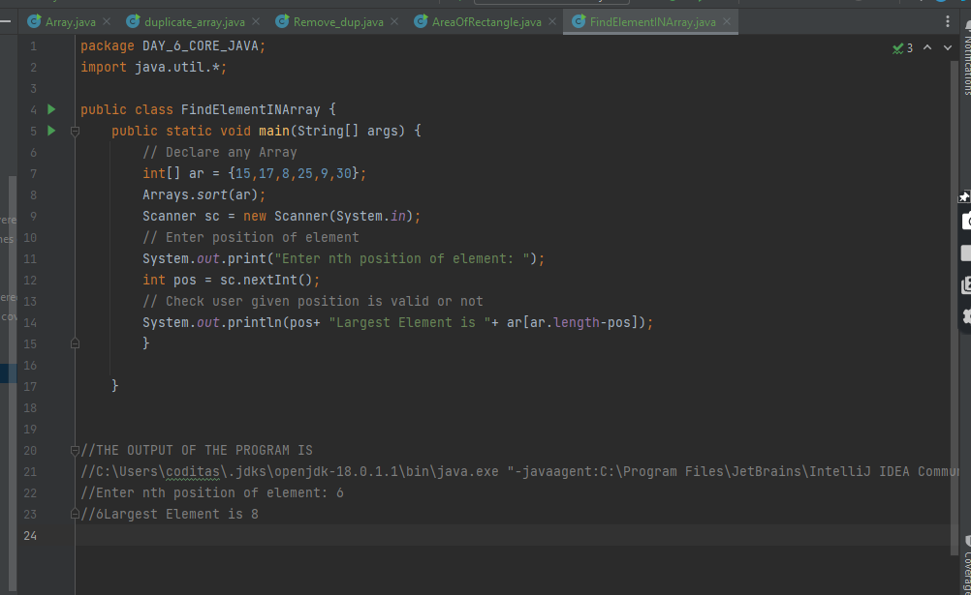

**ENCAPSULATION:**

**Q:1)Consider “Bank System” and decide classes,variables and methods about this using Encapsulation?**

**Ans:1)** 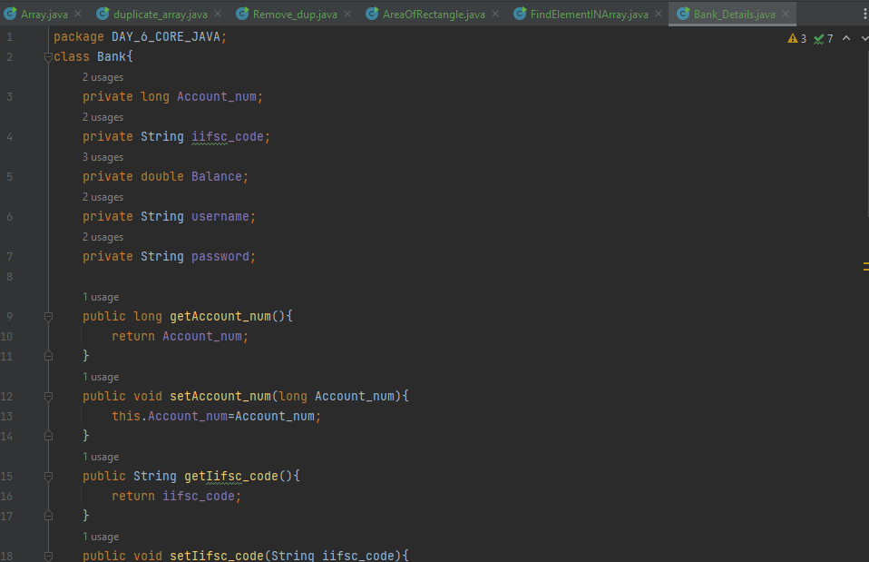

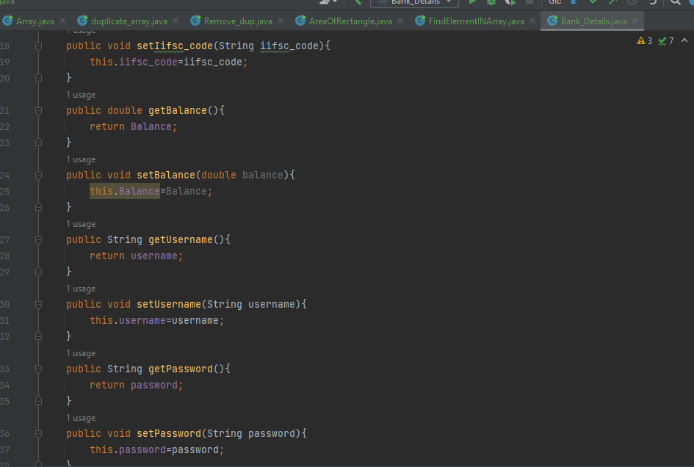

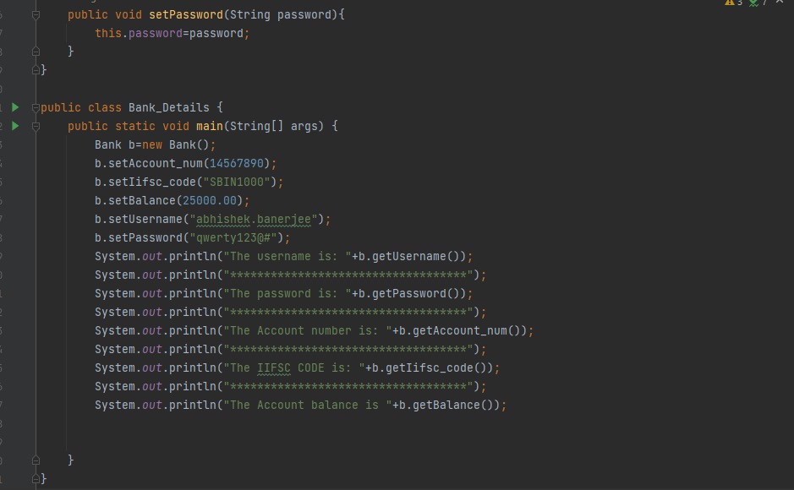

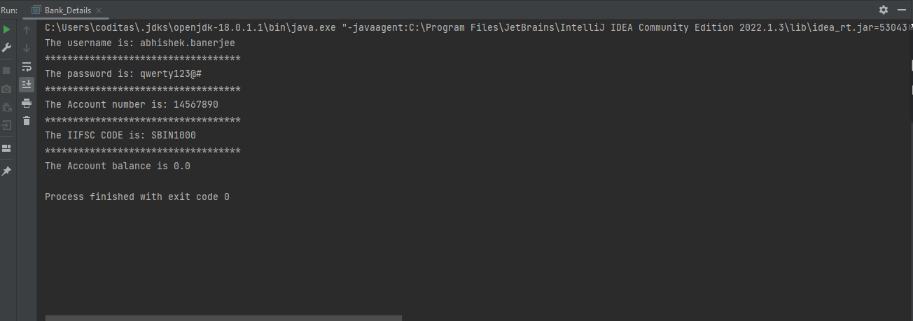

**Q:2)Calculate area of rectangle?**

**ANS:2)**