Report On

Image Processing and Manipulation and Auto- Detection of an object

Semester IV of Second Year Mechanical Engineering

by

Sahil Patil (Roll No. 44) Atharva Vartak (Roll No. 57) Dhruv Kadam (Roll No. 25) Preet Mhatre (Roll No. 33)

Under the guidance of

Mrs. Aarti Puthran



**University of Mumbai**

 **Vidyavardhini's College of Engineering & Technology**

**Department of Mechanical Engineering**

**(A.Y. 2022-23)**

**Contents**

|  |  |  |
| --- | --- | --- |
| **Sr. No.** | **Topic** | **Page No** |
| 1 | Introduction |  |
| 2 | Scope |  |
| 3 | Architecture/ Framework/Block diagram |  |
| 4 | Algorithm and process work |  |
| 5 | Experiment and Results for Validation and Verification |  |
| 6 | Conclusion and Future Work |  |
| 7 | References |  |

# Introduction

* Pictures are the most common and convenient means of conveying or transmitting information. A picture is worth a thousand words. Pictures concisely convey information about positions, sizes and inter-relationships between objects. . Human beings are good at deriving information from such images, because of our innate visual and mental abilities. About 75% of the information received by human is in pictorial form.
* These images are represented in digital form. When represented as numbers, brightness can be added, subtracted, multiplied, divided and, in general, subjected to statistical manipulations that are not possible if an image is presented only as a photograph.
* . Specialized equipment and trained personnel necessary to conduct routine machine analysis of data were not widely available, in part because of limited availability of digital remote sensing data and a lack of appreciation of their qualities.

# Scope

Digital image processing has a broad spectrum of applications, such as

* Remote sensing via satellites and other spacecrafts
* Image transmission and storage for business applications
* Medical processing
* RADAR (Radio Detection and Ranging)
* SONAR(Sound Navigation and Ranging)
* Acoustic image processing (The study of underwater sound is known as underwater acoustics or hydro acoustics.)
* Robotics and automated inspection of industrial parts. Images acquired by satellites are useful in tracking of

1. Earth resources
2. Geographical mapping
3. Prediction of agricultural crops
4. Urban growth and weather monitoring

5∙ Flood and fire control and many other environmental applications.

Architecture/ Framework/Block diagram

* A digital remotely sensed image is typically composed of picture elements (pixels) located at the intersection of each row i and column j in each K bands of imagery. Associated with each pixel is a number known as Digital Number (DN) or Brightness Value (BV), that depicts the average radiance of a relatively small area within a scene (Fig. 1).
* A smaller number indicates low average radiance from the area and the high number is an indicator of high radiant properties of the area. The size of this area effects the reproduction of details within the scene. As pixel size is reduced more scene detail is presented in digital representation.

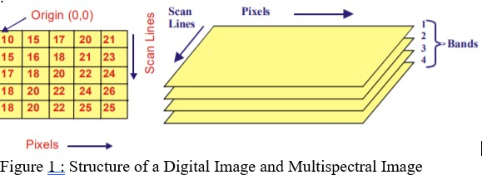

# Algorithm and Process Design

* A digital image f(m,n) described in a 2D discrete space is derived from an analog image f(x,y) in a 2D continuous space through a sampling process that is frequently referred to as digitization.
* The mathematics of that sampling process will be described in subsequent Chapters. For now we will look at some basic definitions associated with the digital image. The 2D continuous image f(x,y) is divided into N rows and M columns. The intersection of a row and a column is termed a pixel.
* 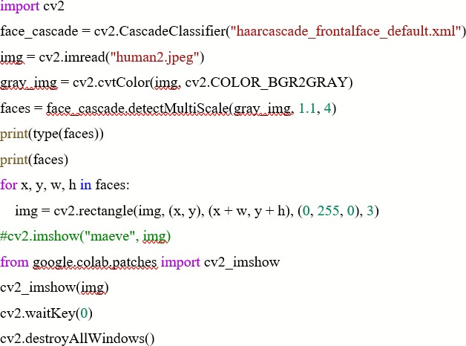The value assigned to the integer coordinates (m,n) with m=0,1,2..N-1 and n=0,1,2…N-1 is f(m,n). In fact, in most cases, is actually a function of many variables including depth, color and time (t).

•

# Experiment and Results for Validation and Verification

**FUTURE WORKS**

Digital image processing has a broad spectrum of applications, such as

* Remote sensing via satellites and other spacecrafts
* Image transmission and storage for business applications
* Medical processing
* RADAR (Radio Detection and Ranging)
* SONAR(Sound Navigation and Ranging)
* Acoustic image processing (The study of underwater sound is known as underwater acoustics or hydro acoustics.)
* Robotics and automated inspection of industrial parts. Images acquired by satellites are useful in tracking of

1. Earth resources
2. Geographical mapping
3. Prediction of agricultural crops
4. Urban growth and weather monitoring

* Flood and fire control and many other environmental applications.

# Conclusion

* Digital image processings of satellite data can be primarily grouped into three categories : Image Rectification and Restoration, Enhancement and Information extraction.
* Image rectification is the pre-processing of satellite data for geometric and radiometric connections.
* Enhancement is applied to image data in order to effectively display data for subsequent visual interpretation.
* Information extraction is based on digital classification and is used for generating digital thematic map.