1. Exercise 1:Screenshot of the ‘students’ table creation command and its output.

1. Exercise 2:Screenshot of the tables listed in HBase

1. Exercise 3:Screenshot of the commands used to add data and their outputs (‘students’ table)

1. Exercise 4: Screenshot of the query and its output

1. Exercise 7: Screenshot of the commands used to query the data with composite key and their outputs.

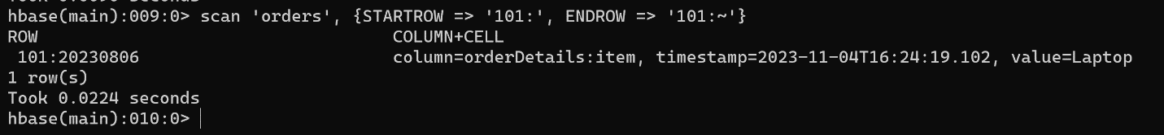

1. Exercise-9: Screenshot of the commands used for data generation and their outputs.

1. Exercise-10: Update First Names from 2 to 50:

We can see the Student ID # 51 is not updated (It is still Student51 and not Scholar51).

1. Exercise-10: Add a Middle Name from 51 to 75.

Some additional validations for Row 50 and 76

1. Exercise-10: Modify Last Names from 76 to 100.

1. Exercise-10: Bulk Delete from 90 to 100

1. Exercise-10: Data Retrieval for 40, 60, 80 and 90.

Scan to retrieve specific rows

Get to retrieve rows

