1. Exercise 2: List the topics to verify that ‘my-topic’ has been successfully created.



1. Exercise 4:

Entered Text



Received Text

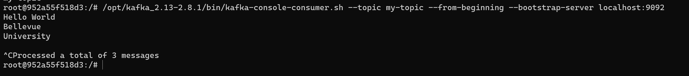

1. Exercise 6: Producer and Consumer Performance Test Results

**Kafka producer performance testing:**

The producer achieved close to the target throughput of 100 records per second. The average latency is low, with most values around 0.6 ms to 1.0 ms. The maximum observed latency during the test was 473.00 ms. The latency percentiles provide insights into the distribution of latencies across different percentiles.

These metrics help evaluate the performance of the Kafka producer in terms of throughput, latency, and overall efficiency in sending messages to the specified Kafka topic.

**Kafka consumer performance testing:**

The test started at 2023-11-11 19:14:30:845 and ended at 2023-11-11 19:14:31:649.

During the test, the consumer consumed approximately 4.7684 MB of data at a rate of 5.9308 MB/sec, corresponding to 50003 messages at a rate of 62192.7861 messages/sec. There was a rebalance during the test that took 452 milliseconds. The time taken to fetch messages was 352 milliseconds. The fetch speed was 13.5466 MB/sec and 142053.9773 messages/sec. These metrics provide insights into the efficiency and speed of the Kafka consumer in processing messages from the specified topic.

1. Exercise 7: Create a topic, this time partitioned and replicated across all three Kafka instances

Exercise 8: Conduct the producer and consumer performance tests on the new topic, observing differences.

**Producer Performance Test:**

The producer sent 50,000 records to the topic my-partitioned-topic. Throughput was targeted at 1000 records per second. The average latency was approximately 4.67 ms, with a maximum latency of 515.00 ms. Latency percentiles are also provided: 50th, 95th, 99th, and 99.9th.

**Consumer Performance Test:**

The test started at 2023-11-11 20:14:45:599 and ended at 2023-11-11 20:14:46:433.

The consumer attempted to consume 50,000 messages from the topic my-partitioned-topic.

The data consumed was approximately 4.7684 MB at a rate of 5.7175 MB/sec.

The consumer processed 50,000 messages at a rate of 59,952.0384 messages/sec.

Rebalance time was 450 ms. Fetch time was 384 ms. Fetch speed was 12.4176 MB/sec and 130,208.3333 messages/sec.

**Interpretation:**

The producer was able to achieve the targeted throughput of 1000 records per second, with varying latencies. The consumer, despite facing a rebalance time of 450 ms, achieved a fetch speed of 12.4176 MB/sec and processed messages at a rate of 130,208.3333 messages/sec.