Assignment-10

import numpy as np

import pandas as pd

import matplotlib.pyplot as plt

import seaborn as sns

df = pd.read_csv("IRISs.csv")

df.head()

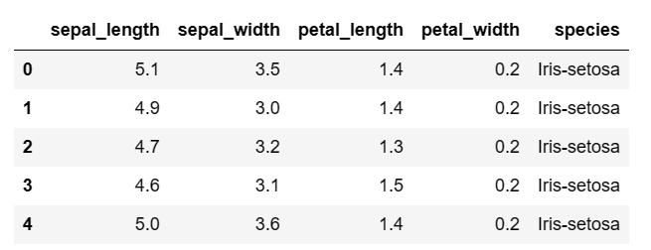

plt.figure(figsize=(15,10))

plt.subplot(2,2,1)

sns.boxplot(x='species',y='petal_length',data=df)

plt.subplot(2,2,2)

sns.boxplot(x='species',y='petal_width',data=df)

plt.subplot(2,2,3)

sns.boxplot(x='species',y='sepal_length',data=df)

plt.subplot(2,2,4)

sns.boxplot(x='species',y='sepal_width',data=df)

plt.show()

fig, axes=plt.subplots(2,2,figsize=(16,9))

sns.histplot(df['sepal_length'],ax=axes[0,0])

sns.histplot(df['sepal_width'],ax=axes[0,1])

sns.histplot(df['petal_length'],ax=axes[1,0])

sns.histplot(df['petal_width'],ax=axes[1,1])

