Top of Form

Bottom of Form

Top of Form

Bottom of Form

|  |  |
| --- | --- |
|  | 1. You are given a table, BST, containing two columns: N and P, where N represents the value of a node in Binary Tree, and P is the parent of N. |
|  | Write a query to find the node type of Binary Tree ordered by the value of the node. Output one of the following for each node: |
|  |  |
|  | Root: If node is root node. |
|  | Leaf: If node is leaf node. |
|  | Inner: If node is neither root nor leaf node |
|  |  |
|  |  |
|  | SELECT CASE |
|  | WHEN P IS NULL THEN CONCAT(N, 'Root') |
|  | WHEN N IN(SELECT DISTINCT P FROM BST) THEN CONCAT(N, 'inner') |
|  | ELSE CONCAT(N, 'Leaf') |
|  | END |
|  | FROM BST |
|  | ORDER BY N ASC; |

2.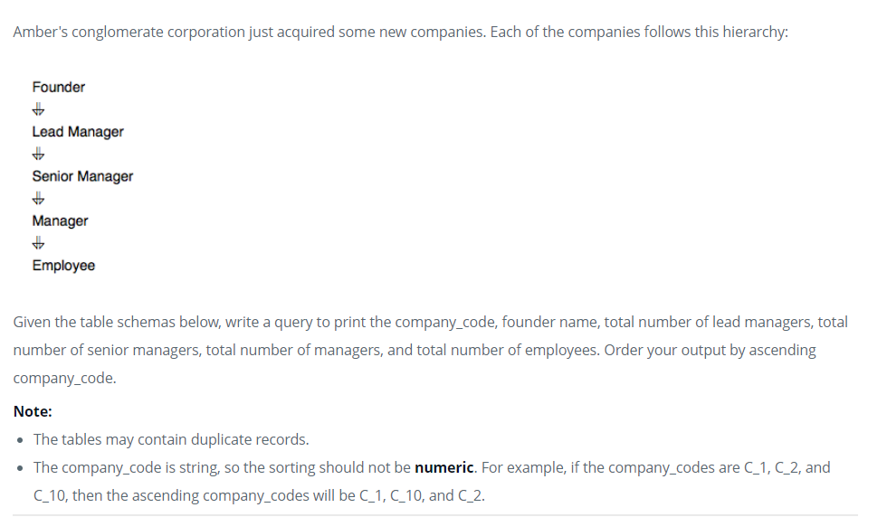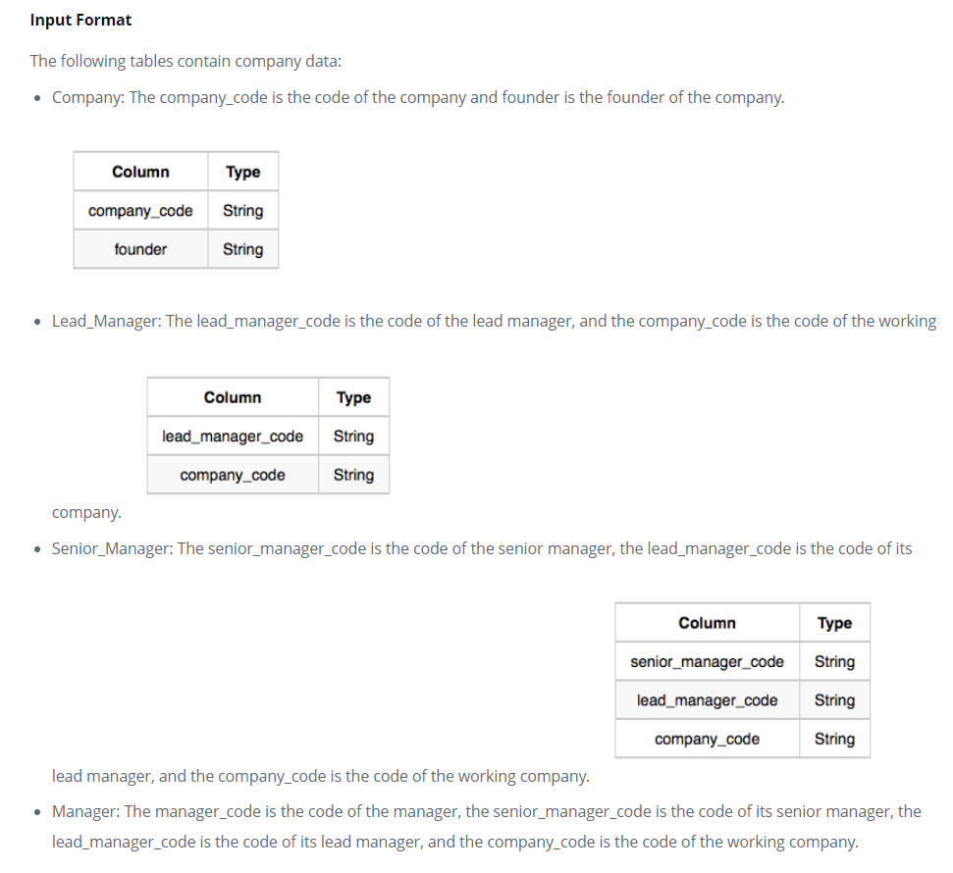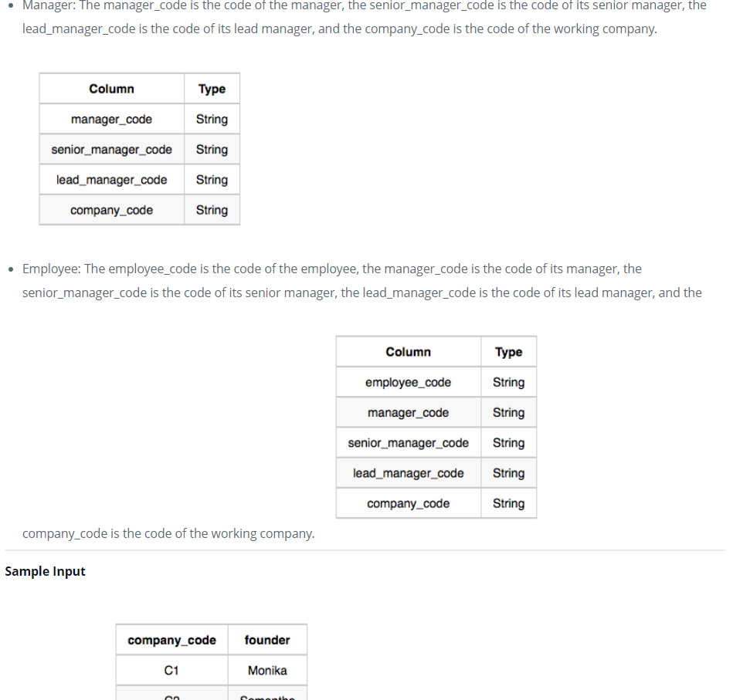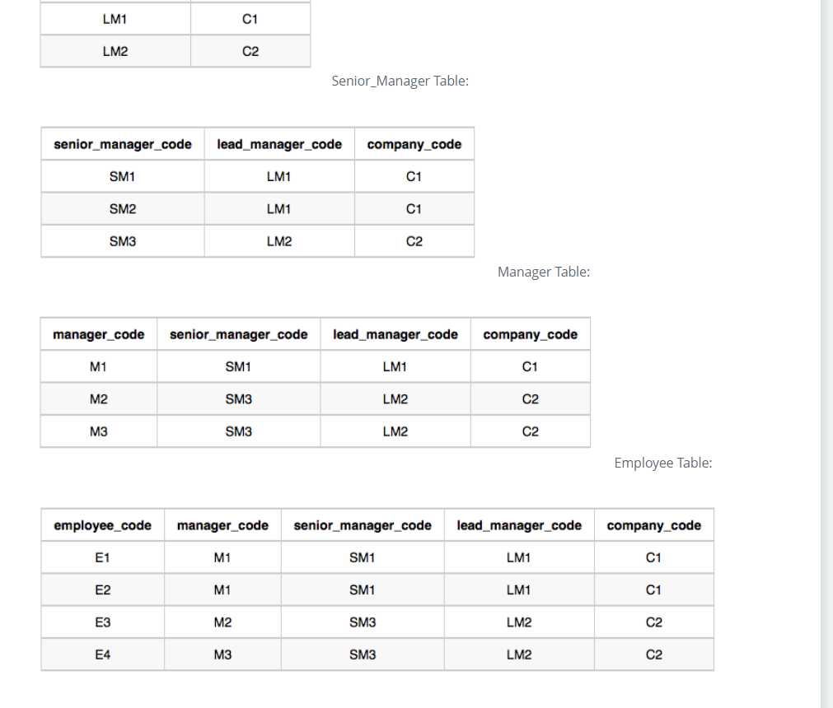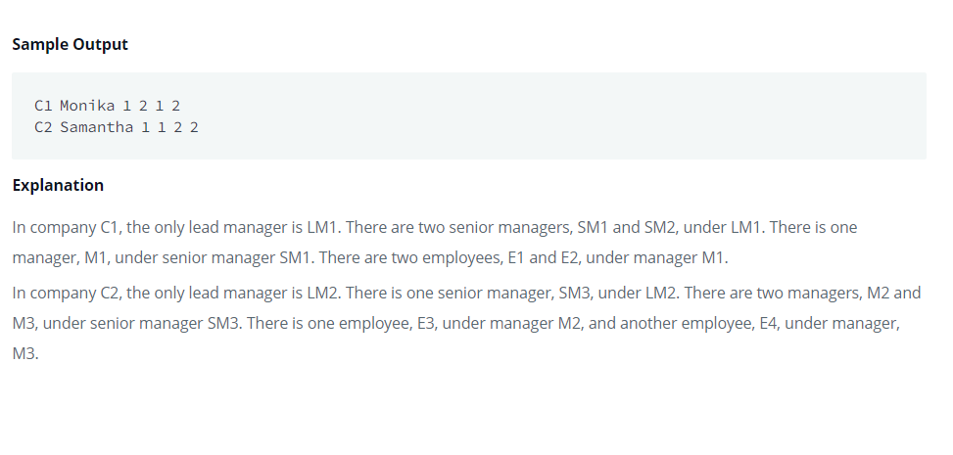

SELECT C.company_code,

C.founder,

COUNT(distinct L.lead_manager_code),

COUNT(distinct S.senior_manager_code),

COUNT(distinct M.manager_code),

COUNT(distinct E.employee_code)

FROM Company as C,

Lead_Manager as L,

Senior_Manager as S,

Manager as M,

Employee as E

WHERE E.manager_code = M.manager_code

AND M.senior_manager_code = S.senior_manager_code

AND L.lead_manager_code = S.lead_manager_code

AND C.company_code = L.company_code

GROUP BY C.company_code, C.founder

ORDER BY C.company_code