Game Design Document

Fill up the following document

1. Write the title of your project.

Ultimate-Spider Runner Game.

1. What is the goal of the game?

The goal is to save the city from the evils.

1. Write a brief story of your game.

From many days, some evils are attacking on the city of New York.

So SpiderMan is defending the city from the enemies. Enemies

have set many traps for him. Lets save the city !!!

1. Which are the playing characters of this game?

* Playing characters are the ones who respond to the user based on the input from the user.
* Cars, monkeys, dinos, wizards, etc., are the playing characters in the game.

|  |  |  |
| --- | --- | --- |
| Number | Character Name | What can this character do? |
| 1 | SpiderMan | It can be controlled to save the city. |

1. Which are the Non-Playing Characters of this game?

* Non-Playing characters are the ones that don't have an action or behavior when the user interacts with the game.
* Hurdles, stones, bananas, coins, etc., are non-playing characters in the game.

|  |  |  |
| --- | --- | --- |
| Number | Character Name | What can this character do? |
| 1 | Helicopter | SpiderMan will use this to land on the city. |
| 2 | Stone,Cars,Dustbin. | Obstacles appear randomly |
| 3 | Venom | Violet Enemy |
| 4 | Lizard | Green Enemy |
| 5 | ElectroMan | Blue Enemy |
| 6 | Building | Obstacle |
| 7 | Coins | Points |
| 8 | Packages | Supplies |

Draw your imagination of this game. What does this game look like?

* Draw the game either on your computer or on paper.
* Add images of the game scenes to show each of the playing and non-playing characters at least once.

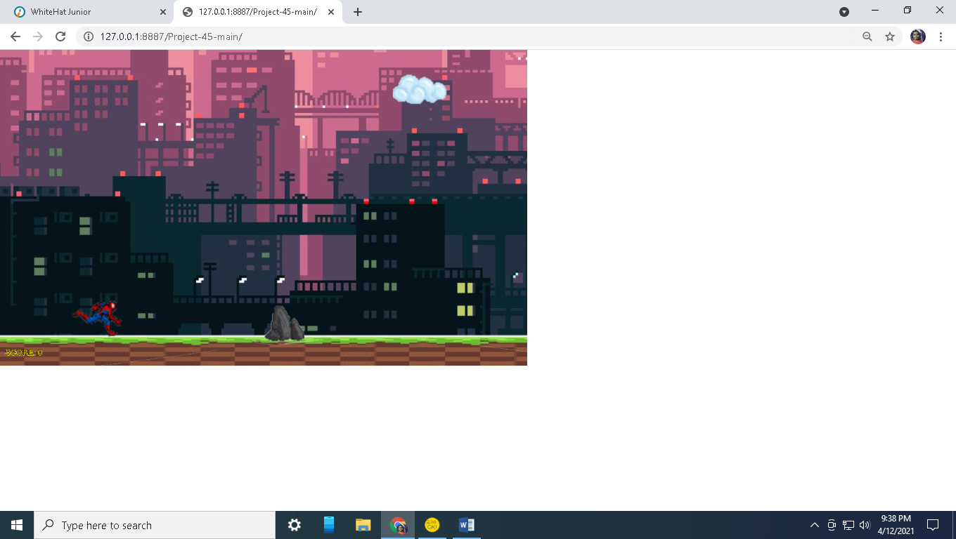

How do you plan to make your game engaging?

The game will be adaptive because level by level it will become hard.

It will be balanced because the game will be little hard and not too easy.

The hero will be having 5 lives and random enemies.

The game will be intresting as well as you will continue playing.