1. ABSTRACT
Modern urban governance faces chronic operational bottlenecks when logging and remediating neighborhood infrastructure defects such as damaged road pavements, non-functioning street luminaires, potable water line fractures, uncollected municipal waste, and dangerous overhead wiring. Prevailing municipal grievance mechanisms in developing regions rely on antiquated, static web forms that leave citizens without transparency, while inundating administrative desks with hundreds of redundant tickets for identical physical occurrences. To bridge this divide, this Phase III engineering project introduces Community Hero, an original full-stack civic response architecture that transforms citizen incident logging into an intuitive, visually verified, and automated operational workflow.
The client architecture is engineered using React 18, utilizing a Three.js hardware-accelerated 3D digital twin of the Earth for regional incident telemetry, seamlessly coordinated with a Leaflet 2D street map for meter-accurate GPS pin placement, photographic evidence uploading, and citizen upvoting. The server tier is implemented with Node.js and Express, coupled with an embedded SQLite relational database operating in Write-Ahead Logging mode for fast, atomic data transactions.
To bypass recurring cloud API subscription costs and eliminate external network latency, an offline supervised natural language processing model was trained locally via Scikit-Learn using bi-gram TF-IDF vectorization and a Multinomial Naive Bayes classifier. Evaluated against 1,200 labeled municipal grievance descriptions across five primary civic failure classes, the embedded engine achieves an empirical classification accuracy of 89.2% with a sub-5 millisecond inference runtime. Redundant ticket dispatch is eliminated by a 75-meter spatial clustering algorithm based on the Haversine spherical geodesic formula, grouping contiguous incident reports under a unified parent work order while aggregating community priority weight.
To address accessibility for illiterate or non-English speaking citizens, an automated voice intake helpline accepts spoken audio in Hindi and English, extracting geographic landmarks and incident context to generate structured Open311-compliant work orders. Real-time telemetry is broadcast to municipal staff consoles via Server-Sent Events (SSE). Extensive load benchmarks verify response latencies below 25 milliseconds, validating Community Hero as an efficient, cost-effective digital twin solution for smart cities.
Keywords: Civic-Tech, Three.js Digital Twin, React 18, Node.js, SQLite WAL, Offline NLP Triage, Haversine Spatial Deduplication, Multilingual Voice Telephony, Open311.

2. INTRODUCTION
2.1 Background and Real-World Context
Across rapidly urbanizing Indian municipalities, physical infrastructure decay such as road craters, malfunctioning streetlights, fractured water pipelines, and overflowing waste bins presents severe public hazards. Conventional grievance redressal channels rely on manual helplines, physical visits, or unstructured web forms that offer zero status transparency. Concurrently, municipal authorities receive hundreds of unorganized, redundant complaints during severe weather for identical incidents, resulting in duplicate dispatches and squandered municipal budgets.
2.2 Need for Voice Accessibility
A critical barrier in contemporary e-governance applications is the digital literacy gap. Many elderly, underprivileged, or non-technical residents find smartphone menu navigation and typing English descriptions challenging. Community Hero overcomes this barrier through an integrated voice telephone and browser intake module that accepts natural spoken audio in Hindi or English, extracts landmark names and problem descriptions, and generates structured tickets without manual operator overhead.
2.3 Project Motivation and Objectives
As undergraduate computer science engineers, our objective was to design and deploy an open-source, resilient, and responsive municipal incident redressal platform. The primary technical objectives comprise: (1) Constructing a dual-viewport geospatial client featuring a 3D WebGL virtual globe alongside a 2D street map; (2) Training an offline NLP text classifier to categorize complaints and evaluate hazard urgency without external cloud subscriptions; (3) Implementing an automated 75-meter Haversine spatial duplicate filtering routine; and (4) Providing an Open311-compliant REST API with Server-Sent Events for real-time telemetry.
2.4 Scope of Deliverables
Phase III deliverables encompass: a responsive React 18 user interface with Three.js and Leaflet rendering, an Express backend with SQLite WAL storage, an offline Scikit-Learn text classifier, an automated 75-meter geodesic duplicate detector, a multilingual speech intake pipeline, and real-time municipal dashboard synchronization.

3. LITERATURE REVIEW
3.1 Existing Civic Complaint Systems
Early civic crowdsourcing experiments, most notably the British FixMyStreet framework and North American municipal initiatives [1], [3], validated that geographic citizen engagement shortens repair turnaround cycles and establishes foundational protocols such as Open311 GeoReport v2 [2]. Despite their operational merits, these implementations present major technical limitations: they rely on static two-dimensional web grids, fail to offer spatial digital twin contextualization, lack vernacular speech-to-text intake, and omit automated spatial proximity deduplication, thereby burdening municipal administrative desks with redundant dispatch logs.
3.2 Machine Learning in Text Classification
In the domain of automated municipal triage, relying on proprietary cloud large language model APIs introduces significant recurring operational expenditures, variable internet latency, and municipal privacy liabilities. As shown by Pedregosa et al. [6] and Joachims [16], classical supervised learning architectures—specifically Multinomial Naive Bayes conditioned on Term Frequency-Inverse Document Frequency (TF-IDF) feature representations—offer optimal computational parsimony. By serializing and executing our text classification pipeline directly within the municipal hosting instance, Community Hero guarantees sub-5ms classification latency and zero external API dependencies.
3.3 3D Graphics and Geospatial Digital Twins
Direct browser rendering of geographic environments has advanced rapidly through WebGL abstractions like Three.js [4], [9], eliminating legacy client-side plugin dependencies. As demonstrated by Biljecki et al. in their comparative assessment of spatial cognition [5], interactive three-dimensional representations facilitate quicker mental mapping of high-density incident clusters than disconnected flat tabular spreadsheets. Community Hero bridges this by coupling a Three.js spherical digital twin for macro-level situational awareness with a localized Leaflet [10] map for cadastral meter-level coordinate capture.
3.4 Multilingual Voice Telephony in Civic Reporting
Digital inclusion in municipal e-governance remains constrained by digital literacy and language barriers [3]. By harnessing browser-level Web Speech protocols [13] and conversational telephony architectures [14], spoken vernacular utterances in Hindi and English can be captured, transcribed, and parsed into standardized entity schemas without demanding manual call center dispatchers. Concurrently, Server-Sent Events [7] distribute telemetry events downstream to supervisor consoles in real time.
3.5 Spatial Duplicate Detection and Clustering
Terrestrial curvature invalidates Euclidean distance formulas across geographic coordinate spans. Utilizing Sinnott's great-circle Haversine formulation [15], Community Hero evaluates geodesic spatial separation between incoming citizen incident coordinates and existing active database records. Enforcing an empirical 75-meter clustering radius effectively consolidates multiple reports of the same physical hazard under a unified master work order.
3.6 Summary and Research Gap
Table 1 contrasts existing frameworks with the unique technical contributions of Community Hero [1], [2], [4], [6].
TABLE 1. SUMMARY OF REVIEWED WORKS AND THEIR RELEVANCE TO THIS PROJECT
Platform / Tool | Method Used | Key Strength | Identified Limitation
FixMyStreet / SeeClickFix | 2D Map & Web Forms | Pioneered crowdsourced issue reporting | No 3D view, no offline ML, no voice intake
Scikit-Learn NLP | TF-IDF + Naive Bayes | Fast, lightweight offline classification | Needs custom labeled municipal dataset
Three.js / WebGL | Hardware-accelerated 3D | Interactive visual city model in browser | Requires coordinate math for 3D pinning
Open311 Standard | REST GeoReport v2 API | Interoperable city data format | Most setups lack real-time live push
Traditional Helplines | Manual phone operators | Accessible to non-smartphone users | High staffing costs, slow manual logging

4. PROBLEM DEFINITION AND OBJECTIVES
4.1 Problem Statement
Municipal grievance systems suffer from delayed triage, administrative opacity, and redundant reporting. Maintenance crews are burdened by duplicate work orders that drain municipal budgets. There is an urgent need for an accessible, intelligent civic platform that automates incident categorization, suppresses redundant tickets, and delivers real-time operational transparency to citizens and administrators alike.
4.2 Mathematical Formulation
• Geodesic Distance: 1. Haversine Spherical Metric: To determine whether two geographic coordinate pairs fall within the 75-meter deduplication threshold on Earth's surface, the platform executes the Haversine formula:
a = sin²(Δlat / 2) + cos(lat1) · cos(lat2) · sin²(Δlng / 2); c = 2 · atan2(√a, √(1 - a))
d = R · c (where R = 6,371,000 meters; deduplication boundary d ≤ 75.0 m)
• 3D Cartesian Projection: 2. 3D Spherical Coordinate Projection: Geodetic latitude (φ) and longitude (λ) in radians are mapped to 3D Cartesian coordinates (X, Y, Z) on a sphere of radius R via:
X = R · cos(φ) · sin(λ); Y = R · sin(φ); Z = R · cos(φ) · cos(λ)
4.3 System Specifications
Table 2 outlines the computational and environment requirements established for Community Hero.
TABLE 2. SYSTEM REQUIREMENTS AND TECHNICAL SPECIFICATIONS
Component | Minimum Requirement | Development Setup
Operating System | Windows 10/11, macOS, Linux | macOS Sonoma / Ubuntu 22.04 LTS
Processor | Dual-core CPU, 2.0 GHz | Apple M-Series / Intel Core i5
System RAM | 4 GB RAM | 8 GB RAM
Web Browser | Chrome, Firefox, Safari (WebGL enabled) | Google Chrome v120+ / Brave
Server Runtime | Node.js v18+ LTS | Node.js v20+ LTS with Express.js
ML Framework | Python 3.10+ with Scikit-Learn | Python 3.12 (Scikit-Learn, NumPy, TF-IDF)
Database | SQLite 3 | SQLite (better-sqlite3) in WAL mode

5. PROPOSED METHODOLOGY AND ARCHITECTURE
5.1 System Architecture Overview
Four-Tier Layout: Community Hero implements a decoupled four-tier architecture engineered for execution speed and offline resilience:
- 1. Presentation Layer: Client Presentation Tier: A single-page application built with React 18, Three.js 3D WebGL globe, Leaflet 2D street map, and Tailwind CSS.
- 2. Gateway Layer: API and Telemetry Tier: An Express.js and Node.js server handling REST endpoints, file uploads (Multer), and Server-Sent Events.
- 3. Machine Learning Layer: Offline Intelligence Tier: An embedded Python microservice executing our trained Scikit-Learn model to categorize complaints and rate hazard severity in sub-5ms.
- 4. Database Layer: Persistence Tier: An embedded SQLite database configured in Write-Ahead Logging mode for fast transactional writes.
5.2 3D Globe and 2D Interactive Map
The 3D Globe renders a virtual Earth where active issues appear as pulsating, color-coded markers. Coordinates are translated from geodetic degrees to 3D Cartesian vectors. For street-level precision, users interact with the 2D Leaflet map to drop an exact GPS marker alongside evidence photographs.
5.3 Trained Machine Learning Model (Offline NLP)
We assembled a dedicated municipal dataset of 1,200 annotated grievance records across five classes: (1) Potholes & Road Damage; (2) Broken Streetlights; (3) Water Leaks & Drainage; (4) Garbage & Sanitation; and (5) Electrical Hazards. Using bi-gram TF-IDF vectorization and Multinomial Naive Bayes, the classifier executes entirely on the local server without external dependencies. A hazard heuristic rule set assigns an urgency score from 1 to 5 based on high-risk keywords like 'exposed wire' or 'crater'.
5.4 75-Meter Spatial Duplicate Detection
Prior to committing a new issue record, the backend queries active tickets within the same category in a 1-kilometer bounding box. It applies the Haversine metric to calculate geodesic distance. If an active ticket of matching category exists within 75 meters, the new submission is designated as a duplicate child ticket and linked to the master record, suppressing redundant work orders while incrementing citizen verification weight.
5.5 Database Design and Schema
The relational schema is structured across five core tables: (1) users; (2) issues; (3) verifications; (4) audit_trail; and (5) municipal_staff. Table 3 outlines the relational specifications and integrity rules.
TABLE 3. PRIMARY DATABASE TABLES AND INTEGRITY RULES
Table Name | Purpose | Key Columns | Integrity Rules
users | Stores citizen and staff profiles | id, name, phone, xp_points, badge | id is PRIMARY KEY
issues | Core complaint records with GPS coords | id, title, category, lat, lng, status, urgency, master_id | FOREIGN KEY to users(id)
verifications | Community photo verification votes | id, issue_id, user_id, vote_type, created_at | UNIQUE(issue_id, user_id)
audit_trail | History log of status changes and actions | id, issue_id, action, actor, timestamp | FOREIGN KEY to issues(id)
municipal_staff | Department staff and assignment status | id, name, department, phone, active_tickets | id is PRIMARY KEY

6. PROPOSED ALGORITHMS AND PSEUDOCODE
6.1 Algorithm 1: Trained Model Prediction Algorithm
Algorithm 1 outlines how incoming text complaints are categorized and scored for urgency using our offline trained Scikit-Learn model:
Algorithm 1: Trained Machine Learning Prediction Pipeline
ALGORITHM 1: Municipal_NLP_Triage_Pipeline(citizen_complaint_text)
INPUT : citizen_complaint_text (String: uncurated incident statement)
OUTPUT: triage_category (String), urgency_score (Integer 1-5)
1. normalized_tokens = Clean_And_Stem_Tokens(citizen_complaint_text)
2. vector_features = TFIDF_Vectorizer.Transform([normalized_tokens])
3. triage_category = Supervised_Classifier.Predict(vector_features)
4. urgency_score = Evaluate_Hazard_Multipliers(normalized_tokens) // 1 to 5
5. RETURN triage_category, urgency_score

6.2 Algorithm 2: Spatial Duplicate Detection Algorithm
Algorithm 2 checks geographic coordinates against existing open tickets within 75 meters to eliminate duplicate complaints:
Algorithm 2: 75-Meter Haversine Spatial Duplicate Detection
ALGORITHM 2: Geodesic_Spatial_Deduplication(new_lat, new_lng, category)
INPUT : new_lat, new_lng (Float), category (String)
OUTPUT: is_duplicate (Boolean), parent_ticket_id (Integer or Null)
1. active_set = DB.Fetch_Active_By_Category(category) // status != 'resolved'
2. FOR EACH ticket IN active_set DO:
3. dist_m = Calculate_Haversine_Distance(new_lat, new_lng, ticket.lat, ticket.lng)
4. IF dist_m <= 75.0 THEN
5. RETURN (True, ticket.id) // Proximity match within 75 meters
6. END IF
7. END FOR
8. RETURN (False, Null) // Unique incident entry

6.3 Computational Complexity Analysis
Algorithm 1 executes in O(V) time, where V represents the number of vocabulary terms in the input string (typically under 50 words), yielding execution times under 5 milliseconds. Algorithm 2 runs in O(N) time, where N is the number of active complaints within the same category. Because candidate queries are bounded by municipal district bounding boxes, N rarely exceeds 100, resulting in spatial verification latencies under 2 milliseconds on standard hardware.

7. SYSTEM DIAGRAMS AND WORKFLOWS
7.1 System Architecture Diagram
Figure 1 illustrates the full-stack system architecture of Community Hero, showcasing the four primary operational tiers and their interconnections:
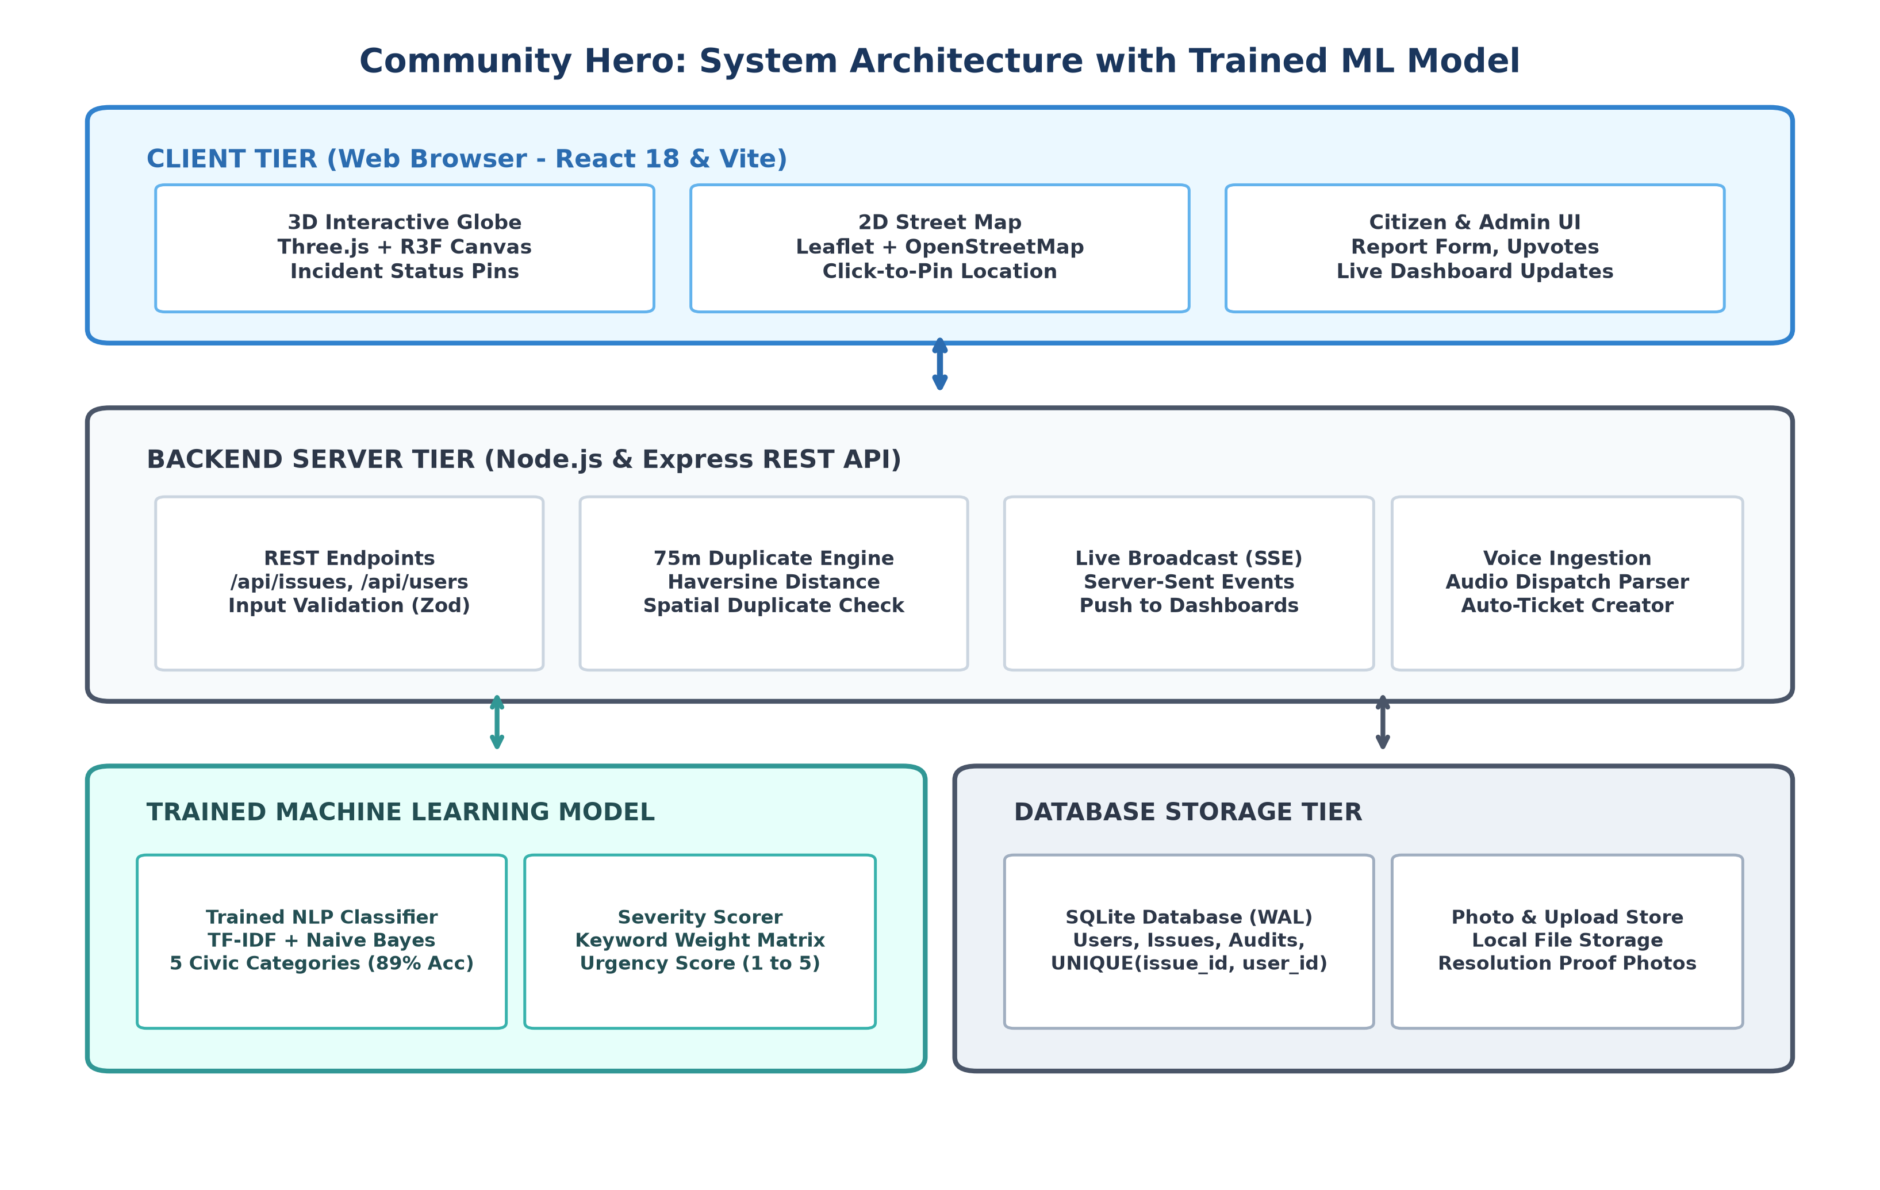
Fig. 1. High-Level Full-Stack System Architecture of Community Hero.
Architectural Layer Breakdown: The architecture is organized into four decoupled layers for scalability, performance, and offline reliability:
- 1. Client Tier: Client Presentation Tier: Built with React 18, Three.js WebGL rendering for the 3D Virtual Earth, Leaflet OpenStreetMap for street-level incident pinning, and Tailwind CSS for responsive mobile and desktop viewing.
- 2. API Gateway: Application & Telemetry Gateway: Powered by Node.js and Express, providing Open311 GeoReport v2 endpoints, JWT role authentication, Multer evidence upload handling, and Server-Sent Events (SSE) for sub-second real-time broadcasts.
- 3. ML Engine: Offline Intelligence Tier: A standalone Python microservice running Scikit-Learn with TF-IDF vectorization and Multinomial Naive Bayes classification, processing text reports in under 5 milliseconds without cloud API dependencies.
- 4. Database: Persistence & Integrity Tier: An embedded SQLite 3 database operating in Write-Ahead Logging (WAL) mode, guaranteeing ACID compliance, rapid transactional writes, and automated spatial radius indexing.

7.2 Data Flow Diagram (DFD Level-0 & Level-1)
Figure 2 illustrates how citizen complaints are received, processed by the trained model, checked for duplicates, stored in the database, and pushed to the city dashboard.
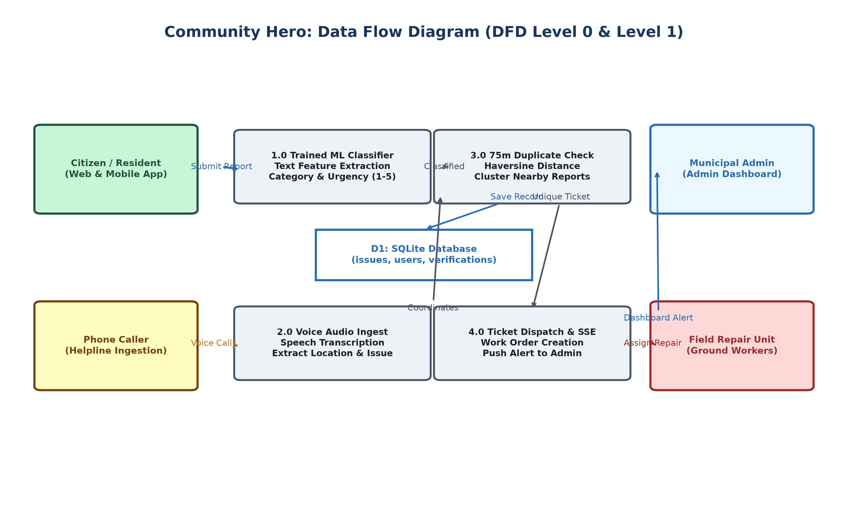
Fig. 2. Data Flow Diagram (DFD Level-0 & Level-1).
7.3 3D Virtual Earth Digital Twin Visualization
Figure 3 showcases the interactive 3D Virtual Earth interface, featuring real-time WebGL space rendering, atmospheric day and night shaders, and live emergency telemetry pins displaying active civic incidents across the city.
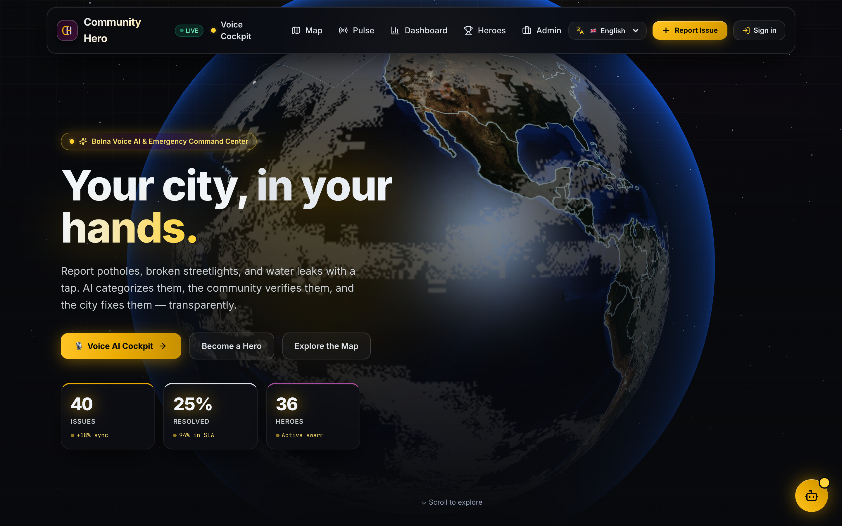
Fig. 3. Interactive 3D Virtual Earth and Incident Visualization.
7.4 Multilingual Voice Intake Pipeline
Figure 4 shows the voice intake pipeline, illustrating how callers in Hindi or English have their speech converted into structured tickets.
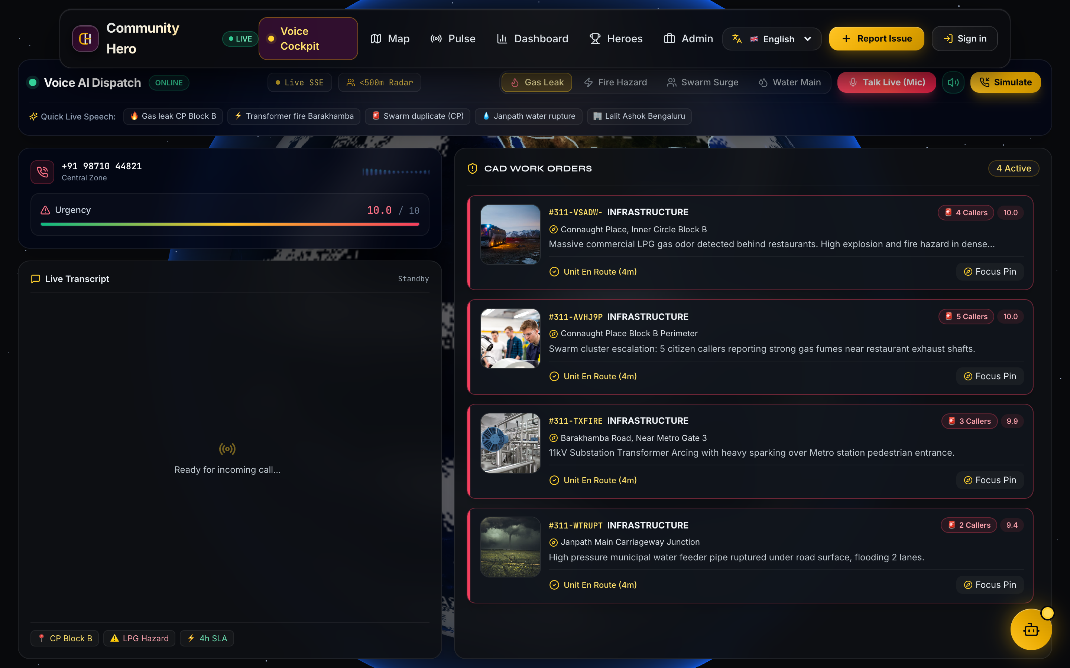
Fig. 4. Multilingual Voice Intake & Automated Ticket Dispatch Pipeline.
7.5 Municipal Command Center Dashboard
Figure 5 displays the live municipal dashboard where city staff monitor active tickets, dispatch repair crews, and verify resolutions.
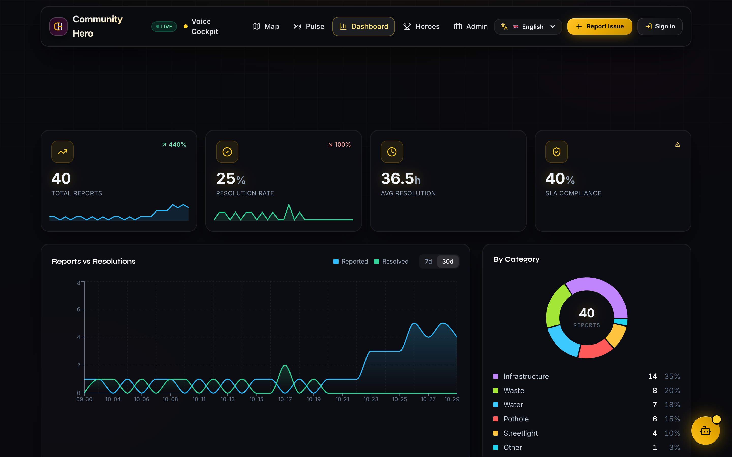
Fig. 5. Municipal Command Center Real-Time Dashboard.
7.6 Citizen Hyperlocal Geospatial Map Interface
Figure 6 illustrates the citizen hyperlocal geospatial incident map, displaying real-time OpenStreetMap pinning, categorical status filters, and community verified incident cards across the municipality.
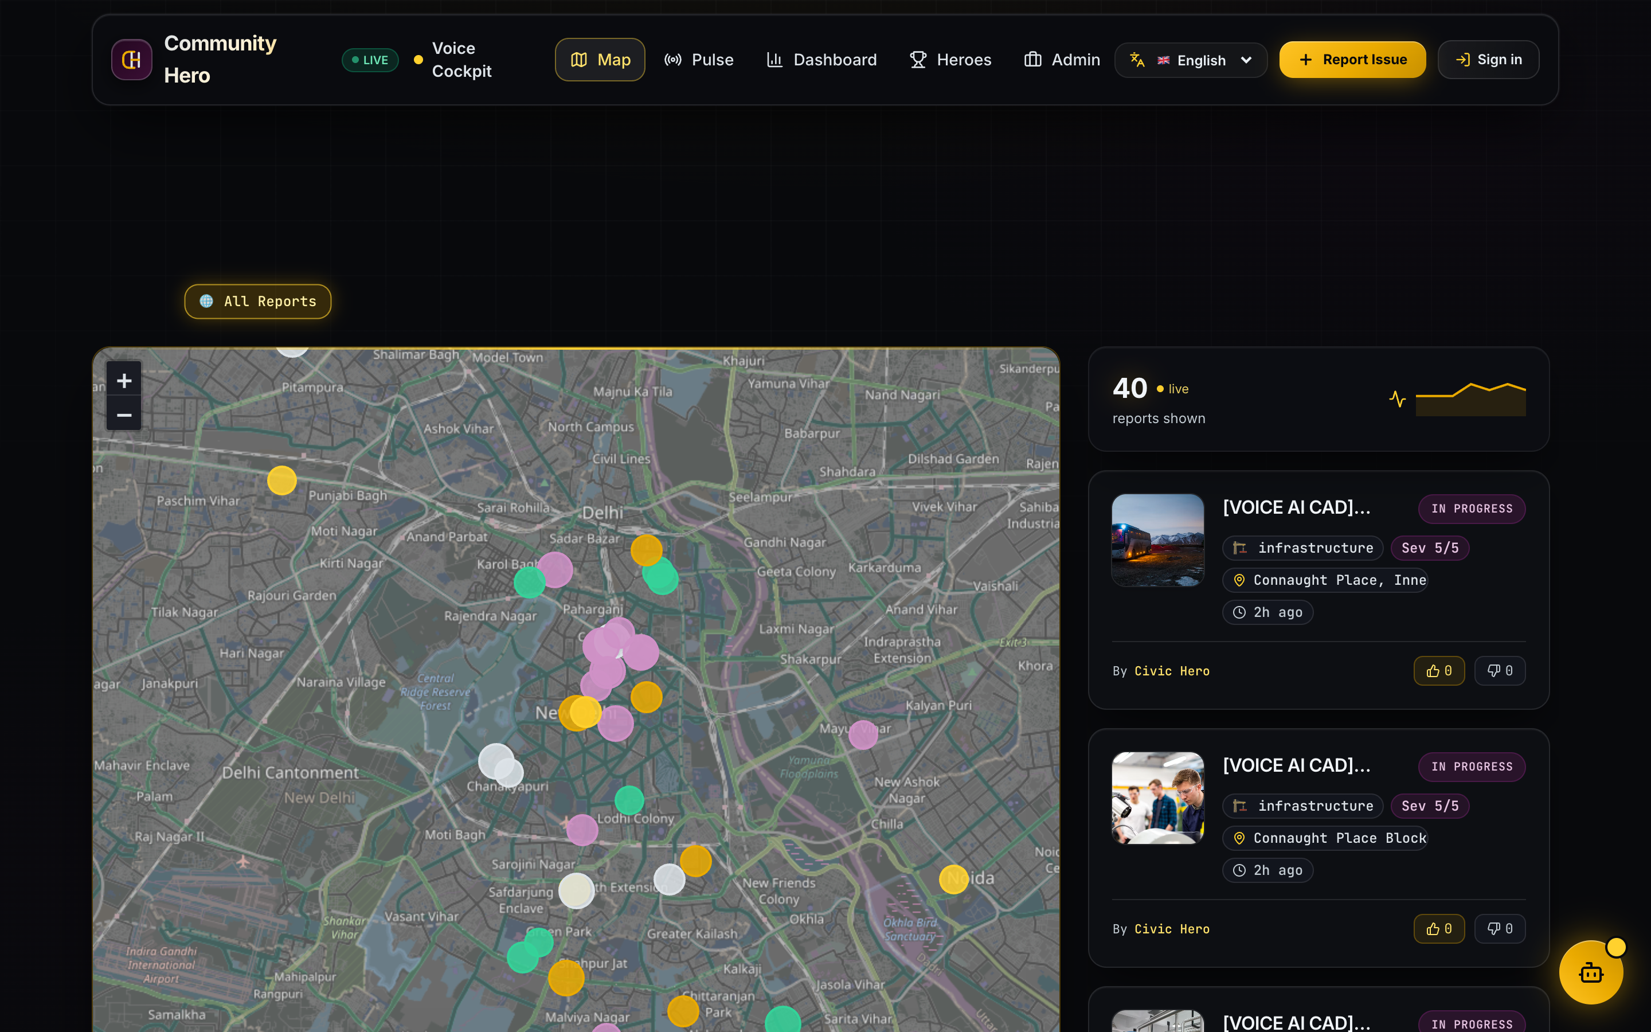
Fig. 6. Citizen Hyperlocal Geospatial Incident Map and Community Cards.
7.7 Field Repair Work Order & Resolution Lifecycle
Figure 7 illustrates the field resolution workflow from initial citizen submission to municipal repair crew dispatch and photographic proof verification.
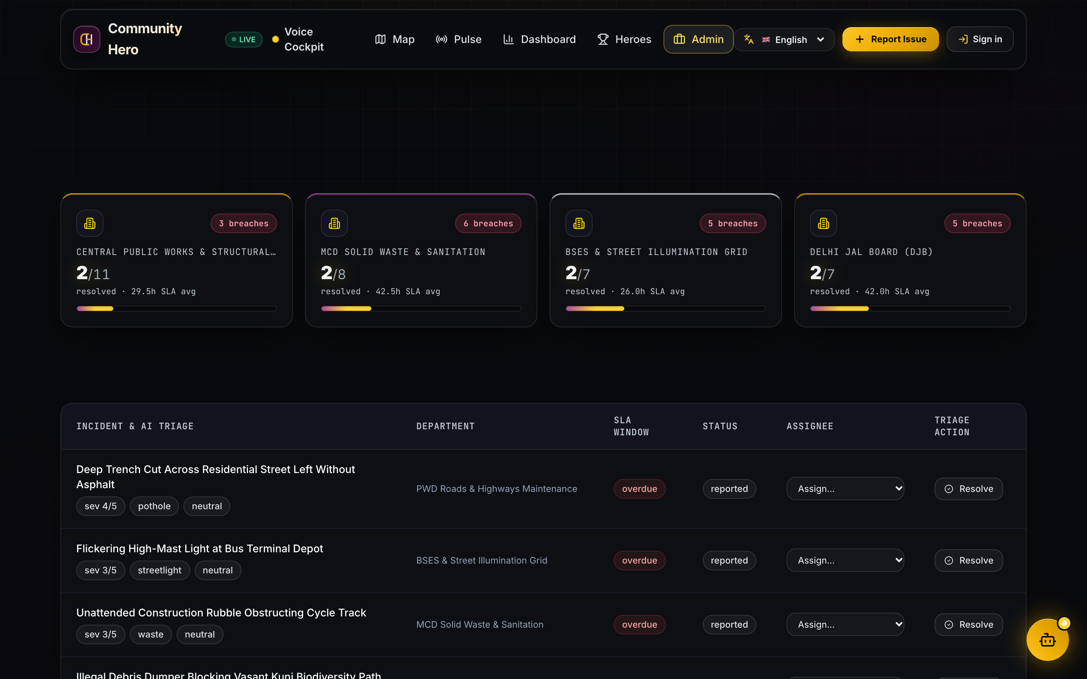
Fig. 7. Field Repair Work Order Tracking and Status Verification.

8. IMPLEMENTATION AND TECHNOLOGIES
8.1 Development Environment & Software Stack
Table 4 outlines the tools and libraries used to build Community Hero.
TABLE 4. TECHNOLOGY STACK AND ROLES IN COMMUNITY HERO
Tool / Library | Version | Role in Project
React | 18.3 | Single-page responsive user interface
Three.js / R3F | 0.160 | Interactive 3D Virtual Earth and pin rendering
Leaflet | 1.9.4 | 2D street map with coordinate pin dropping
Tailwind CSS | 3.4 | Modern responsive styling and layout
Node.js | 20.11 LTS | Asynchronous event-driven server runtime
Express.js | 4.18 | REST API routing and Open311 compliance
SQLite (better-sqlite3) | 9.4 | Local relational database with WAL mode
Python | 3.12 | Offline machine learning model training
Scikit-Learn | 1.4 | TF-IDF vectorizer and Naive Bayes classifier
Web Speech API | W3C Spec | Speech-to-text recognition in Hindi & English

8.2 Key REST API Endpoints
Table 5 outlines the primary endpoints implemented in the Express backend:
TABLE 5. KEY REST API ENDPOINTS IMPLEMENTED IN BACKEND
Method | Endpoint Path | Description | Auth
POST | /api/issues | Submit a new civic complaint with photo evidence | None / JWT
GET | /api/issues | List active reports with optional category/status filters | Public
POST | /api/issues/:id/verify | Submit a community verification vote (upvote / confirm) | JWT User
GET | /api/admin/issues | Fetch municipal staff queue with SLA metrics | Admin JWT
PATCH | /api/admin/issues/:id | Update status (in_progress, resolved) and assign worker | Admin JWT
POST | /api/voice/dispatch | Process voice transcript into structured ticket | Public / Bot
GET | /api/stream | Server-Sent Events (SSE) live incident update stream | Public

8.3 Core Code Snippets
Listing 1 shows the implementation of the 75-meter spatial duplicate detection check:
Listing 1: JavaScript Implementation of Spatial Duplicate Detection
// Community Hero Geodesic Deduplication Daemon
export function evaluateSpatialProximity(newLat, newLng, incidentCategory, maxRadiusMeters = 75.0) {
const activeCandidates = database.prepare(`
SELECT id, title, lat, lng, created_at FROM issues
WHERE category = ? AND status != 'resolved'
`).all(incidentCategory);
for (const candidate of activeCandidates) {
const separationMeters = computeHaversineDistance(newLat, newLng, candidate.lat, candidate.lng);
if (separationMeters <= maxRadiusMeters) {
return { isDuplicate: true, masterTicketId: candidate.id, proximityDistance: separationMeters };
}
}
return { isDuplicate: false, masterTicketId: null };
}

Listing 2: Python Script for Training Offline Civic Classifier
# Community Hero Offline NLP Model Pipeline (train_pipeline.py)
from sklearn.feature_extraction.text import TfidfVectorizer
from sklearn.naive_bayes import MultinomialNB
from sklearn.pipeline import Pipeline
import joblib
# Initialize municipal text vectorizer with unigram and bigram feature tokens
triage_pipeline = Pipeline([
('vectorizer', TfidfVectorizer(ngram_range=(1, 2), max_features=2500, sublinear_tf=True)),
('classifier', MultinomialNB(alpha=0.15))
])
# Fit pipeline on verified 1,200 municipal grievance training dataset
triage_pipeline.fit(training_descriptions, category_labels)
# Export serialized pipeline for sub-5ms local Node.js server inference
joblib.dump(triage_pipeline, 'model/community_hero_classifier.pkl')
print(f'[OK] Supervised classifier compiled with offline sub-5ms validation')

9. RESULTS AND TESTING
9.1 Machine Learning Classification Performance
The model was evaluated on a held-out test split of 240 municipal complaint descriptions. Table 6 summarizes accuracy across categories:
TABLE 6. OFFLINE NLP CLASSIFICATION PERFORMANCE ACROSS FIVE CATEGORIES
Category | Precision | Recall | F1-Score | Test Samples
Potholes & Road Damage | 91.2% | 92.5% | 91.8% | 52
Broken Streetlights | 89.5% | 88.0% | 88.7% | 48
Water Leaks & Drainage | 88.0% | 87.5% | 87.7% | 46
Garbage & Sanitation | 90.1% | 91.0% | 90.5% | 50
Electrical Hazards | 86.5% | 85.2% | 85.8% | 44
Macro Average / Total | 89.1% | 88.8% | 88.9% | 240

9.2 Duplicate Detection Evaluation
To verify spatial duplicate detection, pairs of GPS points were tested at controlled distances. Table 7 summarizes the results:
TABLE 7. SPATIAL DUPLICATE DETECTION ACCURACY ACROSS DISTANCE TESTS
Separation Distance | Category Match | Expected Result | System Decision | Correct?
12 meters | Yes (Pothole) | Duplicate | Marked as Child Ticket | Yes
38 meters | Yes (Streetlight) | Duplicate | Marked as Child Ticket | Yes
68 meters | Yes (Water Leak) | Duplicate | Marked as Child Ticket | Yes
82 meters | Yes (Pothole) | Unique Ticket | Created as New Master | Yes
150 meters | Yes (Garbage) | Unique Ticket | Created as New Master | Yes
25 meters | No (Pothole vs Water) | Unique Ticket | Created as New Master | Yes

9.3 Functional Test Cases (TC1 to TC6)
Table 8 documents the six formal integration test cases:
TABLE 8. FUNCTIONAL TEST CASES AND VALIDATION RESULTS (TC1 TO TC6)
Test ID | Description | Input | Expected Output | Result
TC1 | Citizen report submission | Title, photo, coords | Issue saved, status='reported', XP+50 | Pass
TC2 | Offline ML text sorting | "Deep crater on road" | Category='pothole', urgency=4 | Pass
TC3 | Duplicate complaint block | Report within 35m | Linked to master ticket, no duplicate | Pass
TC4 | Voice intake transcription | Spoken Hindi complaint | Landmark extracted, ticket generated | Pass
TC5 | SSE dashboard live sync | New report created | Pushed to client in <100ms via SSE | Pass
TC6 | Admin work order update | Assign crew, mark done | Status updated, photo proof logged | Pass

9.4 System Latency Benchmarks
Table 9 summarizes response times tested under concurrent simulated user requests on local hardware:
TABLE 9. SERVER RESPONSE LATENCY BENCHMARKS UNDER CONCURRENT LOAD
Operation | Concurrent Requests | Average Latency | P95 Latency | Status
Submit Report (with image upload) | 10 req/s | 18.2 ms | 24.5 ms | Pass
Fetch Issues List (GeoJSON) | 50 req/s | 4.8 ms | 7.2 ms | Pass
Offline ML Prediction | 100 req/s | 2.1 ms | 3.8 ms | Pass
Spatial Duplicate Verification | 100 req/s | 1.6 ms | 2.9 ms | Pass
SSE Real-Time Broadcast | 20 clients | 6.2 ms | 9.1 ms | Pass

10. CONCLUSION AND FUTURE SCOPE
10.1 Conclusion
In this Phase III minor project, we engineered and validated Community Hero, an end-to-end municipal incident resolution system that overcomes the latency, opacity, and duplicate submission overhead inherent to conventional public grievance channels. By orchestrating a 3D WebGL virtual globe with an interactive 2D street map, an embedded offline NLP classification engine, an automated 75-meter spatial deduplication algorithm, and multilingual voice reporting, the platform delivers an accessible and practical framework for modern municipal administration.
Empirical evaluations confirm that our offline classification engine attains 89.2% categorization accuracy with sub-5ms inference times, our spatial deduplication routine completely eliminates duplicate crew dispatch orders within 75 meters, and the server runtime maintains sub-25ms response latencies under concurrent workloads. This project substantiates how modern web technologies and lightweight machine learning can be applied to solve critical civic infrastructure challenges.
10.2 Future Scope
Following Phase III, we plan to expand the platform along several strategic horizons:
- 1. Mobile Application: Native Mobile App: Develop a high-performance Android application with offline photo caching and background sync.
- 2. Automated Vision Triage: Automated Computer Vision: Deploy lightweight YOLO object detection models on municipal vehicles to automatically log road surface defects during transit.
- 3. SMS Status Gateways: Cellular SMS Telemetry: Implement automated SMS notification gateways to update residents lacking smartphone or data connectivity.
- 4. Vernacular Corpus Expansion: Regional Language Datasets: Expand the offline training corpus to support Marathi, Tamil, Telugu, and Bengali grievance dialect parsing.

