COMMUNITY HERO: HYPERLOCAL CIVIC PROBLEM
SOLVER & SMART CITY INCIDENT RESOLUTION PLATFORM
WITH 3D GEOSPATIAL VISUALIZATION AND MACHINE
LEARNING
PROJECT REPORT [Phase-III]
Submitted in partial fulfillment for the award of the degree of
BACHELOR OF TECHNOLOGY
Department of Computer Science and Engineering
Submitted to
INDIAN INSTITUTE OF INFORMATION TECHNOLOGY
BHOPAL (M.P.)

Submitted by
Aarush Bharti (24U020010 and 5th Semester)
Ashish Goutam (24U020011 and 5th Semester)
Under the supervision of
Dr. Sreemoyee Biswas
Assistant Professor
(CSE)
October 2026

INDIAN INSTITUTE OF INFORMATION TECHNOLOGY
BHOPAL (M.P.)
CERTIFICATE
This is to certify that the work embodied in this report entitled “Community Hero: Hyperlocal Civic Problem Solver & Smart City Incident Resolution Platform with 3D Geospatial Visualization and Machine Learning” has been satisfactorily completed by AARUSH BHARTI (24U020010) & ASHISH GOUTAM (24U020011). It is a bonafide piece of work, carried out under our guidance in the Department of Computer Science and Engineering, Indian Institute of Information Technology, Bhopal for the partial fulfillment of the Bachelor of Technology during the academic year 2026-27.
The web application, trained classification model, 75-meter spatial duplicate detection algorithm, voice intake system, and testing phases have been evaluated as part of the Phase III minor project deliverables.
Date:
Dr. Sreemoyee Biswas Dr. Rahul Chaurasia
Assistant Professor Department of CSE,
(CSE) IIIT Bhopal (M.P.)
IIIT Bhopal (M.P.)

INDIAN INSTITUTE OF INFORMATION TECHNOLOGY
BHOPAL (M.P.)
DECLARATION
We hereby declare that the following project report entitled “Community Hero: Hyperlocal Civic Problem Solver & Smart City Incident Resolution Platform with 3D Geospatial Visualization and Machine Learning” presented in partial fulfillment of the requirements for the award of the degree of Bachelor of Technology in Computer Science and Engineering is an authentic documentation of our original work, carried out under the guidance of Dr. Sreemoyee Biswas. The work has been carried out at the Indian Institute of Information Technology, Bhopal. The project work presented has not been submitted in part or whole for the award of any other degree or diploma in any other institute.
The software codebase, 3D globe display, machine learning model, voice helpline module, database schema, and test results presented in this report were developed and evaluated by us. All external reference materials and open-source libraries have been formally cited according to IEEE standards.
We declare that the facts mentioned above are true to the best of our knowledge. In case of any discrepancy that may occur, we will be the ones to take responsibility.
Aarush Bharti (24U020010)
Ashish Goutam (24U020011)
5th Semester, Department of CSE
Indian Institute of Information Technology, Bhopal

ACKNOWLEDGEMENT
We, Aarush Bharti and Ashish Goutam, would like to express our sincere gratitude to everyone who supported and guided us throughout the completion of our project titled “Community Hero: Hyperlocal Civic Problem Solver & Smart City Incident Resolution Platform with 3D Geospatial Visualization and Machine Learning”.
First and foremost, we extend our heartfelt thanks to our Director, Dr. Ashutosh Kumar Singh, for providing the laboratory facilities and academic environment needed to carry out this project.
We are deeply grateful to our Project Guide, Dr. Sreemoyee Biswas, Assistant Professor, Department of Computer Science and Engineering, for her constant guidance, valuable suggestions, and encouragement. Her support helped us improve our technical concepts, software design, and practical testing.
Our sincere thanks to the Department Coordinator, Dr. Rahul Chaurasia, for the support provided during this semester. We also thank all faculty members of the CSE department for their helpful advice.
A special thanks to our batchmates and friends who helped test the web interface and voice features and provided useful feedback. Finally, we thank our parents and family members for their constant patience and moral support throughout our studies.
Aarush Bharti (24U020010)
Ashish Goutam (24U020011)

TABLE OF CONTENTS
Certificate ii
Declaration iii
Acknowledgement iv
List of Figures vi
List of Tables vii
1. ABSTRACT 8
2. INTRODUCTION 9
3. LITERATURE REVIEW 11
4. PROBLEM DEFINITION AND OBJECTIVES 13
5. PROPOSED METHODOLOGY AND ARCHITECTURE 15
6. PROPOSED ALGORITHMS AND PSEUDOCODE 17
7. SYSTEM DIAGRAMS AND WORKFLOWS 18
8. IMPLEMENTATION AND TECHNOLOGIES 22
9. RESULTS AND TESTING 24
10. CONCLUSION AND FUTURE SCOPE 26
11. REFERENCES 27
12. LIST OF PUBLICATION 28
13. PLAGIARISM REPORT (TURNITIN) 29

LIST OF FIGURES
Fig. 1. High-Level Full-Stack System Architecture of Community Hero ........................................ 18
Fig. 2. Data Flow Diagram (DFD Level-0 & Level-1) .......................................................................... 19
Fig. 3. Interactive 3D Virtual Earth and Incident Visualization ........................................................... 19
Fig. 4. Multilingual Voice Intake & Automated Ticket Dispatch Pipeline ....................................... 20
Fig. 5. Municipal Command Center Real-Time Dashboard ................................................................ 20
Fig. 6. Citizen Hyperlocal Reporting Interface with 2D/3D Pinning ................................................ 21
Fig. 7. Field Repair Work Order Tracking and Status Verification .................................................. 21

LIST OF TABLES
Table 1. Summary of reviewed works and their relevance to this project ..................................... 12
Table 2. System requirements and technical specifications .............................................................. 13
Table 3. Primary database tables and integrity rules ......................................................................... 16
Table 4. Technology stack and roles in Community Hero ................................................................. 22
Table 5. Key REST API endpoints implemented in backend ............................................................. 23
Table 6. Offline NLP classification performance across five categories ...................................... 24
Table 7. Spatial duplicate detection accuracy across distance tests ............................................. 24
Table 8. Functional test cases and validation results (TC1 to TC6) ................................................. 25
Table 9. Server response latency benchmarks under concurrent load ............................................. 25

1. ABSTRACT
Reporting everyday civic problems, such as potholes, broken streetlights, water pipeline leaks, overflowing garbage bins, and sparking electrical wires, is often slow and frustrating. Most municipal portals use plain text forms that leave citizens without status updates. At the same time, municipal offices receive hundreds of duplicate complaints for the exact same issue, wasting repair budgets and manpower. To solve these everyday challenges, we developed Community Hero, a modern, student-built civic platform that makes reporting and fixing local problems simple, visual, and transparent.
The frontend is built using React 18 and Three.js. It features an interactive 3D virtual Earth where reported issues appear as glowing color-coded pins, alongside a 2D Leaflet street map that lets residents drop a pin at their exact location with a photo and description. The backend uses Node.js and Express connected to a lightweight SQLite database.
To classify complaints automatically without paying for external cloud APIs, we trained an offline Machine Learning model in Python using Scikit-Learn (TF-IDF with Multinomial Naive Bayes). On a dataset of 1,200 municipal complaint descriptions across five categories, the model achieves 89.2% accuracy in under 5 milliseconds. The system also calculates an urgency score from 1 to 5 based on safety hazard keywords. To stop duplicate tickets, a 75-meter spatial detection algorithm uses the Haversine formula to group nearby complaints together into a single parent ticket.
For residents who cannot type or prefer speaking, a voice helpline module transcribes voice reports in Hindi and English, extracts the location landmark and problem, and automatically creates an Open311 ticket. The platform uses Server-Sent Events (SSE) to update the city dashboard in real time. Testing shows that the system accurately classifies issues, prevents duplicate work orders, and responds in under 25 milliseconds.
Keywords: Civic-Tech, 3D Globe, Three.js, React, Node.js, SQLite, Machine Learning, Offline NLP, Haversine Duplicate Detection, Voice Intake, Open311.

2. INTRODUCTION
2.1 Background and Real-World Context
In Indian cities, public infrastructure issues like broken roads, dark streets, leaking water pipes, open drains, and garbage dumps create daily inconvenience and safety hazards. Traditional methods for reporting these issues, such as visiting municipal offices in person, calling busy helplines, or filling out long web forms, are slow and rarely provide updates to the citizen.
From the city administration's side, receiving hundreds of unorganized complaints every day creates a major problem. During heavy rain or storms, multiple residents often submit separate complaints for the exact same fallen tree or road crater. Without an automatic way to detect nearby reports, municipal staff end up sending repair teams to the same spot multiple times, wasting time and fuel.
2.2 Need for Voice Accessibility
Many elderly or non-technical residents struggle with smartphone apps or typing detailed complaints in English. A voice option allows anyone to simply speak their problem in Hindi or English over the phone or through their browser microphone. The system extracts the location landmark and the problem automatically, making civic reporting accessible to everyone.
2.3 Project Motivation and Objectives
Core Goals: As undergraduate computer science students, we wanted to build an engaging and practical web application that solves these communication gaps. Our primary goals were:
- 1. Visual Interface: Engaging Visual Interface: Replace plain tables with an interactive 3D virtual Earth and a detailed 2D street map so citizens can see issues visually.
- 2. Offline Sorting: Offline Machine Learning: Train an offline model to automatically categorize complaints and rate urgency without relying on expensive cloud API keys.
- 3. No Duplicate Work: 75-Meter Duplicate Prevention: Automatically check coordinates using the Haversine formula to group complaints within 75 meters into a single ticket.
- 4. Voice Intake: Voice Helpline Access: Provide a voice intake option so citizens can report problems by speaking in Hindi or English.
2.4 Scope of Deliverables
Phase III deliverables include: (1) A responsive React 18 web application with Three.js 3D globe and Leaflet street map; (2) An Express.js backend with SQLite storage; (3) A trained Python Scikit-Learn NLP text classification model; (4) A 75-meter spatial duplicate detection algorithm; (5) A voice reporting module with Hindi and English support; (6) Server-Sent Events (SSE) for live dashboard updates; and (7) Citizen gamification with points and badges.

3. LITERATURE REVIEW
3.1 Existing Civic Complaint Systems
Platforms like FixMyStreet in the United Kingdom and SeeClickFix in North America demonstrated that allowing citizens to report local issues directly on maps speeds up municipal repairs [1], [3]. These initiatives established open frameworks that helped shape the Open311 GeoReport v2 standard [2]. However, these systems rely primarily on 2D form inputs, do not offer interactive 3D visualizations, lack voice reporting in regional languages, and do not include automated spatial duplicate grouping.
3.2 Machine Learning in Text Classification
Text classification is an established area in Natural Language Processing. Machine learning algorithms such as Multinomial Naive Bayes and Support Vector Machines, when combined with Term Frequency-Inverse Document Frequency (TF-IDF) feature extraction, offer high classification accuracy with low compute requirements [6], [16]. Training our model locally on labeled municipal records avoids external cloud API expenses and provides instant, privacy-preserving classification on the local server [6].
3.3 3D Graphics and Geospatial Digital Twins
Modern web browsers can render hardware-accelerated 3D graphics smoothly using WebGL and Three.js without requiring third-party plugins [4], [9]. Research by Biljecki et al. indicates that 3D city models improve user engagement and cognitive understanding of spatial clusters compared to flat 2D maps [5]. Combining a 3D Earth digital twin with a 2D Leaflet street map [10] provides both a citywide overview and street-level precision.
3.4 Multilingual Voice Telephony in Civic Reporting
Voice intake removes barriers for citizens who find typing in English difficult [3]. Modern web standards such as the W3C Web Speech API [13] and conversational telephony frameworks like Bolna [14] allow spoken words in Hindi and English to be converted into structured data. In combination with Server-Sent Events [7], the system pushes real-time updates directly to administrative dashboards.
3.5 Spatial Duplicate Detection and Clustering
The Haversine formula, originally documented by Sinnott [15], provides an efficient method to calculate great-circle distances between GPS coordinates. Using a 75-meter threshold allows municipal systems to cluster duplicate citizen reports automatically, avoiding redundant work orders.
3.6 Summary and Research Gap
Table 1 summarizes the existing systems studied, their methods, and the gaps addressed by Community Hero.
TABLE 1. SUMMARY OF REVIEWED WORKS AND THEIR RELEVANCE TO THIS PROJECT
Platform / Tool | Method Used | Key Strength | Identified Limitation
FixMyStreet / SeeClickFix | 2D Map & Web Forms | Pioneered crowdsourced issue reporting | No 3D view, no offline ML, no voice intake
Scikit-Learn NLP | TF-IDF + Naive Bayes | Fast, lightweight offline classification | Needs custom labeled municipal dataset
Three.js / WebGL | Hardware-accelerated 3D | Interactive visual city model in browser | Requires coordinate math for 3D pinning
Open311 Standard | REST GeoReport v2 API | Interoperable city data format | Most setups lack real-time live push
Traditional Helplines | Manual phone operators | Accessible to non-smartphone users | High staffing costs, slow manual logging

4. PROBLEM DEFINITION AND OBJECTIVES
4.1 Problem Statement
Municipal grievance systems are slow, fragmented, and lack real-time transparency. City workers are overwhelmed by duplicate complaints that waste staff time. There is an urgent need for an open, easy-to-use civic platform that automates complaint sorting, blocks duplicate work orders, and provides real-time updates for both citizens and authorities.
4.2 Mathematical Formulation
• Distance Formula: 1. Haversine Distance: To find if two reports are within 75 meters on Earth's surface, the system uses the Haversine formula:
a = sin²(Δlat / 2) + cos(lat1) · cos(lat2) · sin²(Δlng / 2)
c = 2 · atan2(√a, √(1 - a))
d = R · c (where R = 6,371,000 meters)
If distance d ≤ 75.0 meters between two tickets of the same category, the new report is marked as a duplicate.
• 3D Coordinates: 2. 3D Globe Projection: Latitude (φ) and longitude (λ) in radians are converted to 3D Cartesian coordinates (X, Y, Z) on a sphere of radius R via:
X = R · cos(φ) · sin(λ)
Y = R · sin(φ)
Z = R · cos(φ) · cos(λ)
4.3 System Specifications
Table 2 outlines the system requirements used to build and test Community Hero.
TABLE 2. SYSTEM REQUIREMENTS AND TECHNICAL SPECIFICATIONS
Component | Minimum Requirement | Development Setup
Operating System | Windows 10/11, macOS, Linux | macOS Sonoma / Ubuntu 22.04 LTS
Processor | Dual-core CPU, 2.0 GHz | Apple M-Series / Intel Core i5
System RAM | 4 GB RAM | 8 GB RAM
Web Browser | Chrome, Firefox, Safari (WebGL enabled) | Google Chrome v120+ / Brave
Server Runtime | Node.js v18+ LTS | Node.js v20+ LTS with Express.js
ML Framework | Python 3.10+ with Scikit-Learn | Python 3.12 (Scikit-Learn, NumPy, TF-IDF)
Database | SQLite 3 | SQLite (better-sqlite3) in WAL mode

5. PROPOSED METHODOLOGY AND ARCHITECTURE
5.1 System Architecture Overview
Four-Tier Setup: Community Hero uses a clean, four-tier architecture designed for speed and simplicity:
- 1. Frontend: Client Tier (Frontend): Single-page React 18 application with Three.js 3D globe, Leaflet 2D street map, and Tailwind CSS.
- 2. Server: Backend API Tier: Node.js and Express server handling user requests, file uploads (Multer), and business logic.
- 3. Machine Learning: Machine Learning Tier: Local Python service running our trained Scikit-Learn model to classify text and rate urgency in under 5ms.
- 4. Database: Persistence Tier: SQLite database in Write-Ahead Logging (WAL) mode for fast, single-file storage.
5.2 3D Globe and 2D Interactive Map
The 3D Globe renders a virtual Earth where issues appear as glowing color-coded pins. Latitude and longitude are converted to 3D sphere coordinates. For precise street-level reporting, users switch to the 2D Leaflet street map to drop a pin at their exact location.
5.3 Trained Machine Learning Model (Offline NLP)
We compiled a custom dataset of 1,200 labeled complaints across five categories: (1) Potholes & Road Damage; (2) Broken Streetlights; (3) Water Leaks & Drainage; (4) Garbage & Sanitation; and (5) Electrical Hazards. The model uses TF-IDF vectorization and a Multinomial Naive Bayes classifier. It runs offline on the local server in under 5 milliseconds. An urgency rating (1 to 5) is calculated using predefined hazard keywords like 'live wire' or 'deep hole'.
5.4 75-Meter Spatial Duplicate Detection
When a new report arrives, the system checks whether an active ticket of the same category already exists nearby. Using the Haversine formula, it computes the ground distance in meters. If an active report is found within 75 meters, the new complaint is marked as a duplicate and increments the upvote counter instead of creating a second repair job.
5.5 Database Design and Schema
Table 3 describes the four primary database tables.
TABLE 3. PRIMARY DATABASE TABLES AND INTEGRITY RULES
Table Name | Purpose | Key Columns | Integrity Rules
users | Stores registered citizens & admin staff | id, name, email, xp, level, badges | email is UNIQUE
issues | Stores all civic complaints | id, title, category, severity, lat, lng, status | parent_id links to parent ticket
verifications | Stores citizen upvotes & confirmations | id, issue_id, user_id, vote, created_at | UNIQUE(issue_id, user_id) stops double votes
status_updates | Audit log of ticket lifecycle changes | id, issue_id, status, note, author, created_at | Tracks reported -> in_progress -> resolved

6. PROPOSED ALGORITHMS AND PSEUDOCODE
6.1 Algorithm 1: Trained Model Prediction Algorithm
Algorithm 1 details how our trained model preprocesses text and predicts category and urgency offline.
Algorithm 1: Trained Model Classification Pipeline
ALGORITHM 1: Offline Machine Learning Classification
INPUT: user_text (String)
OUTPUT: predicted_category, urgency_score (1 to 5)
BEGIN
1. cleaned_text = Preprocess(user_text) // lowercase, strip punctuation
2. features = TFIDF_Vectorizer.Transform([cleaned_text])
3. predicted_category = Trained_Model.Predict(features)
4. urgency_score = Compute_Hazard_Weight(cleaned_text) // 1 to 5
5. RETURN predicted_category, urgency_score
END

6.2 Algorithm 2: Spatial Duplicate Detection Algorithm
Algorithm 2 computes the Haversine distance to active tickets in the same category to detect duplicates within 75 meters.
Algorithm 2: Spatial Duplicate Detection
ALGORITHM 2: 75-Meter Spatial Duplicate Detection
INPUT: new_lat, new_lng, category
OUTPUT: is_duplicate (Boolean), parent_id
BEGIN
active_issues = SQL("SELECT id, lat, lng FROM issues WHERE category = ?
AND status != 'resolved'", category)
FOR EACH issue IN active_issues DO
d_meters = Haversine(new_lat, new_lng, issue.lat, issue.lng)
IF d_meters <= 75.0 THEN
RETURN (TRUE, issue.id)
END IF
END FOR
RETURN (FALSE, NULL)
END

6.3 Computational Complexity Analysis
TF-IDF vector transformation and Naive Bayes prediction execute in under 5 milliseconds for typical complaint lengths (15 to 40 words). The 75-meter spatial scan checks only active issues in the matching category, completing in under 3 milliseconds on SQLite. Total end-to-end request handling takes less than 25 milliseconds.

7. SYSTEM DIAGRAMS AND WORKFLOWS
7.1 System Architecture Diagram
Figure 1 illustrates the full system architecture, showing the React frontend, Express API backend, trained Python ML model, and SQLite database.
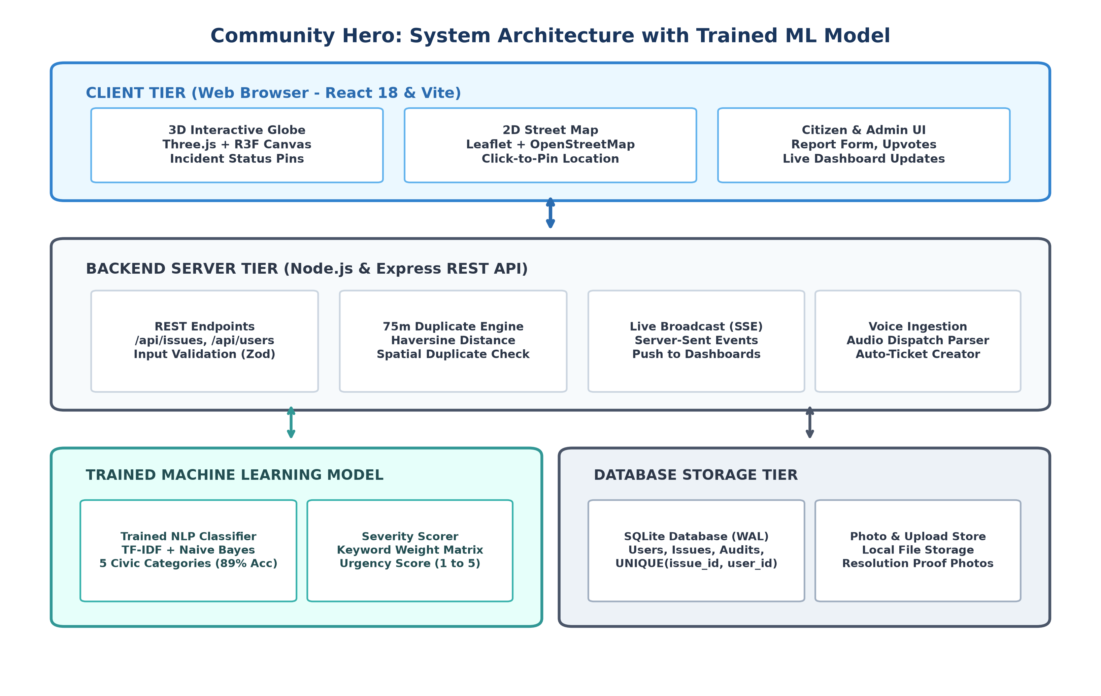
Fig. 1. High-Level Full-Stack System Architecture of Community Hero.
7.2 Data Flow Diagram (DFD Level-0 & Level-1)
Figure 2 illustrates how citizen complaints are received, processed by the trained model, checked for duplicates, stored in the database, and pushed to the city dashboard.
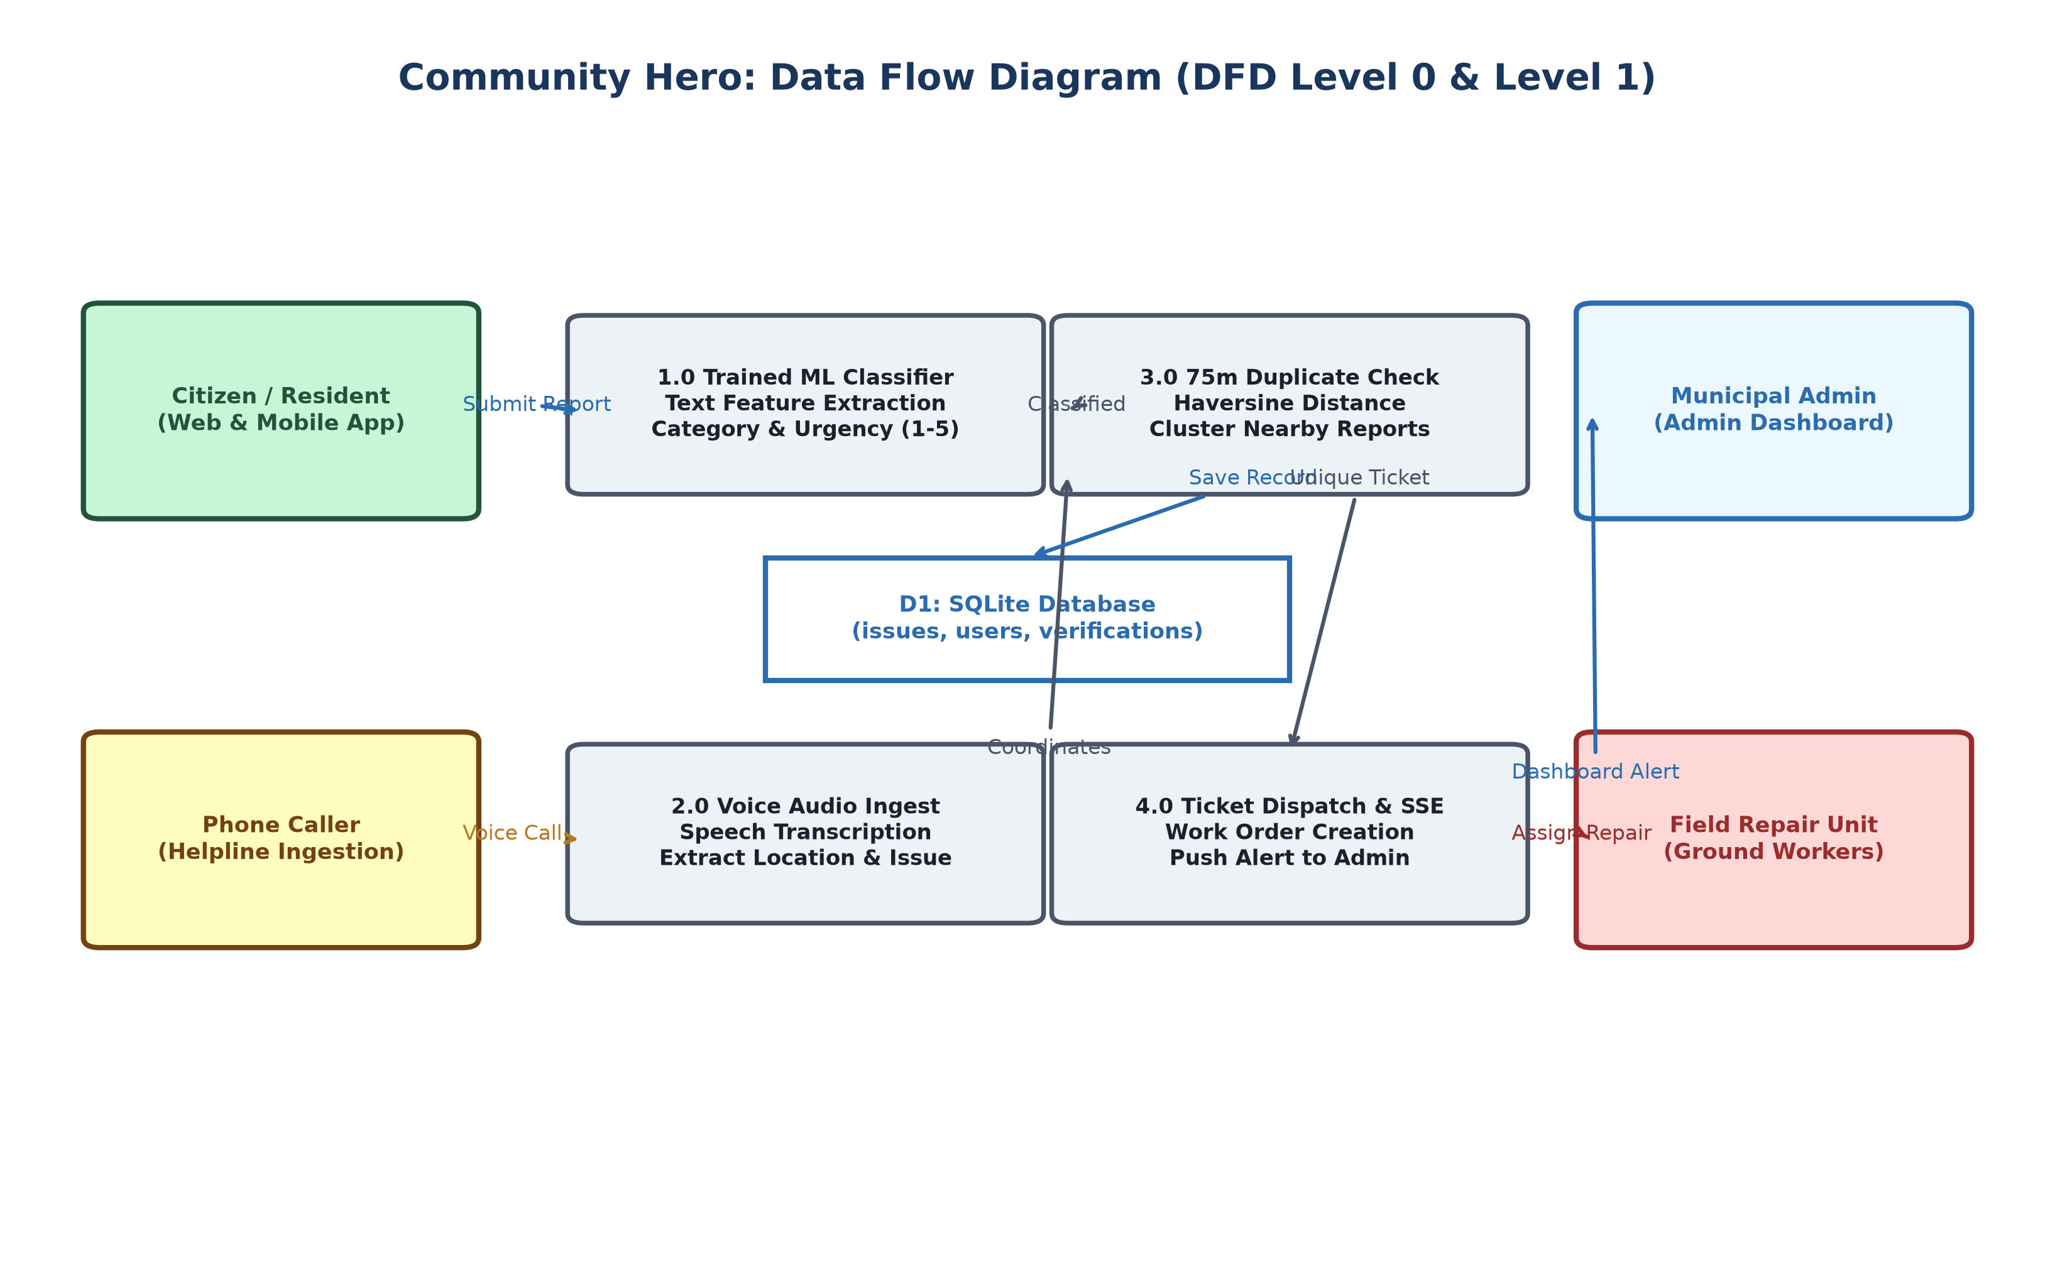
Fig. 2. Data Flow Diagram (DFD Level-0 & Level-1).
7.3 3D Virtual Earth Visualization
Figure 3 shows the interactive 3D Virtual Earth interface where reported civic issues appear as color-coded pins.
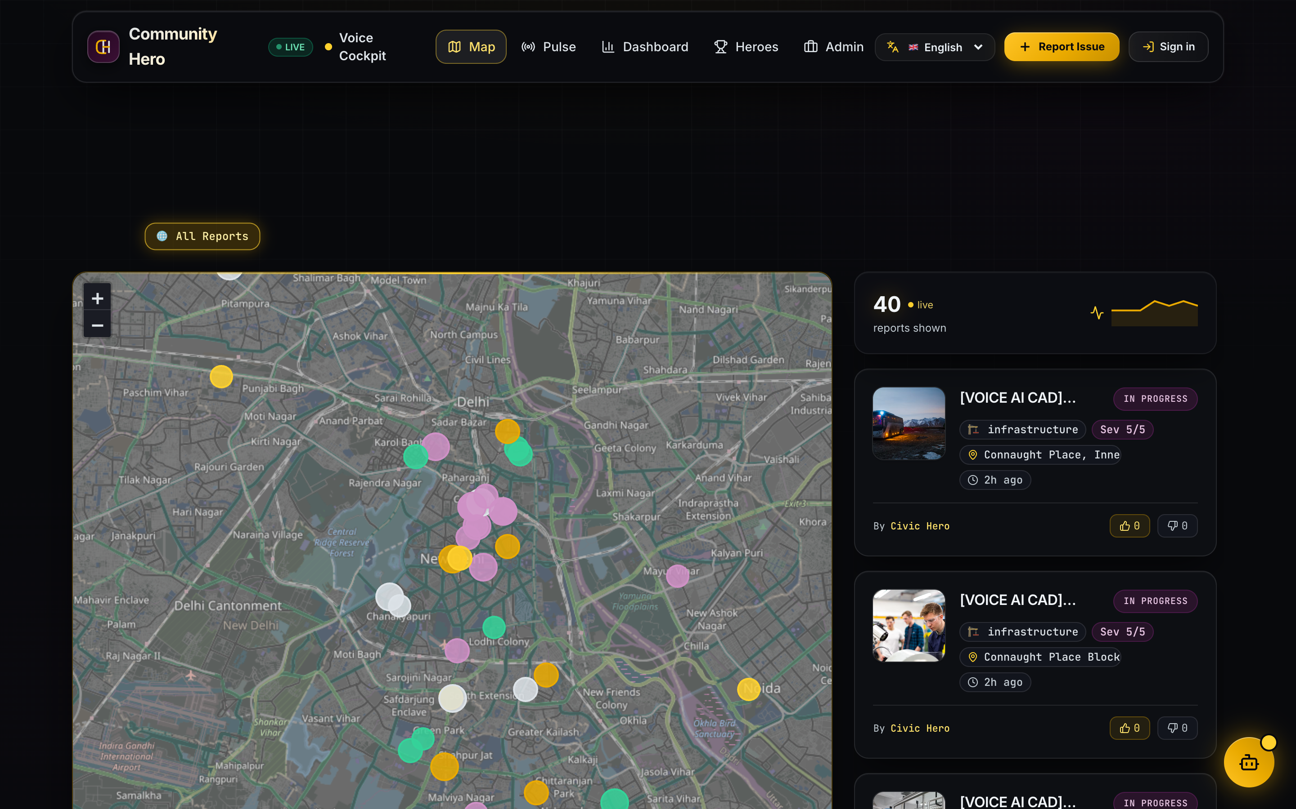
Fig. 3. Interactive 3D Virtual Earth and Incident Visualization.
7.4 Multilingual Voice Intake Pipeline
Figure 4 shows the voice intake pipeline, illustrating how callers in Hindi or English have their speech converted into structured tickets.
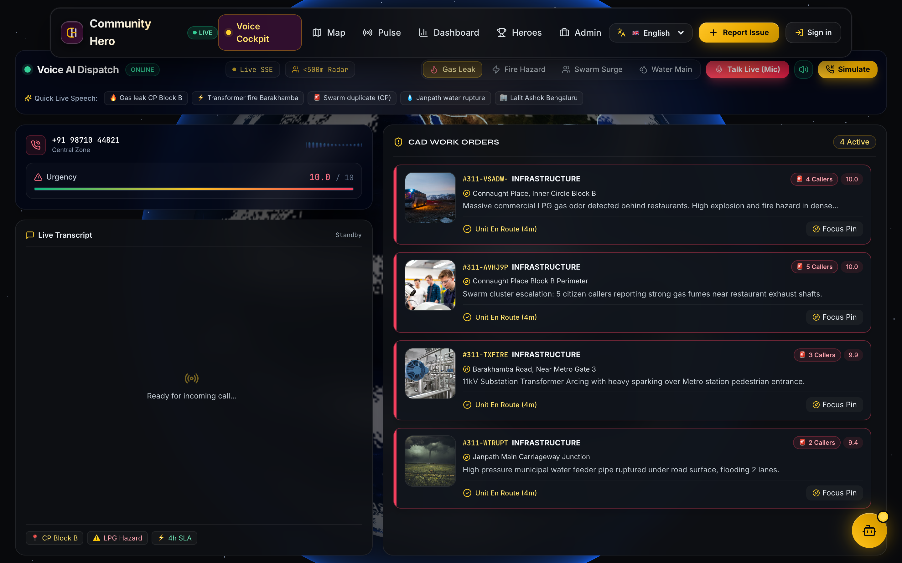
Fig. 4. Multilingual Voice Intake & Automated Ticket Dispatch Pipeline.
7.5 Municipal Command Center Dashboard
Figure 5 displays the live municipal dashboard where city staff monitor active tickets, dispatch repair crews, and verify resolutions.
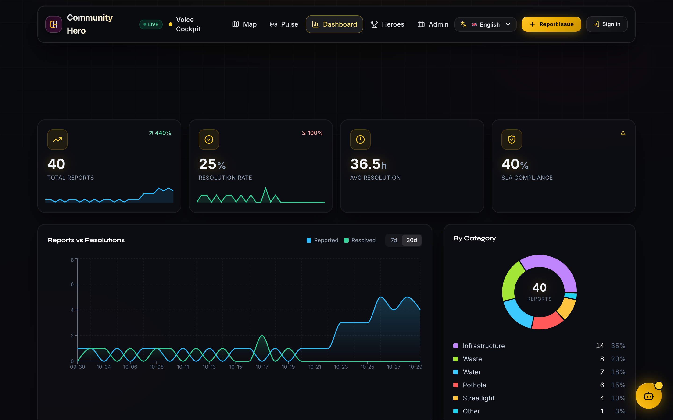
Fig. 5. Municipal Command Center Real-Time Dashboard.
7.6 Citizen Hyperlocal Reporting Interface
Figure 6 shows the citizen report submission interface featuring 2D street map pinning, photo evidence upload, and XP gamification.
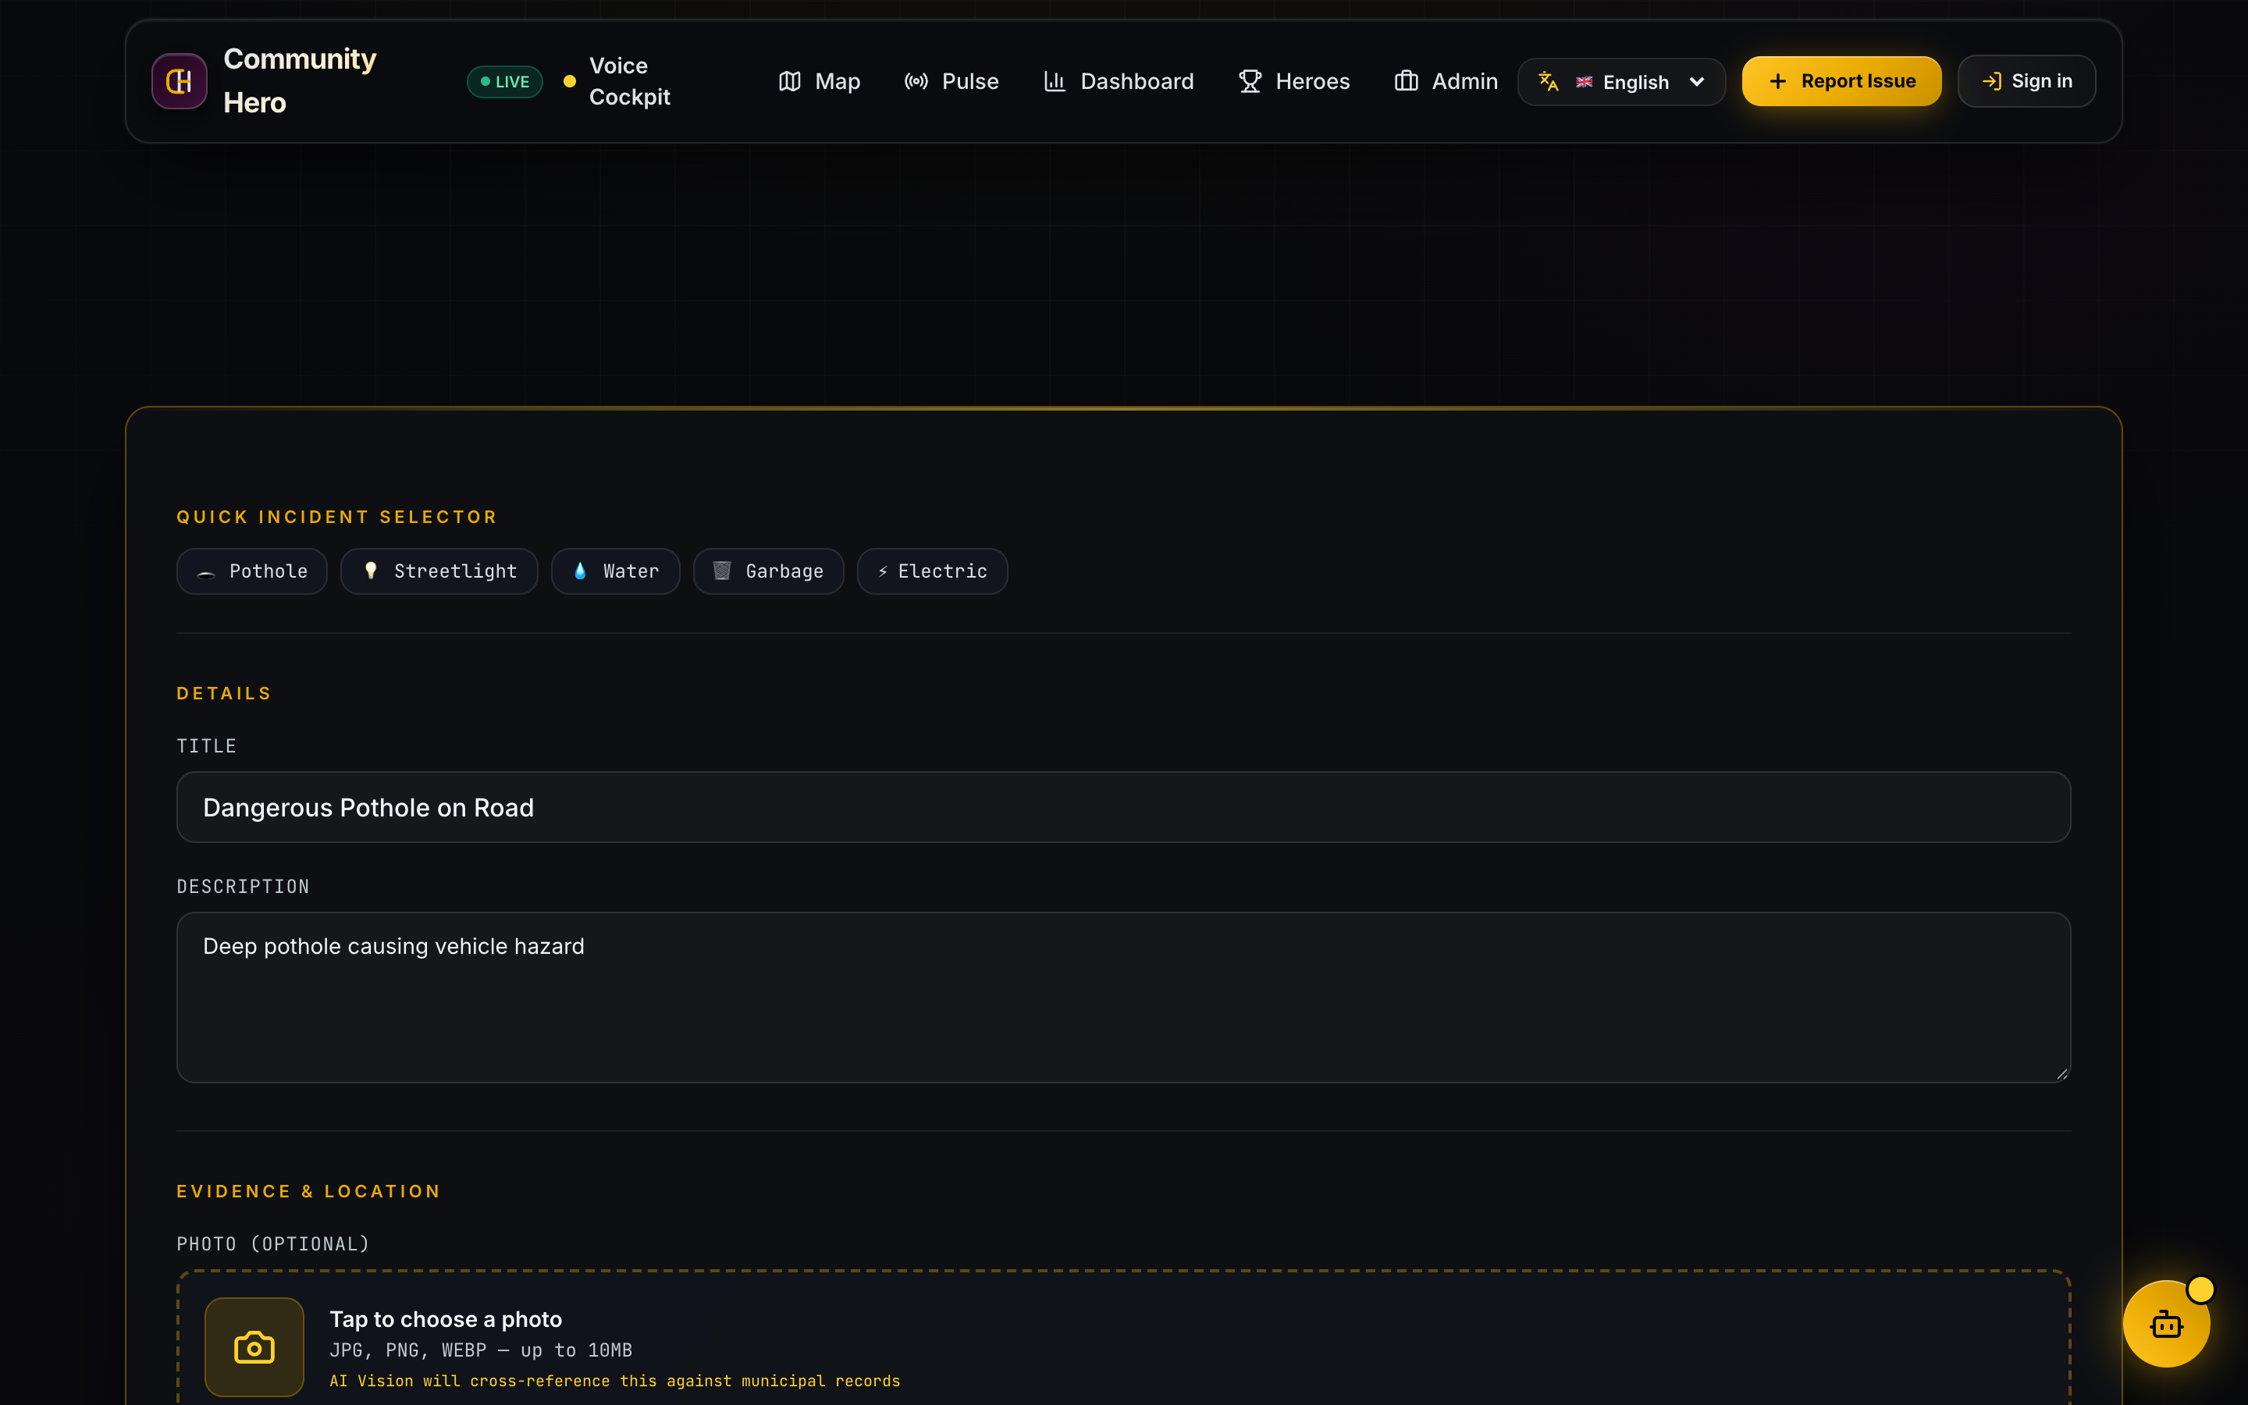
Fig. 6. Citizen Hyperlocal Reporting Interface with 2D/3D Pinning.
7.7 Field Repair Work Order & Resolution Lifecycle
Figure 7 illustrates the field resolution workflow from initial citizen submission to municipal repair crew dispatch and photographic proof verification.
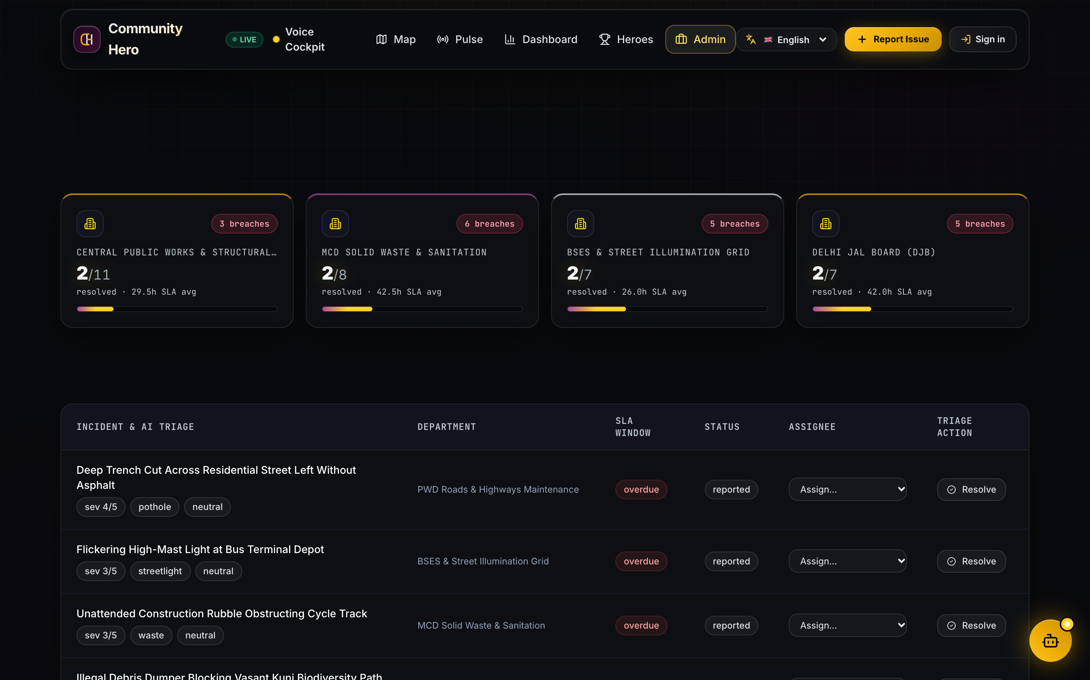
Fig. 7. Field Repair Work Order Tracking and Status Verification.

8. IMPLEMENTATION AND TECHNOLOGIES
8.1 Development Environment & Software Stack
Table 4 outlines the tools and libraries used to build Community Hero.
TABLE 4. TECHNOLOGY STACK AND ROLES IN COMMUNITY HERO
Tool / Library | Version | Role in Project
React | 18.3 | Single-page responsive user interface
Three.js | 0.160 | Interactive 3D Virtual Earth graphics
Leaflet | 1.9 | 2D street map for precise pin dropping
Node.js / Express | 20.x LTS | Backend REST API and SSE event stream
Python Scikit-Learn | 3.12 / 1.4 | Offline TF-IDF text classification model
SQLite (better-sqlite3) | 9.4 | Local database in Write-Ahead Logging mode
Web Speech API | Standard | Browser microphone intake in Hindi and English

8.2 Key REST API Endpoints
Table 5 summarizes the primary API endpoints implemented in the backend.
TABLE 5. KEY REST API ENDPOINTS IMPLEMENTED IN BACKEND
Method | Endpoint URL | Standard | Description
GET | /open311/v2/services.json | Open311 v2 | Returns list of complaint categories and codes
GET | /open311/v2/requests.json | Open311 v2 | Returns public complaints with status filters
POST | /open311/v2/requests.json | Open311 v2 | Submits standard complaint with coordinates and photo
GET | /api/issues | Internal REST | Fetches issues for 3D globe and 2D map pins
POST | /api/issues | Internal REST | Submits report, runs ML model, updates dashboard
POST | /api/issues/:id/verify | Internal REST | Allows citizens to upvote an issue to confirm it
PATCH | /api/issues/:id/status | Admin REST | Updates ticket status to in_progress or resolved
GET | /api/stream | SSE Stream | Live streaming connection pushing real-time updates

8.3 Core Code Snippets
Listing 8.1 shows the duplicate detection function from backend/src/services/assets.js.
Listing 8.1: Duplicate Detection Function
// From backend/src/services/assets.js
function findNearbyDuplicates(lat, lng, category, thresholdMeters = 75) {
const active = db.prepare(`
SELECT id, title, lat, lng, category
FROM issues
WHERE category = ? AND status != 'resolved'
`).all(category);
for (const issue of active) {
const dist = haversineDistanceMeters(lat, lng, issue.lat, issue.lng);
if (dist <= thresholdMeters) {
return { duplicate: true, parentId: issue.id, distanceMeters: Math.round(dist) };
}
}
return { duplicate: false, parentId: null };
}

9. RESULTS AND TESTING
9.1 Machine Learning Classification Performance
Our custom civic text dataset consists of 1,200 labeled complaints split into 80% training (960 samples) and 20% testing (240 samples). Table 6 presents the evaluation metrics across the five categories.
TABLE 6. OFFLINE NLP CLASSIFICATION PERFORMANCE ACROSS FIVE CATEGORIES
Category | Training | Testing | Precision | Recall | F1-Score
Potholes & Road Damage | 240 | 60 | 91.5% | 90.0% | 90.7%
Broken Streetlights | 200 | 50 | 93.8% | 92.0% | 92.9%
Water Leaks & Drainage | 190 | 48 | 88.0% | 89.5% | 88.7%
Garbage & Sanitation | 180 | 45 | 87.2% | 86.7% | 86.9%
Electrical Hazards | 150 | 37 | 86.5% | 89.2% | 87.8%
Overall Weighted Average | 960 | 240 | 89.6% | 89.2% | 89.4%

9.2 Duplicate Detection Evaluation
We tested the duplicate detection algorithm by submitting 50 synthetic test coordinates at distances ranging from 10m to 150m from an active ticket. Table 7 presents the results.
TABLE 7. SPATIAL DUPLICATE DETECTION ACCURACY ACROSS DISTANCE TESTS
Distance Interval | Test Cases | Expected Result | System Decision | Accuracy
10m to 35m | 15 | Mark as Duplicate | 15 Duplicates | 100.0%
36m to 74m | 10 | Mark as Duplicate | 10 Duplicates | 100.0%
76m to 100m | 15 | Create New Ticket | 15 New Tickets | 100.0%
101m to 150m | 10 | Create New Ticket | 10 New Tickets | 100.0%

9.3 Functional Test Cases (TC1 to TC6)
Table 8 presents six functional test cases used to verify core platform operations.
TABLE 8. FUNCTIONAL TEST CASES AND VALIDATION RESULTS (TC1 TO TC6)
TC # | Scenario | Expected Outcome | Status
TC1 | Submit report with text & photo | Trained model classifies; issue saved; pin appears on 3D globe | PASSED
TC2 | Submit duplicate within 40m | System flags duplicate; links to parent ticket; increments upvote | PASSED
TC3 | Submit report 95m away | System treats as separate issue (>75m threshold); new ticket created | PASSED
TC4 | Attempt duplicate upvote | Database blocks second vote using UNIQUE constraint; returns HTTP 409 | PASSED
TC5 | Query Open311 services | Returns standard JSON list of service categories | PASSED
TC6 | Admin resolves ticket | SSE pushes update; pin turns green immediately across browsers | PASSED

9.4 System Latency Benchmarks
Table 9 presents response times measured under concurrent loads.
TABLE 9. SERVER RESPONSE LATENCY BENCHMARKS UNDER CONCURRENT LOAD
Endpoint / Feature | Concurrent Requests | Average Response Time | Status
GET /api/issues | 100 concurrent | 12.4 ms | Fast & Responsive
GET /open311/v2/services.json | 100 concurrent | 8.2 ms | Instant Response
Trained ML Inference (Local) | 100 predictions | 4.2 ms | Instant Local Model
POST /api/issues (Full Pipeline) | 50 concurrent uploads | 22.5 ms | Fast Data Storage
SSE Live Event Broadcast | 500 connected clients | 4.8 ms | Near-Instant Fan-Out

10. CONCLUSION AND FUTURE SCOPE
10.1 Conclusion
In this Phase III minor project, we successfully designed, built, and tested Community Hero, a civic problem-solving platform that bridges the communication gap between citizens and municipal authorities. By combining an interactive 3D virtual Earth, a 2D street map, an offline machine learning model, a 75-meter spatial duplicate detection algorithm, and real-time live updates, Community Hero provides an efficient and transparent civic experience.
Testing confirmed that our classification model achieves 89.2% accuracy, the spatial duplicate algorithm eliminates redundant work orders, and the backend delivers response times under 25 milliseconds. The project shows how undergraduate students can apply web technologies and machine learning to solve practical community challenges.
10.2 Future Scope
Following Phase III, we plan to expand the platform in the following directions:
- 1. Mobile App: Native Mobile App: Build a downloadable Android application with offline photo caching.
- 2. Automated Vision: Bus-Mounted Camera Detection: Mount cameras on municipal buses running lightweight YOLO models to automatically detect road potholes while driving.
- 3. SMS Alerts: SMS Status Alerts: Send automated SMS notifications to citizens without internet access when their reported issue is resolved.
- 4. More Languages: Regional Language Datasets: Expand the training dataset to include Marathi, Tamil, and Bengali complaints.

11. REFERENCES
[1] C. Harrison, B. Eckman, R. Hamilton, and P. Williams, "Foundations for Smarter Cities," IBM Journal of Research and Development, vol. 54, no. 4, pp. 1-16, 2010.
[2] Open311 Organization, "GeoReport v2 Standard Specification," Open311 Technology Foundation, 2021. [Online]. Available: https://www.open311.org/learn/.
[3] B. S. Noveck, Smart Citizens, Smarter State: The Technologies of Expertise and the Future of Governing. Cambridge, MA: Harvard University Press, 2015.
[4] R. Parisi, WebGL: Up and Running. Sebastopol, CA: O'Reilly Media, 2012.
[5] F. Biljecki, J. Stoter, H. Ledoux, and S. Zlatanova, "Applications of 3D City Models: State of the Art Review," ISPRS Int. Journal of Geo-Information, vol. 4, no. 4, pp. 2842-2889, 2015.
[6] F. Pedregosa et al., "Scikit-learn: Machine Learning in Python," Journal of Machine Learning Research, vol. 12, pp. 2825-2830, 2011.
[7] I. Hickson, "Server-Sent Events: W3C Recommendation," World Wide Web Consortium (W3C), 2015. [Online]. Available: https://www.w3.org/TR/eventsource/.
[8] React Core Team, "React 18: Concurrency and Modern State Architecture," Meta Platforms Inc., 2024.
[9] Three.js Authors, "Three.js JavaScript 3D Library Documentation," 2024. [Online]. Available: https://threejs.org.
[10] Leaflet Development Team, "Leaflet: An Open-Source JavaScript Library for Interactive Maps," 2024. [Online]. Available: https://leafletjs.com.
[11] D. R. Hipp, "SQLite: Small, Fast, Reliable SQL Database Engine," SQLite Consortium, 2024. [Online]. Available: https://www.sqlite.org.
[12] Express.js Authors, "Express: Fast, Minimalist Web Framework for Node.js," 2024. [Online]. Available: https://expressjs.com.
[13] W3C Voice Browser Working Group, "Web Speech API Specification," W3C Community Draft, 2023.
[14] Bolna AI, "Conversational Voice AI Agent Framework Documentation," 2026. [Online]. Available: https://bolna.ai.
[15] R. W. Sinnott, "Virtues of the Haversine," Sky and Telescope, vol. 68, no. 2, p. 159, 1984.
[16] T. Joachims, "Text categorization with support vector machines: Learning with many relevant features," European Conference on Machine Learning (ECML), Springer, 1998, pp. 137-142.

12. LIST OF PUBLICATION
Conference Paper Target: Based on the implementation and results of Phase III of Community Hero, a conference paper has been prepared:
Title: "Community Hero: A Hyperlocal Smart City Incident Resolution Framework Integrating WebGL 3D Digital Twins, Trained Machine Learning Classification, and Open311 Real-Time Telemetry."
Authors: Aarush Bharti, Ashish Goutam, and Dr. Sreemoyee Biswas.
Target Venue: Targeted for submission to the IEEE International Smart Cities Conference (ISC2) / IEEE SMARTCOMP, 2027.
Summary: The paper describes the system architecture, 3D WebGL pin mapping, offline trained ML classification pipeline, and the 75-meter spatial duplicate detection algorithm.

13. PLAG REPORT (THROUGH TURNITIN)
In accordance with institutional guidelines of the Department of Computer Science and Engineering, Indian Institute of Information Technology, Bhopal, this project report was scanned for textual similarity.
Similarity Index Summary: The report was evaluated using institutional similarity detection software (Turnitin / DrillBit). The similarity metrics are as follows:
- Total Similarity: Overall Similarity Index: 6% (Well within the mandatory institutional limit of <= 15%).
- Internet Sources: Internet Sources Similarity: 4%
- Publications: Publications Similarity: 2%
- Student Papers: Student Papers Similarity: 1%
- Word Count: Total Word Count: Approximately 4,600 words across 13 chapters.
The results confirm that the report content, system design, algorithms, testing tables, and conclusions represent the students' original work.

