All Learning :-
Modern C++:-
1) lvalue : anything which still exist after the initiation , basically accessible later on with the address
2) rvalue: Something which is temporary and we are either completely moving it or we don’t even have its address .
Eg . Int a = 4; a→lvalue , 4→rvalue , std::move(k) this is rvalue because we can’t use k anymore , string s = string(“a”) , the right side is rvalue and left one is lvalue.
Callable(s):
1) Normal function
2)function pointers
e.g. say there is a function named add1(int x) , we can do int (*fp)(int)= &add1;
then we can call the function like cout << fp(3) << endl;
3) Functor (object with operator() )
e.g. struct twice {int operator()(int x) const {return 2*x;}};
4) Lambda function
auto add[b=21](int x){return x+b;}
Type Deduction :-
template<typename T>
f( T& value) → int x=9;int& y=x , const int& z=x; f(x) param type will be int&
f(y) int& , f(z)const int& , but for int&& u=x; f(u) paramtype will still be int& and not int&&
& + & → & , & + && → & , && + & → & , && + && → &&
The argument passed must be rvalue if we want paramtype to be rvalue .
* IF WE pass a constant pointer by value which is pointing to constant object then constantness of pointer will be lost but that of object to which pointer is pointer remains intact .

Cache Project :
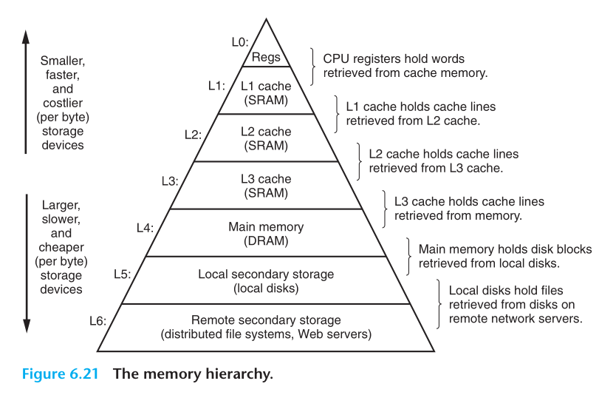
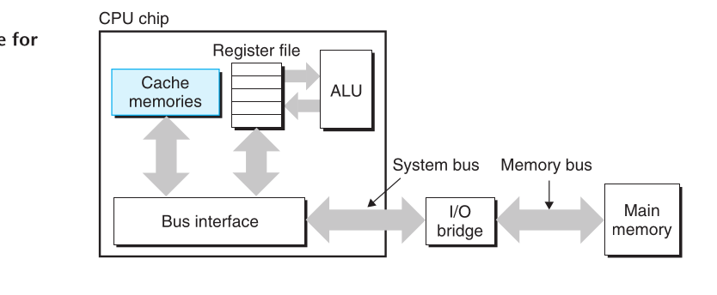
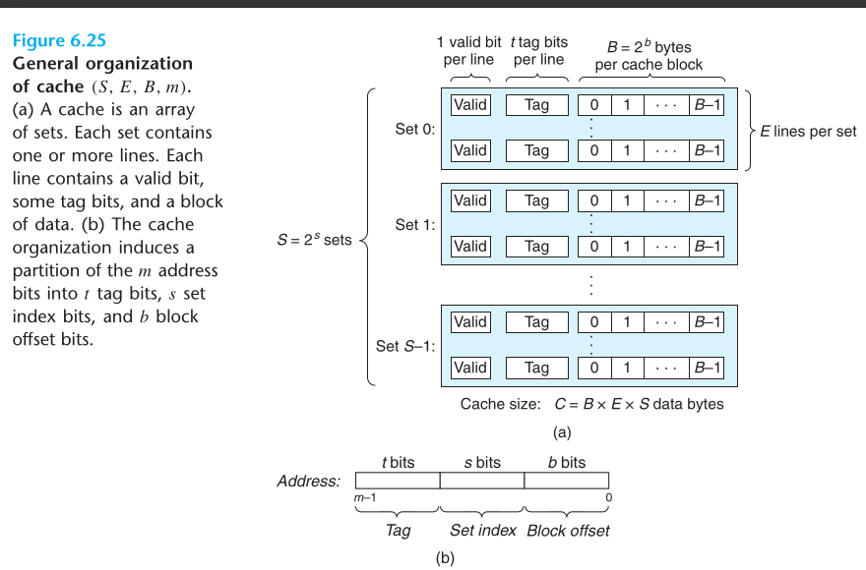
set bits :- Differentiate between the sets so that we can directly go to a set and ignore others , valid bits tells us whether the cache block is empty or not
tag bits differentiate between the different rows
offset tells us the address of the byte from which the data extraction fron the particular block we need to extract the data and in CPU instructions it also sends the amount of bytes to be extracted so it returns the data from offset to offset+k-1 addresses .
Now , I didn’t get the depth of how it exactly access the data from cache but I have rough idea , for each main memory address it maps it to some space in cache and multiple addresses maps to same set , around 1lakh maps to single set then tags is something which differentiate between all those 1lakh addresses so it somehow just checks if the tag matches the desired tag or not !
Simple example to understand Cache hit and misses:-
float dotprod(float x[8], float y[8])
{
float sum = 0.0;
int i;
for (i = 0; i < 8; i++)
sum += x[i] * y[i];
return sum;
}
Now suppose that a block can hold 16bytes and let’s say that floats are 4 bytes so each block can hold 4 floats now , let’s say there are only 2 sets in the memory , then when it tries to fetch x[0] it takes contiguous memory x[o]-x[3] into set 0 but when it needs y[0] it again fetch the data to set 0 overriting the content of set0 and thus there will be continuous cache misses ,
if we instead initiate x to be as x[12] , then we can prevent cache miss now it will assign x[0-3] to set0 , x[4-7] to set0 and then x[8-11] to set0 again so not y[0-3] is assigned to set1 and it won’t overrite the cached memory of x and vice-versa .
* Middle bits are used for caches indexing .
Why ? Because if we use high bits then even if cache is large enough and our array is small , multiple blocks of the array will be mapped to same set as other sets will come into use only if we have large array !!
FOR MY PC :-
L1 :- 64 sets are there each with 8 lines and block size is 64 bytes .
Total size = 32KB
L1i: (L1 for instruction) :- 64kb size , 128 sets , block size of 64bytes and 8 lines per set
L2 :- 2MB , each set 16-line , 2048 sets , 64bytes blocks
L3:- 24MB , 12 line /set , 32,768 sets , 64bytes.block

