A Comparative AI-based Framework of Standardizing School Infrastructure in India Using Global Benchmarking
Name of Authors: Sahil Sikri (2210990758), Aarush Arora (2210991117), Yukti (2210990988), Abhinandan Jain (2210990035)
Chitkara University of Institute of engineering and Technology, Chitkara University, Punjab, India

ABSTRACT
School infrastructure is a subtle element of quality education and retention. And policy decades old. efforts, there are still significant gaps in the school infrastructure in India when compared with global standards. This is a comparative infrastructure AI model that compares the infrastructure gap between the states and five benchmark countries. Japan, USA, Finland, Germany and China used the UDISE+ 2024-25 data. We have analyzed 25 infrastructural indicators in 36 states and union territories, build a table of global benchmark and apply a Random Forest regression model to understand the between infrastructure gaps and secondary level dropouts. R² of the model is 0.893 that show that 89.3% of the variation in the state-level secondary dropout rates can be explained by the infrastructure gaps. The K-means cluster divides the states into four tiers of states. India needs to invest a cost of ₹3.72 lakh crore to achieve global standards, co-curricular facilities (₹1.12 lakh crore) and science the largest investments required are laboratories (₹90,902 crore). What we found was that learning. Environment infrastructure is the best predictor for drop out and that this will provide valuable information to policymakers.
Keywords: school infrastructure, UDISE+, global benchmarking, random forest, dropout prediction, K-means clustering, education policy, India.

INTRODUCTION
School infrastructure is the physical and functional conditions of education. The results of a study conducted by Barrett et al. [1] that reviewed 129 global studies confirm the quality of school building does affect students’ Learning outcomes and poor quality facilities only increase non-attendance and drop-out rates. In India, the Right to Education Act (RTE - 2009) indicates minimum infrastructure requirements in all schools, but this is very patchy across states and across different types of school management. The Unified District Information System of Education (UDISE+), hosted by the Ministry of Education, Government of India, provides an annual data on infrastructure for all the registered schools. UDISE+ reports describe the current status of infrastructure, but there is no research to compare these statistics with the international standards and calculate the cost required to overcome the shortages. The paper outlines three areas of research: (1) a benchmarked comparison of Indian school infrastructure has not been done and international standards;
(2) unmeasured relationship between specific shortages and student drop-outs; and (3) no cost model of infrastructure development is available on a state-wise basis. We introduce a reusable AI-based framework, valid for any country, and any year for which UDISE+ data are available.

RELATED WORK
The two variables, school infrastructure and school achievement are extensively reported in the literature. The most comprehensive review is by Barrett et al. [1] who reviewed 129 studies from overseas and concluded that learning achievement is highly influenced by classroom environment, safety, sanitation and physical conditions of learning achievement. Nugroho and Wibowo [2] demonstrate that good facilities improve interaction in Indonesian schools which is true in the Indian context where socioeconomic conditions are the same. Nagaland’s government and private school facilities vs. Mahapatra and Goowalla [3] finding that differences in types of school management are differences in teaching quality. Their comparative approach underpins our dismantling of school types. Octavia and Ismiyati [4] measure the effect of facilities in the quality of institutional education, which provides a framework of input-output relationship in infrastructure. Vargas-Munoz et al. [5] adopt the machine learning and satellite data in the infrastructure analysis for AI-based infrastructure analysis define the lack of school infrastructure in developing countries, which supports the use of information-based methods for studying school infrastructure. There is no research known to us that combines UDISE+ infrastructure data and benchmarking globally, regression-based forecasting of dropout and costing of schools in one artificial intelligence package.

METHODOLOGY

Dataset Description
The primary data comes from UDISE+ 2024-25 (Booklet on NEP Progress), Ministry of Education, Government of India. It covers 1,471,473 schools from 36 states and union territories with information on 25 infrastructure indicators by school management. The second data source is nationwide drop out rates by gender and level of education from the same source (Table 6.11, 2024-25). The UNESCO UIS and OECD data is collected as benchmark data Education at a Glance 2023, and World Bank EdStats of five model countries.

Infrastructure Gap Computation
The infrastructure gap of each indicator i and state s is calculated as:
Gap (i, s) = Benchmark(i)  India_state(i, s)

where Benchmark(i) is the average of the five model countries of indicator i. The state gap score is a gap score composite, which is the average of the positive gaps (cut at 0).

Predictive Model
The secondary dropout rates are predicted using two regression models on gap scores of infrastructure: Linear Regression (baseline) and Random Forest Regressor (100 estimators, random_state=42). Features are 25 gap scores each state. Target is the aggregate secondary dropout rates (Class IX–XII) in UDISE+ 2024-25. We use R² to measure performance and MAE.

K-means Clustering
The 25-dimensional gap score vector scaled down with StandardScaler are clustered with K-means (k=4, n_init=10). PCA is used to scale down to 2 dimensions for plotting. They are sorted into Cluster of Critical, Developing, Moderate and Advanced mean composite gap score.

Cost Estimation Model
Investment needed to bring state s to bridge indicator i:

Cost (i, s) = (Gap (i, s) / 100) × TotalSchools(s) × UnitCost(i)
UnitCost(i) is calculated based on PWD schedules and Samagra Shiksha Abhiyan norms. The reporting of results is in Crore of rupees.

GLOBAL BENCHMARK ANALYSIS
The global benchmark table has six indicators, a small part of which is seen in Table I. All the 25 UDISE+ indicators are part of the study.
In India, the basic sanitation indicators (water: 99.3, toilet: 98.6) are almost at or above the global level benchmark, which confirms the success of particular programs such as Swachh Bharat Mission. But learning environment indicators show the presence of critical gaps: computer facility (64.7% vs 95.4% global), internet access (63.5% vs 95.2%), science laboratories (57.1% vs 97%), and co-curricular rooms (15.6% vs 92) have deficiencies of 30–76 percentage points.
This whole infrastructure gap is quantified in the magnitude of Fig. 1 and the colour bar represents critical (>10%), moderate (5–10%) and on-track (<5%) indicators.

TABLE I. Global Benchmark vs India — Key Infrastructure Indicators (%)

Country | Electricity % | Drinking Water  % | Computer % | Internet % | Science Lab % | Co-curr. Room %
Japan | 100 | 100 | 98 | 98 | 99 | 95
USA | 100 | 100 | 95 | 95 | 97 | 90
Finland | 100 | 100 | 99 | 99 | 99 | 97
Germany | 100 | 100 | 97 | 97 | 98 | 93
China | 99 | 98 | 88 | 87 | 92 | 85
Global Avg | 99.8 | 99.6 | 95.4 | 95.2 | 97.0 | 92.0
India | 93.6 | 99.3 | 64.7 | 63.5 | 57.1 | 15.6

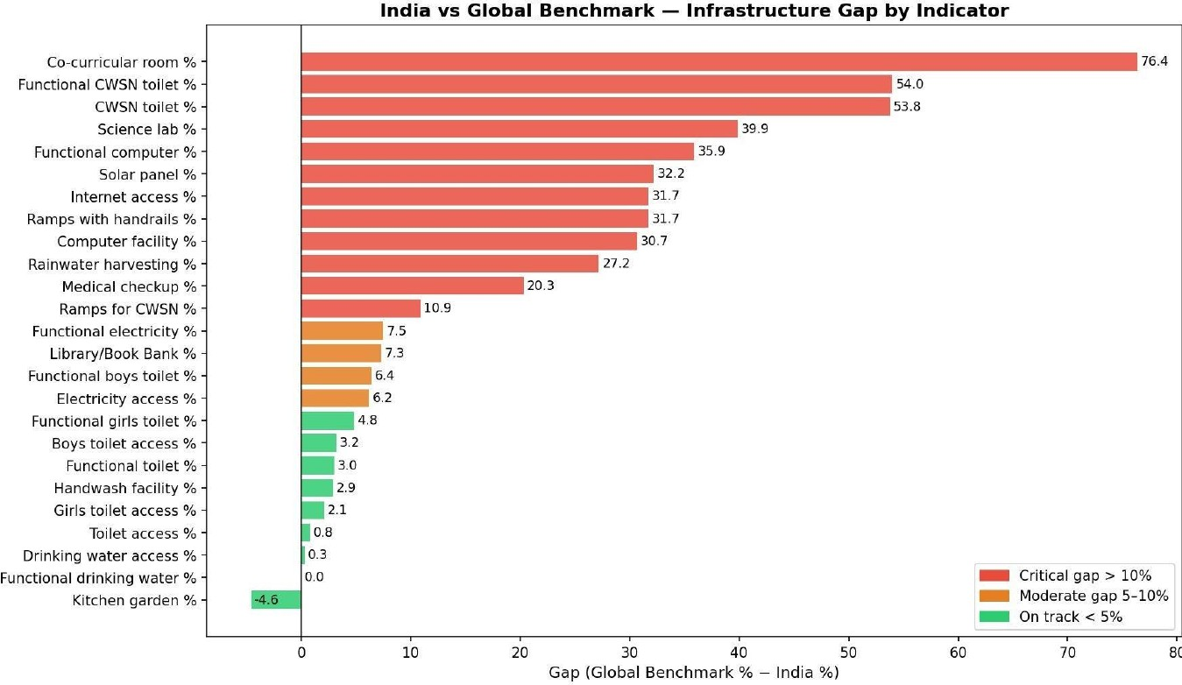
Fig. 1. India vs Global Benchmark — Infrastructure Gap by Indicator. Red: critical gap >10%; Orange: moderate 5–10%; Green: on track <5%.

TABLE II. Infrastructure Gap Analysis — India vs Global Benchmark

Indicator | India (%) | Gap (%)
Co-curricular Room | 15.6 | 76.4
Functional CWSN Toilet | 33.4 | 54.0
CWSN Toilet | 35.6 | 53.8
Science Laboratory | 57.1 | 39.9
Functional Computer | 57.9 | 35.9
Solar Panel | 10.8 | 32.2
Internet Access | 63.5 | 31.7
Computer Facility | 64.7 | 30.7
Rainwater Harvesting | 29.4 | 27.2
Medical Checkup | 75.5 | 20.3
Ramps with Handrails | 54.9 | 31.7
Ramps for CWSN | 79.1 | 10.9
Functional Electricity | 91.9 | 7.5
Library / Book Bank | 89.5 | 7.3
Electricity Access | 93.6 | 6.2
Handwash Facility | 95.9 | 2.9
Drinking Water Access | 99.3 | 0.3
Functional Drinking Water | 99.0 | 0.0

School-Type Comparison
Fig. 2 breaks down the infrastructure performance by the type of school management (Government, Government Aided, and) Little to nothing to the global standard in 10 major indicators.
A general trend is that unaided schools that are privately owned are doing better in digital and learning infrastructure than government schools (computers, internet, library) and government schools are on top of inclusion infrastructure (CWSN ramps, solar panels). This inversion implies that government spending on infrastructure has been directed towards compliance-oriented indicators instead

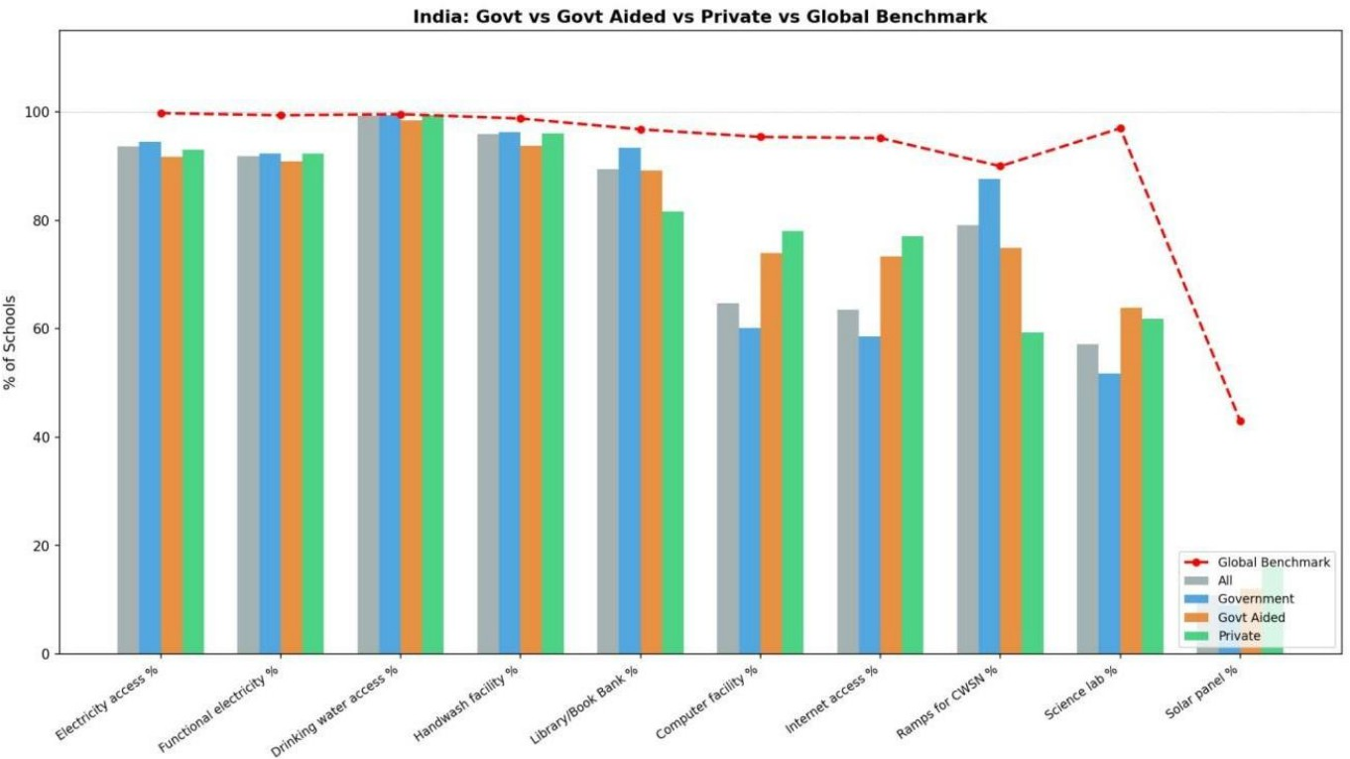
of improvement of learning environment.

Fig. 2. India: Government vs Government Aided vs Private Schools vs Global Benchmark (red dashed line). Private schools lead on digital infrastructure; government schools lead on inclusion infrastructure.

PREDICTIVE MODEL RESULTS

Regression Performance
Both regression models have good predictive power. Linear Regression achieves R² = 0.893 and MAE = 1.109. Random Forest achieves R² = 0.821 and MAE = 1.464. The greater R² of the linear model implies that it is rather linear relationship — infrastructure investment increases by the same percentage as dropout reductions. The R² = 0.893 finding means 89.3% of the change in state-level secondary dropout rates is described by scores on infrastructure gaps alone, without incorporating socioeconomic variables.
Fig. 3 displays the actual vs. predicted dropout rates in the Random Forest, with the states marked as interpretable.
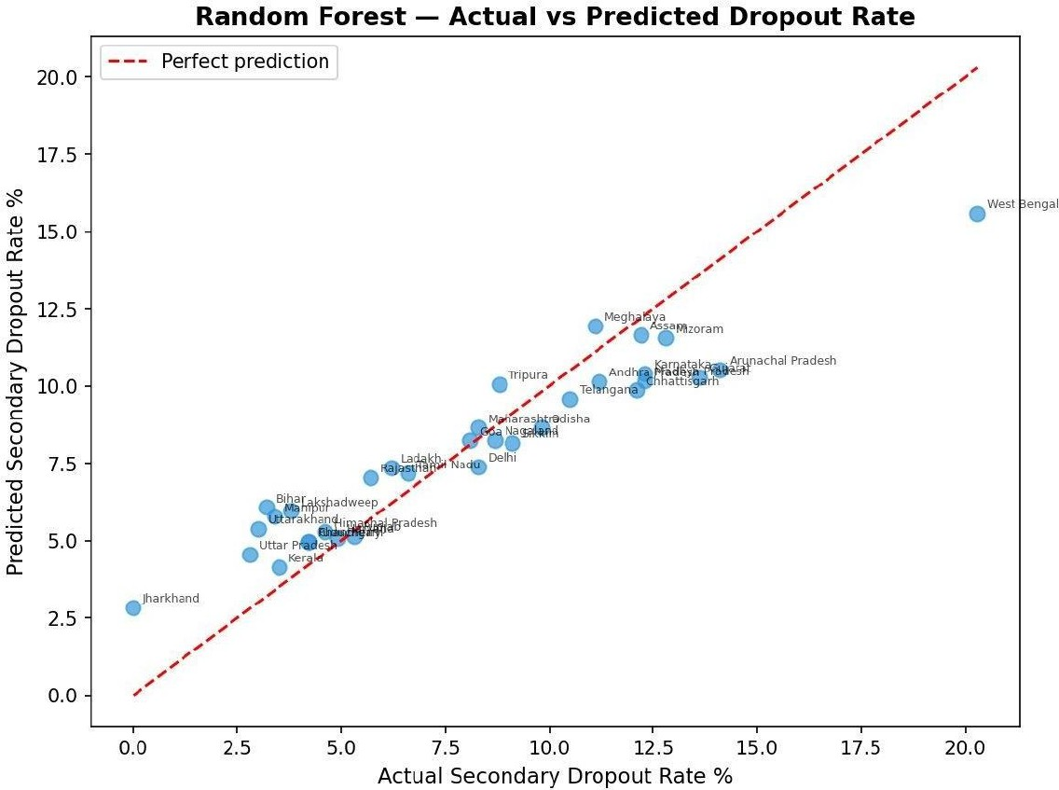
Fig. 3. Random Forest — Actual vs Predicted Secondary Dropout Rate. Points close to the red dashed line indicate accurate predictions. West Bengal (actual 20.3%, predicted 15.6%) is the largest outlier.

Feature Importance

Fig. 4 presents the scores of the Random Forest feature importance, which infrastructure gaps are the best predictors of dropout rate of second degree.
The best predictors include: (1) Co-curricular room gap, (2) Internet access gap, (3) Solar panel gap, (4) Science lab gap, (5) Boys toilet access gap. This shows a policy-critical but counter-intuitive result: infrastructure gaps are the most closely linked to dropout are connected with the learning environment co-curricular facilities, digital connections, science laboratories, etc. instead of sanitation. The policy implication is high: the historical infrastructure investment policy of India, the focus on sanitation, is not in line with the discontinuities that have the most direct impact on student retention.
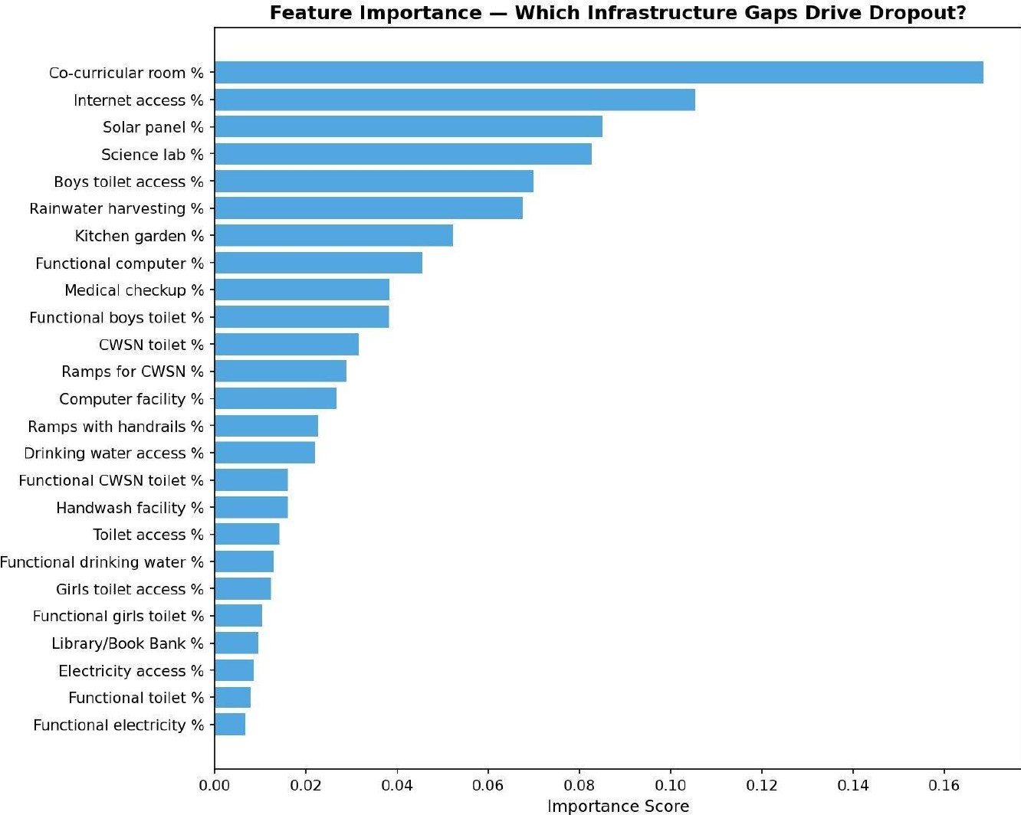
Fig. 4. Feature Importance — Which Infrastructure Gaps Drive Secondary Dropout? Co-curricular room and internet access gaps dominate, far ahead of basic sanitation indicators.

Notable Outliers
The highest prediction error (actual 20.3, predicted 15.6) is in West Bengal, which implies that there are other factors other than physical infrastructure are fueling dropout. Jharkhand is the inverse: large infrastructure discrepancy, but abnormally low actual dropout, which may be indicative of high levels of community involvement. These exceptions are fruitful paths to new qualitative research.

STATE INFRASTRUCTURE TIERS
There are four infrastructure tiers that are identified by K-means clustering. Table III summarises the characteristics of tiers and Fig. 5 visualises PCA space positions of the states.
TABLE III. K-means Clustering Results — State Infrastructure Tiers

Tier | States | Avg Gap | Avg Cost (Cr) | Representative States
Critical | 1 | 49.2 | 6,598 | Meghalaya
Developing | 5 | 32.6 | 1,283 | Arunachal Pradesh, Manipur, Mizoram, Nagaland, Tripura
Moderate | 16 | 20.9 | 19,038 | UP, Bihar, Rajasthan, MP, West Bengal, Karnataka
Advanced | 11 | 8.7 | 4,287 | Delhi, Kerala, Tamil Nadu, Maharashtra, Punjab

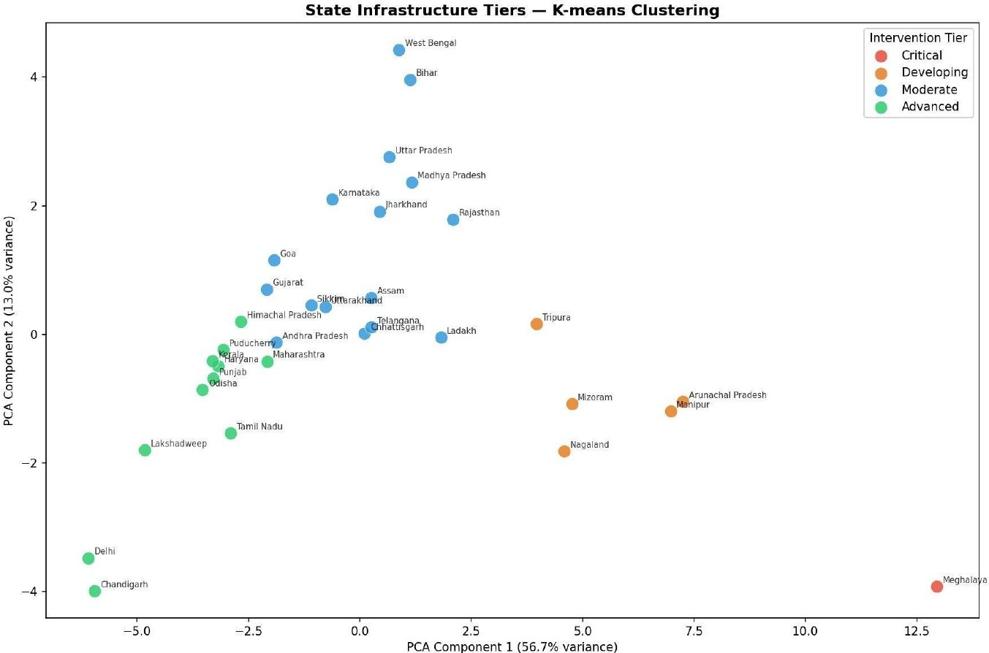
Fig. 5. State Infrastructure Tiers — K-means Clustering visualized via PCA (56.7% + 13.0% = 69.7% variance explained). Red: Critical; Orange: Developing; Blue: Moderate; Green: Advanced.
The Critical tier is comprised of Meghalaya itself (gap = 49.2, dropout = 11.1%), a true statistical outlier due to a very high low computer facility (5.2%), access to internet (7.1%), and availability of co-curricular room (3.4%). The Developing level includes five northeastern with high gap (32.6 avg) and moderate absolute investment requirement (avg. 1283 Cr) making them high-impact low-cost intervention targets. The Moderate category has 16 states including the most populous and that of India accounts for
₹3,04,607 Crore (82%) of total national investment. The Advanced level shows national attainability with 8.7 average gap
5.8 dropout rates.

ECONOMIC COST ESTIMATION
The estimation of the cost at national level per indicator is done in table IV. Investment requirements are state-wise as shown in Fig. 6.
TABLE IV. National Investment Required to Close Infrastructure Gaps ((₹ Crore)
Indicator | National Cost (Cr) | % of Total
Co-curricular Room | 1,12,465 | 30.2%
Science Laboratory | 90,902 | 24.4%
Computer Facility | 36,463 | 9.8%
CWSN Toilet | 27,749 | 7.5%
Solar Panel | 23,661 | 6.4%
Functional Computer | 21,249 | 5.7%
Functional CWSN Toilet | 15,912 | 4.3%
Rainwater Harvesting | 11,009 | 3.0%
Internet Access | 9,410 | 2.5%
All Other Indicators | 23,321 | 6.3%
TOTAL | 3,72,141 | 100%

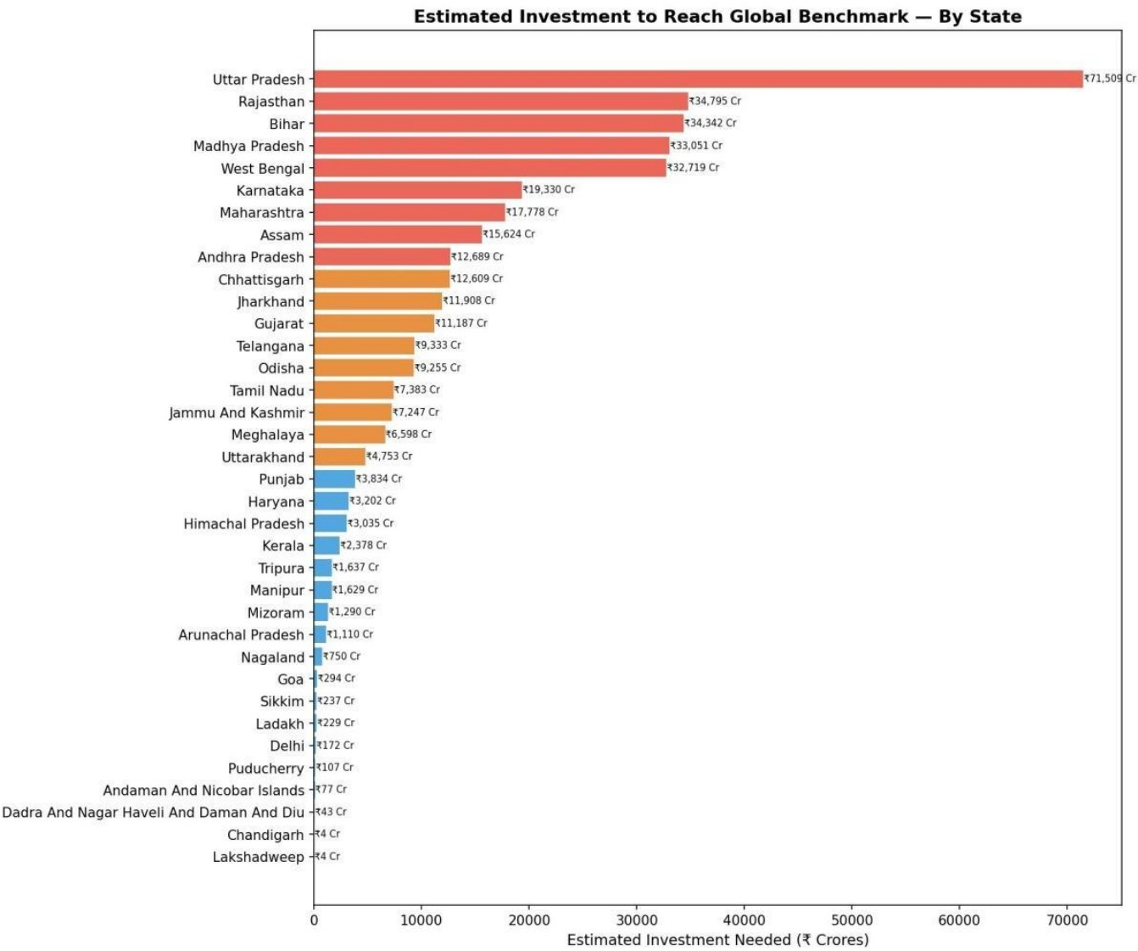
Fig. 6. Estimated Investment to Reach Global Benchmark — By State (₹ Crore). Uttar Pradesh alone requires ₹71,509 Crore. Top 5 states account for 55.5% of national requirement.
The cumulative estimated investment of 3,72,141 Crore (about USD 44.7 billion) can be estimated as about 2.5 years of India total education budget when channeled towards infrastructure alone. Science laboratories and co-curricular rooms require (₹2,03,367 Crore (54.6% of total). Most importantly, they are also the factors that have the most direct link with dropout cutting, developing a strong cost-benefit case to make them a priority over less expensive, less impactful interventions.

Investment Priority, State-wise
The biggest absolute investment is needed in Uttar Pradesh ((₹71,509 Crore), which has a school population of 262,358. The top 55.5% of national requirement is in five states. On a per-school basis, northeastern Developing-tier states have higher unit costs because of geographic remoteness, which implies a differentiated investment strategy, as opposed to a homogeneous national scheme.

DISCUSSION
This paper raises four issues which anyone in the education policy business in India ought to listen to.
The former is really good news - India has already or is almost up to date with the rest of the world in regard to basic sanitation in schools. Toilets, drinking water, handwash facilities - these have become far better than before and that has been an improvement deserves credit. The second discovery is where the worry is: the infrastructure that has a direct impact on whether a student remaining in school or dropping out is no longer sanitation, it is the character of the school atmosphere. Science labs, internet connections, activity rooms these are what are lacking with the students in the secondary level and this lack is silently fueling dropout numbers up. Third finding is encouraging. It’s not the case in all the Indian states. The states in the Advanced tier have already overcome most of these gaps, so if that is the case, it means that you can improve things - it is not some big leap, within the Indian system. Fourth is on the investment - it is significant, not unlimited nor fuzzy. The gap is with the level of investment of five to seven years closable.
Possibly the most surprising result of the study is the role of co-curricular rooms. Of all the things that we measured, only the absence of a separate room to do the activities, sports and non-academic things became the only best predictor of student drop out - even more than toilet, water and electricity. This has a message: When students are in high school, they are not likely to drop out because of lack of hygiene. They drop out because they are bored, uninvolved and the school environment is like “me and the blackboard”. This finding is consistent with other studies from other countries - engagement and belonging to the school are as important as the physical environment. Secondly, we can mention that the model built in this study is not “one-time”. As every year the UDISE+ data is released, the pipeline may be re-run using the same to ensure the progress has been made from the 2024-25 baseline. This makes this a living tool, rather than a paper.

CONCLUSION

What’s it all about? We now have the picture - how much deficit Indian schools are in, globally, what are the gaps responsible for the drop-outs and what a deficit each state is in and how much it will cost to address it. The numbers don’t lie. Nearly 90% of the infrastructure deficit is causing the gaps in the drop-out rates we have in India. And the issues are not what we think - the lack of a place for co-curricular activities or a school not having internet is more damaging than a leaking tap to retention. That’s something policy makers need to be aware of. It will cost us around (₹3.72 lakh crore to fix these problems in the country but rather than that being a metaphor, our model will tell you where to spend - state by state and school by school. It is a product that can in fact go into Samagra Shiksha budgets. What we need in the future is more detail, including incomes and social, looking at smaller kids, making sure the time spent is resulting in progress. But the structure erected here provides India with something new: an open, transparent, factual base.

ACKNOWLEDGMENT
The authors thank the Ministry of Education, Government of India, for making the UDISE+ 2024-25 data public. We get the benchmark values from UNESCO UIS, OECD Education at a Glance 2023 and World Bank EdStats.

REFERENCES
- P. Barrett, A. Treves, T. Shmis and D. Ambasz, The Effect of School Infrastructure on Learning: A Synthesis of the Evidence, World Bank Group, Washington, DC, 2019.
- A. A. Nugroho and U. B. Wibowo, The Influence of School Infrastructure on Student Learning Activeness, Atlantis Press, 2020.
- S. K. Mahapatra and H. Goowalla, A Study on Educational Infrastructure Facilities being provided by Government and non-Government schools in Nagaland, International Journal of Education and Research, 2019.
- E. T. Octavia and Ismiyati, How Do School Facilities Affect School Quality? Journal of Educational Management Studies, 2020.
- J. E. Vargas-Munoz et al., A Multi-tiered Human-in-the-loop Approach to Interactive School Mapping with Earth Observation and Machine Learning, Remote Sensing, vol. 13, no. 3, 2021.
- Ministry of Education, Government of India, UDISE+ 2024-25: Booklet on NEP Progress, Department of School Education and Literacy, New Delhi, 2025.
- OECD, Education at a Glance 2023: OECD Indicators, OECD Publishing, Paris, 2023. doi: 10.1787/e13bef63-en
- UNESCO Institute of Statistics, Education Data, UIS Data Centre, Montreal, 2024. [Online]. Available: http://data.uis.unesco.org
- L. Breiman, Random Forests, Machine Learning, vol. 45, pp. 5–32, 2001.
- J. MacQueen, Some Methods of Classification and Analysis of Multivariate Observations, Proc. Berkeley Symposium on 5th Vol. 1, pp. Mathematical Statistics and Probability. 281–297, 1967.
- Ministry of Education, India, Samagra Shiksha: Framework to be implemented, Department of School Education and Literacy, New Delhi, 2018.
- World Bank, World Development Indicators: Education Statistics, World Bank Open Data, Washington, DC, 2024. [Online]. Available: https://databank.worldbank.org/source/education-statistics

