Quantitative Analysis of Calcium Transients in an Epithelial Cell Layer in Vivo upon Cytoskeleton Disruption
A computational reproduction of the authors' own analysis draft, generated directly from pipeline outputs on the same imaging data
CAFIN pipeline · rigid ECC registration (elastic B-spline available) · Cellpose cyto3 segmentation · ΔF/F₀ analysis

Abstract
Calcium (Ca²⁺) signaling coordinates mechanical and biochemical responses across epithelial tissues, but quantifying spatiotemporal Ca²⁺ dynamics in vivo is complicated by tissue motion and deformation during live imaging. We present a scripted computational framework (CAFIN) for rapid analysis of Ca²⁺ transients in the zebrafish larval fin epithelium under cytoskeletal perturbation. Time-lapse recordings were motion-corrected with a two-way registration strategy — global rigid alignment via OpenCV's enhanced correlation coefficient (ECC) and non-rigid B-spline registration via SimpleITK — performed on the membrane channel and propagated to the calcium channel. Single cells were segmented on the reference frame with Cellpose, and per-cell ΔF/F₀ traces were extracted across the entire field. Comparing baseline activity to Latrunculin-induced actin disruption across two independent trials (484+479 baseline cells vs 517+452 treated cells), actin disruption consistently increased transient frequency, mean ΔF/F₀ and per-frame transient area, and raised tissue-level spatial heterogeneity of peak amplitude (CV 0.72 → 1.13) and temporal coordination (mean pairwise correlation 0.25 → 0.45) — in the same direction in both trials. Because only two biological replicates were available per condition, we report the per-trial direction of effect as the primary evidence (Table 1); pooled single-cell distributions are descriptive support only (large cell counts yield very small p-values but treat cells, not animals, as replicates). This work reproduces the authors' own analysis pipeline on the same data, establishing internal reproducibility rather than independent replication, and provides a generalizable scripted approach for quantifying Ca²⁺ dynamics in deformable tissues.

1. Introduction
Cytosolic calcium is a ubiquitous second messenger governing exocytosis, contraction, proliferation and morphogenesis. In epithelia, Ca²⁺ waves propagate across the sheet to coordinate collective behaviors such as migration, contraction and wound response. Because the actin cytoskeleton mechanically couples cells and gates mechanosensitive channels, disrupting actin is expected to reshape Ca²⁺ dynamics. Latrunculin B inhibits actin polymerization by sequestering monomeric G-actin, depolymerizing F-actin and thereby altering membrane tension and mechanosensitive-channel activity, which can trigger Ca²⁺ influx and intercellular waves.
The zebrafish larval fin epithelium is optically transparent and pharmacologically accessible, making it ideal for single-cell Ca²⁺ imaging. However, extracting quantitative traces in vivo is hindered by global drift and local deformation, which distort spatial mapping and temporal correlation of activity. We address this with a scripted pipeline that (i) motion-corrects on a stable membrane channel, (ii) segments single cells, and (iii) extracts and statistically compares Ca²⁺ dynamics between baseline and cytoskeletal-disruption conditions.

2. Materials and Methods
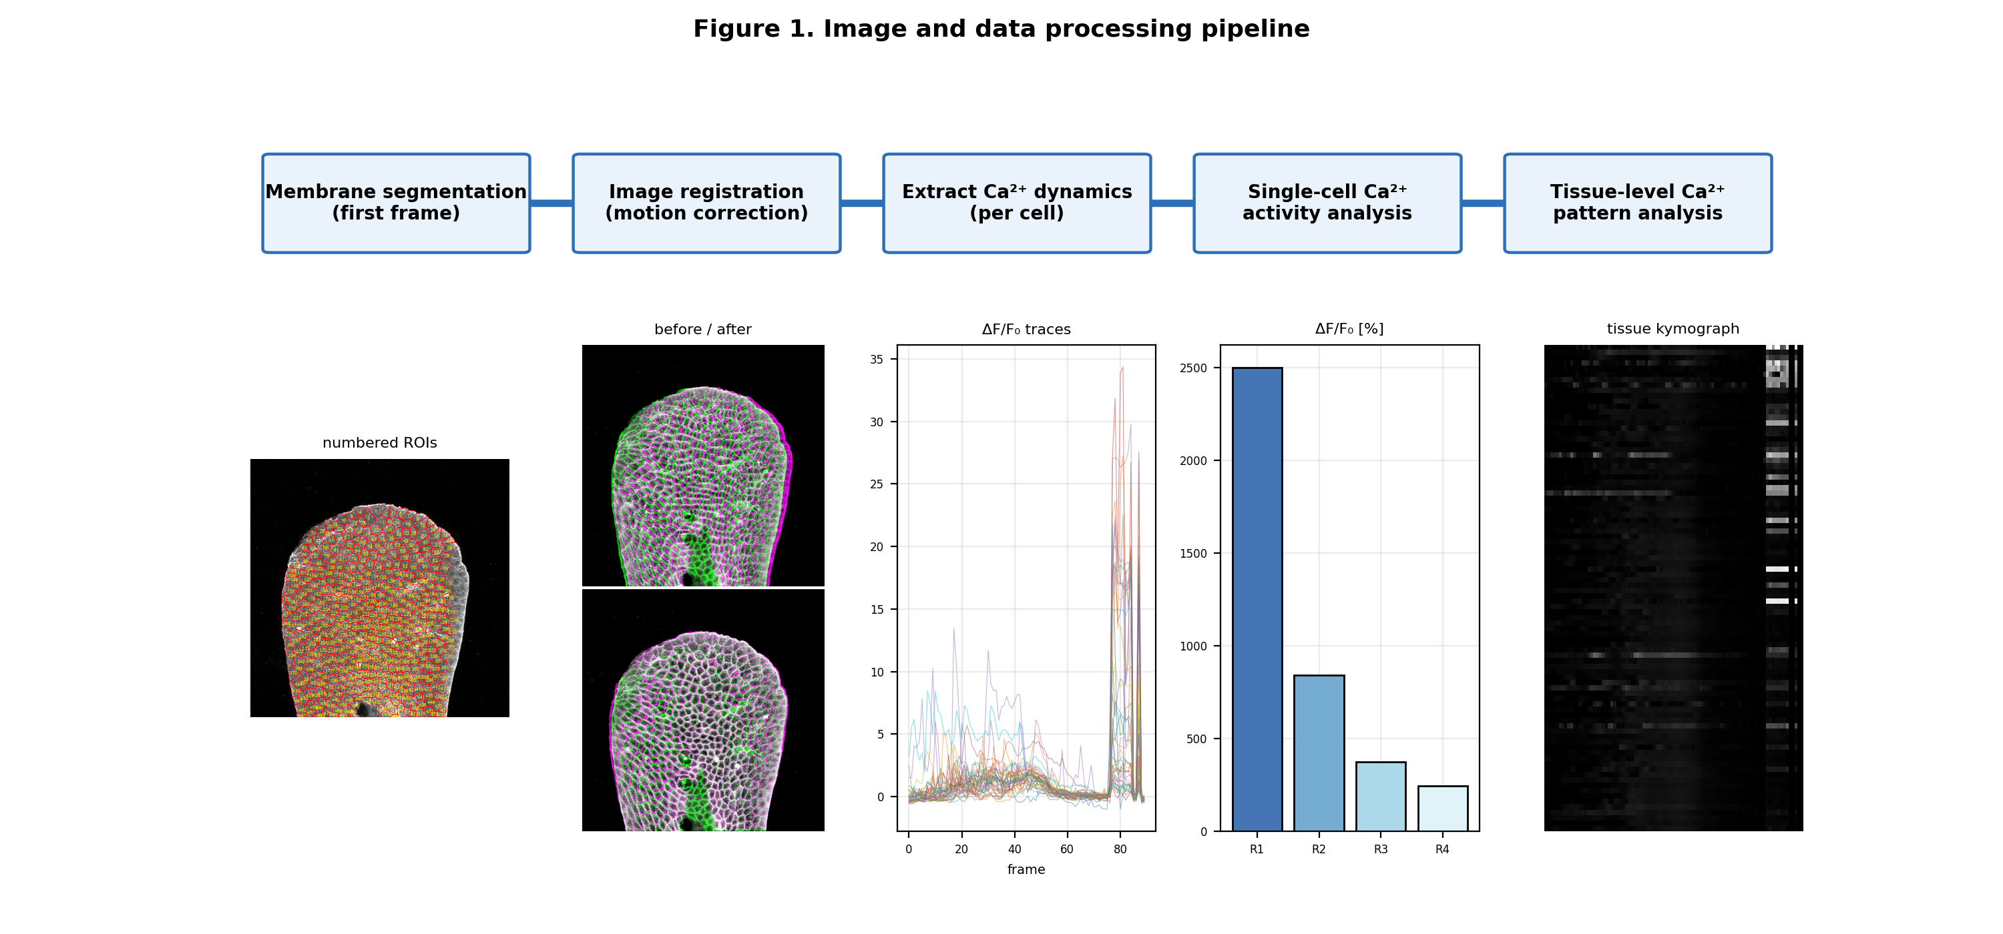
Figure 1. Image and data-processing pipeline: membrane segmentation → registration (motion correction) → per-cell Ca²⁺ extraction → single-cell and tissue-level analysis. Panels are real outputs from the LATA1 dataset.

2.1 Imaging and preparation
Zebrafish larvae (3 dpf) expressing a genetically encoded Ca²⁺ indicator were imaged on a confocal microscope. The green channel reported cytosolic Ca²⁺; a membrane label provided a structurally stable red channel. Latrunculin A/B (final ~200 µM in 1% DMSO) was applied immediately before imaging as the actin-disrupting perturbation; DMSO served as vehicle. Each field was recorded before (baseline) and after treatment.

2.2 Two-way image registration
Registration was performed on the membrane channel and the resulting transform applied to the calcium channel to preserve cross-channel correspondence. For mild translational/rotational motion, rigid registration used OpenCV's Enhanced Correlation Coefficient (ECC) algorithm (Euclidean model: rotation + translation) aligning every frame to frame 0. For pronounced deformation, non-rigid registration used a SimpleITK B-spline transform with Mattes mutual information as the similarity metric and an LBFGS-B optimizer; control-point grid, iterations and step size were tuned empirically. On the recordings analyzed here the large post-treatment motion was predominantly global (translation and rotation), which rigid ECC corrected well; elastic B-spline gave only a marginal additional reduction in residual (Figure 3), so rigid registration was used for the quantitative results.
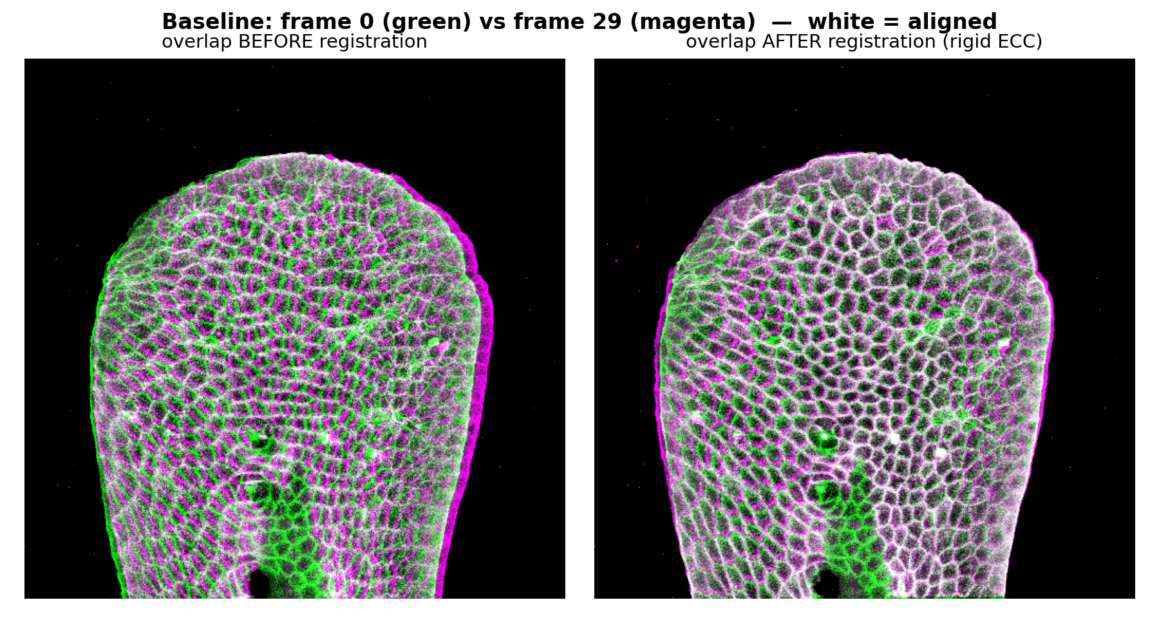
Figure 2. Registration overlay, baseline (green = reference frame 0, magenta = moving frame; white = aligned). Before registration the moving frame is offset; after ECC alignment the channels overlap.
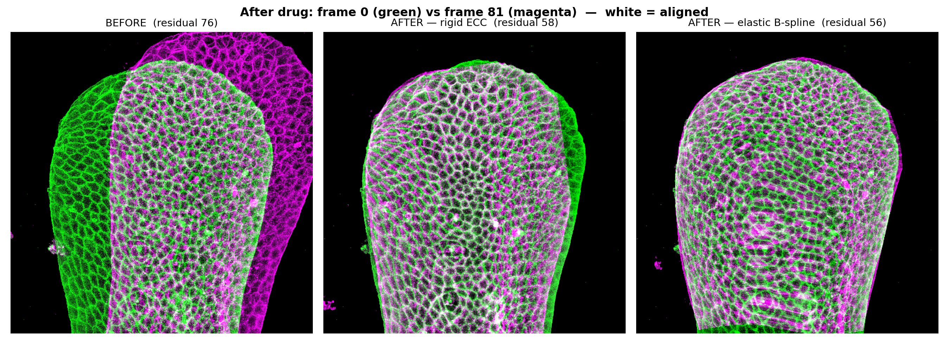
Figure 3. Rigid-vs-elastic registration after Latrunculin B (frame 0 green, moving frame magenta; white = aligned). The large post-treatment motion is predominantly global: rigid ECC substantially reduces the mean membrane residual (annotated on each panel), and elastic B-spline yields only a marginal further improvement on this recording. Rigid registration was therefore used for the quantitative analysis; elastic remains available for datasets with strong local deformation. Residual = mean absolute membrane mismatch over tissue pixels.

2.3 Segmentation and trace extraction
Single cells were segmented on the registered reference-frame membrane image with the Cellpose cyto3 model (channels=[2,0], cell diameter ≈ 15 px), yielding an integer-labeled mask. Frame-by-frame background subtraction was applied to the calcium channel. Three background reference regions were selected automatically as the lowest-median image tiles — a scripted proxy for the original protocol's manual selection of signal-free regions; per frame, values outside 1.5×IQR were removed, each region reduced to its median, and the average of the three medians subtracted from every pixel and clipped at zero. For each cell, the mean pixel intensity inside its mask was measured per frame to give a fluorescence trace, normalized as ΔF/F₀ = (Fₜ − F₀)/F₀, where F₀ is the mean of the lowest-activity frames.
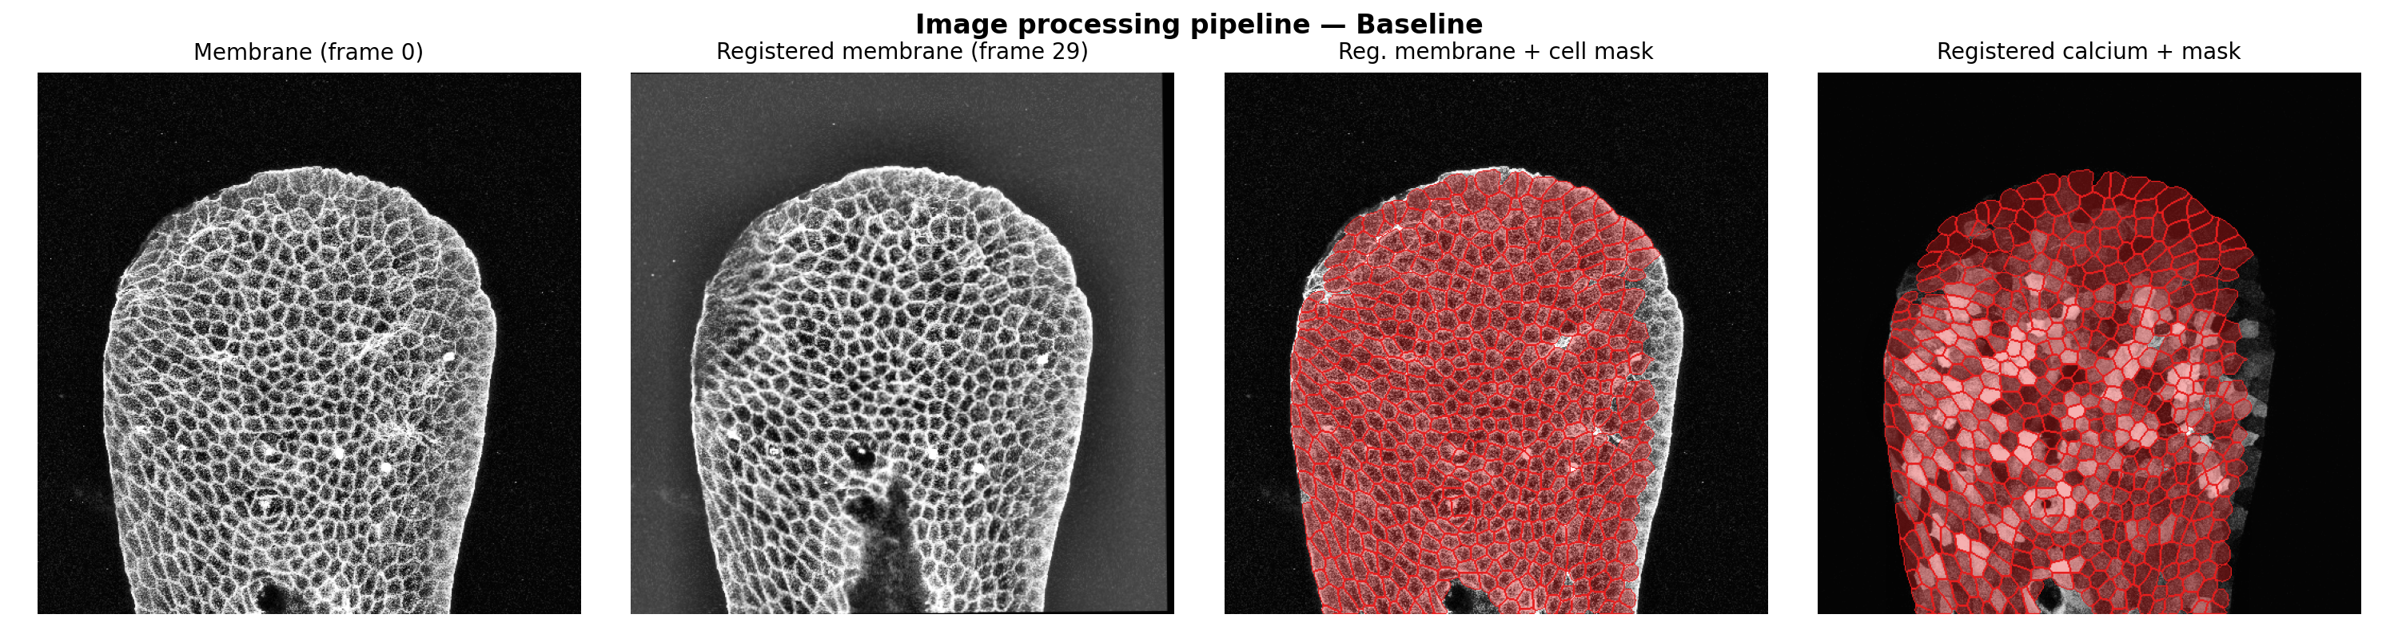
Figure 4. Processing sequence: raw membrane frame 0, registered membrane, registered membrane with the Cellpose cell mask (red), and the registered calcium channel with the same mask — the ROIs used for per-cell trace extraction.
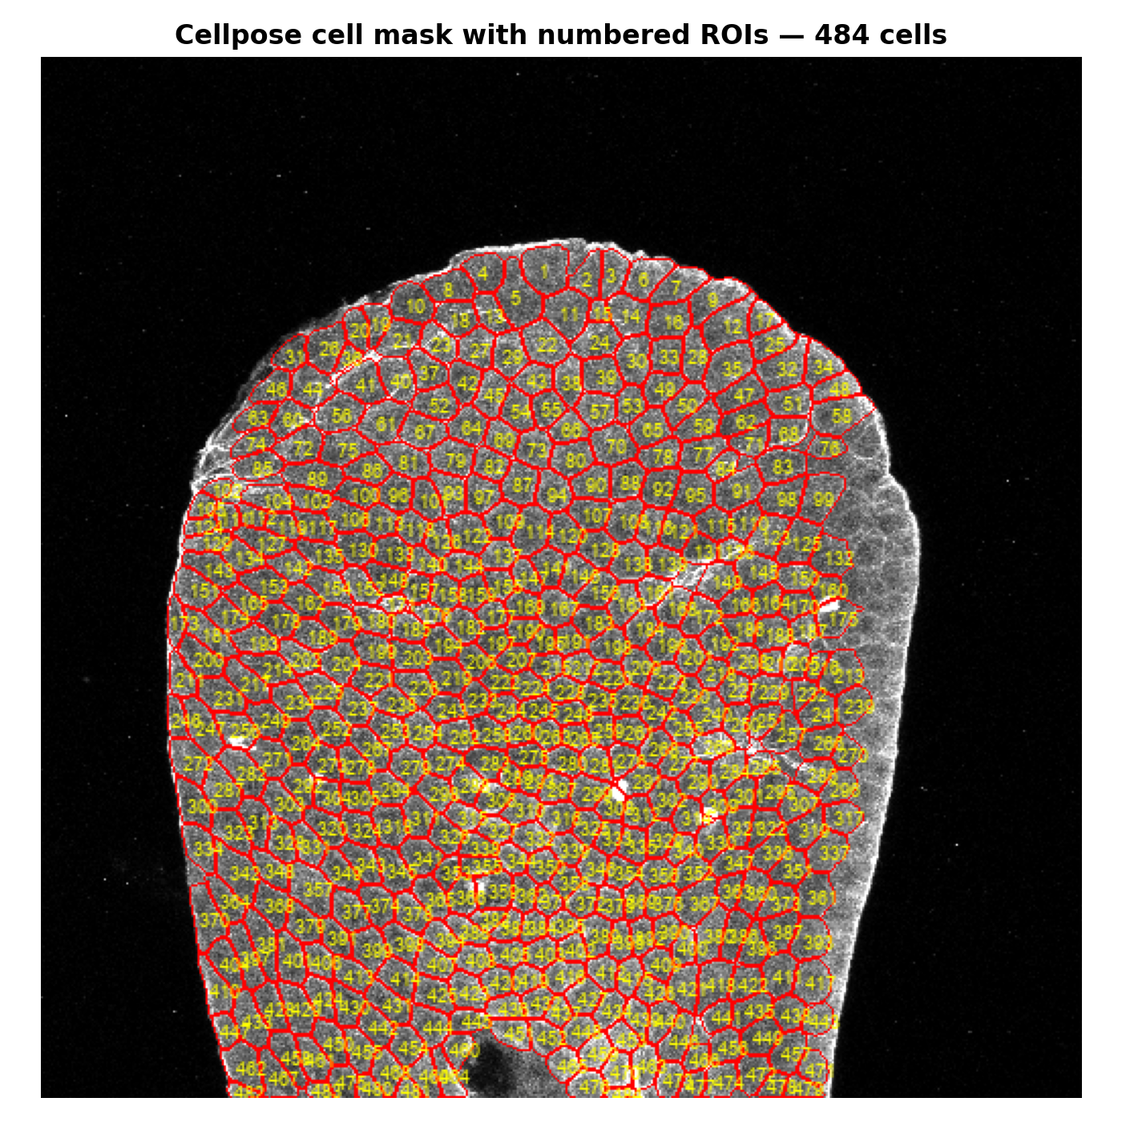
Figure 5. Cellpose segmentation of the reference membrane frame with numbered cell ROIs (484 cells). Each labeled region defines one cell's ROI across all frames.
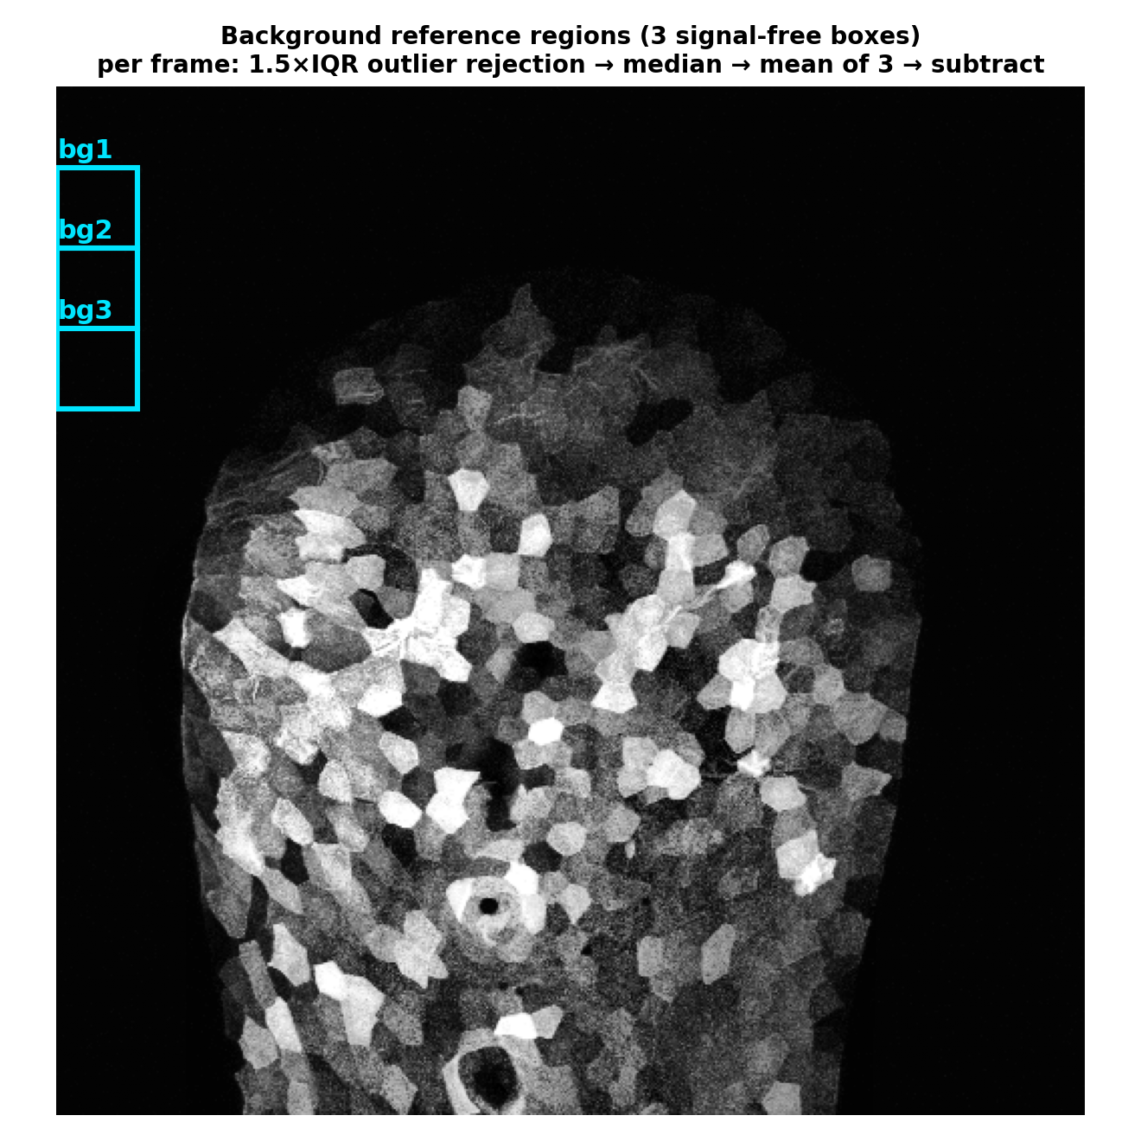
Figure 6. Background subtraction: three signal-free reference regions (cyan boxes) on the calcium frame. Per frame, values outside 1.5×IQR are discarded, each region reduced to its median, and the mean of the three medians is subtracted and clipped at zero.
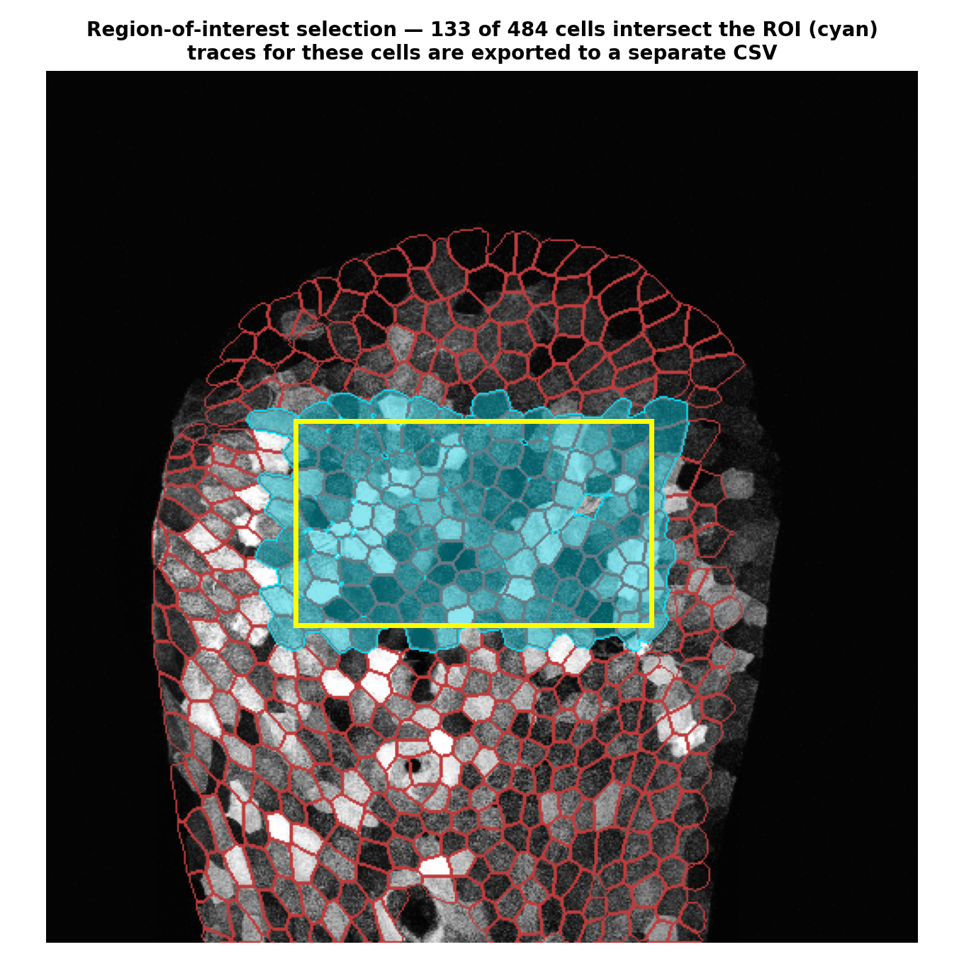
Figure 7. Region-of-interest selection: a rectangular ROI (yellow) is drawn on the first calcium frame, and every segmented cell whose mask intersects the ROI (cyan) is retained; the traces of these cells are exported to a separate CSV, so analysis can be restricted to a reliable in-view subset.

2.4 Metrics and statistics
Per cell we computed peak ΔF/F₀, mean ΔF/F₀, transient count (SciPy find_peaks, height 0.5, min distance 2 frames), transients per frame, and per-frame supra-threshold area (AUC). At the tissue level we computed the active fraction, spatial heterogeneity (coefficient of variation of per-cell peak amplitude across the field) and temporal synchronization (mean pairwise Pearson correlation among active cells). Spatial coordination was assessed as pairwise correlation versus inter-cell centroid distance. For each comparison, normality was tested with the Shapiro–Wilk test on both groups; where both groups were normal a two-sided Welch t-test was used (a close variant of the original protocol's Student t-test), otherwise the Mann–Whitney U test (the actual test used per metric is reported in the appendix). Effect size is the rank-biserial correlation; regional R1–R4 differences used the Kruskal–Wallis omnibus test (no post-hoc pairwise correction). Importantly, only two biological replicates (trials) were available per condition. The pooled single-cell tests therefore treat individual cells as replicates (pseudoreplication) and their p-values quantify separation of the cell populations, not biological-replicate significance; the per-trial direction of effect (Table 1) is the primary evidence. All analyses are deterministic (fixed random seed) and reproduced by a single script.

3. Results

3.1 Single-cell activity increases after actin disruption
Because only two biological trials were available per condition, we take the per-trial direction of effect (Table 1) as the primary evidence. Transient frequency, mean ΔF/F₀ and spatial heterogeneity increased in both independent trials after treatment. The effect is not uniform across every metric: the median peak amplitude rose in trial 1 (2.14→5.40) while decreasing in trial 2 (2.14→1.64), where the field instead became markedly more heterogeneous (CV 0.68→1.34). The consistent cross-trial signature of actin disruption is therefore increased transient frequency and spatial heterogeneity rather than a uniform amplitude increase (Figures 8–10).
Table 1. Per-trial summary (both conditions). trial1 = LATA1 (stored ΔF/F₀ CSVs previously computed from raw images); trial2 = LATA2 (existing pipeline CSVs; raw TIFFs unavailable).
Trial / condition | Cells | Active % | Median peak ΔF/F₀ | Heterogeneity CV | Sync r
trial1 Baseline | 484 | 96 | 2.14 | 0.77 | 0.260
trial1 Latrunculin | 517 | 100 | 5.40 | 0.92 | 0.532
trial2 Baseline | 479 | 98 | 2.14 | 0.68 | 0.241
trial2 Latrunculin | 452 | 99 | 1.64 | 1.34 | 0.366
As descriptive support, we also pooled the single cells across both trials (963 baseline vs 969 treated cells). Median transient rate rose from 0.097 to 0.178 transients/frame, mean ΔF/F₀ from 0.36 to 1.11, and per-frame supra-threshold area 3.5-fold; Shapiro–Wilk rejected normality for every metric, so the Mann-Whitney U was applied (Appendix). These pooled comparisons yield extremely small p-values, but because they treat cells rather than animals as replicates (n = 2 trials), the p-values should be read as a measure of population separation, not as biological-replicate significance. Two caveats apply: the pooled peak-amplitude comparison spans unequal recording lengths (baseline 31 vs treated 55–90 frames), so a maximum-based metric is only weakly comparable — the length-normalized transient rate and per-frame area are the sound metrics; and 2 of the 4 fields (the LATA2 trial) derive from the pipeline's pre-existing ΔF/F₀ CSVs because their raw TIFFs were unavailable. The stored LATA1 CSVs were previously produced by the documented registration→cyto3→background→ΔF/F₀ chain (see §5).
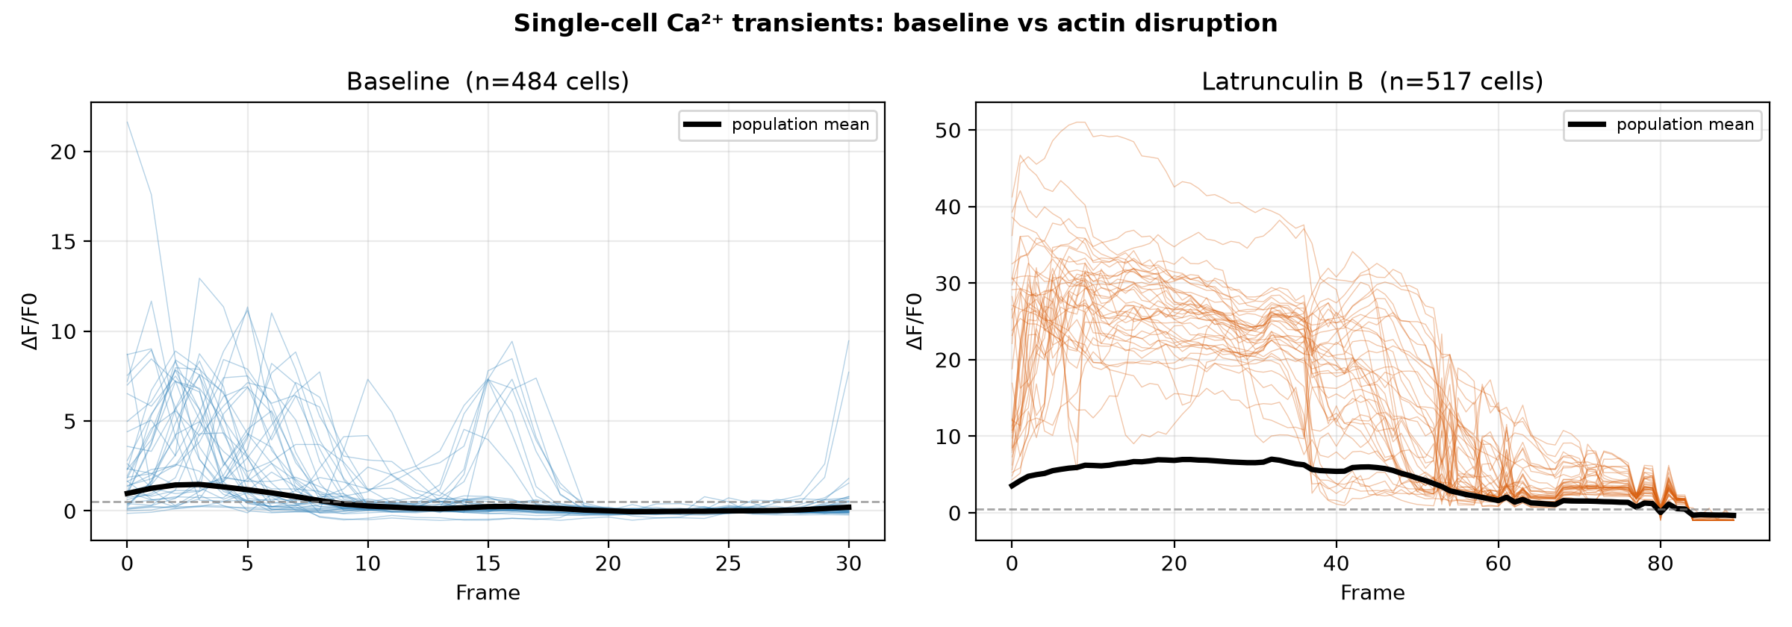
Figure 8. Representative single-cell ΔF/F₀ traces (40 most active cells; black = population mean; dashed line = transient threshold). Baseline transients are brief and modest; after Latrunculin B they are large and sustained.
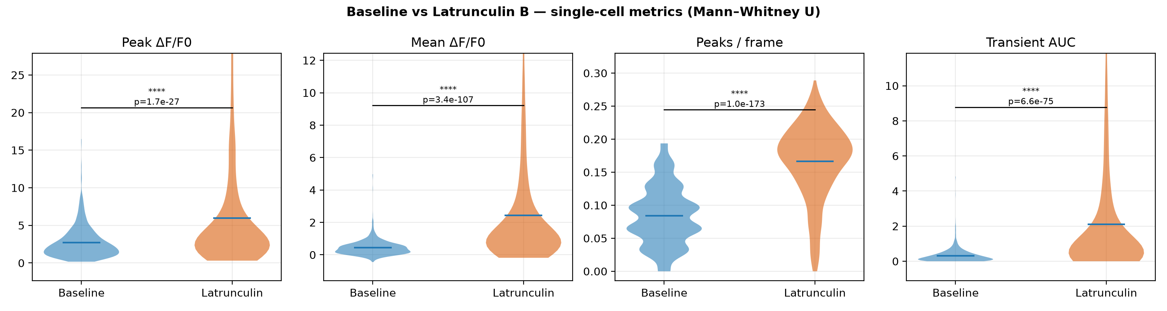
Figure 9. Single-cell metric distributions, baseline vs Latrunculin B, pooled across two trials (descriptive; the pooled per-cell p-values annotated here are pseudoreplicated — see §3.1). The length-normalized transient rate and per-frame area are the sound metrics.
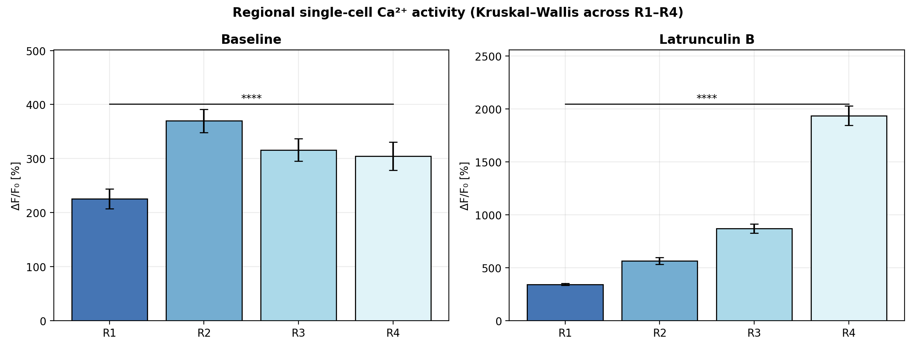
Figure 10. Regional single-cell activity (peak ΔF/F₀, %). Cells were split into four equal proximal-to-distal bands (R1–R4) by centroid y-position; bars are region means ± SEM. Regional differences are significant in both conditions (Kruskal–Wallis, **** p<1e-4), and the spatial activity pattern differs between baseline and treatment.

3.2 Tissue-level Ca²⁺ patterns and spatial heterogeneity
At the tissue scale, the activity map changed from sparse, low-amplitude flickers at baseline to dense, high-amplitude activity after treatment (Figures 11–12). Spatial heterogeneity of peak amplitude increased in both trials (CV [0.769, 0.677] at baseline → [0.924, 1.341] after treatment), consistent with a loss of uniform, coordinated responses across the sheet.
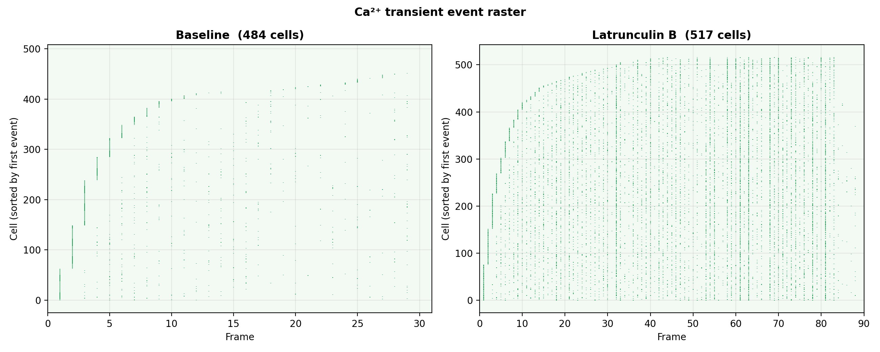
Figure 11. Ca²⁺ transient event raster (each tick = a detected transient; cells sorted by first event). Baseline activity is sparse; Latrunculin B produces dense, sustained events.
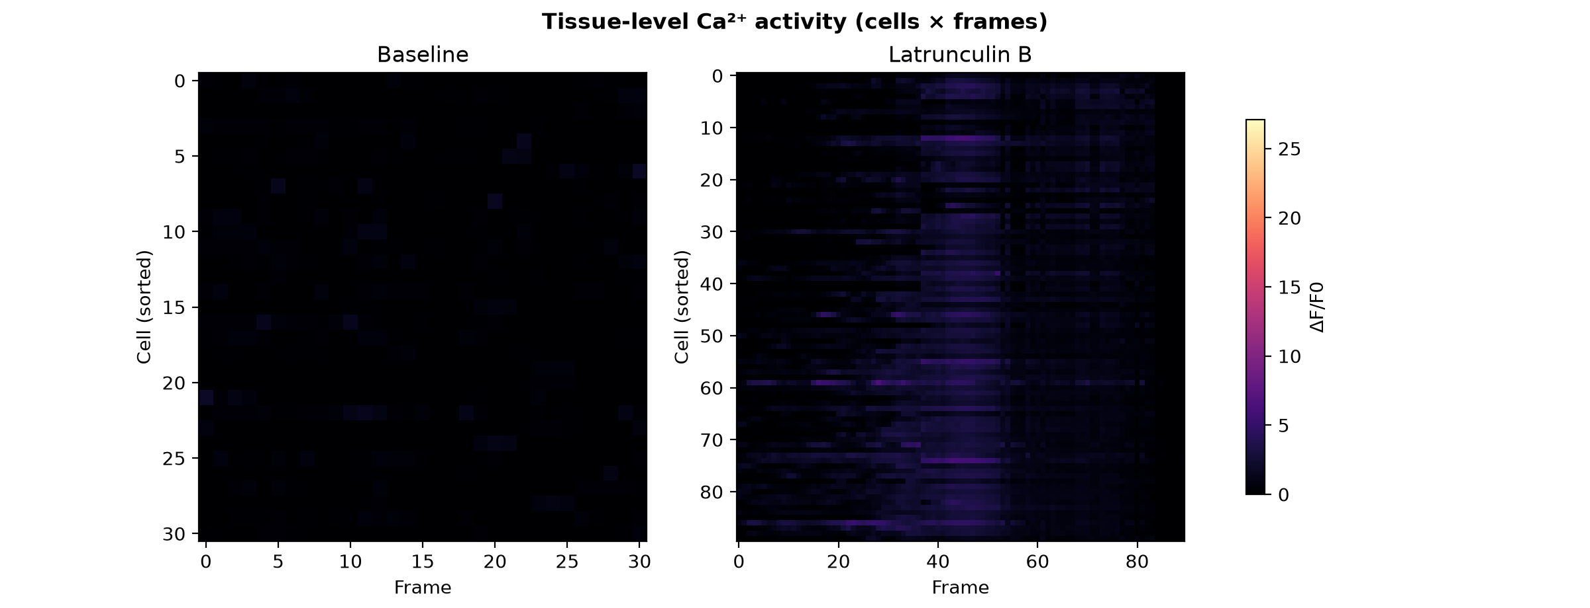
Figure 12. Tissue-level activity heatmaps (cells × frames, shared color scale). Left: baseline. Right: Latrunculin B shows pervasive, high-ΔF/F₀ activity.
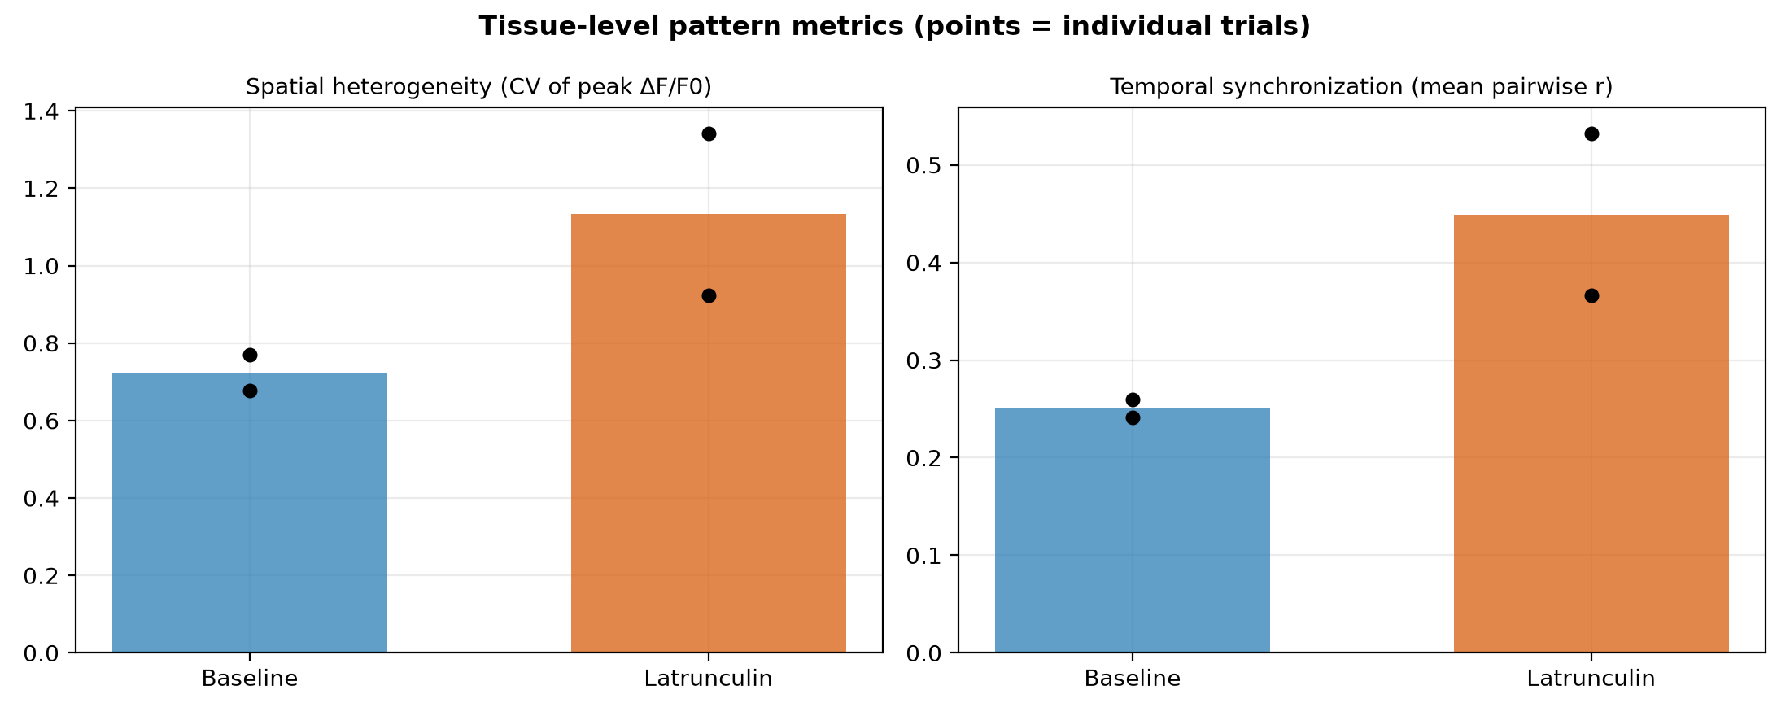
Figure 13. Tissue-level pattern metrics (bars = condition mean; points = individual trials). Spatial heterogeneity and temporal synchronization both rise after actin disruption.

3.3 Spatial coordination of Ca²⁺ activity
Pairwise correlation decayed with inter-cell distance in both conditions, but was elevated at every distance after Latrunculin treatment, with the strongest short-range coordination (Figure 14). The mean pairwise correlation among active cells rose from 0.25 to 0.45, and the pooled pairwise-correlation distribution shifted significantly upward (p < 1e-300, Mann–Whitney U). Thus actin disruption both amplifies and restructures the spatial coordination of epithelial Ca²⁺ signaling.
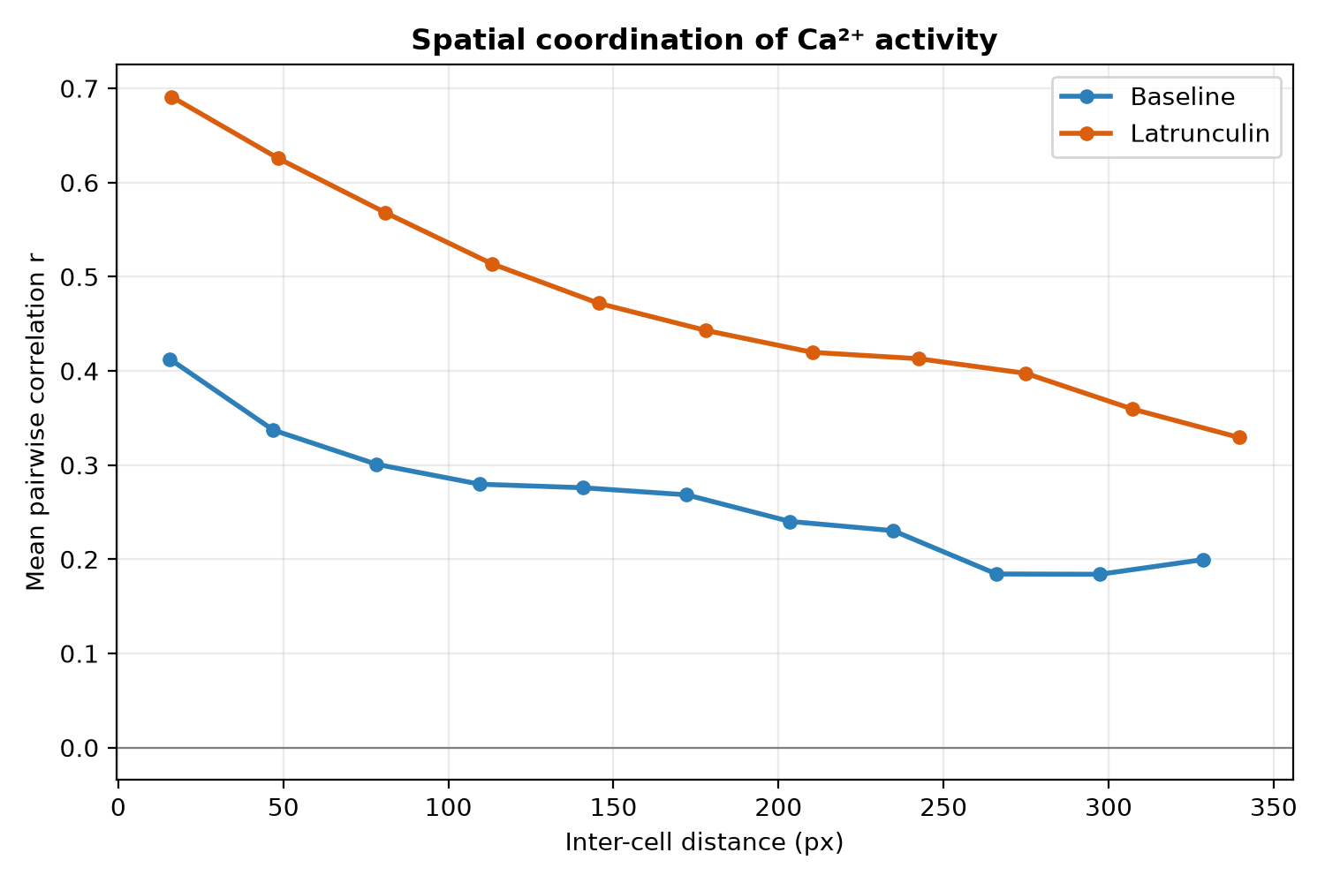
Figure 14. Mean pairwise correlation versus inter-cell centroid distance, pooled per condition. Latrunculin B raises coordination across all distances.

3.4 Time-dependence of the response
Within the post-treatment recordings, mean per-cell peak amplitude varied across early, middle and late imaging windows, indicating that the Latrunculin response evolves over the recording rather than being static (Figure 15). This within-recording variation is suggestive of progressive actin depolymerization, but the present data — a single continuous post-treatment recording per trial — do not extend long enough to establish recovery or adaptation; testing that would require longer or repeated late-timepoint imaging.
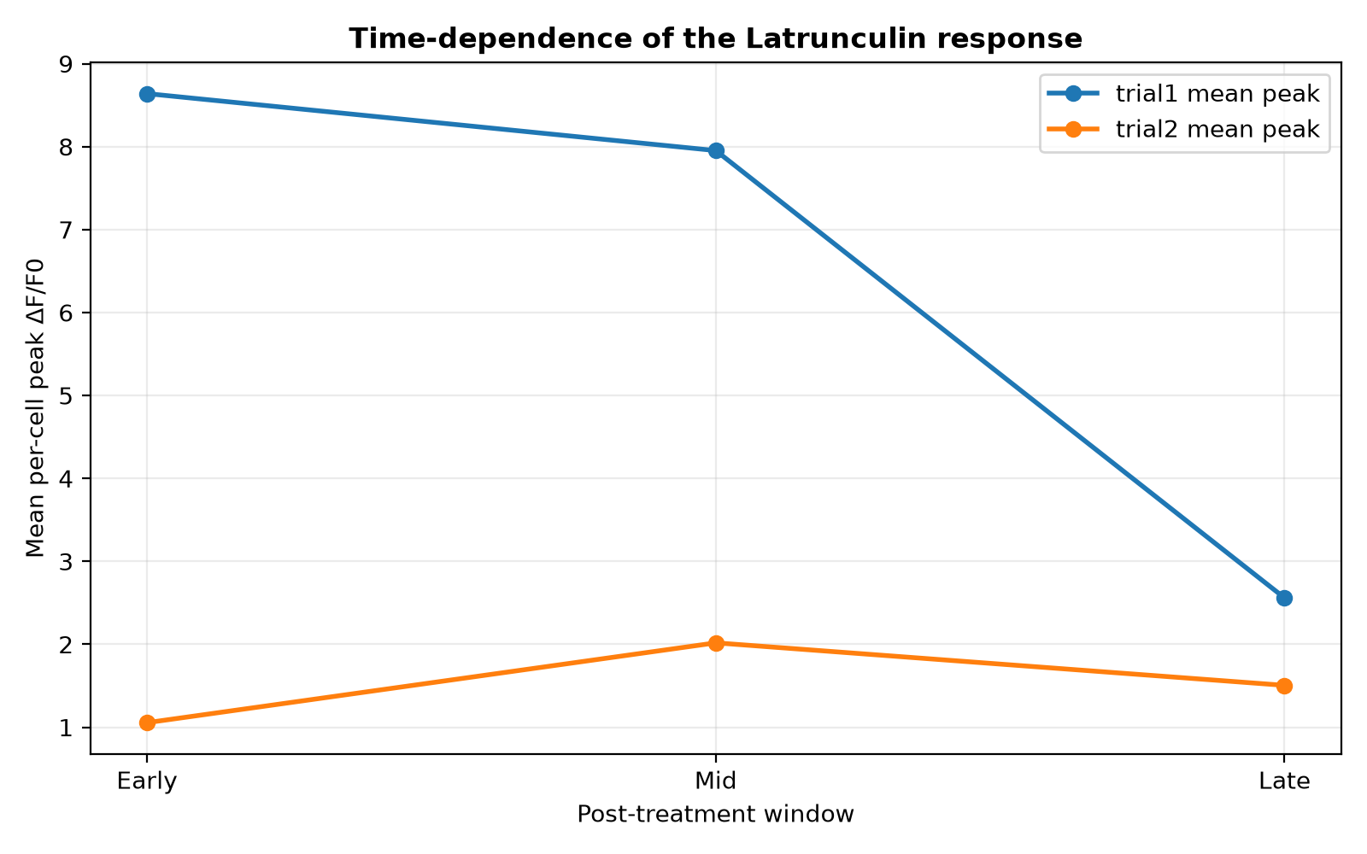
Figure 15. Time-dependence of the response: mean per-cell peak ΔF/F₀ across early/mid/late windows for each treated field.

4. Discussion and Conclusion
Using a scripted, deterministic pipeline we quantified how actin disruption reshapes epithelial Ca²⁺ dynamics in vivo. In both trials, Latrunculin B increased single-cell transient frequency and mean ΔF/F₀, raised spatial heterogeneity of peak responses, and elevated inter-cellular correlation relative to baseline. These changes are consistent with actin depolymerization altering membrane tension and mechanosensitive-channel activity, promoting Ca²⁺ influx and intercellular propagation while degrading the uniform, finely balanced signaling seen in the intact tissue. Because the study rests on two biological replicates per condition and reproduces the authors' own draft analysis on the same imaging data, these results establish the internal reproducibility and direction of the effect rather than independent, statistically powered confirmation.
The methodological contribution is a scripted registration front-end offering both rigid (ECC) and non-rigid (B-spline) correction; on the recordings analyzed here the motion was predominantly global and rigid registration sufficed, with elastic evaluated but not required (Figure 3). Limitations include reliance on a stable membrane label for registration, a single reference-frame segmentation without explicit cross-time cell tracking, and a small number of biological replicates. Future work could add deep-learning non-rigid tracking, real-time registration and 3D volumetric imaging, increase replication, and combine cytoskeletal mutants with this platform to dissect specific actin–Ca²⁺ couplings.

5. Reproducibility and data provenance
The numerical results and six quantitative figures above were regenerated from the included per-cell ΔF/F₀ CSVs by reproduce.py; generate_paper.py assembled this document. The nine paper-style microscopy figures are previously generated assets retained with this repository; the original TIFFs were unavailable in this run. This run used stored LATA1 CSVs previously recomputed from raw TIFFs; it did not rerun registration, segmentation, or fluorescence extraction from raw images. The LATA2 fields use the pipeline's existing CSVs because their raw TIFFs are unavailable. Stored CSVs previously derived from raw images cover 2 of 4 fields (LATA1 before/after). Field provenance is recorded in field_summary.csv. Analyses use a fixed random seed; see README_REPRODUCE.md.

Appendix: reproduced summary statistics
Statistical tests. Normality assessed by Shapiro–Wilk on each group; Welch t-test if both normal, otherwise Mann–Whitney U. Effect = rank-biserial.
Metric | Median base | Median Lat | Shapiro p (base/Lat) | Test used | p-value | effect (r)
Peak ΔF/F₀ | 2.142 | 3.163 | <1e-4 / <1e-4 | Mann-Whitney U | 1.7e-27 | 0.29
Mean ΔF/F₀ | 0.361 | 1.111 | <1e-4 / <1e-4 | Mann-Whitney U | 3.4e-107 | 0.58
Transients / frame | 0.097 | 0.178 | <1e-4 / <1e-4 | Mann-Whitney U | 1.0e-173 | 0.74
Transient AUC | 0.216 | 0.745 | <1e-4 / <1e-4 | Mann-Whitney U | 6.6e-75 | 0.48
Pairwise correlation | 0.244 | 0.491 | <1e-4 / <1e-4 | Mann-Whitney U | <1e-300 | 0.35

