Quantitative Analysis of Calcium Transients in an Epithelial Cell Layer in Vivo upon Cytoskeleton Disruption
A computational reproduction of the authors' own analysis draft, generated directly from pipeline outputs on the same imaging data
CAFIN pipeline · rigid ECC registration (elastic B-spline available) · Cellpose cyto3 segmentation · per-cell ΔF/F₀ᵢ analysis

Abstract
Calcium (Ca²⁺) signaling coordinates mechanical and biochemical responses across epithelial tissues, but quantifying spatiotemporal Ca²⁺ dynamics in vivo is complicated by tissue motion and deformation during live imaging. We present a scripted computational framework (CAFIN) for rapid analysis of Ca²⁺ transients in the zebrafish larval fin epithelium under cytoskeletal perturbation. Time-lapse recordings were motion-corrected with a two-way registration workflow on the membrane channel, with the resulting transform applied to the calcium channel. Rigid alignment used OpenCV's enhanced correlation coefficient (ECC); non-rigid B-spline registration was available for local deformation. Single cells were segmented on the reference frame with Cellpose, and each cell's calcium trace was normalized to its own baseline F₀ᵢ. Comparing baseline activity to Latrunculin-induced actin disruption across two independent trials (484+479 baseline cells vs 517+452 treated cells), actin disruption consistently increased transient frequency, mean ΔF/F₀ᵢ and per-frame transient area, and raised tissue-level spatial heterogeneity of peak amplitude (CV 0.65 → 1.04) and temporal coordination (mean pairwise correlation 0.23 → 0.44) — in the same direction in both trials. Because only two biological replicates were available per condition, we report the per-trial direction of effect as the primary evidence (Table 1); pooled single-cell distributions are descriptive support only (large cell counts yield very small p-values but treat cells, not animals, as replicates). This work reproduces the authors' own analysis pipeline on the same data, establishing internal reproducibility rather than independent replication, and provides a generalizable scripted approach for quantifying Ca²⁺ dynamics in deformable tissues.

1. Introduction
Cytosolic calcium is a ubiquitous second messenger governing exocytosis, contraction, proliferation and morphogenesis. In epithelia, Ca²⁺ waves propagate across the sheet to coordinate collective behaviors such as migration, contraction and wound response. Because the actin cytoskeleton mechanically couples cells and gates mechanosensitive channels, disrupting actin is expected to reshape Ca²⁺ dynamics. Latrunculin A inhibits actin polymerization by sequestering monomeric G-actin, depolymerizing F-actin and thereby altering membrane tension and mechanosensitive-channel activity, which can trigger Ca²⁺ influx and intercellular waves.
The zebrafish larval fin epithelium is optically transparent and pharmacologically accessible, making it ideal for single-cell Ca²⁺ imaging. However, extracting quantitative traces in vivo is hindered by global drift and local deformation, which distort spatial mapping and temporal correlation of activity. We address this with a scripted pipeline that (i) motion-corrects on a stable membrane channel, (ii) segments single cells, and (iii) extracts and statistically compares Ca²⁺ dynamics between baseline and cytoskeletal-disruption conditions.

2. Materials and Methods
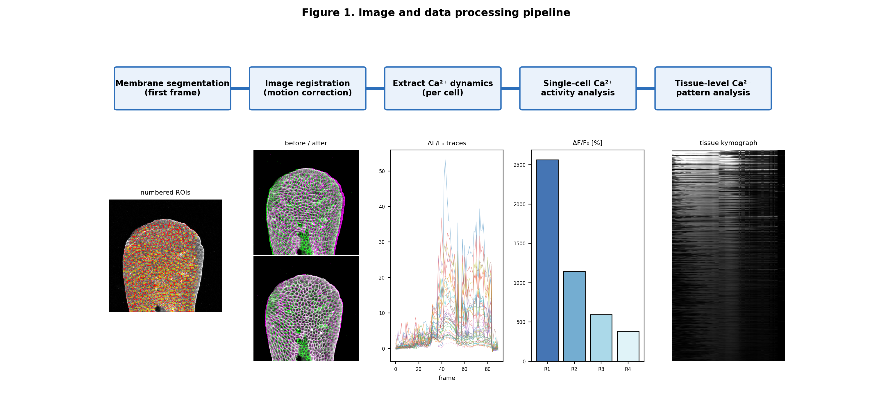
Figure 1. Image and data-processing pipeline: membrane segmentation → registration (motion correction) → per-cell Ca²⁺ extraction → single-cell and tissue-level analysis. Panels are real outputs from the LATA1 dataset.

2.1 Imaging and preparation
Zebrafish larvae (3 dpf) expressing a genetically encoded Ca²⁺ indicator were imaged on a confocal microscope. The green channel reported cytosolic Ca²⁺; a membrane label provided a structurally stable red channel. Latrunculin A (final ~200 µM in 1% DMSO) was applied immediately before imaging as the actin-disrupting perturbation; DMSO served as vehicle. Each field was recorded before (baseline) and after treatment.

2.2 Two-way image registration
Registration was performed on the membrane channel and the resulting transform applied to the calcium channel to preserve cross-channel correspondence. For mild translational/rotational motion, rigid registration used OpenCV's Enhanced Correlation Coefficient (ECC) algorithm (Euclidean model: rotation + translation) aligning every frame to frame 0. For pronounced deformation, non-rigid registration used a SimpleITK B-spline transform with Mattes mutual information as the similarity metric and an LBFGS-B optimizer; control-point grid, iterations and step size were tuned empirically. On the recordings analyzed here the large post-treatment motion was predominantly global (translation and rotation), which rigid ECC corrected well; elastic B-spline gave only a marginal additional reduction in residual (Figure 3), so rigid registration was used for the quantitative results.
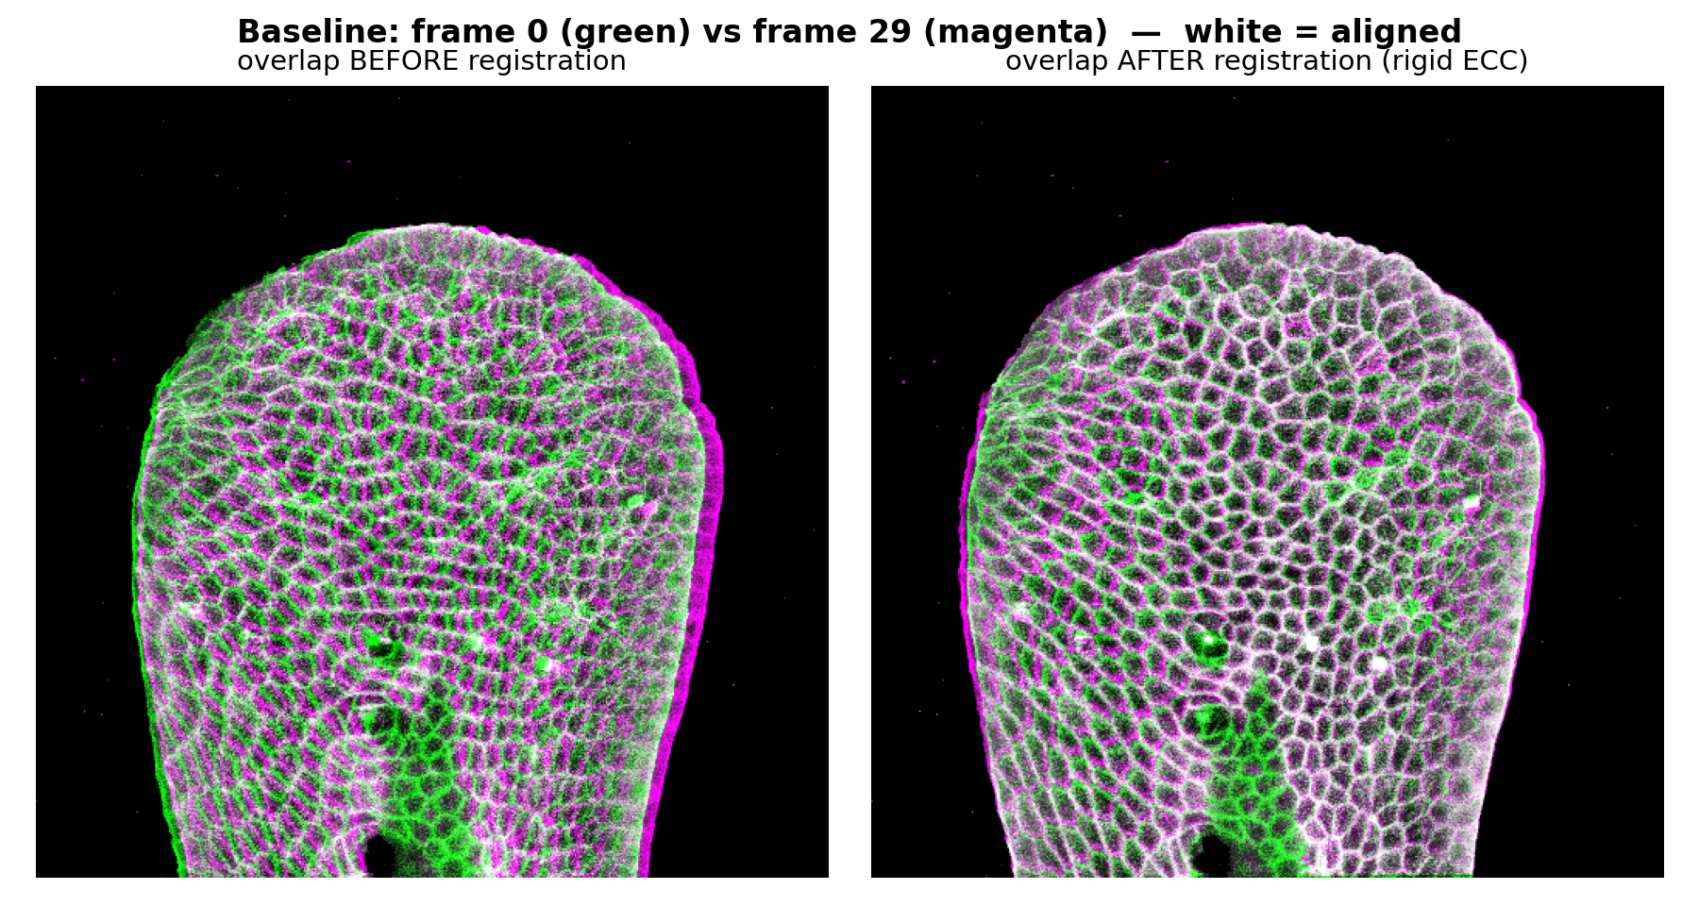
Figure 2. Registration overlay, baseline (green = reference frame 0, magenta = moving frame; white = aligned). Before registration the moving frame is offset; after ECC alignment the channels overlap.
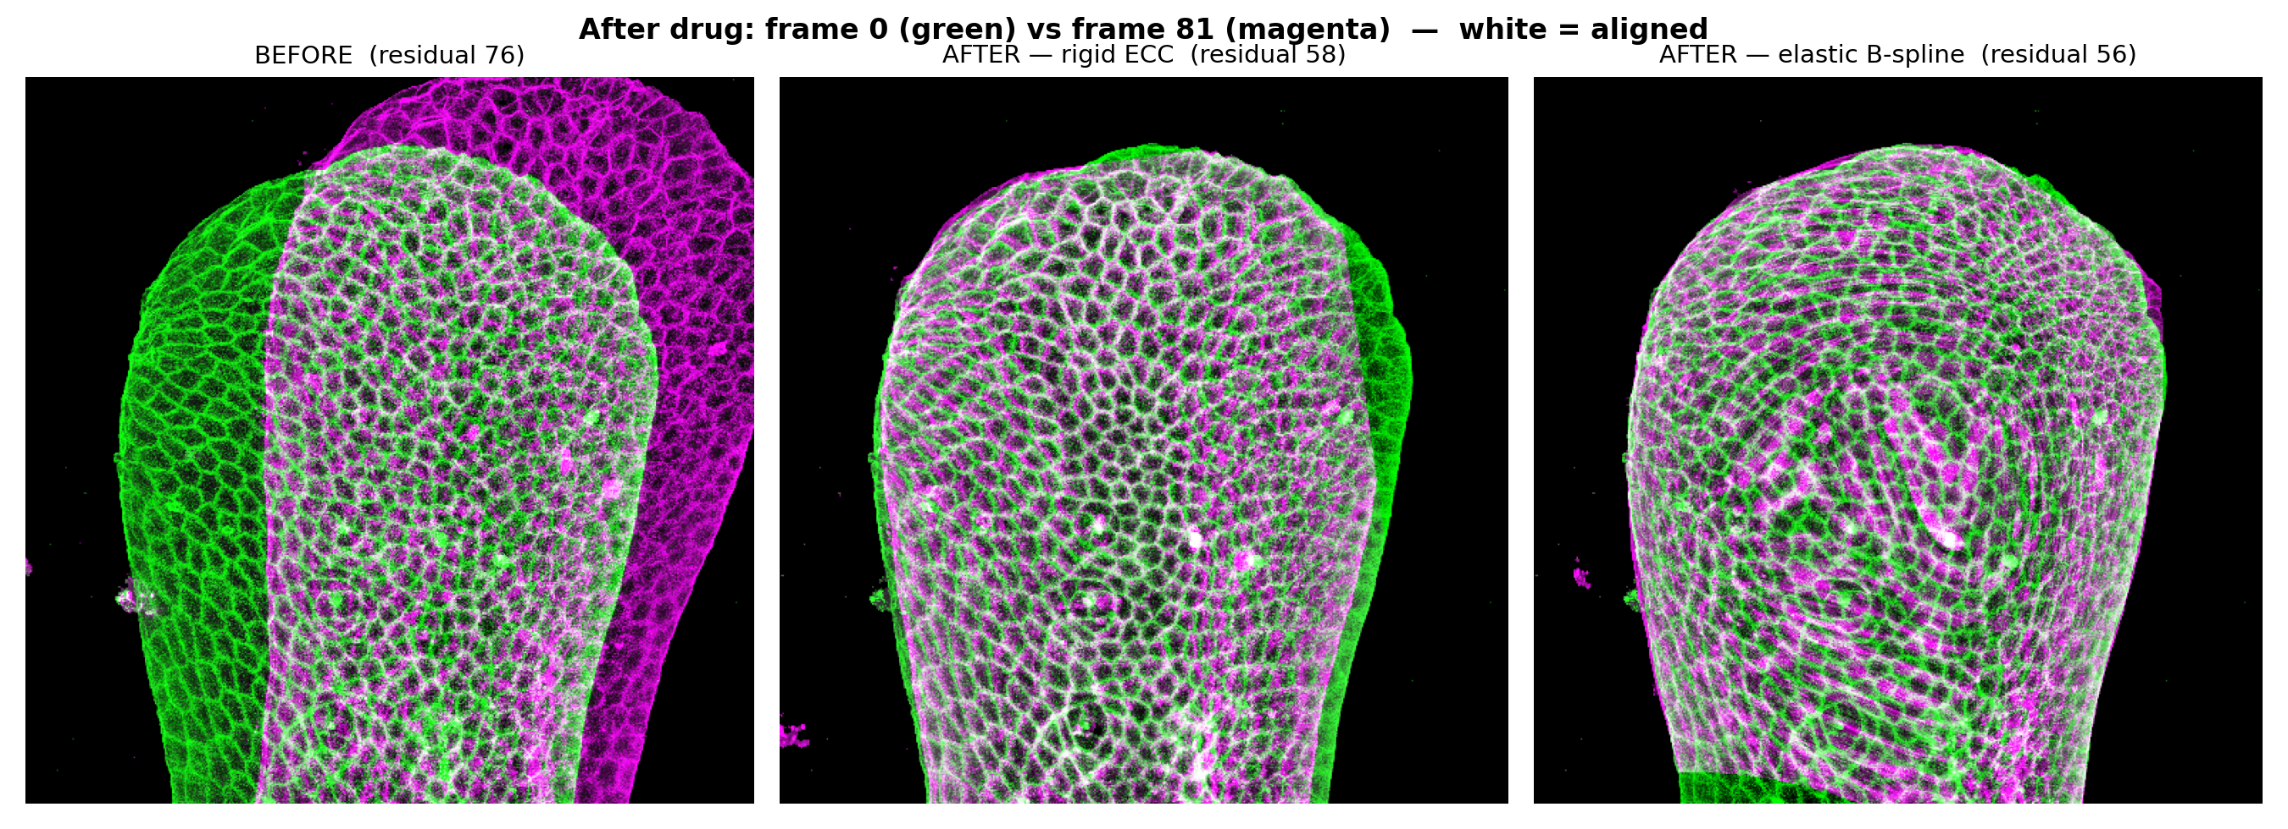
Figure 3. Rigid-vs-elastic registration after Latrunculin A (frame 0 green, moving frame magenta; white = aligned). The large post-treatment motion is predominantly global: rigid ECC substantially reduces the mean membrane residual (annotated on each panel), and elastic B-spline yields only a marginal further improvement on this recording. Rigid registration was therefore used for the quantitative analysis; elastic remains available for datasets with strong local deformation. Residual = mean absolute membrane mismatch over tissue pixels.

2.3 Segmentation and trace extraction
Single cells were segmented on the registered reference-frame membrane image with the Cellpose cyto3 model (channels=[2,0], cell diameter ≈ 15 px), yielding an integer-labeled mask. Frame-by-frame background subtraction was applied to the calcium channel. Three background reference regions were selected automatically as the lowest-median image tiles — a scripted proxy for the original protocol's manual selection of signal-free regions; per frame, values outside 1.5×IQR were removed, each region reduced to its median, and the average of the three medians subtracted from every pixel and clipped at zero. For each cell i, the mean pixel intensity inside its mask was measured at each frame t to give Fₜ,ᵢ. Its own baseline F₀ᵢ was the mean of its n lowest finite, background-corrected frame intensities, where n = min(10, max(3, T // 3)) for a recording of T frames. F₀ᵢ was floored at 1 intensity unit to avoid near-zero division. Each cell was then normalized independently as ΔF/F₀ᵢ(t) = (Fₜ,ᵢ − F₀ᵢ) / F₀ᵢ; no population-wide baseline was used.
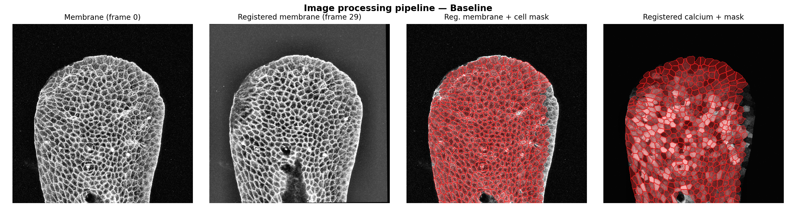
Figure 4. Processing sequence: raw membrane frame 0, registered membrane, registered membrane with the Cellpose cell mask (red), and the registered calcium channel with the same mask — the ROIs used for per-cell trace extraction.
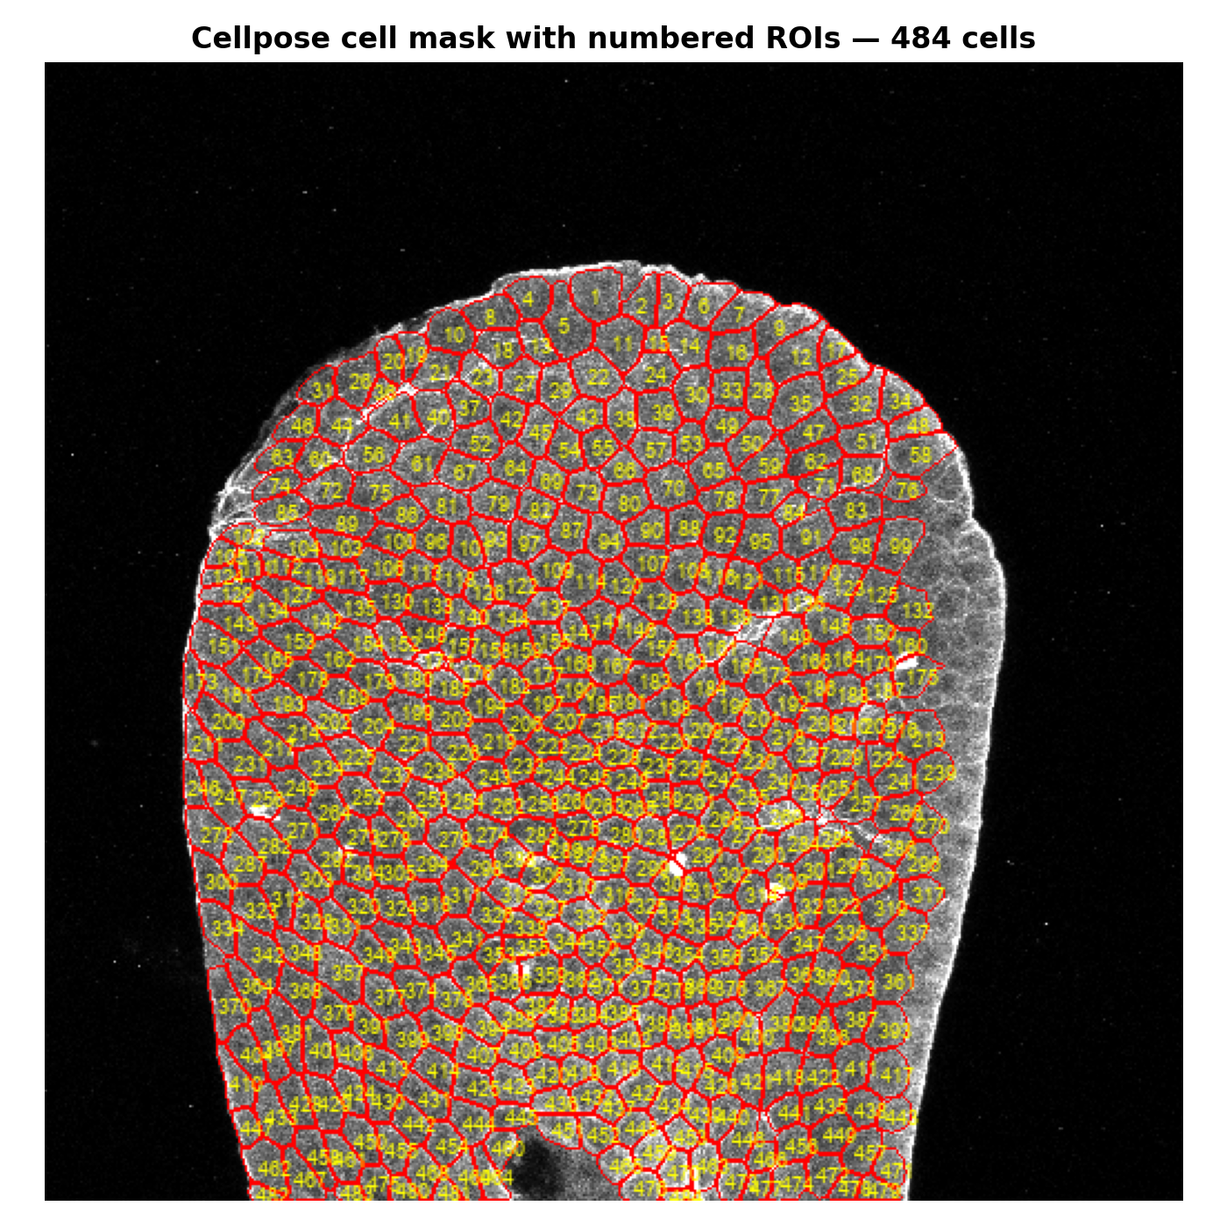
Figure 5. Cellpose segmentation of the reference membrane frame with numbered cell ROIs (484 cells). Each labeled region defines one cell's ROI across all frames.
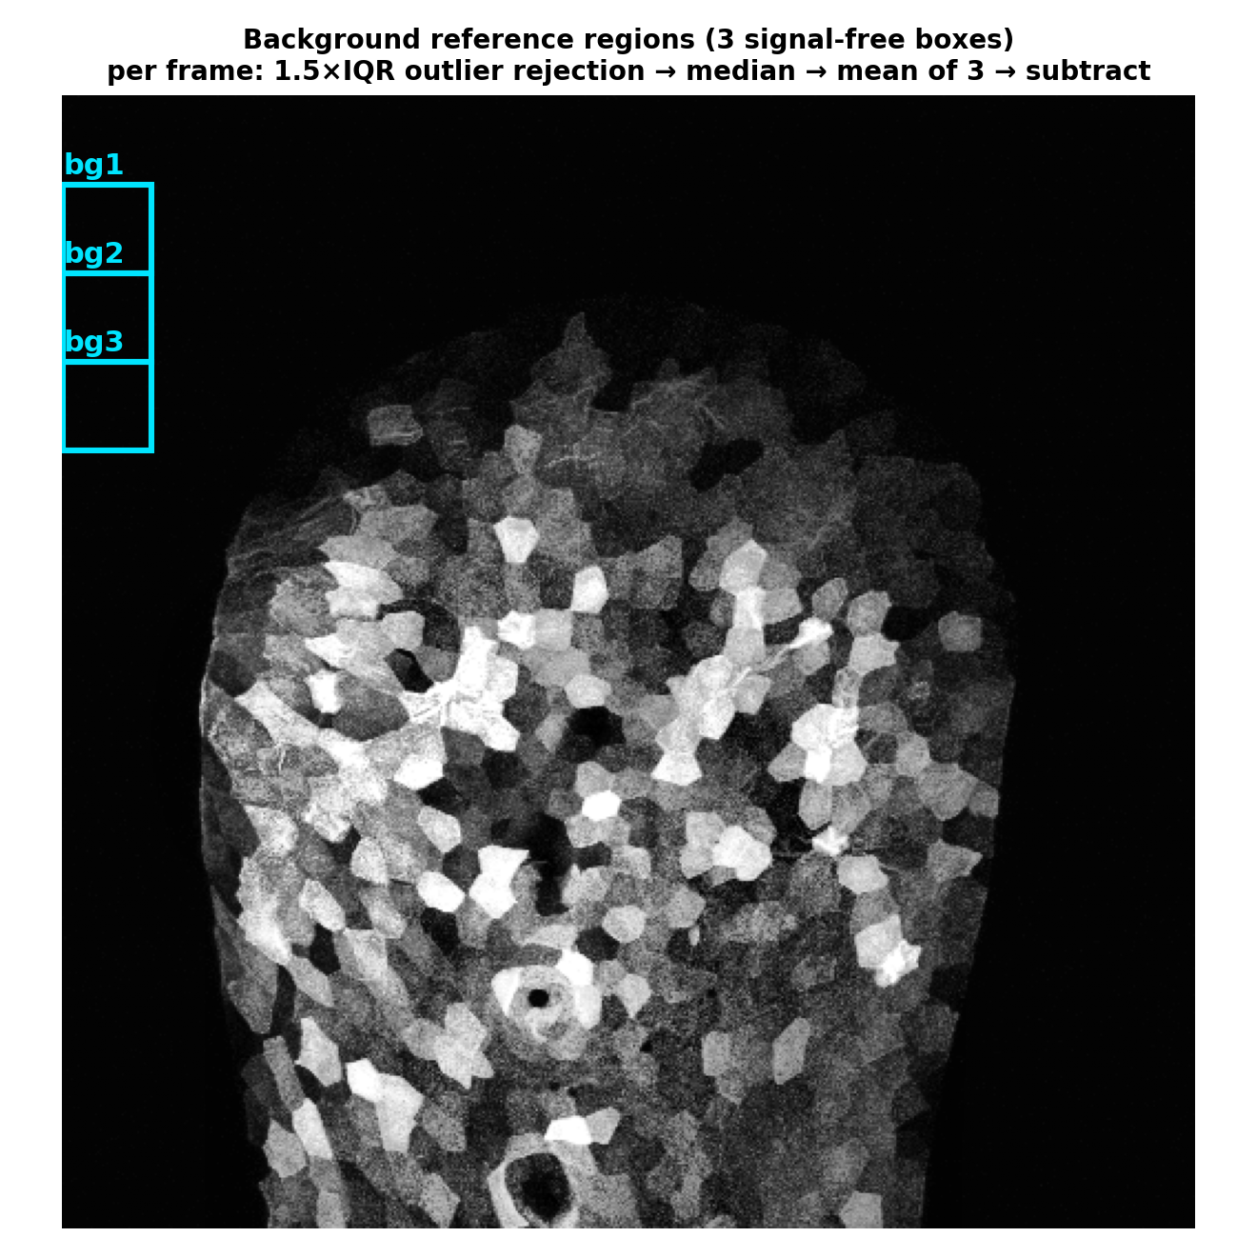
Figure 6. Background subtraction: three signal-free reference regions (cyan boxes) on the calcium frame. Per frame, values outside 1.5×IQR are discarded, each region reduced to its median, and the mean of the three medians is subtracted and clipped at zero.
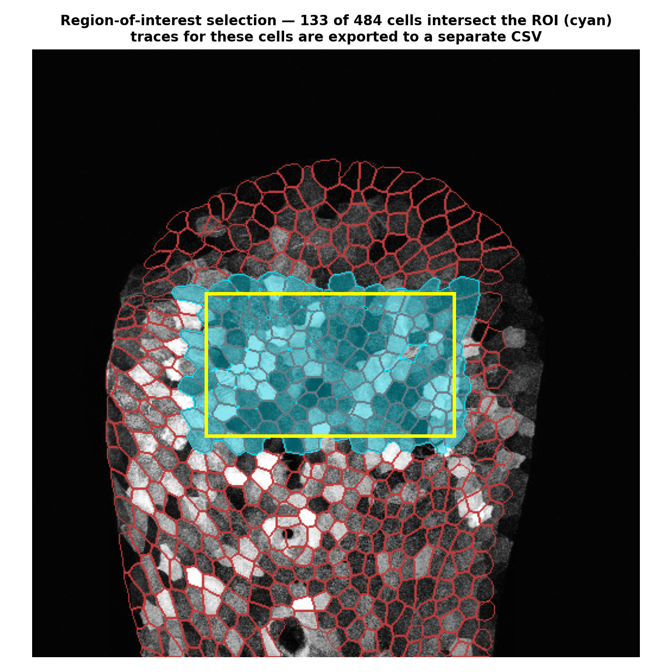
Figure 7. Region-of-interest selection: a rectangular ROI (yellow) is drawn on the first calcium frame, and every segmented cell whose mask intersects the ROI (cyan) is retained; the traces of these cells are exported to a separate CSV, so analysis can be restricted to a reliable in-view subset.

2.4 Metrics and statistics
Per cell we computed peak ΔF/F₀ᵢ, mean ΔF/F₀ᵢ, transient count (SciPy find_peaks, height 0.5, min distance 2 frames), transients per frame, and per-frame supra-threshold area (AUC). At the tissue level we computed the active fraction, spatial heterogeneity (coefficient of variation of per-cell peak amplitude across the field) and temporal synchronization (mean pairwise Pearson correlation among active cells). Spatial coordination was assessed as pairwise correlation versus inter-cell centroid distance. For each comparison, normality was tested with the Shapiro–Wilk test on both groups; where both groups were normal a two-sided Welch t-test was used (a close variant of the original protocol's Student t-test), otherwise the Mann–Whitney U test (the actual test used per metric is reported in the appendix). Effect size is the rank-biserial correlation; regional R1–R4 differences used the Kruskal–Wallis omnibus test (no post-hoc pairwise correction). Importantly, only two biological replicates (trials) were available per condition. The pooled single-cell tests therefore treat individual cells as replicates (pseudoreplication) and their p-values quantify separation of the cell populations, not biological-replicate significance; the per-trial direction of effect (Table 1) is the primary evidence. All analyses are deterministic (fixed random seed) and reproduced by a single script.

3. Results

3.1 Single-cell activity increases after actin disruption
Because only two biological trials were available per condition, we take the per-trial direction of effect (Table 1) as the primary evidence. Transient frequency, mean ΔF/F₀ᵢ and spatial heterogeneity increased in both independent trials after treatment. The effect is not uniform across every metric: the median peak amplitude rose in trial 1 (3.40→7.63) while decreasing in trial 2 (3.04→2.45), where the field instead became markedly more heterogeneous (CV 0.67→1.26). The consistent cross-trial signature of actin disruption is therefore increased transient frequency and spatial heterogeneity rather than a uniform amplitude increase (Figures 8–11).
Table 1. Per-trial summary (both conditions). LATA1 raw fluorescence traces originated from TIFF processing; LATA2 raw traces came from stored pipeline CSVs. Every cell was renormalized to its own F₀ᵢ for this analysis.
Trial / condition | Cells | Active % | Median peak ΔF/F₀ᵢ | Heterogeneity CV | Sync r
trial1 Baseline | 484 | 100 | 3.40 | 0.63 | 0.245
trial1 Latrunculin | 517 | 100 | 7.63 | 0.82 | 0.532
trial2 Baseline | 479 | 100 | 3.04 | 0.67 | 0.221
trial2 Latrunculin | 452 | 100 | 2.45 | 1.26 | 0.353
As descriptive support, we also pooled the single cells across both trials (963 baseline vs 969 treated cells). Median transient rate rose from 0.097 to 0.200 transients/frame, mean ΔF/F₀ᵢ from 0.80 to 1.67, and per-frame supra-threshold area 2.5-fold; Shapiro–Wilk rejected normality for every metric, so the Mann-Whitney U was applied (Appendix). These pooled comparisons yield extremely small p-values, but because they treat cells rather than animals as replicates (n = 2 trials), the p-values should be read as a measure of population separation, not as biological-replicate significance. Two caveats apply: the pooled peak-amplitude comparison spans unequal recording lengths (baseline 31 vs treated 55–90 frames), so a maximum-based metric is only weakly comparable — the length-normalized transient rate and per-frame area are more comparable. The LATA2 fields use stored background-corrected raw fluorescence traces; LATA1 traces originated from the documented registration→cyto3→background-extraction chain. All four fields were renormalized from raw per-cell traces for this analysis (see §5).
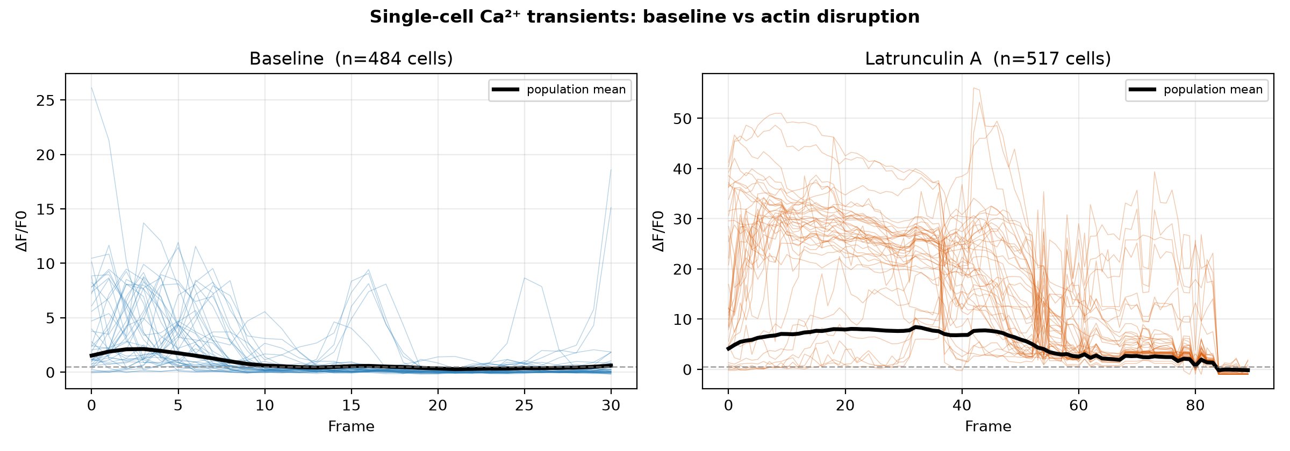
Figure 8. Representative single-cell ΔF/F₀ᵢ traces (40 most active cells; black = population mean; dashed line = transient threshold). Trial-specific changes are summarized in Table 1.
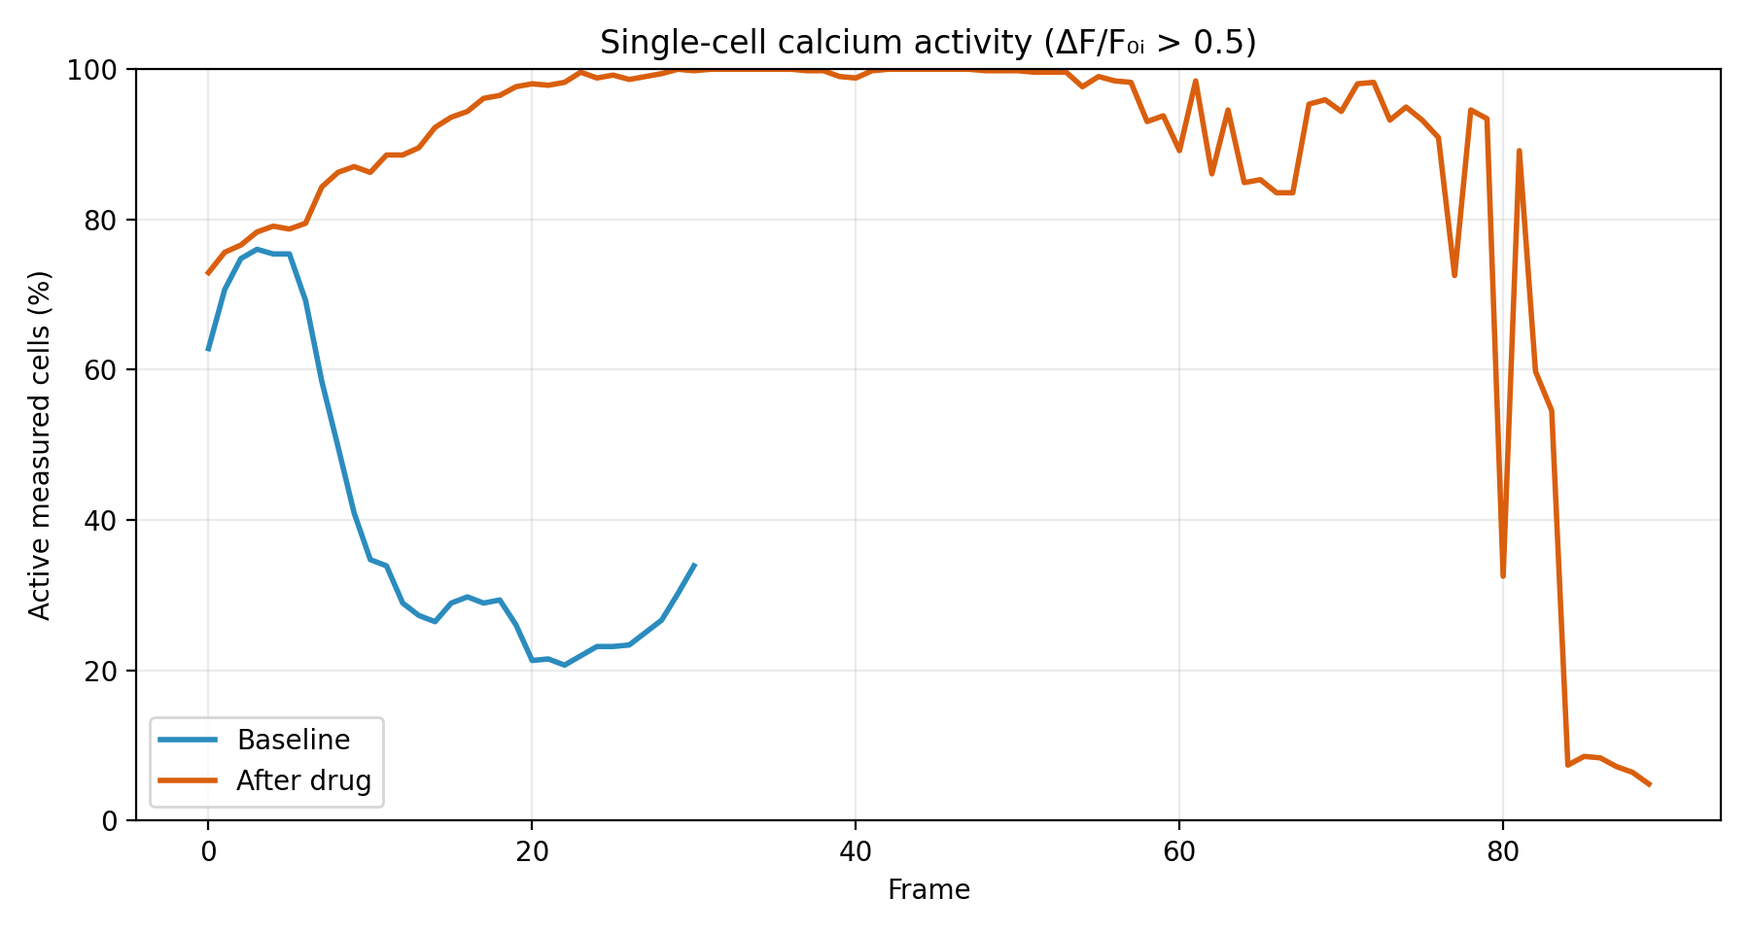
Figure 9. Fraction of segmented cells above ΔF/F₀ᵢ = 0.5 in each processed frame, shown separately for the baseline and Latrunculin A recordings. The curves describe activity within each field; different recording lengths limit direct timepoint comparison.
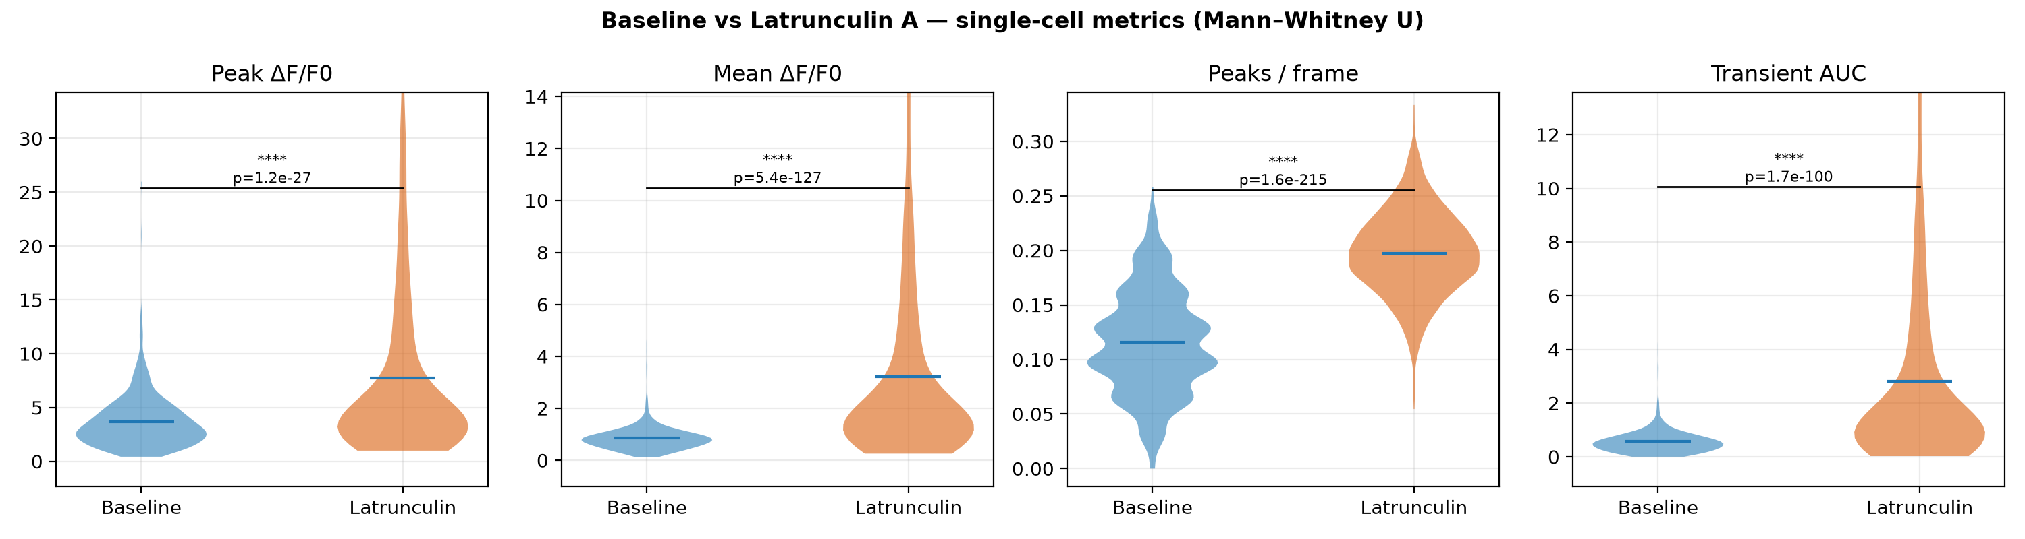
Figure 10. Single-cell metric distributions, baseline vs Latrunculin A, pooled across two trials (descriptive; the pooled per-cell p-values annotated here are pseudoreplicated — see §3.1). The length-normalized transient rate and per-frame area are the sound metrics.
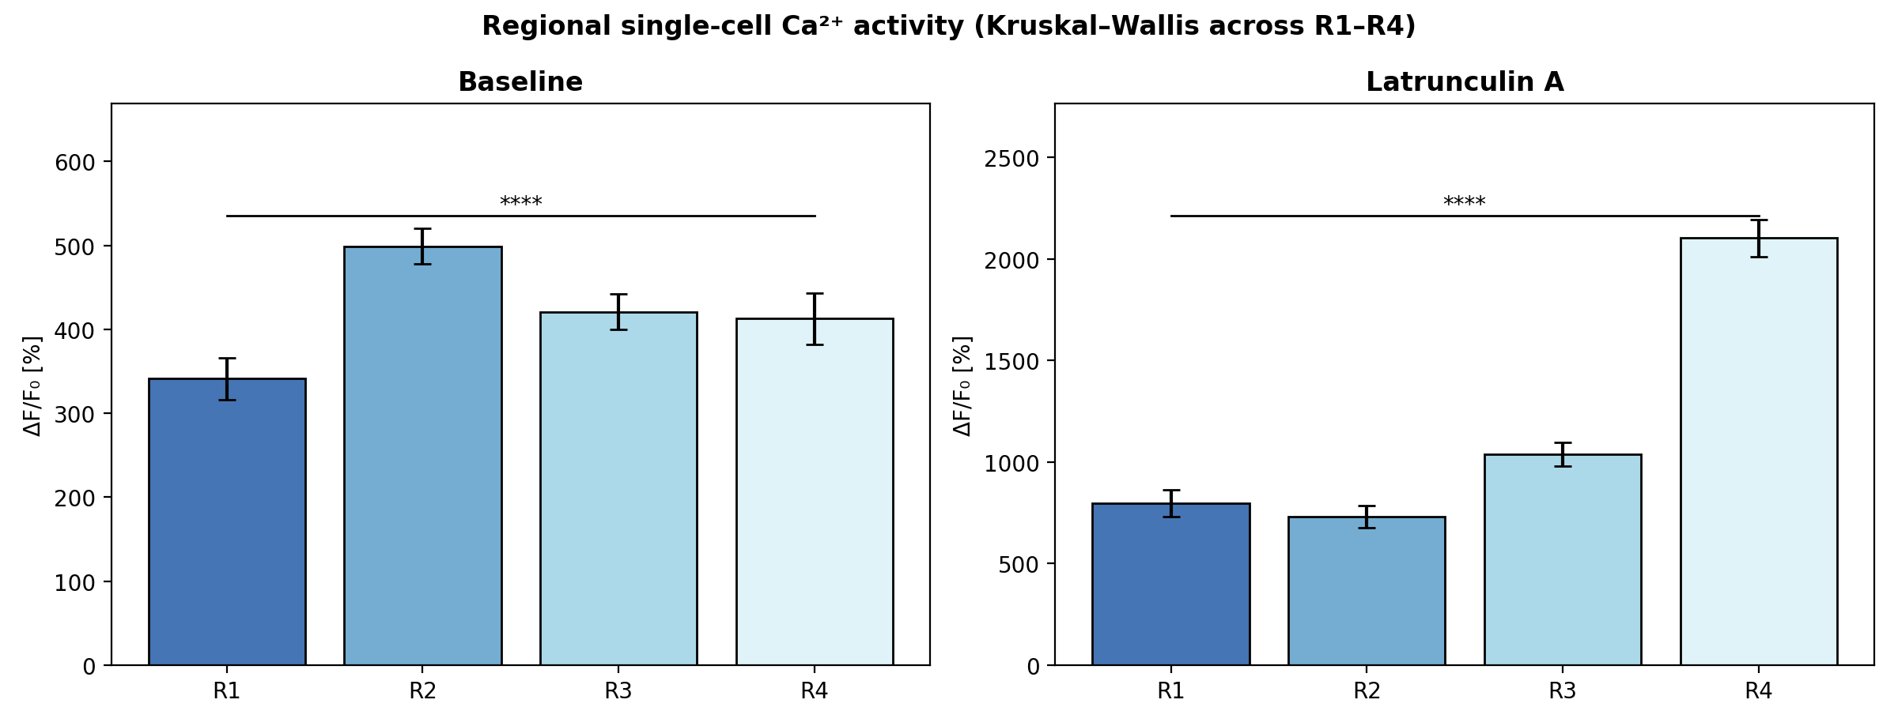
Figure 11. Regional single-cell activity (peak ΔF/F₀ᵢ). Cells were split into four equal proximal-to-distal bands (R1–R4) by centroid y-position; bars are region means ± SEM. The figure reports the Kruskal–Wallis omnibus comparison within each condition.

3.2 Tissue-level Ca²⁺ patterns and spatial heterogeneity
At the tissue scale, the activity map changed from sparse, low-amplitude flickers at baseline to dense, high-amplitude activity after treatment (Figures 12–13). Spatial heterogeneity of peak amplitude increased in both trials (CV [0.634, 0.669] at baseline → [0.819, 1.264] after treatment), consistent with a loss of uniform, coordinated responses across the sheet.
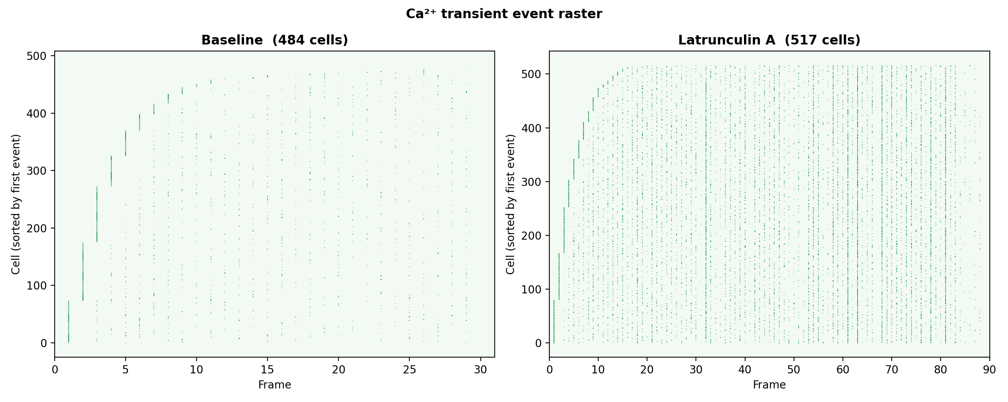
Figure 12. Ca²⁺ transient event raster (each tick = a detected transient; cells sorted by first event). The two conditions show different event patterns.
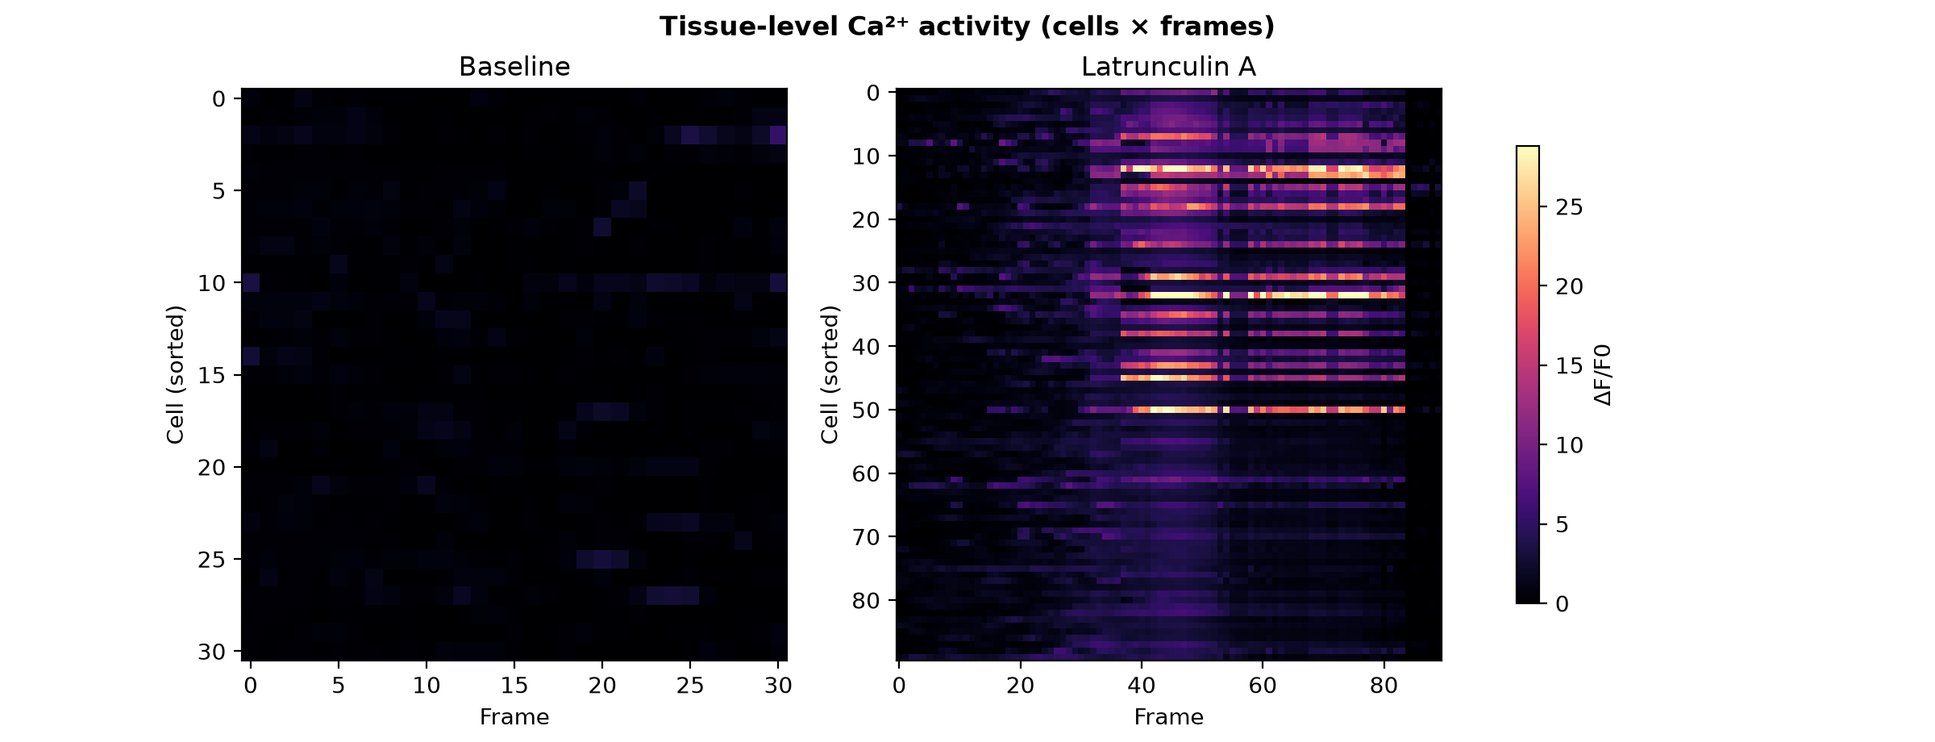
Figure 13. Tissue-level activity heatmaps (cells × frames, shared color scale). Left: baseline. Right: Latrunculin A. Each cell's signal uses its own F₀ᵢ baseline.
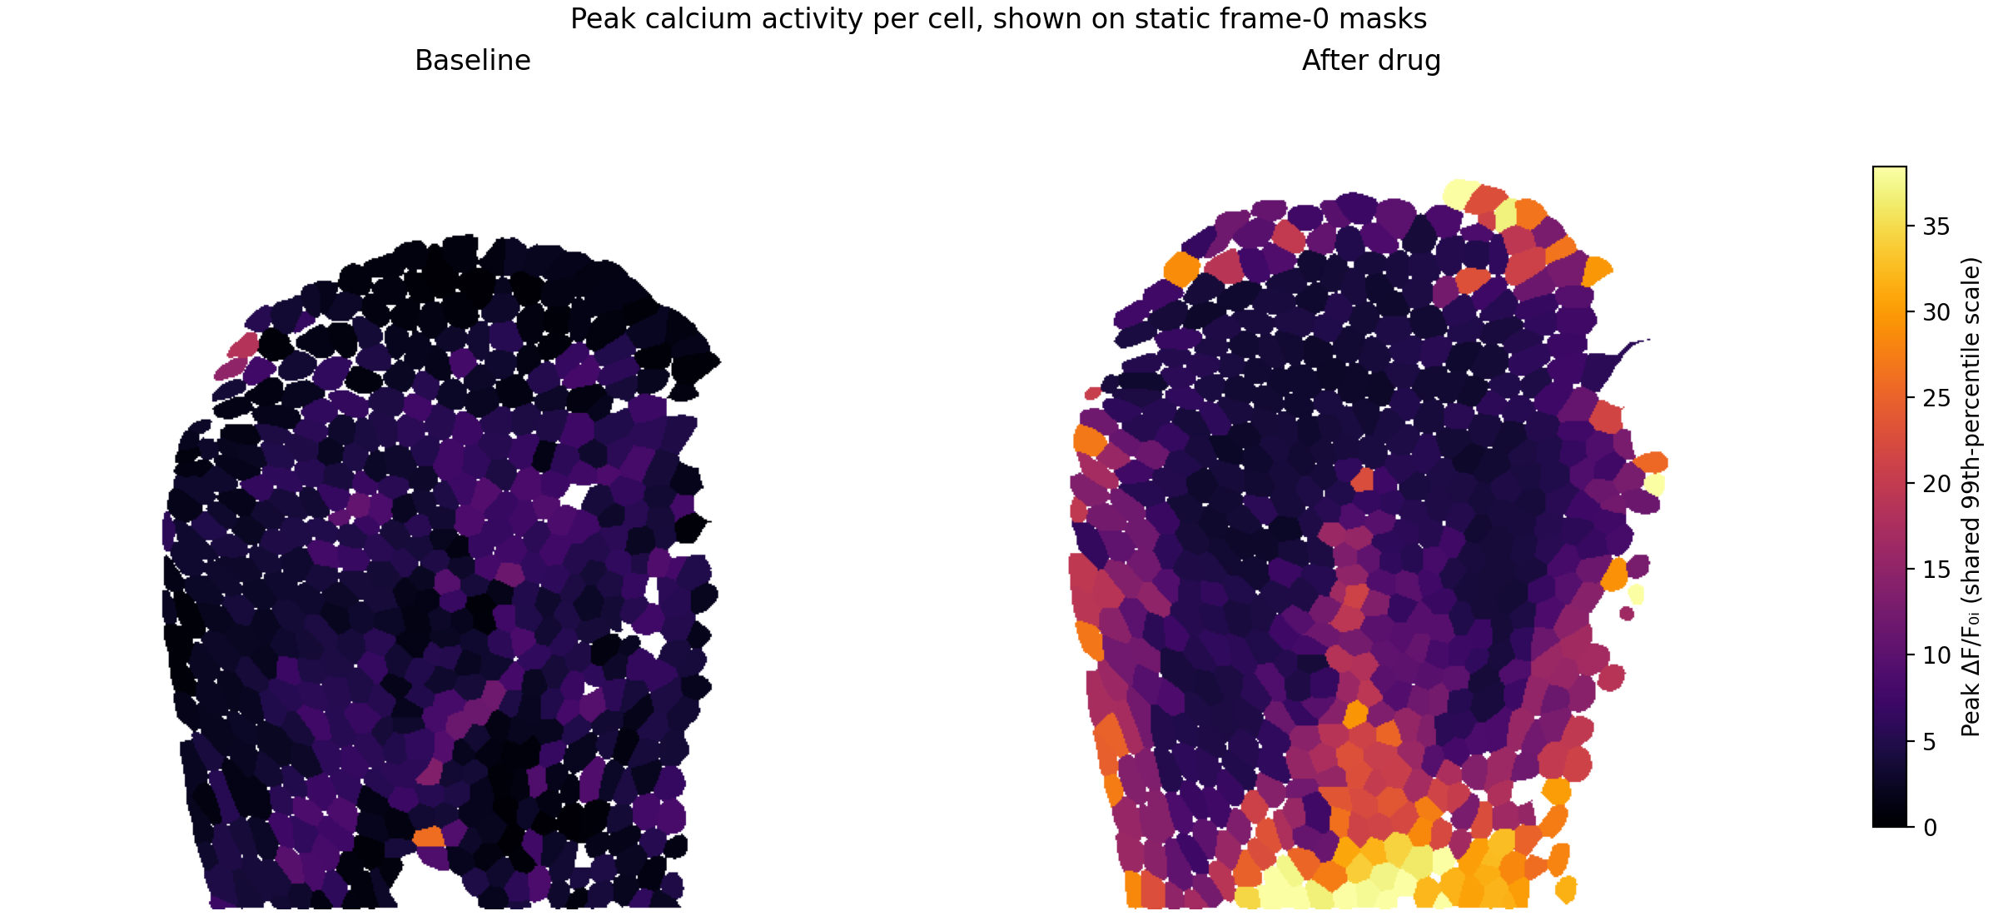
Figure 14. Per-cell peak ΔF/F₀ᵢ painted on the saved frame-0 segmentation masks. Both conditions use the same color scale; the masks define fixed ROIs after registration.
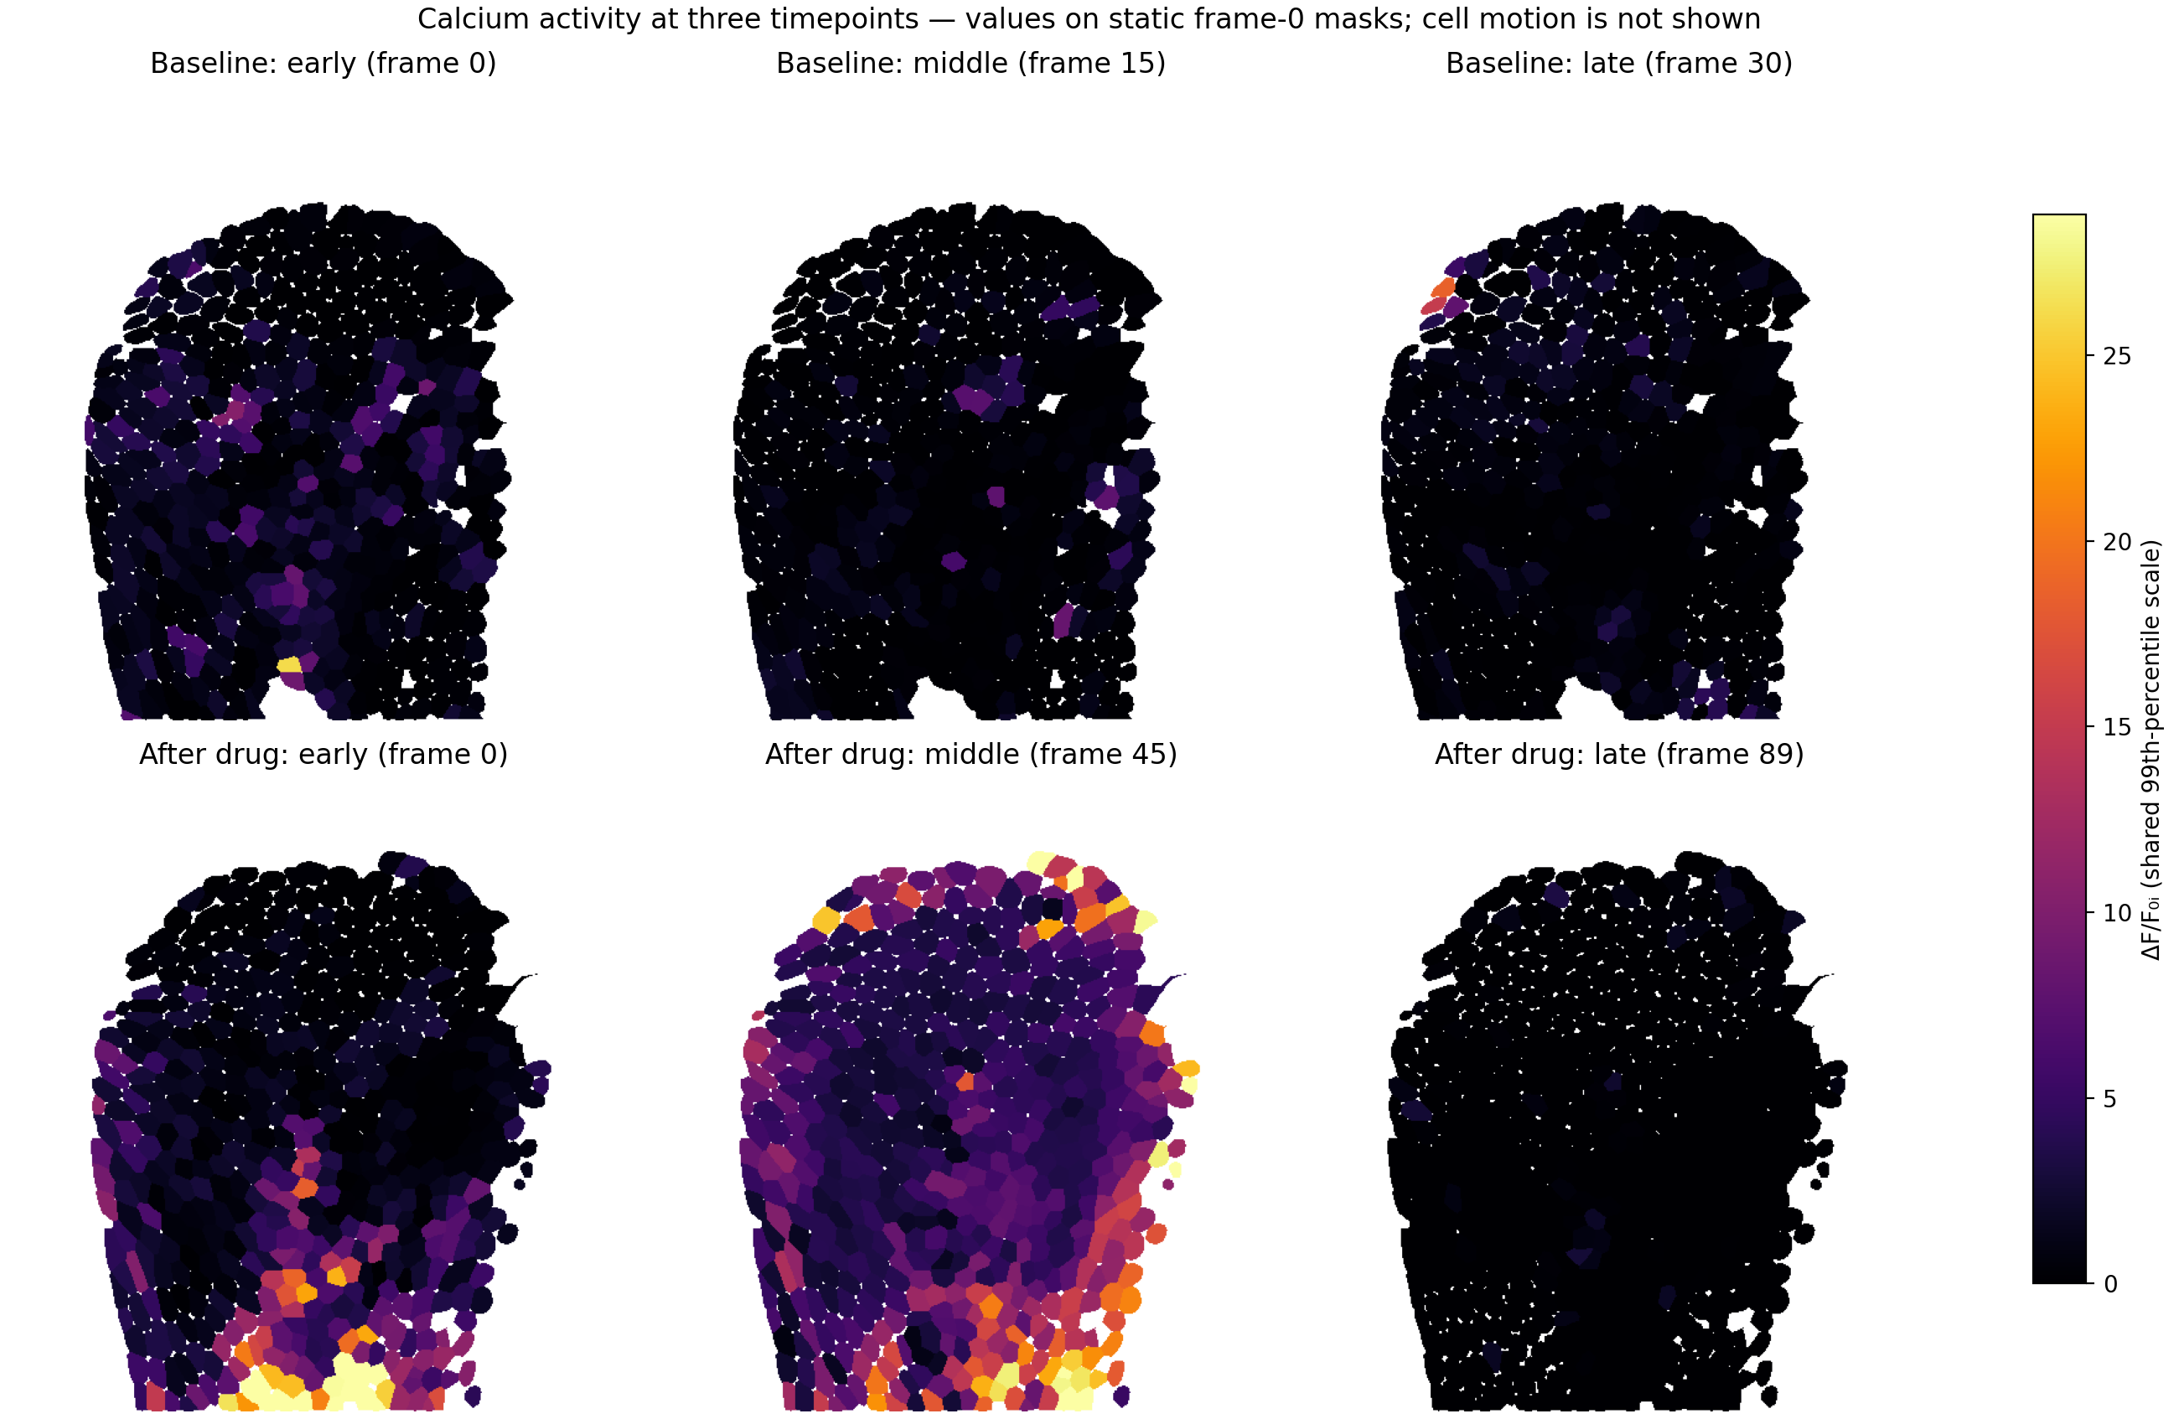
Figure 15. Early, middle, and late per-cell ΔF/F₀ᵢ values mapped to the fixed frame-0 masks. These images show fluorescence in registered ROIs and do not establish cell movement.
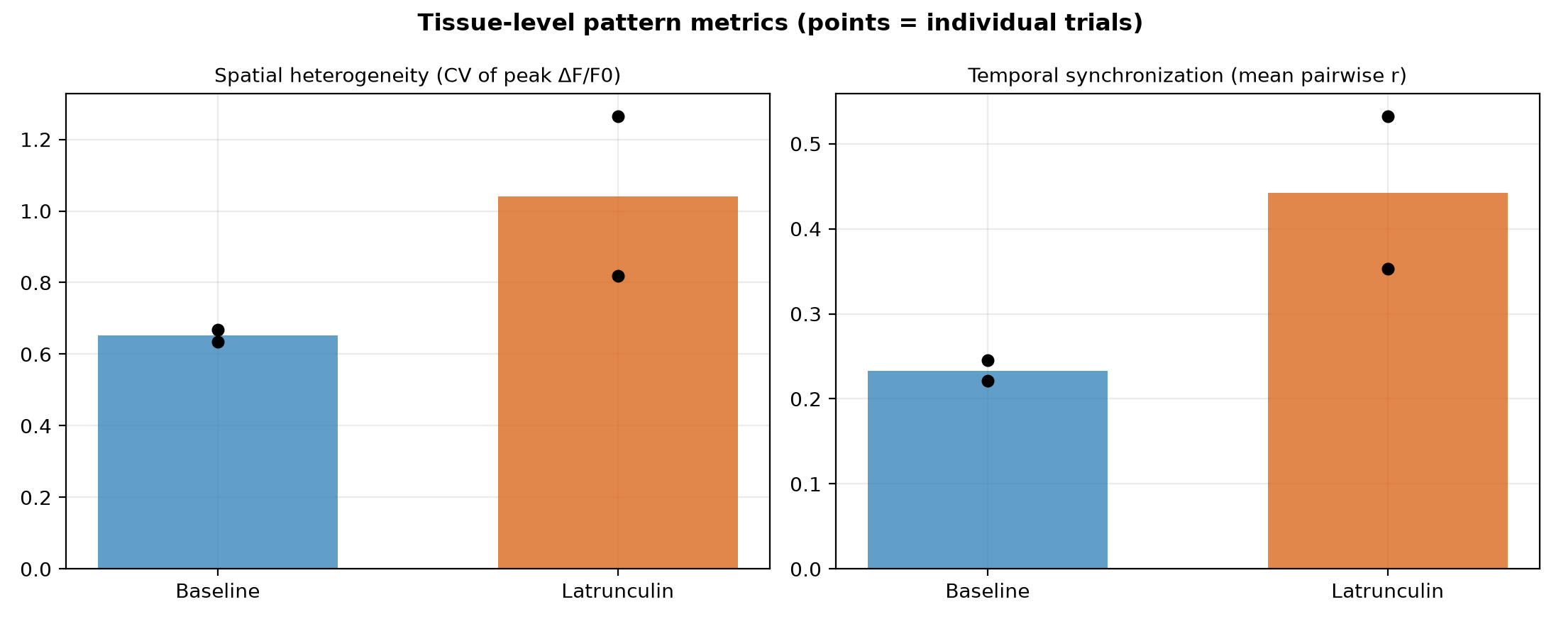
Figure 16. Tissue-level pattern metrics (bars = condition mean; points = individual trials). Spatial heterogeneity and temporal synchronization both rise after actin disruption.

3.3 Spatial coordination of Ca²⁺ activity
Distance-binned pairwise correlations summarize spatial coordination in both conditions (Figure 17). The mean pairwise correlation among active cells rose from 0.23 to 0.44, and the pooled pairwise-correlation distribution shifted upward (p < 1e-300, Mann–Whitney U). This cell-pair comparison is descriptive because pairs within each trial are not independent biological replicates.
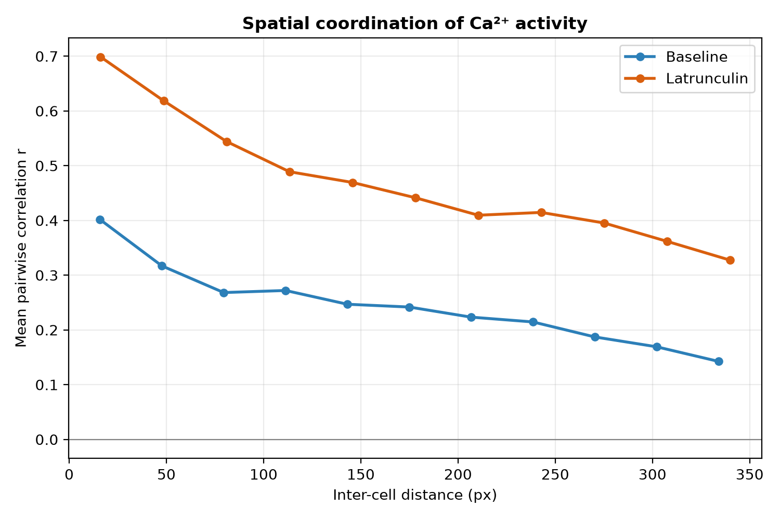
Figure 17. Mean pairwise correlation versus inter-cell centroid distance, pooled per condition. Latrunculin A raises coordination across the distances shown.

3.4 Time-dependence of the response
Within the post-treatment recordings, mean per-cell peak amplitude varied across early, middle and late imaging windows, indicating that the Latrunculin response evolves over the recording rather than being static (Figure 18). This within-recording variation is suggestive of progressive actin depolymerization, but the present data — a single continuous post-treatment recording per trial — do not extend long enough to establish recovery or adaptation; testing that would require longer or repeated late-timepoint imaging.
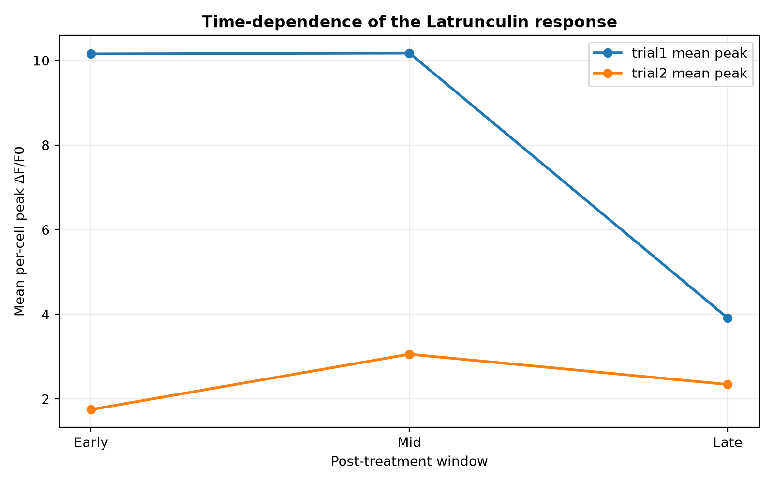
Figure 18. Time-dependence of the response: mean per-cell peak ΔF/F₀ᵢ across early/mid/late windows for each treated field.

4. Discussion and Conclusion
Using a scripted, deterministic pipeline we quantified how actin disruption reshapes epithelial Ca²⁺ dynamics in vivo. In both trials, Latrunculin A increased single-cell transient frequency and mean ΔF/F₀ᵢ, raised spatial heterogeneity of peak responses, and elevated inter-cellular correlation relative to baseline. These changes are consistent with actin depolymerization altering membrane tension and mechanosensitive-channel activity, promoting Ca²⁺ influx and intercellular propagation while degrading the uniform, finely balanced signaling seen in the intact tissue. Because the study rests on two biological replicates per condition and reproduces the authors' own draft analysis on the same imaging data, these results establish the internal reproducibility and direction of the effect rather than independent, statistically powered confirmation.
The methodological contribution is a scripted registration front-end offering both rigid (ECC) and non-rigid (B-spline) correction; on the recordings analyzed here the motion was predominantly global and rigid registration sufficed, with elastic evaluated but not required (Figure 3). Limitations include reliance on a stable membrane label for registration, a single reference-frame segmentation without explicit cross-time cell tracking, and a small number of biological replicates. Future work could add deep-learning non-rigid tracking, real-time registration and 3D volumetric imaging, increase replication, and combine cytoskeletal mutants with this platform to dissect specific actin–Ca²⁺ couplings.
The reference manuscript draft discusses six paired trials. A separate six-trial local audit remains exploratory because its processing methods and data provenance differ from the two trial pairs analyzed here. The present tables and figures therefore do not reproduce the reference draft's six-trial estimates or significance tests.

5. Reproducibility and data provenance
For all four fields, each cell's F₀ᵢ and ΔF/F₀ᵢ trace were recalculated from stored or newly extracted, background-corrected raw fluorescence CSVs. The numerical results and six quantitative figures were then generated by reproduce.py from these normalized traces; generate_paper.py assembled this document. Original microscopy TIFFs were located in a local data folder outside the repository; they are not bundled with this checkout. The paper-style microscopy panels and three activity figures were regenerated from local TIFFs, saved cell masks, and corrected traces in this run. This run used LATA1 raw fluorescence CSVs previously extracted from TIFFs; it did not rerun registration, segmentation, or fluorescence extraction. The LATA2 fields used stored pipeline raw fluorescence CSVs and were renormalized in this run; LATA2 image extraction was not rerun. Each field's baseline values and source trace hashes are retained in normalized_per_cell/, and provenance is summarized in field_summary.csv. Analyses use a fixed random seed; see README_REPRODUCE.md.
The stored LATA2 baseline raw-trace table lacked fluorescence values in frame 0 for every cell. That row was recovered from the locally available source calcium TIFF with the saved frame-0 mask and the same three-region background method. Applying the method to registered frame 1 reproduced all 479 stored cell means within floating-point precision. The original trace table was retained; the repaired row and source checksums are recorded in REPRODUCE/source_repairs/.

Appendix: reproduced summary statistics
Statistical tests. Normality assessed by Shapiro–Wilk on each group; Welch t-test if both normal, otherwise Mann–Whitney U. Effect = rank-biserial.
Metric | Median base | Median Lat | Shapiro p (base/Lat) | Test used | p-value | effect (r)
Peak ΔF/F₀ᵢ | 3.156 | 4.164 | <1e-4 / <1e-4 | Mann-Whitney U | 1.2e-27 | 0.29
Mean ΔF/F₀ᵢ | 0.803 | 1.666 | <1e-4 / <1e-4 | Mann-Whitney U | 5.4e-127 | 0.63
Transients / frame | 0.097 | 0.200 | <1e-4 / <1e-4 | Mann-Whitney U | 1.6e-215 | 0.82
Transient AUC | 0.496 | 1.235 | <1e-4 / <1e-4 | Mann-Whitney U | 1.7e-100 | 0.56
Pairwise correlation | 0.221 | 0.486 | <1e-4 / <1e-4 | Mann-Whitney U | <1e-300 | 0.36

