Business Requirements for a School Portal ERP System

Project Title : | School Management Portal
Prepared By : | Business Analyst
Document Type: | Software Requirements Specification (SRS)
Version : | 1.0
Date : | June 2026

Document Control
VERSION CONTROL

All revisions made to this document are listed below in chronological order.
Version | Date | Author(s) | Notes
1.0 | June 2026 | Business Analyst | Original Draft

School Management Portal

1. Overview
The School Management Portal is a centralized digital platform for managing academic and administrative operations. It provides a single portal for students, teachers, parents, administrators, and principals to access real-time information and perform daily activities. The system covers attendance tracking, assignment management, examination management, notifications, student records, and reporting — accessible via both web and mobile platforms.

2. Business Objectives
- Digitize school operations and eliminate manual record keeping.
- Improve communication between teachers, students, and parents.
- Provide real-time access to academic information and results.
- Enhance transparency in student performance tracking.
- Enable centralized data management and data-driven decision-making.

3. Project Scope
In Scope
User authentication, student & teacher management, attendance, assignments, examination management, notifications, reporting & analytics, and role-based dashboards for all user types.

Module | Student Features | Teacher Features | Admin/Principal
Authentication & Dashboard | Login, view dashboard | Login, view dashboard | Full access
Attendance | View attendance % | Mark & manage attendance | View reports
Assignments | View & submit | Create, update, delete | View
Examinations | View results | Upload marks, publish results | View reports
Notifications | Receive & view | Create & publish | Create & manage
Reporting | — | Limited reports | Full report access

Out of Scope
Online fee payment, video conferencing, LMS integration, third-party educational tools, and biometric integration are excluded from the current release.

4. Stakeholders & User Roles
Module | Student | Teacher | Parent | Admin | Principal
Attendance | View | Manage | View | View | View
Assignments | Submit | Create | View | View | View
Results | View | Upload | View | View | View
Notifications | View | Create | View | Create | View
Reports | No | Limited | No | Full | Full

5. Key Functional Requirements
ID | Requirement
FR-001/002 | Users can log in and out using valid credentials.
FR-003/004 | Teachers mark attendance; students and parents view attendance records.
FR-005/006 | Teachers create assignments; students submit and track submission status.
FR-007/008 | Teachers upload marks; students view their results.
FR-009 | Administrators manage all user accounts and profiles.
FR-010/011 | System generates reports and sends notifications to relevant users.
FR-012 | Parents monitor student performance, attendance, and results.

6. System Architecture
The system follows a three-layer architecture:
Layer | Purpose
Presentation Layer | Web portal and mobile application (responsive)
Business Layer | Logic for login, attendance, assignments, exams, notifications, Authentication & RBAC, Examination , Reporting
Data Layer | School Database (Users, Students, Teachers, Attendance, Assignments, Results, Notifications)

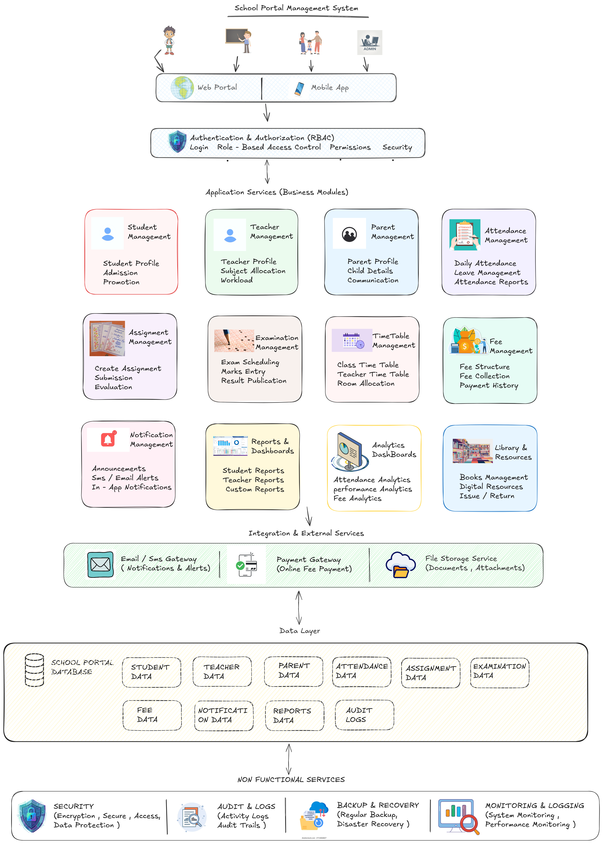
7. Key API Endpoints
Core REST APIs include: POST /login, POST /logout, GET/POST /students, GET/POST /attendance, GET/POST /assignments, GET/POST /results, and GET/POST /notifications. All data exchanges are handled via secure API calls.

Endpoint | Method | Purpose
/login, /logout | POST | Authentication
/students | GET / POST | Retrieve or create student records
/attendance | GET / POST | Retrieve or save attendance
/assignments | GET / POST | Retrieve or create assignments
/results | GET / POST | Retrieve or upload marks
/notifications | GET / POST | Retrieve or create notifications

8. Business Rules
- Usernames and Student/Teacher IDs must be unique.
- Attendance can only be marked once per student per day.
- Marks cannot exceed the defined maximum marks for a subject.
- Assignment due date cannot be earlier than the creation date.
- All passwords must be encrypted before storage.

9. Technical Details (Simple Summary)
Database: Stores user accounts, student profiles, attendance, assignments, results, and notifications.
APIs: The system uses 12 API endpoints (e.g., /login, /attendance, /results) to connect the app with the database.
Business Rules: Usernames must be unique, attendance can only be marked once per day per student, marks cannot exceed the maximum, and all passwords are stored encrypted.

10. Non-Functional Requirements
Area | Requirement
Security | Role-based access control, encrypted passwords, secure sessions with timeout.
Performance | Page load under 3 seconds; supports concurrent users without degradation.
Availability | 99% uptime; planned maintenance communicated in advance.
Reliability | Daily data backups with recovery mechanisms.
Scalability | Designed to support future modules and a growing number of users.
Usability | Responsive, user-friendly interface across web and mobile platforms.

11. Key Risks & Mitigations
- Incomplete requirements — mitigated by regular stakeholder review sessions.
- Data migration errors — mitigated by pre-migration validation.
- Performance issues at scale — mitigated by load and performance testing.
- Security vulnerabilities — mitigated by security best practices and penetration testing.
- User adoption challenges — mitigated by user training programs.

12. Expected Benefits
- Eliminates manual paperwork; reduces administrative workload.
- Real-time access to attendance, results, and notifications for all stakeholders.
- Improved communication between teachers, parents, and students.
- Better decision-making through integrated reports and analytics.
- Centralized, accurate, and reliable data management across the school.

13. Conclusion
The School Management Portal provides a secure, unified platform integrating attendance, assignments, examination results, notifications, and reporting into a single solution. It reduces manual work, improves transparency, and enables data-driven decisions — benefiting students, teachers, parents, and school management alike. This document serves as the baseline for design, development, testing, and future enhancements.

Appendix A – Glossary
Term | Description
SRS | Software Requirements Specification
UI | User Interface
API | Application Programming Interface
DB | Database
HLA | High-Level Architecture
LLA | Low-Level Architecture

Appendix B – References
Reference | Description
Project Requirements | Stakeholder discussions
School Management Process | Business requirements
IEEE SRS Guidelines | Documentation standards

