**Aarushi Agarwal**

**UTD ID: 2021460509**

**Project 2 Report**

## ERD

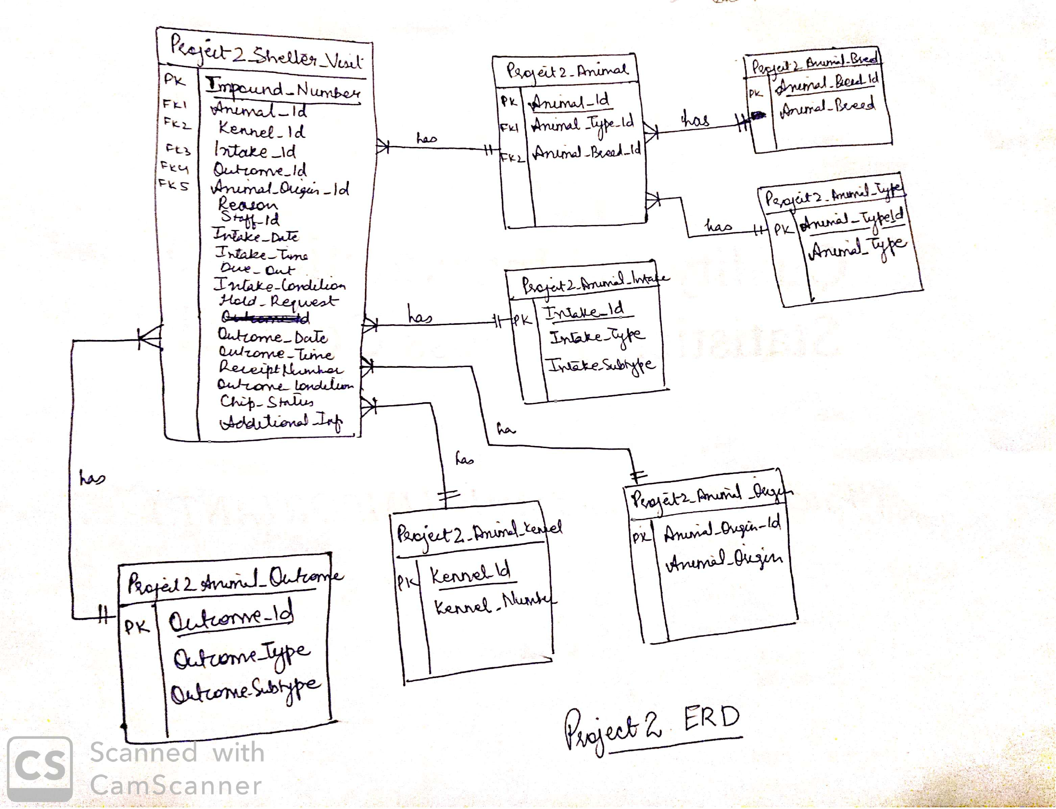

Figure 1: ERD

## SQL scripts to create and populate the tables

create table project2_animal_type as (select rownum as Animal_type_id,animal_type from (select distinct animal_type from project2_data_load));

create table project2_animal_breed as (select rownum as Animal_breed_id,animal_breed from (select distinct animal_breed from project2_data_load));

create table project2_animal_origin as (select rownum as animal_origin_id, animal_origin from (select distinct(animal_origin) from project2_data_load where animal_origin is not null) );

create table project2_animal_outcome as (select rownum as outcome_id, tab1.* from(select outcome_type, outcome_subtype from project2_data_load group by outcome_type, outcome_subtype order by outcome_type, outcome_subtype)tab1);

create table project2_animal_intake as (select rownum as intake_id, tab1.* from(select intake_type, intake_subtype from project2_data_load group by intake_type, intake_subtype order by intake_type, intake_subtype)tab1);

CREATE TABLE PROJECT2_ANIMAL AS (selecT DISTINCT pdl.animal_id, PAT.ANIMAL_TYPE_ID,pab.animal_BREED_ID from project2_data_load pdl,project2_animal_type pat, project2_animal_breed pab where pdl.animal_type= pat.animal_type and pdl.animal_breed=pab.animal_breed);

create table project2_animal_kennel as (select rownum as kennel_id, kennel_number from (select distinct(kennel_number) from project2_data_load order by kennel_number));

create table project2_shelter_visit as( select distinct pdl.impound_number, pdl.animal_id, pak.kennel_id,ai.intake_id,pdl.reason ,pdl.staff_id, pdl.intake_date, pdl.intake_time, pdl.due_out,pdl.intake_condition ,pdl.hold_request,

ao.outcome_id, pdl.outcome_date,pdl.outcome_time,pdl.receipt_number, pdl.outcome_condition,pdl.chip_status, aor.animal_origin_id,pdl.additional_information

from project2_data_load pdl, project2_animal an, project2_animal_intake ai, project2_animal_outcome ao, project2_animal_origin aor , project2_animal_kennel pak

where pdl.animal_id=an.animal_id

and (pdl.intake_type=ai.intake_type and pdl.intake_subtype=ai.intake_subtype)

and (pdl.outcome_type=ao.outcome_type and pdl.outcome_subtype=ao.outcome_subtype)

and (pdl.animal_origin=aor.animal_origin or nvl(pdl.animal_origin,'UNKNOWN')= aor.animal_origin)

and pdl.kennel_number=pak.kennel_number);

## List of normalized tables and counts of records per table

1. Project2_Animal - 71823
2. project2_animal_type - 6
3. project2_animal_breed -324
4. project2_animal_origin - 5
5. project2_animal_outcome - 80
6. project2_animal_intake - 43
7. project2_animal_kennel - 1065
8. project2_shelter_visit - 87669

## SQL scripts to generate the reports and Reports

**Report1**

**Query**: select animal_type, animal_breed,Percentage_of_animals_survived ,total_animals, year from (select tab1.animal_type, tab1.animal_breed,round((tab1.animals_survived/tab2.total_animals)*100,2) as Percentage_of_animals_survived, tab1.animals_survived, tab2.total_animals, tab1.year from

(select pat.animal_type, pab.animal_breed ,to_char(sv.intake_date,'YYYY') as year, count(pab.animal_breed) as animals_survived

from project2_animal_type pat,project2_animal_breed pab,project2_shelter_visit sv, project2_animal ani,project2_animal_outcome ao

where sv.outcome_id=ao.outcome_id

and sv.outcome_id is not null

and sv.animal_id=ani.animal_id

and pab.animal_breed_id=ani.animal_breed_id

and ani.animal_type_id=pat.animal_type_id

and ao.outcome_type not in ('DIED','DEAD ON ARRIVAL','EUTHANIZED')

and pat.animal_type in ('CAT','DOG')

and to_char(sv.intake_date,'YYYY')>='2016'

group by pat.animal_type, pab.animal_breed,to_char(sv.intake_date,'YYYY') having count(pab.animal_breed)>200 ) tab1

inner join

(select pat.animal_type, pab.animal_breed ,to_char(sv.intake_date,'YYYY') as year, count(pab.animal_breed) as total_animals

from project2_animal_type pat,project2_animal_breed pab,project2_shelter_visit sv, project2_animal ani,project2_animal_outcome ao

where sv.outcome_id=ao.outcome_id

and sv.outcome_id is not null

and sv.animal_id=ani.animal_id

and pab.animal_breed_id=ani.animal_breed_id

and ani.animal_type_id=pat.animal_type_id

and pat.animal_type in ('CAT','DOG')

and to_char(sv.intake_date,'YYYY')>='2016'

group by pat.animal_type, pab.animal_breed,to_char(sv.intake_date,'YYYY') having count(pab.animal_breed)>200 )tab2

on tab1.animal_breed=tab2.animal_breed

and tab1.animal_type=tab2.animal_type

and tab1.year=tab2.year )

order by Percentage_of_animals_survived desc;

**Report 1 Output file:** 

**Report 2**

**Query:**

select tab1.intake_type, tab1.outcome_type,tab1.number_of_outcomes,

round((tab3.Total_outcome_type/84630)*100,2) as Percent_total_outcomes,

round((tab1.number_of_outcomes/tab2.Total_intake_type)*100 ,2)as Percent_outcomes_intake_typ,

round((tab1.number_of_outcomes/tab3.Total_outcome_type)*100,2) as Percent_outcomes_outcome_typ

from (select ai.intake_type, ao.outcome_type, count(ao.outcome_type) as number_of_outcomes from project2_shelter_visit sv , project2_animal_intake ai, project2_animal_outcome ao , project2_animal_type pat , project2_animal ani

where sv.intake_id=ai.intake_id

and sv.outcome_id=ao.outcome_id

and sv.animal_id=ani.animal_id

and ani.animal_type_id=pat.animal_type_id

and pat.animal_type in ('CAT','DOG')

group by ai.intake_type, ao.outcome_type order by ai.intake_type) tab1,

(select ai.intake_type, count(ai.intake_type) as Total_intake_type from project2_shelter_visit sv , project2_animal_intake ai, project2_animal_outcome ao , project2_animal_type pat , project2_animal ani

where sv.intake_id=ai.intake_id

and sv.outcome_id=ao.outcome_id

and sv.animal_id=ani.animal_id

and ani.animal_type_id=pat.animal_type_id

and pat.animal_type in ('CAT','DOG')

group by ai.intake_type)tab2,

(select ao.outcome_type, count(ao.outcome_type) as Total_outcome_type from project2_shelter_visit sv , project2_animal_intake ai, project2_animal_outcome ao , project2_animal_type pat , project2_animal ani

where sv.intake_id=ai.intake_id

and sv.outcome_id=ao.outcome_id

and sv.animal_id=ani.animal_id

and ani.animal_type_id=pat.animal_type_id

and pat.animal_type in ('CAT','DOG')

group by ao.outcome_type)tab3 where

tab1.intake_type=tab2.intake_type

and tab1.outcome_type=tab3.outcome_type;

**Report 2 Output File**: 

## Reports:

Report1 

Report2 