Task 2. Solve Balanced Bracket Problem using STACK.  
eg - (()) is balanced, (((()))) is balanced, (((((()) is not balanced.

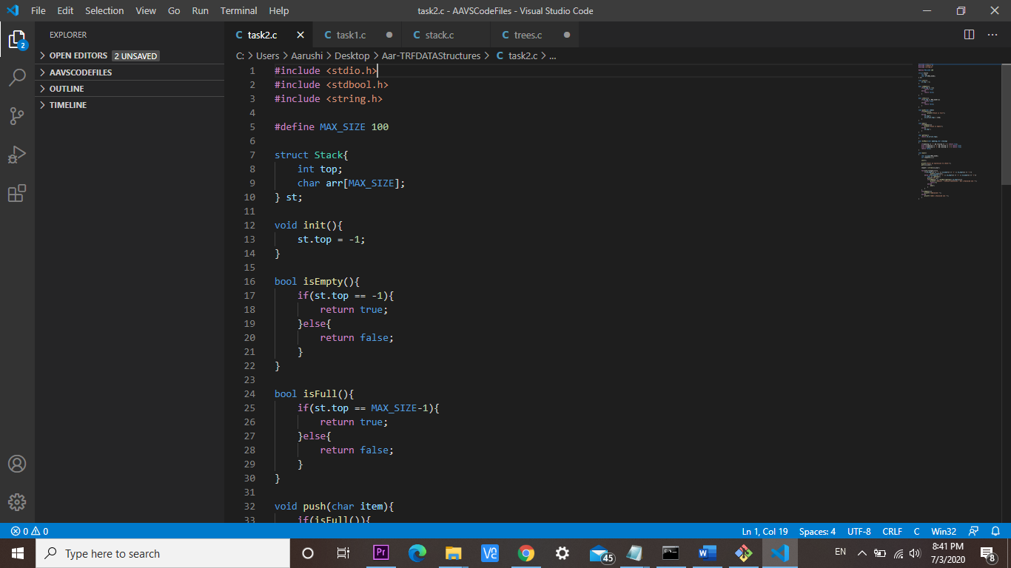

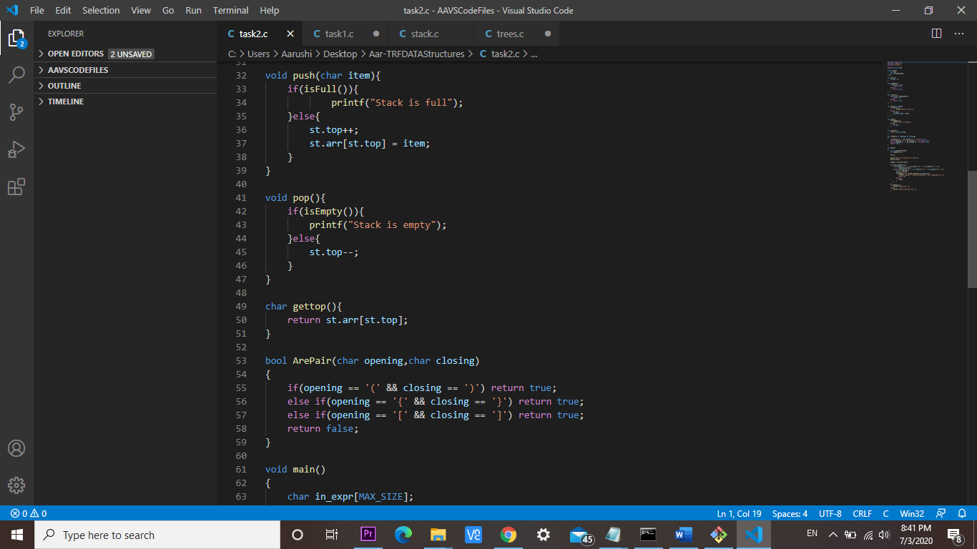

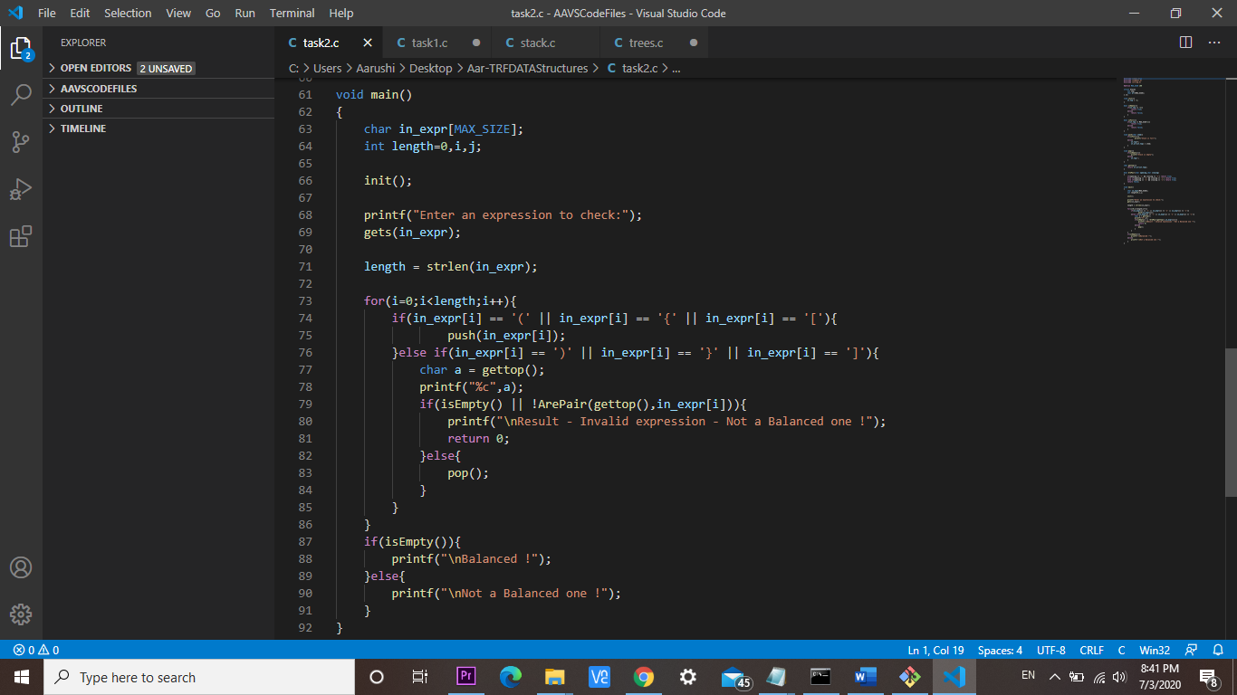

OUTPUT: used online gcc compiler

