**TRAVEL BLOG TEMPLATE**

**Submitted by:**

**Aaron Jibin**

**2462303**

[**aaron.jibin@btech.christuniversity.in**](mailto:aaron.jibin@btech.christuniversity.in)

**Anadhika Goswami**

**2462313**

[**anadhika.goswami@btech.christuniversity.in**](mailto:anadhika.goswami@btech.christuniversity.in)

**Anna Isson**

**2462316**

[**anna.isson@btech.christuniversity.in**](mailto:anna.isson@btech.christuniversity.in)

**Course:** **UI/UX Design Fundamentals**

**Instructor Name: Ms. Nagaveena**

**Institution:** **Christ University**

**Date of Submission: 16/08/2025**

**Abstract**

This project aims to design and develop *Wanderlust Chronicles*, a fully responsive travel blog website using HTML5 and CSS3. The site serves as an online travel journal, featuring articles, photographs, travel tips, and personal insights from global adventures. Its primary goal is to create an engaging, visually appealing, and user-friendly platform that adapts seamlessly to all devices. The blog structure includes a featured post, recent adventures, and integrated social media elements. It is implemented entirely with semantic HTML5 and modern CSS techniques. The project is a clean, organized travel blog layout that can be expanded with backend or JavaScript functionality in the future.

**Objectives**

* Create a visually appealing travel blog using modern UI/UX principles
* Design a fully responsive layout using only HTML5 and CSS3
* Implement structured HTML5 semantic elements for SEO and accessibility
* Apply CSS styling for branding, layout, and responsive behaviour
* Ensure accessibility and readability across device

**Scope of the Project**

* Focused on **front-end design only**
* No JavaScript or server-side integration implemented
* Optimized for **desktop, tablet, and mobile** viewports
* Built entirely with **open-source tools** and pure code (no frameworks/libraries)

**Tools & Technologies Used**

| **Tool/Technology** | **Purpose** |
| --- | --- |
| HTML5 | Markup and content structure |
| CSS3 | Styling, layout, and responsiveness |
| VS Code | Code editor |
| Chrome DevTools | Testing and debugging |

**HTML Structure Overview**

* Semantic tags used: <header>, <nav>, <main>, <section>, <article>, <aside>, <footer>
* Main sections: Featured Post, Recent Adventures, Sidebar (About Me & Categories), Footer
* Navigation menu with anchor links for smooth scrolling
* Grid and card layout for post previews
* Sidebar content for better blog navigation and personal connection

**CSS Styling Strategy**

* Used external CSS file (blog.css)
* Organized code with comments and sections for readability

**Key Features**

| **Feature** | **Description** |
| --- | --- |
| Responsive Design | Adjusts seamlessly to all screen sizes |
| Smooth Navigation | Fixed header navigation with anchor links |
| Featured Post Section | Highlighted travel story with image and excerpt |
| Post Grid Layout | Flex/Grid arrangement for recent adventures |
| Sidebar Widgets | Includes category links |
| Newsletter Subscription Form | Email capture for future engagement |

**Challenges Faced & Solutions**

| **Challenge** | **Solution** |
| --- | --- |
| Overlapping content on smaller screens | Applied media queries to stack and resize elements |
| Maintaining image proportions | Used object-fit: cover and responsive units |
| Aligning post cards consistently | Implemented CSS Grid with gap and consistent sizing |

**Outcome**

* Created a clean, organized, and visually engaging travel blog layout
* Achieved full responsiveness across multiple devices
* Enhanced understanding of CSS and semantic HTML
* Successfully implemented branding through typography and colour schemes

**Future Enhancements**

* Add JavaScript for interactive features (carousel, dynamic loading)
* Implement a CMS or backend for real-time post updates
* Add animations and transitions for improved user experience
* Enable comment sections for user engagement

**Sample Code**

<!DOCTYPE html>

<head>

<meta charset="UTF-8">

<meta name="viewport" content="width=device-width, initial-scale=1.0">

<title>Wanderlust Chronicles - Travel Blog</title>

<link rel="stylesheet" href="css/blog.css">

</head>

<body>

<!-- Header -->

<header class="header">

<div class="container">

<div class="header-content">

<a href="#" class="logo">🌍 Wanderlust Chronicles</a>

<nav class="nav">

<a href="#home">Home</a>

<a href="#destinations">Destinations</a>

<a href="#tips">Travel Tips</a>

<a href="#about">About</a>

<a href="#contact">Contact</a>

</nav>

</div>

</div>

</header>

<!-- Main Content -->

<main class="container">

<div class="main-content">

<section class="main-section">

<!-- Featured Post -->

<article class="featured-post">

<img src="images/hiker.jpg" alt="hiker" class="featured-image">

<div class="featured-content">

<h1 class="featured-title">Chasing Peaks in Ukraine</h1>

<p class="featured-excerpt">One might imagine finding solitude in a war-stricken nation like

Ukraine may prove to be impossible.

Yet, there is something cathartic about the Carpathian peaks. Shrouded in mist and

wildflowers, it's a reminder of

what we've lost, and what could have been. The weight of struggle is heavy in the air, but a

sight like ...

<a href="#" class="read-more">Continue Reading</a>

</div>

</article>

<!-- Recent Posts Section -->

<section>

<h2 class="section-title">Recent Adventures</h2>

<div class="posts-grid">

<article class="post-card">

<img src="images/japan.jpg" alt="Japan" class="post-image">

<div class="post-content">

<h3 class="post-title">The Duality of Japan</h3>

<p class="post-excerpt">From the bustling, neon-lit streets of Tokyo to the sizzling

Takoyaki

and warm laughter of Osaka, I've discovered a side to Japan ...

</p>

<a href="#" class="post-link">Read More →</a>

</div>

</article>

<article class="post-card">

<img src="images/himalaya.jpg" alt="Himalayas" class="post-image">

<div class="post-content">

<h3 class="post-title">A Beginner's Guide to the Himalayas</h3>

<p class="post-excerpt">Prayer flags and piping hot chai, every peak is both a blessing

and a curse. How

to tell if that trail leads to a gentle valley or a world-class climb? ...

</p>

<a href="#" class="post-link">Read More →</a>

</div>

</article>

<article class="post-card">

<img src="images/mexico.jpg" alt="Moroccan market" class="post-image">

<div class="post-content">

<h3 class="post-title">Lost in Mexico</h3>

<p class="post-excerpt">I can still taste the fresh tortillas right off the streets on

my tongue. Beyond

the maze of colours that flood the city, hidden in the jungles...</p>

<a href="#" class="post-link">Read More →</a>

</div>

</article>

<article class="post-card">

<img src="images/thailand.jpg" alt="Thailand" class="post-image">

<div class="post-content">

<h3 class="post-title">Temples and Thai Tides</h3>

<p class="post-excerpt">This was a long-awaited trip, I've heard it all about the Thai

smiles and the

spicy street food, but trying the real thing ...</p>

<a href="#" class="post-link">Read More →</a>

</div>

</article>

<article class="post-card">

<img src="images/greece.jpg" alt="Greece" class="post-image">

<div class="post-content">

<h3 class="post-title">Beyond Athens</h3>

<p class="post-excerpt">Greece has to be one of the most magical places I've ever been

to. You can feel

the history in the cobbled streets and blue skies ...</p>

<a href="#" class="post-link">Read More →</a>

</div>

</article>

<article class="post-card">

<img src="images/egypt.jpg" alt="Egypt" class="post-image">

<div class="post-content">

<h3 class="post-title">A Lesson in Historical Trekking</h3>

<p class="post-excerpt">Three weeks trekking by the Nile, from the metropolis to the

necropolis,

I've learnt more about history and ...</p>

<a href="#" class="post-link">Read More →</a>

</div>

</article>

</div>

</section>

</section>

<!-- Sidebar -->

<aside class="sidebar">

<section class="sidebar-section">

<h3 class="sidebar-title">About Me</h3>

<p class="bio-text">Hey there, digital traveler! I'm Harry, a hiker, a history nerd, and a massive

foodie,

all at the same time. I'm happiest with a pack on my bag and a horizon before my eyes. If you

don't find me

jotting down the next urban legend, or sweating it out over another impossible peak, you'll find

me curled up

with my cat in my cozy little nook at home in Bangalore.

</p>

</section>

<section class="sidebar-section">

<h3 class="sidebar-title">Categories</h3>

<ul class="categories-list">

<li><a href="#">Epic Quests in the Wild</a></li>

<li><a href="#">World Archeology</a></li>

<li><a href="#">Beyond Salt and Pepper</a></li>

<li><a href="#">How To's</a></li>

<li><a href="#">Budgeting Tips</a></li>

<li><a href="#">Solo Travel</a></li>

<li><a href="#">Environmentalism is Easy!</a></li>

</ul>

</section>

</aside>

</div>

</main>

<!-- Footer -->

<footer class="footer">

<div class="container">

<div class="footer-content">

<section class="footer-section">

<h3 class="footer-title">Follow My Journey</h3>

<div class="instagram-grid">

<img src="images/insta1.jpg" alt="Instagram post" class="instagram-thumb">

<img src="images/insta2.png" alt="Instagram post" class="instagram-thumb">

<img src="images/insta3.jpg" alt="Instagram post" class="instagram-thumb">

<img src="images/insta4.jpg" alt="Instagram post" class="instagram-thumb">

<img src="images/insta5.jpg" alt="Instagram post" class="instagram-thumb">

<img src="images/insta6.jpg" alt="Instagram post" class="instagram-thumb">

</div>

<p>@wanderlustchronicles</p>

</section>

<section class="footer-section">

<h3 class="footer-title">Never Miss an Adventure</h3>

<p>Subscribe to my newsletter to get fresh travel tips and exclusive content for free,

straight to your inbox.</p>

<form class="newsletter-form">

<input type="email" placeholder="Your email address" class="newsletter-input" required>

<button type="submit" class="newsletter-button">Subscribe</button>

</form>

</section>

</div>

</div>

</footer>

<!-- Back to Top Button - Always Visible -->

<a href="#" class="back-to-top">↑</a>

</body>

</html>

* {

    margin: 0;

    padding: 0;

    box-sizing: border-box;

}

:root {

    --forest-green: #2d5a3d;

    --sage-green: #7a9b76;

    --ocean-blue: #4a90a4;

    --earth-brown: #8b7355;

    --sand-beige: #f5f1eb;

    --warm-white: #fefefe;

    --text-dark: #2c3e50;

    --text-light: #6c757d;

}

body {

    font-family: 'Georgia', 'Times New Roman', serif;

    line-height: 1.6;

    color: var(--text-dark);

    background-color: var(--warm-white);

}

/* Fonts */

h1,

h2,

h3 {

    font-family: 'Georgia', serif;

    font-weight: 400;

    line-height: 1.3;

    margin-bottom: 0.5em;

}

a {

    color: var(--ocean-blue);

    text-decoration: none;

    transition: color 0.3s ease;

}

a:hover {

    color: var(--forest-green);

}

/* Layout */

.container {

    max-width: 75rem;

    margin: 0 auto;

    padding: 0 1rem;

}

.main-content {

    display: flex;

    flex-direction: column;

    gap: 2rem;

    padding: 2rem 0;

}

/* Header */

.header {

    background: linear-gradient(135deg, var(--forest-green), var(--sage-green));

    color: white;

    padding: 1rem 0;

    position: sticky;

    top: 0;

    z-index: 100;

    box-shadow: 0 0.125rem 0.25rem rgba(0, 0, 0, 0.1);

}

.header-content {

    display: flex;

    justify-content: space-between;

    align-items: center;

    flex-wrap: wrap;

}

.logo {

    font-size: 1.5rem;

    font-weight: bold;

    color: white;

}

.nav {

    display: flex;

    gap: 1.5rem;

    flex-wrap: wrap;

}

.nav a {

    color: white;

    font-size: 0.9rem;

    padding: 0.5rem;

    border-radius: 0.25rem;

    transition: background-color 0.3s ease;

}

.nav a:hover {

    background-color: rgba(255, 255, 255, 0.1);

}

/* Featured Post */

.featured-post {

    background: white;

    border-radius: 0.5rem;

    overflow: hidden;

    box-shadow: 0 0.25rem 1rem rgba(0, 0, 0, 0.1);

    transition: transform 0.3s ease, box-shadow 0.3s ease;

}

.featured-post:hover {

    transform: translateY(-0.125rem);

    box-shadow: 0 0.5rem 1.5rem rgba(0, 0, 0, 0.15);

}

.featured-image {

    width: 100%;

    height: 20rem;

    object-fit: cover;

    display: block;

}

.featured-content {

    padding: 1.5rem;

}

.featured-title {

    color: var(--forest-green);

    margin-bottom: 0.75rem;

}

.featured-excerpt {

    color: var(--text-light);

    font-size: 1.1rem;

    line-height: 1.7;

    margin-bottom: 1rem;

}

.read-more {

    display: inline-block;

    background: var(--ocean-blue);

    color: white;

    padding: 0.75rem 1.5rem;

    border-radius: 0.25rem;

    font-size: 0.9rem;

    transition: background-color 0.3s ease;

}

.read-more:hover {

    background: var(--forest-green);

}

/* Recent Posts */

.section-title {

    color: var(--forest-green);

    text-align: center;

    margin-bottom: 2rem;

    font-size: 2rem;

}

.posts-grid {

    display: grid;

    grid-template-columns: 1fr;

    gap: 1.5rem;

    margin-bottom: 3rem;

}

.post-card {

    background: white;

    border-radius: 0.5rem;

    overflow: hidden;

    box-shadow: 0 0.125rem 0.5rem rgba(0, 0, 0, 0.1);

    transition: transform 0.3s ease, box-shadow 0.3s ease;

}

.post-card:hover {

    transform: translateY(-0.125rem);

    box-shadow: 0 0.25rem 1rem rgba(0, 0, 0, 0.15);

}

.post-image {

    width: 100%;

    height: 12rem;

    object-fit: cover;

    display: block;

}

.post-content {

    padding: 1rem;

}

.post-title {

    color: var(--forest-green);

    font-size: 1.1rem;

    margin-bottom: 0.5rem;

}

.post-excerpt {

    color: var(--text-light);

    font-size: 0.9rem;

    margin-bottom: 0.75rem;

}

.post-link {

    font-size: 0.85rem;

    font-weight: bold;

}

/* Sidebar */

.sidebar {

    background: var(--sand-beige);

    padding: 1.5rem;

    border-radius: 0.5rem;

    margin-bottom: 2rem;

}

.sidebar-section {

    margin-bottom: 2rem;

}

.sidebar-title {

    color: var(--forest-green);

    border-bottom: 0.125rem solid var(--sage-green);

    padding-bottom: 0.5rem;

    margin-bottom: 1rem;

}

.bio-text {

    color: var(--text-light);

    line-height: 1.6;

}

.categories-list {

    list-style: none;

}

.categories-list li {

    margin-bottom: 0.5rem;

}

.categories-list a {

    display: block;

    padding: 0.5rem;

    background: white;

    border-radius: 0.25rem;

    transition: background-color 0.3s ease;

}

.categories-list a:hover {

    background: var(--sage-green);

    color: white;

}

/* Footer */

.footer {

    background: var(--earth-brown);

    color: white;

    padding: 2rem 0;

}

.footer-content {

    display: flex;

    flex-direction: column;

    gap: 2rem;

}

.footer-section {

    text-align: center;

}

.footer-title {

    color: white;

    margin-bottom: 1rem;

}

.instagram-grid {

    display: grid;

    grid-template-columns: repeat(3, 1fr);

    gap: 0.5rem;

    margin-bottom: 1rem;

}

.instagram-thumb {

    width: 100%;

    height: 5rem;

    object-fit: cover;

    border-radius: 0.25rem;

}

.newsletter-form {

    display: flex;

    flex-direction: column;

    gap: 0.75rem;

    max-width: 20rem;

    margin: 0 auto;

}

.newsletter-input {

    padding: 0.75rem;

    border: none;

    border-radius: 0.25rem;

    font-size: 1rem;

}

.newsletter-button {

    background: var(--ocean-blue);

    color: white;

    padding: 0.75rem;

    border: none;

    border-radius: 0.25rem;

    font-size: 1rem;

    cursor: pointer;

    transition: background-color 0.3s ease;

}

.newsletter-button:hover {

    background: var(--forest-green);

}

/* Back to Top */

.back-to-top {

    position: fixed;

    bottom: 2rem;

    right: 2rem;

    background: var(--ocean-blue);

    color: white;

    width: 3rem;

    height: 3rem;

    border-radius: 50%;

    display: flex;

    align-items: center;

    justify-content: center;

    font-size: 1.25rem;

    transition: background-color 0.3s ease;

    z-index: 1000;

}

.back-to-top:hover {

    background: var(--forest-green);

}

/* Responsiveness */

@media (min-width: 48rem) {

    .header-content {

        flex-wrap: nowrap;

    }

    .main-content {

        flex-direction: row;

        gap: 3rem;

    }

    .main-section {

        flex: 2;

    }

    .sidebar {

        flex: 1;

        margin-bottom: 0;

        align-self: flex-start;

    }

    .posts-grid {

        grid-template-columns: repeat(2, 1fr);

    }

    .footer-content {

        flex-direction: row;

        justify-content: space-around;

        text-align: left;

    }

    .newsletter-form {

        flex-direction: row;

        max-width: none;

    }

    .newsletter-input {

        flex: 1;

    }

}

@media (min-width: 64rem) {

    .posts-grid {

        grid-template-columns: repeat(3, 1fr);

    }

    .instagram-grid {

        grid-template-columns: repeat(6, 1fr);

    }

    h1 {

        font-size: 2.5rem;

    }

    h2 {

        font-size: 2rem;

    }

}

**Screenshots of Final Output**

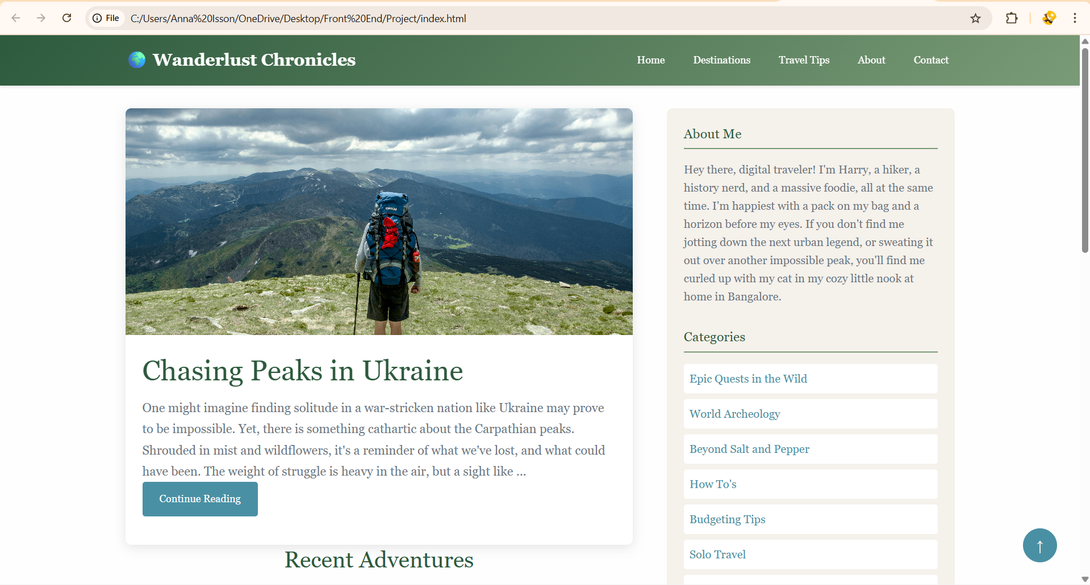

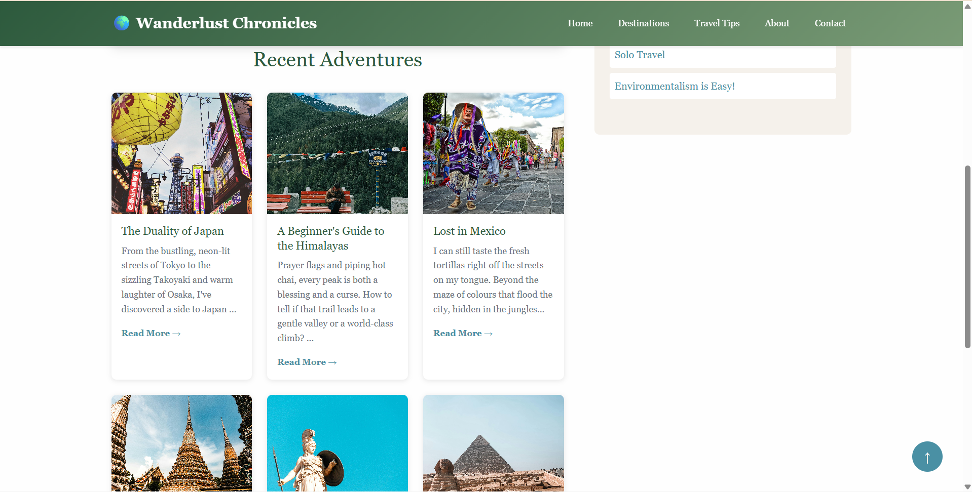

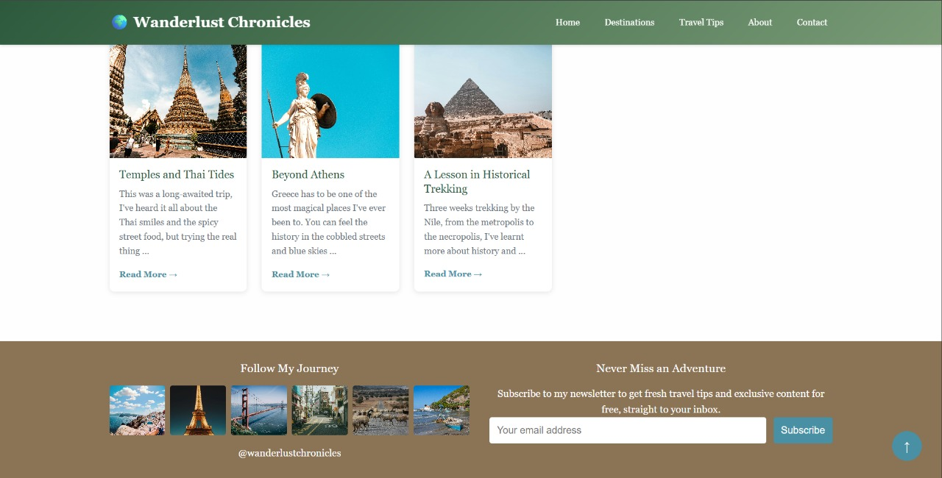

**Conclusion**

The project successfully demonstrates the design and development of a fully responsive travel blog using only HTML5 and CSS3. The implementation process enhanced my understanding of semantic structure, responsive layout techniques, and user-friendly UI design. By focusing on accessibility, content hierarchy, and consistent styling, this project resulted in a professional travel blog layout that can serve as a foundation for further enhancements with JavaScript or backend integration.

**References**

* L&T LMS: <https://learn.lntedutech.com/Landing/MyCourse>