**MOVIE INFO PAGE**

**Submitted by:**

**Aaron Jibin**

**2462303**

[**aaron.jibin@btech.christuniversity.in**](mailto:aaron.jibin@btech.christuniversity.in)

**Anadhika Goswami**

**2462313**

[**anadhika.goswami@btech.christuniversity.in**](mailto:anadhika.goswami@btech.christuniversity.in)

**Anna Isson**

**2462316**

[**anna.isson@btech.christuniversity.in**](mailto:anna.isson@btech.christuniversity.in)

**Course:** **UI/UX Design Fundamentals**

**Instructor Name: Ms. Nagaveena**

**Institution:** **Christ University**

**Date of Submission: 16/08/2025**

**Abstract**

The webpage presents a detailed, visually engaging profile of James Cameron’s *Avatar* (2009). It integrates textual information, images, and interactive links to deliver a comprehensive movie showcase. The design is structured into clear sections with semantic HTML, enhancing both readability and user experience.

**Objectives**

* Create a visually appealing travel blog using modern UI/UX principles
* Design a fully responsive layout using only HTML5 and CSS3
* Implement structured HTML5 semantic elements for SEO and accessibility
* Apply CSS styling for branding, layout, and responsive behaviour
* Ensure accessibility and readability across device

**Scope of the Project**

* Focused on **front-end design only.**
* No JavaScript or server-side integration implemented.
* Optimized for **desktop, tablet, and mobile** viewports.
* Built entirely with **open-source tools** and pure code (no frameworks/libraries).

**Tools & Technologies Used**

| **Tool/Technology** | **Purpose** |
| --- | --- |
| HTML5 | Markup and content structure |
| CSS3 | Styling, layout, and responsiveness |
| VS Code | Code editor |
| Chrome DevTools | Testing and debugging |

**HTML Structure Overview**

* Semantic tags used: <header>, <nav>, <main>, <section>, <article>, <aside>, <footer>
* Main sections: Featured Post, Recent Adventures, Sidebar (About Me & Categories), Footer
* Navigation menu with anchor links for smooth scrolling
* Grid and card layout for post previews
* Sidebar content for better blog navigation and personal connection

**CSS Styling Strategy**

* Used external CSS file (blog.css)
* Organized code with comments and sections for readability

**Key Features**

| **Feature** | **Description** |
| --- | --- |
| Responsive Design | Adjusts seamlessly to all screen sizes |
| Smooth Navigation | Fixed header navigation with anchor links |
| Featured Post Section | Highlighted travel story with image and excerpt |
| Post Grid Layout | Flex/Grid arrangement for recent adventures |
| Sidebar Widgets | Includes category links |
| Newsletter Subscription Form | Email capture for future engagement |

**Challenges Faced & Solutions**

| **Challenge** | **Solution** |
| --- | --- |
| Overlapping content on smaller screens | Applied media queries to stack and resize elements |
| Maintaining image proportions | Used object-fit: cover and responsive units |
| Aligning post cards consistently | Implemented CSS Grid with gap and consistent sizing |

**Outcome**

* Created a clean, organized, and visually engaging travel blog layout
* Achieved full responsiveness across multiple devices
* Enhanced understanding of CSS and semantic HTML
* Successfully implemented branding through typography and colour schemes

**Future Enhancements**

* Add JavaScript for interactive features (carousel, dynamic loading)
* Implement a CMS or backend for real-time post updates
* Add animations and transitions for improved user experience
* Enable comment sections for user engagement

**Sample Code**

<!DOCTYPE html>

<html lang="en">

<head>

    <meta charset="UTF-8">

    <title>Avatar Movie Info</title>

    <link rel="stylesheet" href="css/movie.css">

</head>

<body>

    <header class="header">

        <h1>Avatar</h1>

        <p>Genre: Science Fiction | Release Year: 2009</p>

    </header>

    <section class="banner">

        <img src="images/avatar-banner.jpg" alt="Avatar Banner" height="auto" width="100%">

        <br><br>

    </section>

    <section class="synopsis">

        <h2>Synopsis</h2>

        <p>

            "Avatar" is a science fiction epic set in the mid-22nd century on Pandora, a lush moon inhabited by the

            Na’vi, a tall, blue-skinned species. Jake Sully, a paraplegic former Marine, is sent to Pandora to operate

            an avatar — a genetically engineered Na’vi body — to interact with the locals. As he integrates into Na’vi

            society, he learns their culture and deep connection to nature. Torn between following orders from the human

            corporation exploiting Pandora’s resources and protecting the Na’vi, Jake faces a moral choice. The story

            explores themes of environmentalism, colonialism, and identity against a visually stunning alien backdrop.

        </p>

    </section>

    <br><br>

    <section class="images">

        <h2>Images</h2>

        <div class="images-grid">

            <img src="images/avatar1.png" alt="Scene 1 from Avatar">

            <img src="images/avatar2.png" alt="Scene 2 from Avatar">

            <img src="images/avatar3.png" alt="Scene 3 from Avatar">

            <img src="images/avatar4.png" alt="Scene 4 from Avatar">

        </div>

    </section>

    <br><br>

    <section class="cast">

        <h2>Cast</h2>

        <div class="cast-grid">

            <div class="card">

                <a href="https://www.imdb.com/name/nm0941777/" target="_blank">

                    <img src="images/sam-worthington.png" alt="Sam Worthington">

                </a>

                <p>Sam Worthington<br><small>Jake Sully</small></p>

            </div>

            <div class="card">

                <a href="https://www.imdb.com/name/nm0757855/" target="_blank">

                    <img src="images/zoe-saldana.png" alt="Zoe Saldana">

                </a>

                <p>Zoe Saldana<br><small>Neytiri</small></p>

            </div>

            <div class="card">

                <a href="https://www.imdb.com/name/nm0000244/" target="_blank">

                    <img src="images/sigourney-weaver.png" alt="Sigourney Weaver">

                </a>

                <p>Sigourney Weaver<br><small>Dr. Grace Augustine</small></p>

            </div>

            <div class="card">

                <a href="https://www.imdb.com/name/nm0002332/" target="_blank">

                    <img src="images/stephen-lang.png" alt="Stephen Lang">

                </a>

                <p>Stephen Lang<br><small>Colonel Miles Quaritch</small></p>

            </div>

            <div class="card">

                <a href="https://www.imdb.com/name/nm0735442/" target="_blank">

                    <img src="images/michelle-rodriguez.png" alt="Michelle Rodriguez">

                </a>

                <p>Michelle Rodriguez<br><small>Trudy Chacon</small></p>

            </div>

            <div class="card">

                <a href="https://www.imdb.com/name/nm0000610/" target="_blank">

                    <img src="images/giovanni-ribisi.png" alt="Giovanni Ribisi">

                </a>

                <p>Giovanni Ribisi<br><small>Parker Selfridge</small></p>

            </div>

        </div>

    </section>

    <br><br>

    <section class="reviews">

        <h2 style="text-align: center;">User Reviews</h2>

        <div>

            <p>"You know the feeling when you start watching a movie, realizing it's almost 3 hours, and

                saying to yourself - "Well this is probably gonna be mostly boring", well, the creators of this movie

                didn't

                let that happen, rest assures.From the beginning up until the ending, every scene is perfected,

                with amazing acting, stunning directing, great visual effects, and astounding sound effects.

                The story building is just great, characters are well-developed, and the concept is brilliant. The only

                thing

                that's missing to me, is a fitting-soundtrack which could've give some scenes a great boost.I avoided

                watching

                this movie for a long time, because it just seemed a little ridiculous to me (Come on there are blue

                people)

                but I'm so glad I finally decides to give it a chance, and boy did it serve.

                Loved it. 9.5/10."</p>

            <cite>- Benjamin Heckendorn</cite>

        </div>

        <br><br>

        <div>

            <p>"A film with the scope of James Cameron's Avatar was always going to be a risk both artistically and

                financially, especially in today's economic climate. Whether it will pay off monetarily is a question

                only time can answer, but this viewer can at the very least attest to it being an artistic triumph.

                Avatar brings us as close as cinema ever has to actually visiting an alien world. The beautiful

                environs, the exotic creatures and incredibly lifelike natives of Pandora arrest the senses, visually,

                aurally and emotionally. The world in Avatar is the true star of the show. The amount of detail and work

                that has gone into bringing this new world alive is seriously impressive, and it will be a while before

                we see anything that overtakes it in scope and quality. WETA Workshop and ILM have truly outdone

                themselves.

                Relative newcomer, Aussie Sam Worthington provides a solid human heart amongst all the

                science-fiction/fantasy beauty and Zoe Saldana gives an impressive performance as the 8 foot tall Na'vi,

                Neytiri. Even though the characters they both play are blue, giant, catlike aliens, they managed to

                evoke a chemistry and likability that pierces through the special effects.

                That's not to say that everything is perfect. The story is basic and dare I say, clichéd and

                predictable. We have seen it plenty of times in all forms of media. The bad guys are cartoonishly evil,

                and sadly paper thin. The love story, while charming, is also clichéd despite being between man and

                alien. But in the face of these shortcomings, Avatar is a success because its storytelling lies in the

                brilliant visuals.

                Avatar is a beautiful piece of film and a true event. It does exactly what cinema was always intended to

                - it takes us away from our problems and worries for a few hours and gives us memorable images which

                will undoubtedly and deservedly enter into the cultural lexicon to stay for the foreseeable future"</p>

            <cite>- GoldenEye Online</cite>

        </div>

    </section>

    <br><br>

    <section class="where-to-watch">

        <h2>Where to Watch</h2>

        <a href="https://www.netflix.com/title/70109892" class="buttons" target="_blank"><img src="images/netflix.png"

                height="56px" width="80px"></a>

        <a href="https://www.amazon.com/Avatar-Sam-Worthington/dp/B0B657C78K" class="buttons" target="_blank"><img

                src="images/prime.png" height="56px" width="80px"></a>

        <a href="https://www.disneyplus.com/browse/entity-357d8505-b9bc-41e3-9f27-0414738df143" class="buttons" target="_blank"><img

                src="images/plus.png" height="56px" width="80px"></a>

        <a href="https://tv.apple.com/us/movie/avatar/umc.cmc.1hmaf5hccvdvn71dc5hr7mgcj" class="buttons" target="_blank"><img

                src="images/apple.png" height="56px" width="80px"></a>

    </section>

    <br><br>

    <br><br>

    <footer class="footer">

        <p>&copy; 2025 3BTCSDS. All rights reserved.</p>

    </footer>

</body>

</html>

@font-face {

    font-family: 'Ava';

    src: url(papyrus.ttf);

    font-weight: normal;

    font-style: normal;

}

@font-face {

    font-family: 'AvaBold';

    src: url(TorukscRegular-z8MA1.ttf);

    font-weight: normal;

    font-style: normal;

}

h2 {

    font-family: AvaBold;

}

body {

    background-image: linear-gradient(to right, #1B2E61, #264189);

    color: #9fd3d8;

}

section {

    animation: fade-up 1s ease-out;

}

@keyframes fade-up {

    from {

        transform: translateY(30px);

        opacity: 0;

    }

    to {

        transform: translateY(0);

        opacity: 1;

    }

}

.header {

    text-align: center;

    font-family: AvaBold;

    font-size: 35px;

    animation-duration: 3s;

    animation-name: slide-in;

}

@keyframes slide-in {

    from {

        transform: translateX(150vw) scale(2, 1);

    }

    to {

        transform: translateX(0) scale(1, 1);

    }

}

.banner img {

    animation: slow-zoom 10s ease-in-out forwards;

}

@keyframes slow-zoom {

    from {

        transform: scale(1);

    }

    to {

        transform: scale(1.05);

    }

}

.synopsis {

    font-family: papyrus;

    width: 80%;

    margin: 0 auto;

    text-align: center;

    animation-delay: 1s;

}

.images {

    padding: 30px;

    max-width: 1000px;

    margin: auto;

    text-align: center;

    animation-delay: 2s;

}

.images h2 {

    margin-bottom: 20px;

}

.images-grid {

    display: flex;

    flex-wrap: wrap;

    gap: 15px;

    justify-content: center;

}

.images-grid img {

    max-width: 220px;

    border-radius: 10px;

    box-shadow: 0 4px 8px rgba(0, 0, 0, 0.6);

    transition: transform 0.3s ease, box-shadow 0.3s ease;

}

.images-grid img:hover {

    transform: scale(1.05);

    box-shadow: 0 6px 15px rgba(0, 0, 0, 0.8);

}

.cast {

    font-family: papyrus;

    width: 80%;

    margin: 0 auto;

    text-align: center;

    animation-delay: 3s;

}

.cast img {

    height: 250px;

    width: 180px;

    object-fit: cover;

}

.cast-grid {

    display: flex;

    flex-wrap: wrap;

    gap: 1.5rem;

    justify-content: center;

}

.card {

    background-color: #1f2833;

    border-radius: 12px;

    overflow: hidden;

    box-shadow: 0 4px 8px rgba(0, 0, 0, 0.7);

    max-width: 200px;

    text-align: center;

    transition: transform 0.3s ease, box-shadow 0.3s ease;

}

.card:hover {

    transform: scale(1.05);

    box-shadow: 0 0 15px #9FD3D8;

}

.card img {

    width: 100%;

    display: block;

    height: auto;

}

.reviews {

    font-family: papyrus;

    width: 80%;

    margin: 0 auto;

    animation-delay: 4s;

}

.where-to-watch {

    font-family: papyrus;

    width: 80%;

    margin: 0 auto;

    text-align: center;

}

.where-to-watch img:hover {

    transform: scale(1.05);

    box-shadow: 0 0 15px #9FD3D8;

}

.buttons {

    margin: 0 24px;

}

.footer {

    font-family: papyrus;

    text-align: center;

}

**Screenshots of Final Output**

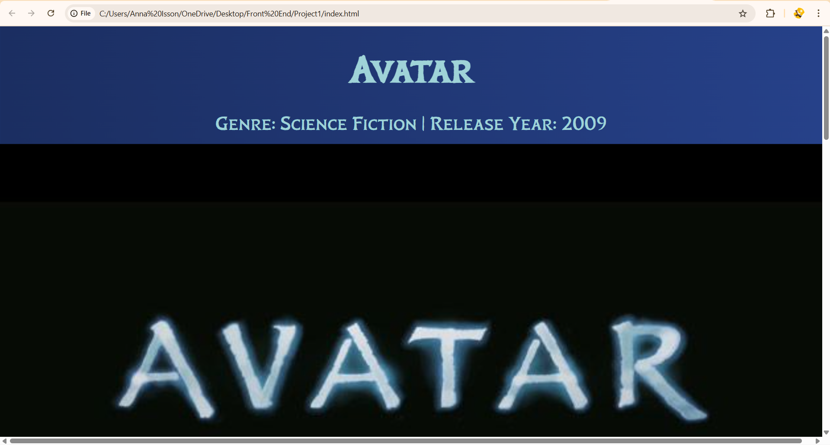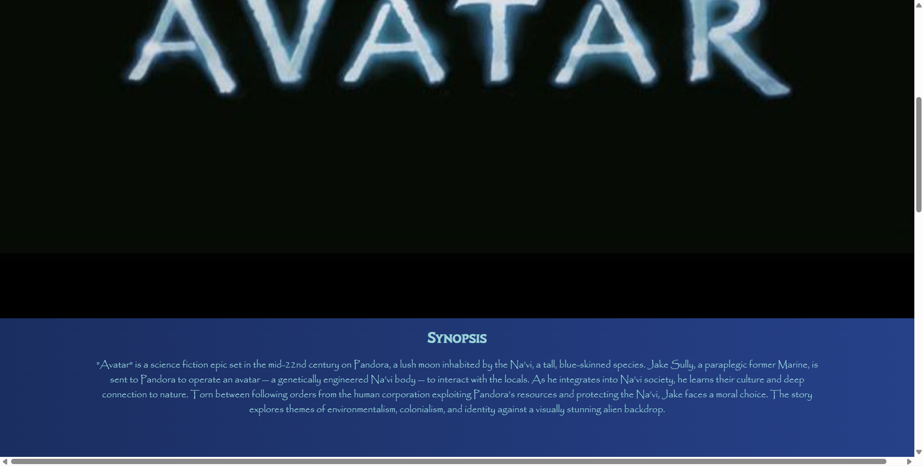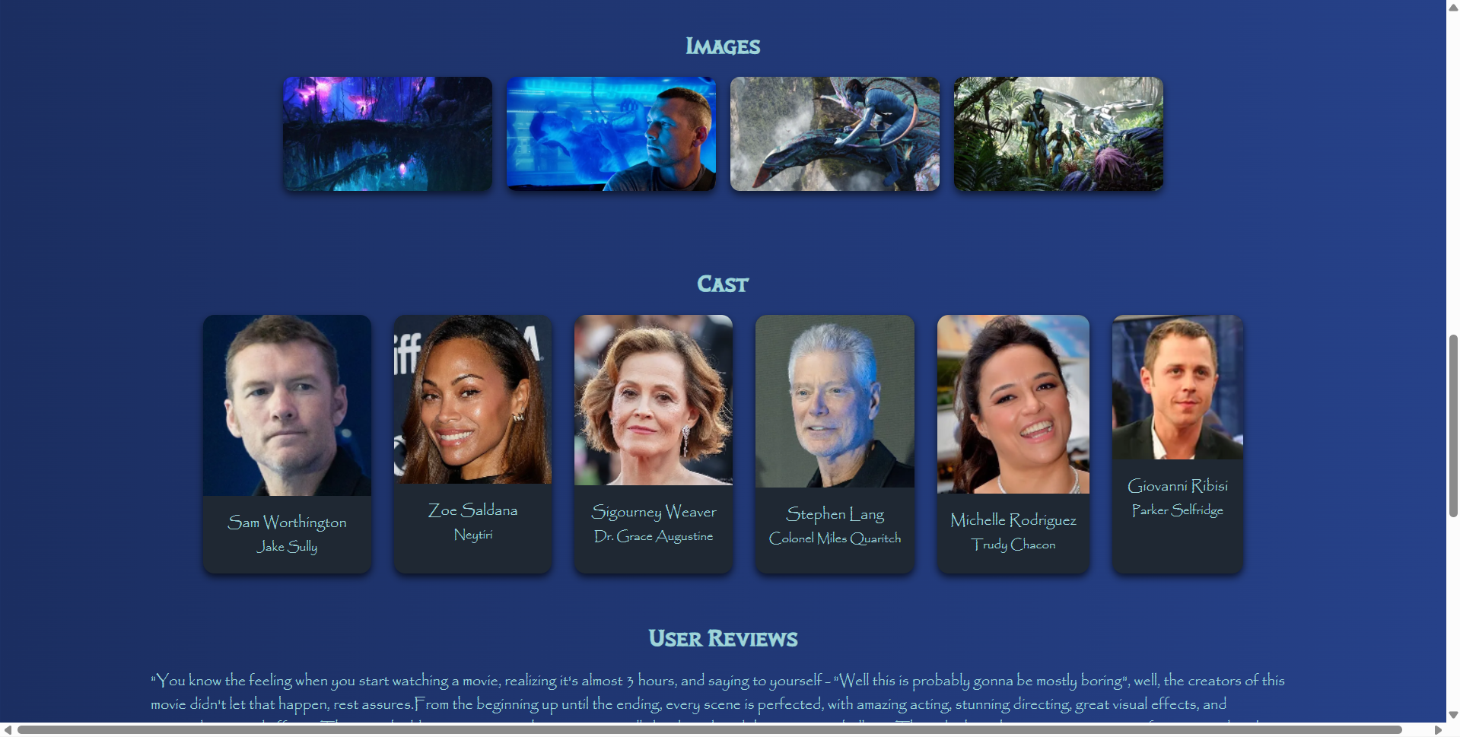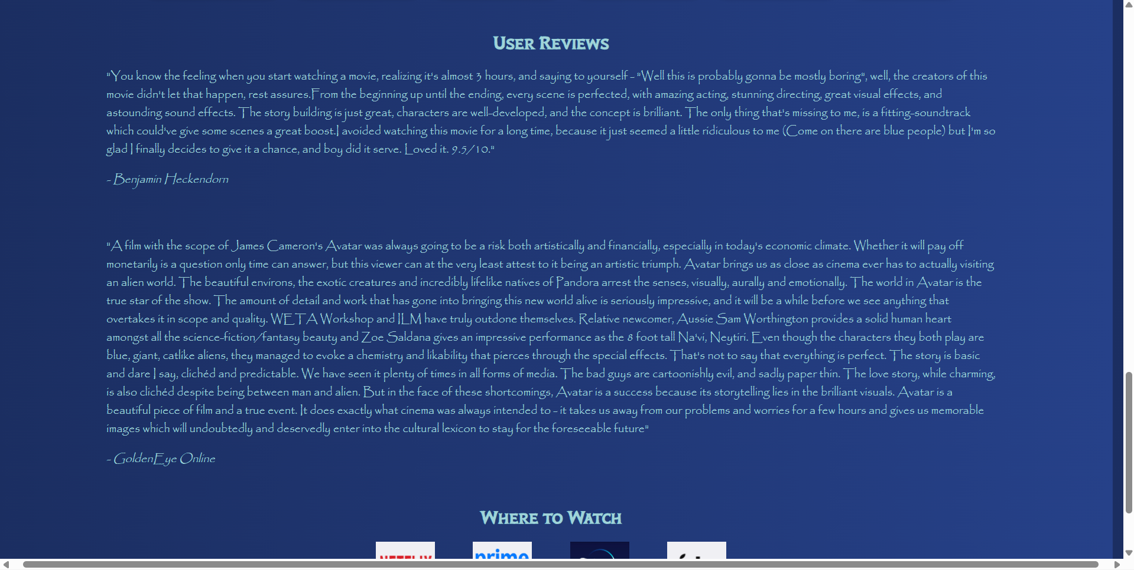



**Conclusion**

The project successfully demonstrates the design and development of a fully responsive travel blog using only HTML5 and CSS3. The implementation process enhanced my understanding of semantic structure, responsive layout techniques, and user-friendly UI design. By focusing on accessibility, content hierarchy, and consistent styling, this project resulted in a professional travel blog layout that can serve as a foundation for further enhancements with JavaScript or backend integration.

**References**

* L&T LMS: <https://learn.lntedutech.com/Landing/MyCourse>