METADATA CAPTURE &
LINEAGE ENGINE

Project Definition, Technical Specification & Architecture
Phase 1 — Foundation Document

Automatically track, version, and govern data flow across heterogeneous pipelines.

01 Problem Statement

Modern data and AI ecosystems generate enormous volumes of metadata across heterogeneous pipelines — from raw ingestion through transformation to downstream consumption by dashboards, ML models, and reporting tools. Despite this complexity, most organisations lack any automated, scalable mechanism to track, version, or govern how data flows through these systems.
Compounding Operational Failures
The absence of lineage infrastructure creates high-impact, cascading failures:

- Pipeline debugging is guesswork — when a dashboard reports incorrect figures or a model behaves unexpectedly, engineers have no authoritative lineage to trace the root cause. Debugging hours stretch into days.
- Manual documentation is immediately stale — spreadsheet-based metadata catalogues are abandoned within weeks of creation because they cannot scale or self-update as pipelines evolve.
- Critical questions go unanswered — teams cannot determine: Where did this data originate? Which downstream assets does this schema change affect? Which feature versions trained this model?
- AI and ML reproducibility is broken — without end-to-end provenance capturing training datasets, feature transforms, schema versions, and run parameters, model auditing and rollback are impossible.
- Regulatory exposure is unquantified — meeting GDPR, CCPA, and HIPAA obligations requires full, auditable, bi-temporal data traceability.

CORE PROBLEM
Data and AI pipelines generate massive, unstructured metadata with no automated, scalable way to track, version, or govern data flow across heterogeneous systems — resulting in brittle pipelines, regulatory risk, and broken AI reproducibility.

02 Project Scope

The Metadata Capture & Lineage Engine is a backend system that captures, stores, and exposes lineage metadata for data pipelines. It records how data moves between sources, transformations, and destinations — storing those relationships in a graph database and making them queryable via a REST API. The initial scope is focused on core lineage capture and traversal; advanced AI features are explicitly deferred to later phases.
2.1 What's In Scope

- Graph database schema using Neo4j (community edition) with nodes for Jobs, Datasets, and Runs — edges representing PRODUCES and CONSUMES relationships with timestamps for historical reference.
- OpenLineage event ingestion endpoint via FastAPI — receives lineage events emitted by Apache Airflow and writes them to the graph. Airflow is the sole supported orchestrator in Phase 1.
- SQLGlot-based SQL parser for table-level lineage extraction from SQL logs — covering PostgreSQL and Snowflake dialects. Output feeds the same graph as runtime events.
- Core REST API with four endpoints: POST /lineage/events (ingest), GET /lineage/upstream/{dataset_id}, GET /lineage/downstream/{dataset_id}, and GET /lineage/runs/{job_id}. Responses validated with Pydantic v2.
- PostgreSQL 15+ backend for run metadata — job name, run ID, start/end timestamps, status (success/failure), and input/output dataset references. Queryable independently of the graph.
- dbt manifest.json parser — reads dbt's manifest to extract model dependency relationships and loads them into the graph as static lineage.
- PII tag propagation — if a source dataset is tagged (e.g. 'pii', 'sensitive'), that tag is automatically applied to all directly derived downstream datasets on ingestion.
- Docker Compose development environment with pre-configured Neo4j, PostgreSQL, and FastAPI containers, including a README and example Airflow DAG.

OUT OF SCOPE — Phase 1
Column-level lineage, authentication/authorisation, AI-powered natural language querying, governance policy enforcement, and multi-orchestrator support are explicitly deferred. The design is intentionally additive — these capabilities can be layered in without rearchitecting the core.

03 Project Objectives

Five measurable objectives define project success. Each includes a quantitative success criterion for unambiguous evaluation at project completion.

ID | Objective | Success Criterion
O1 | Capture table-level lineage automatically for all Airflow-orchestrated pipelines, eliminating manual metadata documentation. | ≥90% of Airflow DAG runs produce a captured lineage event in the graph within 60 seconds of completion, verified across a 2-week pilot in Phase 2.
O2 | Make lineage traversal queryable via REST API so any engineer can identify upstream/downstream impact without writing Cypher. | All four core API endpoints return correct results in <2 seconds on a graph of up to 100k edges, validated by integration tests in Phase 3.
O3 | Parse and ingest table-level lineage from existing SQL scripts (PostgreSQL & Snowflake dialects) for historical lineage coverage. | SQLGlot parser correctly extracts source/target tables from ≥85% of a representative set of 50 SQL scripts from the production query log.
O4 | Automatically propagate sensitivity tags from source datasets to directly derived downstream datasets, reducing manual tagging. | 100% of datasets derived from a PII-tagged source are automatically tagged on ingestion with zero manual intervention, demonstrated in Phase 3.
O5 | Deliver a working local development environment so any team member can run the full lineage stack with a single command. | Docker Compose environment starts cleanly on macOS/Linux in under 3 minutes with a working Airflow DAG, completed by end of Phase 1.

04 System Architecture

The engine is structured as a three-layer backend system: an Ingestion Layer that collects lineage events from Airflow and SQL parsing, a Storage Layer using Neo4j for the lineage graph and PostgreSQL for run metadata, and an API Layer exposing lineage traversal via FastAPI.
The design is intentionally simple — the goal is a working, trustworthy lineage store, not a feature-complete platform. Advanced capabilities are designed as additive layers introduced in subsequent phases without rearchitecting the core.
4.1 Full System Architecture Diagram

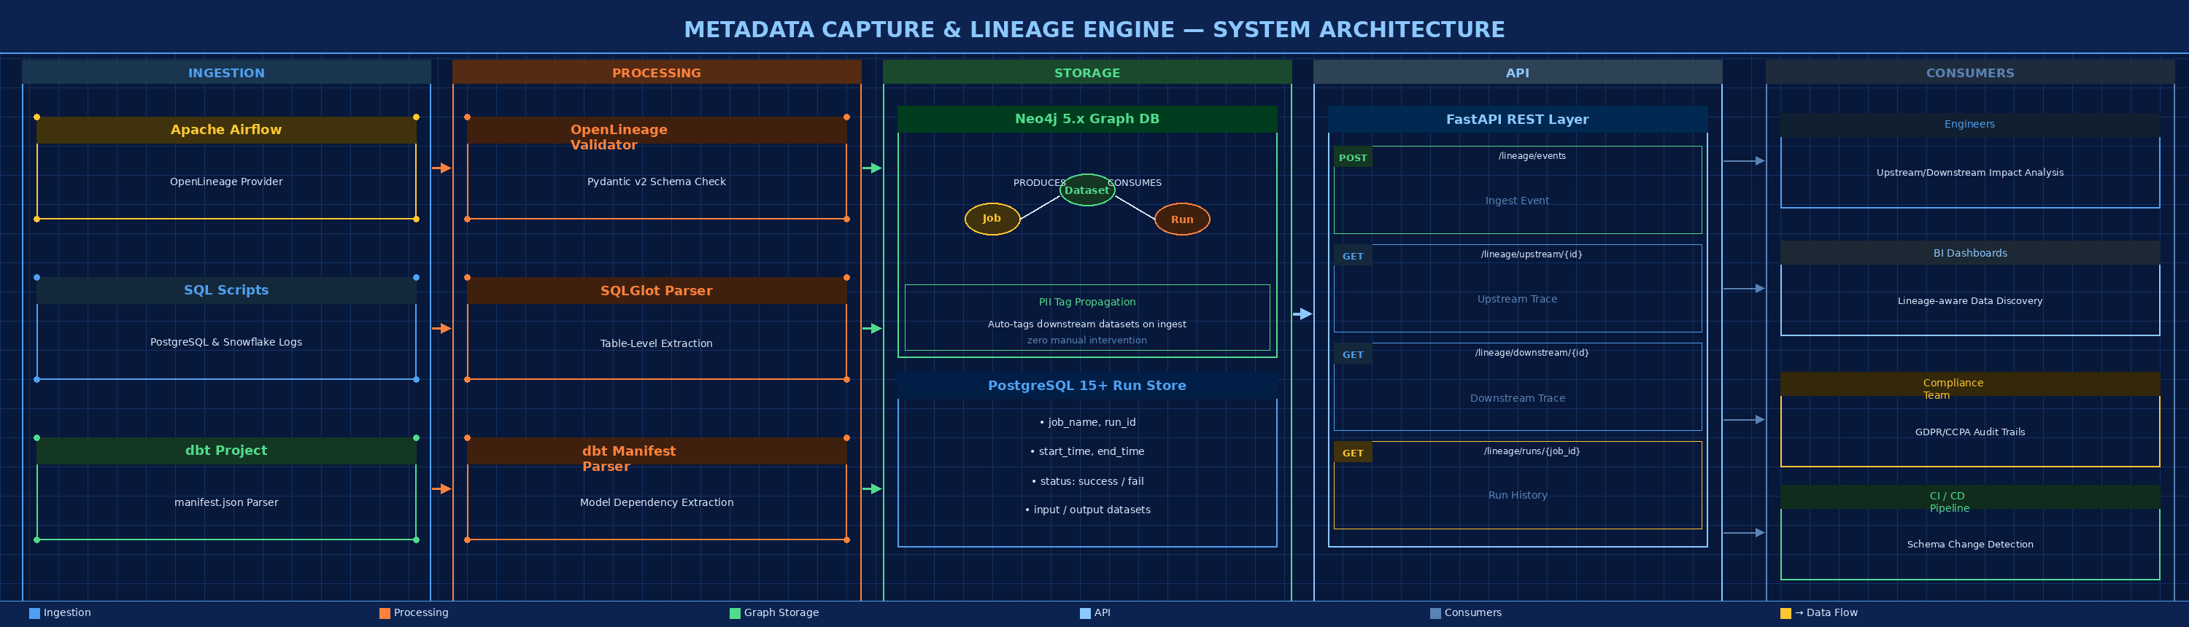
Figure 1 — Blueprint System Architecture: Ingestion → Processing → Storage → API → Consumers

Layer Breakdown

Layer | Role | Key Technologies
Ingestion Layer | Collects lineage events from all pipeline sources | Apache Airflow + OpenLineage + SQLGlot + dbt manifest.json
Processing Layer | Validates, normalises, and routes events to storage | Pydantic v2 validation + SQLGlot table extraction + manifest parsing
Storage — Graph | Stores lineage graph with typed nodes and edges | Neo4j 5.x Community Edition — Cypher query language
Storage — Relational | Stores structured run metadata and audit log | PostgreSQL 15+ — independent of graph, always queryable
API Layer | Exposes lineage traversal and ingestion endpoints | FastAPI + Pydantic v2 + uvicorn ASGI server
Consumer Layer | Downstream teams and tools that consume lineage | Engineers, BI Dashboards, Compliance Teams, CI/CD systems

4.2 Core Data Flow

Every lineage event — whether emitted by Airflow at runtime, extracted from a SQL script by SQLGlot, or read from a dbt manifest — follows the same normalised path through the system before reaching the graph.
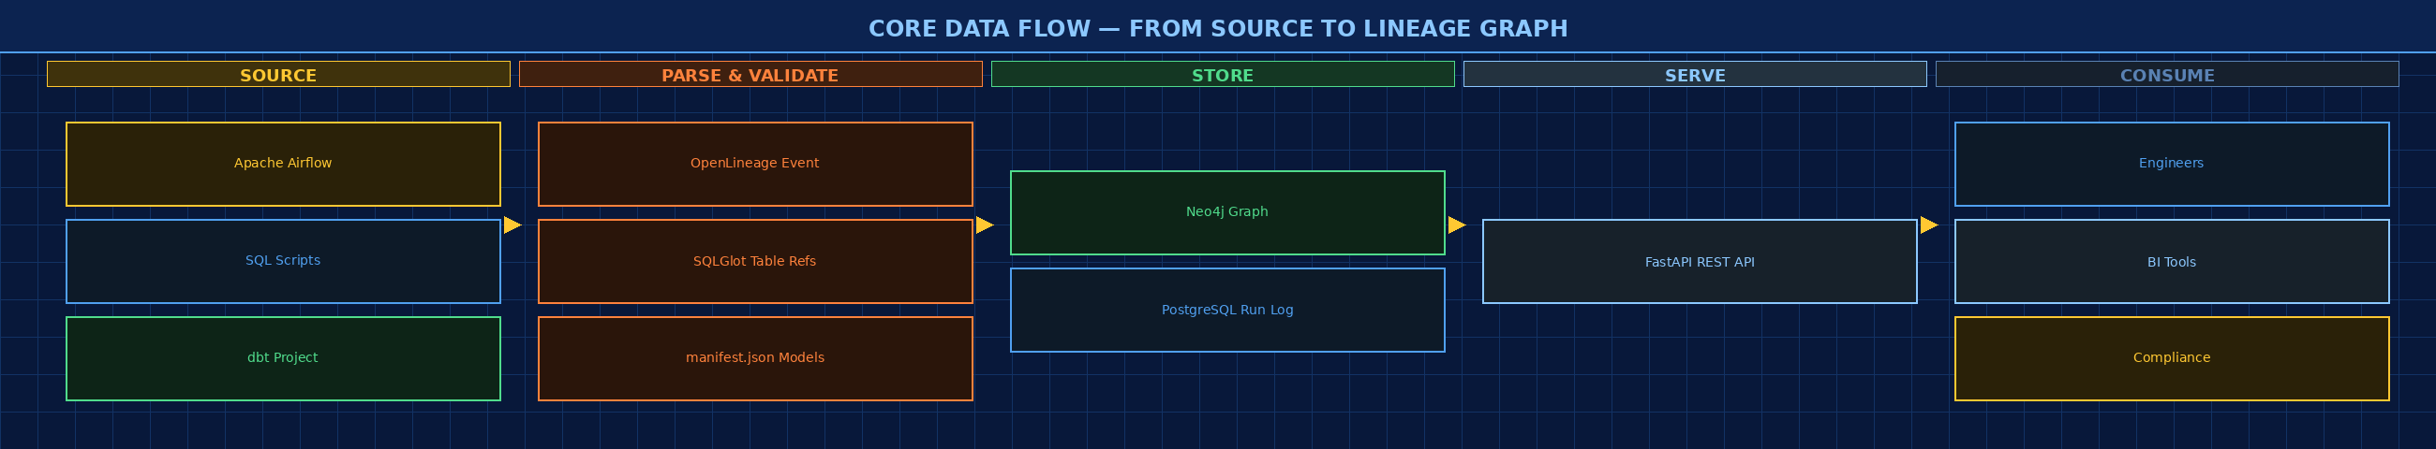
Figure 2 — Core Data Flow: Source → Parse/Validate → Store → Serve → Consume

Ingestion Paths Explained

Path A — Runtime (Primary): Apache Airflow + OpenLineage
Airflow emits OpenLineage events via the openlineage-airflow provider after each task run. The engine's POST /lineage/events endpoint receives these, validates them with Pydantic v2, and writes Job/Dataset nodes and PRODUCES/CONSUMES edges to Neo4j.

Path B — Static Parsing: SQLGlot
SQLGlot parses SQL scripts (PostgreSQL and Snowflake dialects) to extract table-level source and target references. Results are normalised to the same graph schema — providing lineage for pipelines without native OpenLineage support.

Path C — dbt Integration
The dbt manifest.json file is parsed on demand to extract model dependency relationships. These are loaded as static lineage edges, giving the graph full dbt DAG coverage without requiring runtime hooks.

4.3 Neo4j Graph Schema

The lineage graph is centred on three node types — Job, Dataset, and Run — connected by two directional edge types: PRODUCES and CONSUMES. All edges carry timestamps to enable historical queries.
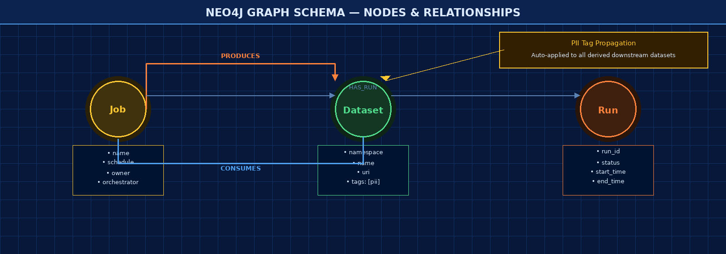
Figure 3 — Neo4j Graph Schema: Job / Dataset / Run nodes with PRODUCES, CONSUMES & HAS_RUN edges

Node & Edge Reference
Element | Type | Key Properties
Job | Node | name, schedule, owner, orchestrator
Dataset | Node | namespace, name, uri, tags: [pii, sensitive, ...]
Run | Node | run_id, status (success/fail), start_time, end_time
PRODUCES | Edge (Job → Dataset) | timestamp — written on every Airflow task completion
CONSUMES | Edge (Dataset → Job) | timestamp — records which datasets each job reads
HAS_RUN | Edge (Job → Run) | links a job definition to each of its execution runs

4.4 Key Architectural Principles

Simple by Default
Start with table-level lineage and four endpoints. Every additional feature must justify its complexity against the working baseline.

Event-Driven Where Possible
Runtime OpenLineage events from Airflow are more accurate than static SQL parsing and require less maintenance. Parsing fills gaps only.

Additive Design
The graph schema and API contract are designed so that column-level nodes, policy tags, and AI query layers can be added in later phases without breaking existing consumers.

Observable from Day One
Every ingest call writes a structured log entry (job, datasets, status, latency). The PostgreSQL run table provides an audit trail without requiring the graph.

4.5 Technology Stack

Category | Technology | Notes
Primary Language | Python 3.11+ with FastAPI & Pydantic v2 | Modern async-capable web framework
SQL Parsing | SQLGlot (open-source, no dependencies) | PostgreSQL and Snowflake dialects
Graph Database | Neo4j 5.x Community Edition | Free, no licence cost, standard Cypher
Relational Backend | PostgreSQL 15+ | Run metadata and audit log
Runtime Lineage | OpenLineage spec via openlineage-airflow | Airflow 2.x provider
dbt Integration | dbt manifest.json parser (Python) | No external library required
API Framework | FastAPI + Pydantic v2 + uvicorn | High-performance ASGI server
Testing | pytest + Testcontainers | Neo4j + PostgreSQL spun up in CI per test run
Deployment | Docker Compose (4 services) | neo4j, postgres, api, example Airflow

05 Project Methodology

The project follows a sequential, phase-gated methodology with a demo-at-end-of-sprint cadence. Each step builds directly on the previous — ensuring a working baseline exists before adding complexity. This minimises integration risk and keeps the team aligned on a single clear deliverable per phase.
5.1 End-to-End Methodology Flowchart
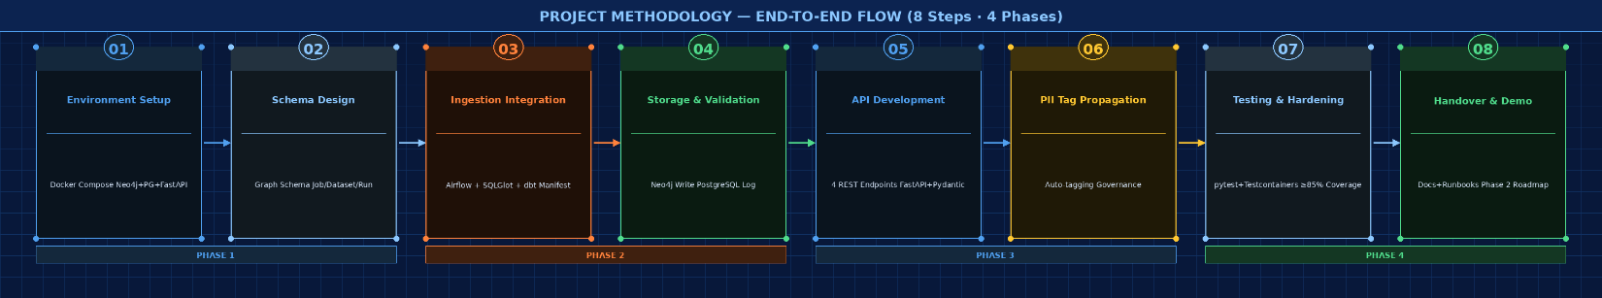

Figure 4 — 8-Step Project Methodology across 4 Phases (left to right)

5.2 Step-by-Step Methodology Explained

01  Environment Setup | WHAT: Provision the local development environment and validate all services can communicate.  HOW: Run docker compose up to start Neo4j, PostgreSQL, and FastAPI. Verify connectivity. Define and apply the Neo4j graph schema (Job, Dataset, Run nodes with typed edges). Create PostgreSQL run_log table.  WHY: Without a working local environment, no other step can proceed. This is the foundation every engineer will use throughout the project.

02  Schema Design | WHAT: Define the canonical graph schema that all three ingestion paths will write to.  HOW: Design Neo4j node labels (Job, Dataset, Run) and relationship types (PRODUCES, CONSUMES, HAS_RUN) with required properties. Apply via Cypher init scripts in Docker startup.  WHY: A shared, stable schema ensures Airflow events, SQLGlot output, and dbt relationships all land in the same graph without collision or duplication.

03  Ingestion Integration | WHAT: Connect all three lineage sources (Airflow, SQL scripts, dbt) to the ingestion endpoint.  HOW: Install the openlineage-airflow provider; configure a pilot DAG to emit OpenLineage events. Build POST /lineage/events with Pydantic v2 validation. Implement the SQLGlot parser and dbt manifest reader.  WHY: This step produces the first real lineage data — proving the system works end-to-end with actual pipeline activity.

04  Storage & Validation | WHAT: Persist validated lineage events to Neo4j and run metadata to PostgreSQL; verify correctness.  HOW: Write Cypher queries to upsert Job/Dataset nodes and create PRODUCES/CONSUMES edges. Write run records to PostgreSQL. Run validation scripts against 50 SQL scripts to measure SQLGlot accuracy.  WHY: Storage is the source of truth. Correctness here directly determines whether all downstream API queries and tag propagation are trustworthy.

05  API Development | WHAT: Expose the lineage graph to consumers via four REST API endpoints.  HOW: Implement GET /lineage/upstream and downstream using Cypher graph traversals. Implement GET /lineage/runs from PostgreSQL. Generate OpenAPI/Swagger documentation. Write integration tests using Testcontainers.  WHY: The API is the product that engineers, BI teams, and compliance teams will interact with — fast, correct traversal queries are the primary value delivered.

06  PII Tag Propagation | WHAT: Automatically propagate sensitivity tags from source datasets to all directly derived downstream datasets.  HOW: On each ingest event, check if the source Dataset node carries a PII or sensitive tag. If so, apply the same tag to downstream Dataset nodes. Implemented as a post-write hook in the ingest pipeline.  WHY: Reduces manual governance effort significantly — compliance teams no longer need to tag derived datasets by hand, and the audit trail is automatic.

07  Testing & Hardening | WHAT: Achieve reliable, repeatable test coverage across all components before handover.  HOW: Run pytest integration tests with Testcontainers (Neo4j + PostgreSQL fresh per test run). Validate all four API endpoints return correct results on 100k edge graphs in <2 seconds. Measure SQLGlot accuracy on the 50-script corpus.  WHY: Production readiness requires evidence. Testcontainers ensure tests reflect real database behaviour — giving the team confidence before handover.

08  Handover & Demo | WHAT: Deliver a fully documented, demo-ready system and define the Phase 2 roadmap.  HOW: Run an end-to-end demo using real pipeline data through the complete stack. Publish OpenAPI/Swagger documentation. Complete README and operator runbooks. Log known edge cases. Draft the Phase 2 roadmap covering column-level lineage and authentication.  WHY: A successful handover ensures the system is adoptable by the broader team without the original engineers present — documentation is as important as code.

06 Execution Plan

The project is structured into four focused phases over approximately 8 weeks. Each phase has a single clear deliverable demoed at the end of the sprint. Phases are sized for 2–3 engineers working part-time alongside other responsibilities.
Phase | Milestone | Key Deliverables | Timeline
Phase 1 | Environment & Schema | Docker Compose stack running (Neo4j, PostgreSQL, FastAPI); graph schema defined for Job, Dataset, Run nodes; PostgreSQL run_log table created; health-check endpoint live. | Weeks 1–2
Phase 2 | Ingestion: Airflow + SQL Parser | POST /lineage/events endpoint accepting OpenLineage events and writing to Neo4j; Airflow pilot DAG emitting events end-to-end; SQLGlot parser extracting table references from 50 sample SQL scripts. | Weeks 3–4
Phase 3 | API + dbt + Tag Propagation | All four REST endpoints implemented and integration-tested; dbt manifest.json parser loading model dependencies; PII tag propagation active on ingest; Testcontainers CI pipeline passing. | Weeks 5–6
Phase 4 | Hardening & Handover | End-to-end demo with real pipeline data; OpenAPI/Swagger documentation; README and runbooks complete; known edge cases logged in backlog; Phase 2 roadmap (column-level lineage, auth) drafted. | Weeks 7–8

PROJECT AT A GLANCE
8-week delivery | 2–3 engineers part-time | 4 phases | Neo4j + PostgreSQL + FastAPI | OpenLineage-compatible | Docker-first development

