AARYA V S (192512067)
3.A GENERATION OF PHASE MODULATED (PM) SIGNALS AND CALCULATION OF PHASE DEVIATION USING MATLAB SIMULATION
Objectives
PROGRAM (MATLAB Code)
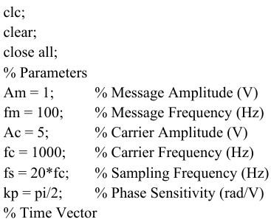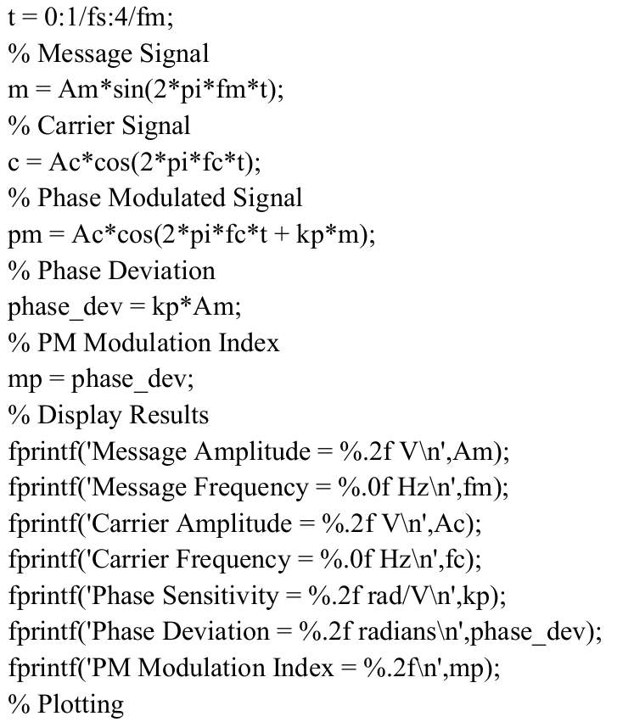
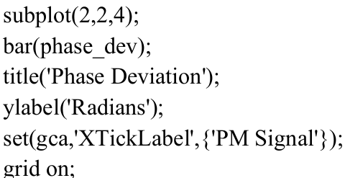
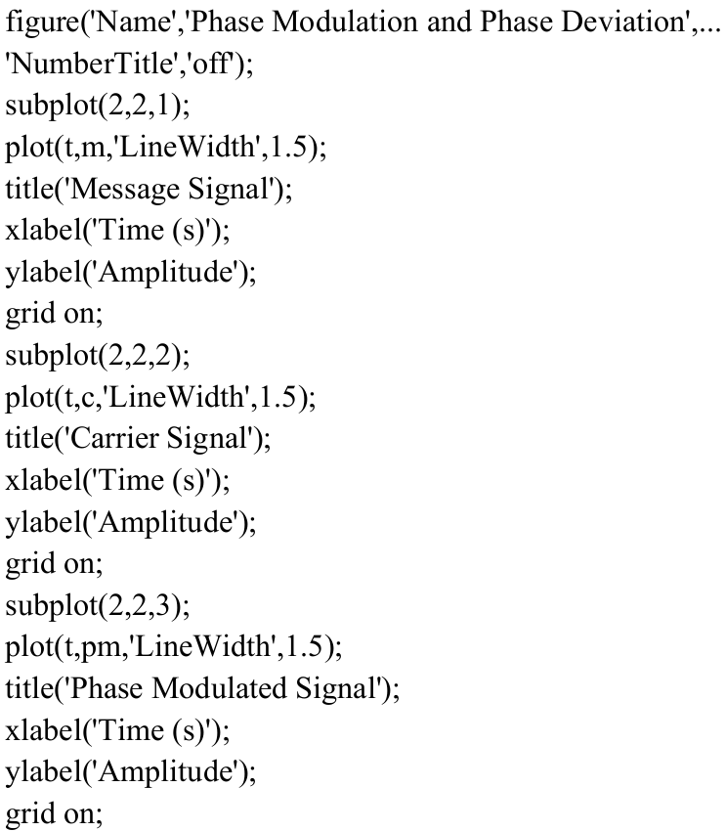

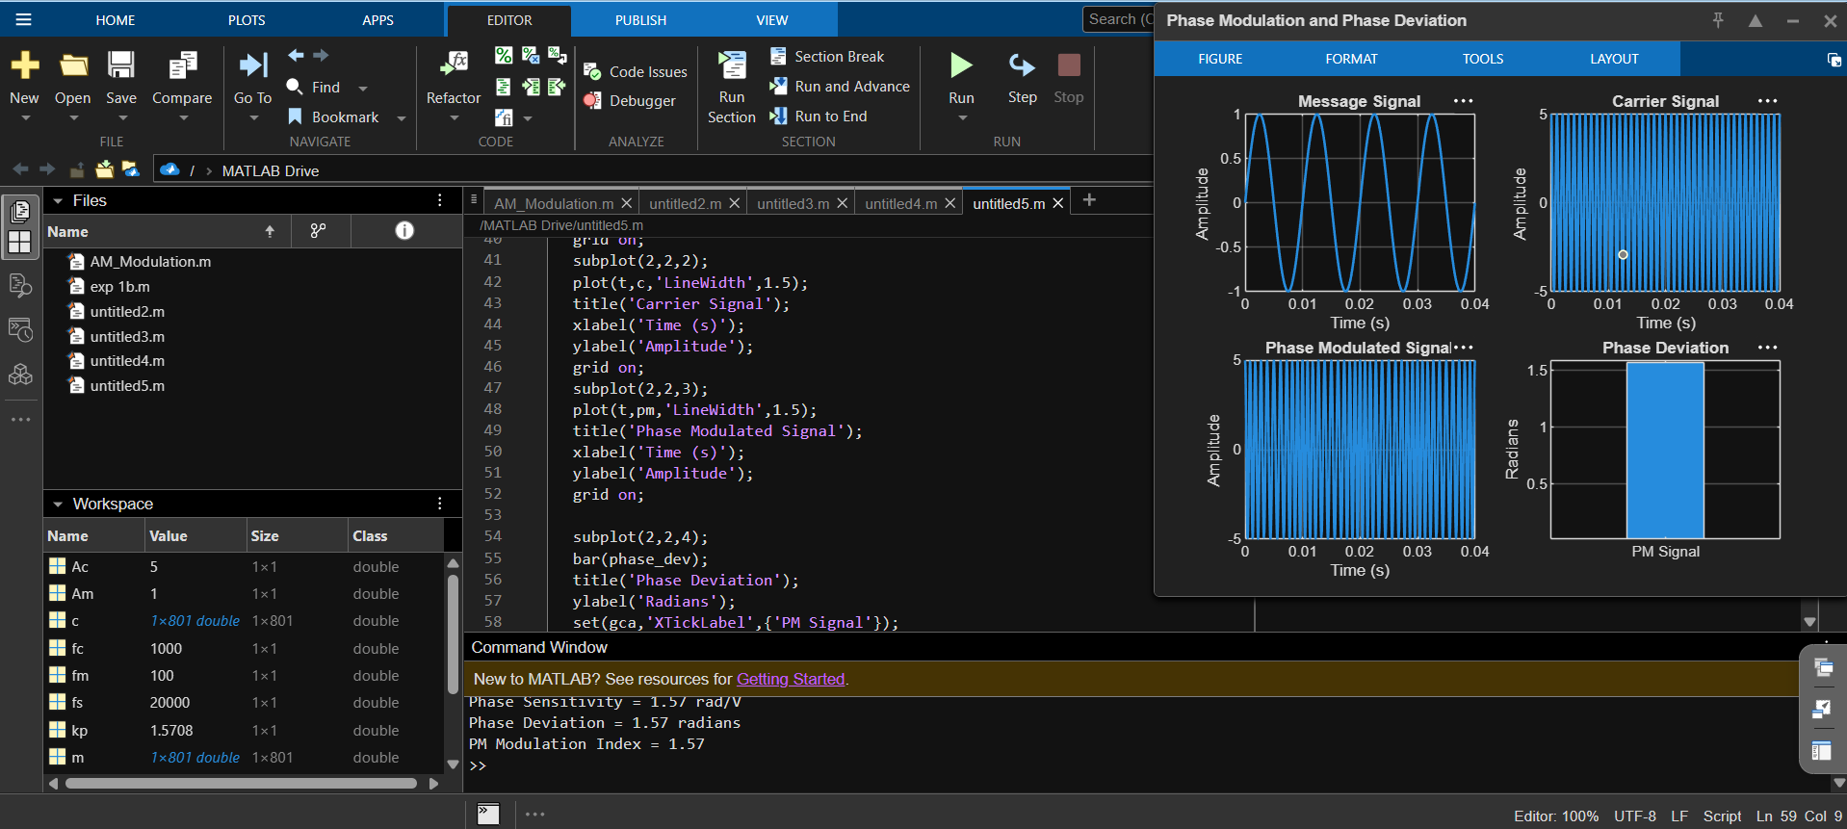
OUTPUT

