AARYA V S (192512067)
8.B SIMULATION AND ANALYSIS OF QPSK MODULATION USING CONSTELLATION DIAGRAMS IN MATLAB
PROGRAM (MATLAB Code)
clc;
clear;
close all; %% Objective 1: Generate QPSK Symbols
N = 1000;
data = randi([0 1], N, 1); % Number of bits
% Random binary sequence
% Ensure even number of bits
if mod(N,2)~=0
data = [data; 0];
N = N + 1;
end
% Group bits into pairs
bit_pairs = reshape(data,2,[])';
% QPSK Mapping
qpsk_symbols = zeros(size(bit_pairs,1),1);
for k = 1:size(bit_pairs,1)
if isequal(bit_pairs(k,:),[0 0])
qpsk_symbols(k) = (1+1j)/sqrt(2);
elseif isequal(bit_pairs(k,:),[0 1])
qpsk_symbols(k) = (-1+1j)/sqrt(2);
elseif isequal(bit_pairs(k,:),[1 1])
qpsk_symbols(k) = (-1-1j)/sqrt(2);
elseif isequal(bit_pairs(k,:),[1 0])
qpsk_symbols(k) = (1-1j)/sqrt(2);
end
end
%% Objective 2: Plot QPSK Constellation
scatter(real(qpsk_symbols),imag(qpsk_symbols), 30);
xlim([-1 1])
ylim([-1 1])
hold on;
xline(0,'k','LineWidth',1.5);
yline(0,'k','LineWidth',1.5);
grid on;
axis equal;
xlabel('In-Phase (I)');
ylabel('Quadrature (Q)');
title('Ideal QPSK Constellation');
%% Objective 3: Add Noise and Evaluate Performance
SNR = 5;
rx_signal = awgn(qpsk_symbols,SNR,'measured');
figure;
scatter(real(rx_signal),imag(rx_signal), 15);
hold on;
xline(0,'k','LineWidth',1.5);
yline(0,'k','LineWidth',1.5);
grid on;
axis equal;
xlabel('In-Phase (I)');
ylabel('Quadrature (Q)');
title(['Noisy QPSK Constellation (SNR = ',num2str(SNR),' dB)']); %% Symbol Detection
detected_bits = zeros(length(rx_signal)*2,1);
for k = 1:length(rx_signal)
I = real(rx_signal(k));
Q = imag(rx_signal(k));
if I>0 && Q>0
bits = [0 0];
elseif I<0 && Q>0
bits = [0 1];
elseif I<0 && Q<0
bits = [1 1];
else
bits = [1 0];
end
detected_bits(2*k-1:2*k) = bits;
end %% BER Calculation
num_errors = sum(data ~= detected_bits);
BER = num_errors/N;
fprintf('Number of Transmitted Bits : %d\n',N);
fprintf('Number of Bit Errors
: %d\n',num_errors);
fprintf('Bit Error Rate (BER)
: %f\n',BER);

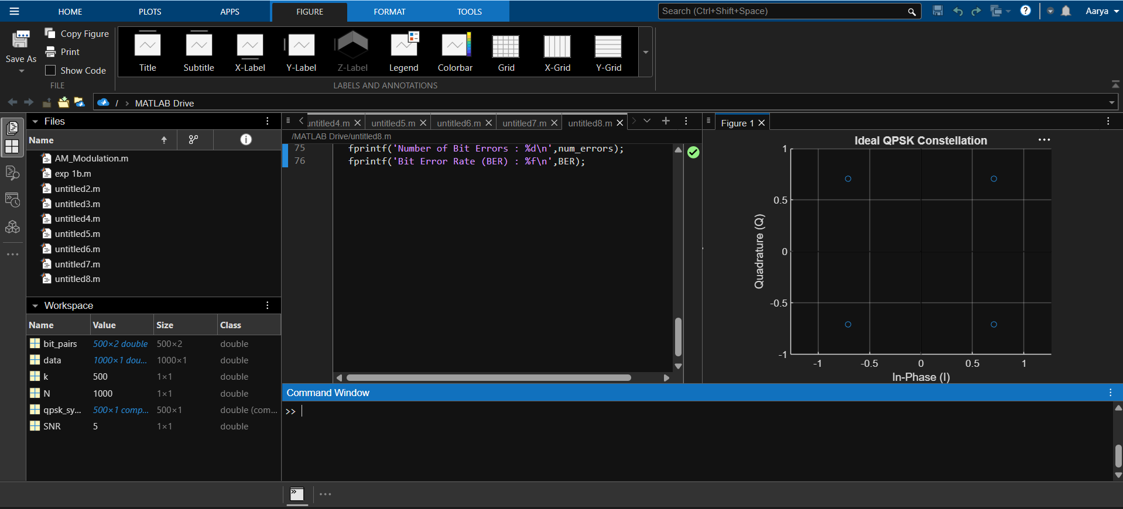
OUTPUT

