AARYA V S (192512067)
2.A GENERATION AND ANALYSIS OF FREQUENCY MODULATED (FM) SIGNALS USING MATLAB
Objectives
PROGRAM (MATLAB Code)
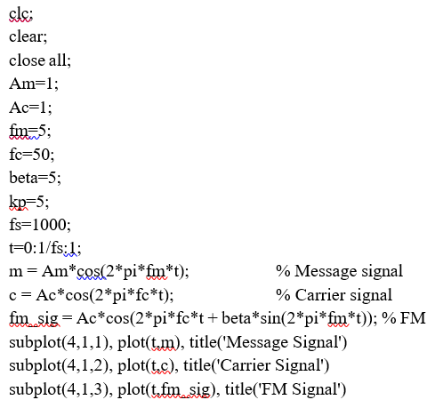
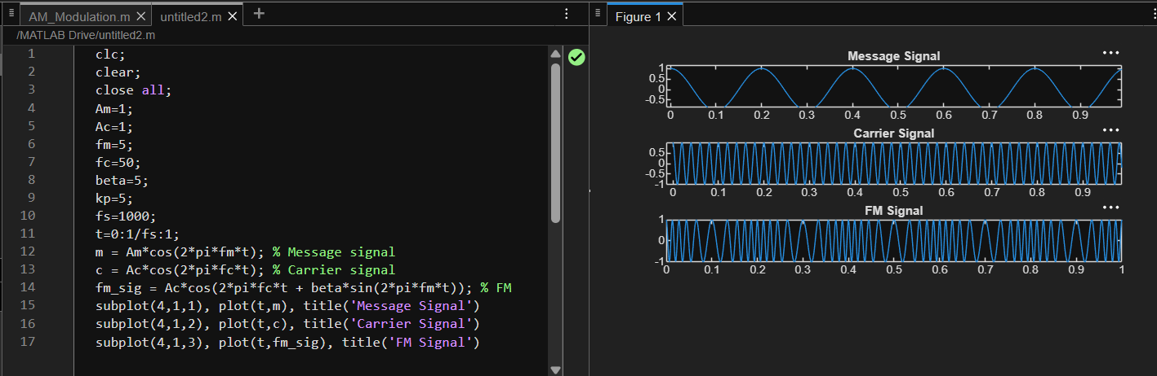
OUTPUT

