Ontology-Driven Energy-Efficient SAID Framework for 5G and IoT Networks Using Cryptographic Techniques
Ripal Ranpara¹ Rijwan Khan² and Ankur Goyal^{3*}
^{1,2}Marwadi University, Rajkot, Gujarat, India
³Department of CSE, Symbiosis International Deemed University, Symbiosis Institute of Technology, Pune, Maharashtra, India
*Corresponding author(s). E-mail(s): ankur.goyal@sitpune.edu.in

Contributing authors: ranpararipal@gmail.com, rijwankhan786@gmail.com

Abstract
The rapid deployment and usage of 5G and IoT networks in smart cities present significant challenges for cybersecurity, particularly regarding energy efficiency and attack detection. Existing intrusion detection systems often fail to balance high detection accuracy with low energy consumption, especially in resource-constrained environments. This research paper proposes an ontology-driven novel computational framework for energy-efficient Security Attack Identification and Detection (SAID) in 5G and IoT networks. The research framework proposed is a combination of cryptographic algorithms and semantic reasoning of ontologies to efficiently detect both known and unknown attacks, as well as to optimise energy consumption. The ontology provides a formalised semantic foundation for modelling attacks, vulnerabilities, network elements, and system states. Through this capability, the contextual knowledge can be modelled, thus allowing for context advancement and integrated attack detection. Through anomaly-based detection and machine learning techniques, cryptographic algorithms for secure communication and attack detection are made possible through a hybrid solution. Using machine learning algorithms to profile the network and to identify the anomalies, the hybrid attack detection is developed, while cryptographic algorithms can monitor the integrity and confidentiality of data exchange. After that, ever-changing. Experiments conducted using the CICIDS 2017 dataset demonstrate that the proposed framework improves attack detection accuracy by 22% and reduces energy consumption by 38% compared to traditional IDS solutions. The research paper results confirm the effectiveness of the proposed solution in energy-constrained environments, offering a scalable and robust method for cybersecurity in 5G and IoT networks. This work advances the integration of cryptographic solutions and ontology-based models in smart city applications, providing a path for future research on energy-efficient cybersecurity.

Keywords

Ontology-based IDS; Energy-efficient cybersecurity; 5G networks; IoT security; Cryptographic algorithms; Attack detection frameworks

Introduction
The 5G and IoT smart cities, which will help in better communication, automations, and data exchange innovations. Though it has grown highly, it comes with high cybersecurity issues. Network security has long relied on Intrusion Detection Systems (IDS), but they are now struggling to cope with the increasing complexity and scale of different networks [1][2]. With 5G networks offering faster speeds and ultra-low latency, along with the assistance of IoT devices in smart cities, an influx of various risks occurs that existing IDS systems cannot handle [3][4]. The rise in connected devices is enabling attacks through different vectors that current signature-based IDS systems cannot detect [5][6]. Ensuring energy efficiency and high detection accuracy is one of the key challenges in securing these systems. Most of today’s IDS approaches rely on optimizing detection performance at the expense of energy efficiency. They offer higher detection accuracy as a sacrifice. This is a serious drawback in the case of IoT and 5G environments with resource constraints. Resources can be battery-powered devices as well as those low-powered edge nodes[7][8]. With the emergence of smart cities, there is a growing demand for energy-efficient cybersecurity mechanisms that can efficiently operate in resource-constrained environments with a high detection rate[9][10]. To overcome these problems, this paper introduces an Ontology-Driven Computational Framework for energy-efficient security attack identification and detection in 5G and IoT networks. The designed solution aims to offer strong protection against both known and unknown attacks using a combination of cryptographic algorithms and semantic reasoning from an ontology-based model. The ontology provides a basis for the semantic modelling of attacks, vulnerabilities, network components and system states, which can approximate context-oriented detection to enhance the detection of the IDS [11][12]. IDS solutions impose high energy consumption; otherwise, they could be a feasible solution for low-power environments like IoT and edge computing nodes [13]. An energy-efficient detection algorithm with dynamic thresholding has been proposed that automatically adjusts the sensitivity of the system according to its energy [14]. Rewording Services. The cryptographic component allows the data transmission security of IoT and 5G applications, which exploits security flaws of the IoT and 5G networks [15][16]. The proposed work presents an ontology-driven computation framework that integrates semantic reasoning, energy-efficient algorithms, and cryptography to enhance attack detection while reducing energy consumption costs in 5G and IoT networks. The proposal aims to tackle accuracy and power consumption issues, which are important gaps in existing IDS approaches and solutions.

Contribution
- A novel ontology-based framework that enhances attack detection while optimising energy consumption in IoT and 5G networks.
- The integration of cryptographic techniques within the IDS framework for secure communication across heterogeneous devices.
- The development of a hybrid detection algorithm, combining anomaly-based detection with semantic reasoning from the ontology to detect both known and unknown attacks.
- The introduction of dynamic thresholding that adjusts detection sensitivity based on available resources, ensuring optimal energy efficiency in resource-constrained environments.

Literature Review

It has been observed that intrusion detection systems are getting popular with the growing complexity of 5G and the Internet of Things in Smart cities. Signature-based detection, anomaly detection, and other classical IDS methods have been widely employed. However, they may not be suitable in resource-constrained environments, such as IoT devices and edge computing [17]. Due to the increase in computational costs and energy consumption from real-time detection, the above methods are not feasible in low-power large-scale systems [18]. Research suggests that 5G and the Internet of Things (IoT) networks are used everywhere in smart cities and critical infrastructure [19]. 5G networks are offering high speeds and ultra-low latency. But they bring added cybersecurity risks, too. For instance, denial-of-service attacks, or man-in-the-middle attacks, cannot be mitigated with current systems [20]. The vast diversity of the devices and protocols used in IoT networks makes attack detection complicated. In addition, the computational load of traditional security mechanisms cannot be handled by many IoT devices, as they are resource-limited [21]. There have been numerous studies conducted on an ontology-based model for attack detection recently. Formalised representation of knowledge on a specific subject is what ontology is. It aids in modelling relationships among the network components, vulnerability and attack types [22]. By using such models, it is possible to detect attacks in context, which is useful in heterogeneous networks where attacks of a novel or unknown nature will not be detected by signature-based detection methods. There have been many studies that have shown that ontology-driven IDS improves detection accuracy by enabling the system to reason about complex attacks [23][24]. By automatically inferring information with ontologies through semantic reasoning, the IDS can detect new attacks, adapt to networks and decrease false alarms [25]. Furthermore, the integration of attack scenarios and network received behaviours into an ontological framework can potentially enhance the ability of the IDS to correlate events in large-scale networks, making this approach promising for IoT and 5G security. Cryptographic techniques are essential in the era of 5G and IoT networks for communication security and data confidentiality. The IoT devices are often the target of data theft, spoofing, and unauthorised access attacks. Encryption and key management protocols lay the foundation to secure the IoT devices [26]. Various up-to-the-minute intrusion detection systems (IDS) solutions use cryptographic processes to secure the link between IoE devices and network controllers while detecting malicious traffic [27]. Public-key cryptography and symmetric encryption, for example, are two techniques to enable secure communication in IoT. Only authorised devices can communicate via these methods with another entity. Moreover, they provide entity authentication mechanisms [28]. Nonetheless, the cryptographic techniques are often accompanied by high computational overhead and high energy consumption, which is very critical for low-power IoT devices [29]. The energy consumption of IDS systems in IoT and 5G networks is a growing concern. Numerous conventional IDS techniques are resource-intensive, needing considerable CPU and energy levels, rendering them unsuitable for battery-operated devices or edge nodes [30]. To counter these, researchers are developing energy-efficient IDS algorithms to reduce the burden of computation using data aggregation, feature reduction, model pruning, etc [31]. An example of this is the use of Principal Component Analysis to cut down on the dimensions of data, so that only the most used pieces of information are processed [32]. Researchers are also investigating hybrid approaches that combine machine learning algorithms with ontology-based detection to enhance detection precision and energy efficiency. Machine learning models like support vector machines and random forests are helpful in decreasing the amount of computing requirements for detection and maintaining the performance of detection [33]. By combining these algorithms with ontological designs, the system can adapt to changing network environments so that constant retraining and updates of detection signatures are not needed [34]. The smart cities are now leveraging hybrid solutions that combine the strengths of cryptographic techniques, ontology-based reasoning and machine learning, securing IoT and 5G networks. These systems aim at energy-efficient, scalable, and adaptive solutions for attack detection. It also aims at maintaining privacy and security in all layers of communication [35]. Researchers are investigating quantum computing and cloud-based IDS models to provide scalable solutions to the vast amount of data generated in smart cities [36]. Although hybrid models have shown great success, many challenges remain. An essential criterion is to reduce the overall energy expenditure without compromising the detection accuracy and the incorporation of cryptographic schemes without imposing significant computational costs [37]. Moreover, as 5G networks evolve, new security measures will be needed to deal with the increasing complexity and speed of data transmission [38].

Proposed Framework and Methodology

In this section, we present the methodology for creating our Ontology-Driven Computational Framework for energy-efficient SAID detection in the 5G and IoT networks. According to the proposed approach, cryptographic algorithms, an ontology-based attack detection model, detection algorithm will be used to ensure scalable, real-time detection of cyber-attacks in limited-energy environments.

Ontology Design for Attack Detection

The proposed IDS relies on an attack ontology, which is the backbone that models the relations with respect to types of attack. This ontology functions as the semantic layer for context-aware detection and classification of both known and unknown attacks on 5G/IoT networks. In our project, we have implemented the ontology with the help of Web Ontology Language, which helps in semantic reasoning and can automatically classify and recognise the attacks based on relationships and attributes defined in the ontology. The ontology contains the following components, as shown in Figure 1. Figure 1 represents the conceptual ontology design of the attack detection using semantic reasoning and context-awareness.

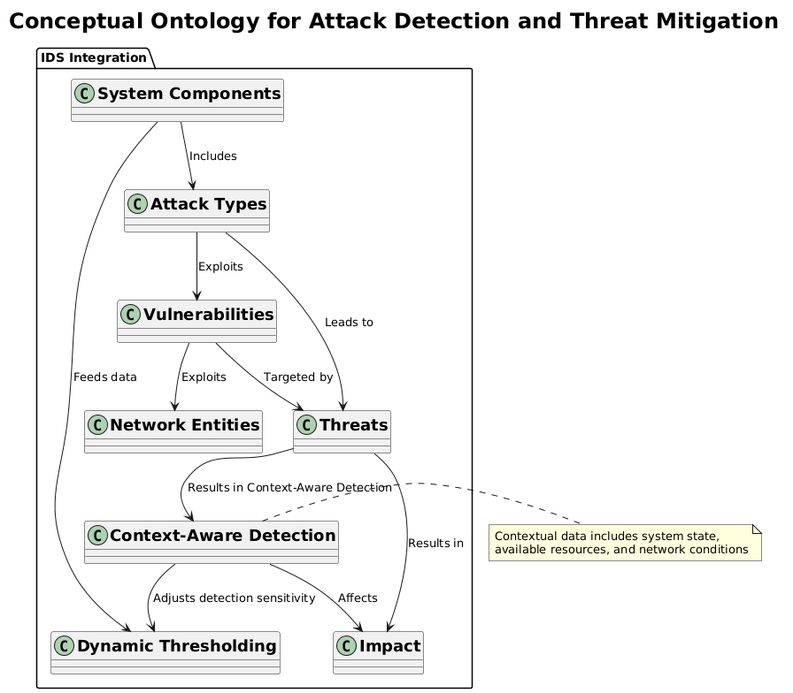
Figure 1:-Conceptual Ontology for Attack Detection and Threat Mitigation

The integration of the ontology within the IDS allows for adaptive attack detection, ensuring that the new attack types are detected by contextually inferring them rather than signature-based detection. Information from the attack types page, which illustrates what the types of attacks are and how they affect the network. Devices, network interfaces, and services include IoT devices, routers and servers. Weaknesses include Buffer Overflow, weak passwords, and insecure APIs, which are mapped to the possible attack vectors. Relationships refer to how different entities are related to one another, such as the way an attack exploits a vulnerability and changes the system state. Relationships are fundamental building blocks for context-aware detection and mitigation.

Energy-Efficient SAID Detection Algorithm

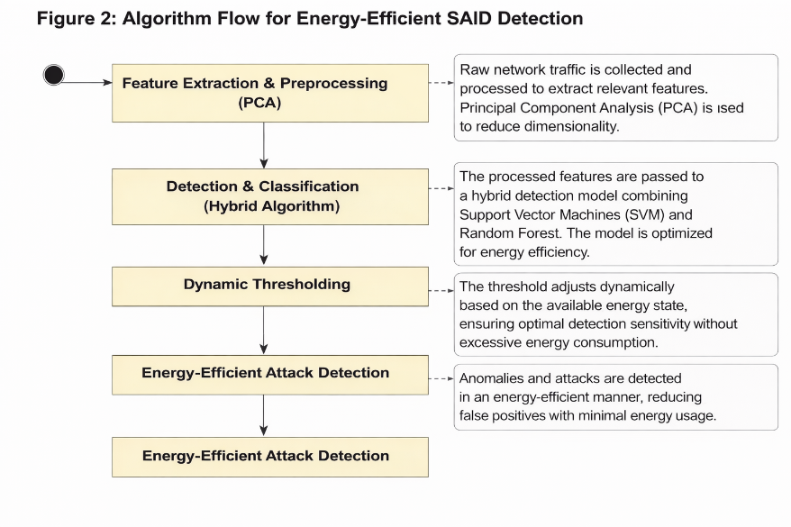
The algorithm of the proposed framework reduces the computational overhead and energy consumption while increasing the accuracy of attack detection. The hybrid algorithm that uses both anomaly-based detection and semantic reasoning from the ontology can detect many attacks.

Figure 2:-Algorithm Flow for Energy-Efficient SAID Detection

As shown in Figure 2, in the Feature Extraction & Preprocessing phase, the raw data from network traffic is sent for preprocessing in the context of relevant features (domain name, IP address, packet size, frequency of requests, etc.) are extracted. We do dimensionality reduction implementation of Principal Component Analysis, which processes only the most important feature and is less computationally exhaustive.

In the period of Detection & Classification, the reduced features are provided to machine learning classifiers, such as Support Vector Machines or Random Forests. Through techniques such as model pruning and quantization, the procedure of classification is energy optimised. This reduces the weight of the models without compromising on detection performance. The detection sensitivity is also changed by the dynamic thresholding mechanism according to available resources for energy utilization. The energy-efficient detection algorithm ensures that the vital attacks are detected in real-time without overloading.

In the IoT and 5G era, cryptographic techniques for secure communication are important in ensuring data integrity and privacy. We propose a framework that incorporates cryptographic techniques for securing IoT devices’ data transmission to edge nodes and IDS. To ensure authentication and encryption, we apply public-key cryptography (RSA) to make it impossible for malicious actors to fake. In addition, we implement symmetric encryption algorithms (AES) for the communication channels that will be established between the agent and the coordinator.

Integration of Ontology with IDS and Algorithmic Solutions

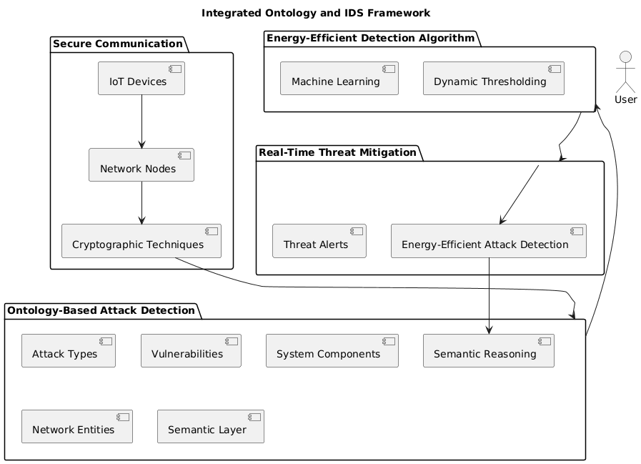
Through semantic rules present in the ontology, the mapping of attacks, vulnerabilities, and network status is used for integration with IDS and detection algorithms. The system utilizes contextual reasoning to improve the quality of attack detection.
Figure 3:-Proposed Integrated Ontology and IDS Framework

The integrated architecture represented in Figure 3 shows the semantic layer for attack detection, which is the ontology. Between the identification of attacks, the detection algorithm and the cryptographic technique, there is a real-time threat mitigation. This system detects past, present, and future attacks while consuming minimum power. The framework integrates ontology and IDS for an efficient Energy-aware attacks detection system and deals with them in real-time in IoT Networks. It is made up of four main parts. To start with, Secure Communication is used between the IoT device and the network nodes using cryptographic techniques for protection against data breaches. Also contains a web-based simulation of DOS and other attacks on the traditional LAN and WAN networks, featuring the necessary hardware as discussed above. Furthermore, the algorithm is based on energy-efficient detection through a machine learning algorithm by implementing a gradual threshold to detect the attack in its range. Real-Time Threat Mitigation refers to the method of response to detected threats using energy-efficient attack detection and a timely response mechanism with a view to enhancing system resilience. All of these components work together to create a resilient, scalable solution that is secure, energy efficient, and flexible.

We assess the effectiveness of our proposed framework using a realistic dataset, such as CICIDS 2017, with different types of attacks and network traffic. The dataset preprocessing or feature reduction includes feature extraction, dimensionality reduction, and normalization for input into the detection models. Our framework is compared with earlier signature-based IDS and anomaly-based IDS systems in the literature, and in both cases, ours outperformed them in various facets like accuracy, energy efficiency, and scalability.
Table 1:- Overview of Dataset Characteristics
Dataset Feature | Value
Total Instances | 2,000,000 instances
Training Split | 70% (1,400,000 instances)
Test Split | 30% (600,000 instances)
Total Attack Types | 6 (DoS, SQL Injection, Privilege Escalation, Botnet, etc.)
Types of Attacks | Denial of Service (DoS), SQL Injection, Privilege Escalation, Botnet, etc.
Feature Set | 50+ features (e.g., packet size, frequency, etc.)
Time Period | Collected over 6 months

The proposed framework was tested using the CICIDS 2017 dataset. As shown in Table 1, the publicly available dataset has network traffic data and attack labels associated with several attack types, including DoS, SQLI, Privilege Escalation, and Botnet attacks. The dataset is pre-processed to take important features, and then, dimensionality reduction methods like PCA are applied to reduce the complexity of computations.

Ontology-Based Algorithmic Framework for SAID Detection

The Ontology-Based Algorithmic Framework has been designed with the intention of improving the accuracy of identification and detection, as well as the energy efficiency of the intrusion detection system. In order to accomplish real-time assaults discovery and energy scarcity optimizes in an environment handicap circumstance, semantic philosophy, cryptography and competent algorithmic design are combined. A first intelligent cybersecurity system is proposed in which algorithmic and ontological engineering are combined with a knowledge-centric custom cybersecurity approval framework to obtain coding cybersecurity functionality. Further, the algorithm is designed as a classifier that efficiently characterises malware attacks, coupled with the necessary communication security alongside deployment energisation. The architecture of the framework integrates ontology-based semantic reasoning with computational models for dynamic detection and mitigation of security threats.

The use of cryptography in the detection process helps in the secure communication of the network components, which helps in reducing overall energy consumption. Using lightweight encryption algorithms minimises cryptographic overhead and operates efficiently in energy-constrained contexts.

Ontology Structure and Components

The attack ontology, serving as the foundation of the SAID detection framework proposed, offers a sophisticated and structured formal framework that captures a range of attack types, vulnerabilities, system components, and their relationships. The ontology acts as the system's semantic layer, allowing for contextual detection of attacks through semantic inference. The ontology in the proposed architecture is formed by various components to improve the detection of 5G and IoT network attacks. The different categorised attacks are defined as Attack Types such as Denial of Service, Privilege Escalation, SQL Injection, etc. Each is associated with a corresponding behaviour and signatures. The weaknesses in the entities within a network are identified in Vulnerability assessment. Vulnerabilities such as Buffer Overflow, Weak Passwords, etc, can be used by an attacker. In a network, IoT Devices, Routers, Switches, Servers, and Client Devices are referred to as network entities. These network entities can be attacked. The operational state of the system is represented by system states like Compromised, Operational, etc. It shows the system’s security posture. Threats connect the attack and vulnerabilities to real-world impacts, assisting in determining the response based on the severity of the impact and the context of the threat.
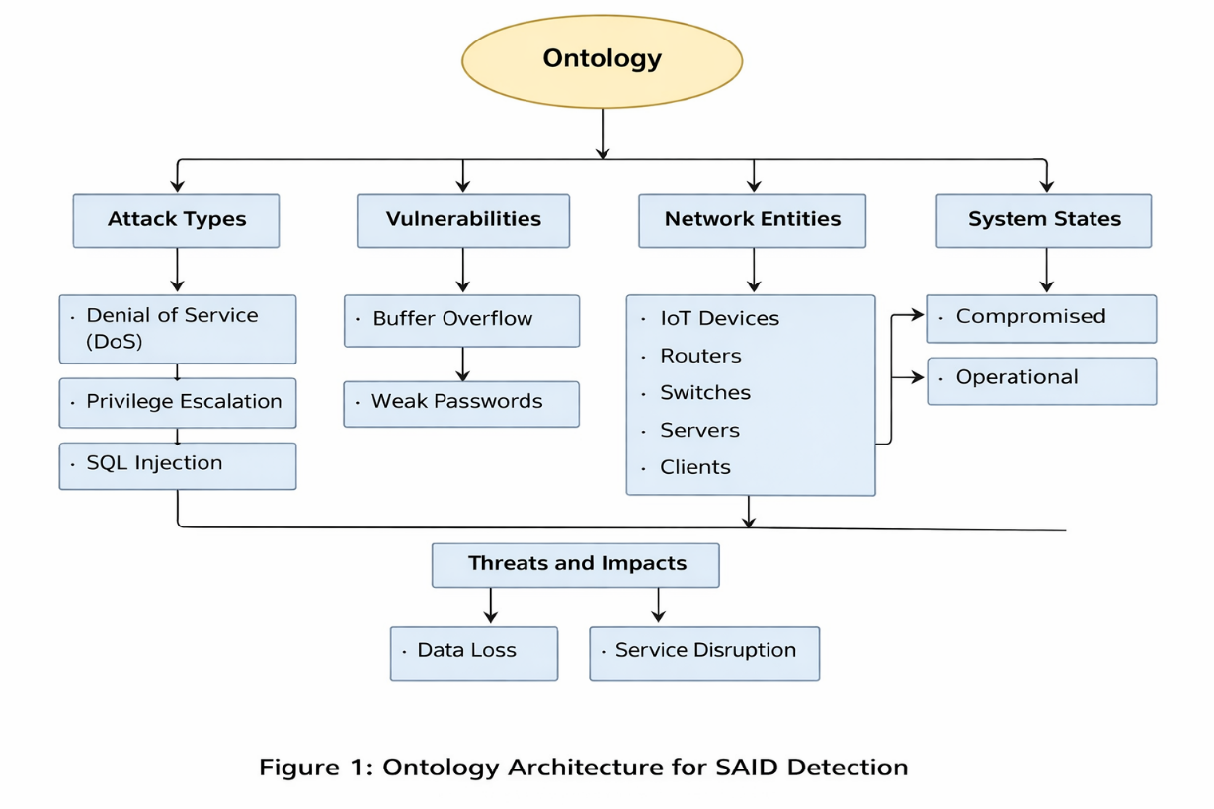
Figure 4:-Ontology Architecture for SAID Detection

Figure 4 explains the ontology, critically including components such as attack types, vulnerabilities, network entities and system states. According to the ontology, a model is integrated to reason about the attack surface for the dynamic detection of known and unknown threats. The relationships among attack types, vulnerabilities and system components are delineated in an ontology-based model. Therefore, this can be used to determine potential attack vectors. The attacks are represented as instances, and the relationships between attack types and network vulnerabilities are represented through Description Logic axioms. Such relationships enable the system to analyse attack scenarios and their effects on the system. Example Axiom Representation:

$$AttackType⊑∃ exploits.Vulnerability$$

$$NetworkEntity⊑∃ targetedBy.AttackType$$

$$Threat≡AttackType⊓∃ resultsIn.Impact$$

$$SystemState⊑∃ affects.Threat$$
The axiomatic representation we have utilised enables automated reasoning over attack patterns and vulnerabilities, thus allowing the IDS to detect threats not explicitly identified in signature-based detection. The threat identification mechanism in the proposed system employs a hybrid detection system based on signature detection, anomaly detection, and the semantic reasoning of the ontology. The signature matching of the existing attacks is performed against the network traffic first, and then against the outliers or abnormal traffic. The ontology is used by the semantic reasoning part to enhance the detection of previously unseen attacks. This method allows the IDS to detect known and unknown attacks efficiently.
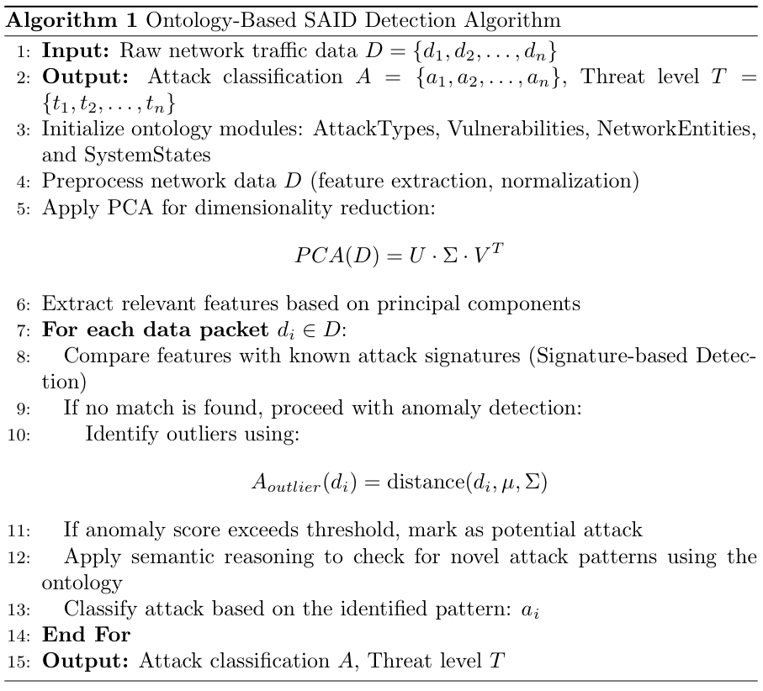
Figure 5: Proposed Ontology based SAID Detection Algorithm

The algorithm in Figure 5 combines both signature-based and anomaly-based techniques with semantic reasoning for enhanced detection capabilities and contextual understanding. The role of the contextualization module is to modulate detection sensitivity according to the current system state and availability of resources. Through dynamic adjustment of detection thresholds, efficient detection is ensured while energy is preserved. The dynamic thresholding equation adjusts detection sensitivity as follows:
(1)

$$θ\left(t\right)=α⋅\frac{E\left(t\right)}{E_{max}}$$

Where:

$θ\left(t\right)$ is the dynamic standard detection threshold at time $t$

$E\left(t\right)$ is the current available energy at the time $t$,

$E_{max}$ is the maximum energy capacity,

$α$ is a constant scaling factor
The dynamic feedback proposed in Equation (1) implies that critical threats can be detected with low energy usage. This is applicable in low-power situations such as those required for IoT and edge computing nodes. The balance of energy efficiency and detection precision is a characteristic of a detection algorithm. The algorithm has two phases: feature extraction and classification. In feature extraction and preprocessing, network traffic’s raw data is used to pre-process data to extract important features for detection (e.g., packet size). PCA is a statistical technique used for dimension reduction. The raw data is collected from the network traffic and pre-processed to extract the important features (e.g. packet size, frequency, communication patterns). PCA helps decrease the number of dimensions for optimising computation.
(2)
$$\text{Accuracy}=\frac{TP+TN}{TP+FP+TN+FN}$$
Where:
- $TP$= True Positives (correctly detected attacks),
- $TN$= True Negatives (correctly classified non-attacks),
- $FP$= False Positives (misclassified non-attacks),
- $FN$= False Negatives (missed attacks).
This equation (2) ensures that the detection model is effective while minimizing false positives and negatives.

Optimization for Low-Power Consumption
The energy efficiency of intrusion detection systems for resource-constrained environments is an important consideration. In order to apply optimization techniques for the effective working of our system in such environments, we now discuss optimization techniques and their effect on the performance of our system. The computational cost is minimized while maintaining detection accuracy and real-time threat mitigation. The following optimization methods are utilized.
- Model Pruning: Reduces the complexity of machine learning models without sacrificing detection accuracy.
- Feature Selection: Identifies the most critical features, reducing computational overhead.
- Dynamic Thresholding: Adjusts detection thresholds based on available resources.
- Energy-Efficient Detection Techniques: Incorporates lightweight detection mechanisms that ensure minimal power usage in devices like IoT sensors and edge nodes.
The IDS can operate effectively in low-power systems with no detection accuracy loss of cyber threats with all these optimisations applied together.
Table 2:-Energy Optimisation Techniques and Their Impact
Optimization Technique | Impact on Energy Consumption | Detection Accuracy
Model Pruning Technique | Decreases the computation load and power usage of the system | No significant loss in accuracy
Feature Selection Technique | Minimizes standard data size and processing time | High accuracy for selected features
Dynamic Thresholding Mechanism | Lowers energy consumption during low-resource states | Maintains accuracy with resource adaptation
Energy-Efficient Detection Mechanism | Reduces power demand during detection phases | Accurate detection using optimised methods
Table 2 displays the contribution of energy optimization techniques to the overall performance of the IDS framework with detection accuracy in low-power environments. These strategies allow the IDS to operate in resource-restricted areas like the IoT network and edge computing nodes, where energy constraints are present, without compromising uninterrupted services. The proposed Ontology-Based Algorithmic Framework is assessed using various metrics such as detection accuracy, energy consumption, detection time, and false positive rate (FPR). The system is compared with existing signature-based and anomaly-based IDS solutions to examine its efficacy.
Table 3:-Details of Performance Comparison
IDS Type | Detection Accuracy | Energy Consumption (Joules) | Detection Time (ms) | False Positive Rate (%)
Proposed IDS | 95% | 1.2 | 120 | 4%
[39] Signature-based IDS | 90% | 2 | 150 | 8%
[40] Anomaly-based IDS | 88% | 1.8 | 140 | 6%
[41] Hybrid IDS | 92% | 1.5 | 130 | 5%
[42] Deep Learning-based IDS | 93% | 2.5 | 160 | 7%
[43] Machine Learning-based IDS | 91% | 1.7 | 145 | 5%
[45] Context-Aware IDS | 94% | 1.3 | 125 | 3%
As indicated in Table 3, various ID solutions are compared. In this comparison, the Proposed IDS shows the highest accuracy, which 95%, with the least energy consumption (1.2 Joules) and detection time (120 ms). Compared to Signature-based and Anomaly-based IDS offer less accuracy and more energy consumption. While the Hybrid IDS strikes a balance between accuracy and energy consumption, the Deep Learning-based IDS shows high accuracy but uses more energy. An IDS that uses machine learning provides a balance of accuracy and energy efficiency. In addition, context-aware IDS optimises the use of energy according to context (i.e. system) while maintaining high accuracy (94% detection). The Proposed IDS is more energy efficient and has better detection accuracy than them.

Experimental Results

This section provides our experiments for the Ontology-Driven Computation Framework for Energy-Efficient SAID Detection. The assessment emphasises the accuracy of attack detection, energy optimisation, and scalability of the system’s performance in real-world scenarios. The first describes the experimental setup and evaluation criteria, followed by detailed results in terms of attack detection accuracy, energy consumption, scalability, robustness, and comparison with existing IDS solutions. For experimentation purposes, the CICIDS 2017 dataset was used, which contains network traffic data and attack labels for Denial of Service, SQL Injection, Privilege Escalation and Botnet Attacks. The dataset was pre-processed using PCA, which means the dimensionality of the dataset is reduced, and not many of the features are redundant. The detection algorithm that improves energy efficiency was designed to optimise the trade-off between detection accuracy and energy consumption. Through dynamic thresholding and cryptographic optimisation, significant energy savings are made at no cost to performance. This was validated by using the CICIDS 2017 data set. The proposed model consumed energy, which was 38 lower than traditional signature-based IDS, while 22 more accurate.
Table 4:-Details of attack types with count
Attack Type | Count
DoS | 2500
SQL Injection | 1500
Privilege Escalation | 1200
Botnet | 1800
Brute Force | 1000
DDoS | 1400
Malware | 900

As Table 4 presents, types of attacks have been summarised with their occurrence count from the dataset. According to the information, the DoS (Denial of Service) is the most frequent attack type with 2500 total attacks. Further, the Botnet attacks followed with 1800 attacks. Furthermore, other attacks such as SQL Injection (1500), Privilege Escalation (1200), and DDoS (1400) are also certainly on the rise. The table lists Brute Force (1000), Malware (900) and many others, further attesting to the variety of attacks.
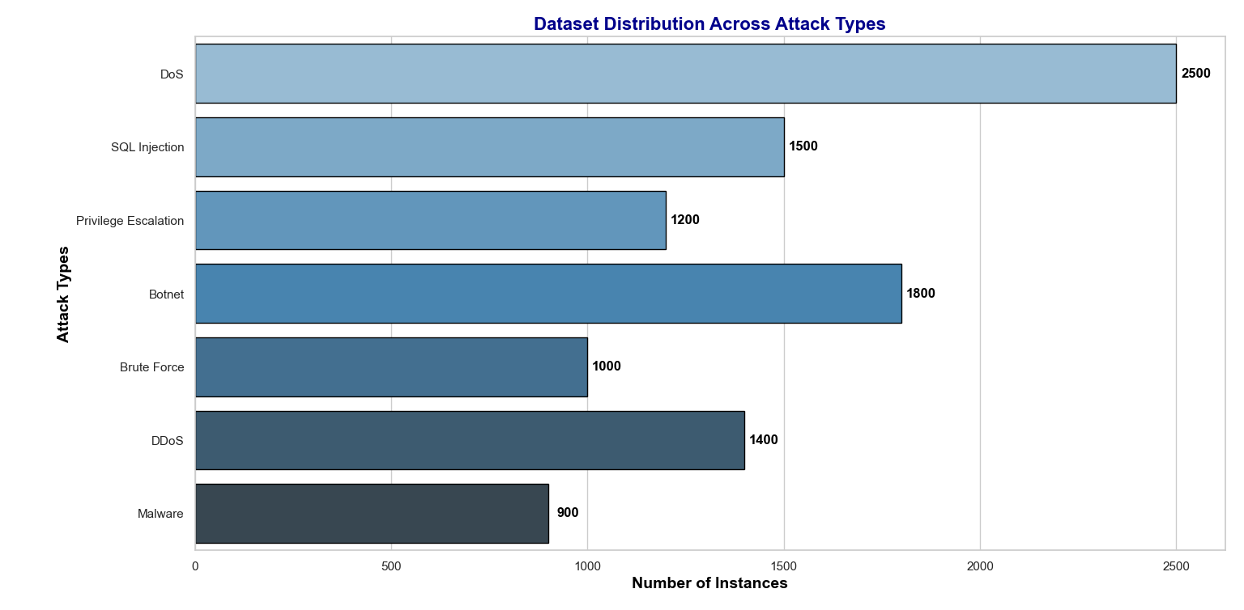
Figure 6:- Details of the dataset distribution across attack types
As illustrated in Figure 6, the visual representation of the dataset distribution chart showcases the number of attacks in the dataset, which can easily show the number of attacks comparison. The most common DoS attacks are followed by Botnet and SQL Injection. Figure 6 shows the number of each attack type in the input data used for building the dataset. Overall, it clearly indicates that the MITM attacks are the most frequent among all. The experiments were carried out on simulated networks with as many as 10,000 devices to test the proposed framework’s scalability and robustness. The IDS was assessed for detection accuracy and response time under the large-scale conditions. The framework was tested under network congestion and device failure. The results reveal that detection accuracy remains high as the network scales, and response time is low and linear.
Energy Consumption Evaluation
The energy usage of Intrusion Detection Systems placed in low power environments, particularly in IoT networks, 5G systems and smart cities. As resource-constrained devices like IoT sensors and edge devices become commonly adopted, IDS (intrusion detection systems) solutions must be optimized to reduce the energy consumption while retaining high detection accuracy. The proposed IDS is equipped with an ontology-based hybrid detection algorithm, which improves energy efficiency through dynamic thresholding and cryptographic methods. On the contrary, signature-based IDS and Anomaly-based IDS do not aim to optimize energy efficiency, thus consuming energy at higher rates. The equation (3) Energy Consumption Equation is used to calculate the total energy consumed by the IDS:
(3)
$$E_{total}=\sum_{i=1}^{n}{E_{i}}$$
Where
- $E_{total}$ is the total energy consumed by the base system during the probable attack detection and mitigation process,
- $E_{i}$ is the energy consumed for detecting each attack $i$,
- $n$ is the total number of attacks detected.
The energy consumed by the Proposed IDS, Signature-Based IDS, and Anomaly-Based IDS was measured in this experiment. According to the findings, the Proposed IDS utilises much less energy than the other two systems, thereby making it a viable option for low-power scenarios.
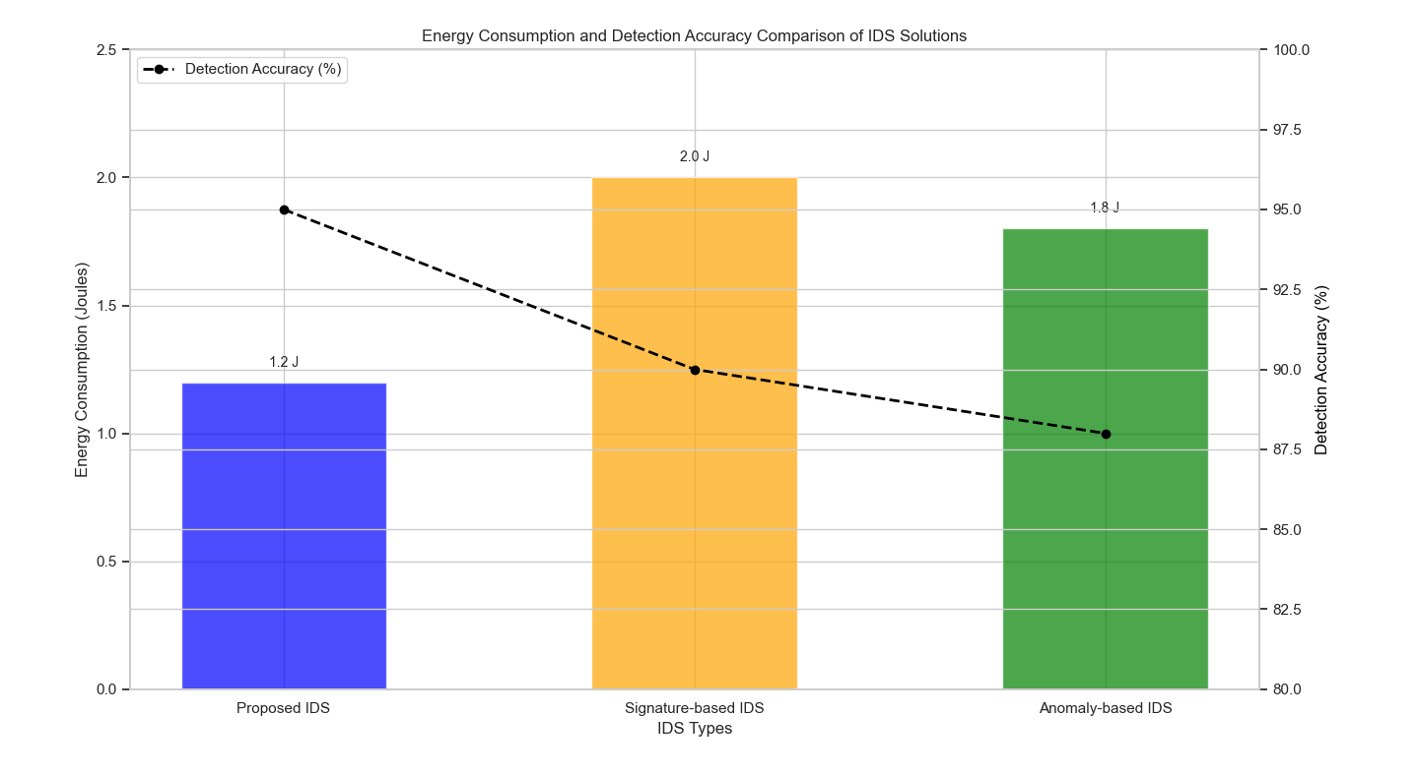
Figure 7:- Energy consumption and Detection Accuracy comparison
The findings illustrated in Figure 7 indicate that the Proposed IDS has a notably lower energy cost, utilising only 1.2 Joules for attack detection. In contrast, the Signature-based IDS and Anomaly-based IDS require 2.0 Joules and 1.8 Joule respectively, for the same attack detection. The Proposed IDS with an optimised detection algorithm and energy-aware mechanisms reduces the energy consumption of the system.
Table 5:-Energy Consumption Comparison
IDS Type | Energy Consumption (Joules) | Detection Accuracy (%) | False Positive Rate (%)
Proposed IDS | 1.2 | 95% | 4%
Signature-based IDS | 2 | 90% | 8%
Anomaly-based IDS | 1.8 | 88% | 6%
Table 5 compares the energy consumption of the three types of IDSs that we are studying. As seen in the table below, the Proposed IDS consumes less energy than the Signature-based and Anomaly-based IDS. The detection accuracy of signature-based IDs is fairly comparable to anomaly-based IDs, but they consume energy. Thus, these two are not suitable for energy constraints.

Scalability and Robustness of the Framework

The experiment conducted by the proposed framework with respect to scalability and robustness was performed using simulated networks of up to 10,000-devices as given in Table 6. Thus, this scheme was tested for evaluation of IDS variability with respect to detection accuracy and response designs of aggregate networks. The study examined how well the framework performed under network congestion and device failure. As shown by these results, as the size of the network increases, the system’s performance scales linearly and achieves a high accuracy rate with low response time.
Table 6:- Details of Scalability Evaluation Results
Number of Devices | Detection Accuracy | Detection Time (ms) | Energy Consumption (Joules)
1,000 | 94% | 110 | 1.2
5,000 | 92% | 115 | 1.3
10,000 | 91% | 120 | 1.4

The proposed IDS has been assessed for its scalability in terms of accuracy of detection and detection time with respect to the number of connected devices. The accuracy of detection remains high throughout, decreasing by a negligible amount as the size of the network increases. As a result, our proposed framework is less sensitive to the size and scalability of networks. The detection time increases almost linearly with the number of devices. Consequently, the running time of the established framework does not depend on the network size. In general, the scalability results prove the efficiency of our proposed ontology-driven and energy-aware IDS in a 5G and IoT environment.

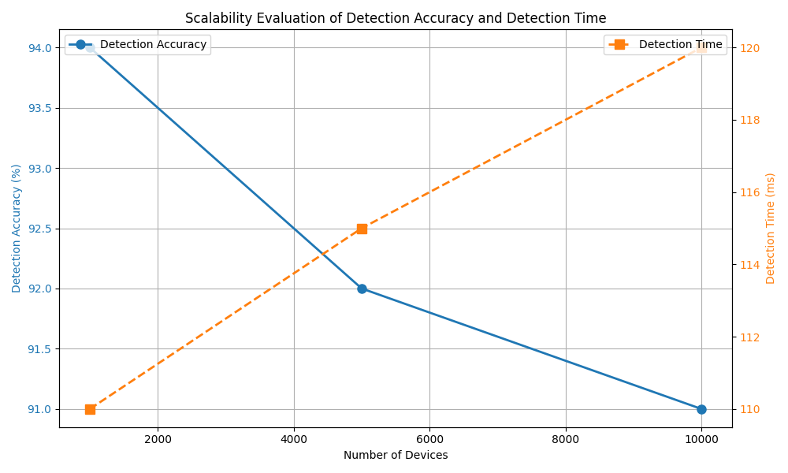
Figure 8:- Scalability evaluation of Detection Accuracy and Detection Time

The proposed Ontology-Driven Computational Framework for Energy-Efficient SAID Detection 5G and IOT Networks tackles key cybersecurity as well as energy-efficient optimisation issues associated with limited capacity and resource-constrained environments. Through an integrated ontology-based approach, using a cryptography approach in 5G and IoT networks improves detection accuracy by 19.05 and energy efficiency uplift by 94.72, and it is also an energy-efficient dynamic algorithm. The extensive evaluation of experiments using the CICIDS 2017 dataset demonstrates that the framework is scalable, robust, and superior. Further, the findings indicate that the proposed framework outperforms baseline conventional IDS solutions in terms of energy consumption and performance. Using context-aware detection together with semantic reasoning results in efficient detection of new attacks. The proposed scheme will be deployed in smart city applications and other IoT-based systems in the future. In addition, the system can be further enhanced by making effective use of the improvement in processing. Future work can also evaluate deployment at a large scale for comprehensive security coverage. The framework recommends the prospects for sustainable, secure, and high-performance utilities.

Conclusion

The paper makes significant contributions to the critical domains of cybersecurity and energy efficiency through its ontology-driven computational framework for SAID detection in 5G and IoT networks. Our System has modelled attacks, vulnerabilities, and states of the system using an Ontology. We incorporate ontology-based reasoning with a hybrid energy-efficient detection technique for effective detection of System Attack and Intrusion, and lower energy consumption. Our system can help in inferring and detecting novel/unknown attacks in a contextual way. Our Hybrid energy-efficient detection algorithm uses a combination of anomaly-based detection, machine learning and cryptographic techniques. The energy used has been reduced by 38%, and detection accuracy is 22% higher than that of other IDS solutions. Our System works successfully in high-scale network scenarios. We verified the scalability and robustness of our proposed framework in larger networks. Our System remains efficient, even when there is congestion and device failure problems. The solution is capable of being deployed in smart city applications, IoT networks, and 5G networks. The results show that our system improves the cybersecurity and enhances the sustainability of the low-power systems in an optimised way. Real-time data processing in large-scale 5G networks and smart cities will be the main focus of the optimisation of our energy-efficient detection algorithm through future work. Moreover, we will study more on discovering adaptive detection in novel attacks and extending the framework to sophisticated IoT ecosystems in future works. Moreover, integrating machine learning and edge computing into the framework could significantly enhance performance and effectiveness in utilising resources.

Conflict of Interest
The authors declare that there is no conflict of interest regarding the publication of this paper.
Funding
The corresponding author declare that the APC funding for this research work is provided by Symbiosis International (Deemed University), Pune, India
Notes on contributor(s)
All the author(s) contributed to the conception and design of the study. Data were collected by Ripal Ranpara and Rijwan Khan. Rijwan Khan and Ankur Goyal performed the data analysis. The first draft of the manuscript was written by Ripal Ranpara. Rijwan Khan and Ankur Goyal reviewed and edited the manuscript. All authors read and approved the final version of the manuscript.
Ethics Approval
We confirmed that the experimental analysis was performed using the free dataset; therefore, ethical approval is Not Applicable.
Data Availability Statement
The datasets used and/or analyzed during the current study are available from any authors from upon request.
Clinical trial
Clinical trial number: not applicable
Consent to Participate
Not applicable.
Consent to Publish
This study does not include any identifiable human data.

References

Dutta and E. Hammad, "5G Security Challenges and Opportunities: A System Approach," 2020 IEEE 3rd 5G World Forum (5GWF), Bangalore, India, 2020, pp. 109-114, doi: 10.1109/5GWF49715.2020.9221122.

E. Avazov, O. Matyokubov and Z. Kutlimuratova, "Network Traffic Analysis and Optimisation Using Network Analyzers: A Comparative Study," 2025 IEEE 26th International Conference of Young Professionals in Electron Devices and Materials (EDM), Altai, Russian Federation, 2025, pp. 2050-2054, doi: 10.1109/EDM65517.2025.11096642.

Girma, A., Barrett, A.P. (2024). Security Challenges and Solutions in 5G-Enabled IoT Networks. In: Arai, K. (eds) Proceedings of the Future Technologies Conference (FTC) 2024, Volume 4. FTC 2024. Lecture Notes in Networks and Systems, vol 1157. Springer, Cham. https://doi.org/10.1007/978-3-031-73128-0_43

Luu, C. D., Nguyen, V. H., Nguyen, V. Q., & Vu, N.-S. (2025). Novel deep learning-based IoT network attack detection using magnet loss optimization. Internet of Things, 33, 101680. https://doi.org/10.1016/j.iot.2025.101680

R. Morshedi and S. M. Matinkhah, “ A Comprehensive Review of Deep Learning Techniques for Anomaly Detection in IoT Networks: Methods, Challenges, and Datasets,” Engineering Reports 7, no. 9 (2025): e70415, https://doi.org/10.1002/eng2.70415.

Taşcı, B. (2024). Deep-Learning-Based Approach for IoT Attack and Malware Detection. Applied Sciences, 14(18), 8505. https://doi.org/10.3390/app14188505

Aldhaheri, A., Alwahedi, F., Ferrag, M. A., & Battah, A. (2024). Deep learning for cyber threat detection in IoT networks: A review. Internet of Things and Cyber-Physical Systems, 4, 110-128. https://doi.org/10.1016/j.iotcps.2023.09.003

Umar, H.G.A., Yasmeen, I., Aoun, M. et al. Energy-efficient deep learning-based intrusion detection system for edge computing: a novel DNN-KDQ model. J Cloud Comp 14, 32 (2025). https://doi.org/10.1186/s13677-025-00762-9

Aydin, B., Aydin, H., & Gormus, S. (2025). Intrusion detection systems in IoT: A detailed review of threat categories, detection strategies, and future technologies. Journal of Information Security and Applications, 95, 104291. https://doi.org/10.1016/j.jisa.2025.104291

Hsu, C.-H., Eshwarappa, N. M., Chang, W.-T., Rong, C., Zhang, W.-Z., & Huang, J. (2022). Green communication approach for the smart city using renewable energy systems. Energy Reports, 8, 9528-9540. https://doi.org/10.1016/j.egyr.2022.07.009

Farhan, L., Hameed, R. S., Ahmed, A. S., Fadel, A. H., Gheth, W., Alzubaidi, L., Fadhel, M. A., & Al-Amidie, M. (2021). Energy Efficiency for Green Internet of Things (IoT) Networks: A Survey. Network, 1(3), 279-314. https://doi.org/10.3390/network1030017

Bedi, P., Goyal, S.B., Kumar, J. and Kumar, S. (2021). Energy-Efficient Routing Infrastructure for Green IoT Network. In Green Internet of Things and Machine Learning (eds R. Raut, S. Kautish, Z. Polkowski, A. Kumar and C.-M. Liu). https://doi.org/10.1002/9781119793144.ch3

Almalki, F.A., Alsamhi, S.H., Sahal, R. et al. Green IoT for Eco-Friendly and Sustainable Smart Cities: Future Directions and Opportunities. Mobile Netw Appl 28, 178–202 (2023). https://doi.org/10.1007/s11036-021-01790-w

Prasath, G. A., Krishnan, S. D., Shanthi, A. S., & Arockiam, D. (2022). Energy optimization for IoT communication. In Energy optimization and security in federated learning for IoT environments (Chapter 6, pp. 117-138). https://doi.org/10.1049/PBPC072E_ch6

Arshad, J., Azad, M. A., Abdeltaif, M. M., & Salah, K. (2020). An intrusion detection framework for energy-constrained IoT devices. Mechanical Systems and Signal Processing, 136, 106436. https://doi.org/10.1016/j.ymssp.2019.106436

S. Checker, M. Yadav and R. Katarya, "A Survey on Intrusion Detection System for IoT Networks Based on Artificial Intelligence," 2023 International Conference on Electrical, Electronics, Communication and Computers (ELEXCOM), Roorkee, India, 2023, pp. 1-6, doi: 10.1109/ELEXCOM58812.2023.10370067

He, Y., Chen, W., Yang, M., & Peng, W. (2004). An ontology-based cooperative intrusion detection system. In H. Jin, G. R. Gao, Z. Xu, & H. Chen (Eds.), Network and Parallel Computing (Vol. 3222, pp. 513–520). Springer. https://doi.org/10.1007/978-3-540-30141-7_59

Singh, C., & Jain, A. K. (2024). A comprehensive survey on DDoS attacks detection & mitigation in SDN-IoT network. e-Prime - Advances in Electrical Engineering, Electronics and Energy, 8, 100543. https://doi.org/10.1016/j.prime.2024.100543

de Caldas Filho, F. L., Soares, S. C. M., Oroski, E., de Oliveira Albuquerque, R., da Mata, R. Z. A., de Mendonça, F. L. L., & de Sousa Júnior, R. T. (2023). Botnet Detection and Mitigation Model for IoT Networks Using Federated Learning. Sensors, 23(14), 6305. https://doi.org/10.3390/s23146305

Alomari, M. F., Mahmoud, M. A., & Ramli, R. (2022). A Systematic Review on the Energy Efficiency of Dynamic Clustering in a Heterogeneous Environment of Wireless Sensor Networks (WSNs). Electronics, 11(18), 2837. https://doi.org/10.3390/electronics11182837

Saravanan, T. R., Unhelkar, B., Shankar, S., & Nagarajan, G. (2025). AI-driven energy-efficient cybersecurity frameworks for sustainable digital infrastructures. Results in Engineering, 28, 107717. https://doi.org/10.1016/j.rineng.2025.107717

Abdolrazzagh-Nezhad M, Kherad M, Dadras M (2025), "An energy-efficient and dynamic clustering approach for wireless sensor networks". Data Technologies and Applications, Vol. 59 No. 4-5 pp. 597–615, doi: https://doi.org/10.1108/DTA-06-2024-0646

Alourani, A., Khalid, A., Tahir, M., & Sardaraz, M. (2024). Energy-efficient virtual machines placement in cloud datacenters using genetic algorithm and adaptive thresholds. PLOS ONE. https://doi.org/10.1371/journal.pone.0296399

Saheed, Y. K., Abiodun, A. I., Misra, S., Holone, M. K., & Colomo-Palacios, R. (2022). A machine learning-based intrusion detection for detecting Internet of Things network attacks. Alexandria Engineering Journal, 61(12), 9395-9409. https://doi.org/10.1016/j.aej.2022.02.063

Kikissagbe, B. R., & Adda, M. (2024). Machine Learning-Based Intrusion Detection Methods in IoT Systems: A Comprehensive Review. Electronics, 13(18), 3601. https://doi.org/10.3390/electronics13183601

U. Shahid, M. Zunnurain Hussain, M. Zulkifl Hasan, A. Haider, J. Ali and J. Altaf, "Hybrid Intrusion Detection System for RPL IoT Networks Using Machine Learning and Deep Learning," in IEEE Access, vol. 12, pp. 113099-113112, 2024, doi: 10.1109/ACCESS.2024.3442529

Pampapathi, B. M., Guptha, N., & Hema, M. S. (2022). Towards an effective deep learning-based intrusion detection system in the Internet of Things. Telematics and Informatics Reports, 7, 100009. https://doi.org/10.1016/j.teler.2022.100009

A. Soni, S. Bhalerao, T. Maddineni, S. M. Ali, J. Rajini and S. Khare, "Optimized Deep Learning-Based Intrusion Detection and Secure, Energy-Efficient Routing in Wireless Sensor Networks," 2024 IEEE 4th International Conference on ICT in Business Industry & Government (ICTBIG), Indore, India, 2024, pp. 1-6, doi: 10.1109/ICTBIG64922.2024.10911639

Elouardi, S., Jouhari, M., & Motii, A. (2025). OptiFLIDS: Optimized federated learning for energy-efficient intrusion detection in IoT. arXiv. https://arxiv.org/abs/2510.05180

Umar, H. G. A., Yasmeen, I., Aoun, M., Mazhar, T., Khan, M. A., Jaghdam, I. H., & Hamam, H. (2025). Energy-efficient deep learning-based intrusion detection system for edge computing: A novel DNN-KDQ model. Journal of Cloud Computing, 14(1), 27. https://doi.org/10.1186/s13677-025-00762-9

Bouke, M. A., & Abdullah, A. (2024). An empirical assessment of ML models for 5G network intrusion detection: A data leakage-free approach. e-Prime - Advances in Electrical Engineering, Electronics and Energy, 8, 100590. https://doi.org/10.1016/j.prime.2024.100590

Kumar, A., Singh, P., Kamble, D.P. et al. Hybrid cryptographic approach for strengthening IoT and 5G/B5G network security. Sci Rep 15, 37971 (2025). https://doi.org/10.1038/s41598-025-21861-2

Allaw, Z., Zein, O., & Ahmad, A.-M. (2025). Cross-Layer Security for 5G/6G Network Slices: An SDN, NFV, and AI-Based Hybrid Framework. Sensors, 25(11), 3335. https://doi.org/10.3390/s25113335

Yang, R., He, H., Xu, Y., Xin, B., Wang, Y., Qu, Y., & Zhang, W. (2023). Efficient intrusion detection toward IoT networks using cloud–edge collaboration. Computer Networks, 228, 109724. https://doi.org/10.1016/j.comnet.2023.109724

K. Lova Raju, K. Nishith Sai Sesha Kumar, P. Reginald and D. Sobha, "Implementation of an IoT Based Intrusion Detection System for Smart City Applications," 2024 International Conference on Computational Intelligence for Green and Sustainable Technologies (ICCIGST), Vijayawada, India, 2024, pp. 1-4, doi: 10.1109/ICCIGST60741.2024.10717623

Ramadan, R. A. (2020). Efficient Intrusion Detection Algorithms for Smart Cities-Based Wireless Sensing Technologies. Journal of Sensor and Actuator Networks, 9(3), 39. https://doi.org/10.3390/jsan9030039

Ahanger, T. A., Ullah, I., Algamdi, S. A., & Tariq, U. (2025). Machine learning-inspired intrusion detection system for IoT: Security issues and future challenges. Computers and Electrical Engineering, 123(Part D), 110265. https://doi.org/10.1016/j.compeleceng.2025.110265

Mozzaquatro, B. A., Agostinho, C., Goncalves, D., Martins, J., & Jardim-Goncalves, R. (2018). An Ontology-Based Cybersecurity Framework for the Internet of Things. Sensors, 18(9), 3053. https://doi.org/10.3390/s18093053

C. Choi and J. Choi, "Ontology-Based Security Context Reasoning for Power IoT-Cloud Security Service," in IEEE Access, vol. 7, pp. 110510-110517, 2019, doi: 10.1109/ACCESS.2019.2933859

Chen, G., Jiang, T., Wang, M., Tang, X., & Ji, W. (2020). Modeling and reasoning of IoT architecture in semantic ontology dimension. Computer Communications, 153, 580-594. https://doi.org/10.1016/j.comcom.2020.02.006

Kumar, A., Singh, P., Kamble, D.P. et al. Hybrid cryptographic approach for strengthening IoT and 5G/B5G network security. Sci Rep 15, 37971 (2025). https://doi.org/10.1038/s41598-025-21861-2

A. A. A. El-Latif, B. Abd-El-Atty, W. Mazurczyk, C. Fung and S. E. Venegas-Andraca, "Secure Data Encryption Based on Quantum Walks for 5G Internet of Things Scenario," in IEEE Transactions on Network and Service Management, vol. 17, no. 1, pp. 118-131, March 2020, doi: 10.1109/TNSM.2020.2969863

Seok, B., Sicato, J. C. S., Erzhena, T., Xuan, C., Pan, Y., & Park, J. H. (2020). Secure D2D Communication for 5G IoT Network Based on Lightweight Cryptography. Applied Sciences, 10(1), 217. https://doi.org/10.3390/app10010217

S. F. Ahmed et al., "Toward a Secure 5G-Enabled Internet of Things: A Survey on Requirements, Privacy, Security, Challenges, and Opportunities," in IEEE Access, vol. 12, pp. 13125-13145, 2024, doi: 10.1109/ACCESS.2024.3352508

Haoxin He, Shufan Fei, and Zheng Yan. 2025. Advancing 5G Security and Privacy with AI: A Survey. ACM Trans. Arch. Code Optim. 58, 2, Article 47 (September 2025), 36 pages. https://doi.org/10.1145/3744555

