Honeywell Campus Connect
AI-Powered Behavioral Anomaly Detection for Cybersecurity

Project Title:
Sentinel-Behavioral SOC Report
Author:S
Aarya Butolia
Candidate ID:
20509197
Mail ID:
aaryabutolia@gmail.com

Summary Overview:
Modern cybersecurity solutions often rely on predefined signatures and static rules, making them ineffective against evolving threats such as insider attacks, credential misuse, device spoofing, and other unknown attack patterns. To address this limitation, we developed Sentinel AI, an AI-powered behavioral anomaly detection platform that learns normal user and device behavior to identify suspicious activities in real time. Instead of searching for known attack signatures, the system builds personalized behavioral baselines from authentication and access patterns, enabling it to detect deviations that may indicate malicious activity. Sentinel AI employs a two-stage detection pipeline where an ensemble of unsupervised anomaly detection models first identifies suspicious events, followed by a supervised LightGBM classifier that categorizes them into five attack types: Credential Misuse, Brute Force, Lateral Movement, Impossible Travel, and Device Spoofing.
The system leverages 21 behavioral features capturing temporal, geographical, authentication, device, and resource-access characteristics while incorporating cold-start handling, explainable AI, and continuous behavioral learning. A synthetic enterprise dataset containing 20,351 authentication events, including 1,151 labeled attacks, was generated to evaluate the proposed approach. The anomaly detection stage achieved a ROC-AUC of 0.9855, 87.1% precision, 76.3% recall, and an F1-score of 81.3%, while the supervised classifier achieved 100% macro precision, recall, and F1-score on the held-out synthetic attack data. The complete solution is integrated with a FastAPI backend, real-time WebSocket alert streaming, and an interactive SOC dashboard featuring live alerts, behavioral insights, explainable risk scores, and threat visualizations, demonstrating a scalable and intelligent approach to modern cyber threat detection

1. Proposed Solution
1.1 Problem Summary
Modern organizations generate thousands of authentication and access events every minute across cloud platforms, enterprise networks, VPNs, and endpoint devices. Traditional cybersecurity solutions rely heavily on predefined attack signatures and static detection rules, making them ineffective against evolving threats such as insider attacks, credential misuse, lateral movement, device spoofing, and zero-day attacks. Security teams require an intelligent, behavior-driven solution capable of learning normal user activity, identifying anomalous behavior in real time, and providing explainable insights to reduce false positives and accelerate incident response.
1.2 High-Level Solution
We propose Sentinel AI, an AI-powered Behavioral Anomaly Detection platform that continuously learns normal user and device behavior instead of relying on predefined attack signatures. The system ingests authentication and access logs, extracts 21 behavioral features, and builds personalized behavioral baselines for every user. An ensemble of unsupervised anomaly detection models assigns a behavioral risk score to each event, while a supervised LightGBM classifier identifies the specific attack type. The platform further integrates explainable AI, real-time alert streaming, analyst feedback, and an interactive SOC dashboard to enable proactive threat detection and efficient security operations.
1.3 How It Addresses the Problem
- Learns personalized behavioral profiles for every user, enabling the detection of previously unseen and evolving cyber threats.
- Detects suspicious activities such as Credential Misuse, Brute Force, Lateral Movement, Impossible Travel, and Device Spoofing in real time.
- Generates explainable risk scores and human-readable alert explanations, helping SOC analysts investigate incidents faster and reduce false positives.
- Continuously adapts to changing user behavior through online baseline updates, cold-start handling, and behavioral drift monitoring.
- Provides a centralized SOC dashboard with live alerts, behavioral analytics, threat visualization, and real-time monitoring for efficient incident response.
1.4 Innovation & Uniqueness
- Introduces a hybrid two-stage AI pipeline that combines unsupervised anomaly detection with supervised attack classification for improved accuracy and reduced computational overhead.
- Utilizes 21 behavioral intelligence features to model user behavior across temporal, geographical, authentication, device, and resource-access dimensions rather than relying on static signatures.
- Incorporates Explainable AI (SHAP) to provide transparent, human-readable justifications for every detected anomaly, improving analyst trust and decision-making.
- Addresses practical cybersecurity challenges including cold-start users, concept drift, severe class imbalance, and real-time streaming, making the solution suitable for modern enterprise environments.
- Delivers an end-to-end cybersecurity platform with a FastAPI backend, WebSocket-based live alert streaming, analyst feedback loop, and an interactive Security Operations Center (SOC) dashboard.
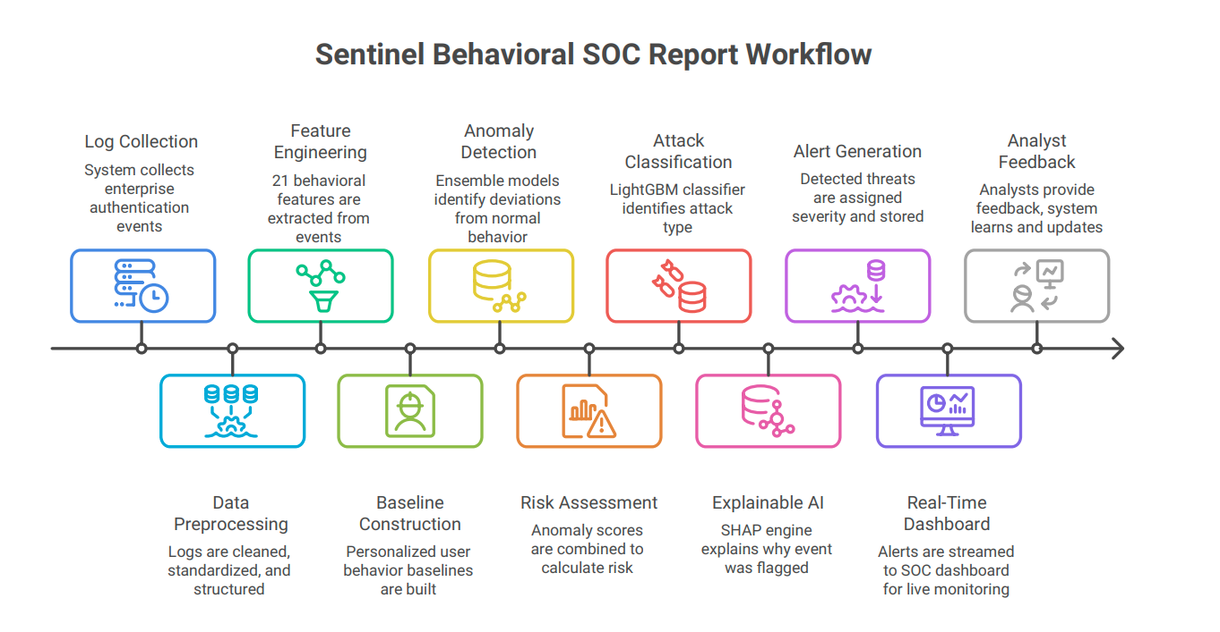
2. Technical Approach
2.1 Data Sources
The prototype uses a realistic synthetic enterprise authentication dataset that simulates normal user activity and multiple cyberattack scenarios.
- Authentication Logs: User login events containing timestamps, IP addresses, devices, geolocation, authentication status, accessed resources, and session details.
- Behavioral Profiles: Historical user information used to build personalized behavioral baselines.
- Attack Injection Engine: Generates labeled attack events including Credential Misuse, Brute Force, Lateral Movement, Impossible Travel, and Device Spoofing for training and evaluation.

2.2 Technologies & Tools
- Languages: Python (Backend & ML), JavaScript (Frontend)
- Frameworks: FastAPI, React.js, Tailwind CSS
- Libraries: Pandas, NumPy, Scikit-learn, LightGBM, SHAP, SQLAlchemy
- Models: Isolation Forest, LOF, One-Class SVM, Autoencoder, LightGBM
- Storage: SQLite (Prototype)
- Deployment: FastAPI Backend + React Dashboard with WebSocket support

2.3 Data Pipeline (High-Level Flow)
- Generate synthetic authentication logs with normal and attack events.
- Extract 21 behavioral features from each authentication event.
- Build personalized behavioral baselines for every user.
- Detect suspicious activities using an ensemble anomaly detection model.
- Classify detected anomalies into one of five cyberattack categories using LightGBM.
- Generate explainable risk scores and stream alerts to the SOC dashboard.
- Collect analyst feedback and monitor behavioral drift for future model improvement.
2.4 Models and Methods
- Behavioral Profiling: Learns normal user behavior through 21 engineered behavioral features.
- Ensemble Anomaly Detection: Combines Isolation Forest, LOF, One-Class SVM, and Autoencoder to detect abnormal activities.
- Attack Classification: Uses LightGBM to classify anomalies into five attack categories.
- Explainable AI: SHAP-based explanations provide feature importance and human-readable alert reasoning.
- Drift Monitoring: Tracks behavioral changes and recommends model retraining when required.
2.5 Interface & UX
- SOC Dashboard: Displays live alerts, threat timeline, risk metrics, behavioral insights, and attack statistics.
- Threat Visualization: Interactive charts, risk radar, and geographical threat mapping for security monitoring.
- Explainability Panel: Shows AI-generated reasons and contributing behavioral features behind each alert.
- Live Alert Stream: Real-time WebSocket notifications with analyst feedback support.

3. Feasibility & Viability
3.1 Feasibility Analysis
- Data Availability: The prototype uses a realistic synthetic enterprise authentication dataset with labeled attack scenarios, while the architecture is designed to integrate real-world authentication logs from enterprise identity providers, VPNs, cloud platforms, and SIEM solutions.
- Technical Feasibility: The proposed solution is built using widely adopted technologies including FastAPI, React, Scikit-learn, LightGBM, and SQLite, making it practical to develop, deploy, and scale within a standard machine learning environment.
- Deployment Feasibility: The modular architecture supports real-time streaming, REST APIs, and database integration, allowing seamless deployment in modern Security Operations Centers (SOCs).

3.2 Challenges & Risks
- Class Imbalance: Real-world enterprise logs contain very few attack events compared to legitimate activities, making model training challenging.
- Behavioral Drift: User behavior changes over time due to new devices, locations, or work patterns, potentially reducing detection accuracy.
- Cold-Start Users: New users with limited historical data make it difficult to establish reliable behavioral baselines.
- Scalability: Processing high volumes of authentication events in real time requires efficient feature engineering and anomaly detection.

3.3 Mitigation Strategies
- Imbalance Handling: Apply class weighting and SMOTE oversampling to improve learning on rare attack classes.
- Adaptive Behavioral Learning: Continuously update user baselines and monitor concept drift to maintain detection performance.
- Cold-Start Handling: Blend organizational behavior with limited user history until sufficient behavioral data is available.
- Efficient Architecture: Use a two-stage detection pipeline and incremental baseline updates to minimize computational overhead while supporting real-time threat detection.

4. Performance Evaluation & Results
4.1 Experimental Setup
The proposed system was evaluated using a synthetic enterprise authentication dataset generated to simulate real organizational login behavior and cyberattack scenarios. The dataset contained 20,351 authentication events, including 19,200 normal events and 1,151 labeled attack events distributed across five attack categories: Credential Misuse, Brute Force, Lateral Movement, Impossible Travel, and Device Spoofing.
The evaluation was performed in three stages: (i) behavioral anomaly detection, (ii) attack classification, and (iii) end-to-end replay simulation to assess real-time performance.

4.2 Stage 1 – Behavioral Anomaly Detection
The ensemble anomaly detection model (Isolation Forest, LOF, One-Class SVM, and Autoencoder) was evaluated using standard anomaly detection metrics.
Metric | Value
ROC-AUC | 0.9855
Precision | 87.1%
Recall | 76.3%
F1-Score | 81.3%
The confusion matrix at the selected operating threshold showed:
- True Negatives: 19,070
- False Positives: 130
- False Negatives: 273
- True Positives: 878
These results demonstrate excellent separation between normal and malicious behavior while maintaining a low false-positive rate.
4.3 Stage 2 – Attack Classification
Suspicious events detected during Stage 1 were classified using a LightGBM classifier.
Metric | Value
Macro Precision | 100%
Macro Recall | 100%
Macro F1-Score | 100%
The classifier correctly identified all five attack categories on the held-out synthetic test dataset, indicating effective discrimination between different attack behaviors.
4.4 End-to-End Replay Evaluation
To evaluate the complete pipeline, 4,071 authentication events were replayed as a simulated live stream.
Metric | Value
Live Events | 4,071
True Attacks | 231
Attacks Detected | 166
End-to-End Detection Recall | 71.9%
Attack-wise detection performance:
Attack Type | Detected / Total
Brute Force | 128 / 128 (100%)
Credential Misuse | 9 / 9 (100%)
Device Spoofing | 6 / 6 (100%)
Impossible Travel | 8 / 16 (50%)
Lateral Movement | 15 / 72 (20.8%)
The results indicate that the proposed two-stage detection pipeline effectively identifies high-confidence attack patterns while maintaining a low false-positive rate. More subtle behavioral attacks, such as lateral movement, present greater detection challenges and represent an important direction for future enhancement.

4.5 Key Outcomes
- Successfully generated and evaluated 20,351 enterprise authentication events.
- Achieved ROC-AUC of 0.9855 for behavioral anomaly detection.
- Achieved 87.1% Precision, 76.3% Recall, and 81.3% F1-Score in anomaly detection.
- Correctly classified all detected attack categories using the LightGBM classifier on the synthetic test set.
- Successfully detected and classified 166 cyberattacks during live replay, achieving an overall 71.9% end-to-end detection recall.
- Demonstrated real-time threat detection, explainable risk scoring, and live alert visualization through the SOC dashboard.
Note: The reported performance metrics are obtained on a synthetically generated enterprise dataset with injected attack scenarios. These results validate the correctness and effectiveness of the proposed architecture but should not be interpreted as production-level performance on real-world enterprise traffic.

5. Research & References
- MITRE ATT&CK Framework – Enterprise knowledge base of adversary tactics and techniques used for modeling cyberattack behaviors such as credential access, lateral movement, and privilege escalation.
https://attack.mitre.org/
- NIST Cybersecurity Framework (CSF) 2.0 – Industry-standard framework for cybersecurity risk management, detection, response, and recovery.
https://www.nist.gov/cyberframework
- Scikit-learn: Machine Learning in Python – Core machine learning library used for anomaly detection and data preprocessing.
https://scikit-learn.org/stable/
- LightGBM Documentation – Gradient boosting framework used for supervised attack classification.
https://lightgbm.readthedocs.io/
- SHAP (SHapley Additive exPlanations) – Explainable AI framework used to interpret model predictions and generate analyst-friendly explanations.
https://shap.readthedocs.io/
- Pedregosa, F., et al. "Scikit-learn: Machine Learning in Python." Journal of Machine Learning Research, 12, 2825–2830, 2011.
https://jmlr.org/papers/v12/pedregosa11a.html
. Prototype Website for Proposed Model
(The data displayed on this website is assumed/sample data. It is not calculated in the prototype stage. Once the model is fully developed, the results will be integrated into the website.)
Website URL:
GitHub Repository:

6. Results:

Thank You!

