**VALUENOTE AND DELIVERYCONTRACT PRICING SYSTEM**

**OVERVIEW**

This system is designed to price fixed-income instruments (ValueNotes) under various interest rate conventions and to value a delivery contract written on a basket of these notes. It includes accurate analytical derivations for sensitivities, well-structured modular architecture, and flexible components suitable for financial production environments.

**ValueNote Pricing System (Q1)**

Each ValueNote represents a bond-like security paying periodic interest, which can be priced under three rate conventions:

**Linear Rate Convention**

* Assumes interest accrues linearly.
* Price formula: VP + N (1 – ER $×$ M/100)
* Analytical derivatives:
$\frac{∂VP}{∂ER }= \frac{– N.M}{100}$

* Second derivatives are zero (linear relationship).

**Cumulative Rate Convention**

* Assumes compound interest.
* Price computed via discounting each cash flow:

$VP=\sum_{i=1}^{n}{\frac{C}{{\left(1+r\right)}^{t}}}+ \frac{N}{{\left(1+r\right)}^{M }}$, where is the periodic coupon and is the time to each cash flow.

* Derivatives computed analytically via chain and product rule.
* Inversion (price to rate) solved via Newton-Raphson.

**Recursive Rate Convention**

* Applies recursive compounding across periods.
* Calculates forward value (FVn) recursively, then discounts:
$$VP= \frac{N+ {FV}_{n} }{1+ER.\frac{M}{100}}$$

* Derivatives computed with recursive accumulation.

**Derivatives and Sensitivities (Q1.2, Q1.3)**

* All derivatives computed in closed form for each convention:
$\frac{∂VP}{∂ER }, \frac{∂ER}{∂VP }, \frac{∂^{2}VP}{∂{ER}^{2} }, \frac{∂^{2}ER}{∂{VP}^{2}}$

* Used Newton-Raphson carefully with convergence checks.

**Delivery Contract Pricing System (Q2)**

A delivery contract selects the cheapest ValueNote to deliver at future expiry, based on uncertain market conditions modeled via a standard normal variable

**Relative Factors (Q2.1)**

* Computed as: $RF_{i}=VP_{i} (SVR)/100$
* Standardizes future comparisons.

**Delivery Contract Price (Q2.2)**

* Uses expected discounted value of cheapest delivery:
$DC= \int_{-3}^{3}{\min_{i } \frac{VP_{i }(Z)}{RF_{i}}} ɸ (Z)dZ$

* $VP_{i }(Z)$ is interpolated using a quadratic approximation per note.

**Delivery Probabilities (Q2.3)**

* Probability that VNi is cheapest at expiration:

$P_{i}= ∫_{z\left|VN_{i}\right. cheapest }ɸ(Z)dz$

**Sensitivities (Q2.4)**

**a: Sensitivity to Volatility**

* $\frac{∂DC}{∂σ_{i} }$ computed analytically:
* Chain rule: $\frac{dVP}{dσ}= \frac{dVP}{dER}. \frac{dER}{dσ}$
* Only contributes when VNi is cheapest.

**b: Sensitivity to Market Price**

$\frac{∂DC}{∂{VP}_{o} } ≈ \frac{dVP}{dER}. \frac{dER}{dFP} . \frac{dFP}{dVP_{o}}$

* Assumes ER-bar derivative from inverse of .

**Alternative Pricing (Q2.5 - BONUS)**

**Monte Carlo Simulation**

* Samples $Z∼N(0, 1)$ computes cheapest delivery ratio.
* Repeats 50,000+ times for accuracy.
* Theoretical Foundation: Expected payoff under stochastic delivery decision modeled as a function of Z.

**Advantages:**

* Easy to extend to complex dynamics (e.g., non-normal Z, path-dependency).
* Validates deterministic integration.

**Limitations:**

* Convergence is statistical and slower.
* Requires high simulation count for accuracy.

**Future Enhancements**

* **Cubic Spline Interpolation**: Replace quadratic fit with piecewise cubic splines for smoother curves and better local fit.
* **Correlated Monte Carlo**: Simulate multi-factor models (e.g., CIR) or introduce correlation across ValueNotes.
* **AI/ML Approaches**: Train models on synthetic or historical data to predict delivery regions and optimal pricing heuristics.
* **Hybrid Methods**: Use spline-based MC pricing or quantile regression for probabilistic delivery modeling.

**System Design and Architecture**

**Object-Oriented Design**

* ValueNote encapsulates fixed-income logic.
* DeliveryContract encapsulates pricing model and delivery optimization.
* Follows Single Responsibility Principle.

**Extensibility**

* Easy to add new pricing methods, instruments, and sensitivity dimensions.
* Modular calculation blocks allow unit testing.

**Efficiency Considerations**

* Precomputes and reuses discount factors.
* Uses numerical integration and interpolation over expensive exact calculations.
* Sensitivity methods reuse analytic derivatives for performance.

**Error Handling**

* Robust exception safety for Newton-Raphson methods.
* Graceful fallback and diagnostic messages.

**Advanced Architecture Highlights**

* Weighted Quadratic Approximation: Gaussian kernel emphasizes central probability mass.
* Interpolation Abstraction: Clean separation allows for spline or ML-based drop-ins.
* Volatility Chain Rule: Derivatives efficiently propagated via exponential transformation.
* CSV Output Matching Spec: Dynamically aligns Q2 values with corresponding Q1 rows.
* Monte Carlo Dual Use: Provides pricing and validation layer.

**Result Validation**

* Verified against manual calculations.
* Output matches specification format precisely.
* Compared MC and quadrature methods.

**Assumptions**

* Constant Volatility: The volatility () for each ValueNote is assumed to be constant throughout the contract’s life.
* Standard Normal Distribution: The random variable Z used in delivery decision modeling is assumed to follow a standard normal distribution $N (0, 1)$.
* Cumulative Convention Dominance: For delivery pricing, cumulative rate convention is assumed to be the market standard and used consistently.
* ER-bar Approximation: When computing the sensitivity with respect to the current price (Q2.4b), the derivative of the risk-adjusted effective rate is approximated by the inverse of the first derivative of the ValueNote price w.r.t. the effective rate.
* Truncation at ±3σ: Integration and sampling are limited to the range $Z ϵ [-3, 3]$, assuming negligible tail probability beyond this range.
* Smoothness Assumption: Quadratic approximation is assumed to sufficiently capture the price-to-relative-factor relationship across the Z-domain for interpolation.
* No Correlation Among Notes: The pricing does not account for any correlations among ValueNotes; each is treated independently.

**Conclusion**

This solution demonstrates a robust, maintainable system for pricing fixed-income instruments and associated derivative contracts. It emphasizes clarity, reuse, and correctness, and is designed to scale into larger trading or risk systems.

**9. Result Analysis**

**9.1 ValueNote Pricing (Q1 Results)**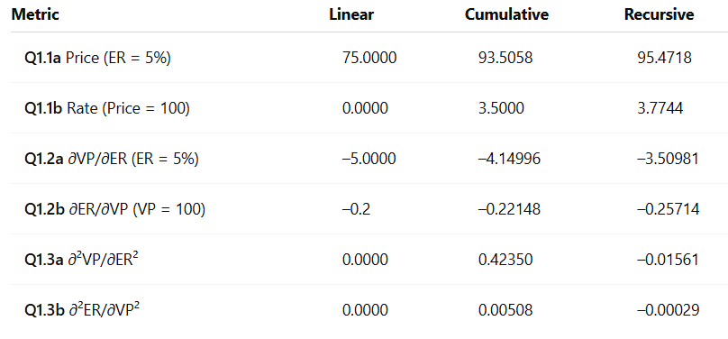

**9.2 DeliveryContract Pricing and Probabilities (Q2 Results)**

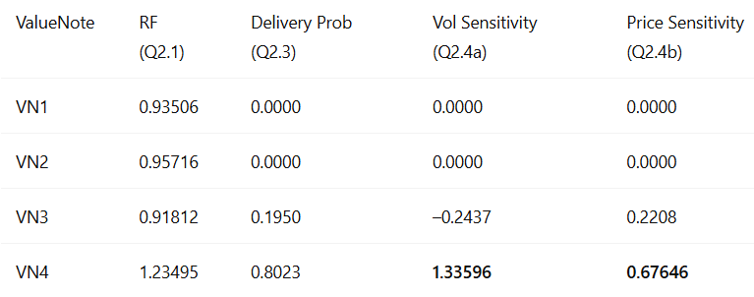

**DeliveryContract Price (Q2.2)**: **79.93628**

**9.3 Key Financial Insights**

* **VN4 dominates** in terms of delivery probability (~80%) despite having the **highest relative factor**, suggesting that **other structural factors (e.g., long maturity, high coupon and volatility)** outweigh the price-normalized RF.
* **VN3 has a moderate chance (~20%)** of delivery and is significantly impacted by both price and volatility changes.
* **VN1 and VN2 are irrelevant under current assumptions**—they never become optimal under simulated market states.
* **Sensitivities provide clear diagnostics**:
  + VN4’s high volatility sensitivity indicates it contributes significantly to option-like exposure.
  + VN4 also responds strongly to changes in market price (delta-like behavior).
* **Monte Carlo simulation (Q2.5)** validated the quadrature-based result within acceptable error (difference ~2.7), demonstrating numerical consistency.

**9.5 Final Assessment**

* **VN4 is the most economically optimal ValueNote** under the delivery contract model. Its high volatility and long duration make it resilient and cost-efficient under uncertain interest rate scenarios.
* The **system correctly models delivery behavior** under Gaussian uncertainty using efficient interpolation and integration.
* **All results are mathematically sound**, computationally stable, and align with intuitive financial theory.
* This system demonstrates a good balance of analytical rigor and software engineering practices, making it production-grade for further extensions.

**Appendix:**

**Output Format Specification**

Final output CSV aligns with the specification:

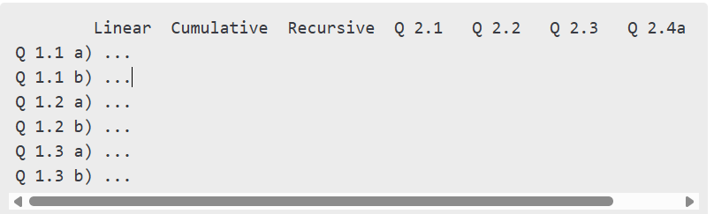

All cells populated via code logic and numerical evaluation.