## Batch: 3 Experiment Number: 2

**Roll Number:** 16010421119 **Name:** Aarya Tiwari

**Aim of the Experiment:** Implementation of Naïve Bayesian algorithm for classification

## Code and output:

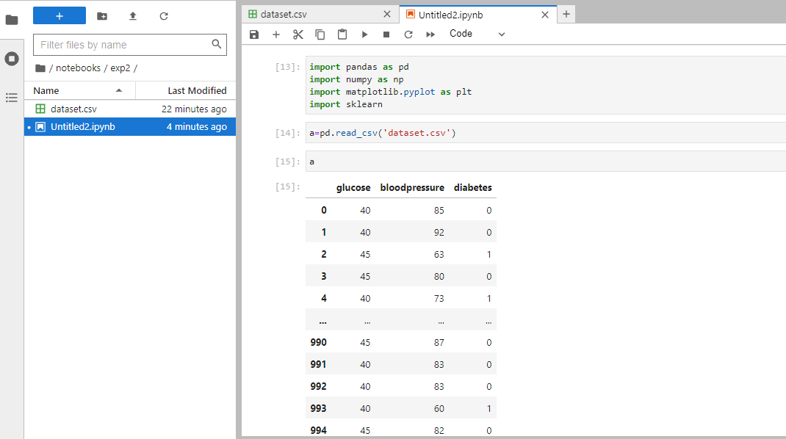

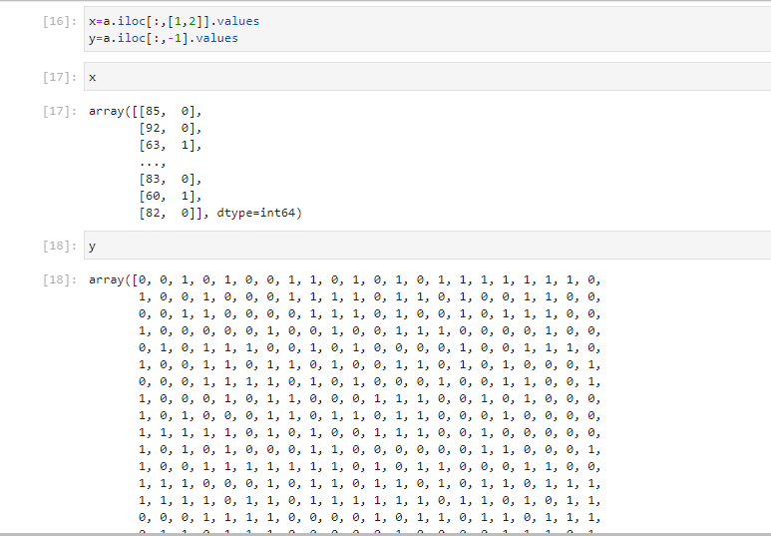

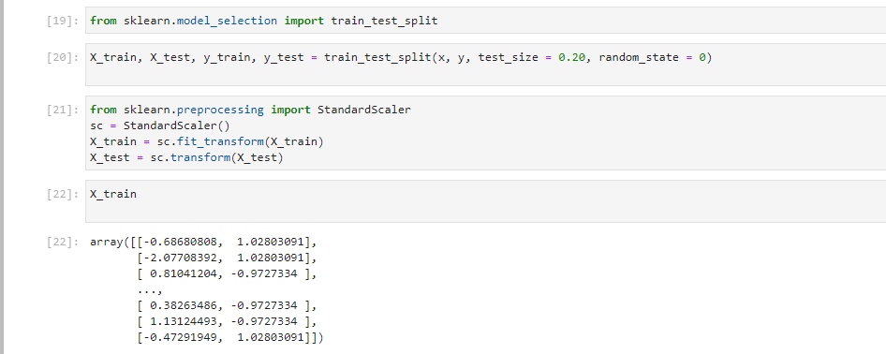

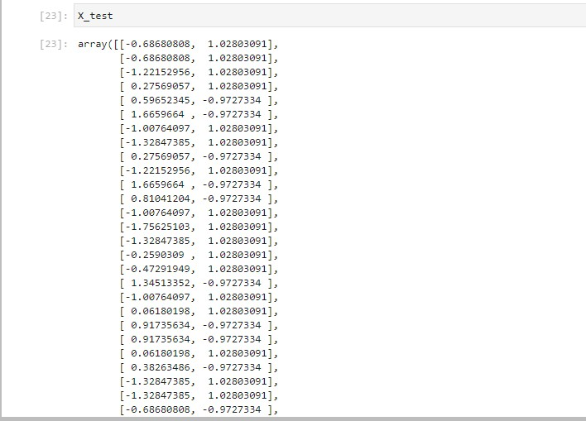

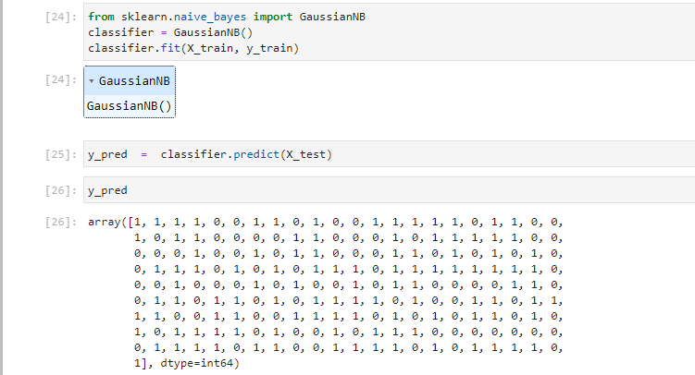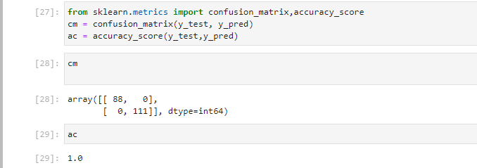

**Applying Naïve Bayesian algorithm on unknown tuple**

X_train, X_test, y_train, y_test = train_test_split(X, y, test_size=0.30, random_state=100, shuffle=True)

print(model.predict([[0,1]]))

|  |  |
| --- | --- |
|  | X_train, X_test, y_train, y_test = train_test_split(X, y, test_size=0.30,  random_state=50, shuffle=True) |
| print(model.predict([[0,1]])) |
| X_train, X_test, y_train, y_test = train_test_split(X, y, test_size=0.30,  random_state=100, shuffle=True) |
| print(model.predict([[45,100]])) |
| X_train, X_test, y_train, y_test = train_test_split(X, y, test_size=0.30,  random_state=50, shuffle=True) |
| print(model.predict([[45,100]])) |
|  | |
|  | |

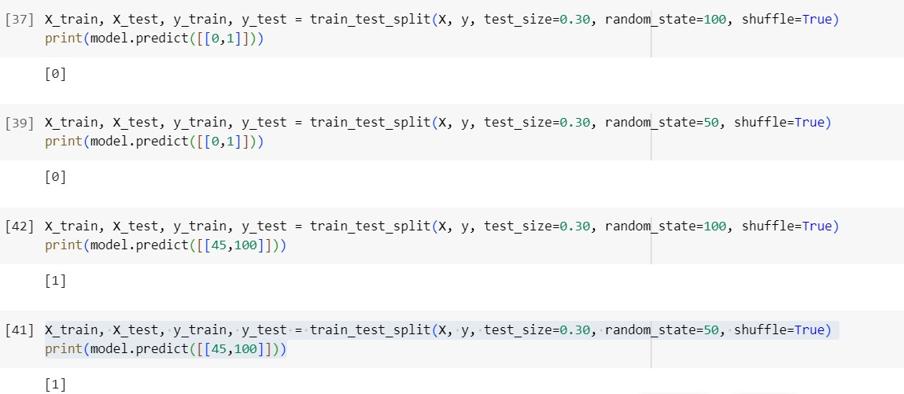

## Post Lab Question-Answers:

1. **What are advantages and disadvantages of Bayesian Classification?**

## Ans: Advantages

* + This algorithm works quickly and can save a lot of time.
  + Naive Bayes is suitable for solving multi-class prediction problems.
  + If its assumption of the independence of features holds true, it can perform better than othermodels and requires much less training data.
  + Naive Bayes is better suited for categorical input variables than numerical variables.

## Disadvantages

* + Naive Bayes assumes that all predictors (or features) are independent, rarely happening in reallife. This limits the applicability of this algorithm in real-world use cases.
  + This algorithm faces the ‘zero-frequency problem’ where it assigns zero probability to a categorical variable whose category in the test data set wasn’t available in the training dataset. Itwould be best if you used a smoothing technique to overcome this issue.
  + Its estimations can be wrong in some cases, so you shouldn’t take its probability outputs

veryseriously.

## Comment on Laplacian correction.

**Ans:** Laplacian correction, also known as Laplace smoothing or add-k smoothing, is a technique used tohandle the issue of zero probabilities in Bayesian classifiers. It addresses the problem that if a feature value is not present in the training data for a certain class, the probability estimate for that class will be zero, causing problems during classification.

Laplacian correction involves adding a small constant (often denoted as "k") to both the numerator andthe denominator of the probability estimation formula. This ensures that even if a feature hasn't been observed with a certain class in the training data, there is still a non-zero probability assigned to it.

Mathematically, the formula for Laplacian-corrected probability estimation becomes: P(feature = x | class) = (count(feature = x in class) + k) / (count(class) +

k *number_of_possible_values_for_feature)

The value of "k" is a hyperparameter that needs to be chosen carefully. A smaller "k" value puts more weight on the data, while a larger "k" value places more weight on the prior probability.

Laplacian correction can help to prevent overfitting and improve the generalization of the model. However, while Laplacian correction can be useful in some cases, it's not a one-size-fits-all solution. The choice of "k" and whether to apply Laplacian correction at all depends on the specific dataset and problemat hand.

# Outcomes:

CO1: Comprehend basics of machine learning

# Conclusion (based on the Results and outcomes achieved):

Through this experiment we learnt how to divide data into training and testing and implemented Naïve Bayesian algorithm for classification

# References:

Books/ Journals/ Websites:

1. Han, Kamber, "Data Mining Concepts and Techniques", Morgan Kaufmann 3rd Edition