KJSCE/IT/TY/SEM-V/ML-H/2023-24



**Experiment No.6**

**Title:** Design and implement Decision tree based ID3 algorithm.

(A Constituent College of Somaiya Vidyavihar University)

KJSCE/IT/TY/SEM-V/ML-H/2023-24

**Batch: B2** **Roll No.: 16010421119** **Experiment No.:6**

**Aim:** Design and implement Decision tree based ID3 algorithm.

___________________________________________________________________________

**Resources needed:** Python 3.6 onwards

___________________________________________________________________________

**Theory:**

ID3 Algorithm

ID3(Examples, Target_attribute, Attributes)

Examples are the training examples. Target_attribute is the attribute whose value is to be predicted by the tree. Attributes is a list of other attributes that may be tested by the learned decision tree. Returns a decision tree that correctly classifies the given Examples.



* Create a Root node for the tree
* If all Examples are positive, Return the single-node tree Root, with label = +
* If all Examples are negative, Return the single-node tree Root, with label = -
* If Attributes is empty, Return the single-node tree Root, with label = most common value of Target_attribute in Examples
* Otherwise Begin
  + A ← the attribute from Attributes that best* classifies Examples
  + The decision attribute for Root ← A
  + For each possible value, *vi*, of A,
    - Add a new tree branch below *Root*, corresponding to the test A = *vi*
    - Let *Examples vi*, be the subset of Examples that have value *vi* for *A*
    - If *Examples vi* , is empty
      * Then below this new branch add a leaf node with label = most common value of Target_attribute in Examples
      * Else below this new branch add the subtree

ID3(*Examples vi*, Targe_tattribute,

Attributes – {A}))

* End
* Return Root

(A Constituent College of Somaiya Vidyavihar University)

KJSCE/IT/TY/SEM-V/ML-H/2023-24

**ENTROPY:**

Entropy measures the impurity of a collection of examples*.*



Where, *p+* is the proportion of positive examples in S *p-* is the proportion of negative examples in S.

**INFORMATION GAIN:**

* ***Information gain,*** is the expected reduction in entropy caused by partitioning the examples according to this attribute.
* The information gain, Gain(S, A) of an attribute A, relative to a collection of examples S, is defined as

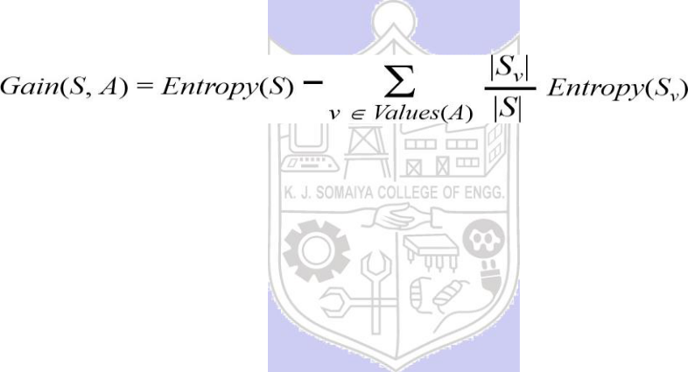

**Activity:**

Write a program to demonstrate the working of the decision tree based ID3 algorithm. Use an appropriate data set for building the decision tree and apply this knowledge to classify a new sample.

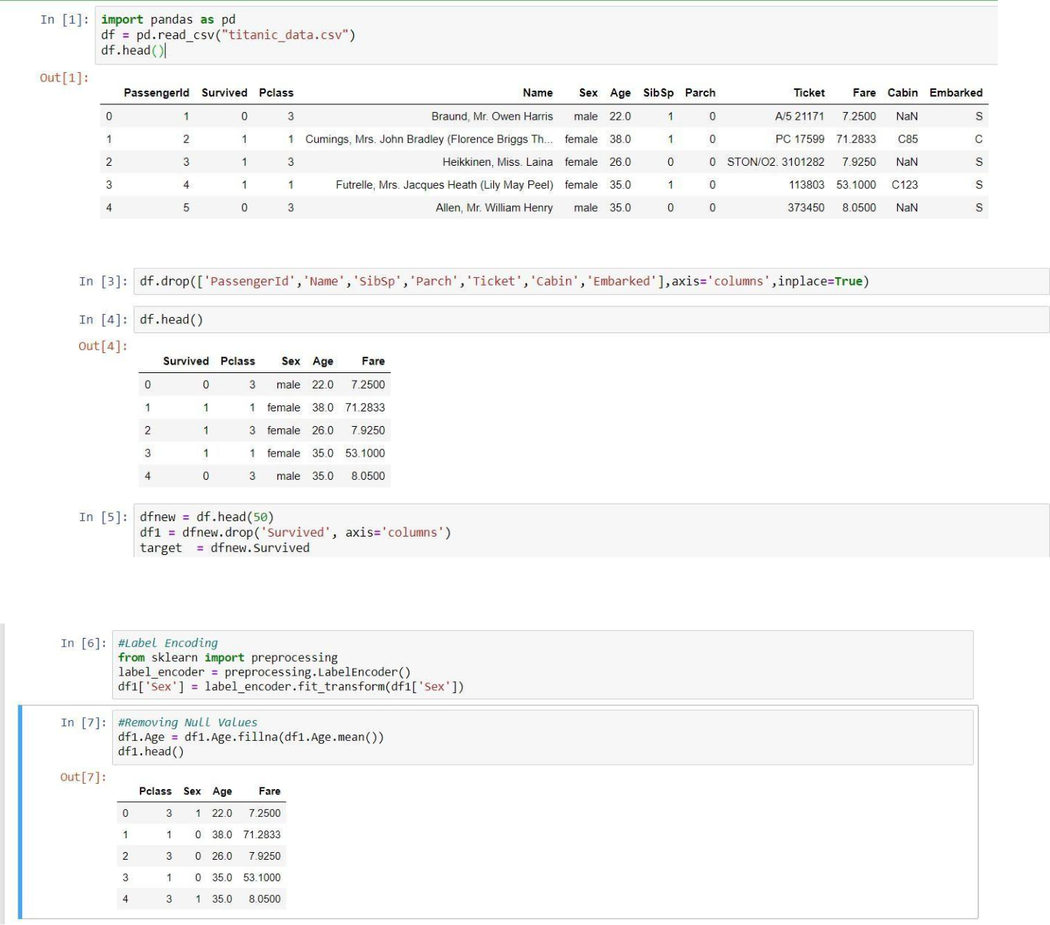

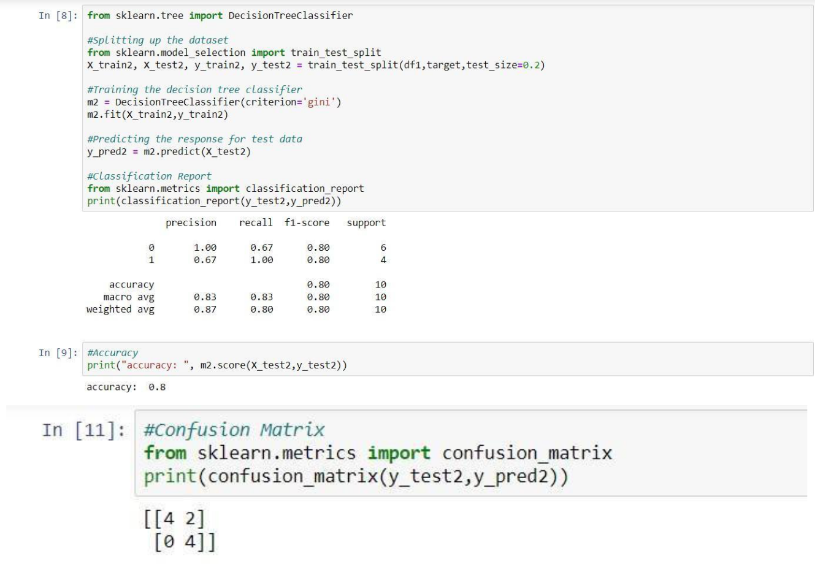

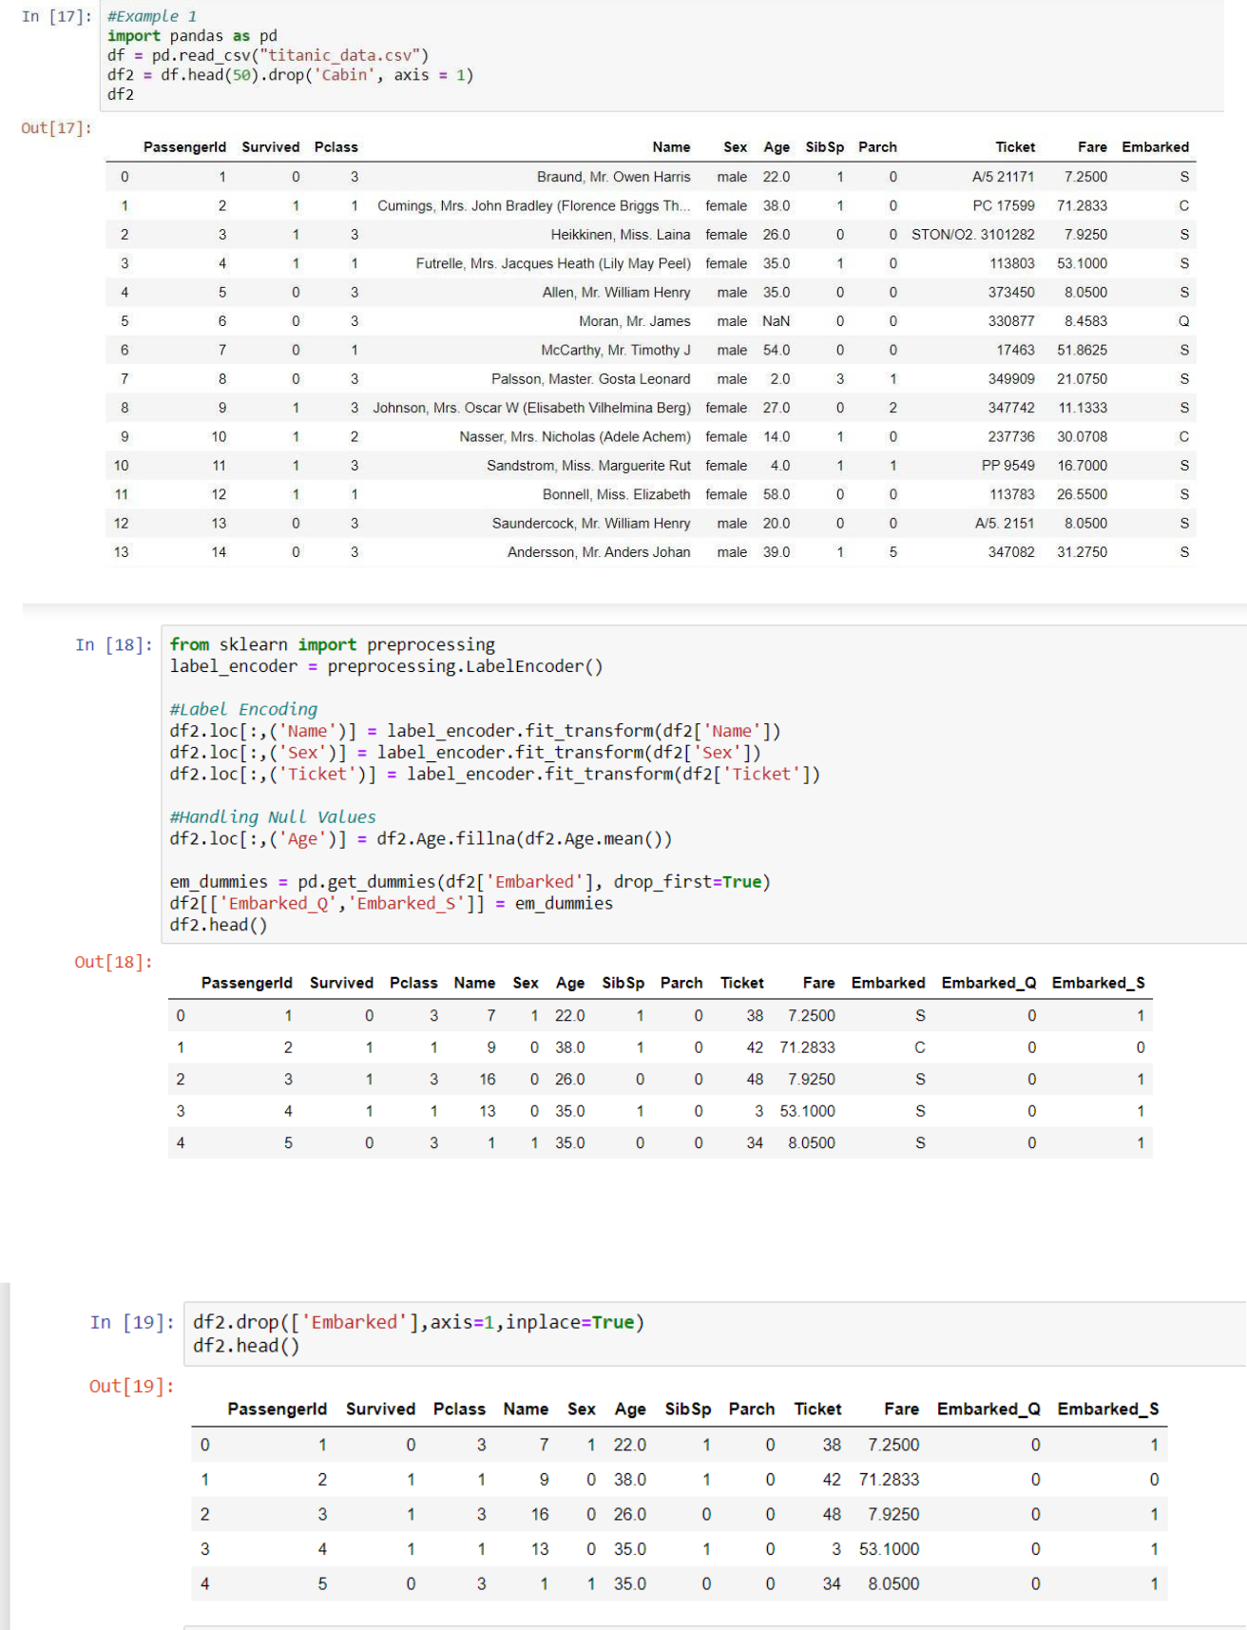

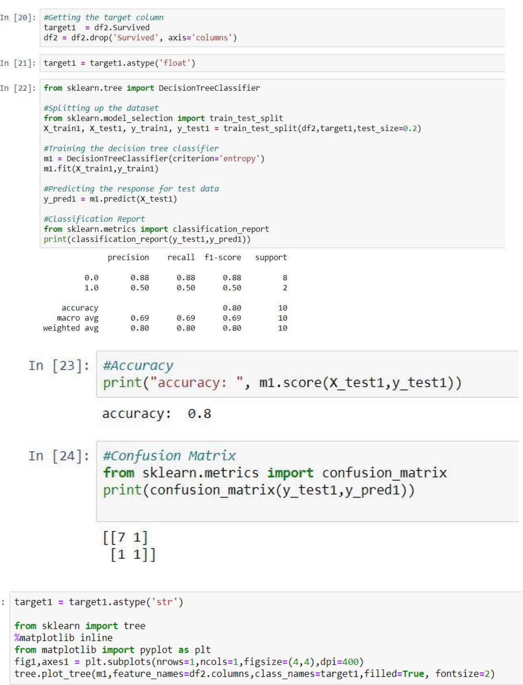

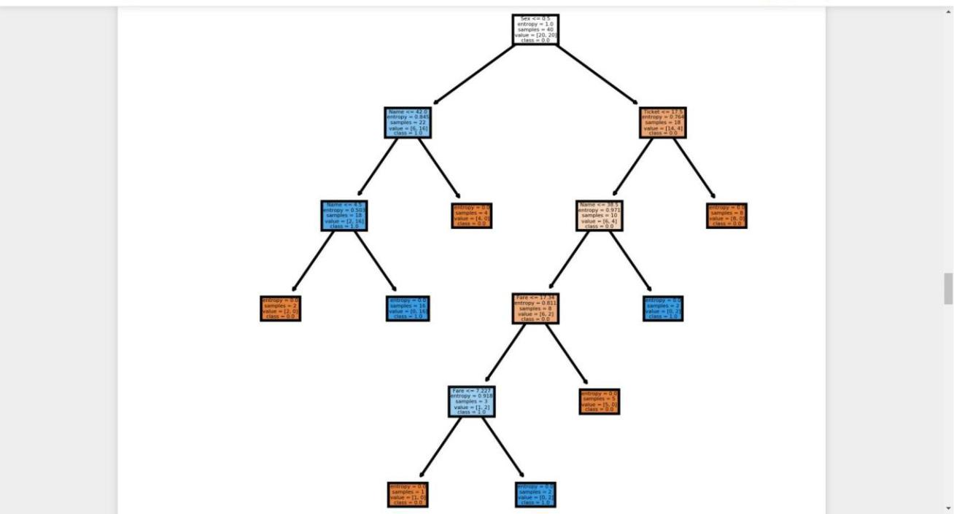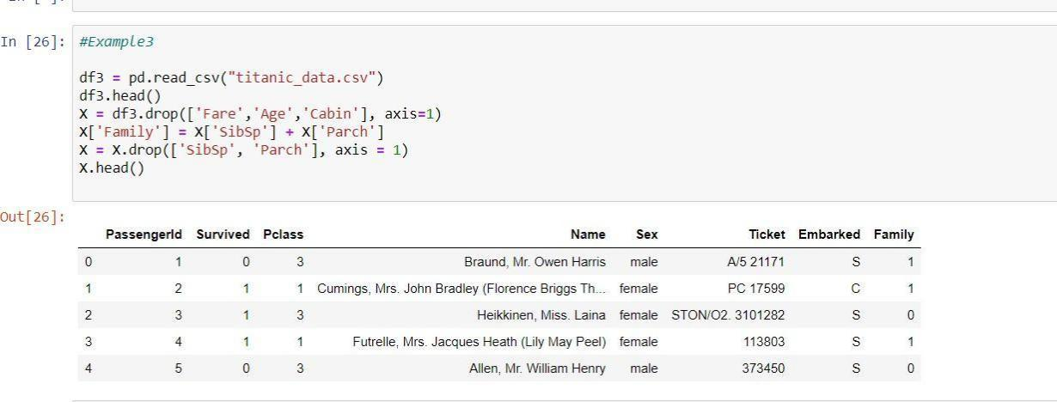

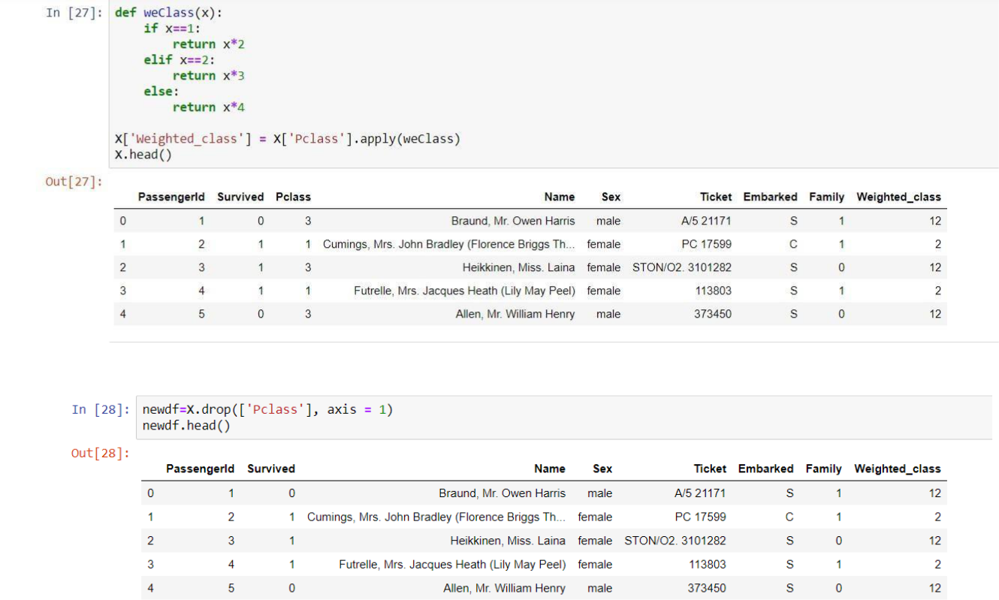

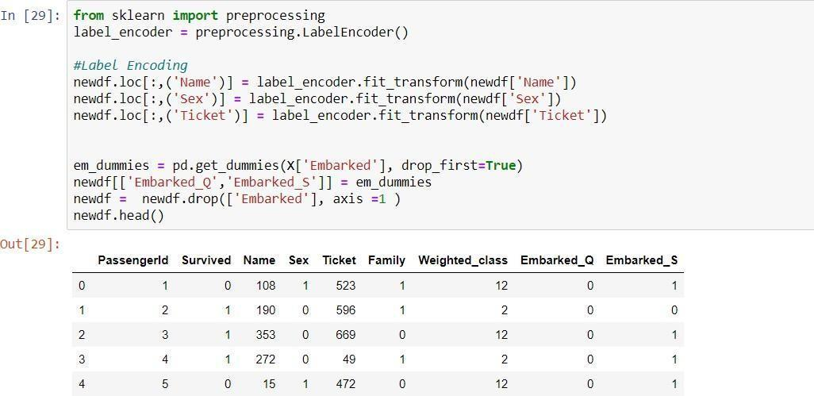

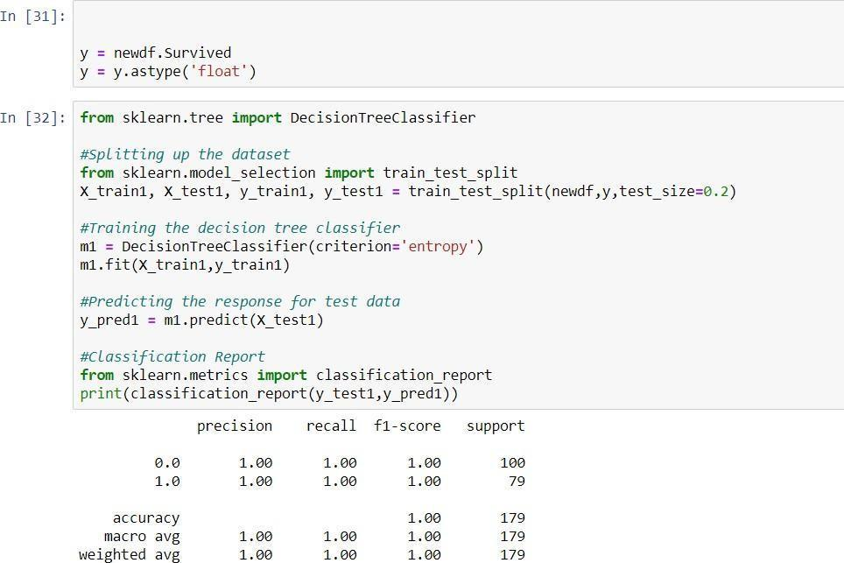

_______________________________________________________________________

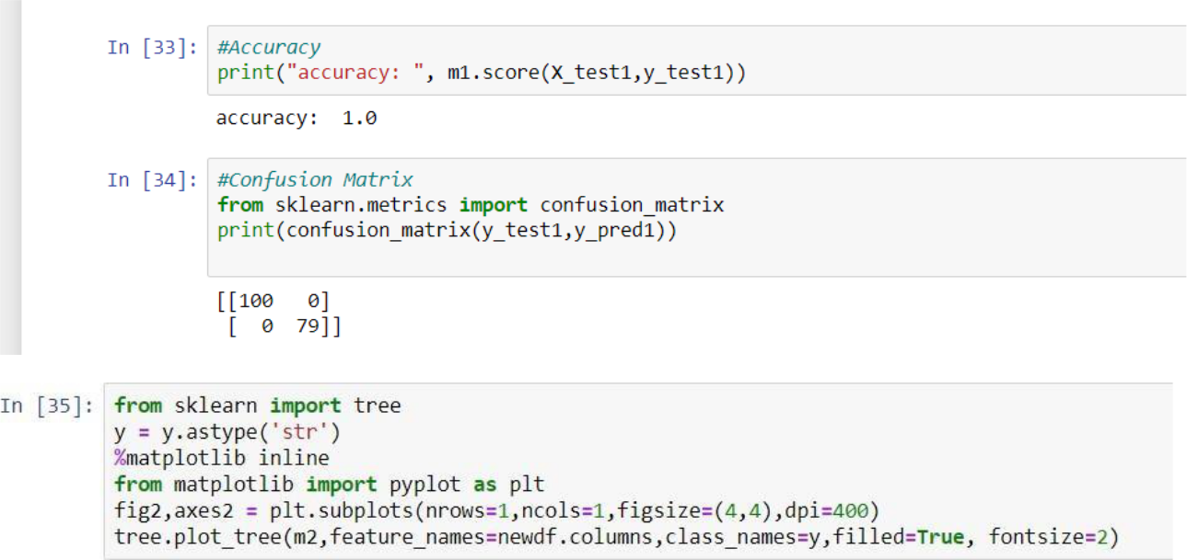

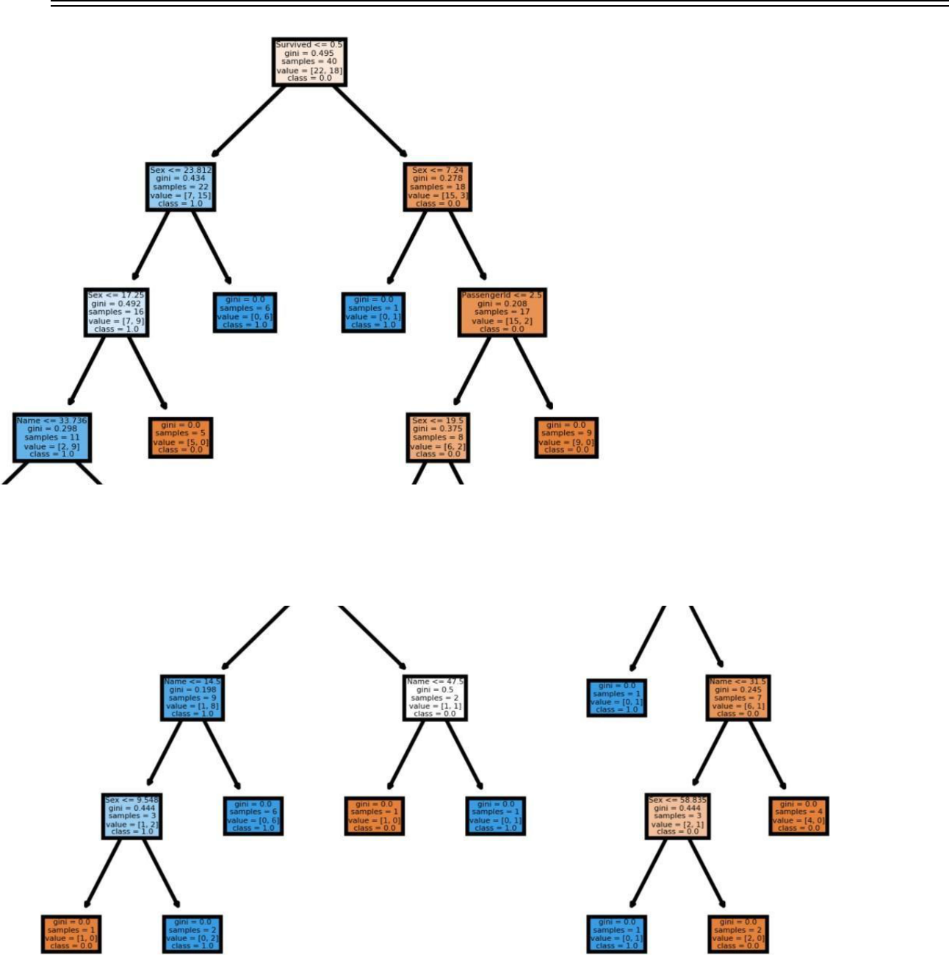

**Results: (Program printout with output / Document printout as per the format)**



**Questions:**

1. Which one is more prone to overfitting, Decision Trees or ID3? Why?
2. What is the role of Pruning in the Decision Tree Algorithm, and why is it important?
3. What is entropy, and how it is used in the ID3 algorithm?

**Outcomes: CO2 :** Apply concepts of different types of Learning and Neural Network

___________________________________________________________________________

___________________________________________________________________________

___________________________________________________________________________

___________________________________________________________________________

___________________________________________________________________________

______________________________________________________________________

(A Constituent College of Somaiya Vidyavihar University)

KJSCE/IT/TY/SEM-V/ML-H/2023-24

**Conclusion: (Conclusion to be based on the objectives and outcomes achieved)**

We learnt how to make a decision tree and test data and accuracy of that decision tree

___________________________________________________________________________

___________________________________________________________________________

___________________________________________________________________________

___________________________________________________________________________

_______________________________________________________________________



**Grade: AA / AB / BB / BC / CC / CD /DD**

Signature of faculty in-charge with date

___________________________________________________________________________

**References:**



Books/ Journals/ Websites:

1. Han, Kamber, "Data Mining Concepts and Techniques", Morgan Kaufmann 3nd Edition

(A Constituent College of Somaiya Vidyavihar University)