**Experiment -1.1 - Installing Git & Creating Repository.**

**Student Name: Aaryan Maheshwari UID: 22BDO10001**

**Branch: AITCSE(DevOps) Section/Group: 22BCD-1(A)**

**Semester: Fourth Date of Performance: 18/01/2024**

**Subject Name – Git and Hub Subject Code: 22CSH-293**

**1. Aim/Overview of the practical:**

**Installation of Git Software and Creating a Repository on GitHub.**

**2. Task to be done:**

1. **Creation of an account on GitHub**
2. **Installation of Git**
3. **Creating a repository**
4. **Using the repository on Git Software**
5. **Exploring GitHub and using common and basic features available on GitHub**

**3. Apparatus(For applied/experimental sciences/materials based labs):**

**Networking Device, Networking Connection, GitHub Account, Git Software**

**4. Algorithm/Flowchart (For programming based labs):**

**N.A.**

**5. Theme/Interests definition( For creative domains):**

Version control is a system that records changes to a file or set of files over time so that you can recall specific versions later. Git is a distributed version control system that tracks changes in any set of computer files, usually used for coordinating work among programmers who are collaboratively developing source code during software development.

**6. Steps for experiment/practical:**

1. **Downloading Git 🡪**

These are the steps to be followed while downloading the Git Software:-

1. Browse to the official Git website and download the Application.
2. Now follow the mentioned steps:- (Unless specified, use by default option)
3. Text Editor:- Choose Vim Editor or your preferred text editor. Keep the default branch name as 'master' unless working in a team.
4. Environment Configuration: Keep the recommended PATH environment setting. Use the default Git SSH client.
5. Certificates and Line Endings: Use default options for server certificates. Leave line endings conversion on the default setting.
6. Terminal Emulator and Git Pull Command: Choose MinTTY as the terminal emulator. Stick to the default git pull command behaviour.
7. Credential Helper and Extra Options: Use the default credential helper. Optionally enable symbolic links.
8. Finalization: Uncheck experimental features. Complete the installation, and optionally view Release Notes or launch Git Bash.

**Now, to launch Git BASH:**

Step-1: Open the Windows Start menu

Step-2:Search for git bash in the Search Menu and press Enter (or click the application icon).

Step-3: Connecting to a Remote Repository Git Bash.

1. **Configuring GitHub Credentials 🡪**
2. Configure your local Git installation to use your GitHub credentials by entering the following:

🡪 git config --global user.name "github_username"

🡪 git config --global user.email "email_address"

1. We can also see the list of configurations by using the command

🡪 git config -- list.

1. **Cloning a GitHub Repository 🡪**
2. Go to your repository on GitHub.
3. On the top right above the list of files, open the Clone or Download drop-down menu.
4. Copy the URL for cloning over HTTPS.
5. Switch to your PowerShell window, and enter the following:

🡪 git clone repository_url

1. **Lisiting all the Remote Repositories 🡪**
2. Your working directory should now have a copy of the repository from GitHub.
3. Now type ‘ls’ to list the name of files available in the directory.
4. **Creating Repository on GitHub🡪**
5. After successful login into your account. Click on the option (+) to add new repository to your account.
6. After clicking new repository option, we will have to initialize some things like, naming our project, choosing the visibility etc. After performing these steps click Create Repository button.
7. After clicking the button, we will be directed to the next page. After that we added some files using add files option. This is how our repository looks now.

**7. Observations/Discussions(For applied/experimental sciences/materials based labs):**

**We have observed how to clone a repository in Git and how to make a repository on the GitHub**

**8. Percentage error (if any or applicable):**

**N.A.**

**9. Calculations/ Chemical Reactions / Theorems /Formulas used etc :**

**N.A.**

**10. Result/Output/Writing Summary:**

**We have successfully created a repository and downloaded the Git Software into our version.**

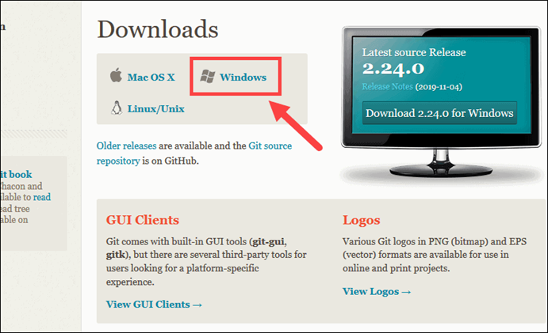

**Downloading interface for the Git Software**

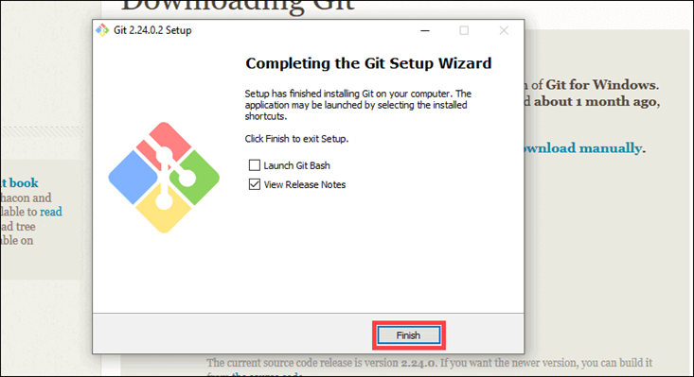

**Git Software successfully downloaded into the version and now launching the GitBash**

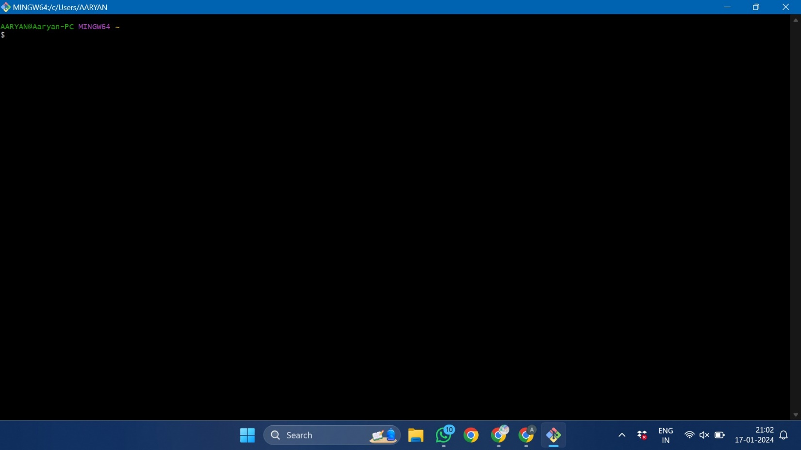

**GitBash Interface**

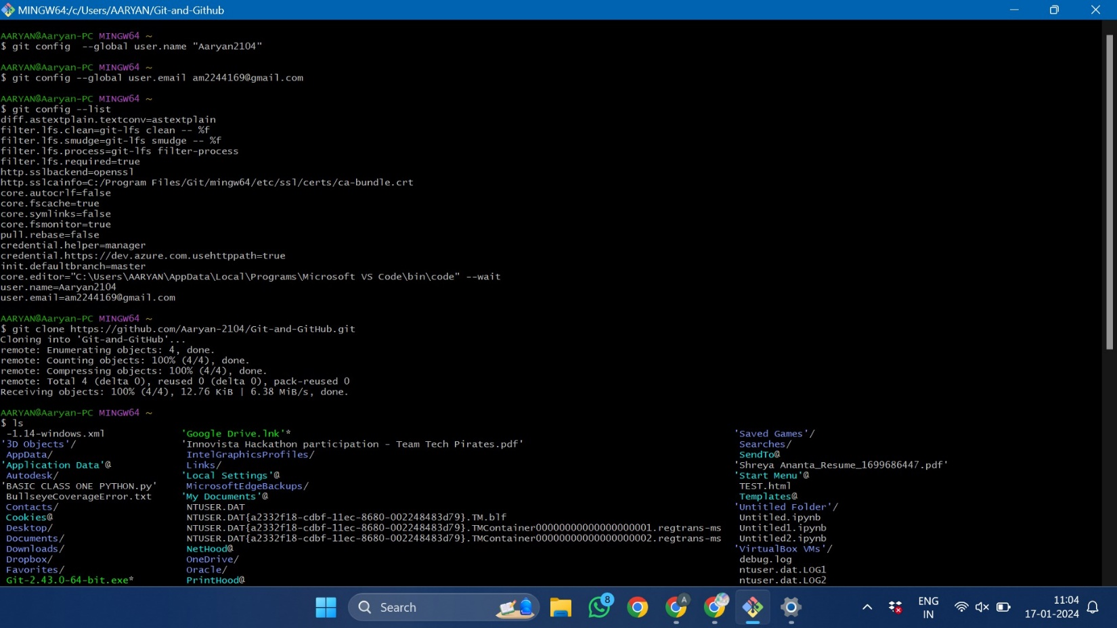

**Using basic commands on GitBash**

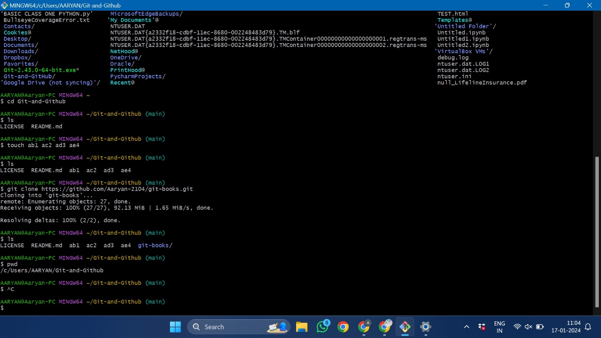

**Cloning a Repository**

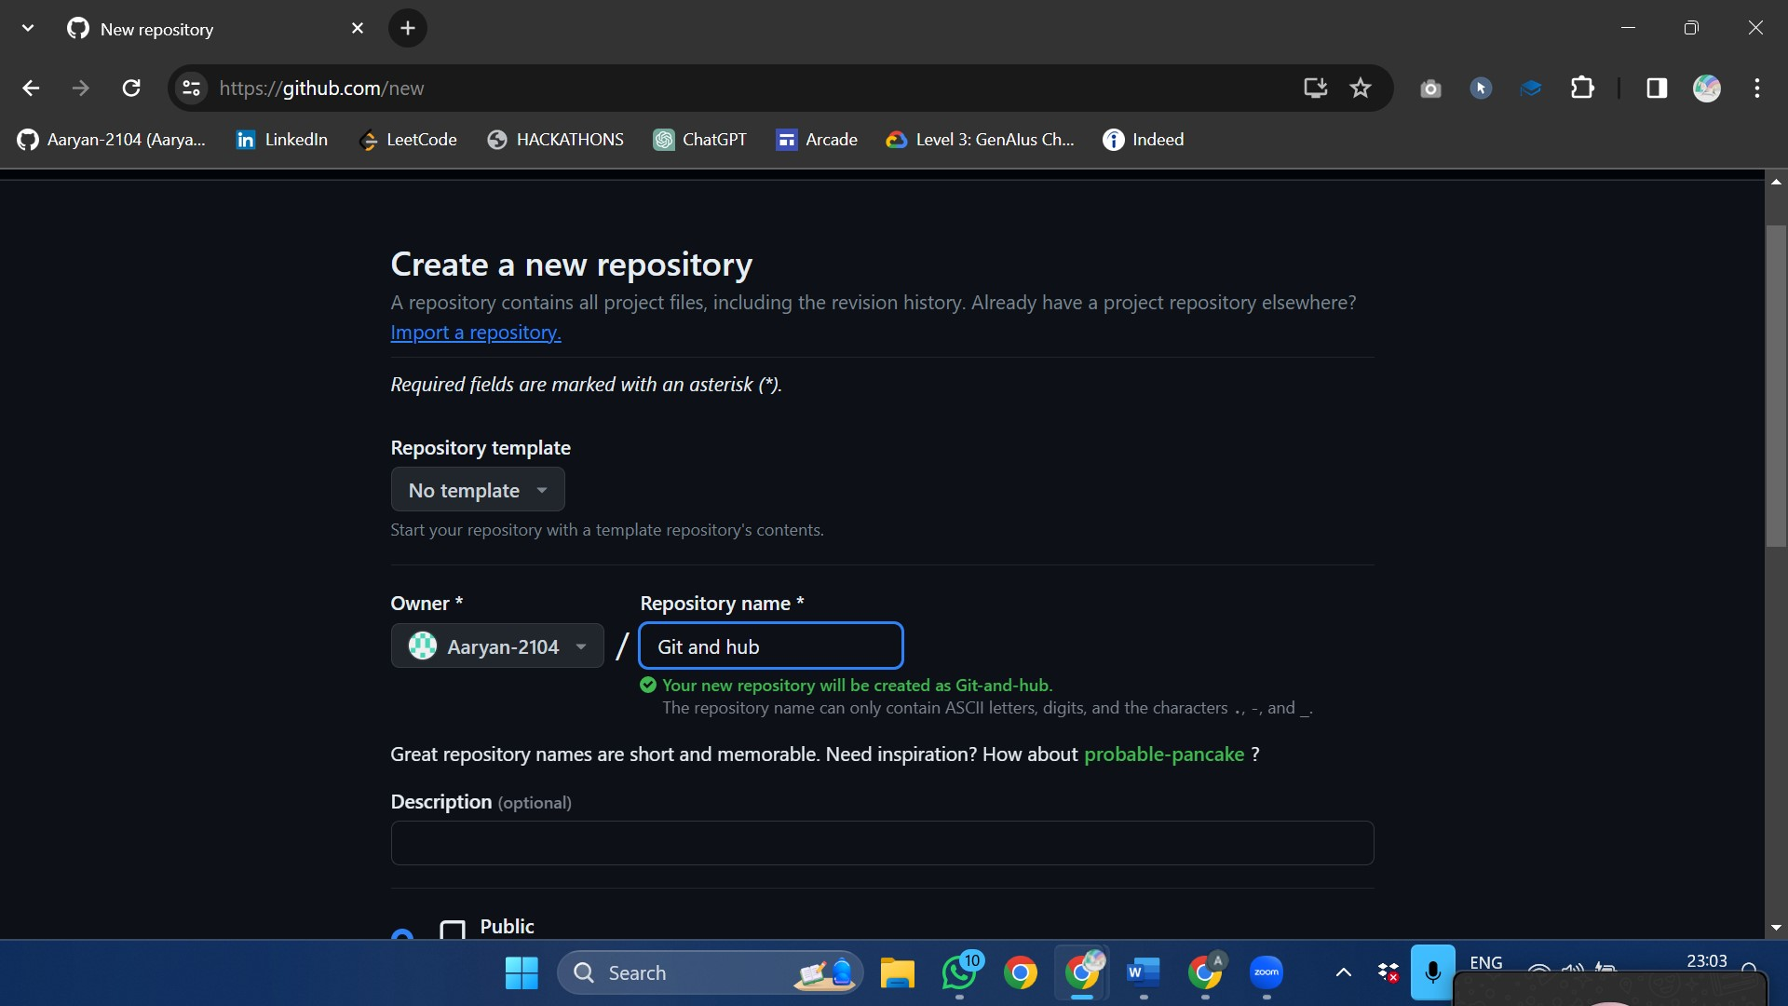

**Creating a Repository on the Github named Git and Hub**

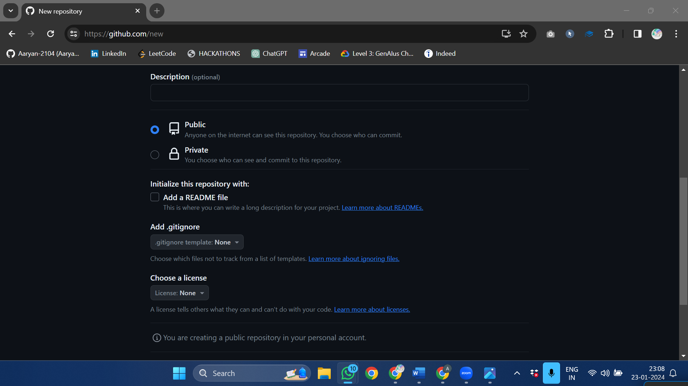

**Specify the License and choose whom to track the template.**

**11. Graphs (If Any): Image /Soft copy of graph paper to be attached here**

**N.A.**

**Learning outcomes (What I have learnt):**

**1.** Learnt about GitHub.

**2.** Learnt about Git.

**3.** Learnt about various git commands that can be applied on Git Bash.

**4.** Learnt about repositories.

**5.** Learnt about how to clone a repository.

**Evaluation Grid (To be created as per the SOP and Assessment guidelines by the faculty):**

|  |  |  |  |
| --- | --- | --- | --- |
| Sr. No. | Parameters | Marks Obtained | Maximum Marks |
| 1. |  |  |  |
| 2. |  |  |  |
| 3. |  |  |  |
|  |  |  |  |