**Experiment -1.2**

**Student Name: Aaryan Maheshwari UID: 22BDO10001**

**Branch: AIT-CSE(DEVOPS) Section/Group:22BCD-1/A**

**Semester: Fourth Date of Performance: 24/01/2024**

**Subject Name: GIT AND GITHUB Subject Code: 22CSH-293**

**1. Aim/Overview of the Practical:**.To create branches with GitHub and use it.

**2. Software used:** Git Bash and Github.

**3. Hardware Used:** Computer system.

**4. Steps for experiment:**

**To Create a branch on GitHub :**

**1.** Login to your GitHub profile on Chrome.

**2.**  Click on the repository where you want to do branching.

**3.** Click on Add the file to add a new file.

**4.** Give this file the name “**myfile. c”** and add any code.

**5.** Click on the **“commit changes”** button to commit the change.

**6.** Provide **“commit message”** and **“Extended description”** and then click **“commit changes”**

**7.** Now go on that file and click on branch **“main”**.

**8.** Type a new branch name **“br24.c”** and click **“Create branch br24.c from main”**

**9.** Click on the **“edit”**  button and edit the code.

**10.** After editing click on **“commit changes “** to commit the changes.

**11.** Add **“Commit message”** And  **“Extended description”** and then click on **“Commit changes”**

**12.** After committing the changes go to **“parent repository”** and click **“compare and pull request”.**

**13.** Compare the code in two modes.

**14.** Click on **“Create pull request”** And add **“title and description to code”**

**15.** Click on **“Merge pull request”**

**16.** After Merging the code Click on **“Delete branch”** if you wish to delete the branch.

**From Creating Branch On GitBash:**

**1.** Create a new folder named **“git”** on the desktop.

**2.** Initialize the git using the *“git init”* command.

**3.** Create a new file using the *“vi command”* For example, here we have created 🡪 **“vi cm.txt”**

**4.** Edit the file and add content to it.

**5.** Put the file in the staging area using *“git add (file name)”* For example **“git add cm.txt ”**

**6.** Commit this file using the *“git commit -m “message”*

**7.** Create a new branch using code *“git checkout -b branch_name”*

**8.** Open and Edit the file using “vi file name” and add content.

**9.** Put the file in the staging area using *“git add (file name)”* For example **“git add cm.txt ”**

**10.** Commit this file using the *“git commit -m “message”*

**11.** Move to the master branch using *“git checkout master”*

**12.** Merge the branch using code *“ git merge new”*

**13.** Show the status of the file using *“git status”.*

**5. Outputs:  
For GitHub**

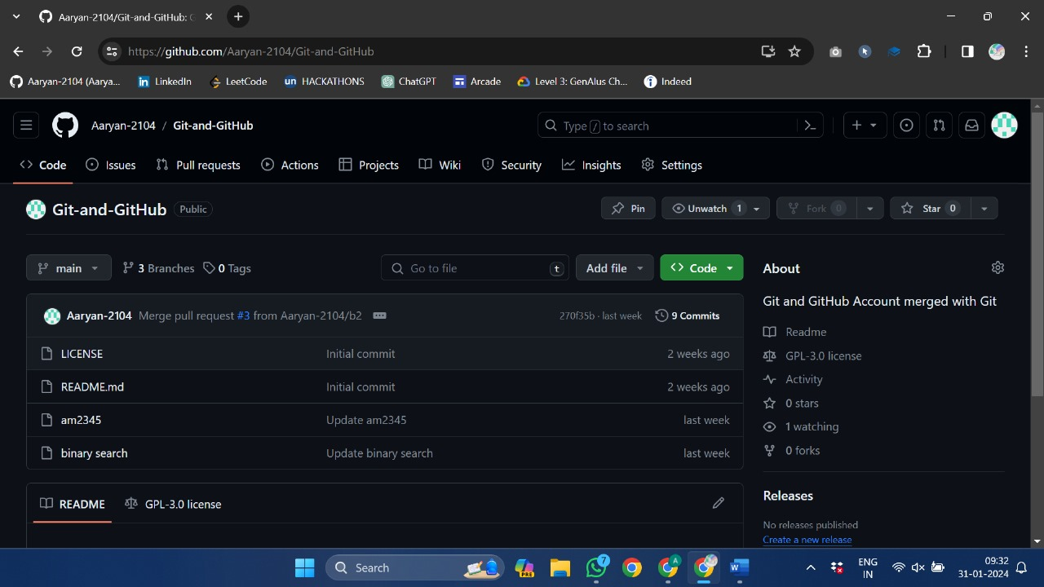

*Create new file*

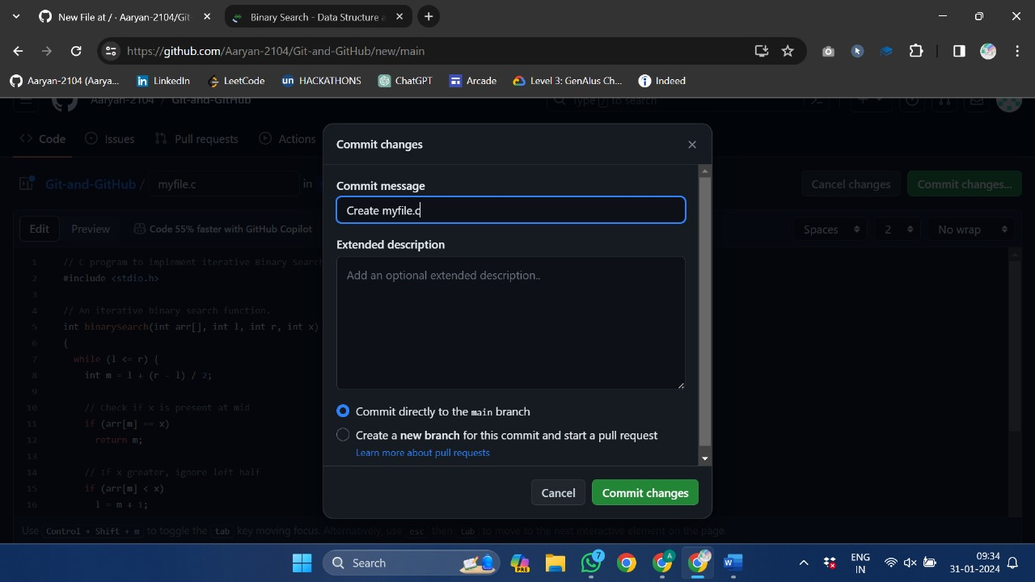

*Give this file name as myfile.c*

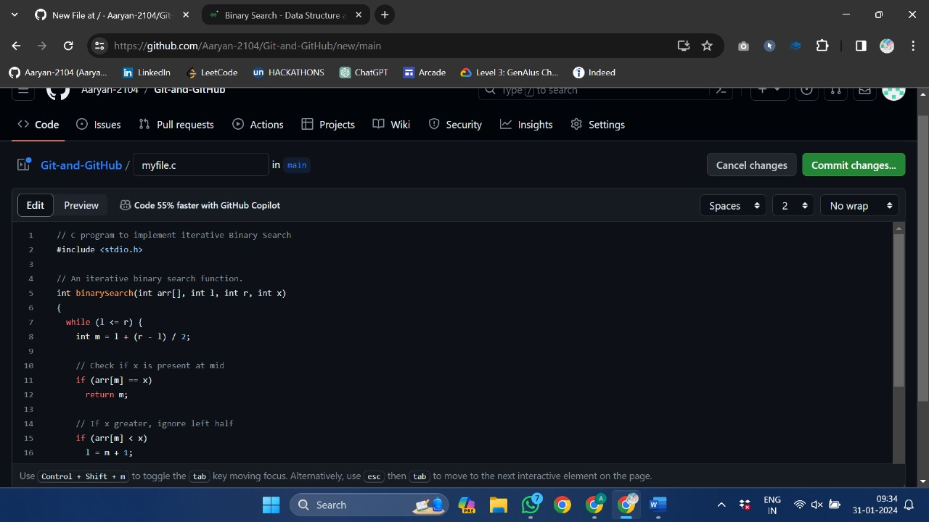

*Add Binary Seach Code into this file*

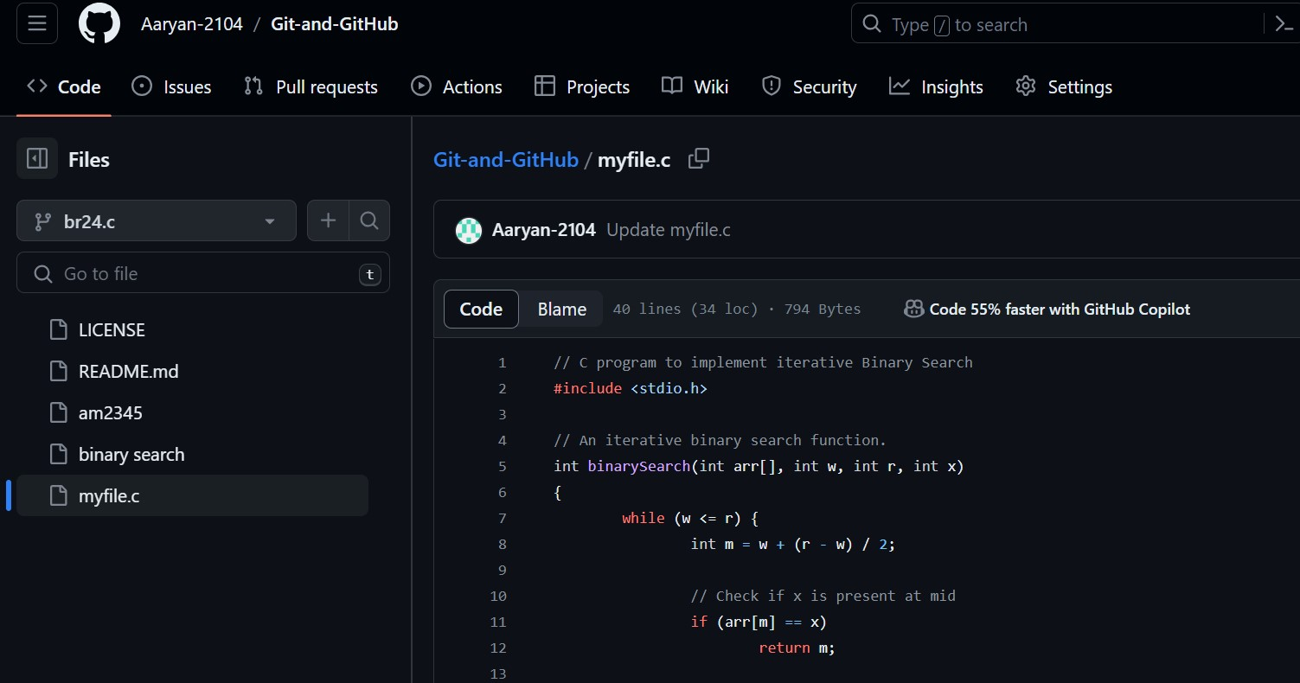

*Now create a branch named br24.c*

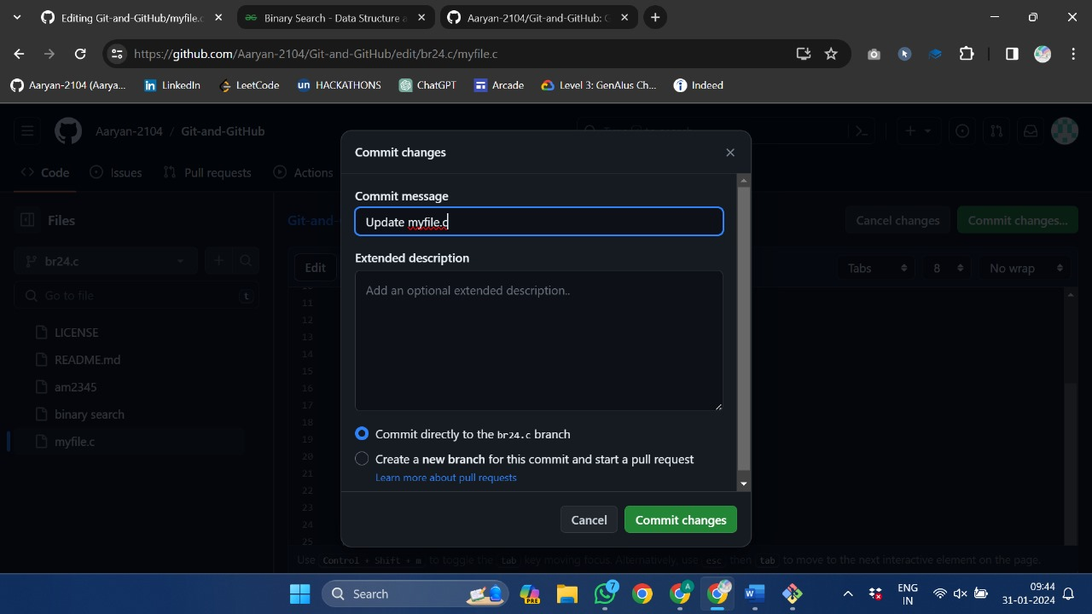

*Edit this branch and click on commit changes*

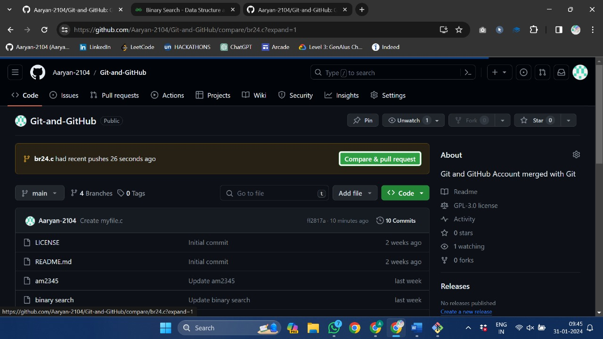

*Click on Compare and Pull Request*

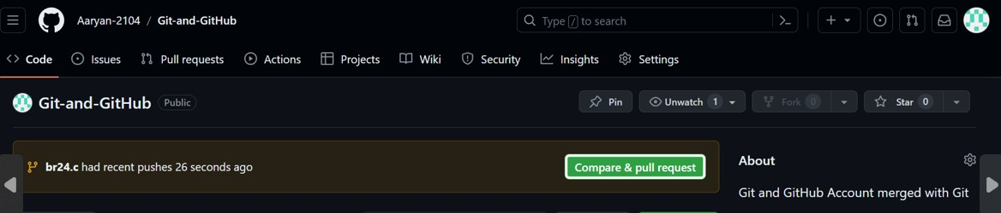

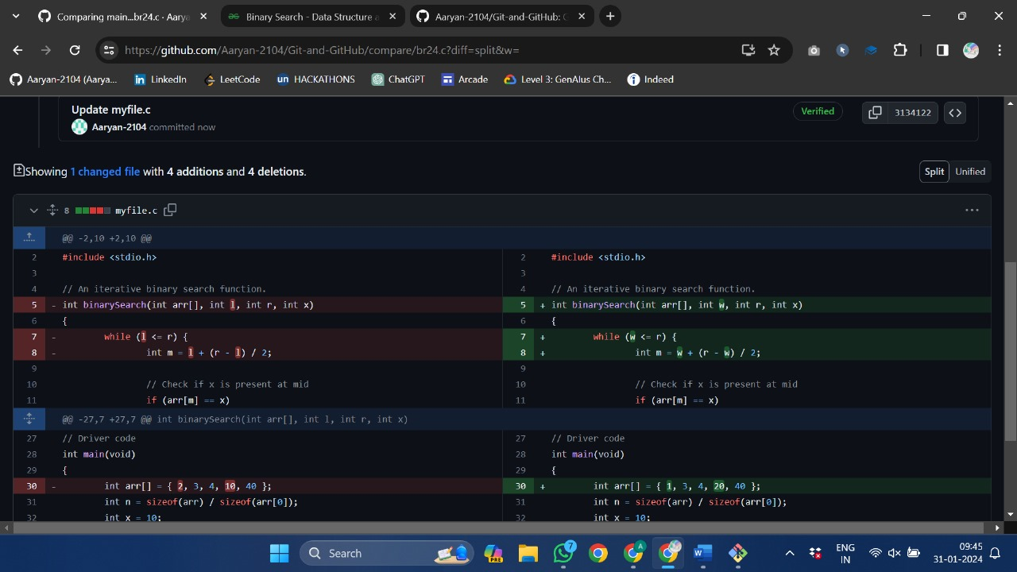

*Compare the 2 codes in the Split Mode*

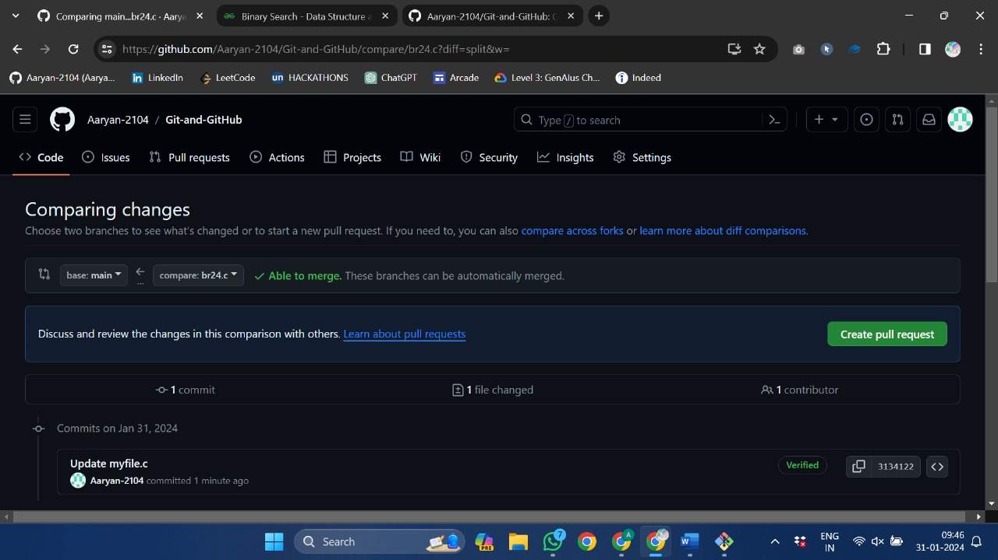

*Click on Create Pull Request*

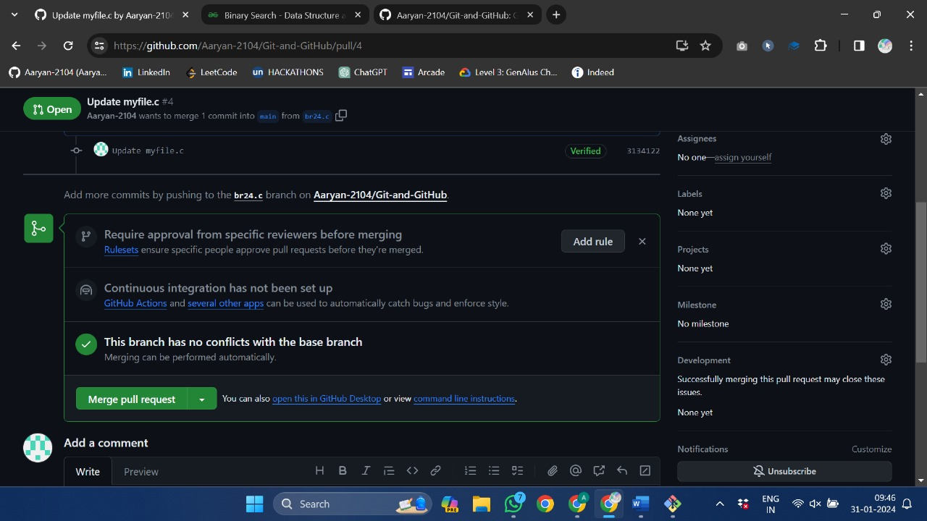

*Click on Merge Pull Request*

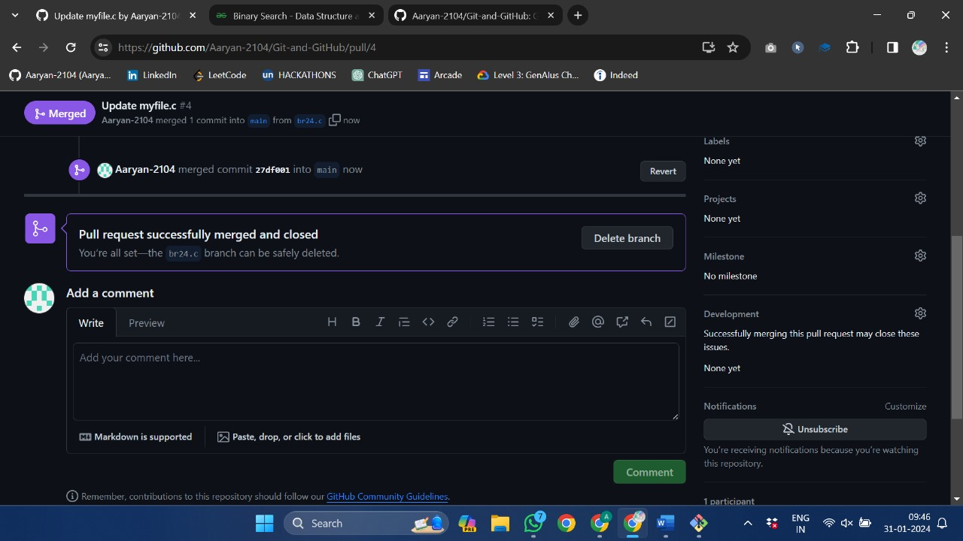

*Pull Request successfully Merged and now you have an option to Delete as well. You can delete it as well*

**For GitBash -->**

**(Creating Branch on GitBash)**

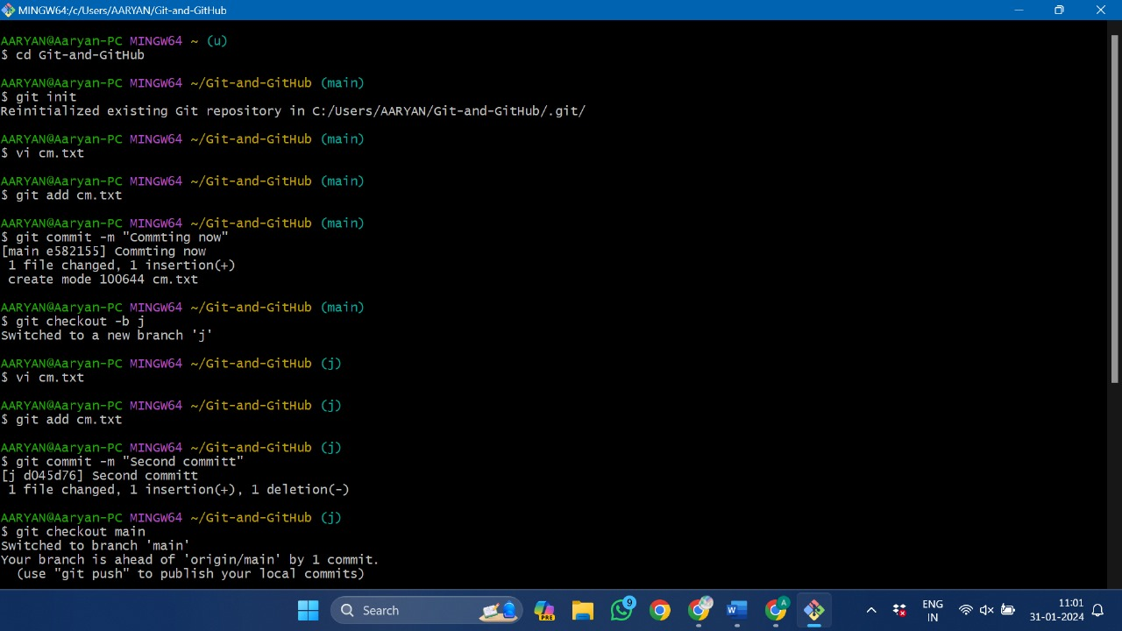

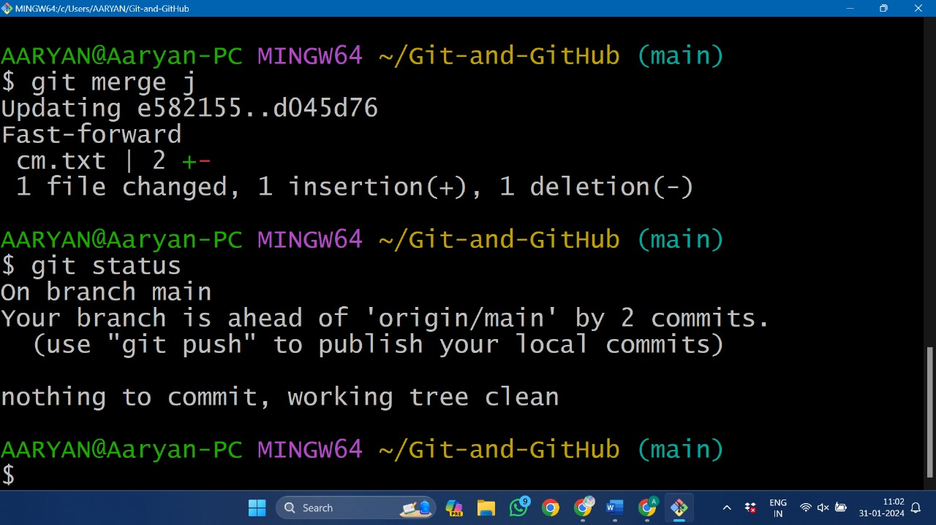

**6. Result/Output/Writing Summary:**

In this experiment, we have created a branch on a file in the repository using GitHub and Gitbash. We have merged this branch with the parent main branch.

**7. Learning outcomes (What I have learnt):**

**1.** Learnt About branching.

**2.** Learnt how to create a branch using Git Hub.

**3.** Learnt how to create a branch using gitbash.

**4.** Learnt how to merge the two branches.

**5.** Also learnt how to differentiate these two files.

**Evaluation Grid (To be created as per the SOP and Assessment guidelines by the faculty):**

|  |  |  |  |
| --- | --- | --- | --- |
| Sr. No. | Parameters | Marks Obtained | Maximum Marks |
| 1. |  |  |  |
| 2. |  |  |  |
| 3. |  |  |  |
|  |  |  |  |