Experiment -2.1

**Student Name:** Aaryan Maheshwari **UID:** 22BDO10001

**Branch:** AITCSE(DevOps) **Section/Group**: 22BCD-1(A)

**Semester:** Fourth **Date of Performance:** 07/02/2024

**Subject Name**: Git and Hub **Subject Code:** 22CSH-293

1. **Aim/Overview of the practical:** ToEdit a file and commit the changes on GitHub.
2. **Software Used:** Git Bash, GitHub.

# Steps for experiment/practical:

* 1. Create or clone a repository on your local machine and open GIT BASH.
  2. Move to the directory using the **cd** command.
  3. In our case, the repository is there, so we used the git init command, to initialize the already loaded git repository.
  4. Create or open a file in the master or main branch, eg, **exp. c** and add some text to the file.
  5. Add the file to the staging area using **git add** and then commit the changes using the **git commit -m** message.
  6. Pull the changes to the remote repo using the command **git push <remote_name>**

**<branch_name>**, here **git push origin rep.**

* 1. You will be able to see the changes in the remote repository.
  2. Now, make some changes in the file in the remote repository and pull those changes in the local repository.
  3. Create a new branch and checkout to it using the **git checkout -b** command, eg, **rep**.
  4. Open the **exp. c** on the **vi** editor and make some changes to it.
  5. Merge the changes made in the **test** branch with the **master** branch and resolve the conflicts manually if necessary.
  6. Push the **master** and **rep** branch onto the remote repository.
  7. You will be able to see the new changes in the remote repository.
  8. Now, Go to Git Hub, open the repository move to the **rep** branch and make some changes in a file.
  9. Commit the changes and move to the **master** branch. Click on the **Compare & Pull request**.
  10. **Create the pull request,** resolve the merge conflicts (if any) and then **merge the pull request**.
  11. After the merging, you may choose to delete your branch, i.e., **rep**
  12. Now, pull the changes to the local repository using **git pull**.
  13. You will be able to see the changes in your local repository.

# Outputs:

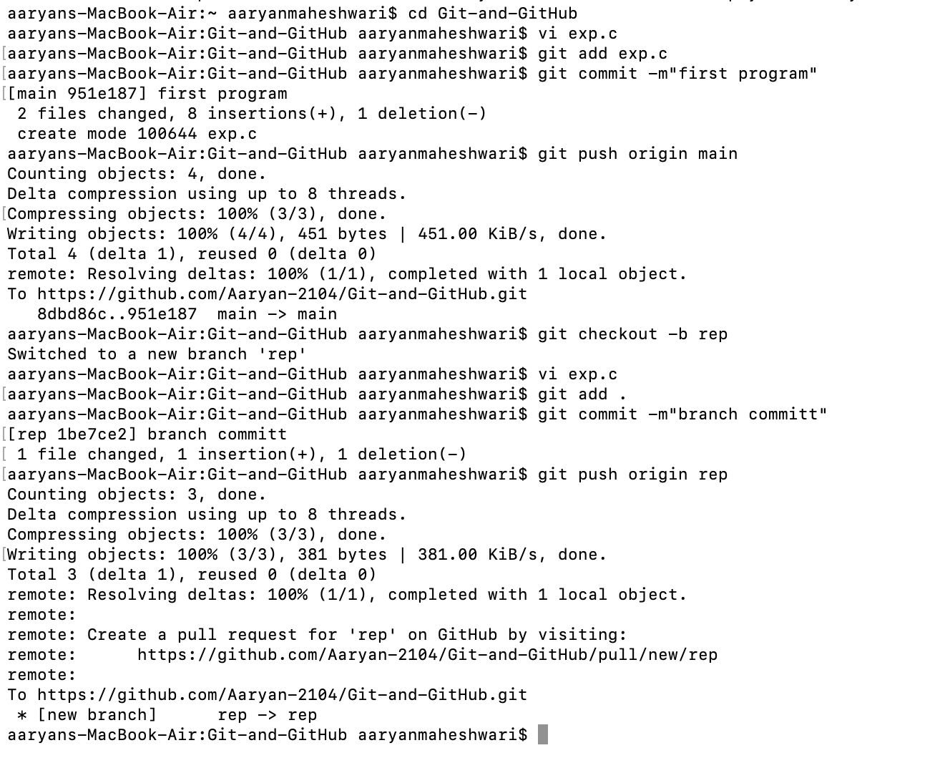

*Commands related to the experiment on GitBash*

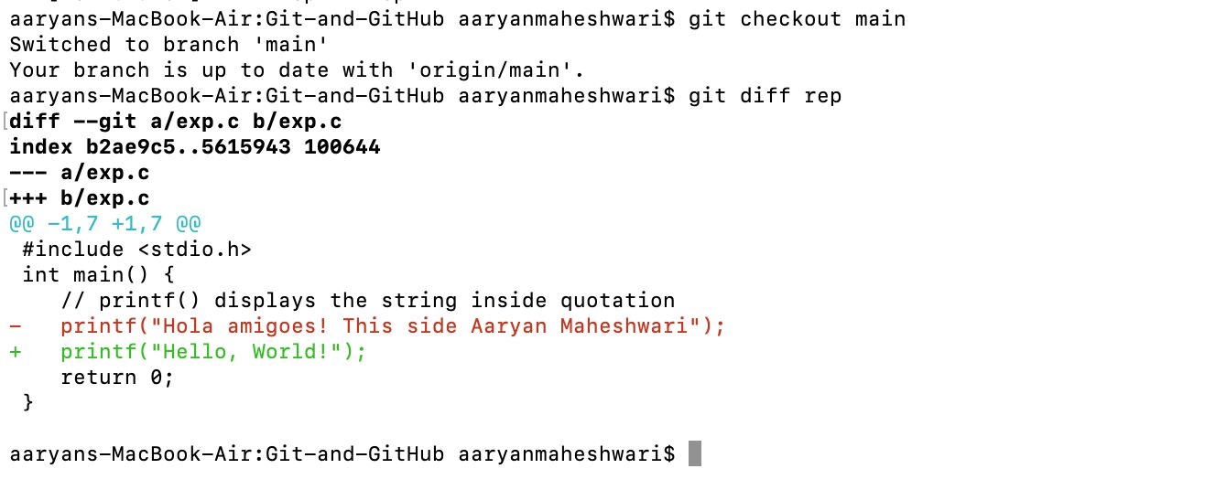

*Continued Commands related to the experiment on GitBash*

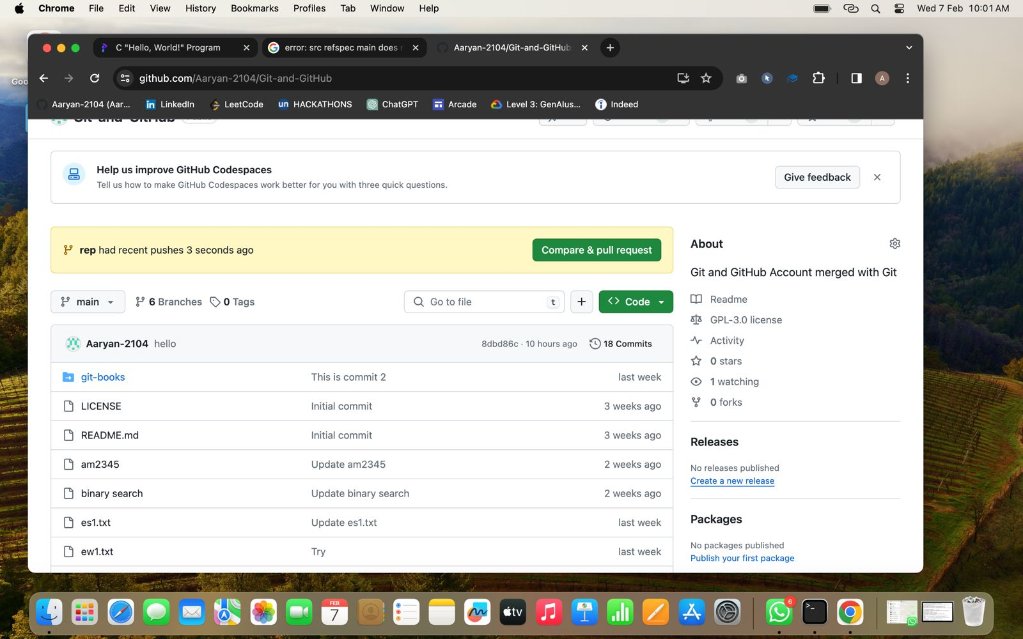

*Check for Request onto the account*

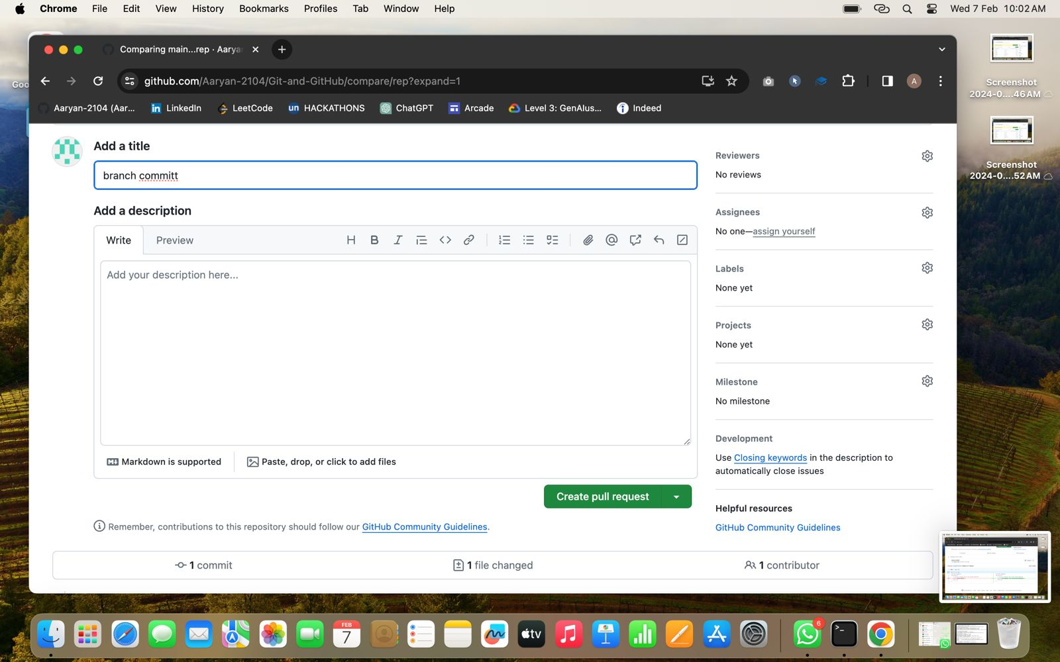

*Name the commit*

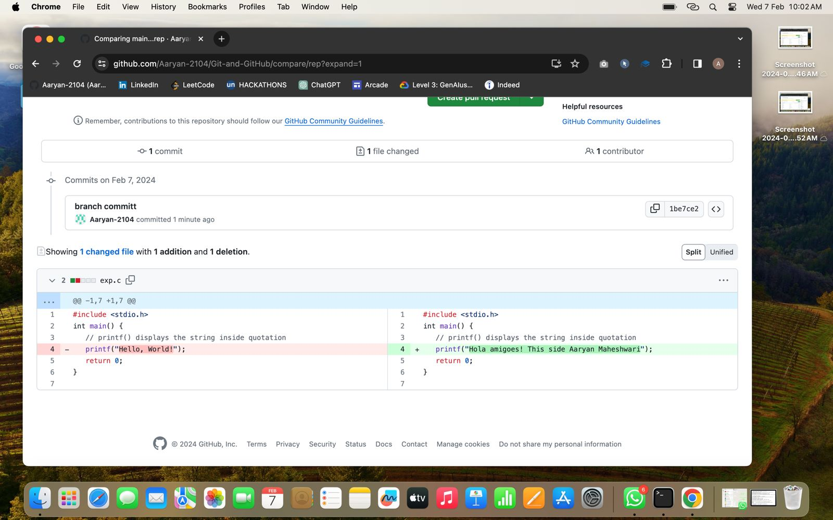

*Review the changes*

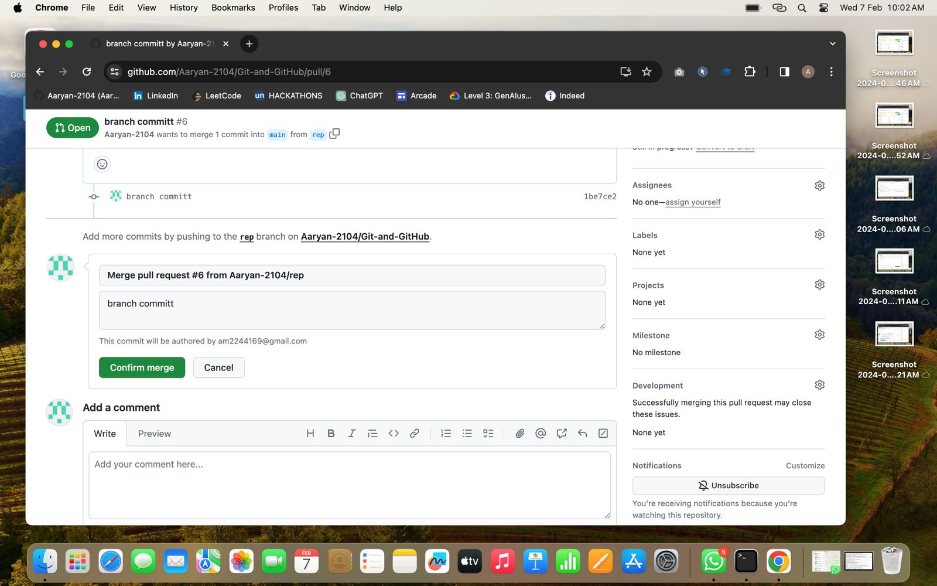

*Confirm the Merge Request*

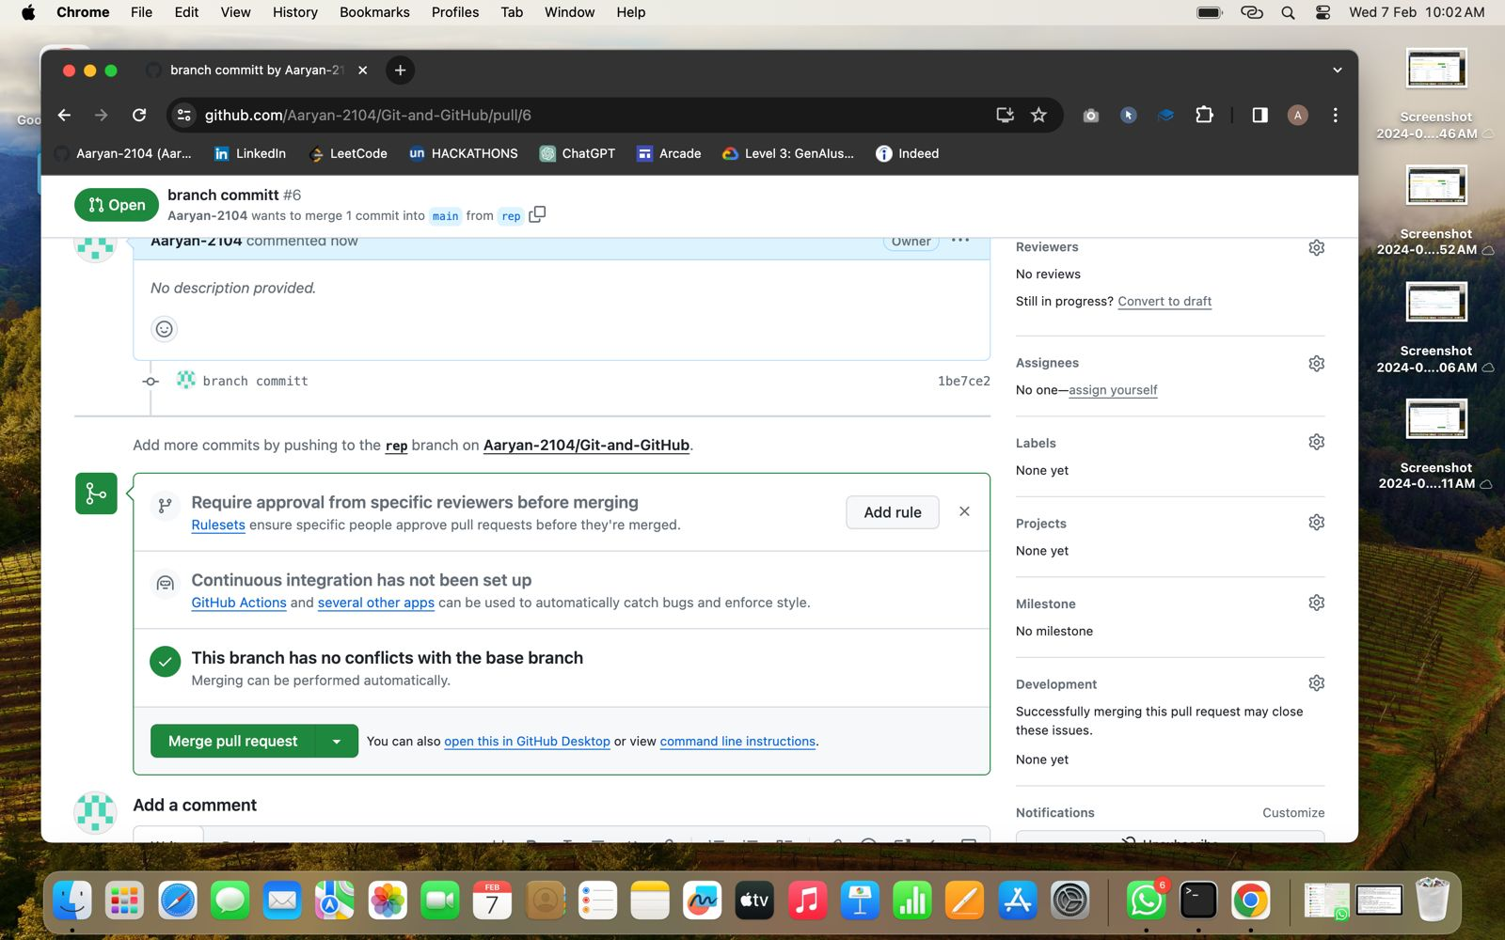

*Verify the request*

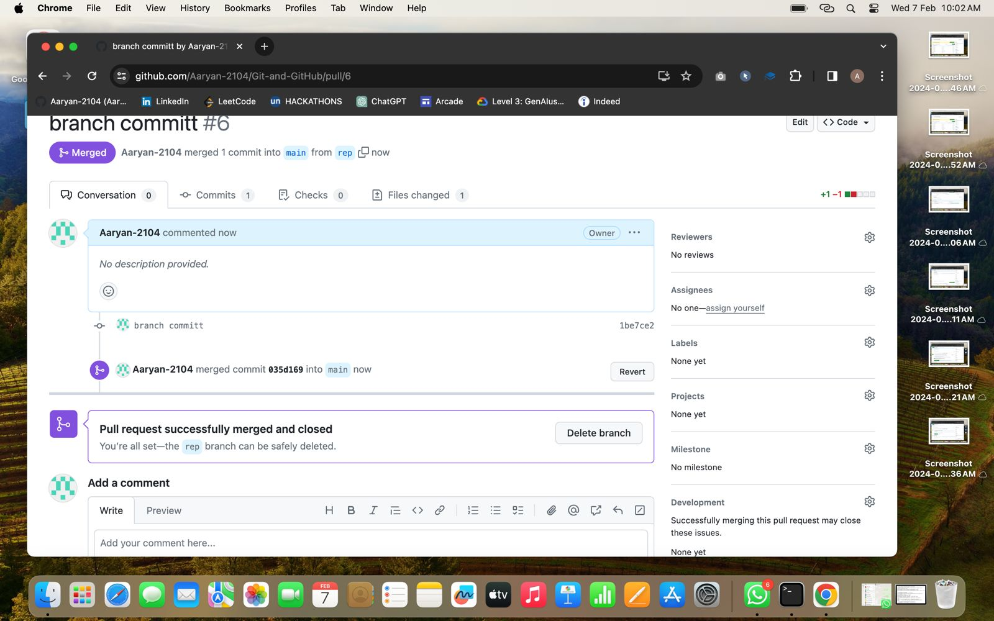

*Successfully created*

1. **Result/Output/Writing Summary:-** In this experiment, we edited a file in the local repository and showed the changes on the remote repository and vice versa. For this purpose, we have made use of both Git and GitHub.

# Learning outcomes (What I have learnt):

1. Learnt how to create a branch.
2. Learnt how to push the changes to the remote repository.
3. Learnt how to pull the changes from the remote repository.
4. Learnt to merge two branches.
5. Learnt how to resolve merge conflicts.

**Evaluation Grid (To be created as per the SOP and Assessment guidelines by the faculty):**

|  |  |  |  |
| --- | --- | --- | --- |
| Sr. No. | Parameters | Marks Obtained | Maximum Marks |
| 1. |  |  |  |
| 2. |  |  |  |
| 3. |  |  |  |
|  |  |  |  |