**Template for Sensors interfacing with Arduino**

1. Infrared (IR) Sensor
2. Passive Infrared (PIR) Sensor
3. Ultrasonic Sensor
4. Temperature and Humidity (DHT11) Sensor

**Evaluation Criteria:**

1. Connection diagram.

2. Code for Arduino for each sensor.

3. Successful execution of all four sensor activities.

**Performance-15 Marks**

**Submission-10 Marks**

**Team**

|  |  |  |  |
| --- | --- | --- | --- |
| **Sr No** | **Roll No** | **Name** | **Work Done** |
| 1 | 16010123011 | Aaryan Dubey | Coding and Connection |
| 2 | 16010123012 | Aaryan Sharma | Coding and Connection |
| 3 | 16010123013 | Aayush Hardas | Coding and Connection |
| 4 | 16010123014 | Aayush Sawant | Coding and Connection |
| 5 | 16010123015 | Abdullah Qureshi | Coding and Connection |

**Fill your details as per following points**

* **Photos of Actual implementation**

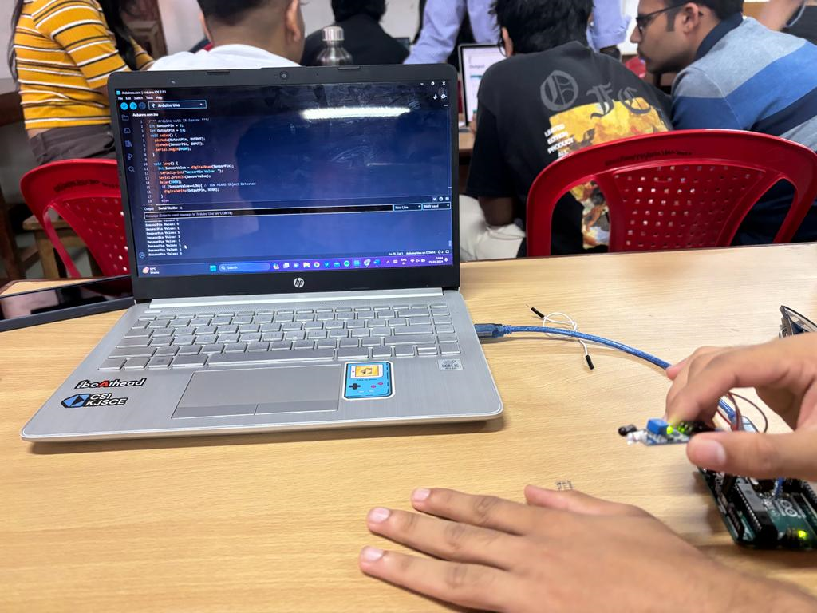

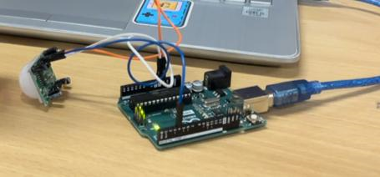

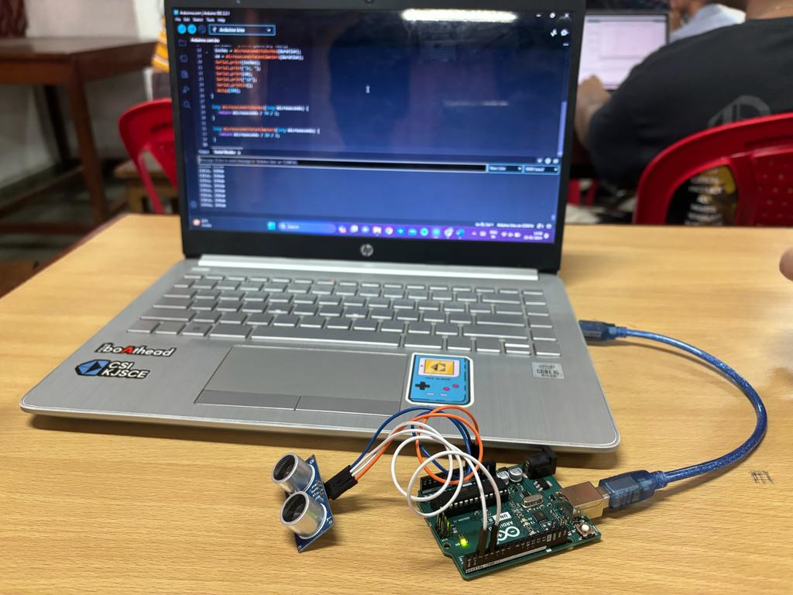

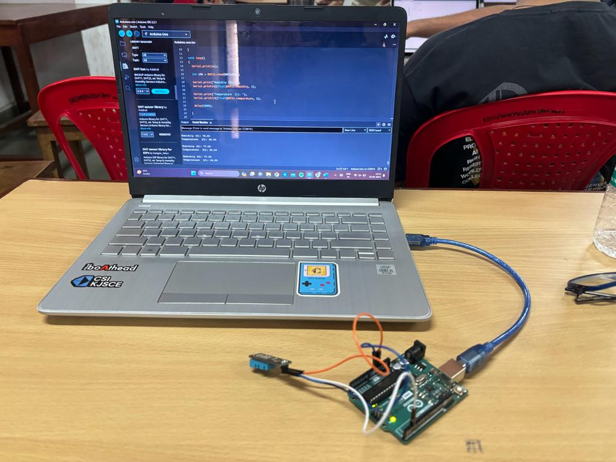

* **Video of Actual implementation**

[**https://drive.google.com/drive/folders/1e3VmT2wYiRHO3HBCjcNAdBn5KCvEH0jb?usp=sharing**](https://drive.google.com/drive/folders/1e3VmT2wYiRHO3HBCjcNAdBn5KCvEH0jb?usp=sharing)

* **Conclusions**

We learnt the working of different types of sensors and the code behind them .