- Step to Start Eagle Software
File > New > Schematic
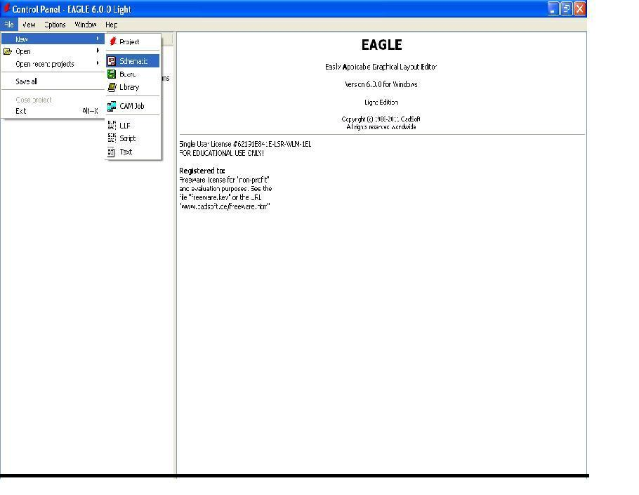

- Schematic View

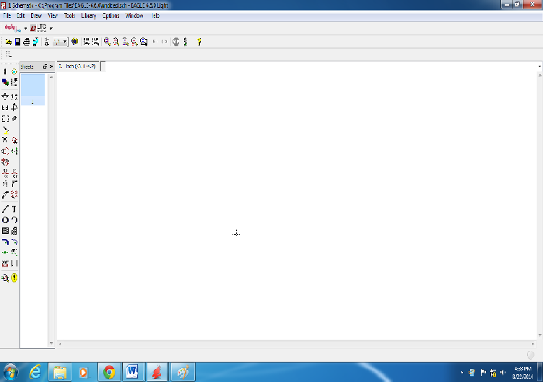

- Step to Add Component
Click Add icon
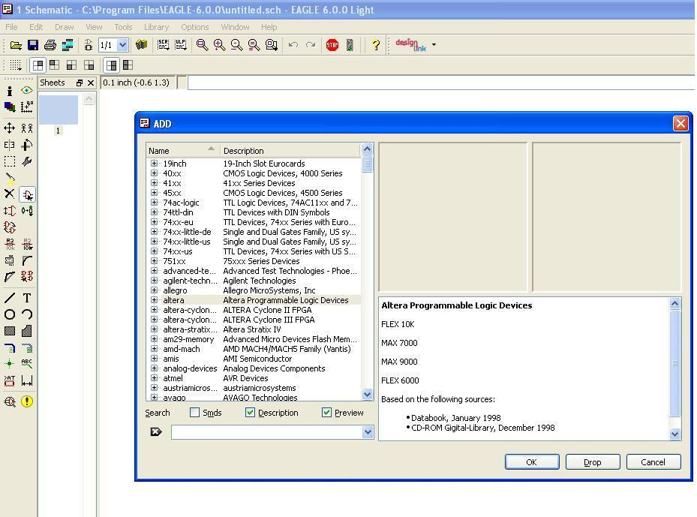

- Step to Search Specific Component from list
Type diode or Resistor or Capacitor etc in Search box

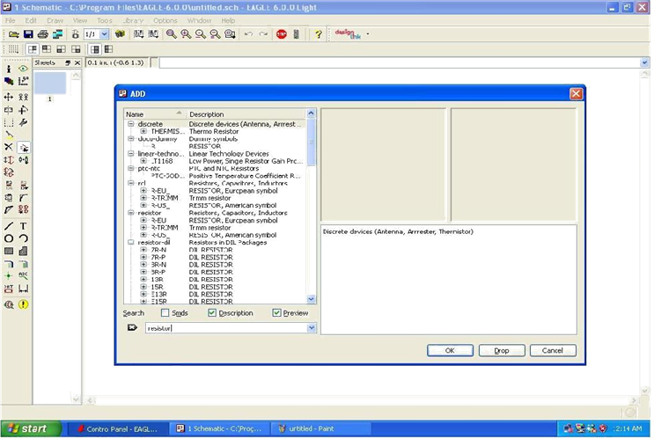

- Search diode we will get list of different diodes.

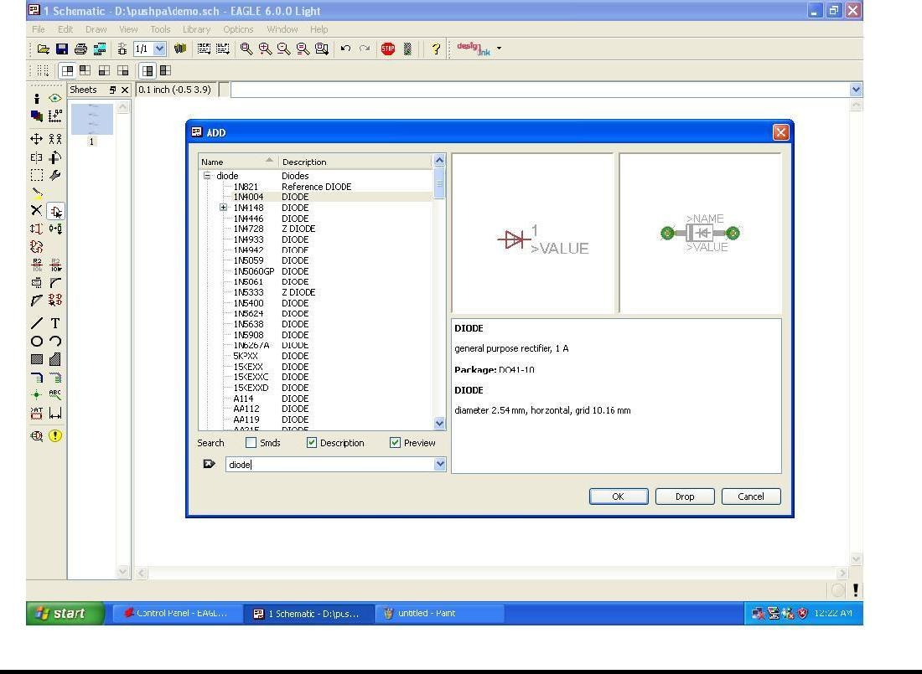

- Add diode of Particular type by pressing Ok show in above diagram.

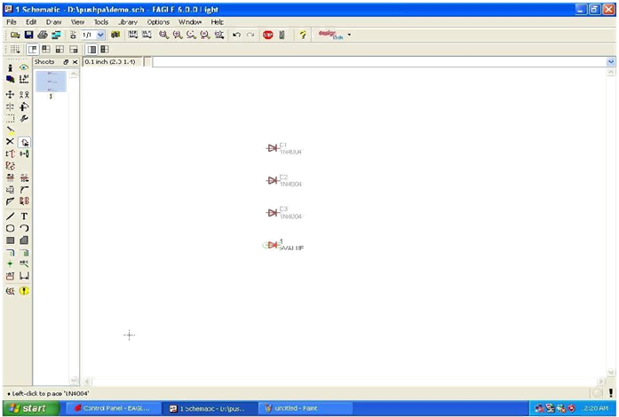

- After addition of Component Make Connection Between them by clicking toolbar
icon

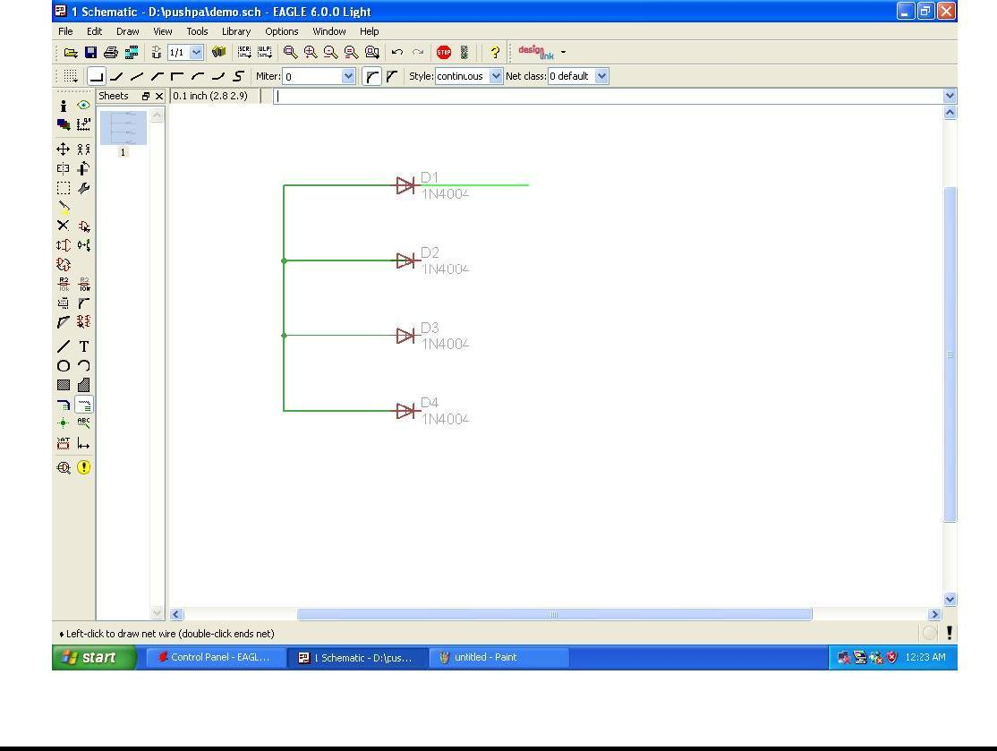

- Schematic view after connection completed.

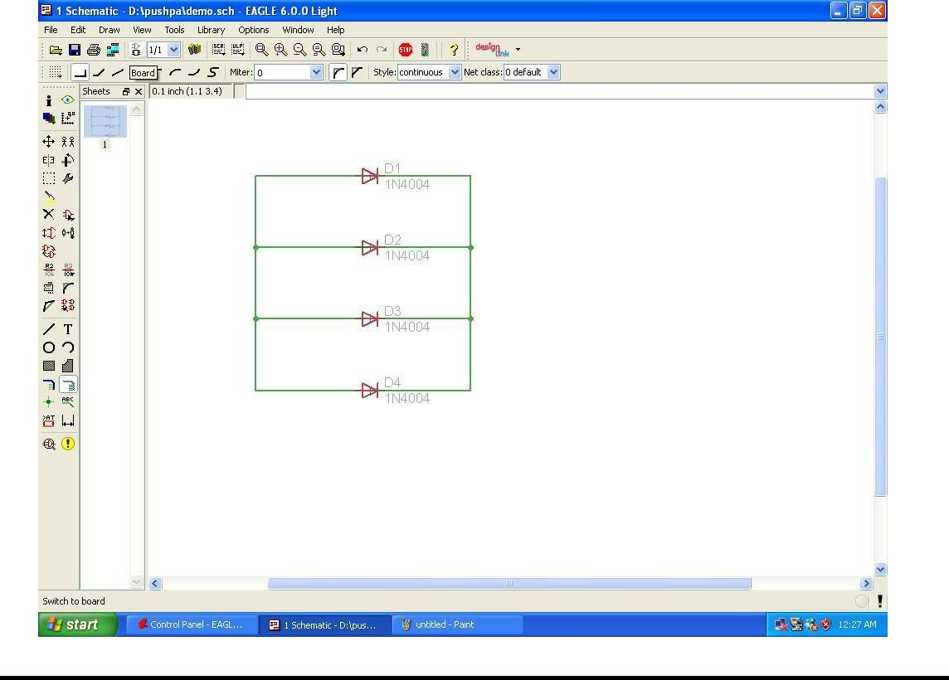

- Step to convert schematic into Layout click
File Switch to Board

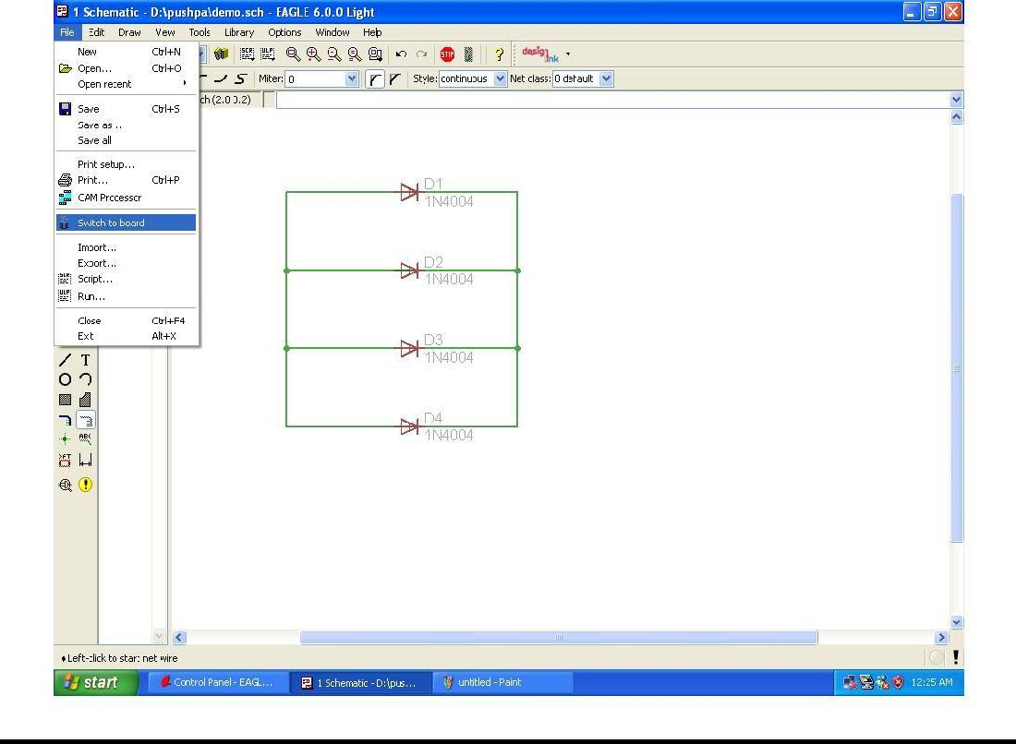

- Layout window now move diode inside square area using Move icon

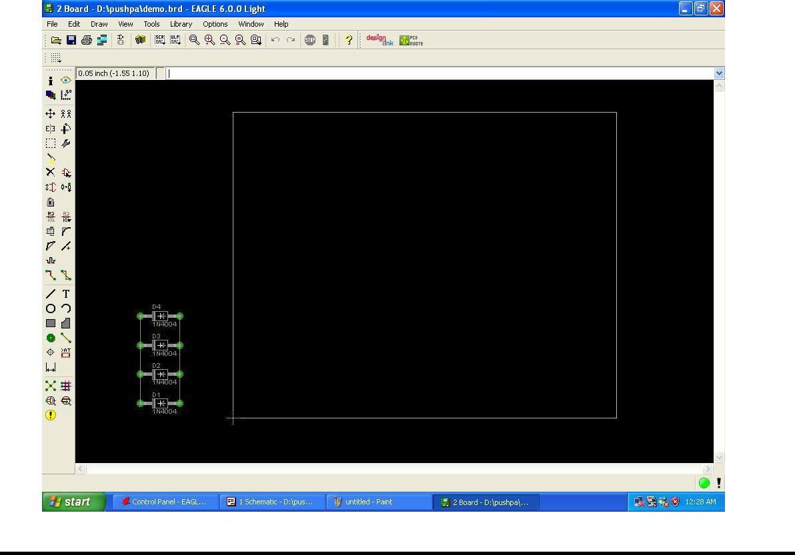

- Component moving Window

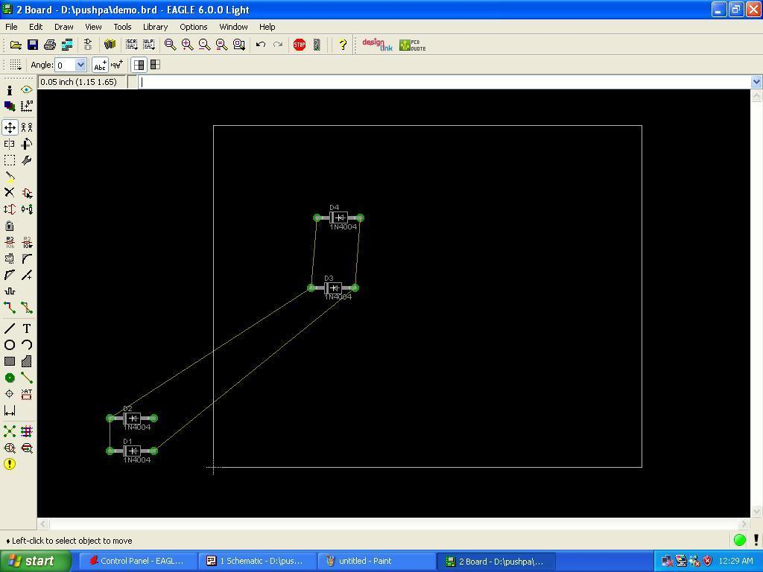

- After Movement of Component completed Layout view.

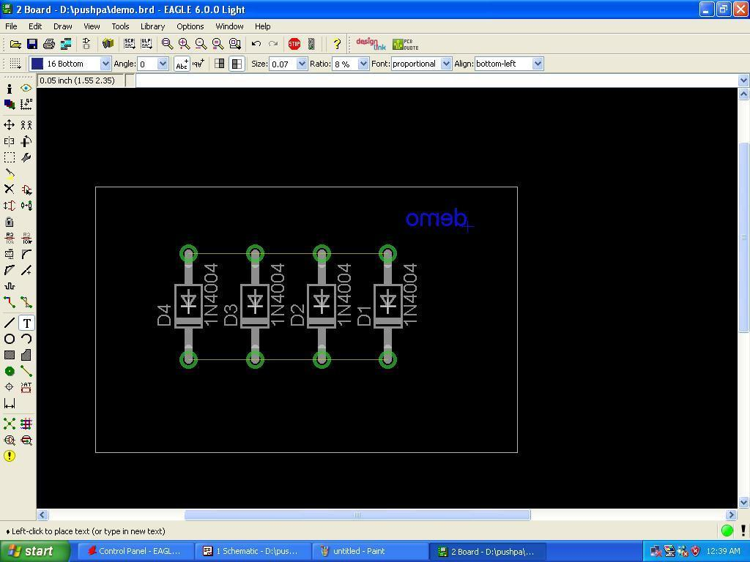

- Choose Layer to be display using icon Layer

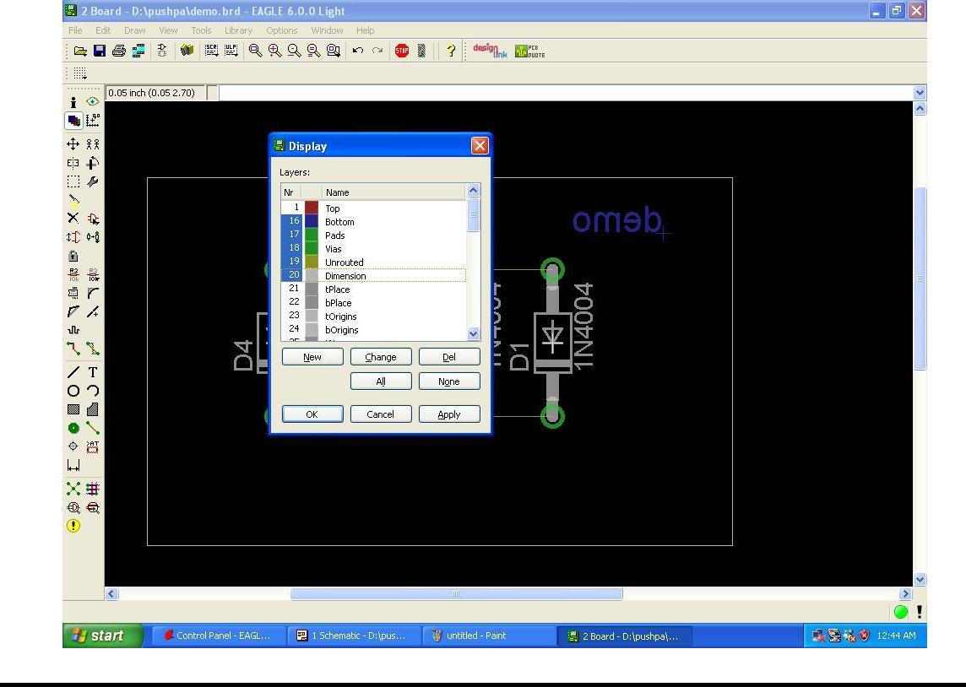

- Step to make Route Connection click Route icon
Set Width 0.05 for best track thickness.
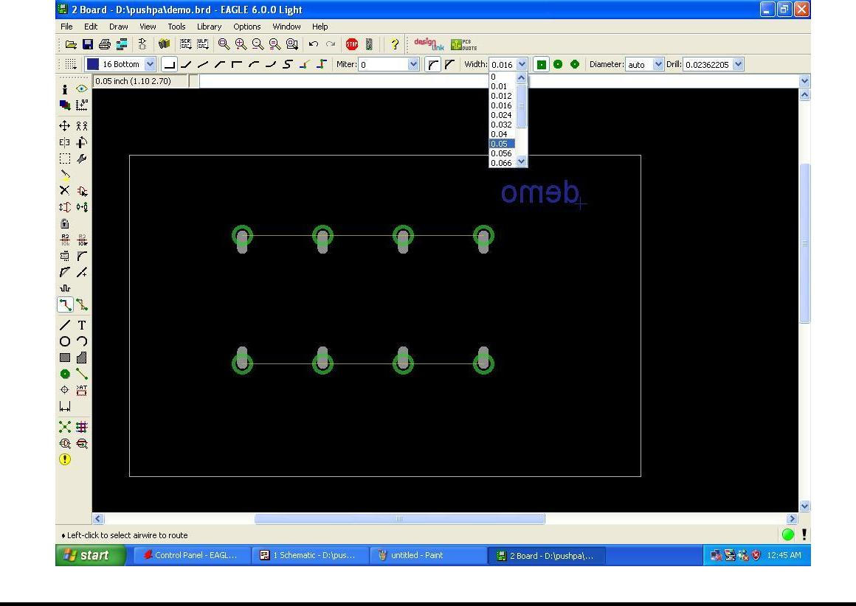

- Making Route Connection Window display.

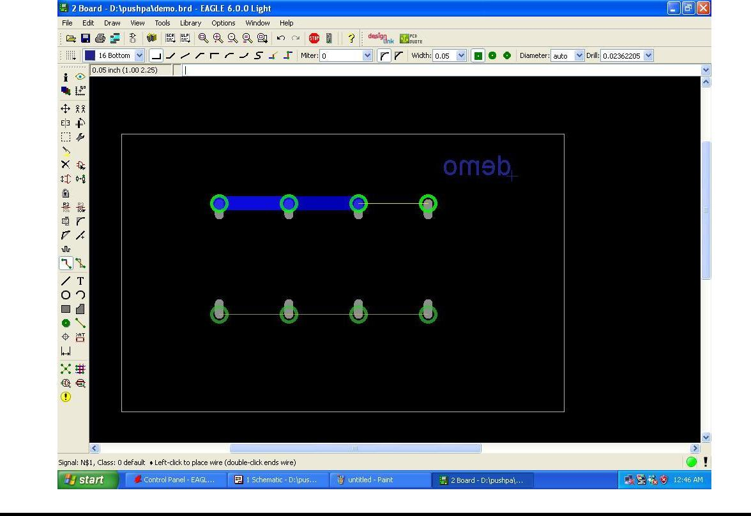

- After Completed Route Connection window display.
To take Print Go to File Export image
Set Monochrome view, Resolution 750 and Area Window
