PostgreSQL Disaster Recovery Using pgBackRest:
WAL Archiving, Point-in-Time Recovery and Backup Evaluation
DevOps Theory — Internal Assessment Case Study
StagePass — Event Registration & Operations • Date: 2026-10-13
Group member 1 (Name / Roll)
Group member 2 (Name / Roll)
Group member 3 (Name / Roll)
Faculty / Evaluator
Placeholder rows above are filled by the team; no student details are invented in this report.

Contents: use Word → References → Update Table after opening (headings below are numbered for navigation).

2. Abstract / Executive Summary
StagePass, a fictional event-registration platform, loses all KJSCE Garba Eve bookings to an accidental DELETE. A consistent rsync snapshot-only baseline recovers to snapshot time (100/120 bookings; 20 legitimate post-snapshot registrations lost, reproduced twice). pgBackRest with archived WAL and a verified named restore point recovers to 120/120 bookings with all 20 post-backup registrations present (reproduced twice). Differential/incremental backups cost ~2.5–3.0 s and ~0.6–0.7 MB vs a 10.6 s / 4.5 MB full backup on a 20k-row bench dataset. RTO differs by seconds; recoverability differs by 20 transactions.

3. Introduction
PostgreSQL is a common DevOps backing service; operator error (bad DELETE) is a leading incident class. This case study makes recovery observable through a real app, repeatable HTTP workload, incident, recovery and measurement—not merely a successful backup command.

4. Problem Statement
After legitimate registrations arrive, an accidental DELETE removes every KJSCE Garba Eve booking (Garba count 0, dashboard visibly wrong). Requirements: restore service, lose as few legitimate transactions as possible, quantify time/storage costs.

5. Research Question and Objectives
Research question: How does pgBackRest with archived WAL improve PostgreSQL recoverability after accidental data loss compared with a consistent file-system snapshot alone, and what are the time and storage trade-offs of its backup strategies?
Objectives: (1) build the StagePass demo; (2) compare snapshot-only vs PITR on identical data/workload; (3) measure full/diff/incr + dump trade-offs; (4) interpret RTO/RPO honestly.

6. Scope and Assumptions
Local Docker lab on one laptop; disposable synthetic data (`@example.test`); headline metric = booking rows; repo on the same host (convenience, not off-site DR); single-trial bench medians pending a bigger host.
- In scope: rsync baseline, pgBackRest PITR, modes, dump comparison, retention demo.
- Out of scope: Kubernetes, multi-node HA, encryption-at-rest tuning, production sizing.

7. DevOps Relevance
Reliability (MTTR/RTO), recovery as code (Compose + scripts), observability (dashboard reflects true DB state), change safety (guards, no destructive endpoints), reproducibility (seeded data, run IDs, raw logs).

8. Literature / Tool Review
pgBackRest User Guide and Command Reference (Debian/PG17 track); PostgreSQL Backup & Restore, WAL configuration, pg_dump/pg_restore/pg_basebackup docs (accessed 2026-10-12; see SOURCES.md for claim mapping). Blogs were not used for technical claims.

9. Logical versus Physical Backups
pg_dump emits logical SQL/custom archives: portable, selective, but no WAL replay by itself. pgBackRest physical backups copy cluster files + WAL: enable PITR. Measured: dump 0.3 s/0.5 MB vs full physical 10.6 s/4.5 MB on the same data.

10. PostgreSQL WAL and Crash Recovery
WAL records every change; `wal_level=replica`, checkpoints and `archive_command` ship segments to the repo; replay from a backup + WAL restores consistency and enables time/name-targeted recovery.

11. pgBackRest Architecture
Stanza `stagepass` binds PG path + repo; repo holds backups + WAL archive; `archive-push/get` integrate with PostgreSQL; `restore` rebuilds PGDATA and writes recovery config. Here pgBackRest runs in the DB container (simplest reliable); control/restore split across db/backup-tools containers is documented in §16.

12. Full, Differential and Incremental Semantics
Full: everything. Differential: since last full. Incremental: since last backup of any kind (needs full + chain). Measured artifact sizes diverge from row-change ratios because PostgreSQL writes pages and pgBackRest compresses (§21).

13. PITR Theory and Named Recovery Targets
Recovery replays WAL to a target (time/LSN/XID/name) then promotes. Named targets (`pg_create_restore_point` + `--type=name`) are self-documenting and were used here; the target must postdate required WAL archival—verified, not assumed (§18).

14. System Architecture Diagram
Compose: app (FastAPI/Jinja2, :8000) → db (PG17 + pgBackRest, :5433) ↔ backup-tools (rsync/pgBackRest, shares pgdata/repo/snapshots). Volumes isolate PGDATA, repo, snapshots, results. Diagram: 16:9 deck slide 5; live screenshot evidence below.

15. StagePass Application Design and Database Schema
Events/attendees/bookings with FKs, CHECKs and indexes (sql/schema.sql). Seed: 100 bookings (20/50/30), ids bk_seed_001..100, Garba date field 2026-10-12 shown as 12 OCT. API: GET /api/health|/events|/events/{slug}/registrations|/dashboard/summary|/registrations/recent, POST /api/events/{slug}/register (transactional, validated). UI: maroon/plum/saffron/cream, local CSS/SVG only.
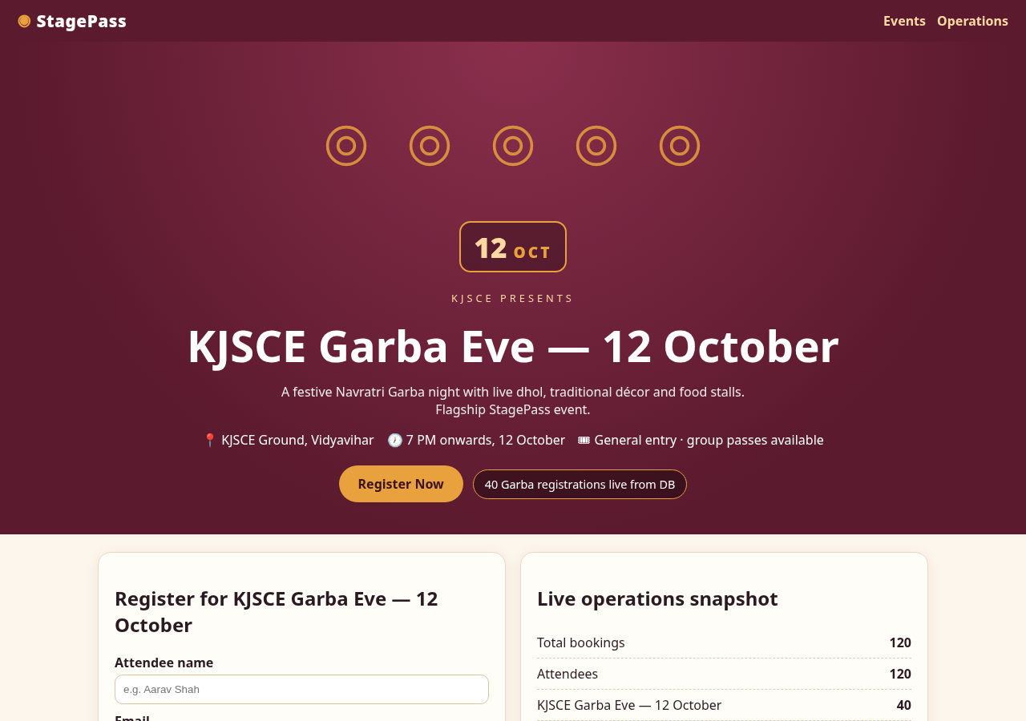
Figure 1 — StagePass home (genuine screenshot).
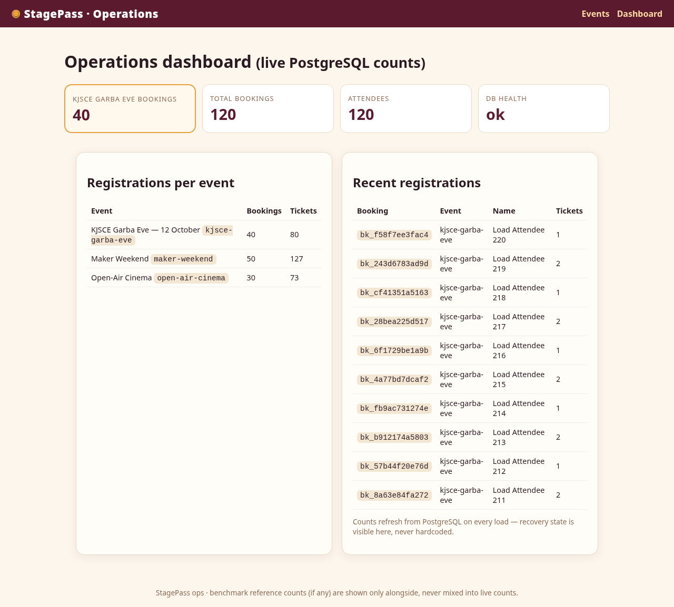
Figure 2 — Operations dashboard (genuine screenshot).

16. Implementation Environment and Versions
Host: {'os': 'NAME="Arch Linux"', 'platform': 'Linux-7.2.6-arch2-1-x86_64-with-glibc2.44', 'cpus': 8}. PostgreSQL 17.11 (Debian 17.11-1.pgdg12+2) on x86_64-pc-linux-gnu, compiled by gcc (Debian 12.2.0-14+deb12u1) 12.2.0, 64-bit. pgBackRest 2.59.3. Docker version 29.8.1, build 4a63305d74, Docker Compose version 5.5.1. Full metadata: results/experiment_metadata.json. Custom Debian-based PG image installs matched pgBackRest+rsync; config under version control, no secrets.

17. Configuration and Commands
archive_mode=on, archive_command=`pgbackrest --stanza=stagepass archive-push %p`, wal_level=replica, max_wal_senders=5, archive_timeout=60.
Key commands: `stanza-create`, `check`, `--type=full backup`, `info`, `restore --type=name --target=<point> --target-action=promote`, `expire --repo1-retention-full=1`. `check` proves config health, not target availability; restore requires a cleaned PGDATA (documented) or --delta.

18. Controlled Experimental Methodology
Same seed + same 20-HTTP workload in A and B; guarded scripts; invariants asserted (100/20 → 120/40 → incident 0 Garba → recovered); B4 blocks PITR until the restore-point WAL segment is proven archived (one aborted run2 attempt evidences the guard); each scenario reproduced twice with separate run IDs and batches.

19. rsync Snapshot-Only Baseline
Consistent (stopped-cluster) `rsync -aHAX --delete` mirror + external manifest. Restores to snapshot time; by design replays no WAL. Result (×2): 100 total / 20 Garba; 0/20 post-snapshot registrations recovered.

20. pgBackRest PITR Experiment
Full backup → 20 regs → named restore point (LSN recorded) → verified WAL archival → incident → named restore + promote → log-confirmed target → 120/40 with 20/20 batch IDs, 0 orphans (×2). The DELETE is absent because the target precedes it; later transactions would be discarded by target choice—a documented property, not a defect.

21. Backup-Mode and Dump Benchmarks
Bench 20k rows: full 10.6 s/4.5 MB; diff 2.5 s/697.7 KB; incr 3.0 s/635.8 KB (compressed repo bytes; DB 33.5 MB reported separately). pg_dump -Fc 0.3 s/0.5 MB, restore 1.4 s, selective yes, WAL replay no. Single trials; 3-trial medians PENDING a larger host.

22. Results Tables and Charts (real data)
Source: results/experiment_runs.csv, backup_benchmarks.csv. Charts generated by scripts/compare.py from those files.
run | baseline | pre | recovered | new regs | backup | restore
rsync-run1 | 100 | 120 | 100 | 0 | 1.1 | 15.0
pgbackrest-run1 | 100 | 120 | 120 | 20 | 13.3 | 17.6
rsync-run2 | 100 | 120 | 100 | 0 | 0.5 | 10.6
pgbackrest-run2 | 100 | 120 | 120 | 20 | 7.2 | 20.6

trial | type | rows | duration_s | label
1 | full | 20000 | 10.6 | 20261012-210822F
1 | differential | 20000 | 2.5 | 20261012-210822F_20261012-210833D
1 | incremental | 20000 | 3.0 | 20261012-210822F_20261012-210836I

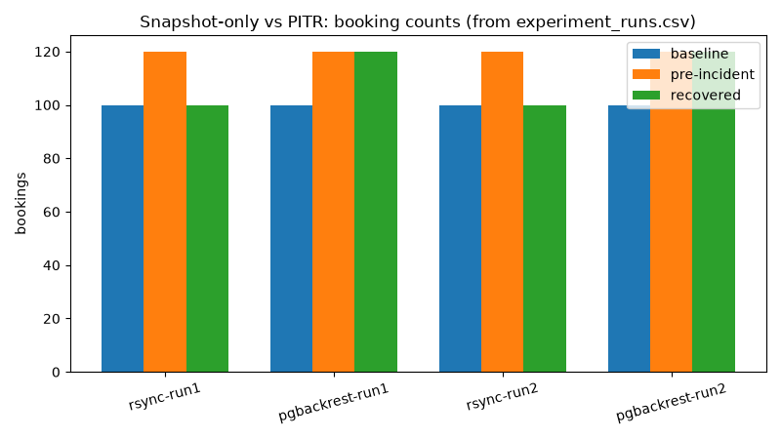
Figure 3 — booking counts per run (generated).
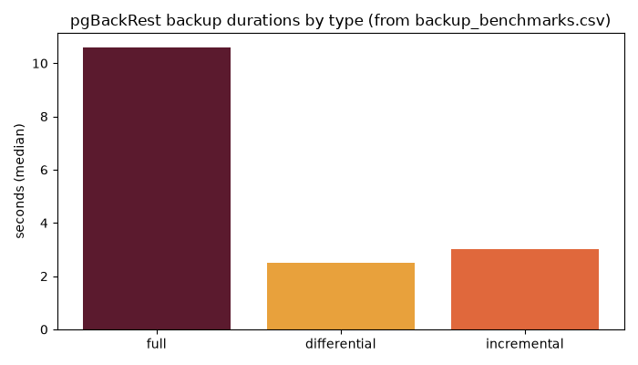
Figure 4 — backup durations (generated).

23. Comparison Matrix
Snapshot-only: RTO ~11–15 s, RPO = snapshot time (20 txns lost), storage = full PGDATA copy. PITR: RTO ~18–21 s, RPO = named target (0 lost in lab), storage = full + WAL. Dump: fastest/smallest, no PITR.

24. Discussion and Evaluation
The recoverability gap (20 transactions) dwarfs the time gap (seconds) on this scale. WAL archiving is the difference between 'state at backup time' and 'state at chosen target'. Diff/incr trade full-chain dependence for speed/size.

25. RTO and RPO Interpretation
RTO measured to verified usable service (not process exit). RPO is the achieved target; production RPO depends on archive lag and monitoring. No zero-RPO claim: success at one target does not guarantee all targets.

26. Threats to Validity and Limitations
Laptop-local repo (no disk-failure protection); single bench trial; lab-scale data; timeline/repo resets between runs; target selection discards later data; results require retained backups+WAL.
- Laptop-local repo does not protect against host disk failure.
- Lab ≠ production performance study.
- Single-trial bench needs 3-trial medians.
- PITR target choice discards later transactions.

27. Security Considerations
Synthetic `@example.test` data; no destructive app endpoints; no Docker socket in app; secrets via env, not VCS; lab DB credentials are non-production; restore commands guarded to the disposable lab volume.

28. Conclusion (answering the RQ)
pgBackRest + archived WAL improves recoverability from 'whatever existed at snapshot time' to 'the chosen pre-incident target', preserving all 20 legitimate post-backup registrations that snapshot-only loses, at a cost of seconds of RTO and full+WAL storage; differential/incremental backups cut routine backup time/size to a fraction of full.

29. Future Improvements
Off-host S3-compatible repo; 3-trial bench on larger host; standby/restore drills; alerting on archive lag; retention policies per RPO; encrypted repos; destructive-guard CI.
- S3-compatible off-host repository.
- Scheduled drill restores with RTO budgets.
- Archive-lag alerting.

30. References
[1] pgBackRest User Guide. https://pgbackrest.org/user-guide.html
[2] pgBackRest Command Reference. https://pgbackrest.org/command.html
[3] pgBackRest releases. https://pgbackrest.org/news.html
[4] PostgreSQL Backup and Restore. https://www.postgresql.org/docs/current/backup.html
[5] PostgreSQL WAL configuration. https://www.postgresql.org/docs/current/runtime-config-wal.html
[6] pg_dump. https://www.postgresql.org/docs/current/app-pgdump.html
[7] pg_restore. https://www.postgresql.org/docs/current/app-pgrestore.html
[8] pg_basebackup. https://www.postgresql.org/docs/current/app-pgbasebackup.html
(All accessed 2026-10-12; claim mapping in docs/SOURCES.md.)

31. Appendix
A. Reproduction: make up && make seed && make test && make demo-rsync && make demo-pgbackrest && make benchmark && make compare. B. Config: docker/pgbackrest.conf, docker-compose.yml. C. SQL: sql/*. D. Tests: 8 pytest tests green. E. Raw: results/*.csv, results/logs/, results/experiment_metadata.json. F. Deviations fixed during work: seed-CTE visibility, dashboard GROUP BY, exec-into-stopped-container, PGDATA clean step, timeline-aware WAL check, benchmark %% typo (see docs/RESULTS.md).

