**Transcription: Rupa**

**Proof Name:**

**Strength of Materials**

**Prof S. K. Bhattacharya**

**IIT Kharagapur**

**Department of Civil Engineering**

**Session 7: Analysis of strain - I**

Welcome to the first lesson of the second module which is on analysis of strain. In the first module we discussed about stresses and we have seen various aspects of stresses. Now we are going to discuss certain aspects of strain.

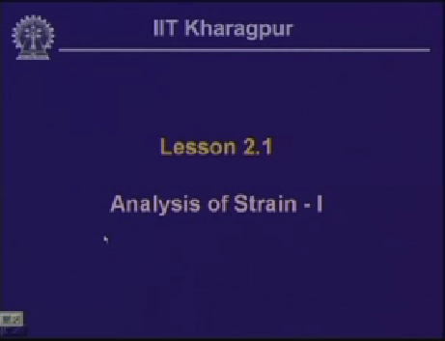

Slide 1-1:07

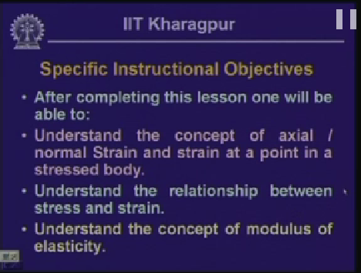

Slide 2-1:11

after completion of this particular lesson one will be able to understand the concept of axial strain, the concept of normal strain and strain at a point in a stressed body.

One will be able to understand the relation between stress and strain, which is very important when we talk about the strength of material, is not only the stresses but the relation between the stress and the strain is important. One will be able to understand the concept modulus of elasticity which we need for the analysis as we go along.

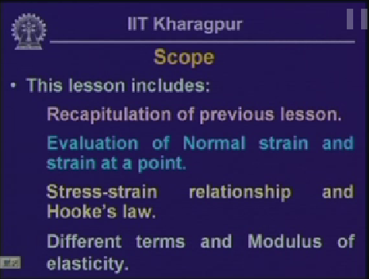

Slide 3-1:55

We will evaluate normal strain and strain at a point. We look into the relationship between stress and strain and thereby the Hooke’s law which are defined for the elastic body and then the different terms which we get in the stress and strain relationship and the modulus of elasticity.

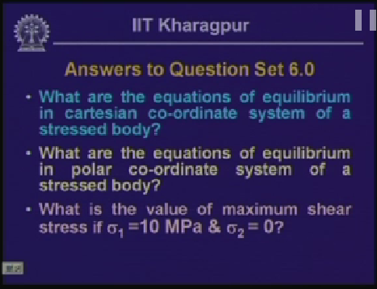

Slide 4-2:49

before we start looking into the aspect of the strain let us look into the questions. The first question is what are the equations of Cartesian co-ordinate system in a stressed body?

(Refer slide time: 5:58)

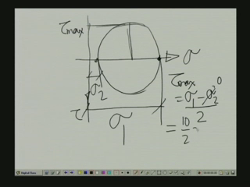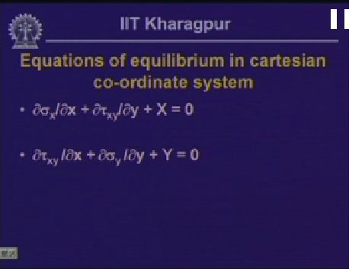

Slide 5-3:10

The equations of equilibrium in Cartesian co-ordinate system are dell  dell x + dell  dell y + X = 0 and dell  dell x + dell  dell y + Y = 0 where x and y are the body force components.

Now as you know  and  are the normal stresses to the x and y direction and  is the shearing stress component. So these two define the equations of the equilibrium in two dimensional system.

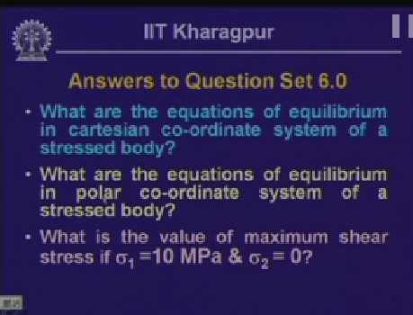

Slide 4-4;11

The second question posed was, what are the equations of equilibrium in a polar coordinate system of a stressed body?

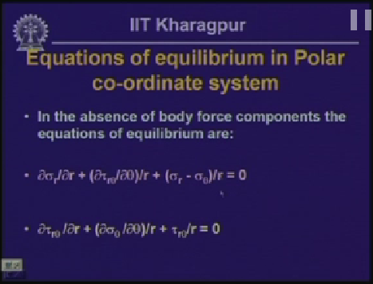

Slide 6-4:23

the equations of equilibrium in polar co-ordinate system, this particular aspect was discussed in the sixth lesson of the module one, wherein we defined stress components, the radial stress, sigma r, the circumferential stress sigma theta and we have seen how to derive this equations of equilibrium.

The radial directional stress is sigma r, the circumferential stress sigma theta and consequently we are sharing stress component which are. And in a polar coordinate form these are the equations of equilibrium dell sigma r dell r + 1/r dell tow theta by dell theta + sigma r – sigma theta/r = 0. Dell  dell r + dell sigma theta dell theta/r + by r = 0. These are the two equations which defines the equations of equilibrium in polar co-ordinate system for two dimensional stress analysis.

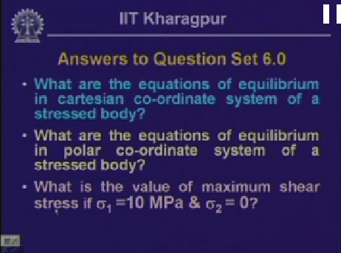

Slide 4-5;40

The third question was, what is the value of maximum shear stress if  is equal to 10 MPa and  =0?

Let us look in to, if you remember the Mohr us circle of stress in which we had sigma axis and the tow axis. Now in the Mohr us circle, the point on the maximum stress is , and the minimum stress is . Now radius of this circle is defined as the maximum value of the shearing stress, which is tow max. And tow max is given by  – /2. In the given problem,  is 0, and  is 10. So there by maximum shearing stress is 10 by 2 is 5 MPa.

These are the three questions which were posed and the answers for these were defined. Let us look forward into strain analysis.

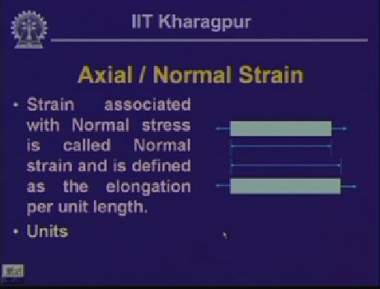

Slide 8-7:21

Now we are going to look in to axial normal strain. Now let us assume we have a body which is acted on by force P, length of the body let us assume as L.

When a body is subjected to either change in the temperature or subjected to the forces, it undergoes deformations, and in strength of material we are interested to look in to this deformation and we try to define a quantity in terms of this deformation.

Let us assume after deformation, the length is L + delta. Thereby delta is the deformation or the extension of the body. Now we will define a quantity, which is the ratio of this deformation to the original in the length and is generally designated as epsilon.

Epsilon as equals to delta by L and this is known as strain. The load, the force which is acting on the body is in the axial direction and we assume that the deformation is uniform along the length of the body.

And there by everywhere the strain is same. Also as we looked in to earlier, when the body is subjected to axial force, we get a stress which we call as normal stress which is the stress normal to the cross section of the body.

In line with that, we define that the strain or the deformation which is along the axis has the axial strain, since to compare with the normal stress we call this strain as normal strain.

So the strain associated with the normal stress is called normal strain and we define this as elongation per unit length. Now as this is the ratio of two lengths, basically this is a dimensionless number quantity and thereby there are no units as such.

However, it is customary to define strain in terms of the ratio of the lengths, say meter by meter or millimeter by millimeter for a body. Accordingly some times we say the units of strain as millimeter by millimeter. And this strain is defined in terms of a number and sometimes we define this in terms of percentage as well.

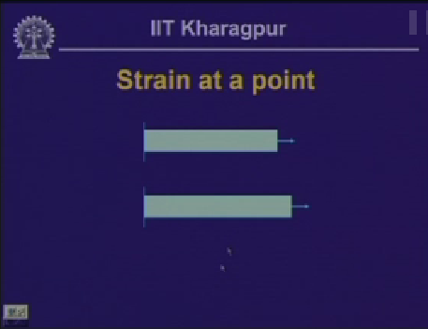

Slide 9-10:42

Now the strain when we are calculating for the deformation delta, we are assuming that this uniform deformation in the entire length of the bar.

If the deformation is not uniform, if we compute the strain from delta by L, then we are assuming the strain on an average sense over the entire body.

Now if the deformation is not same everywhere and if the deformation varies along the length of a bar then the way we have computed stress at a point in a stress body, we compute strain also in a stress body.

Now let us look into this particular figure where a bar which is fixed at one end is subjected to a pull P. Now let us assume that we are interested find out the strain at a point, within this body where this is A which is at a distance of x from the fixed end.

To evaluate strain at a point in a stress body, what we do is consider an imaginary fiber, let us say A B, which is of length dx or delta x.

This bar when it is subjected to pull P the fiber also is stretched or deformed and let us assume this is the stretched fiber which was originally delta x, let us say this as A’ B’ and the length of this stretched fiber is delta x + dell delta.

Thereby the extension of this fiber is dell delta.

And as we have defined, the strain epsilon for this particular fiber is dell delta/dell x. And this strain at this particular point A you can define as; strain = delta x tends to 0, this is dell delta/dell x. This we can write as d delta/dx.

Hence d delta = epsilon dx. So what is the length L if this is the length of the member which is defined as L, then over the entire length the deformation delta which is integral 0 to L d delta = integral 0 to L epsilon dx and this is the deformation if the strain varies along the length of the bar.

If we have uniform strain everywhere then this is equal to epsilon integral 0 to L dx which is L and epsilon we get as delta/L as we have seen earlier.

If the strain is constant everywhere then it is uniform and we get delta/L. If it is not then delta is integral 0 to L epsilon dx. That is how we compute the strain at a point.

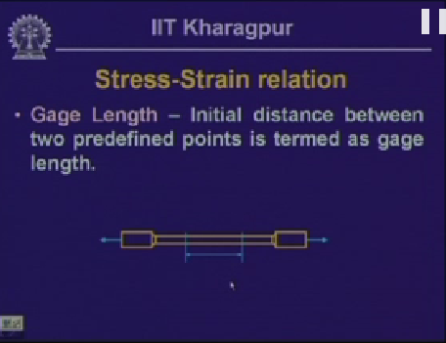

Slide 10-14:51

In strength of materials, we have seen how to calculate the stress at any point in a stressed body and we have seen various components of the stresses.

Now we have defined a quantity which we call as strain, strain at a point or strain on an average sense, if it is uniform over the length of the bar. Now what we need to do which is of relevance in Strength of Materials is that the relationship between stress and the strain.

Now for evaluating the relation between the stress and strain, take a body apply a tensile pull in the body, and we apply this load gradually over the bar, for each increment of the load, we try to find out how much deformation the body undergoes.

Here if we look, if this is a bar we a formed a section in different cross section form. This part is called as the grip, which is inserted in the tensile stress equipment and the whole bar is pulled. Now on this bar we fix up a length which is in between this bar, which is little away from this grip, so that the length on which we focus our attention is not affected by the variation of the load in the grip zone. And this length on which we focus our attention we call this as the gauge length. So this is the initial distance between the two predefined bars and this we call as gauge length.

And as I said this length we consider between the bar and little away from the grip zone so that this particular zone is not affected by the force distribution or the stress distribution in the grip zone.

Now if we apply a pull on this bar gradually, as we have seen the bar will under go deformation and there by there will be change in the gauge length and if we measure that increment or the deformation, then we can compute the strength.

And as we have seen earlier the stress for a body which is subjected to an axial pull, the normal stress is the axial pull divided by the cross sectional area. So for each increment of the load, we can compute the stress, we can compute the correspondingly the strain and then we can plot a graph to establish the relationship between the stress and the strain.

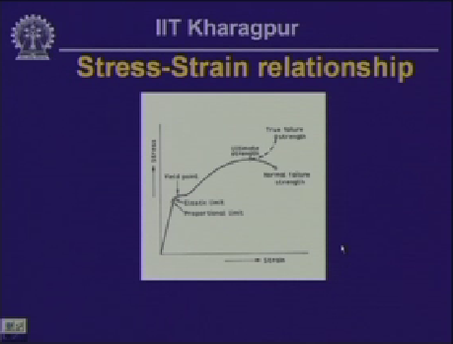

Slide 11-18:14

Now if look in to the plot between the stress and the strain, the plot is something like this. In this particular figure, this axis represents the strain and the y-axis represents the stress.

Now plot each increment of the load, we compute the deformation, there by we get the strain. And for several such points we plot it, on a steel bar this is the profile we get a different stage of loadings.

Now for this particular figure there are various terms indicated with it. One we have called as proportional limit, this we have called it elastic limit, this particular point we have called it a yield point, this is the ultimate strain or ultimate stress, this particular point, actually this is wrong. This is not normal, this should be nominal and this is the nominal failure strength. Now here if you note it that we compute the stresses here with reference to the original cross section of the bar which we have computed. If you can visualize, when we are pulling this bar or when we are applying a tensile pull, as it deforms the cross sectional area of the bar reduce, now the stress a we know is stress divided by the cross sectional area, the cross sectional area as we take the original cross sectional area, and accordingly we get the profile of this curve. If we take the actual area, load divided by the actual area then the stress value will be different from this. In fact from this particular point configuration is some thing like this. Now the stress when you compute reference to the original cross sectional area of the bar, we call those stresses as the nominal stresses and correspondingly the nominal strain.

Otherwise if we compute the stresses with reference to the change cross sectional area of the bar, we call that stress as true stress and the corresponding strain as true strain. So here what we have plotted is the nominal stress and the strain.

Now the meaning of this proportional limit is, up to the level of proportional limit, the stress is proportional to the strain. So we say the stress, sigma is proportional to the strain epsilon. Now this particular point elastic limit is the point, up to which if the load is applied on the body and if it is released the body comes back to its original state and that we call as the elastic limit of the body.

But beyond elastic limit, if we apply load and go beyond the elastic limit, and if we release the load the specimen will not come back to its original place and some amount of deformation is permanently set in the body and that we call as permanent state. And yield point is the point, when the body starts yielding. It goes beyond the elastic limit, the plasticity starts forming in the section.

And if we keep on applying the load at that particular point in fact increasing the load, the bar deforms and the extension, the deformation becomes excessive and reaches o the stress which we call as loading down on the load when the bar fails and that how we get failure stress which is less than the ultimate stress.

What is the maximum stress a bar can attain? Which we call as ultimate stress and this particular point is the failure stress. Now in the bar these two points proportional limit and the elastic limit is vary difficult to distinguish and we consider that up to this level, this up to the elastic limit, the stress is proportional to the strain. If we remove this proportionality constant, sigma is written as constant times E, which is constant for that material and this is what we know as Hooke’s law. Up to the proportionality limit or up to the elastic limit, the stress is proportional to the strain. Or stress equal to E times strain, where E is called as the constant of proportionality or the modulus of the elasticity, which is an important parameter in the Strength of Materials and this is constant for the material which we are considering during the evaluation of the stress and the strain known as Hooke’s law which is at the elastic limit, the stress is proportional to the strain or sigma = E times epsilon.

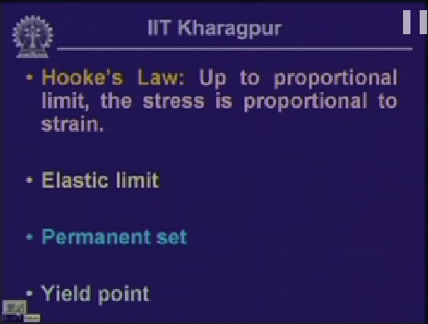

Slide 12-24:23

So we have seen the Hooke’s law which is up to the proportionality limit, the stress is proportional to the strain and there by we get sigma = E times epsilon. We have seen the elastic limit, if the bar is loaded and is allowed to extend and if the bar is within the elastic limit, if we release the load, the bar is expected to come back to its original state.

The permanent set is, as the member yields as it reaches to yield stress then plasticity forms in the section, then if we release the load, as we have seen in the case of elastic material when the bar is still within its elastic limit the bar comes back to its original position but once it starts yielding, then if we release the load, the bar does not comes back to its original position and some amount of deformation sets permanently in the body and that is what we call as permanent set. Yield point again is the point where the material starts yielding or it goes beyond the elastic limit and plasticity starts setting in the member.

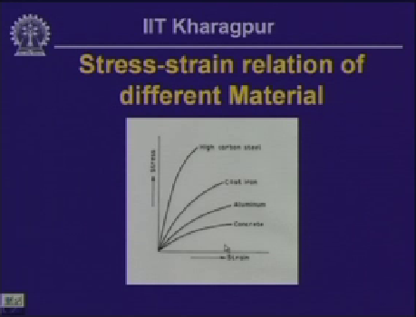

Slide 13-25:52

Well these are some of the stress strain relationship for different materials. If we take concrete specimen, apply tensile pull in tensile stress equipment, and then we get the profile similar to this, which is the stress strain relationship. If we take materials like aluminum, cast iron or high carbon steel we get these kind of profile and these are necessary to know the relationship between stress and strain by the modulus state of elasticity. So that we can compute the stress and can compute the strain and we can establish the relationship between stress and strain in a body when the material is used either for some equipment or the machine part or in structural body where we interested to find stress and strain, we need to know the relationship between stress and strain material that with which the machine part or the structure is composed of.

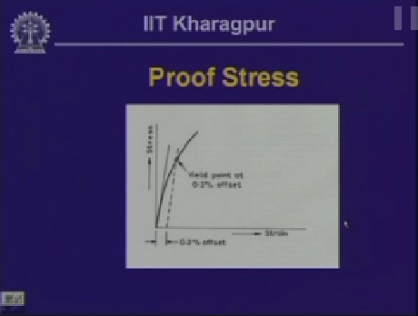

Slide 14-27:07

Now as we have seen in the previous figure, in the first figure, in this particular figure as you have seen that we have defined yield point.

In this particular zone, this particular curve shows that we have defined yield point. So corresponding to this stress we know that this is the yield stress we defined as  but as we have seen in the subsequent figure that we do not have any defined yield point and in strength of material when we deal within the elastic limit we need to know the what is the value of the yield stress beyond which the member will start yielding.

So we try to limit our stress when we deal with elastic level of analysis. We like to limit over self to the elastic level, so we need to know what is the value of the yield stress?

But from this kind of stress strain distribution, it is difficult to know the value of the yield stress. Now to compute the value of yield stress we do is to observe that the strain corresponding to the yield stress value is the order of point two percent, this is point 0, 0 two is the strain.

Now if we draw a tangent to the curve at this particular point, which we call it as initial tangent and if we draw a line at point two percent strain and if draw a line parallel to initial of the tangent, the point were it cuts the curve, the stress strain curve, the corresponding stress we call as yield stress and this yield stress is normally we designate as proof stress.

So for the material where we apply a tensile pull and plot a stress strain curve and corresponding to that stress strain curve if we do not get a defined yield point, corresponding to which we are interested to find yield stress then we compute the yield stress in the direct way corresponding to point two percent of strain and this stress we call as proof stress or the yield stress of that particular material.

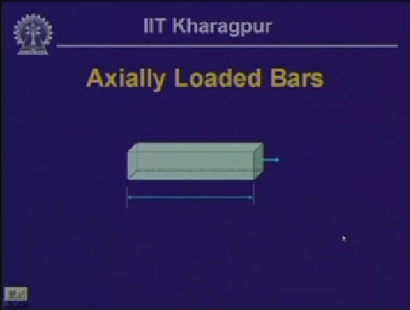

Slide 15-30:04

Well as we have seen earlier, in case of the stresses when a bar is subjected to axial pull we have computed the stress which we have defined as the normal stress, the stress which is normal to the cross section of the bar and the load is acting perpendicular to the cross section through the axis of the bar.

Now for an axially loaded bar, if we are interested to compute the strain, let us assume that this particular bar say is fixed at this end, the length of this bar is L and is subjected to pull P, thereby if the delta is the extension then the strain =delta by Land we consider that for this particular bar a this analysis you carry out is within the elastic limit of the bar.

And we have seen right now in the stress strain relationship that within the elastic limit of the bar is the stress is proportional to the strain. And we write sigma equals to E(epsilon).

So, in place of epsilon, you can write E(delta/L). Hence from this equation we can write the deformation delta as sigma times L/E. As we know that this is a bar which is axially loaded and the load is acting through the axis of the bar, any cross section.

Normal stress sigma P is divided by the cross sectional area. So sigma =P divided by A. So if we substitute the value of sigma in this we get, delta =PL by AE. So for an axially loaded bar if we know the axial pull, if we know the cross sectional area, if we know the length and if we know the material with which this bar is made of, for which we know the modulus of elasticity then we can compute what will be the deformation in the bar.

Considering that every where the strain is same, however the strain is not everywhere, if there is the variation of the strain everywhere, in the previous calculation that the strain or the deformation, delta as we have seen at deformation delta =the integral 0 to L epsilon dx and as we have seen in the stress strain relationship, sigma = E times epsilon so this = integral 0 to L, incase of epsilon, if you write this is sigma by E dx and sigma if we write as P by A then we have deltas equals to integral 0 to L P/A E dx.

Now if P and cross sectional area are different then we get deformation different at different points. But if the axial load P and the cross sectional area A they remains same, if there is no change then we get the same expression which is P/AE, if the P/AE is constant then integral dx will be L.

So delta PL by AE is constant for the cross sectional area A.

However, if there is variation in the P, area A and the length of the bar then we get different deformations at different points and correspondingly the strain value will be different. That is how we calculate deformation in the axially loaded bar.

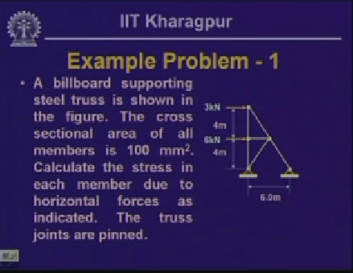

Slide 17-35:40

Having defined this strain we have looked in to the concepts of stress in the module one, now we defined he quantity called strain, we have established the relationship between stress and strain and within elastic limit we have seen in the axially loaded bar, how we can evaluate the deformation if we know the load and if the strain is uniform and what is the relation between deformation and the load corresponding to the cross sectional area of the member and in terms of the modulus of elasticity of the material and if there is the variation of the load, if there is the variation in the cross sectional area, then it is expected that the deformation to be different and accordingly the strain will be different at different point.

Let us once again look at an example related to evaluation of stresses at different points.

Now this is the truss member in which, which is supporting the bill board. Billboard is supported by two which are stress and cross sectional area of all the members.

Call this as A, this point as B this is then C and this is D and this as E. Now we are interested to know the stress in each member when the particular board is subjected to a load and the area, they are the forces which are acting at 3 Kilo Newton here and 6 Kilo Newton here, so what we need to do is to evaluate first the forces in each member and once we can compute the forces in each member. So when the supports are pin jointed, we have the axial force in each member and this axial force at each member area will give out the stress, that us what we are interested in, to calculate the stress in each member.

Now from this triangular configuration this length is six meter, this is given as 4m and this is given as 4m. So the distance BC is also going equals to this divided by this is equal to the force divided by A which is ½, so this is 3m.

So, if we call this as theta. Now if we take the cross section area here, then we have the member which is like this. This is theta, and we have the horizontal force is acting here, which is 3 Kilo Newton, now the direction of the force is this and the direction of the force is in this direction. Now if we take the horizontal component of this force, which is FAC, so FAC sin theta = 3 Kilo Newton. FAC sin theta = 3 Kilo Newton. Now sin theta over here = 3/5, this is 4 and this is 3 hence this is going to be 5.

Sin theta = 3/5. So FAC = 5 Kilo Newton. If we take the vertical equilibrium of the forces so FAC cos theta and if we call this force as FAB then FAC cos theta =FAB or FAB cos theta = – FAB =0, that is the vertical forces in the equilibrium. So FAB =FAC cos theta. And value of cos theta is 4/5 and FAC being 5, so the value of FAB is 4 Kilo Newton.

Now, if we look in to the direction of the forces as we have assumed over here, this is the force in the joint. Member is subjected to like this, which is compressive in nature. So the member AC the joint force direction in this will be subjected to a compressive force so in the member the force is in this direction and thereby the member AB is on the tension and so this is the tensile force.

The member AC and member AB is subjected to a force of 5 Kilo Newton and 4 Kilo Newton so these divided by the cross sectional area, 5 Kilo Newton divided by 100mm2 will give us the stress in FAC and correspondingly 4 Kilo Newton/100mm2 will give me the stress in FAB.

Likewise we have to compute the forces in this bar, in this bar, this bar and this bar. Supposing if we take or cut the structure from here and take the free body of the upper part of it then we get a configuration which is like this here; we have 3 Kilo Newton, here we have 6 Kilo Newton, his is force call FBD, this is A, this is B, this is C and let us call this as D and this point here we call as E.

So this is ABD member in this direction, which is FCD and here we have force FCE. We can compute forces if we take the moment of all the forces with respect to this then, 3 Kilo Newton is going to distribute the forces three times the moment and FBD will have the moment this times this distance which is equal to 3. So 3 Kilo Newton × 4 which is in anticlockwise moment, if we take moment about C = 0, so 3 × 4 = FBD × 3.

This is going to be in anticlockwise direction, so thereby FBD = 4 Kilo Newton. And again this is at a joint at this direction, so the member the force will be in this particular direction so this gives us again a tensile pull, so this is a tensile force. So this force divided by the cross sectional area will give me the stress in the member. Now this particular angle we have assumed as theta and this is also theta and again we can take the horizontal and the equilibrium forces of all the forces and we can compute the value of FCE and FCD and thereby the value of FCD we will get as equals 5 Kilo Newton and this is a tensile pull and the force FCE we will get as 10 Kilo Newton which is compressive force. And so we have seen AB, BC, BD, CD, CE and the member which is BC.

If we take the equilibrium of this particular joint and we have 6 Kilo Newton here and 6 Kilo Newton at joint B, we have member AB, we have member BD and we have member BC where force will be FBC and value from this will come as 6 Kilo Newton, which is a compressive force.

Once we get force in each of this member, force divided by cross section area will give me the stress in each member. That is how we compute the stresses in the member. Now by stating that the truss joints are pinned means that the forces transmitted in each of these members are purely axial in nature.

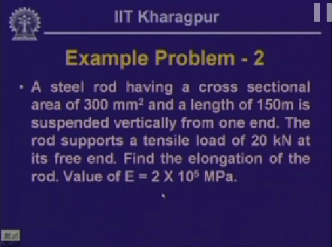

Slide 19-45:46

Having discussed that particular problem related to the evaluation of the stress as we had discussed in the previous module, how to compute stresses at a point in a stress body, now in this particular lesson we have seen how to compute the deformation in a member for an axially loaded member or there is variation in the load of the cross sectional area, what is going to be deformation in the member along with the length of the member.

Now let us look into some examples; how do you compute these deformations if the forces in the member is known, we know the cross sectional area of the member and we know the material property which is of the elasticity of the material. Now in this example, we have steel rod, which is having cross sectional area of three hundred millimeter square and the length of the bar is one fifty meter, is suspended vertically from one end.

The rod supports the tensile load of 20 Kilo Newton at the free end we will have to find out the elongation of the rod. Or first we will have to find out the deformation. The value of E is given as 2 × 105 MPa. So it us like you have a bar of length 150m and it is supported at one end, it is hung from the top and at this free end this bar is subjected to a load of 20 Kilo Newton, the length is 150m.

So we are interested to compute that what is going to be the elongation of the bar because of the axial pull? Bar is going to be stretched or it is going to deform, so we are interested to know how much this bar under go deformation because of the axial pull which is acting, one end is fixed and the other end is pulled. Now here as we have seen deformation delta = PL/AE where P is the axial pull acting in the bar, L is the length of the bar, A is the cross sectional area of the member, which is uniform here and E is the modulus of elasticity of the material. So this = P is given as 20 Kilo Newton, so 20 × 103 Newton, L is 150m, so 150 × 103 so much of millimeter divided by cross sectional area A which is 300mm2 × E which is 2 × 105 which is N/mm2 MPa.

So this 103, 103 cancels with 105 and 0, 6. These two 0s cancel. This 2 and this 2 gets canceled. So we have 15 = 3 × 15 = 50mm. So the amount of elongation, this particular bar will be under going because of this load.

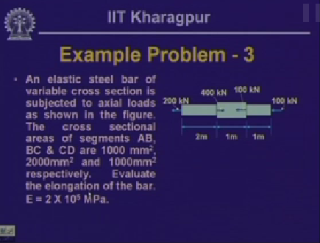

Slide 20-49:42

Now let us look in to another example problem, this is interesting, because here we have a bar, a plastic bar is in the elastic limit, and in this we have variable cross section. The bar cross section is not uniform as in the previous case. Here for this particular stretch of the bar, here one cross sectional area, let us call this as A and this as B and this is C and this is D, here part AB, the segment AB is having area of 1000m2, segment BC is having 1000m2 and segment CD is of 1000m2 and this particular bar is subjected to pull here of 200 Kilo Newton, here it is 400 Kilo Newton, here it is 100 Kilo Newton and here it is 100 Kilo Newton.

Now for such kind of system, we need to look into whether the whole bar is under the action of equilibrium of the forces or not. We look into a bar which is subjected to the action of axial force of 400 Kilo Newton in the positive x-direction. In the negative x-direction which is 100 + 100 + 200 = 400 so this is in equilibrium. Now if we take the free body of different part of this particular bar, then we can find out that what is the amount of forces that is each member is subjected to.

Now let us take a section somewhere here, let us call section one-one and if you take free body of this, this particular segment is subjected to pull here, 200 Kilo Newton, and as we have seen the free body in our module one, the opposing force will also be 200 Kilo Newton.

This particular member is subjected to pull of two hundred Kilo Newton. If we take section here, section two-two and if you take the free body part of it, then here we have force 200 Kilo Newton, here we have a force which is four hundred Kilo Newton acting in the other direction, so the resulting force 200 Kilo Newton acting in the opposite direction, if we balance this has to be 200 Kilo Newton.

So this is being pulled which has compressive force of two hundred Kilo Newton and if we take the free body of this part, then we have the free body part is like this, this is 200, this is 400 and this is 100, so 100 + 200 on this side and 400 on this side, so it has to be balanced by hundred on this side. So this particular member is subjected to 100 here and 100 here which is under compression.

So the first part, this part is under tensile pull of 100 Kilo Newton and central part is under compression of two hundred Kilo Newton, the third part is in the compression of 100 Kilo Newton.

Now for these if we compute, if we calculate the deformation for the three segments we can find out the total delta as the sum of summation of P L/A E. As in each of these three segments the cross section area over these stretch, over this cross sectional area of particular section remains same. For this particular cross section area for this section is same. For this cross sectional area the cross sectional area is same. So we can write this equation as, for the segment AB as the P1 L1/A1 E + P2 L2/A2 E + P3 L3/A3 E for the three segments. Now for the second segment this P2 is negative, this is compressive, if we call P one as tensile as positive, for the third segment P3 is compressive again negative.

Now if we substitute the values as we know P, we know the value of L1, we know the value of L1, correspondingly P2, L2 and A2 and we know the value of P3, L3 and A3 and if we calculate that we can compute the vale of the deformation and this delta = 200 and 103 × 2000/1000(2 × 105), second one will be minus = 100 – this 100 × 103 × 1000/1000(105) = 1mm.

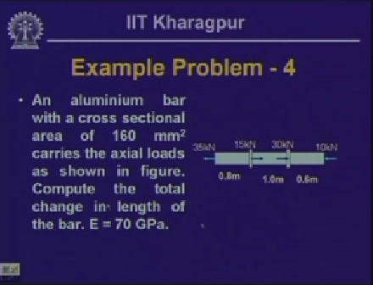

Slide 21-56:07

Here is another problem which is aluminium bar with cross sectional area of 160mm2 carries the axial loads, you have to compute the values of deformation to compute.

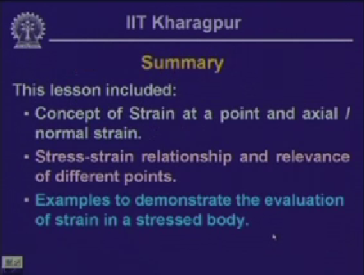

Slide 22-56:19

Now to summarize, this particular lesson included concept of strain at a point and axial and normal strain, stress-strain relationship and the relevance of different point in the stress strain curve, example to demonstrate how to evaluate the strain and the deformation stress body.



Slide 23-56:41

Here are some questions:

What is meant by elastic limit?

What is the difference between nominal stress and true stress?

How will you evaluate strain in a bar with gradually varying cross section?