**Jai Chhabra**

**Computer Networks**

**Lab 7**

**E18CSE071**

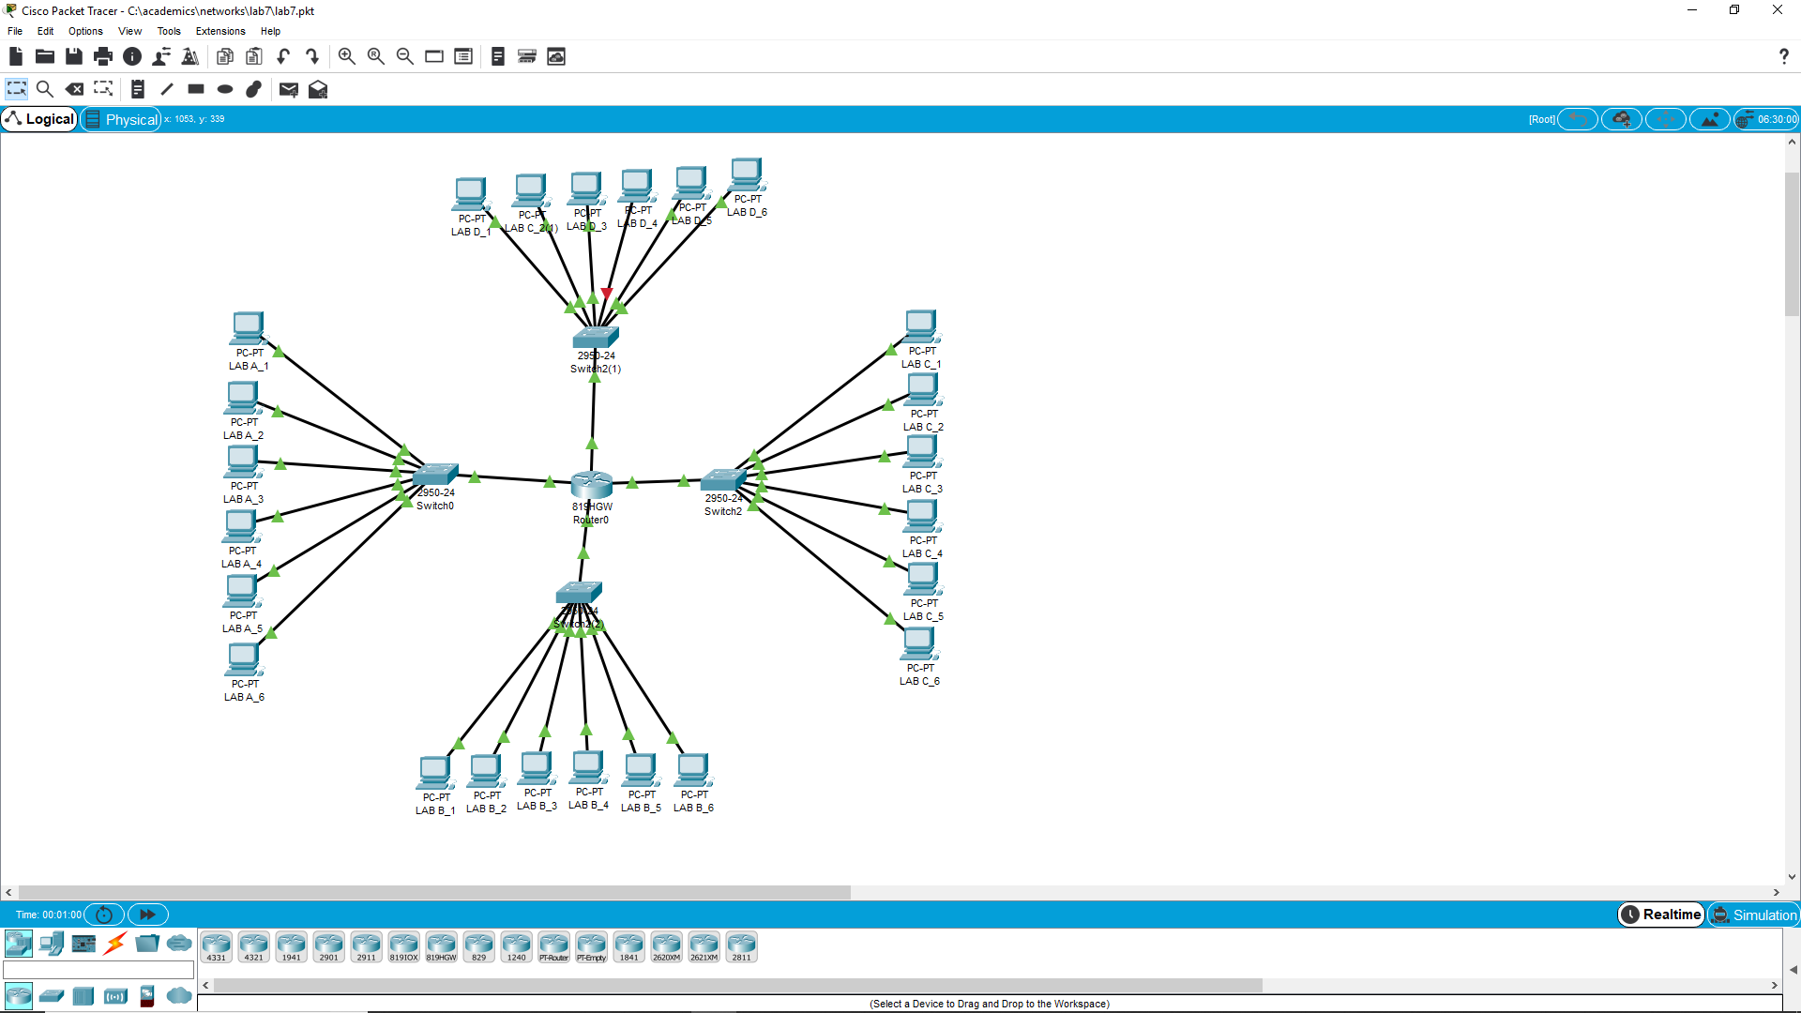

Steps:

1. Place all systems.
2. Configure all desktops.
3. Add everything to a network with 4 part-networks.
4. Configure network and build subnetting network.
5. Try and test network