**Chemical Reaction Engineering I**

**Professor Bishnupada Mandal**

**Department of Chemical Engineering**

**Indian Institute of Technology Guwahati**

**Lecture - 3**

**Kinetic Model and Temperature Dependency**

(Refer Slide Time: 1:02)

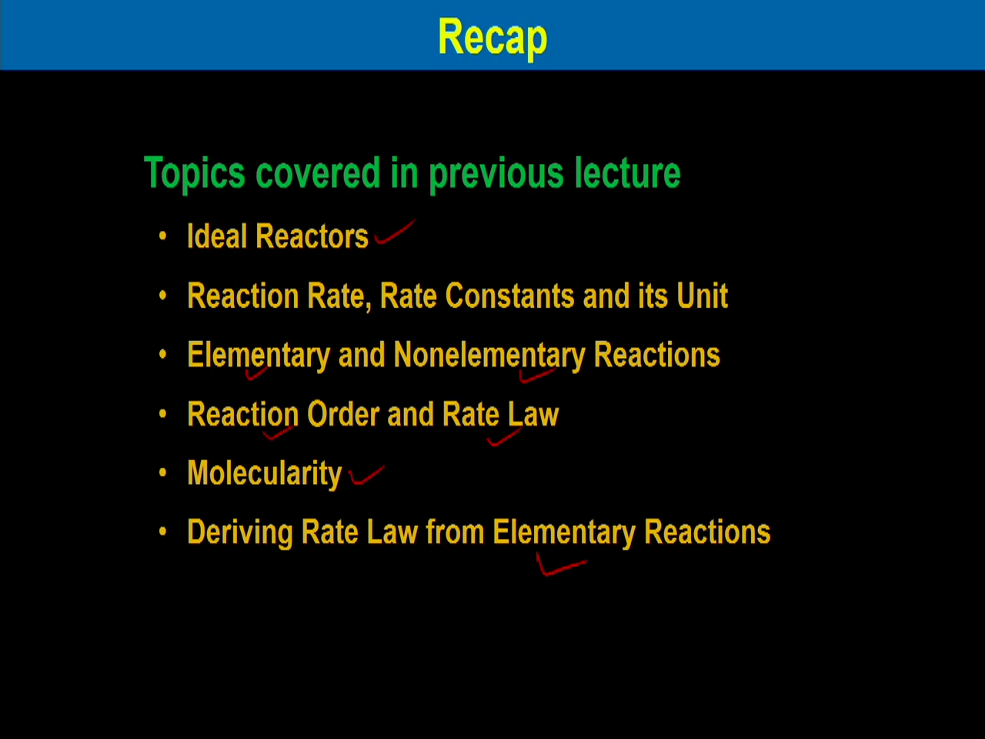

Welcome to the third lecture of module 1 on Chemical Reaction Engineering I. In this module we are discussing chemical kinetics and in this lecture we will discuss temperature dependency and testing of kinetic theories. Before going to this lecture, let us have brief recap on our previous lecture. The topic which we covered in our previous lecture is ideal reactors and we have seen there are three different types of reactors batch reactor, and then plug flow reactor and continuous stir tank reactor.

Then we have discussed reaction rates, rate constants and its unit. We have distinguished between elementary and non-elementary reactions. Then we have seen what is the concept of order of the reactions and different rate laws, then molecularity of the reaction and different rate law which derived from the elementary reactions.

(Refer Slide Time: 1:58)

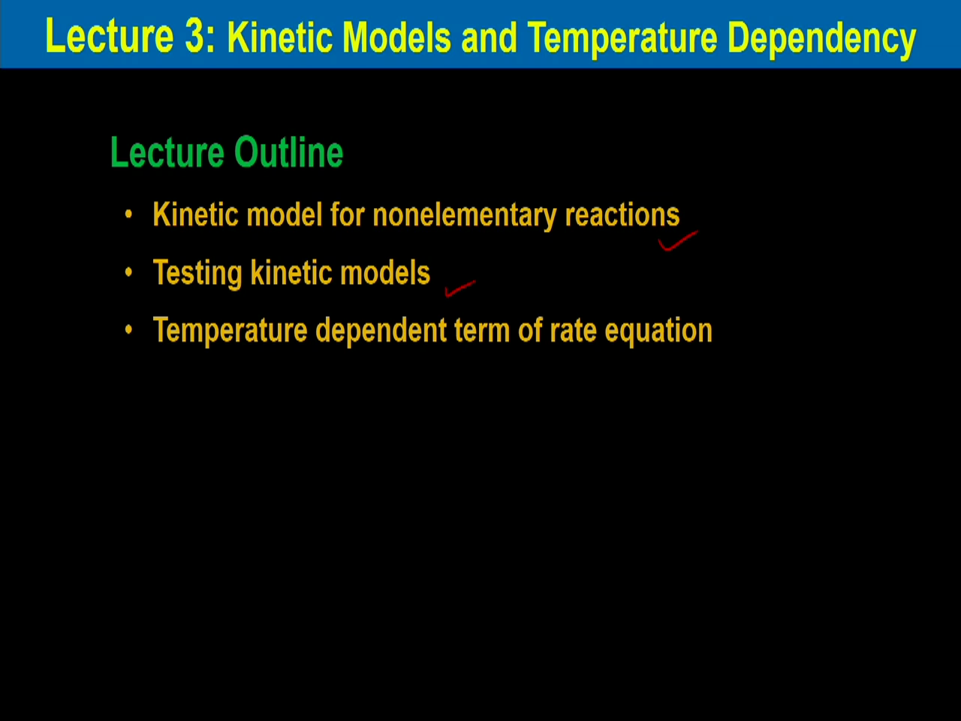

Now, in this lecture we will consider kinetic models and temperature dependency. So the brief outline of this lecture are kinetic model for elementary reactions, kinetic model for non-elementary reactions. And then we will discuss the kinetic models and finally we will discuss the temperature dependency term of rate equation.

(Refer Slide Time: 3:20)

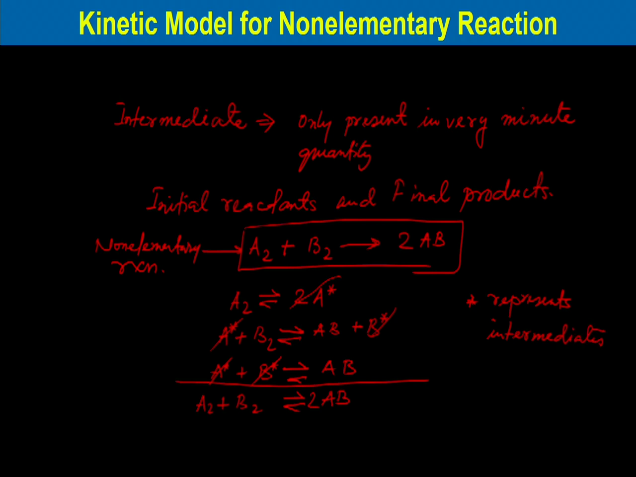

So, kinetic model for non-elementary reactions. As you know for elementary reactions, there are series of reactions which take place and finally we obtained the product. The some products we call the intermediate products, for which we do not see the change of concentration or that is not stable compound and then that disappears. So, its concentration present in the system is very minute quantity. So, intermediates only present in very minute quantity. So that is why it is very difficult to observe in the reaction system. And only we observe the initial reactants and final products. If we consider a single reaction, say 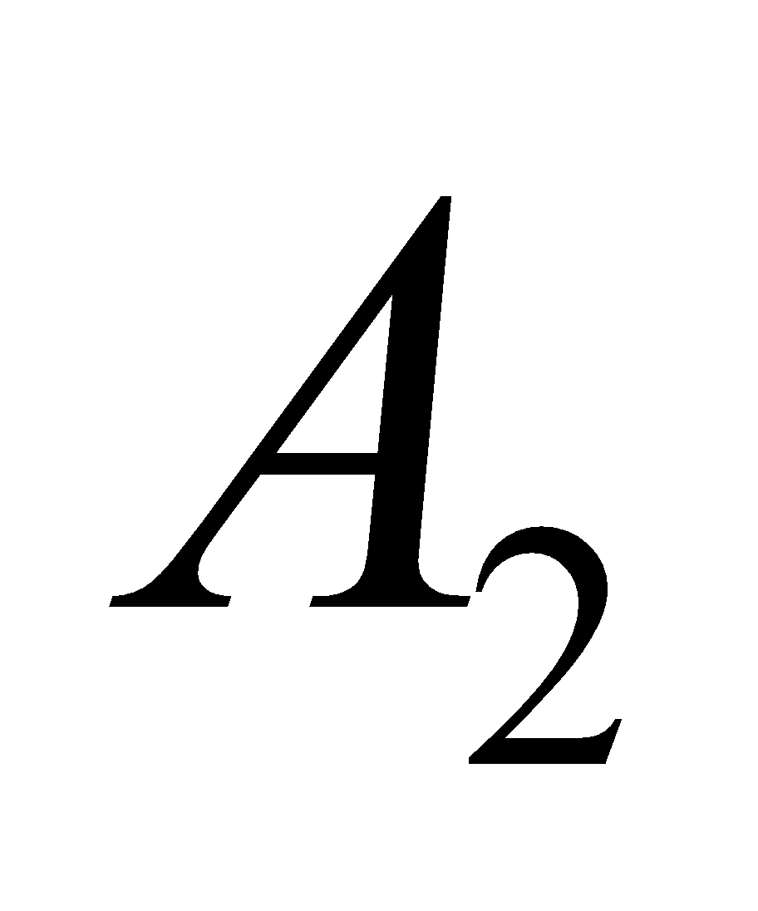 reacts with 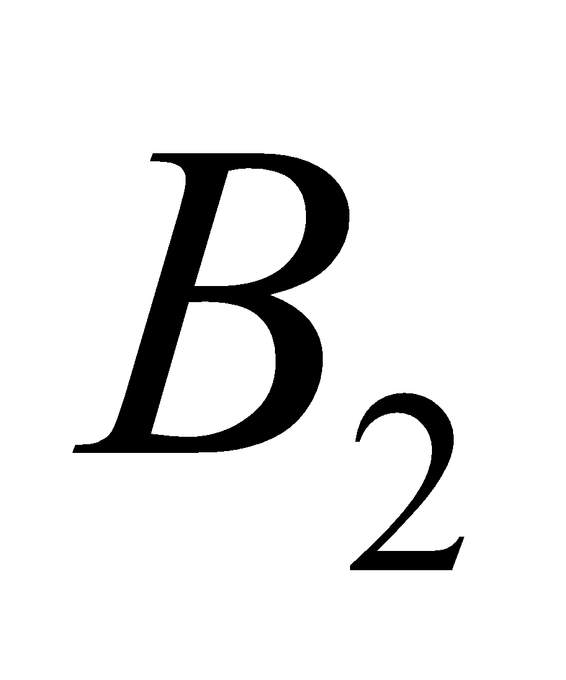 and produce twice AB. This reaction is non-elementary reaction.

So, to explain the kinetics of this non-elementary reaction, we can assume these reactions can take place with a series of reaction. Suppose the kinetics may be assumed like this,  can dissociate reversibly to twice  and then  reacts with  form AB plus  and reacts with  for AB. So, if you look into the overall reaction, you can see that this, this cancelled out, this cancel out and you will get  plus forming twice AB. And this star(*) represents intermediates.

(Refer Slide Time: 6:47)

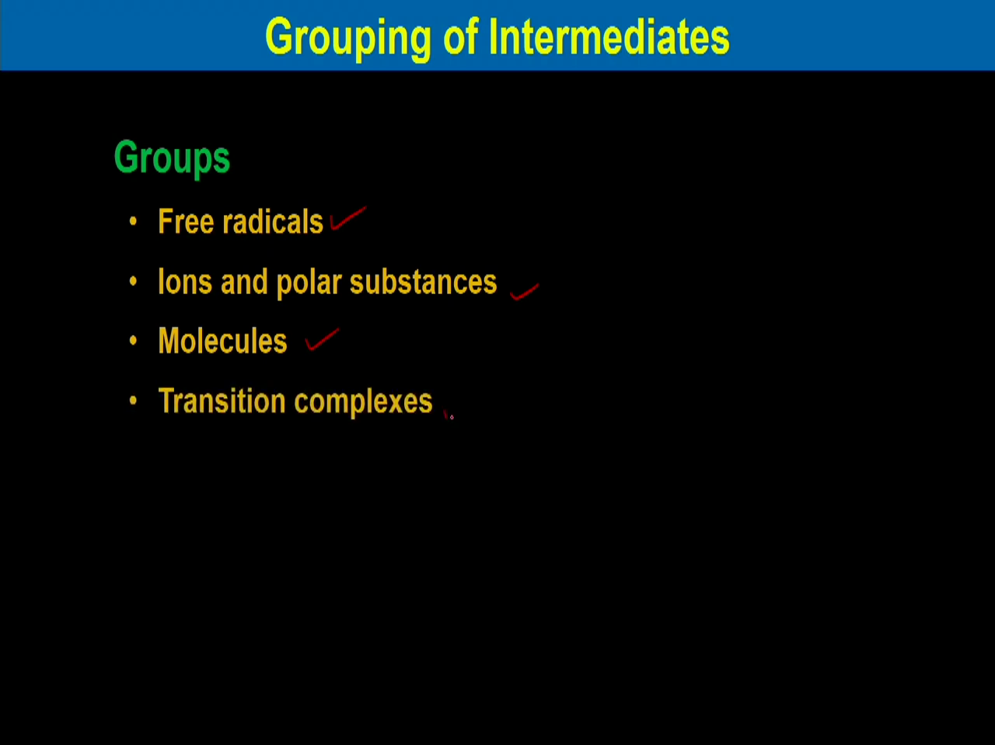

Kinetics of this reaction, the intermediates can be grouped in four different categories. One is free radicals, then second one is Ions and polar substances, then molecules and then transition complexes.