**Foundation of Wavelets and Multirate**

**Digital Signal Processing**

**Professor Vikram M. Gadre**

**Department of Electrical Engineering**

**Indian Institute of Technology, Bombay**

**Lecture Number 3**

**Module No. 1**

**Piecewise Constant Representation of a Function**

Warm welcome to the 3rd lecture on the subject of Wavelets and multi-trate digital signal processing. Let us spend the minute on what we talked about in the second lecture. We had introduced the idea of a wavelet in the second lecture. And we had done so by using the Haar wavelets. Essentially where piecewise constant of approximations are refined in steps by factors of 2 at a time.

In today’s lecture, we intend to build further on the idea of the Haar wavelet by introducing what is called a multiresolution analysis or an MRA as is often referred to in brief. So let me title today’s lecture, we shall title today’s lecture as the Haar multiresolution analysis and in fact let me also put down here the abbreviation for multiresolution analysis MRA.

(Refer Slide Time: 01:49)

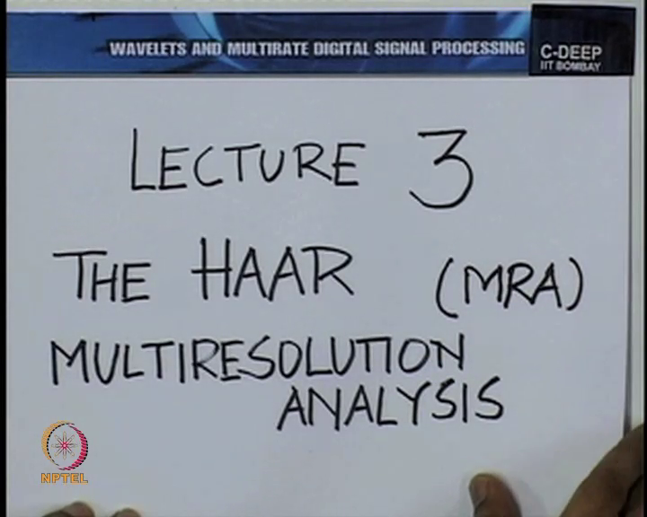

You see, the whole idea of multiresolution analysis has been briefly introduced in the context of piecewise constant approximation. So recall what we said that the whole idea of the wavelet is to capture incremental information. Piecewise constant approximation inherently brings in the idea of representation at a certain resolution. We took the idea of representing an image at different resolution.

In fact we use the term resolution when we represent images in the computer. 512x512 is a resolution lower than 1024x1024 and one way to understand the notion of wavelets or to understand the notion of incremental information is to ask, if I take the same picture, the same two dimensional scene or same two dimension objects and represent it first at the resolution of 512x512 and then at a resolution of 1024x1024.

What is it that I’m additionally putting in to get that greater resolution of 1024x1024 which is not there in 512x512? The Haar wavelet captures this. So in some sense, you may want to think of the Haar wavelet as being able to capture the additional information in the higher resolution and therefore if you think of an object with many shells. So this is a very common analogy.

(Refer Slide Time: 03:50)

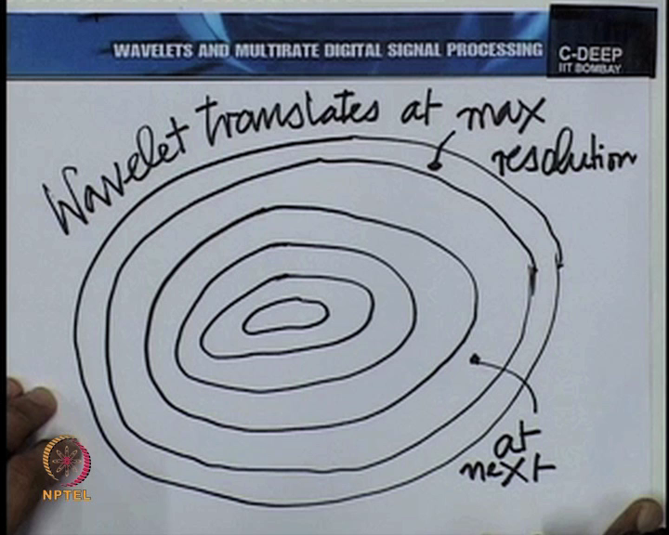

You know, if you think of the maximum information, maybe as a cabbage or an onion informally. And if you visualize the shells of this cabbage or the onion like this, then the job of the wavelet is to take out a particular shell. So the wavelet at the highest resolution, wavelet translates at highest resolution, at max resolution would essentially take out this. At next resolution, it would take out this shell and so on.

So when you reduce the resolution, what you are doing is to peel off shell by shell. In fact this idea is so important that we should write it down.

(Refer Slide Time: 05:12)

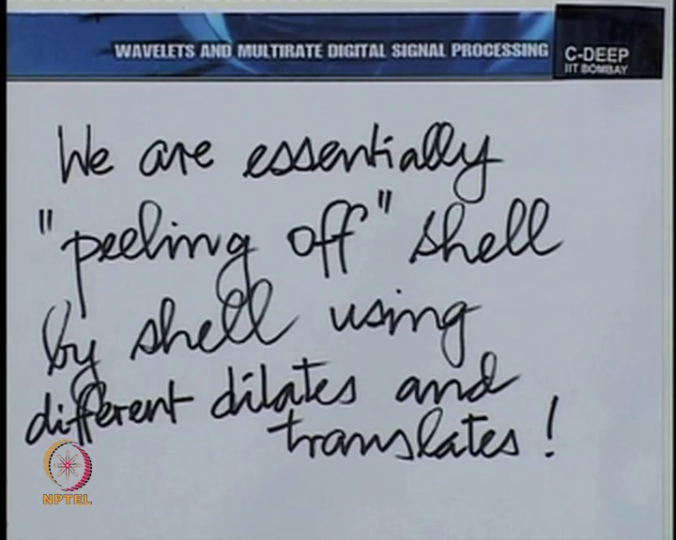

We are essentially peeling off shell by shell using different dilates and translates of the Haar wavelet. And there again a little more detail, different dilates correspond to different resolutions, and different translates essentially take you along a given resolution.

That is the relation between peeling off shells and dilates and translates. Now all this is an informal way of expressing this, we need to formalize it and that is exactly what we intend to do in the lecture today. Again we would now like to talk in terms of linear spaces. So, without any loss of generality let us begin with a unit length for piecewise constant approximation.

I say, without the loss of generality because after all what you consider as unit length is entirely your choice; you can call 1 meter unit length, you can call 1 centimetre unit length. Or if you are talking about time, you can talk about 1 second as unit length or unit piece and so on. So unit on the independent variable is our choice and that sense without any loss of generality.