**Heat Transfer**

**Prof. Sunando Dasgupta**

**Department of Chemical Engineering**

**Indian Institute of Technology, Kharagpur**

**Lecture - 04**

**Relevant Boundary Conditions in Conduction**

So, in the last class we have derived the heat diffusion equation, which is the fundamental equation for conduction heat transfer and there, we have considered the flow of heat, net flow of heat by conduction in the x direction, in the y and in the z directions. And then we invoked the conservation of energy, which tells us that for a control volume the rate net rate of energy in, the rate of energy in minus the rate of energy out plus any heat, that can be generated that is generated inside the system the algebraic sum of these three terms should result in a change in the energy stored of the system.

Or in other words it is expressed as

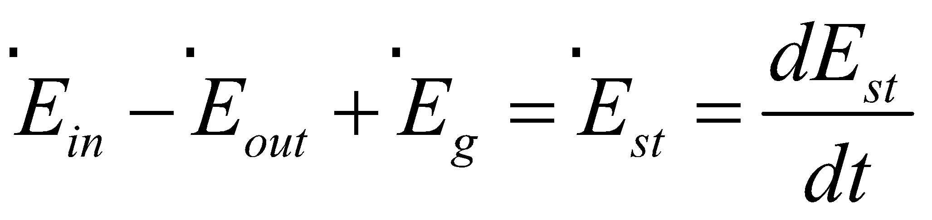

that is rate of energy in minus the rate of energy out is equal to the rate of energy stored in the system that is the time rate of energy stored in the system. And we know that the energy of a system can be expressed as ρ, the density, Cp, that is the heat capacity times the temperature minus the reference temperature. So, when we express that for a control volume and from this equation, which is a difference equation we have obtained the governing equation for conduction in Cartesian coordinate systems.

(Refer Slide Time: 01:49)

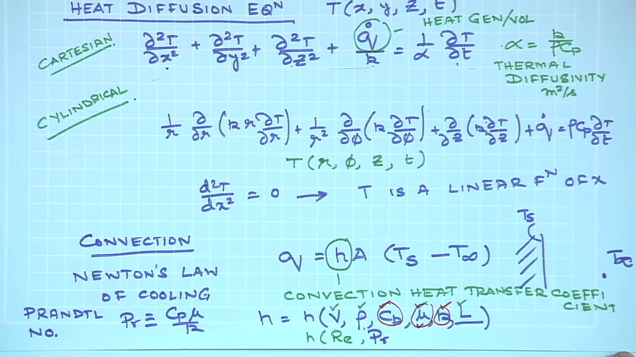

And this is the equation which we have derived in the last class, where for, Cartesian coordinates systems the temperature change now, so, in all these cases T could be a function of x, y, z and time. So, the 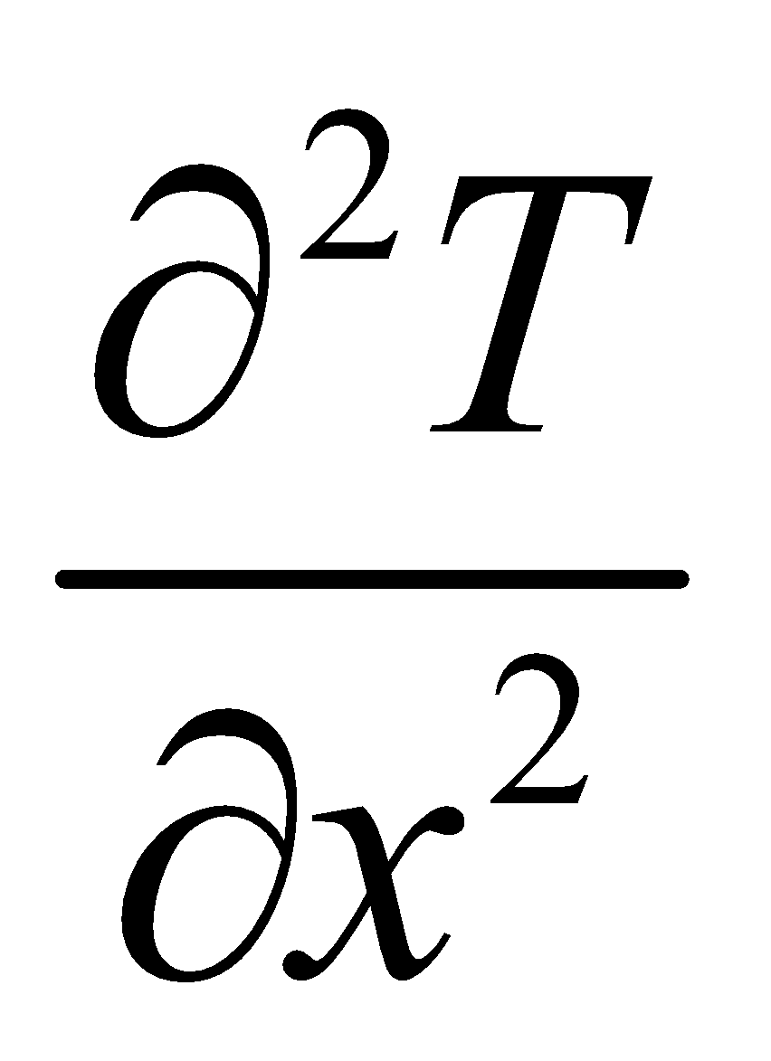and for y, for z and this 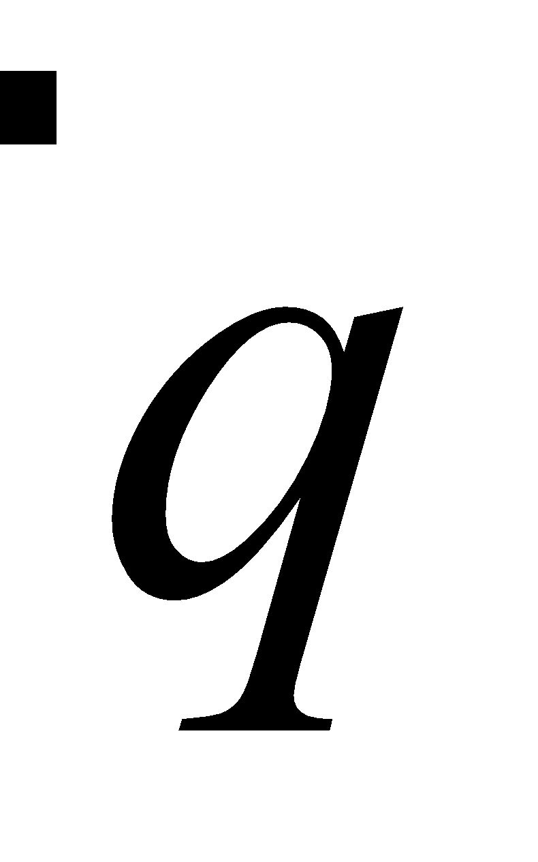is the amount of heat generated per unit volume. k is the thermal conductivity and this α as we have as we have seen its units of meter square per second, it is defined as 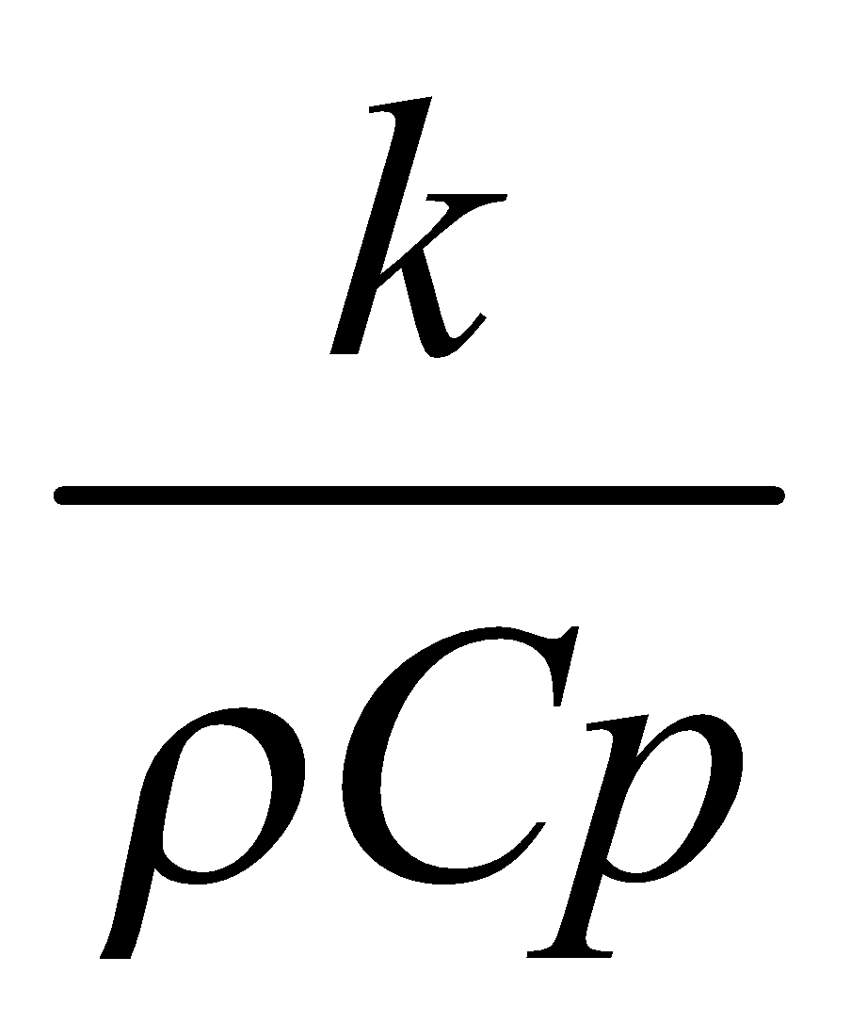and its known as the thermal diffusivity.

So, this is the equation that one has to use one this is the starting point, for any conduction analysis for a system, where the temperature could be a function of location, where there could be some amount of heat generation and as a result of all these, the temperature can also vary with time at fixed x y and z.

So, this is the fundamental equation, which is also known as the heat diffusion equation. Similarly, the similar type of equation can be derived for cylindrical systems as well as for spherical systems. I did not write the spherical systems which fundamentally, conceptually there is no difference between these 2 except for the coordinate system. So, here you see that T is essentially function of r, Φ, and axial location z and it could also be a function of time. So, the same way the equation for the spherical coordinate systems can also be written, it is there in your textbooks. So, am not writing it over here once again and we have all discussed that how this equation, let us say this equation can be simplified when we have for different conditions. For example, let us say we have a steady state system. In a steady state system the temperature does not vary with time, ok. So, the right hand side would be 0 and let us also assume that we have a situation in which there is no heat generation in the system; so, this term would also be 0.

So, therefore, temperature is a function of x y and z only. Under certain under some conditions it can also happen the temperature is a function only of x and not of y or of z. So, if we think about steady state condition with no heat generation and temperature being a function of only one spatial coordinates, then this equation would simply this equation would then can simply be written as 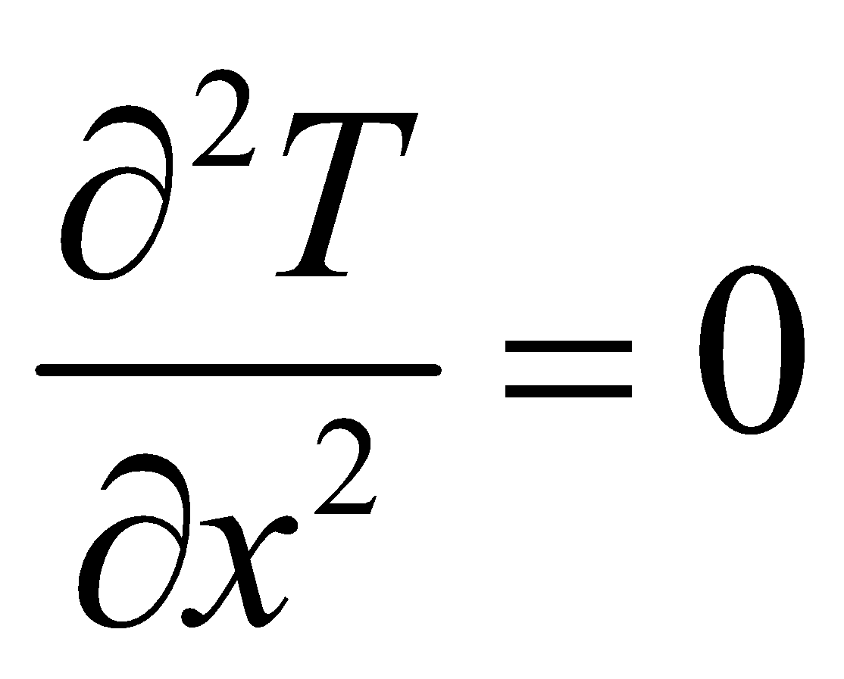. I do not need to use the partial sign anymore, since t is function of time in which would T is a linear function of x.