**Introduction to Proteomics**

**Dr. Sanjeeva Srivastava**

**Department of Biosciences and Bioengineering**

**Indian Institute of Technology - Bombay**

**Lecture – 02**

**Introduction to proteins**

**(Refer Slide Time: 00:14)**

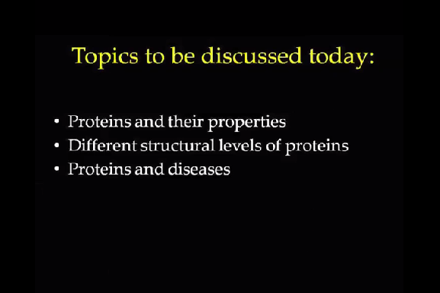

Let me give you the lecture outline. We will first talk about protein and its function and then different levels of protein structure, primary, secondary, tertiary and quaternary.

**(Refer Slide Time: 00:34)**

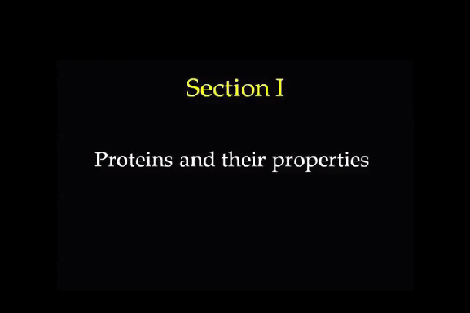

The protein term was derived from the Greek word Proteios which means of the first rank or very important.

**(Refer Slide Time: 00:38)**

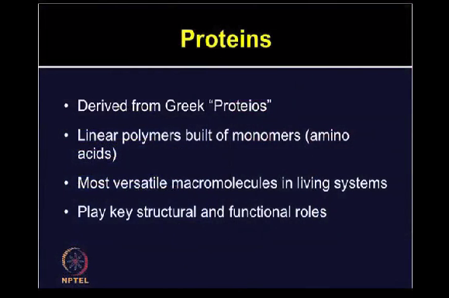

This term was coined by scientist Berzelius in 1833. These are the linear polymers which are built of monomers or amino acid subunits. These are the most versatile macromolecules in any living system. They are crucial for various essential functions of all the biological processes and they play very critical role, both from structural and functional point of view. Therefore, studying about proteins is very important.

**(Refer Slide Time: 01:25)**

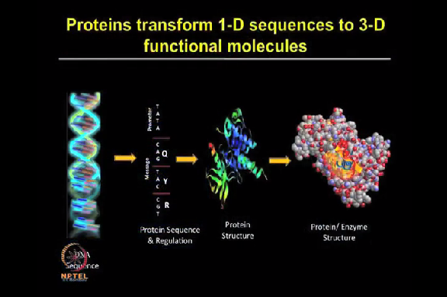

If you look at a central dogma starting from DNA to RNA and protein, the proteins can transform the 1-dimensional sequence to the 3-dimensional functional information. Proteins can play wide range of functional properties because of their different functional groups which can account for various protein function and its activity. Protein-protein or protein and other biomolecular interactions, they are generated because of the synergistic capability of these proteins which cannot be obtained from any given individual protein.

**(Refer Slide Time: 02:15)**

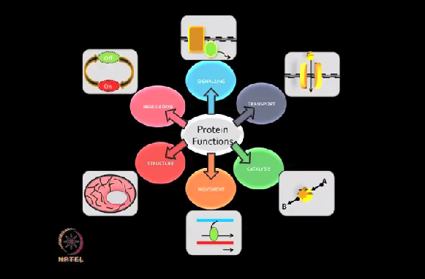

Proteins can perform various type of functions whether it is catalysis, movement, structure, regulation, signalling, transport, etc. As you can see in the slide various type of functions have been shown. Enzyme catalysis, the enzyme catalyse biochemical reactions by increasing the rate of reactions. Transport and storage, proteins can transport small molecule such as oxygen and iron.

Proteins are involved in the movement with muscle contraction if you talk about microorganism in bacteria the chemotaxis, they are responsible for the mechanical strength for example in the skin and bones, the collagen and keratin, all of these are different examples of mechanical strength. Proteins are also present as immunoglobulin responsible for the immunity.