**Mass Transfer Operations II**

**Professor Chandan Das**

**Department of Chemical Engineering**

**Indian Institute of Technology Guwahati**

**Lecture 03 - Humidification and Air Conditioning**

Hi, welcome back to the course Mass Transfer Operations 2, we were discussing on humidification and air conditioning. In the previous class, we discussed the step by step procedure of humidification tower design and today we will be discussing on the humidification problem.

**HUMIDIFICATION PROBLEM**

(Refer Slide Time: 00:57)

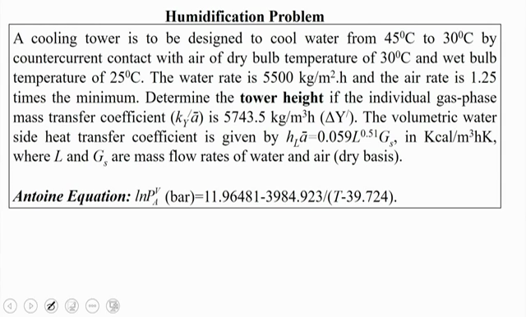

The problem is like that a cooling tower is to be designed to cool water from 45 degree Celsius to 30 degree Celsius by counter current contact with air of dry bulb temperature of 30 degree Celsius and wet bulb temperature of 25 degree Celsius, the water rate is 5500 kg per meter square hour and the air rate is 1.25 times the minimum. Determining the tower height if the individual gas phase mass transfer coefficient k Y a prime is 5743.5 kg per meter cube hour, the volumetric water side heat transfer coefficient is given by the relation h L a prime is equal to 0.059 into L to the power 0.51 into G s in kilo calories per meter cube hour Kelvin where L and G s are mass transfer rates of water and air on dry basis. The Antoine Equation is ln P A V is equal to 11.96481 minus 3984.923 divided by T minus 39.724 where this temperature is in Kelvin and the pressure is in bar.

Before the start of the solution of this tower design, we will recapitulate the step by step procedure of the cooling tower design. The steps are like this:

(Refer Slide Time: 02:26)

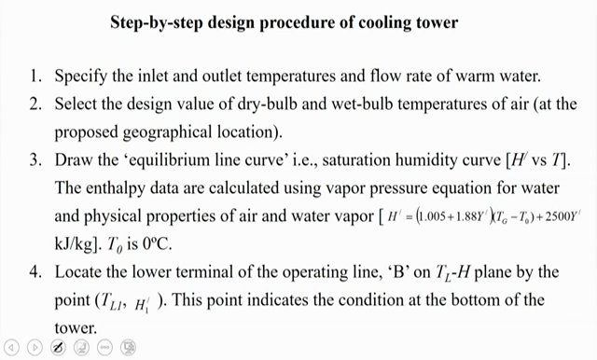

Firstly we have to specify the inlet and the outlet temperature and flow rate of warm water. Say for our practical case the inlet and outlet temperature and flow rate of warm water is given. Then we have to select the design value of dry bulb and wet bulb temperature of air at the proposed geographical location. Here also in this problem the dry bulb and wet bulb temperature of air is applied.

Then third step is draw the equilibrium line curve that is saturation humidity curve which is nothing but the H prime versus temperature, the enthalpy data are calculated using this vapor pressure equation and the physical properties of air and water vapor just by H prime is equal to 1.005 plus 1.88 into Y prime into T G minus T 0 plus 2500 into Y prime that will be in kilojoule per kg, where the T 0 or we can say the reference temperature is taken as 0 degree Celsius. Then the fourth step will be we have to locate the lower terminal of operating line that is B on this TL H plane by the point TL1 and H1 prime, this point indicates the condition of the bottom of the tower that is whenever this cold water will be leaving the cooling tower.

(Refer Slide Time: 03:59)

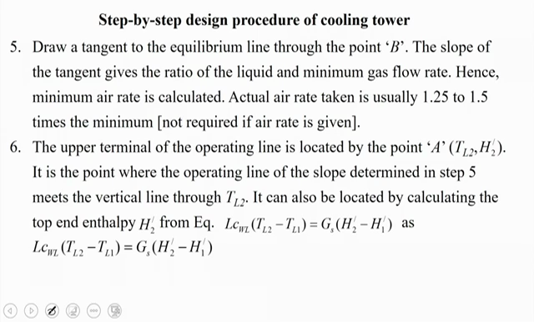

Then this fifth step will be, this we have to draw the tangent to the equilibrium line that we have already drawn from this HT diagram and we have to draw a tangent through this point “B” or we can say this the whatever the bottom point of the cooling tower, the slope of the tangent gives the ratio of the liquid to minimum gas flow rate or that is L by G s minimum, hence the minimum air rate is calculated and in this particular problem the actual air rate is taken as 1.25 times the minimum. And then upper terminal of the operating line is located by point A that is whenever we will be getting this G s minimum and if we multiply by 1.25 we will be getting the actual operating line for this cooling tower.