**Tissue Engineering**

**Prof. Vignesh Muthuvijayan**

**Department of Biotechnology**

**Indian Institute of Technology, Madras**

**Lecture - 03**

**Introduction to Tissue Engineering - Part 3**

Today, we will continue our discussion on the Introduction to Tissue Engineering. We looked at the two arms of the tissue engineering triad; we looked at what are biomaterials and how they can be used. We also looked at cells and what are the different sources and types which we can use.

Today we will talk about signaling molecules; signals basically, not just signaling molecules. We will first start with the signaling molecules, and I will also briefly introduce other signals. Our focus here is just an introduction. So, we will go into greater details in the later part of the semester, ok.

(Refer Slide Time: 00:57)

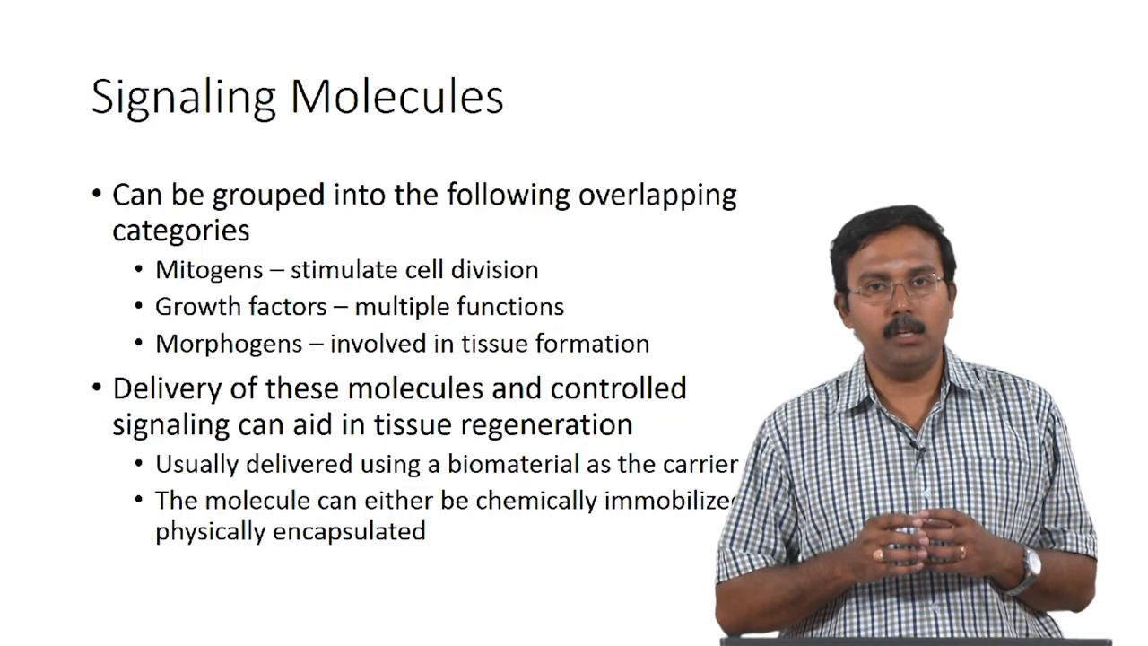

Signaling molecules themselves can actually be grouped into three major categories, but there are overlapping category; some of the molecules will act as both as a mitogen and a growth factor or a morphogen and a growth factor and so on. These are mitogens, growth factors, and morphogens. Classically, mitogens are the ones which will simulate cell division, growth factor was initially identified to be the molecules that help in cell proliferation, and it was later identified that it actually can have multiple functions.

The major challenge with respect to signaling molecules is how you deliver these molecules. You need to have a controlled delivery with maybe spatiotemporal release; so that there can actually be proper control over signaling, which will aid in tissue regeneration. Usually, this is delivered using a biomaterial as the carrier, and the molecules can be chemically mobilized or physically encapsulated to provide some kind of a controlled release. So, this is what is currently being looked at.

(Refer Slide Time: 02:09)

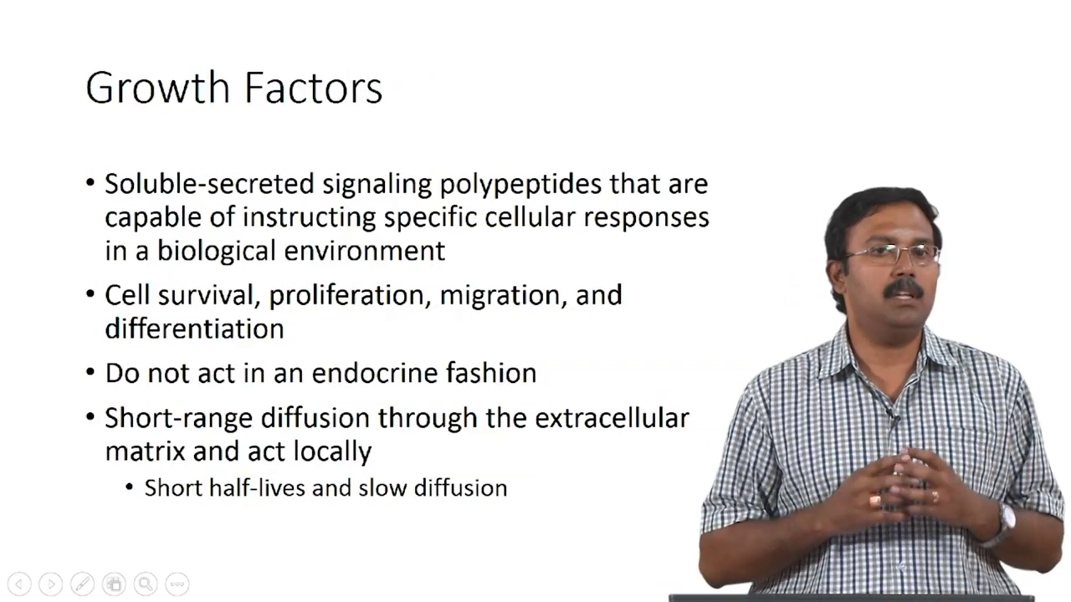

So, what are growth factors? These are soluble secreted signaling polypeptides that are capable of instructing specific cellular responses in biological environments. Can you identify some growth factors which you already know?

Student: BMP.

BMP ok. So, that is a Bone Morphogenetic Protein, that is a growth factor.

Student: VEGF.

VEGF which is?

Student: Vascular Endothelial Growth Factor.

Vascular endothelial growth factor, you know what is the role for that?

Student: It helps in blood vessel formation.

Ok, It is part of angiogenesis. So, there are many other growth factors we will look at some examples which are commonly used in tissue engineering applications. Actually, growth factors can help in so many different cellular responses from cell survival to proliferation to migration to differentiation and even with tissue formation.

It has a wide range of applications, and it is seen that they do not act in an endocrine fashion. It’s not that like the growth factors can circulate in your bloodstream and reach different places. That is primarily because they have short half-lives, and because of this, they only go through diffusion. But these are actually proteins; these are reasonably large molecules.

So, they are not going to diffuse very fast; so, they have very short-range diffusion, and this diffusion happens through the extracellular matrix, which is present in the tissue, and they will act locally. So, it will not have a large, like a systemic effect.

(Refer Slide Time: 03:45)

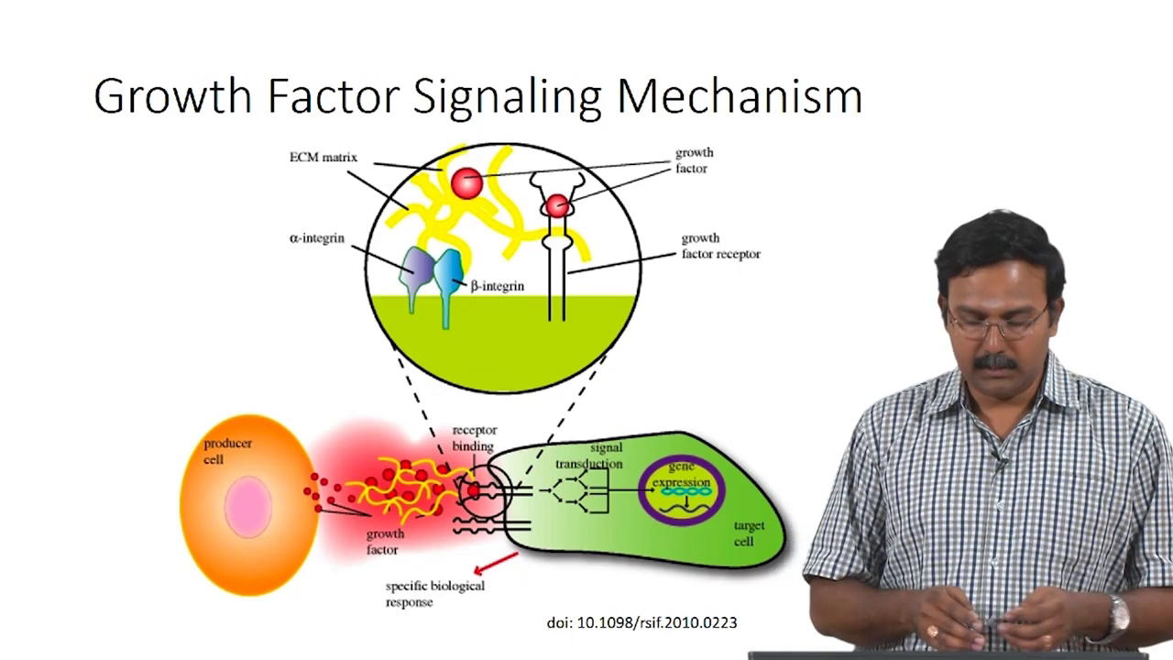

This is a general growth factor signaling mechanism. So, this is not for any specific growth factor. What you have is a producer cell, which would be producing some growth factors. All the growth factors are secreted by some cells.