JAVA ASSIGNMENT REPORT
Assignment 14 – Student Marks Viewer
JTable, MVC Architecture & Introduction to JavaFX

Student Name | Aaryan Ganesh Kuchekar
Course | B.Tech – Computer Science & Engineering
Subject | Java Programming
Unit | Unit 8 – GUI Programming with Swing & JavaFX
Topic | JTable, MVC Architecture & Introduction to JavaFX
Assessment | Practical Assignment

1. Aim
To develop a Student Marks Viewer using Java Swing and JTable following the Model–View–Controller (MVC) architecture, and to display the calculated class average using a minimal JavaFX window.

2. Objectives
- Create a StudentMarks model class containing roll number, name, and marks.
- Maintain student records in one central collection.
- Display records using a Swing JTable backed by DefaultTableModel.
- Implement Add, Update, Delete, and Show Average operations using ActionListener.
- Handle invalid table selections using ArrayIndexOutOfBoundsException.
- Introduce JavaFX by displaying the class average in a separate Stage and Scene.

3. Technologies and Concepts Used
- Java 26.0.1 (OpenJDK)
- Java Swing – JFrame, JTable, JPanel, JButton, JLabel, JTextField
- DefaultTableModel for table data management
- MVC (Model–View–Controller) architecture
- JavaFX 26.0.1 – Application, Stage, Scene, Label and Button
- Event handling using ActionListener
- Exception handling
- Collections using List / ArrayList

4. Program Structure
Class | Role | Main Responsibility
StudentMarks | Model | Stores student data and calculates the class average.
StudentMarksView | View | Builds the Swing GUI, JTable, fields, buttons and average label.
StudentMarksController | Controller | Handles button actions and coordinates model/view operations.
JavaFXAveragePreview | JavaFX UI | Displays the calculated average in a JavaFX Stage.

5. Functional Features
Feature | Description
Add | Reads roll number, name and marks, creates a StudentMarks object and adds the record to the table.
Update | Updates the selected JTable row using the values entered in the input fields.
Delete | Removes the selected student record from the table.
Show Average | Recalculates the average marks and displays it in the Swing window and JavaFX preview.
JavaFX Preview | Creates a JavaFX Stage/Scene with the current class average and a close button.

6. Sample Records
Roll No | Name | Marks
101 | Rahul Sharma | 88
102 | Priya Verma | 92
103 | Aman Singh | 85
104 | Ananya Gupta | 95

7. Implementation Highlights
The model is kept independent of GUI code. Student records are stored centrally and the model provides operations for adding, removing and calculating the average. The view is responsible for the Swing interface and JTable, while the controller connects user actions to the appropriate operations.
The JavaFX portion uses a Stage and Scene to present the same calculated class average separately from the Swing interface. This demonstrates the introductory use of JavaFX alongside an existing Swing application.

8. Execution Evidence
The following screenshots show the completed Student Marks Viewer running on macOS and the Java development environment with the Assignment 14 source files.
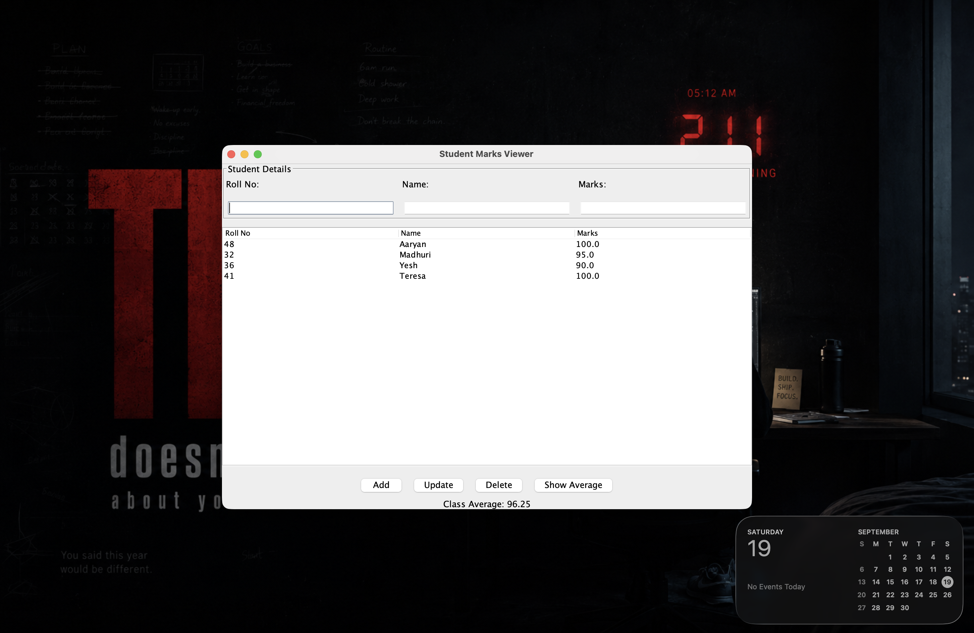
Figure 1: Assignment 14 execution / implementation evidence
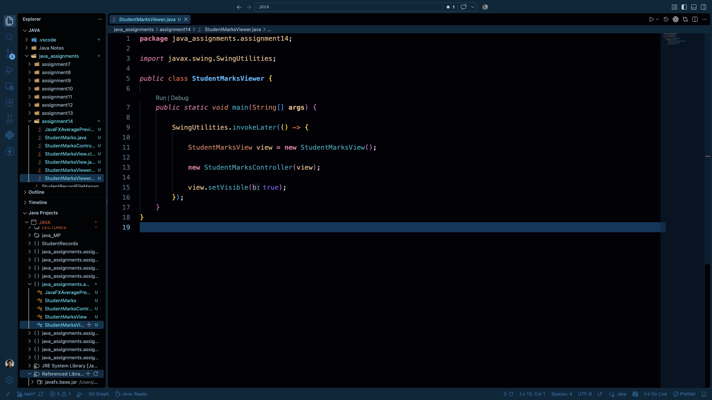
Figure 2: Assignment 14 execution / implementation evidence

9. Result
The Student Marks Viewer was successfully implemented using Java Swing and JTable with an MVC-style separation of model, view and controller responsibilities. The application displays student records and provides Add, Update, Delete and Show Average operations. A JavaFX preview was also integrated to display the class average.

10. Conclusion
This assignment demonstrates practical GUI programming in Java, JTable-based data presentation, event-driven programming, MVC architecture, collection handling and exception handling. It also provides an introduction to JavaFX by connecting the calculated result from the Swing application to a JavaFX Stage and Scene.

