JAVA PROGRAMMING MINI PROJECT
ATM TRANSACTION SIMULATOR
Mini Project Report
Semester III | B.Tech CSE 2025–29
Student Name | Aaryan Ganesh Kuchekar
Enrollment ID | 150096725048
Cohort | Demis Hassabis
Assessment Type | Mini-Project
Topic: do-while Loop, Switch Statement, Classes

1. Objective
The objective of this mini project is to develop a simple ATM Transaction Simulator in Java. The application maintains an account balance and allows the user to deposit money, withdraw money, check the current balance, and exit the session through a menu-driven interface.

2. Problem Statement
The program simulates a basic ATM session. A separate Account class stores the balance and provides methods for deposit, withdrawal, and balance retrieval. The main program uses a do-while loop to keep showing the ATM menu and a switch statement to perform the selected operation. The program must prevent withdrawals greater than the available balance and must display the final balance when the user exits.

3. Project Requirements
- Create an Account class containing the account balance and methods deposit(), withdraw(), and getBalance().
- Present a menu with Deposit, Withdraw, Check Balance, and Exit options inside a do-while loop.
- Use a switch statement to route each menu choice to the correct Account method.
- Prevent an over-withdrawal and display “Insufficient funds.” without terminating the menu.
- Display a closing message with the final account balance when the user selects Exit.

4. Java Concepts Demonstrated
Concept | Implementation | Purpose
Class | Account | Groups account data and operations together.
Object | Account account = new Account(0.0); | Creates the account used by the program.
Encapsulation | private double balance; | Protects the balance from direct outside access.
Constructor | Account(double balance) | Initializes the account balance.
Methods | deposit(), withdraw(), getBalance() | Perform specific account operations.
Scanner | nextInt(), nextDouble() | Accepts menu choices and transaction amounts.
do-while | do { ... } while (choice != 4); | Repeats the menu until Exit is selected.
switch | case 1–4, default | Routes fixed menu choices to operations.
if statement | amount <= 0 / amount > balance | Validates transaction conditions.

5. Program Flow
- The program creates a Scanner object for keyboard input.
- An Account object is created with an initial balance of ₹0.00.
- The ATM menu is displayed inside a do-while loop.
- The switch statement selects Deposit, Withdraw, Check Balance, or Exit.
- Deposit adds a positive amount to the balance.
- Withdraw checks the amount against the available balance before subtracting it.
- The loop continues until the user selects option 4.
- The final balance is printed and the Scanner is closed.

6. Java Source Code
import java.util.Scanner;

class Account {

private double balance;

public Account(double balance) {
this.balance = balance;
}

public void deposit(double amount) {
if (amount <= 0) {
System.out.println("Invalid amount. Please enter a positive amount.");
return;
}

balance += amount;
System.out.printf("Deposited. Balance: ₹%.2f%n", balance);
}

public void withdraw(double amount) {
if (amount <= 0) {
System.out.println("Invalid amount. Please enter a positive amount.");
return;
}

if (amount > balance) {
System.out.println("Insufficient funds.");
return;
}

balance -= amount;
System.out.printf("Withdrawn. Balance: ₹%.2f%n", balance);
}

public double getBalance() {
return balance;
}
}

public class ATMTransactionSimulator {

public static void main(String[] args) {

Scanner scanner = new Scanner(System.in);
Account account = new Account(0.0);
int choice;

System.out.println("===== ATM Transaction Simulator =====");

do {
System.out.println("1.Deposit 2.Withdraw 3.Check Balance 4.Exit");
System.out.print("Choice: ");
choice = scanner.nextInt();

switch (choice) {

case 1:
System.out.print("Enter amount: ");
double depositAmount = scanner.nextDouble();
account.deposit(depositAmount);
break;

case 2:
System.out.print("Enter amount: ");
double withdrawAmount = scanner.nextDouble();
account.withdraw(withdrawAmount);
break;

case 3:
System.out.printf("Balance: ₹%.2f%n", account.getBalance());
break;

case 4:
break;

default:
System.out.println("Invalid choice. Please try again.");
}

} while (choice != 4);

System.out.printf(
"Thank you for banking with us. Final Balance: ₹%.2f%n",
account.getBalance()
);

scanner.close();
}
}

7. Execution Evidence
INSERT CODE / TERMINAL SCREENSHOT HERE
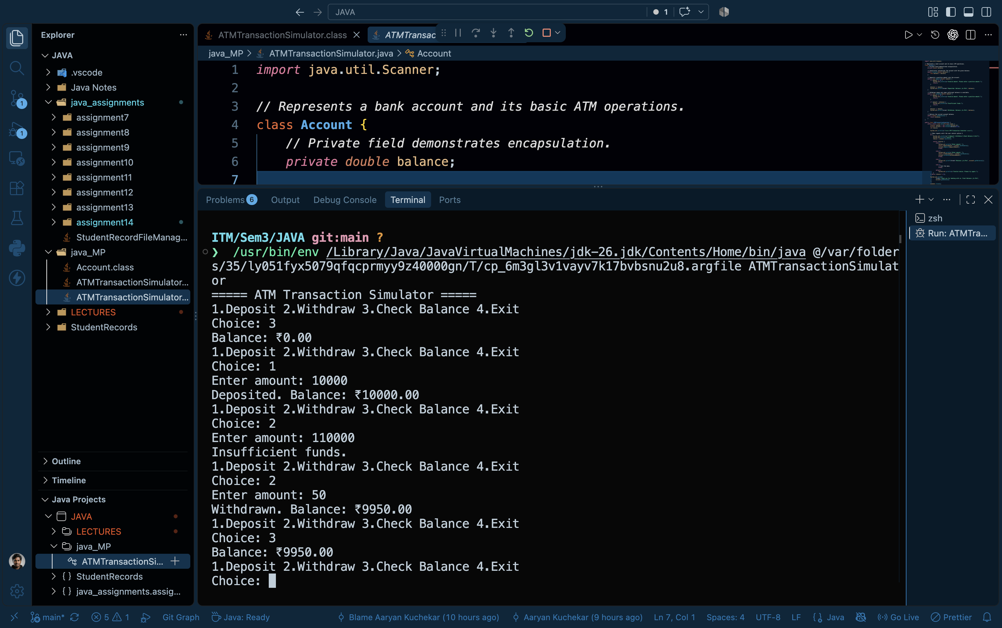
Code Execution and Output

8. Sample Execution
===== ATM Transaction Simulator =====
1.Deposit 2.Withdraw 3.Check Balance 4.Exit
Choice: 1
Enter amount: 5000
Deposited. Balance: ₹5000.00

1.Deposit 2.Withdraw 3.Check Balance 4.Exit
Choice: 2
Enter amount: 8000
Insufficient funds.

1.Deposit 2.Withdraw 3.Check Balance 4.Exit
Choice: 2
Enter amount: 2000
Withdrawn. Balance: ₹3000.00

1.Deposit 2.Withdraw 3.Check Balance 4.Exit
Choice: 4
Thank you for banking with us. Final Balance: ₹3000.00

9. Requirement Verification
Requirement | Status | Evidence in Program
Account class with balance and required methods | Implemented | Account class contains private balance, deposit(), withdraw(), getBalance().
Menu inside do-while loop | Implemented | do-while repeats until choice != 4 becomes false.
Switch-based routing | Implemented | switch routes choices 1–4 and handles default.
Prevent over-withdrawal | Implemented | if (amount > balance) prints Insufficient funds and returns.
Final balance on exit | Implemented | Closing message calls getBalance() after the loop.

10. Rubric Alignment
Criterion | Weightage | How the Project Addresses It
Account class design | 25% | Account encapsulates balance and provides deposit, withdraw, and getBalance operations.
do-while menu loop | 25% | The ATM menu repeats inside a do-while loop until option 4 is selected.
Switch-based routing | 20% | Each menu choice is dispatched using switch-case with break.
Balance safety checks | 30% | Withdrawals above the available balance are blocked without ending the menu session.

11. Result
The ATM Transaction Simulator was implemented successfully in Java as a menu-driven application. The program supports deposit, withdrawal, balance checking, and exit operations while maintaining the account balance safely.

12. Conclusion
This mini project provided practical experience with Java classes, objects, encapsulation, constructors, methods, Scanner input, conditional statements, switch-case routing, and do-while loops. The application also demonstrates basic validation by preventing invalid amounts and over-withdrawal.

13. Submission Checklist
- ☑ ATMTransactionSimulator.java created.
- ☑ Account class implemented with private balance.
- ☑ Deposit, withdraw, and getBalance methods implemented.
- ☑ do-while menu and switch statement implemented.
- ☑ Insufficient-funds condition handled without terminating the menu.
- ☑ Final balance displayed when exiting.
- ☑ Execution screenshot to be inserted by the student.

