JAVA PROGRAMMING LABORATORY
ASSIGNMENT 12
Multi-Counter Ticket Booking Simulator
Unit 7 – Multithreading in Java
Student Name | Aaryan Kuchekar
Assignment | 12 – Multi-Counter Ticket Booking Simulator

1. Objective
To develop a Java-based Multi-Counter Ticket Booking Simulator that demonstrates multithreading using the Thread class and Runnable interface. The program uses a shared ticket pool and synchronized access to prevent two counter threads from selling the same ticket concurrently.
2. Problem Statement
The application simulates multiple ticket counters operating concurrently. Counter-A is created by extending Thread, while Counter-B uses the Runnable interface. The program provides a menu to start counters, set thread priority, inspect thread status, display available tickets, wait for all counters using join(), reset the ticket pool, and exit.
3. Technologies and Concepts Used
- Java Thread class and run() method
- Runnable interface and Thread object
- start() for launching threads
- Thread.sleep() for simulating ticket-selling delay
- synchronized method for protecting the shared ticket count
- setPriority(), getName(), getPriority(), and isAlive()
- join() for waiting until counter threads complete
- Scanner for menu input
- switch statement and loop-based menu
- try-catch handling for NumberFormatException and InterruptedException
4. Program Design
The simulator maintains a shared integer representing the number of available tickets. A synchronized ticket-selling method checks whether tickets remain and then decreases the shared count atomically. This ensures that concurrent counters cannot oversell the available pool.
5. Thread Implementations
Two different Java threading techniques are demonstrated:
- CounterThread extends Thread and overrides run() to repeatedly sell tickets.
- CounterRunnable implements Runnable and is passed to a new Thread object.
- Both counters use a short sleep interval between sales to make concurrent execution observable.
- Thread priorities can be assigned before a counter is started.
- The main thread can use join() to wait for all active counters to finish.
6. Synchronization
The shared ticket-decrement operation is synchronized. Only one counter thread can execute the protected operation at a time, so the ticket count is updated safely. When the last ticket is sold, subsequent attempts report that no tickets are available instead of producing a negative ticket count.
7. Menu Features
Option | Menu Operation | Purpose
1 | Start Counter using Thread Class | Creates and starts Counter-A.
2 | Start Counter using Runnable Interface | Creates and starts Counter-B.
3 | Set Thread Priority | Changes the priority of the selected counter thread.
4 | Display Thread Status | Shows thread name, priority, and whether it is alive.
5 | Display Available Tickets | Shows the current shared ticket count.
6 | Wait for All Counters to Finish | Uses join() to wait for running counters.
7 | Reset Ticket Pool | Restores the ticket pool to its initial value.
8 | Exit | Terminates the simulator.
8. Execution Evidence
The following screenshots document the program running from the Java terminal. They show the menu, ticket status, counter execution, and synchronized ticket updates.
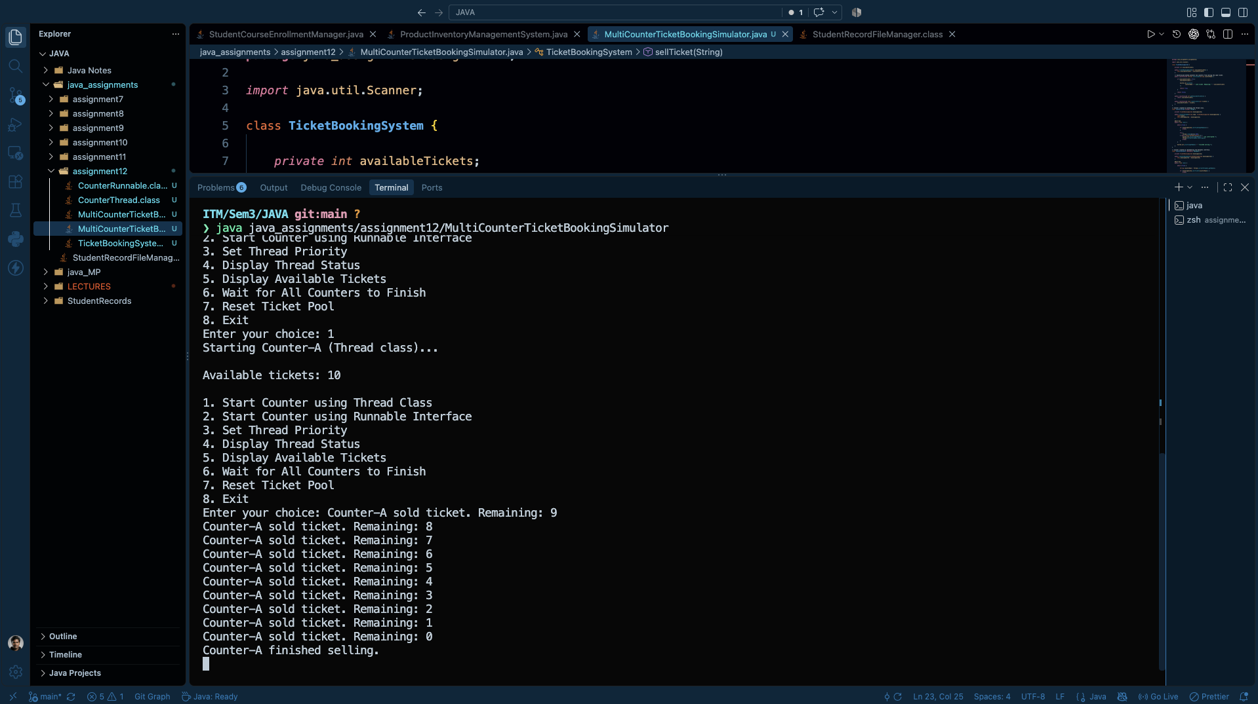
Figure 1 – Counter-A execution using the Thread class
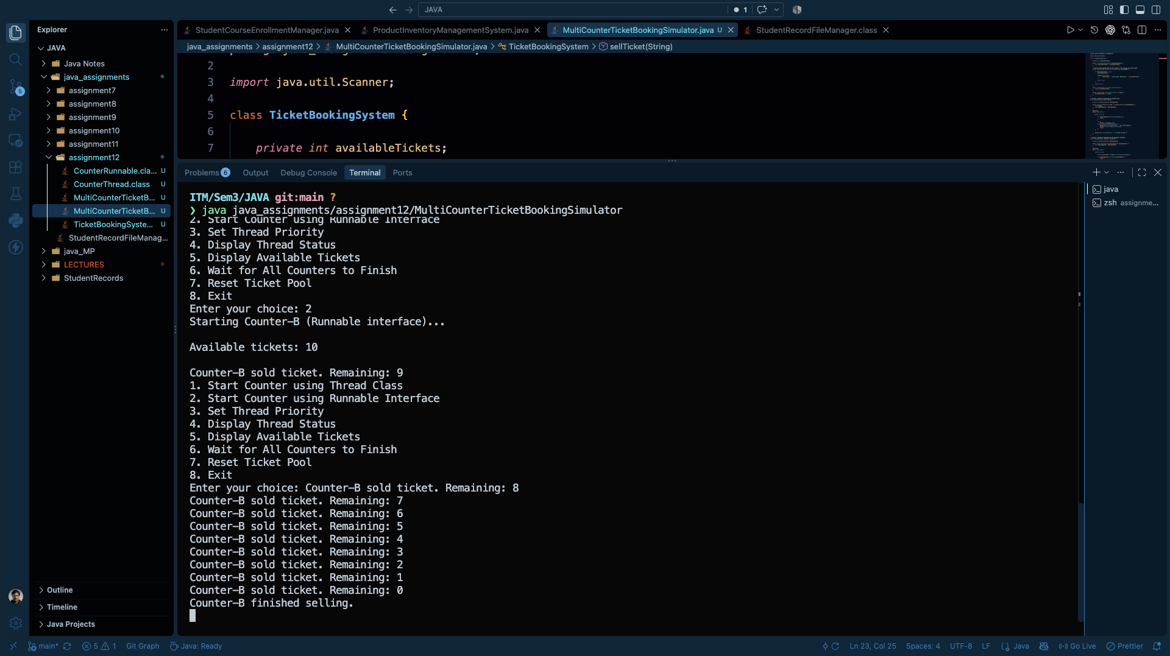
Figure 2 – Counter-B execution using the Runnable interface
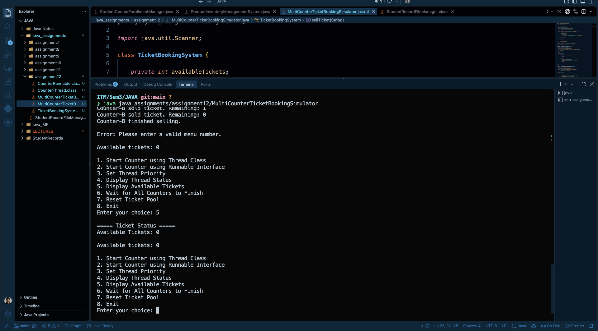
Figure 3 – Ticket status and reset/menu interaction
9. Observed Output
- The simulator starts with an available ticket count of 10.
- Counter-A and Counter-B can sell tickets concurrently.
- The output shows the remaining ticket count decreasing after successful sales.
- The synchronized operation prevents the shared count from being corrupted or oversold.
- The program displays the current ticket status through the menu.
10. Exception Handling
Thread.sleep() operations are handled with InterruptedException so an interrupted counter does not terminate the application unexpectedly. Menu input is also validated so invalid numeric choices can be reported with a meaningful error message.
11. Requirement Verification
Requirement | Implementation / Evidence | Status
Thread class | Implemented through Counter-A extending Thread. | ✓
Runnable interface | Implemented through Counter-B using Runnable. | ✓
start() and run() | Used to launch and execute counter tasks. | ✓
synchronized | Used to protect the shared ticket pool. | ✓
sleep() | Used to simulate time between ticket sales. | ✓
setPriority() | Used to configure counter thread priority. | ✓
getName(), getPriority(), isAlive() | Used for thread status information. | ✓
join() | Used to wait for counters to finish. | ✓
Scanner + switch + loop | Used for repeated menu-driven interaction. | ✓
Exception handling | Thread interruption and invalid menu input are handled. | ✓
12. Result
The Multi-Counter Ticket Booking Simulator was successfully implemented and executed. The program demonstrates both major approaches to creating threads in Java, controlled thread execution, synchronization of shared data, thread status inspection, and completion using join(). The execution screenshots provide evidence of the working menu and ticket-selling simulation.
13. Conclusion
This assignment demonstrates the practical use of Java multithreading. It shows why shared resources require synchronization when accessed by multiple threads and how Thread and Runnable provide two standard approaches for concurrent task execution. The simulator also demonstrates basic thread control and safe exception handling.

