JAVA PROGRAMMING
ASSIGNMENT REPORT
Assignment 13
Swing-Based Student Feedback Form

Student Name | Aaryan Kuchekar
Unit / Chapter | Unit 8 – GUI Programming with Swing
Topic | Layout Managers, Event Handling, Menus & Dialog Boxes
Assessment Type | Individual Coding Assignment

1. Objective
The objective of this assignment is to develop a Java Swing-based Student Feedback Form that demonstrates GUI layout management, event handling, menus, dialog boxes, and input validation. The application allows a student to enter feedback details and submit them to a displayed feedback list.

2. Problem Statement
The program implements a desktop feedback form using JFrame and Swing components. The interface contains fields for Name, Course, Rating, and Comments, along with a Submit Feedback button. A File menu provides Save Feedback, Clear Form, and Exit operations, while a Help menu provides an About dialog. Validation prevents empty names and handles non-numeric rating input using NumberFormatException.

3. Technologies and Java Concepts Used
- Java Swing: JFrame, JPanel, JLabel, JTextField, JTextArea, JButton, JMenuBar, JMenu, JMenuItem and JOptionPane.
- BorderLayout for arranging the major regions of the main window.
- GridLayout for arranging the feedback form labels and input fields.
- FlowLayout for arranging the submit button area.
- ActionListener for button and menu-item event handling.
- JOptionPane for confirmation, information, and error dialogs.
- NumberFormatException handling for invalid rating input.
- Scanner is not required for this GUI-based implementation because Swing text fields collect user input.

4. GUI Design and Layout
The main window is created as a JFrame titled “Student Feedback Form”. The overall content uses BorderLayout. The form panel uses GridLayout so that Name, Course, Rating, and Comments appear in aligned rows. The submit-button area uses FlowLayout, and the submitted feedback is displayed in a JTextArea.

5. Menu Bar and Dialog Operations
Menu / Component | Operation | Java Concept
Submit Feedback | Reads fields and appends formatted feedback | ActionListener
File → Save Feedback | Performs the same submission operation | JMenuItem + ActionListener
File → Clear Form | Clears all input fields | ActionListener
File → Exit | Asks for confirmation before closing | JOptionPane.showConfirmDialog()
Help → About | Displays application information | JOptionPane.showMessageDialog()

6. Input Validation and Exception Handling
Before feedback is submitted, the program checks that the Name field is not empty. If it is empty, an error dialog is displayed. The Rating field is converted from text to a number inside a try-catch block. If the user enters a non-numeric value, NumberFormatException is caught and a meaningful error dialog is displayed instead of allowing the application to fail.

7. Implementation Evidence
The following screenshots document the implemented Swing application and its source code. The first screenshot shows the running Student Feedback Form window with its File and Help menus, form fields, Submit Feedback button, and Submitted Feedback area. The second screenshot shows the Java source implementation in VS Code, including the JFrame setup, form components, and layout code.
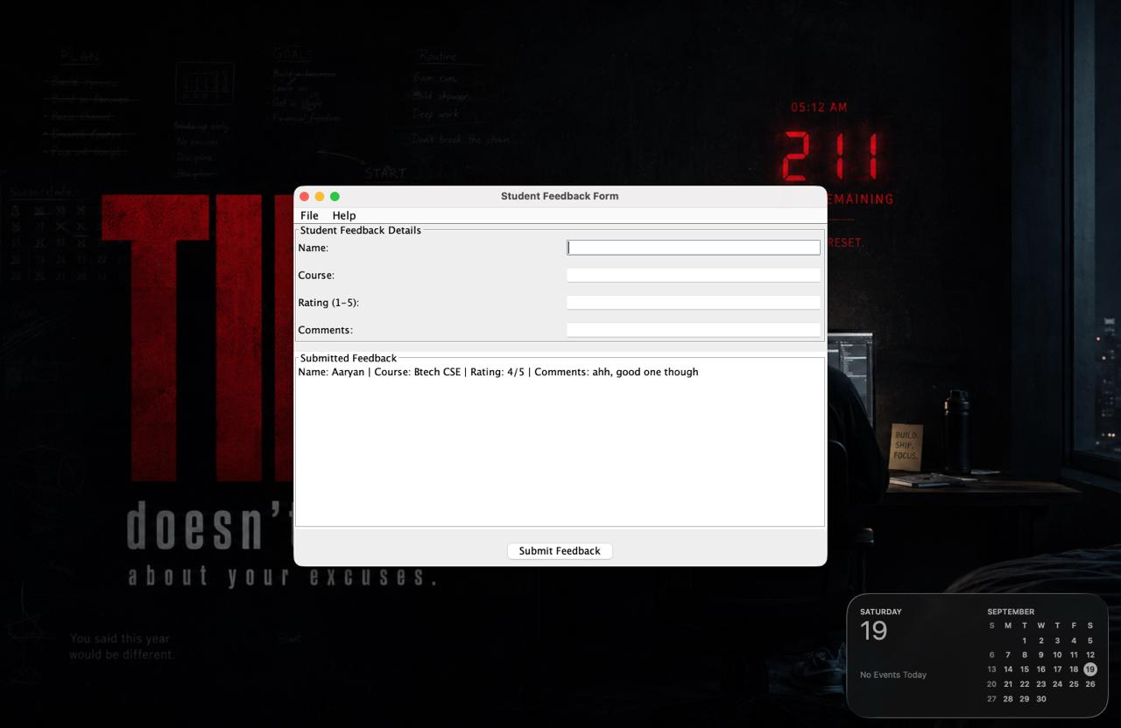
Figure 1: Running Student Feedback Form application
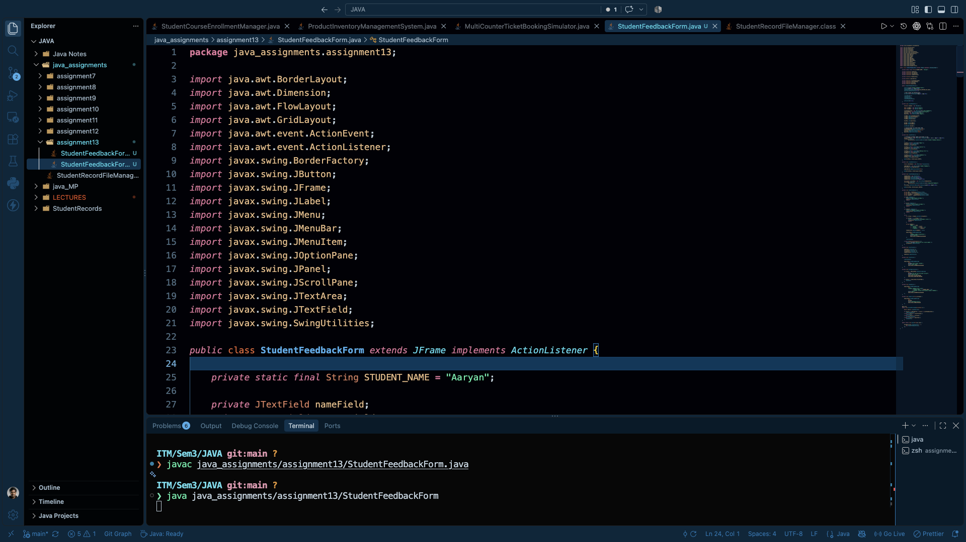
Figure 2: StudentFeedbackForm.java implementation in VS Code

8. Requirement Verification
Requirement | Implementation / Evidence
BorderLayout | Used for the main JFrame arrangement.
GridLayout | Used for the form labels and input fields.
ActionListener | Handles Submit and menu-item actions.
JMenuBar / JMenu / JMenuItem | File and Help menus are included.
JOptionPane | Used for exit confirmation, About information, and validation errors.
Name validation | Empty Name input is rejected.
NumberFormatException | Invalid numeric Rating input is handled with try-catch.
JTextArea | Submitted feedback entries are displayed in the feedback area.

9. Result
The Student Feedback Form was successfully implemented as a Java Swing GUI application. The application demonstrates the required layout managers, event handling, menu system, dialog boxes, input validation, and exception handling. The screenshots provide implementation evidence for the completed program.

10. Conclusion
This assignment provided practical experience with Java Swing and GUI programming. The implementation demonstrates how layout managers organize interface components, how ActionListener responds to user actions, and how menus and JOptionPane dialogs improve application interaction. Exception handling and validation also make the application safer and more user-friendly.

