Aryan Sharma 8025320024 PCS223 — Advanced Computer Networks Lab
Network Topologies in Cisco Packet Tracer
Assignment 3

Objective
To create simple network topologies using Cisco Packet Tracer and verify connectivity using PING command.

Screenshots & Observations
Screenshot 1: Q1 — PC to PC Direct (Crossover Cable)
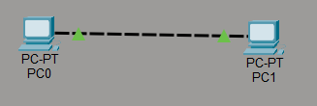________________________________________________________________________
Screenshot 2: Q1 — Ping Test PC1 to PC2
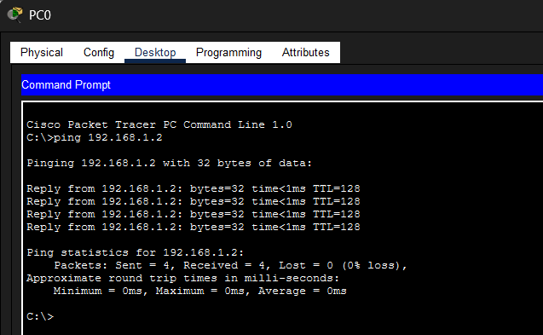

Screenshot 3: Q2 — PC to Router
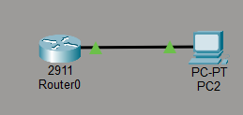________________________________________________________________________
Screenshot 4: Q2 — Ping Test
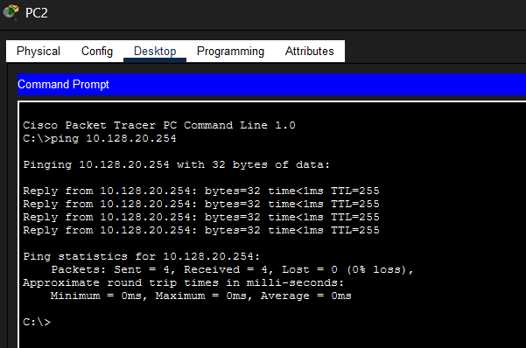
________________________________________________________________________
Screenshot 5: Q3 — 2 PCs via Hub
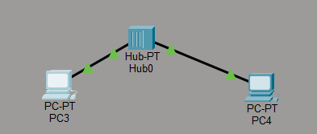
________________________________________________________________________
Screenshot 6: Q3 — Ping Test
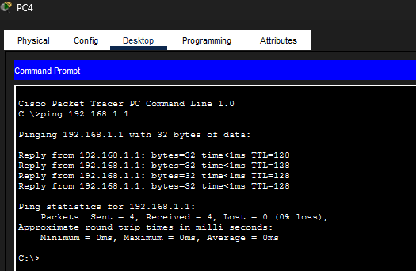
________________________________________________________________________
Screenshot 7: Q4 — 2 PCs via Switch
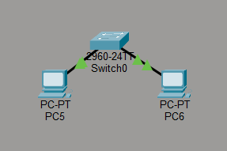
________________________________________________________________________
Screenshot 8: Q4 — Ping Test
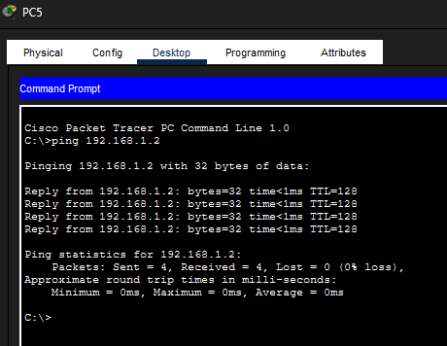
________________________________________________________________________
Screenshot 9: Q5a — Bus Topology (Single Hub, 6 PCs)
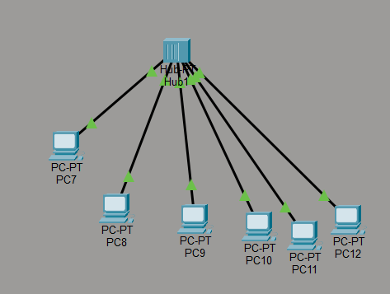 ________________________________________________________________________

Screenshot 10: Q5b — Bus Topology (Two Hubs)
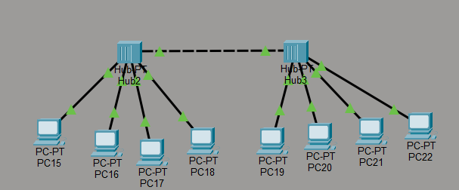
________________________________________________________________________
Screenshot 11: Q6 — Ring Topology (3 Hubs)
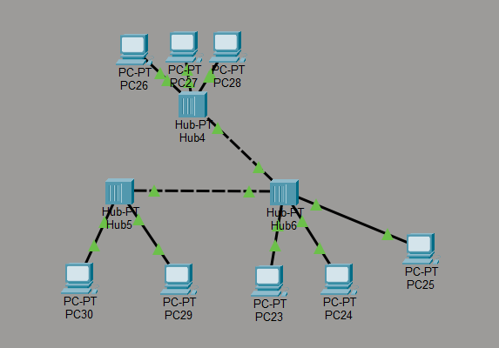 ________________________________________________________________________

Screenshot 12: Q7 — Ring Topology (Switch-based)
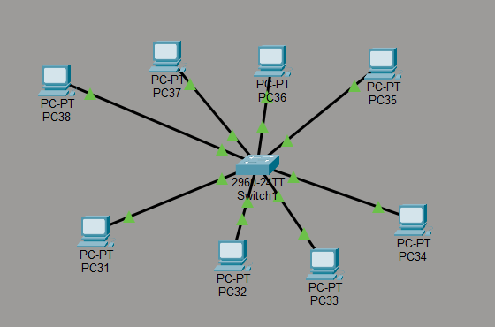
________________________________________________________________________
Screenshot 13: Q8 — Tree Topology
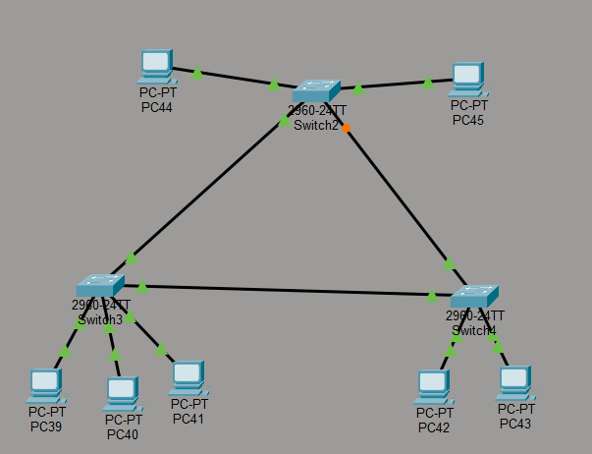
________________________________________________________________________
Screenshot 14: Q8 — Ping Test (cross-branch)
