Aryan Sharma 8025320024 PCS223 — Advanced Computer Networks Lab
RIP Version 2 Dynamic Routing
Assignment 6

Objective
To configure and verify RIP Version 2 routing protocol on a 3-router topology and observe automatic route propagation.

Screenshots & Observations
Screenshot 1: Physical Topology
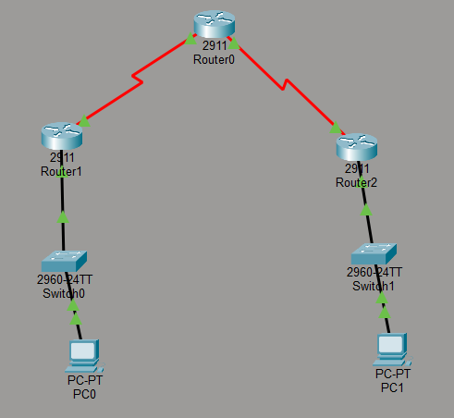________________________________________________________________________
Screenshot 2: R1 — Interface Configuration
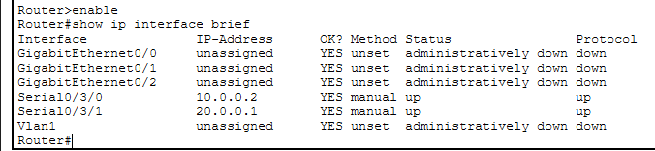________________________________________________________________________
Screenshot 3: R2 — Interface Configuration
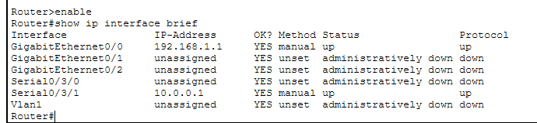
________________________________________________________________________
Screenshot 4: R3 — Interface Configuration
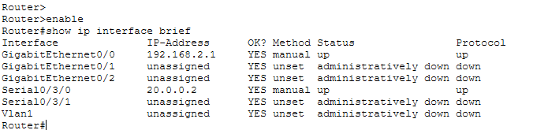________________________________________________________________________
Screenshot 5: R1 — Routing Table with R routes
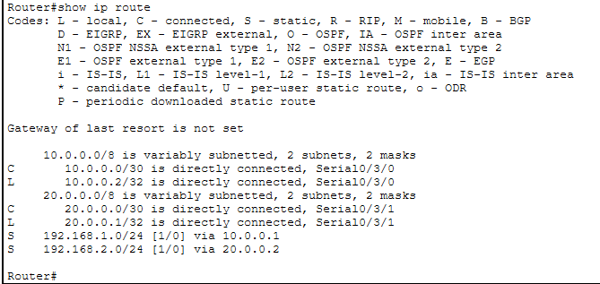________________________________________________________________________

Screenshot 6: R2 — Routing Table with R routes
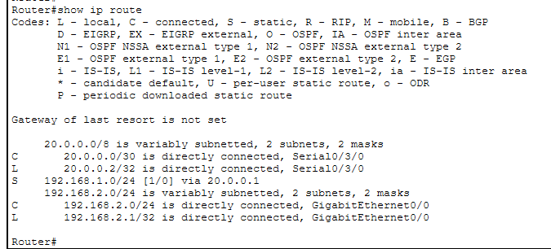________________________________________________________________________
Screenshot 7: PC1 Ping to PC2


