Aryan Sharma 8025320024 PCS223 — Advanced Computer Networks Lab
OSPF Link State Routing
Assignment 7

Objective
To configure OSPF (Open Shortest Path First) routing on a 3-router topology, analyze the Link State Database, and verify route selection using SPF algorithm and OSPF cost.

Screenshots & Observations
Screenshot 1: Physical Topology — All Green
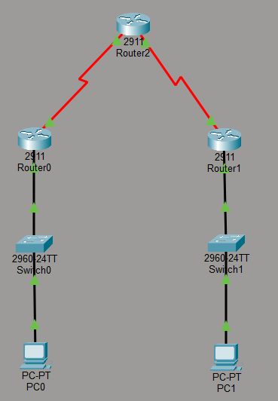________________________________________________________________________
Screenshot 2: OSPF Neighbor Table — FULL state
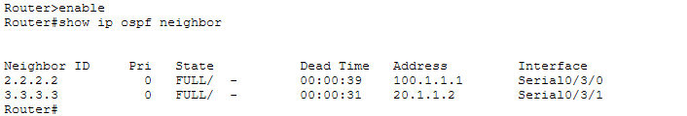________________________________________________________________________
Screenshot 3: Routing Table
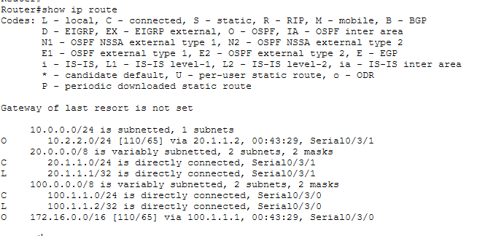________________________________________________________________________
Screenshot 4: OSPF Link State Database
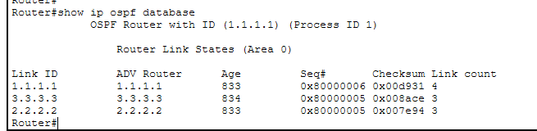________________________________________________________________________
Screenshot 5: PC0 Ping to PC1
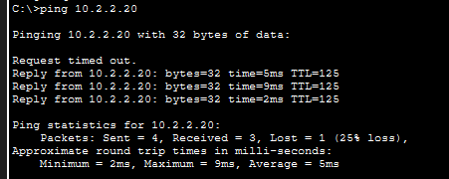________________________________________________________________________
Screenshot 6: Traceroute PC0 to PC1


