CIA-3 PROJECT DEVELOPMENT — SUBMISSION REPORT
Christ University • 5th Semester
Field | Detail
Project Code & Title | P19 — Online Grocery Delivery Platform
Domain | Quick Commerce / Grocery
Course Name | Backend Development with Node.js, Express, and Mongo
Section / Batch | 5 BTCS B
Semester | 5th Semester
Team Number | 19

Team Details
S.No | Student Name | Roll No. | Department | Section
1 | A Aaryan Dharrmik | 2460301 | B.Tech CSE | 5 BTCS B
2 | Abhishek R | 2460307 | B.Tech CSE | 5 BTCS B
3 | Adriel B John | 2460314 | B.Tech CSE | 5 BTCS B
4 | Abhay Job K J | 2460485 | B.Tech CSE | 5 BTCS B

GitHub Repository: https://github.com/Aaryan658/L-T-5th-sem-grocery-delivery-platform
The repository is public and contains the complete Node.js + Express.js + MongoDB source code, a README.md (project title, team details, module list, setup steps, API endpoints), a .gitignore, a .env.example, and the exported Postman collection. node_modules and .env are excluded from version control.

Table of Contents
Table of Contents 2
1. Project Overview 4
1.1 Problem Statement 4
1.2 Objectives 4
1.3 Scope & Boundaries 4
1.4 Technology Stack 4
1.5 Summary of Implemented Modules 5
2. System Architecture 6
2.1 Request Pipeline 6
2.2 Project Structure 6
2.3 Response Envelope 6
3. Database Design 7
3.1 Collections 7
3.2 Reference vs. Embed Reasoning 7
3.3 Indexes 8
3.4 Entity Relationships 8
3.5 Order Status State Machine 8
4. Functional Modules & Evidence 9
4.1 Module 1 — User Registration & Authentication 9
4.2 Module 2 — Dark-Store Management 11
4.3 Module 3 — Product Catalog & Store-Wise Stock 12
4.4 Module 4 — Order Placement with Nearest-Store Check 13
4.5 Module 5 — Order Picking & Packing Workflow 15
4.6 Module 6 — Delivery Partner Assignment 16
4.7 Module 7 — Delivery Status Tracking 17
4.8 Module 8 — Real-Time Order Status for Customer 19
4.9 Module 9 — Stock Replenishment Alerts 21
4.10 Module 10 — Delivery Time Slot Selection 22
4.11 Module 11 — Customer Order History & Reorder 23
4.12 Module 12 — Store & Delivery Performance Reports 24
4.13 Module 13 — Role-Based Access Control 25
5. Complete API Endpoint Reference 28
5.1 Auth 28
5.2 Dark-Stores & Store Stock 28
5.3 Products 28
5.4 Orders 28
5.5 Delivery Partners, Slots & Admin Reports 29
6. Testing, Validation & Error Handling 30
6.1 Negative & Edge Cases 30
6.2 Validation & Error-Handling Design 31
7. Setup & Run Instructions 33
7.1 Seed Accounts 33
8. Known Limitations 33
9. Learnings & Challenges 34
10. Conclusion 34

1. Project Overview
The Online Grocery Delivery Platform (P19) is a backend-focused quick-commerce system. It lets customers order daily essentials for home delivery, lets dark-store staff pick and pack those orders from live per-store inventory, and lets delivery partners handle last-mile delivery — all tracked through one unified order pipeline with role-based access for four roles: Customer, Store Staff, Delivery Partner, and Admin.
The system is delivered as a REST API built with Node.js and Express.js, backed by MongoDB (Mongoose ODM). Authentication uses JSON Web Tokens with bcrypt password hashing; every request body is validated with Joi before it reaches business logic; and every response follows a single JSON envelope. A small vanilla HTML/CSS/JS frontend is included to demonstrate every role's flow live, and a Postman collection covers every endpoint.

1.1 Problem Statement
Quick-commerce grocery delivery needs a backend that lets customers order daily essentials for home delivery, lets dark-store staff pick and pack those orders from live per-store inventory, and lets delivery partners handle last-mile delivery, all tracked through one unified order pipeline with role-based access for Customer, Store Staff, Delivery Partner, and Admin.

1.2 Objectives
- Provide secure registration and login for four distinct user roles using JWT and hashed passwords.
- Manage multiple dark-stores, a shared product catalog, and independent per-store stock levels.
- Resolve a customer's nearest serviceable store by pincode and validate stock before an order is accepted.
- Model the full order lifecycle as an explicit, guarded state machine (placed to picking to packed to assigned to out-for-delivery to delivered).
- Let store staff run a picking/packing queue and let delivery partners update live delivery status.
- Give customers real-time order status with a complete status-history timeline, order history, and one-tap reorder.
- Support delivery time-slot selection, low-stock replenishment alerts, and an admin performance report.
- Enforce access control at the route level (by role) and at the record level (a user only sees orders it is party to).

1.3 Scope & Boundaries
In scope: the complete order pipeline, inventory, RBAC, slots, alerts and reporting as REST endpoints, plus a demo UI and Postman collection. Out of scope (not mocked beyond the nearest-store-by-pincode lookup): online payments, SMS/email notifications, and maps/geolocation routing.

1.4 Technology Stack
Layer | Technology
Runtime / Framework | Node.js 18+, Express.js 4
Database / ODM | MongoDB, Mongoose 7
Authentication | jsonwebtoken (JWT), bcrypt password hashing
Validation | Joi schemas via a validate() middleware on every write route
API testing / docs | Postman collection (all endpoints, auto-captured token)
Demo frontend | Vanilla HTML / CSS / JavaScript, served statically by Express
Config | dotenv (.env), central config/constants.js for business constants

1.5 Summary of Implemented Modules
All 13 planned modules are implemented and working (minimum required: 12).
# | Module | Status
1 | User Registration & Authentication | Implemented
2 | Dark-Store Management | Implemented
3 | Product Catalog & Store-Wise Stock | Implemented
4 | Order Placement with Nearest-Store Check | Implemented
5 | Order Picking & Packing Workflow | Implemented
6 | Delivery Partner Assignment | Implemented
7 | Delivery Status Tracking | Implemented
8 | Real-Time Order Status for Customer | Implemented
9 | Stock Replenishment Alerts | Implemented
10 | Delivery Time Slot Selection | Implemented
11 | Customer Order History & Reorder | Implemented
12 | Store & Delivery Performance Reports | Implemented
13 | Role-Based Access Control | Implemented

2. System Architecture
The backend is a layered Express application. A request flows through the layers top to bottom, and any error at any layer is converted to the standard JSON error envelope by a single central error handler.

2.1 Request Pipeline
HTTP request
-> CORS + express.json() body parsing
-> Route (routes/*.js) maps URL + method to a controller
-> protect (middleware/auth.js) verifies JWT, loads live user -> req.user
-> authorize(...roles) route-level role allow-list (RBAC)
-> validate(schema) Joi validates + strips the request body
-> Controller (controllers/*.js) business logic, record-level checks
-> Model (models/*.js) Mongoose schema + indexes -> MongoDB
-> apiResponse.success/error single JSON envelope
-> notFound + errorHandler catch-all -> clean JSON, never a stack trace

2.2 Project Structure
backend/
config/ db.js (Mongo connection), constants.js (business constants)
models/ Mongoose schemas, one file per collection
routes/ Express routes, grouped by resource
controllers/ business logic for each route
middleware/ auth.js, authorize.js, validate.js, errorHandler.js, notFound.js
validators/ Joi schemas per resource
utils/ jwt, hash, apiResponse, asyncHandler, slots, ApiError
seed.js demo data (2 stores, 6 products, stock, 1 user per role)
server.js app entry point, wires every route
frontend/ optional static demo UI (served at /)
postman/ exported Postman collection covering every endpoint
docs/ ER notes, team split, screenshot runbook

2.3 Response Envelope
Every endpoint returns one of these two shapes, so the client never has to special-case a route:
{ "success": true, "message": "...", "data": { ... } }
{ "success": false, "message": "...", "errorCode": "VALIDATION_ERROR" }

3. Database Design
MongoDB with six collections. The design deliberately mixes referencing and embedding: shared, independently-updated entities are referenced by ObjectId; small sub-documents that are always read with their parent (and, for orders, must be frozen as a point-in-time snapshot) are embedded.

3.1 Collections
Collection | Purpose | Key Fields
users | Every account: customer, storeStaff, deliveryPartner, admin | name, email (unique), passwordHash, role, storeId (staff only), addresses[] (embedded)
darkStores | Fulfilment locations | name (unique), area, serviceablePincodes[] (embedded), location, isActive
products | Master catalog, store-agnostic | name, category, unit, price, isActive
storeStock | Per-store quantity for each product | storeId (ref), productId (ref), quantity, reorderPoint
orders | The unified order pipeline | customerId/storeId/deliveryPartnerId (ref), items[] (embedded snapshot), pricing (embedded), deliverySlot (embedded), status, statusHistory[] (embedded), packedAt, deliveredAt
deliveryPartners | Operational profile for a deliveryPartner user | userId (ref, unique), vehicleType, isAvailable, currentStoreId (ref)

3.2 Reference vs. Embed Reasoning
Data | Choice | Why
order.items[] | Embedded | Always read with the order; price/name frozen as a snapshot of the moment of purchase so a later catalog price change never rewrites a past invoice; never queried on their own.
order.pricing, order.deliverySlot | Embedded | Small, single-purpose, only ever meaningful attached to their one order.
order.statusHistory[] | Embedded | Small append-only audit trail; always read with the order to render its timeline (Module 8).
user.addresses[] | Embedded | Small, rarely updated independently, always needed inline when placing an order.
darkStore.serviceablePincodes[] | Embedded | The nearest-store check needs the whole list in one read; edited only alongside the store.
storeStock (storeId, productId) | Referenced | Large in aggregate, queried independently of both parents, updated on its own every order; embedding would rewrite a whole store/product doc per quantity change.
deliveryPartners.userId | Referenced | isAvailable is write-hot; assignment queries scan this collection alone without the rest of the user profile.
order.customerId / storeId / deliveryPartnerId | Referenced | Shared across many orders, updated independently of any single order.

3.3 Indexes
Collection | Index | Reason
users | { email: 1 } unique | Enforces uniqueness, speeds up login lookups
users | { role: 1, storeId: 1 } | 'staff of store X' lookups
darkStores | { name: 1 } unique | Prevents duplicate store names
darkStores | { serviceablePincodes: 1 } | Nearest-store-by-pincode check
products | { name: 1 }, { category: 1 } | Catalog browsing / search
storeStock | { storeId: 1, productId: 1 } unique | One stock row per store/product pair; blocks duplicates under a race
storeStock | { productId: 1 } | 'which stores carry this product' queries
orders | { customerId: 1, createdAt: -1 } | Customer order history (Module 11)
orders | { storeId: 1, status: 1, createdAt: -1 } | Store picking queue + performance report (Modules 5, 12)
orders | { deliveryPartnerId: 1, status: 1 } | A partner's active deliveries (Modules 6, 7)
deliveryPartners | { userId: 1 } unique | One partner profile per user
deliveryPartners | { isAvailable: 1, currentStoreId: 1 } | Assignment queries (Module 6)

3.4 Entity Relationships
users (role=customer) places >-- orders
users (role=storeStaff) belongs to --< darkStores
users (role=deliveryPartner) has --1 deliveryPartners profile
darkStores stocks >-- storeStock rows
darkStores fulfils >-- orders
products appears in >-- storeStock rows
products snapshotted >-- order.items[] (embedded copy, not a live ref)
orders assigned to --1 deliveryPartners (via deliveryPartnerId -> users)
orders embeds: items[], pricing, deliverySlot, statusHistory[]

3.5 Order Status State Machine
Every transition is declared in config/constants.js (ORDER_STATUS_FLOW). The controller rejects any transition not in the allow-list with 409 INVALID_TRANSITION, so a caller can never push an order into an illegal state.
placed -> picking | cancelled
picking -> packed | cancelled
packed -> assigned | cancelled
assigned -> out-for-delivery | cancelled
out-for-delivery -> delivered | failed
delivered / failed / cancelled -> (terminal)

4. Functional Modules & Evidence
Each module below lists its purpose, its endpoints, and a request/response screenshot captured against the live backend (Postman) and/or the demo UI.

4.1 Module 1 — User Registration & Authentication
Public register and login endpoints. Passwords are bcrypt-hashed (passwordHash, select:false). Login and register both return a signed JWT ({ id, role }) that every protected route consumes. Registering as a deliveryPartner also auto-creates the matching deliveryPartners operational profile. GET /auth/me returns the live user record decoded from the token.
Endpoints:
POST /api/auth/register Public Register customer / staff / partner / admin
POST /api/auth/login Public Login, returns JWT
GET /api/auth/me Any Current authenticated user
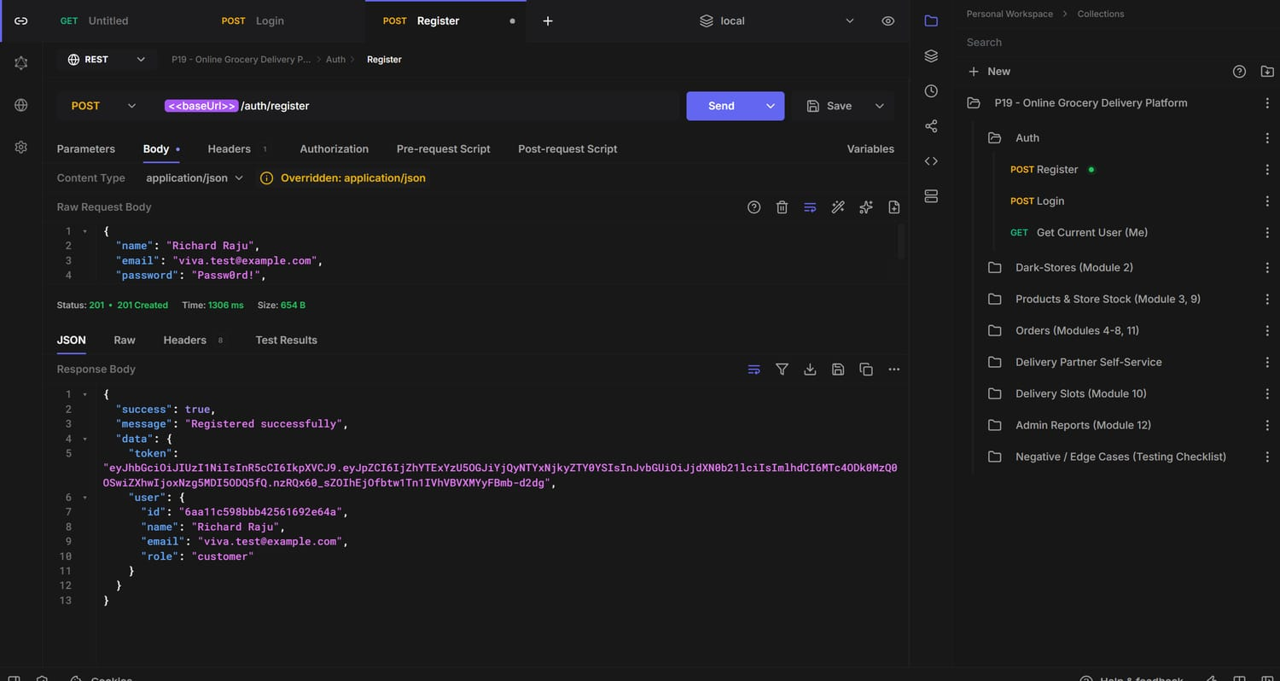
Postman — POST /api/auth/register -> 201 Registered successfully (token returned)
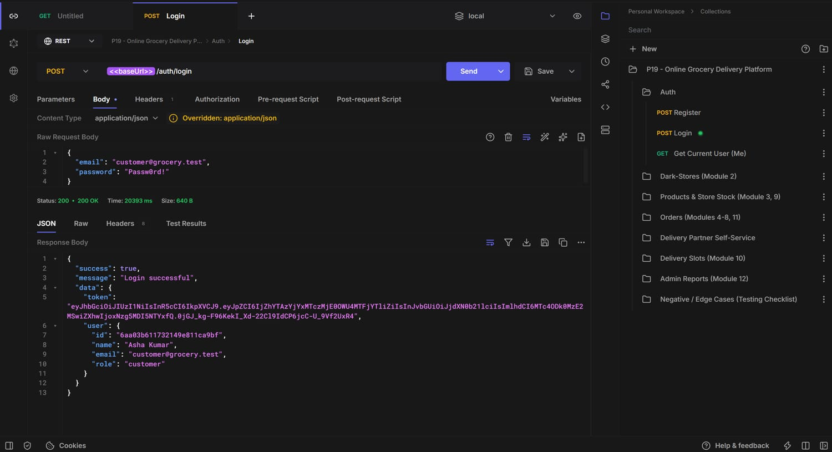
Postman — POST /api/auth/login -> 200 Login successful; token auto-captured
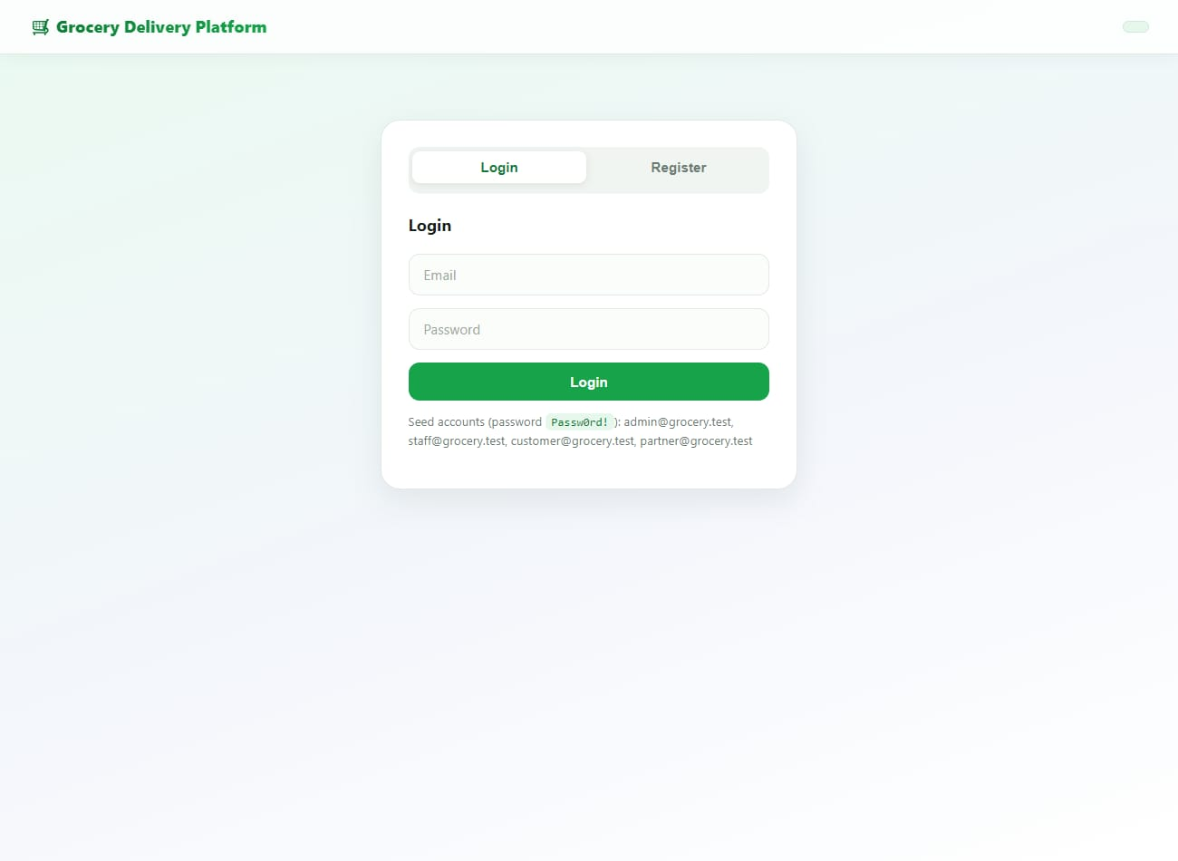
Demo UI — login screen with seed-account hint
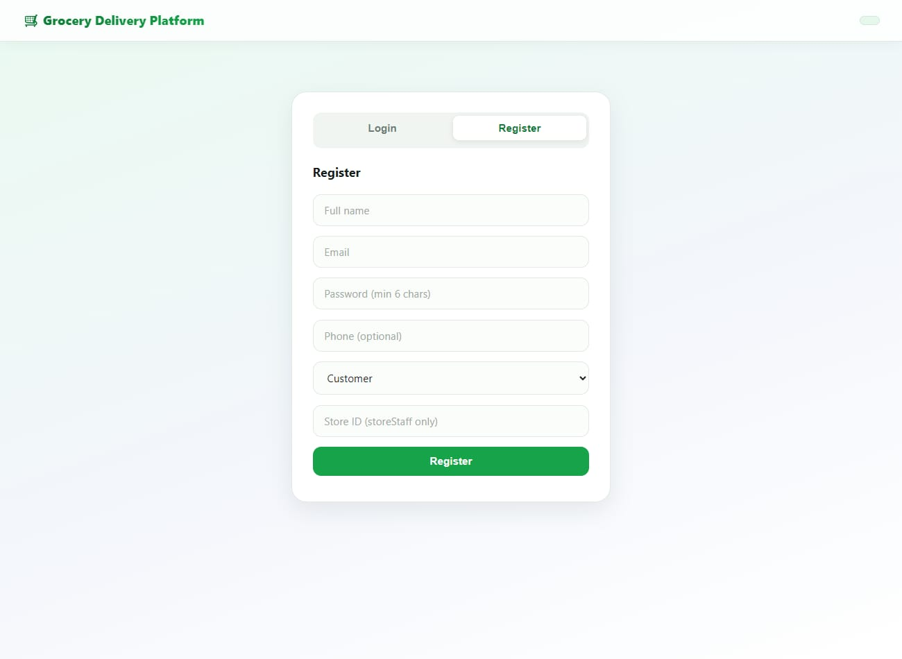
Demo UI — registration form (role selector for all four roles)
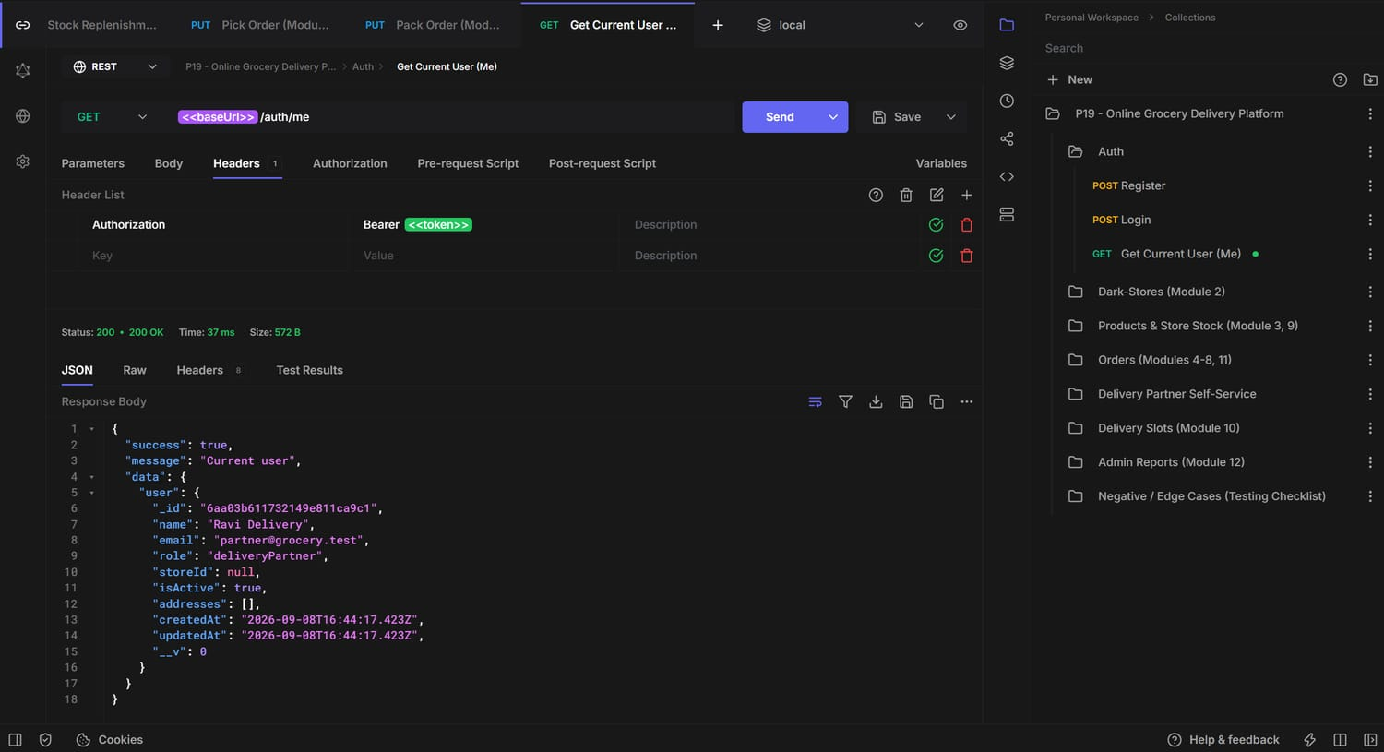
Postman — GET /api/auth/me -> 200 Current user

4.2 Module 2 — Dark-Store Management
Admin CRUD over dark-stores. Browsing is open to any authenticated user so a customer can resolve their nearest store; writes are admin-only. Delete is a soft delete (isActive:false) so historical orders and stock rows stay intact.
Endpoints:
POST /api/stores Admin Create a dark-store
GET /api/stores Any List dark-stores
GET /api/stores/:id Any Get one store
PUT /api/stores/:id Admin Update a store
DELETE /api/stores/:id Admin Deactivate a store (soft delete)
GET /api/stores/nearest?pincode= Any Nearest-store check by pincode
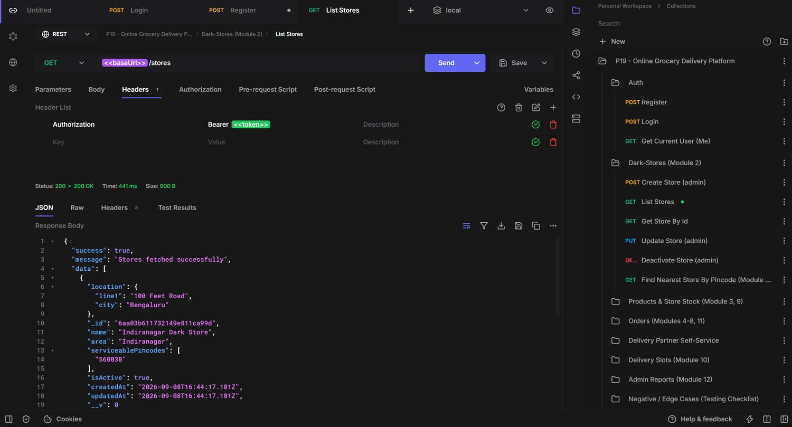
Postman — GET /api/stores -> 200 Stores fetched successfully

4.3 Module 3 — Product Catalog & Store-Wise Stock
A store-agnostic master catalog (products) plus a separate storeStock collection holding quantity and reorderPoint for each (store, product) pair. Catalog browse/search is open to any authenticated role; catalog writes are admin-only; stock is managed by admin and the staff of that store. A unique compound index on (storeId, productId) guarantees exactly one stock row per pair.
Endpoints:
GET /api/products?category=&search= Any Browse / search products
POST /api/products Admin Create a product
GET /api/stores/:storeId/stock Admin/Staff List a store's stock
POST /api/stores/:storeId/stock Admin/Staff Upsert stock for a product
PUT /api/stores/:storeId/stock/:productId Admin/Staff Update quantity / reorderPoint
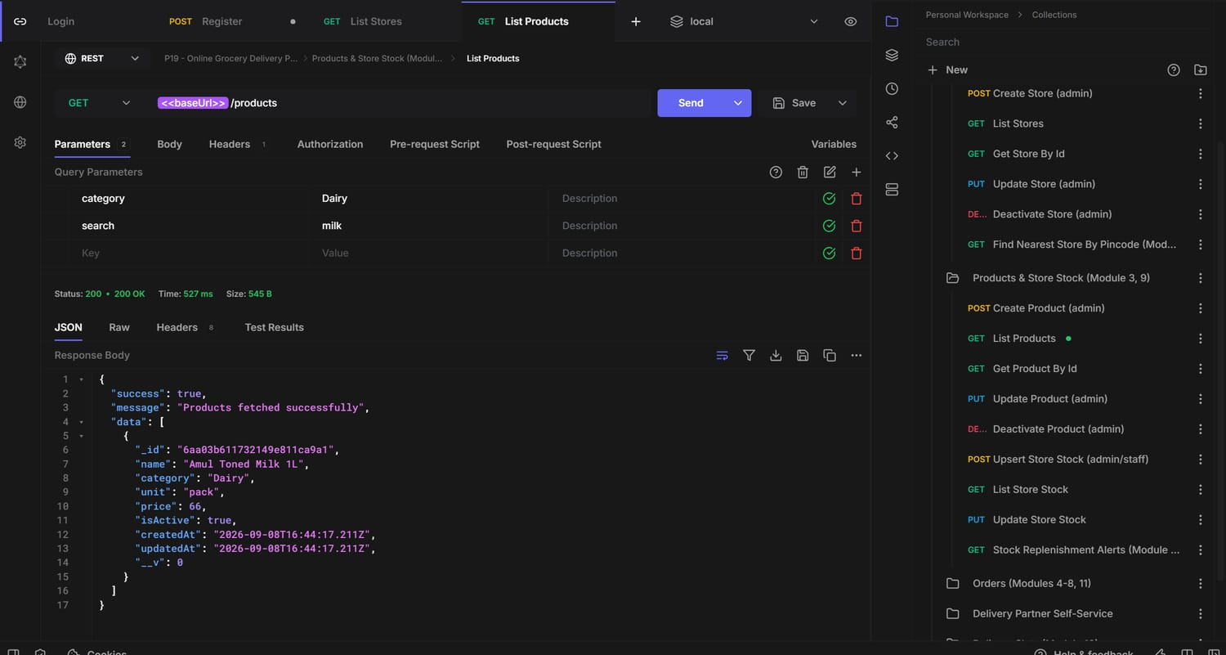
Postman — GET /api/products -> 200 Products fetched successfully
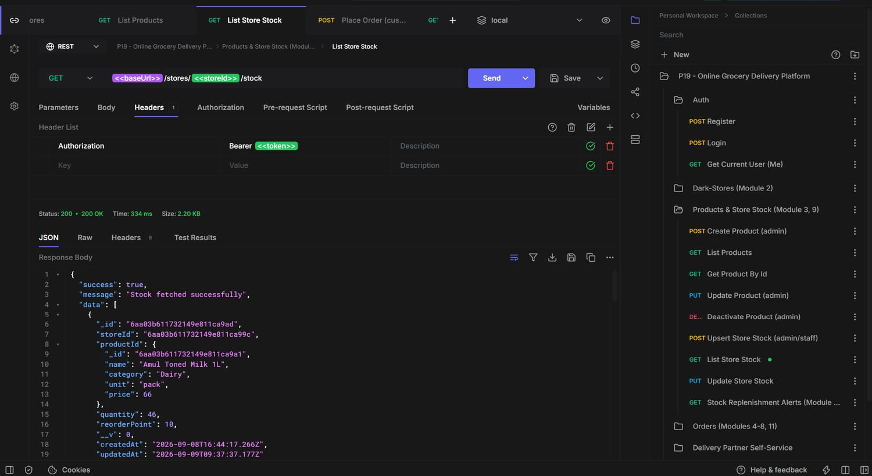
Postman — GET /api/stores/:storeId/stock -> 200 Stock fetched successfully (6 rows)

4.4 Module 4 — Order Placement with Nearest-Store Check
Customer-only. The controller (a) optionally validates the chosen delivery slot, (b) resolves the serviceable store for the pincode, (c) checks live stock for every requested line item at that store and rejects the whole order if any item is short (409 OUT_OF_STOCK, with a message naming the product, store, requested and available quantity), (d) computes pricing (flat Rs 30 delivery fee, free above Rs 499), (e) decrements stock, and (f) writes the order with a frozen item snapshot and an initial 'placed' status event.
Endpoints:
POST /api/orders Customer Place an order (nearest-store + stock check)
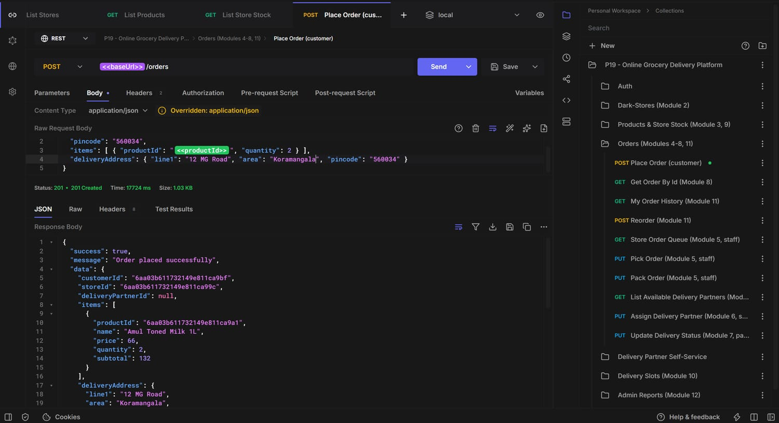
Postman — POST /api/orders -> 201 Order placed successfully (itemsTotal 132, deliveryFee 30, total 162)
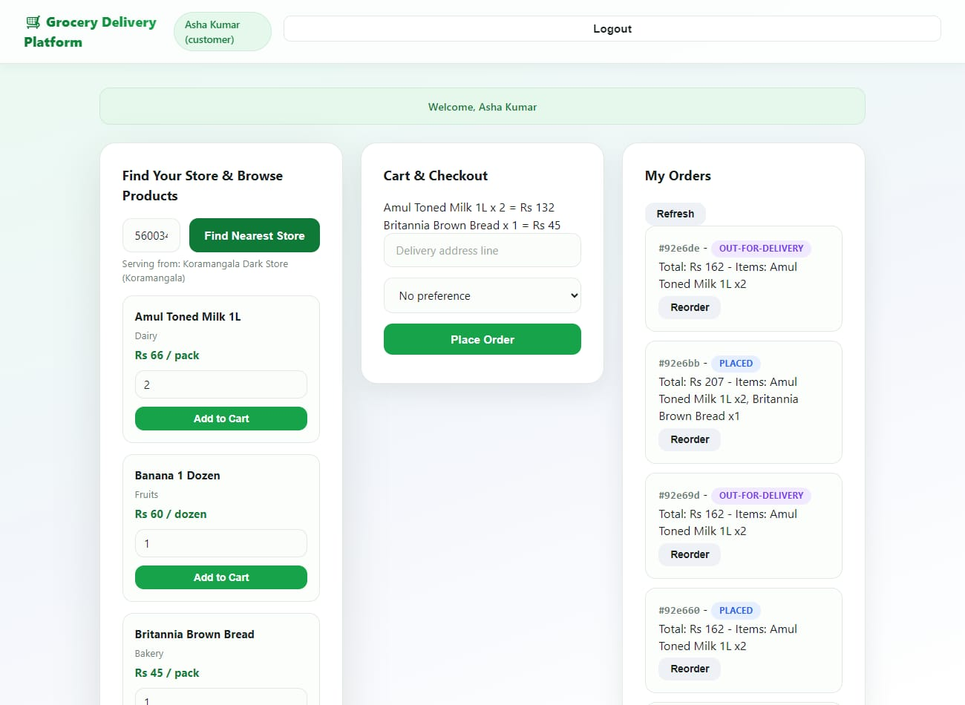
Demo UI — customer finds nearest store by pincode, browses products, builds a cart and checks out

4.5 Module 5 — Order Picking & Packing Workflow
Store staff (and admin) move an order through picking -> packed via two guarded transitions. Packing stamps packedAt (used later by the performance report). Staff also have a per-store order queue filtered by status. Every transition is checked against ORDER_STATUS_FLOW and against the record-level canAccessOrder guard (staff can only act on their own store's orders).
Endpoints:
GET /api/stores/:storeId/orders?status= Admin/Staff Store picking / packing queue
PUT /api/orders/:id/pick Staff/Admin Mark items being picked (-> picking)
PUT /api/orders/:id/pack Staff/Admin Mark order packed (-> packed)
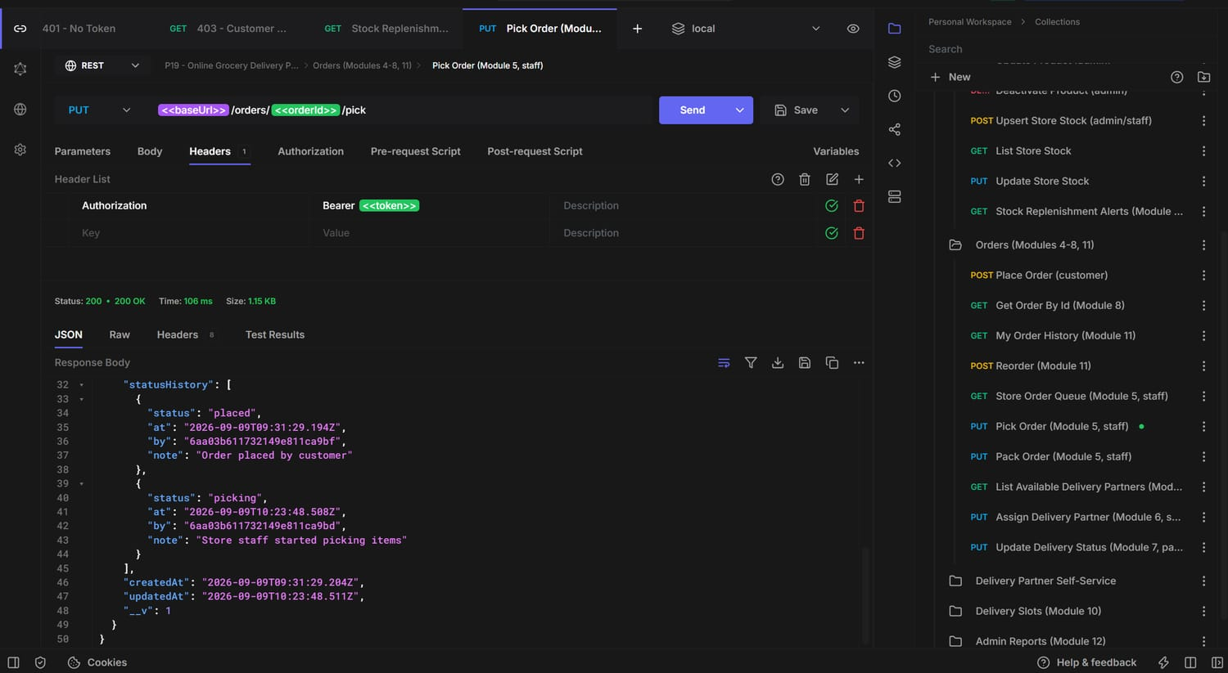
Postman — PUT /api/orders/:id/pick -> 200 Order moved to picking
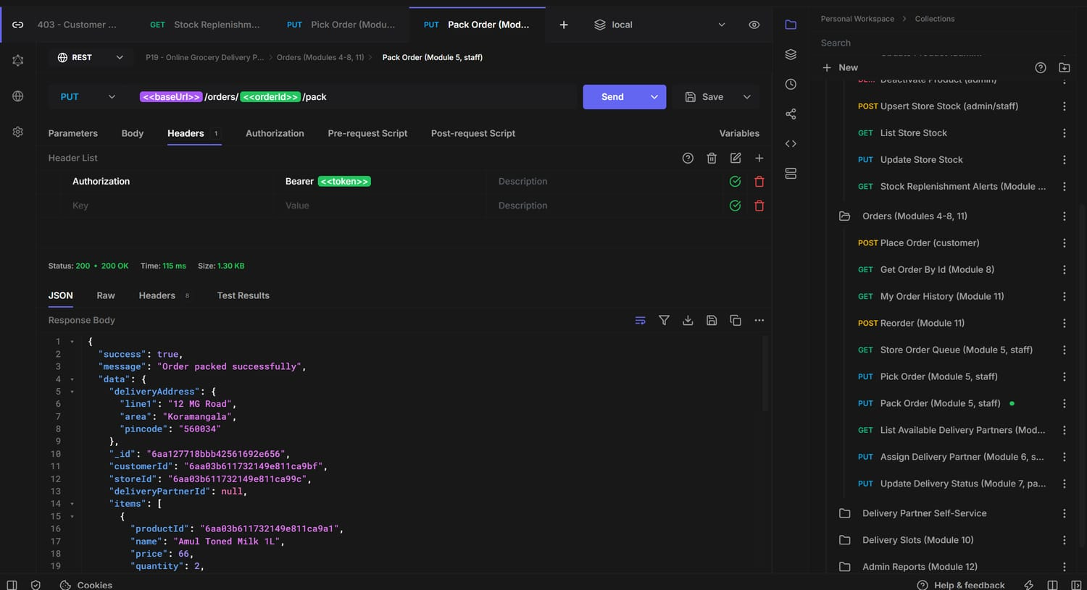
Postman — PUT /api/orders/:id/pack -> 200 Order packed successfully (packedAt set)
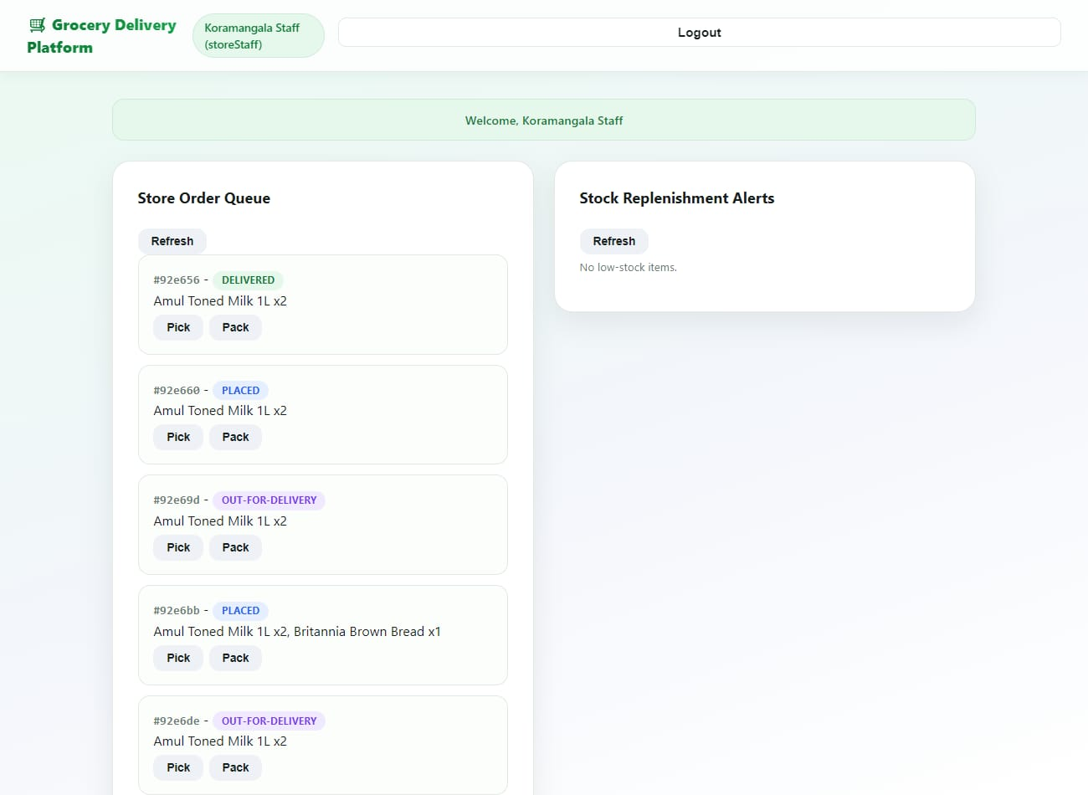
Demo UI — store staff order queue with Pick / Pack actions and status pills

4.6 Module 6 — Delivery Partner Assignment
Staff/admin dispatch a packed order to an available delivery partner. The controller verifies the target transition (packed -> assigned), that the partner profile exists, and that isAvailable is true (else 409 PARTNER_UNAVAILABLE); it then sets order.deliveryPartnerId, flips the partner to unavailable, and records the partner's currentStoreId. Supporting endpoints list available partners and let a partner toggle their own availability.
Endpoints:
GET /api/delivery-partners/available?storeId= Staff/Admin List available partners
GET /api/delivery-partners/me Partner My partner profile
PUT /api/delivery-partners/me/availability Partner Toggle availability
PUT /api/orders/:id/assign Staff/Admin Assign a delivery partner (-> assigned)
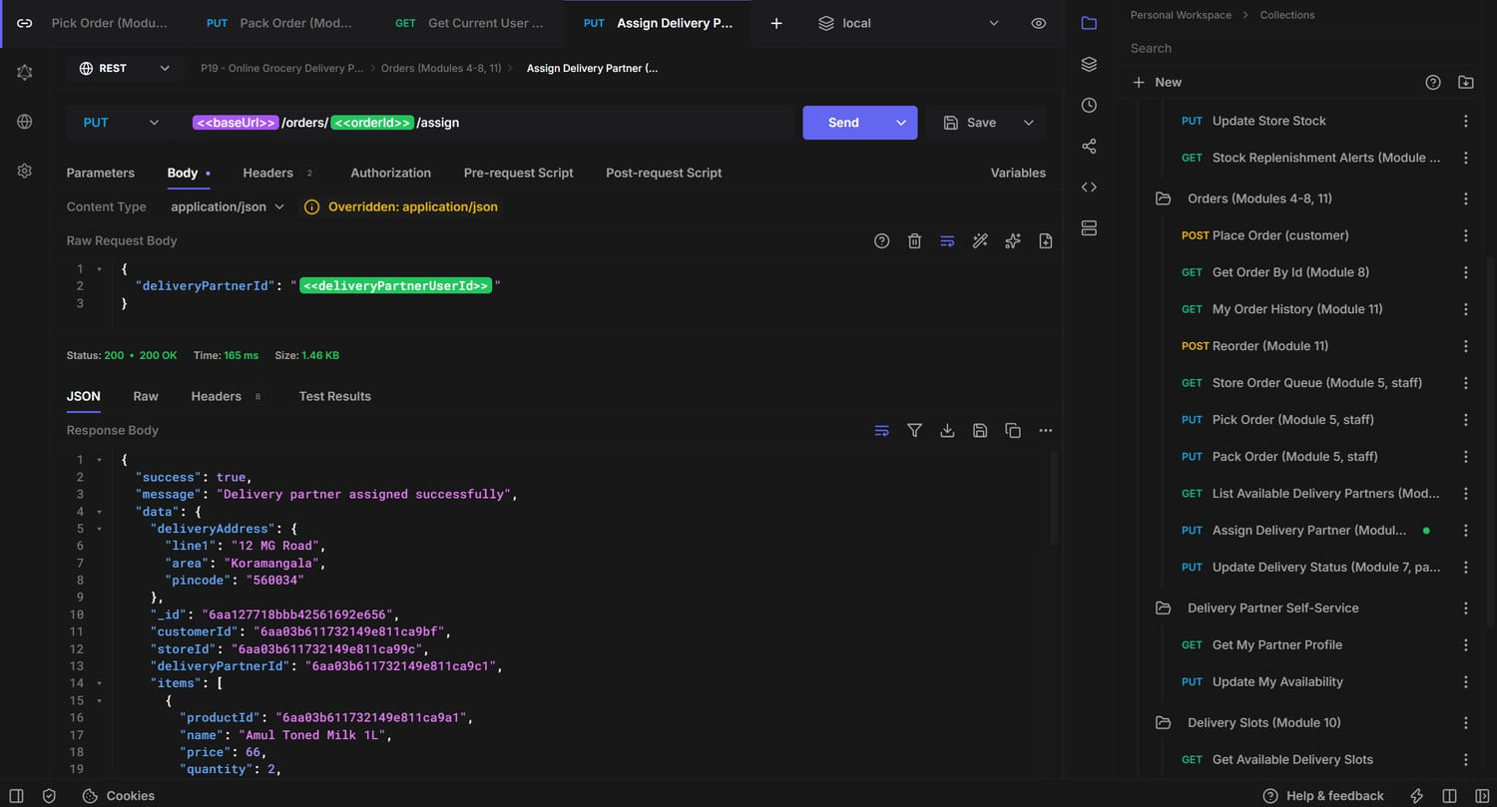
Postman — PUT /api/orders/:id/assign -> 200 Delivery partner assigned successfully (status: assigned)

4.7 Module 7 — Delivery Status Tracking
The assigned delivery partner (or admin) advances the order assigned -> out-for-delivery -> delivered (or -> failed). Reaching a terminal state stamps deliveredAt and frees the partner (isAvailable back to true). Illegal jumps are rejected with 409 INVALID_TRANSITION.
Endpoints:
PUT /api/orders/:id/status Partner/Admin Update delivery status { status, note }
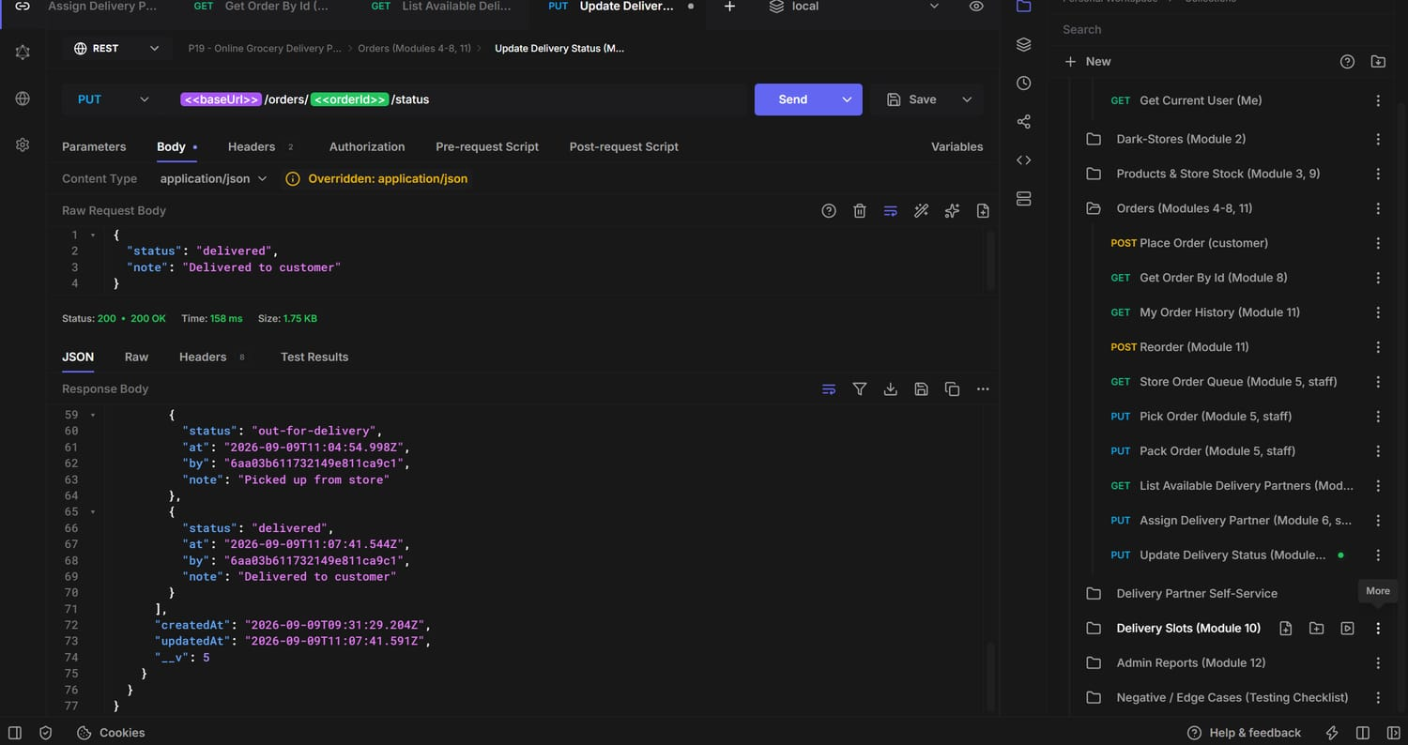
Postman — PUT /api/orders/:id/status -> 200 status: out-for-delivery
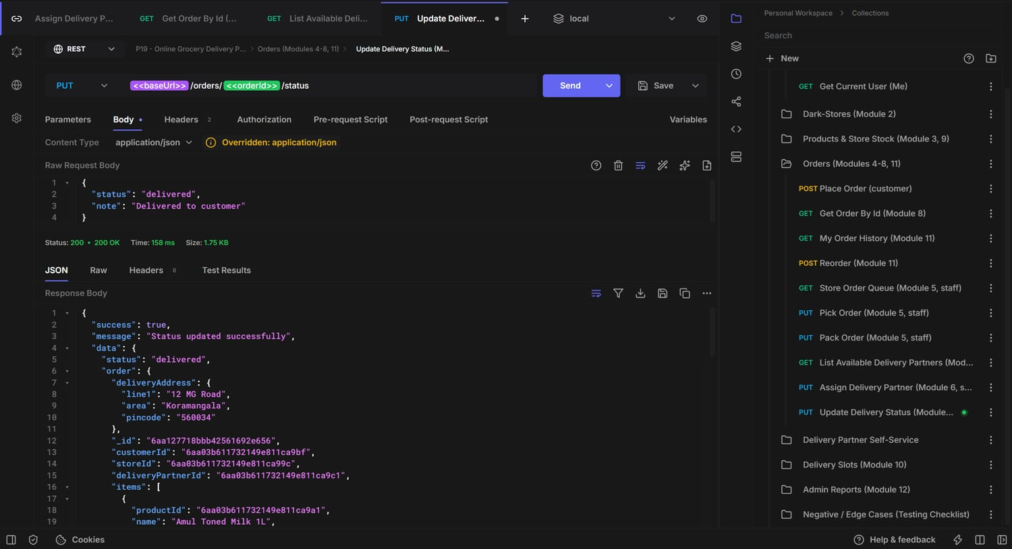
Postman — PUT /api/orders/:id/status -> 200 status: delivered (deliveredAt set)
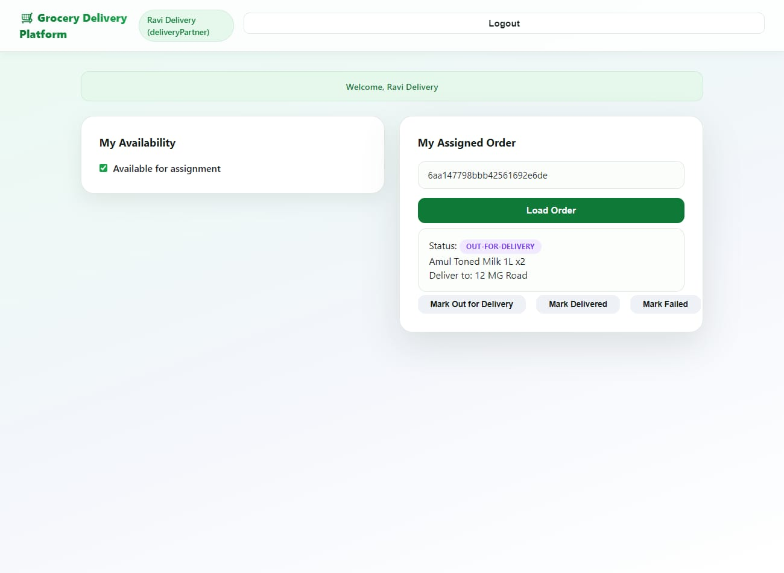
Demo UI — delivery partner loads the assigned order and updates its status

4.8 Module 8 — Real-Time Order Status for Customer
GET /api/orders/:id returns the order plus its full statusHistory[] — an append-only list of { status, at, by, note } events — so the customer app can render a live timeline. Access is checked inside the controller: a customer sees only their own orders, staff only their store's, a partner only the order assigned to them, admin everything.
Endpoints:
GET /api/orders/:id Owner / Staff / Partner / Admin Real-time status + full history
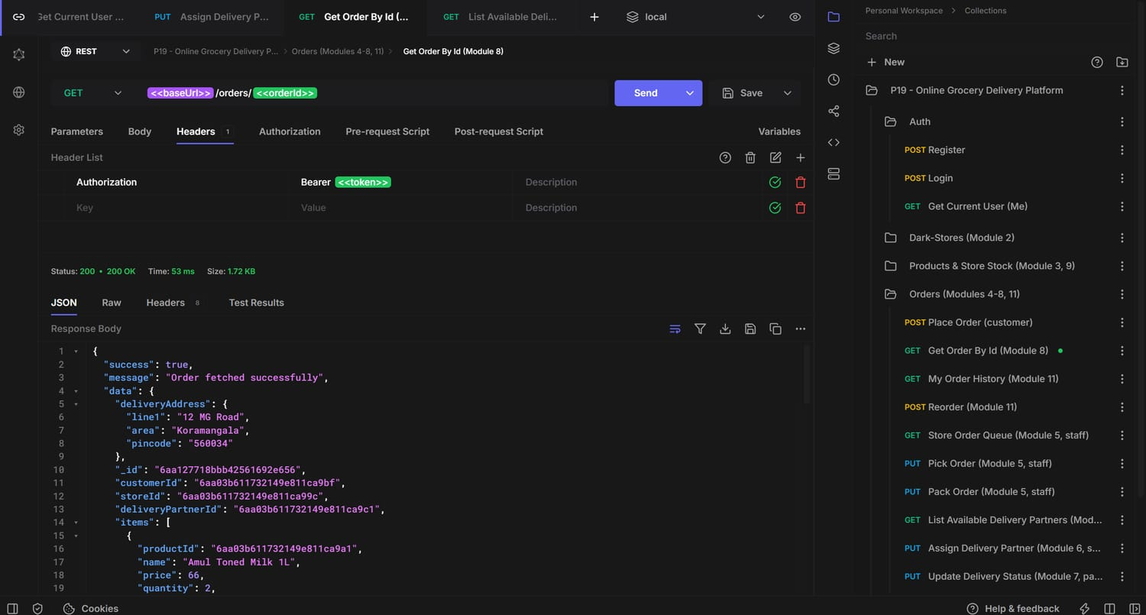
Postman — GET /api/orders/:id -> 200, status history (1/4): placed -> picking
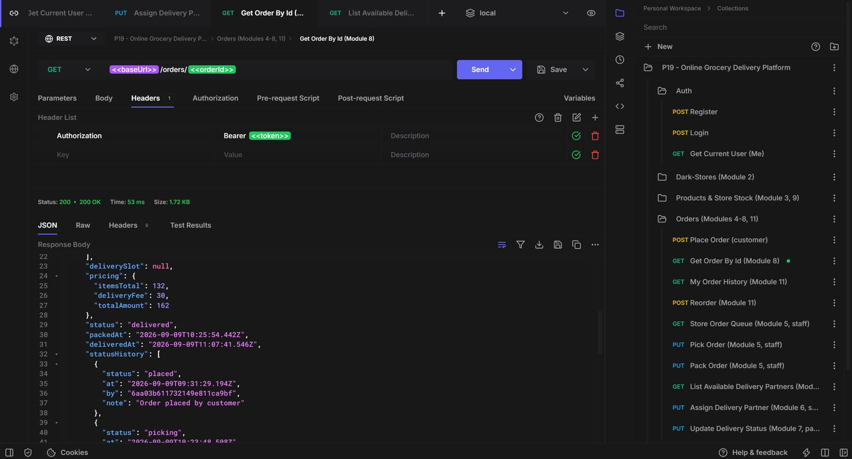
Postman — full timeline (2/4): packed -> assigned
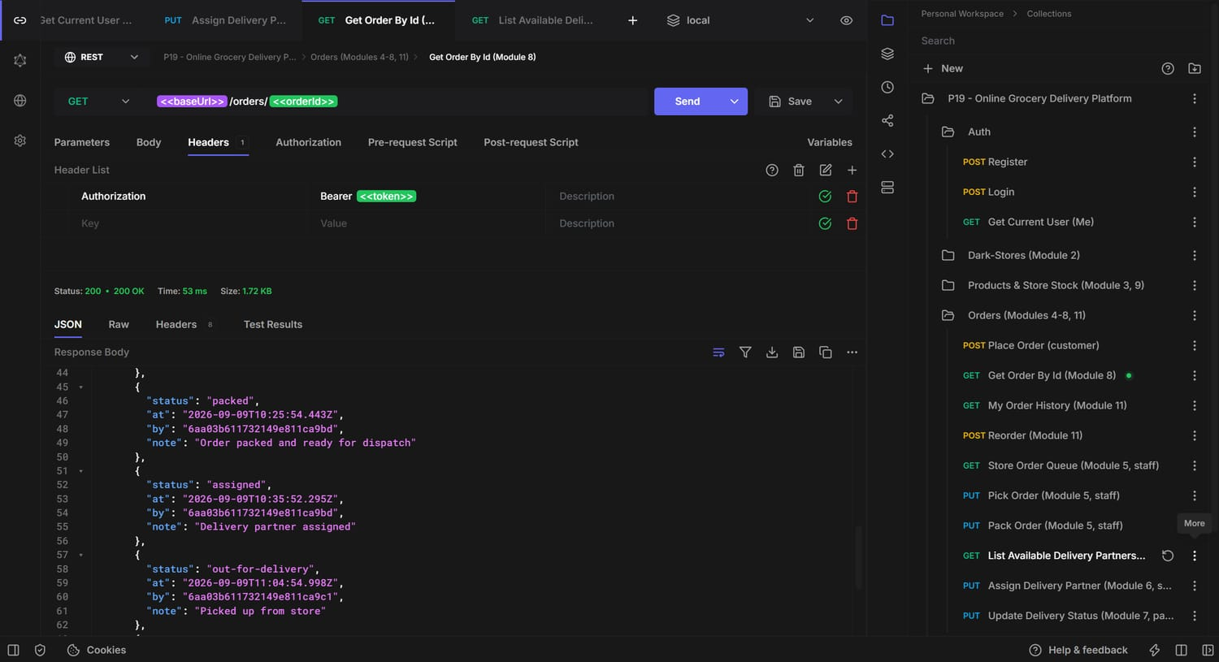
Postman — full timeline (3/4): out-for-delivery
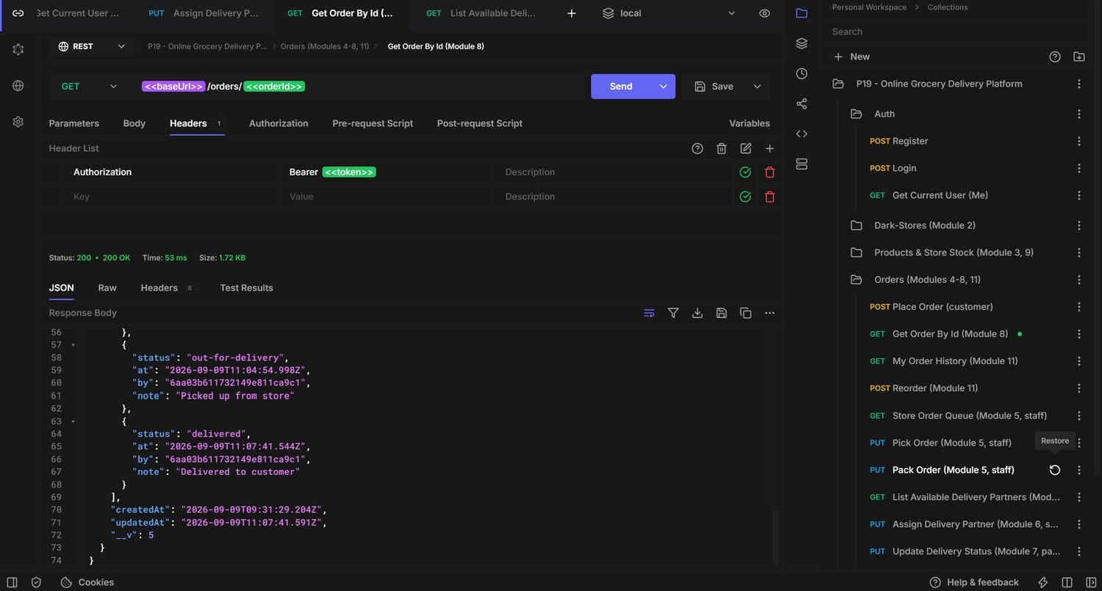
Postman — full timeline (4/4): delivered — all six events present

4.9 Module 9 — Stock Replenishment Alerts
GET /api/stores/:storeId/stock/alerts returns every stock row where quantity <= reorderPoint (default reorderPoint 10), populated with product name/category/unit, so staff know what to restock.
Endpoints:
GET /api/stores/:storeId/stock/alerts Admin/Staff Items at or below reorderPoint
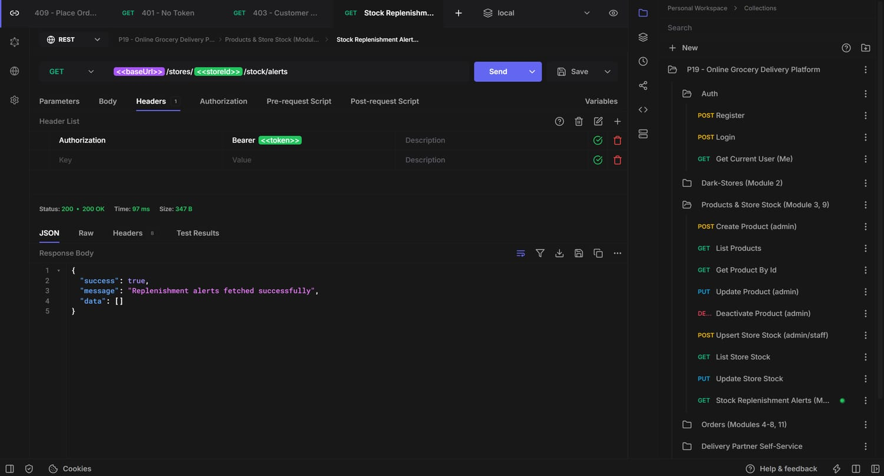
Postman — GET /api/stores/:storeId/stock/alerts -> 200 Replenishment alerts fetched successfully

4.10 Module 10 — Delivery Time Slot Selection
GET /api/slots generates bookable two-hour windows for today and tomorrow from DELIVERY_SLOT_WINDOWS (09:00-21:00, six windows/day = 12 slots). A slot passed at checkout is validated against this same generator before the order is accepted.
Endpoints:
GET /api/slots Any Bookable delivery windows (today + tomorrow)
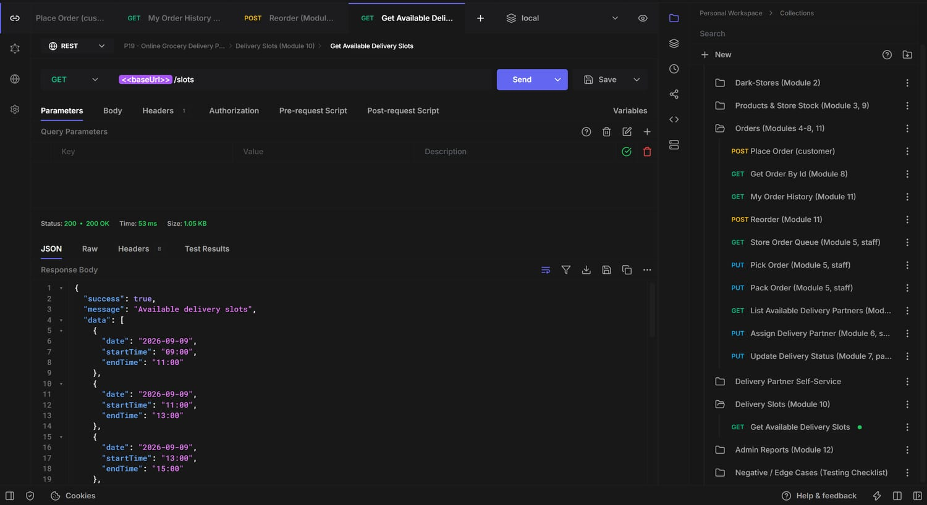
Postman — GET /api/slots -> 200 Available delivery slots (12 windows)

4.11 Module 11 — Customer Order History & Reorder
GET /api/orders/my lists the customer's orders newest-first (served by the { customerId, createdAt:-1 } index). POST /api/orders/:id/reorder rebuilds the request from a past order and re-runs the full placement path — so current stock and current prices are re-validated rather than blindly replaying an old snapshot; it returns a brand-new order.
Endpoints:
GET /api/orders/my Customer Order history
POST /api/orders/:id/reorder Customer Reorder a past order (re-validates stock & price)
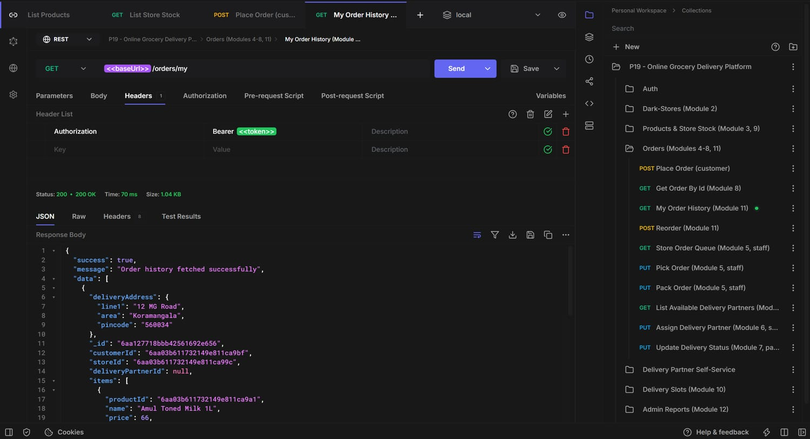
Postman — GET /api/orders/my -> 200 Order history fetched successfully
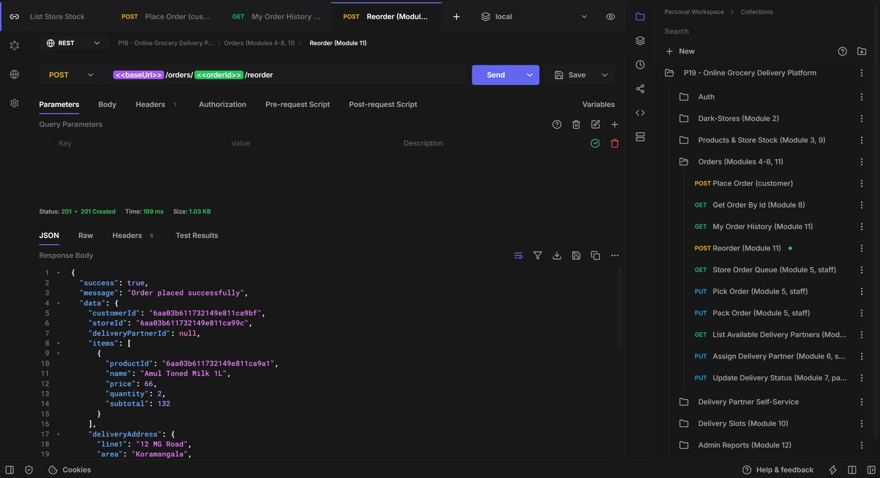
Postman — POST /api/orders/:id/reorder -> 201 Order placed successfully (new _id)
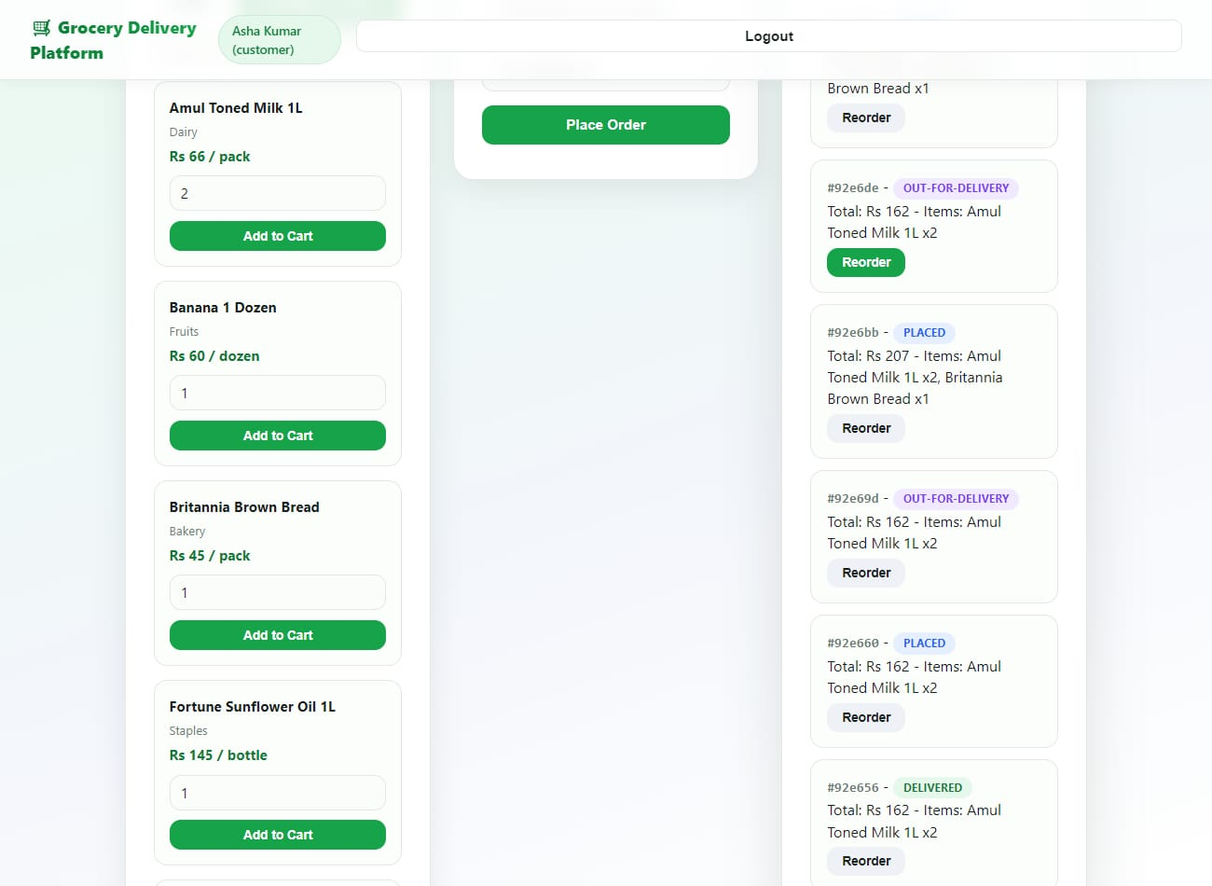
Demo UI — customer order history with per-order status and one-tap Reorder

4.12 Module 12 — Store & Delivery Performance Reports
Admin-only. A single MongoDB aggregation pipeline computes, per store: order volume, delivered/failed counts, average pick time (createdAt -> packedAt), average delivery time (assigned event -> deliveredAt), and revenue (sum of totalAmount for delivered orders) — straight from timestamps already on each order, with no separate reporting table.
Endpoints:
GET /api/admin/reports/performance Admin Per-store volume, avg pick/delivery time, revenue
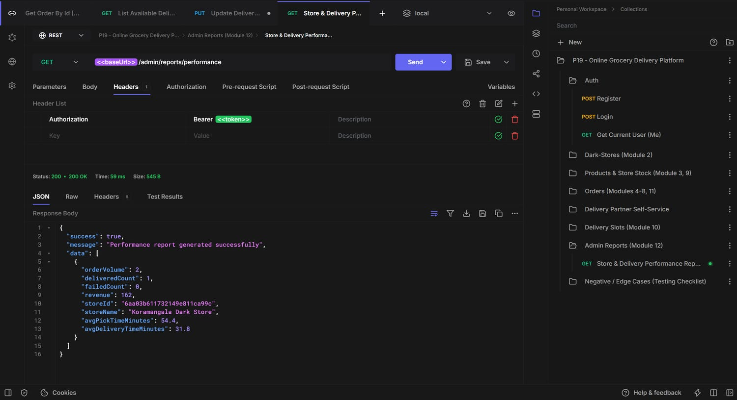
Postman — GET /api/admin/reports/performance -> 200 Performance report generated successfully
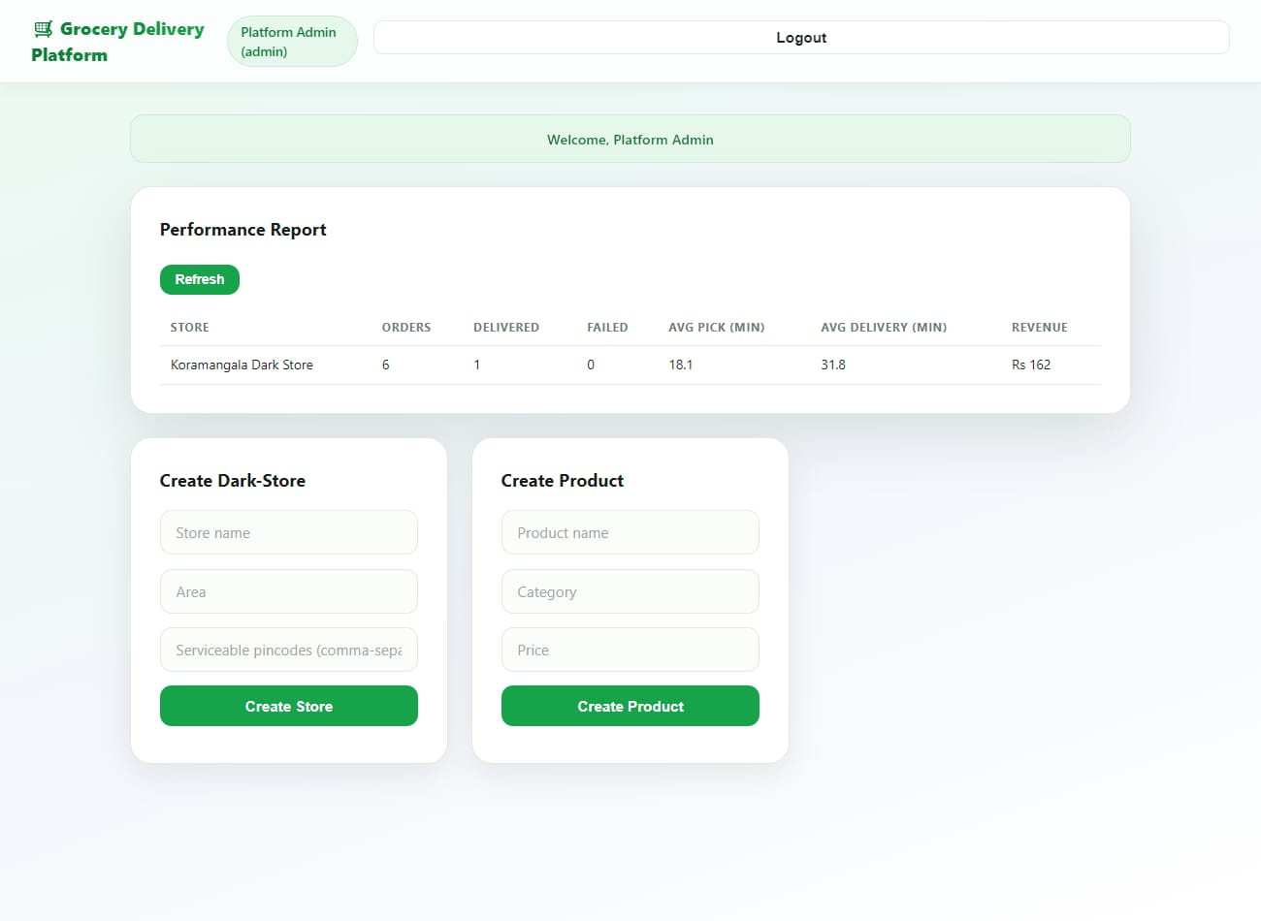
Demo UI — admin performance report (6 orders, 1 delivered, avg pick 18.1 min, avg delivery 31.8 min, revenue Rs 162)

4.13 Module 13 — Role-Based Access Control
Enforced in three layers: (1) middleware/auth.js verifies the JWT and attaches the live user record (so a revoked/deactivated user is rejected even with a valid token); (2) middleware/authorize(...roles) is a per-route role allow-list; (3) record-level checks inside orderController.canAccessOrder restrict each role to the orders it is actually party to. Missing token -> 401; wrong role -> 403.
Endpoints:
protect -> 401 Authentication required (no/invalid token)
authorize('admin', ...) -> 403 You do not have permission to perform this action
canAccessOrder(order,user) -> 403 on another user's order even with a valid token
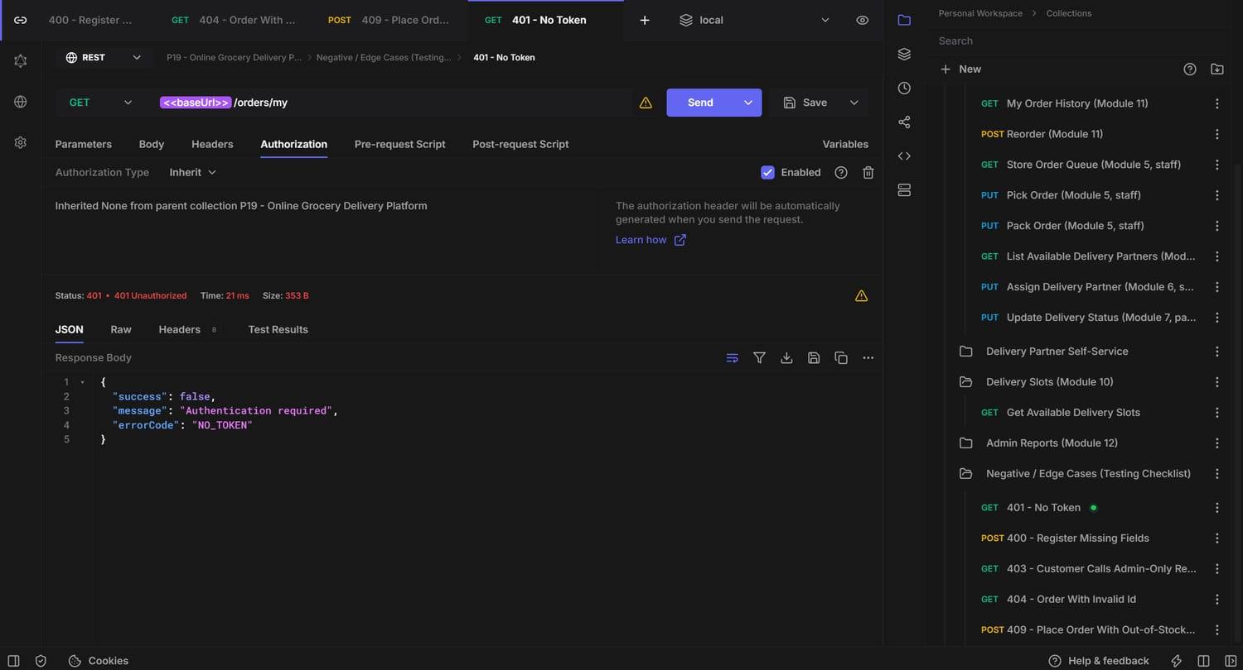
Postman — protected route with no token -> 401 Authentication required
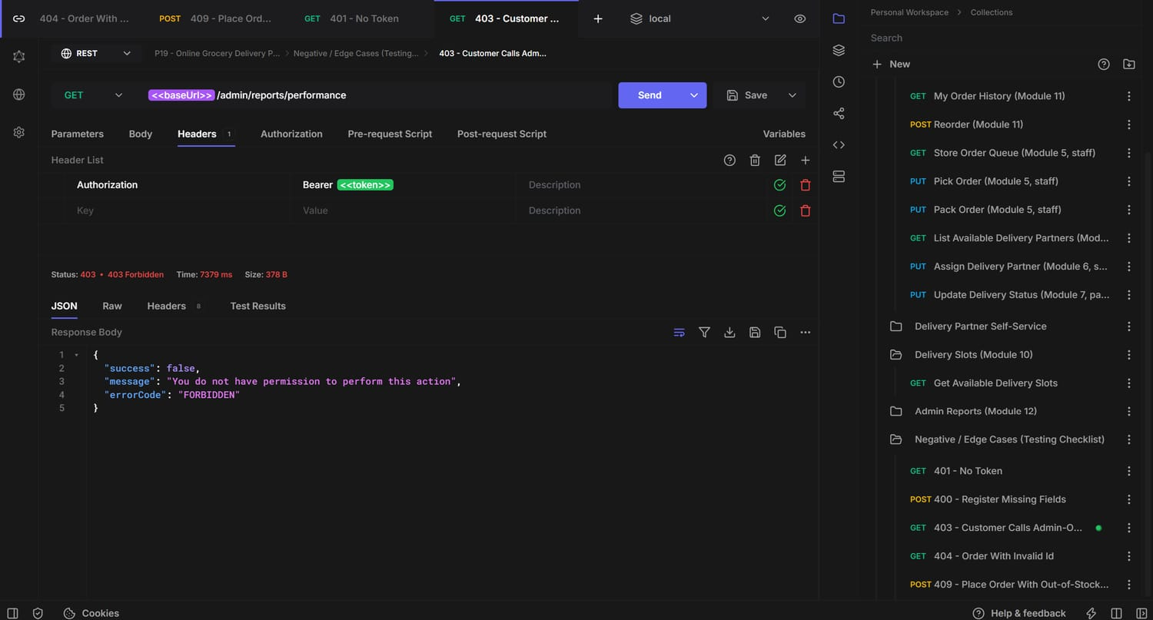
Postman — customer token calling the admin report -> 403 Forbidden

5. Complete API Endpoint Reference

5.1 Auth
Method | Endpoint | Auth | Description
POST | /api/auth/register | Public | Register customer/staff/partner/admin
POST | /api/auth/login | Public | Login, returns JWT
GET | /api/auth/me | Any | Current authenticated user

5.2 Dark-Stores & Store Stock
Method | Endpoint | Auth | Description
POST | /api/stores | Admin | Create a dark-store
GET | /api/stores | Any | List dark-stores
GET | /api/stores/:id | Any | Get one store
PUT | /api/stores/:id | Admin | Update a store
DELETE | /api/stores/:id | Admin | Deactivate a store (soft delete)
GET | /api/stores/nearest?pincode= | Any | Nearest-store check by pincode
POST | /api/stores/:storeId/stock | Admin/Staff | Upsert stock for a product
GET | /api/stores/:storeId/stock | Admin/Staff | List a store's stock
PUT | /api/stores/:storeId/stock/:productId | Admin/Staff | Update quantity / reorderPoint
GET | /api/stores/:storeId/stock/alerts | Admin/Staff | Items at/below reorderPoint
GET | /api/stores/:storeId/orders?status= | Admin/Staff | Store picking / packing queue

5.3 Products
Method | Endpoint | Auth | Description
POST | /api/products | Admin | Create a product
GET | /api/products?category=&search= | Any | Browse / search products
GET | /api/products/:id | Any | Get one product
PUT | /api/products/:id | Admin | Update a product
DELETE | /api/products/:id | Admin | Deactivate a product

5.4 Orders
Method | Endpoint | Auth | Description
POST | /api/orders | Customer | Place an order (nearest-store + stock check)
GET | /api/orders/:id | Owner/Staff/Partner/Admin | Real-time order status + history
GET | /api/orders/my | Customer | Order history
POST | /api/orders/:id/reorder | Customer | Reorder a past order
PUT | /api/orders/:id/pick | Staff/Admin | Mark items being picked
PUT | /api/orders/:id/pack | Staff/Admin | Mark order packed
PUT | /api/orders/:id/assign | Staff/Admin | Assign a delivery partner
PUT | /api/orders/:id/status | Partner/Admin | Update delivery status

5.5 Delivery Partners, Slots & Admin Reports
Method | Endpoint | Auth | Description
GET | /api/delivery-partners/available?storeId= | Staff/Admin | List available partners
GET | /api/delivery-partners/me | Partner | My partner profile
PUT | /api/delivery-partners/me/availability | Partner | Toggle availability
GET | /api/slots | Any | Bookable delivery windows (today/tomorrow)
GET | /api/admin/reports/performance | Admin | Per-store performance report

6. Testing, Validation & Error Handling
Every endpoint was exercised end-to-end with the Postman collection against the live backend, role by role (customer, staff, partner, staff, partner, customer, admin), reproducing the full order lifecycle. Beyond the happy path, the collection includes a dedicated set of negative / edge cases that assert the correct status code and error envelope.

6.1 Negative & Edge Cases
Status | Scenario | Response
400 | Register with missing fields | "name" is required, "password" is required — errorCode VALIDATION_ERROR (Joi, abortEarly:false)
401 | Protected route with no token | Authentication required — errorCode NO_TOKEN
403 | Customer calls the admin-only report | You do not have permission to perform this action — errorCode FORBIDDEN
404 | GET order with a non-existent ObjectId | Order not found — errorCode NOT_FOUND
409 | Place order with quantity above stock | '<product>' is out of stock at <store> (requested N, available M) — errorCode OUT_OF_STOCK
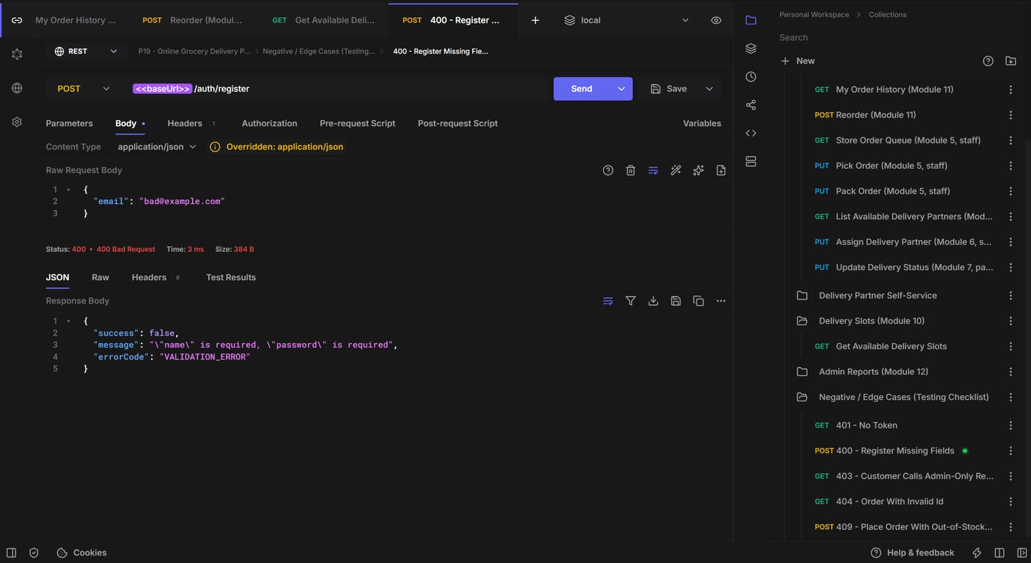
400 — validation error, all missing fields reported at once
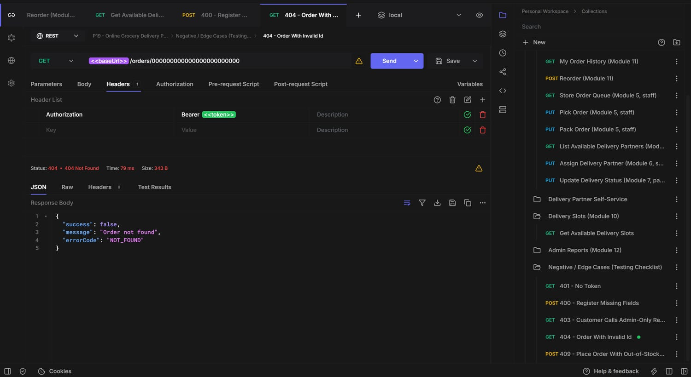
404 — order with an invalid / unknown id
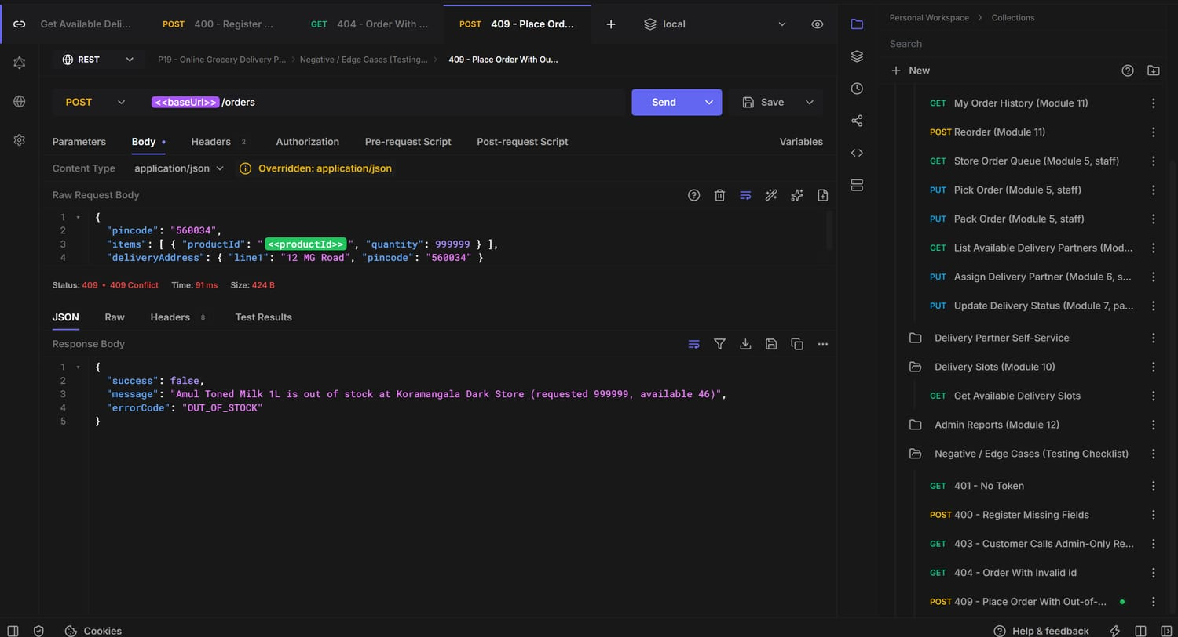
409 — out-of-stock guard blocks the order before any stock is decremented

6.2 Validation & Error-Handling Design
- Joi schema per write route via a validate() middleware; abortEarly:false reports every problem at once; stripUnknown removes unexpected keys before controllers run.
- A single central errorHandler converts every thrown/rejected error into the standard JSON envelope — Mongoose ValidationError -> 400, duplicate key (11000) -> 409, CastError -> 404, explicit err.statusCode/err.errorCode otherwise — so a stack trace is never leaked to the client and the process never crashes on an unhandled rejection.
- asyncHandler wraps every async controller so rejected promises reach the error handler.
- State-machine guard (assertTransition) rejects any illegal order status change with 409 INVALID_TRANSITION.

7. Setup & Run Instructions
- Prerequisites: Node.js 18+ and npm; MongoDB (local install or a free MongoDB Atlas cluster).
- Install dependencies:
cd grocery-delivery-platform/backend
npm install
- Configure environment — copy .env.example to .env and set MONGO_URI, PORT, JWT_SECRET, JWT_EXPIRES_IN, SALT_ROUNDS.
MONGO_URI=mongodb://127.0.0.1:27017/grocery_delivery
PORT=5000
JWT_SECRET=<long-random-string>
JWT_EXPIRES_IN=1d
SALT_ROUNDS=10
- Seed demo data (2 stores, 6 products, per-store stock, one login per role — password Passw0rd! for all):
npm run seed
- Run the server:
npm run dev # nodemon (auto-restart)
# or
npm start
- API is live at http://localhost:5000/api ; the demo frontend is served at http://localhost:5000/ .
- Import postman/grocery-delivery-platform.postman_collection.json, set baseUrl = http://localhost:5000/api, run Auth > Login — the token is captured automatically for every subsequent request.

7.1 Seed Accounts
Role | Email | Password
Admin | admin@grocery.test | Passw0rd!
Store Staff (Koramangala) | staff@grocery.test | Passw0rd!
Customer | customer@grocery.test | Passw0rd!
Delivery Partner | partner@grocery.test | Passw0rd!

8. Known Limitations
- Stock is decremented at order placement (not at pack time); a cancelled/failed order does not currently auto-restock.
- Stock decrements run as sequential updateOne calls rather than a MongoDB multi-document transaction, because a single-node local MongoDB has no replica set. On Atlas (always a replica set) this upgrades to a transaction with no other code change.
- Payment, SMS/email notifications, and maps/geolocation are out of scope and are not mocked beyond the nearest-store-by-pincode lookup.
- Delivery-slot capacity is not tracked — a window can be selected by unlimited customers; only the customer's own preferred window is recorded.
- The frontend is a minimal demo to make the live API demo easier to follow, not a polished consumer UI.

9. Learnings & Challenges
- Modelling the order lifecycle as an explicit state machine in one constant (ORDER_STATUS_FLOW) made the pick/pack/assign/deliver controllers tiny and impossible to misuse — every transition is validated against one table.
- Deciding embed vs. reference per field (not per collection) was the key database lesson: order line items must be an embedded frozen snapshot so past invoices never change, while stock must be its own referenced collection because it is updated on every single order.
- Two-layer RBAC (route-level role allow-list + record-level ownership check) is necessary — authorize('storeStaff') alone would still let one store's staff act on another store's orders without canAccessOrder.
- A single response envelope + one central error handler + asyncHandler removed almost all try/catch noise from controllers and guaranteed consistent error output for the Postman assertions.
- Running the whole collection role-by-role surfaced ordering bugs (e.g. a token overwritten by a later register call) that testing endpoints in isolation would have missed.
- Compound indexes were chosen to match the actual query shapes (customer history, store queue, partner deliveries) rather than added blindly per field.

10. Conclusion
P19 delivers a complete, working quick-commerce grocery backend: all 13 modules implemented and verified, a considered MongoDB schema with justified embed/reference choices and query-shaped indexes, a guarded order state machine, three-layer role-based access control, consistent validation and error handling, a full Postman collection, and a demo UI that exercises every role. The GitHub repository contains the full source, README, .env.example and Postman collection; node_modules and .env are git-ignored.
Repository: https://github.com/Aaryan658/L-T-5th-sem-grocery-delivery-platform

